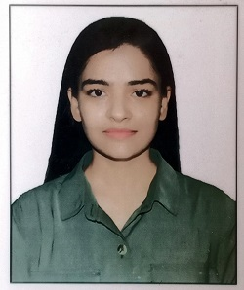

**RESUME**

**SHRUTI SINHA**

**H/O -14, Kusumpuram Colony**

**Ward No - 37, Gola Road**

**Danapur, Patna**

**Pin Code - 801503**

**Mob No:+918210511855,8797506858**

**Email:sinhashruti64@gmail.com**



**Objective:**

To perform the task assigned to me with the best of my ability and to work dedicated towards the success of the organization and excel leader.

**ACADEMIC QUALIFICATION :**

| **QUALIFICATION** | **UNIVERSITY /BOARD** | **PASSING YEAR** | **PERCENTAGE** |
| --- | --- | --- | --- |
| **BA(ASPASM)** | **PATNA UNIVERSITY** | **2018** | **69%** |
| **12 th** | **BSEB** | **2015** | **63%** |
| **10 th** | **NIOS** | **2013** | **45%** |

**CARRIER ACHIEVEMENT:**

●Workshop event organizing for sales promotion in advertising at college

* coordinator in PATNA BOOK FAIR 2017

**INTERNSHIP & TRAINNING:**

* + At Dainik Jagran for 45 days
  + At Siddhartha advertising agency for 45 days
  + At Patna Book Fair 2017 for 3 months

**WORK EXPERIENCE**

* + At Spicejet Patna for 3 months
  + Worked in Exarmymen's welfare for vistara airlines from 2 years as a Customer Service Agent
  + Now working in AIATSL for Vistara as Customer Agent
  + Trained on Altea software

**SKILLS**:

* **Computer Skills**
* Advanced Diploma in Computer Application (One Year)

**PERSONAL DETAILS:**

* Father’s Name : Mr.Ramesh Kr. Sinha
* Mother’s Name : Mrs.Veena Devi
* Date of Birth : 04 **Sep** 1996
* Marital Status : Single
* Nationality : Indian
* Gender : Female
* Language known : English, Hindi.

**Declaration:**

I here by declare that the above-mentioned information is correct upto my knowledge And bear the responsibility for the correctness of the above-mentioned particulars.

**Place:** Patna

**Date:**

***Shruti Sinha***