Vishal BASAWARAJ

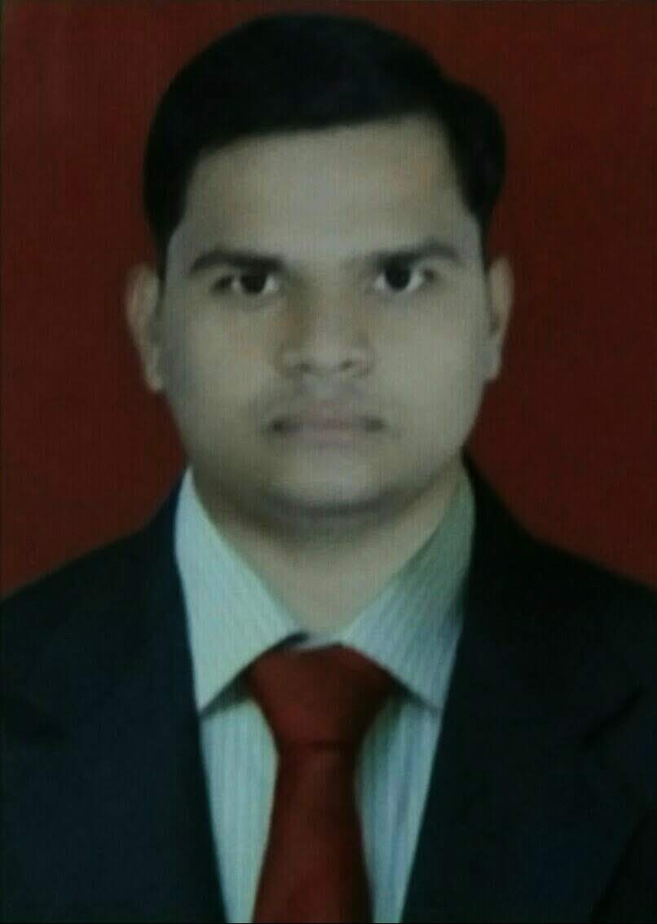 Bangar

Add:- Aarey Milk Colony Unit No 30,

Near Flim City Road

Goregaon East

Mumbai

400 065

Mob:- 8652772102

7738304033

Email:- [vishalbangar008@gmail.com](mailto:vishalbangar008@gmail.com)

# Objective

Secure a responsible career opportunity to fully utilize my training and skills, while making a

Significant contributions to the success of the company.

# Professional EXPERINCE

* Bizpaye Ltd, Marketing Calling and Back Office, Eight Month Experience.
* Kotak Mahindra Bank, Assistant manager Digital marketing (AMD) Manager.
* Joying Date Jun 2018 to November 2020 last date.
* Handle 811 Account Open, Saving Account open & Current Account open
* Insurance 811, health insurance, Accident insurance etc.
* Jana small finance bank, operation Assistant cum cashier (OAC),
* Joining date March 3rd & till date.
* Handle Thirty Lakh Gold Portfolio and Twenty Five Lakh Cash Portfolio for the Bank,
* Handle Gold Loan Renewal Process.
* Co-ordinate with Front-office Team For System Entry Of All Loan Leads

Generated By Front-office Team.

* Responsible For Maintaining Register of cash & Gold Disursement,cash Suspense

Register, and Manual Receipt Book Register.

# Academic/EDUCATIONal QUALIFICATION

* Bachelor Of Commerce (B.com) From Lords Universal College in Mumbai.
* Second Year Of Commerce (Sy.B.com) From Lords Universal College in Mumbai.
* First Year Of Commerce (Fy.B.com) From Lords Universal College in Mumbai
* Higher Secondary certificate (H.s.c) From Lords universal college in mumbai.
* Secondary School Certificate(S.s.c) From Navjyoti Vidya Mandir High School in Mumbai.

# Professional QUALIFICATION

* Certified in Office Admin Course By kotak Academy with Certified
* Certified Maharashtra State Certificate in Information Technology (Ms-cit) From Mumbai.
* Certified in Digital Design course, coraldraw ,photoshop & 3D MX Designing.
* Excellent Communication, Team work and Leadership Skills.

# PERSONAL INFormation

Father's Name : Basawaraj Bangar

Mother’s Name : Shakuntala Bangar

Date of birth : 7th December 1995

Gender : Male

Marital status : Unmarried

Nationality : Indian

Language known : English, Hindi & Marathi

Religious : Hindu.

Hobbies : Reading Book, Playing Football, workout (Gym), music.

# Declaration

I hereby affirm the information given in their document is correct to best of my knowledge.

**Place :- Mumbai**

**Date :- (VISHAL BANGAR)**