 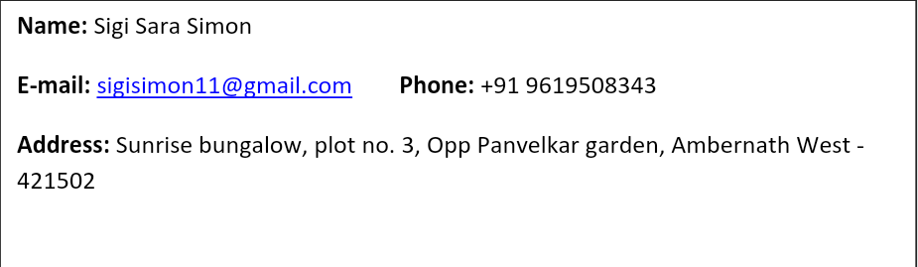

Company: QualityKiosk Technologies Pvt. Ltd. Period: **Jan’18** **- Present**

Location: Mumbai

Designation: **Assistant Manager – Bid Management**

**Key Roles & Responsibilities**

* **Presales/Bid Management**
* Managing end-to-end RFP process
* Working on RFPs, RFIs response- support in creating solution presentations, documents
* Prepare SOW for projects and phases
* Handle Far East region requests single handedly
* SPOC for Far East region & help in coordination with the Head office (Mumbai)
* Assisted in setting up CRM Suite for Far East region by updating the opportunities, leads, contacts, etc. for each client
* Supporting finance, delivery and sales with CRM organisation wide
* Maintain & Track of Presales data/repositories
* Bid planning - creating bid schedule, deciding and allocating roles and responsibilities, tracking progress, follow up with each team
* Preparation of proposal template, pre-qualification document and main response document
* Managing and coordinating with multiple internal stakeholders like business team, legal team, transition team, hiring, quality for creating solution / proposal as per client requirements
* Having a good grip on preparation of PowerPoint presentations
* Working on designing corporate presentations for showcasing to clients using corporate brand guidelines (colors used, font style and uniformity)
* Formatting presentations and documents in terms of look and feel and relevance to subject
* Create and updating capability presentations, Case Studies- Support in preparation of decks from various stakeholders
* Good working knowledge of MS Word, MS PowerPoint,etc.
* Was part of the team for winning major deals in Far East & Phillipines

Company: Hexaware Technologies Limited (Hexaware BPS) Period: **Sep’13 —Jan’18**

Location: Mumbai

Designation: **Inside Sales – Business Development**

**Key Roles & Responsibilities**

* **Business Development**
  + Generating contacts and lead for the Sales Team
  + Focused geography – APAC with current focus on Australian & Middle East Markets
  + Initiate and conduct introductory calls with client and pitch for different service offerings of the organization
  + Attending meetings with clients for first level interaction with Sales Team
  + Leads include all sectors including - manufacturing & production, FMCG, power, energy & utility, oil & gas, construction, etc.
  + Relationship management with clients through follow ups for existing engagements, new opportunities
  + Preparing capability presentation for first level meetings
  + Coordinating with Operations & presales teams for timely delivery to prospects
* **Presales/Corporate Sales Support**
  + Preparing decks for existing clients, new opportunities for pitching, highlighting company capabilities, solutions offered, etc.
  + Working on qualified leads (post lead generation) – decks, proactive proposals
  + Working on RFIs/RFPs/Proposals on standard content and coordinating with different teams for inputs on solution and delivery
  + Creating and formatting PowerPoint presentations as per corporate standards for internal and external stakeholders
  + Support in preparing and updating corporate collaterals like corporate presentations, case studies, etc.
  + Good knowledge on MS Office products (Word, PPT, Excel)
* **Market Research and Database**
  + Gather data and intelligence on competitors and analyze their prices, sales, method of marketing, etc.
  + Responsible for database building and maintenance for Demand Generation
  + Market Research and Account Based Marketing
  + Assist in content marketing
  + As a Research analyst searching desired organization and executive details such as person-based address, contact details- telephone number, fax number, email address, company’s yearly turnover etc., Creating database and submitting reports in the form of excel
  + Having good knowledge of collecting Source for Specified Services through Web research on various search engines and Business Directories like Hoovers, Lead 411, Jigsaw, and some Professional networking sites like LinkedIn
  + Good knowledge on MS Office products
* **Senior Executive - Operations**
  + Part of the operations/process team for one of our international clients - background verification processes for the largest US background verifications provider
  + Process included employment, education and reference checks for prospective employees of the clients
  + Handled 40% voice verification and 60% database records
  + Handled a team of around 7 people

Company: Sunil Enterprises

Location: Kolkata Period: **Jun ‘11 —Jul ’12**

Designation: **Research Executive**

**Key Roles & Responsibilities**

* **Research Executive**
  + Online research for prospective clients
  + Preparing picture quotations
  + Tending to the requirements of the current clients
  + Looking into the export requirements



* + Won Quarterly Star Performer Award
  + Have received appreciation mails from external & internal clients for my work
  + Received client appreciation for good pitching during first level calls and follow up
* **Post-Graduation** 
  + Specialization: – PGDM-Logistics & Supply Chain Management; Year of passing: 2012
  + Institute: St. Xavier’s College, Kolkata
  + Percentage of Marks: 70%
* **Graduation** 
  + Specialization: – Bachelor of Commerce – Hons. (B.Com Hons); Year of passing: 2011
  + Institute: St. Xavier’s College, Kolkata
  + Percentage of Marks: 58%
* **HSC** 
  + Completed 12th from I.S.C Board
  + School: St. Thomas’ Girls’ School, Kolkata.
  + Percentage of Marks: 79%



* I enjoy reading
* Listening to music
* Travelling
* Played basketball in school and represented in inter-school events
* State Convener in AICUF for Women Commission in West Bengal



* References available upon request



I hereby declare that the above-mentioned information is correct and true and I bear the responsibility for the correctness of the above-mentioned particulars