**MANORANJAN NAYAK**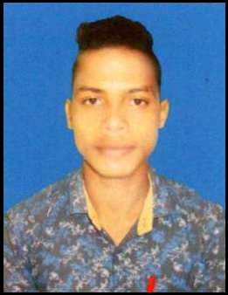

CONTACT No: +91-8456910815

E-MAIL: [nayakmanoranjan916@gmail.com](mailto:nayakmanoranjan916@gmail.com)

**OBJECTIVE :**

To work for a professional organization which offers challenging opportunities, an excellent cooperative working environment to utilize my professional and technical knowledge, enabling me to improve my abilities, develop my functionality, and improve the organization plans and work procedures.

**ACADEMIC  CAREER:**

* Pursuing…. **Bachelor Of Business Administration(BBA)** iDream management college , Balhar Chhack,  Talcher (2016-2019)

* **+2 Arts,** Bapujee h.s School.Garpalasuni,Odisha (2014-2016).
* **BSE** ,Grampanchayat High School, Bhimkand, Odisha (2011-2014)

EDUCATION QUALIFICATION

|  |  |  |  |
| --- | --- | --- | --- |
| *YEAR* | *COURSES* | *PERCENTAGE* | *INSTITUTION* |
| **2014** | **10**th | **61%** | **Grampanchayat High School,Bhimkand** |
| **2016** | **+2(sc)** | **50%** | **Bapujee h.s School**  **Garhpalasuni** |

**STRENGTH  :**

* Decision Making

**PERSONAL DETAILS:**

NAME : MANORANJAN NAYAK

D. O .B                            : 14/06/1998

MOTHER NAME            : BANITA NAYAK

FATHER NAME              : KULAMANI NAYAK

HOBBIES                       : Football , Exploring new places , Reading Books .

LANGUAGES KNOWN : > Oriya > Hindi > English >

**DECLARATION:**

I hereby declare that the above-mentioned information is true and

correct and I bear the responsibility for the correctness of the above-mentioned particulars.

DATE    :

PLACE :                                                                 Signature: