**Mr. SONJIB GOGOI**

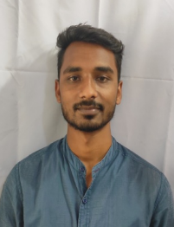 Bordirak

P.O- Bordirak

Dist- Tinsukia Assam

Pin- 786152

Mobile- 7086775801

Email ID: sonjibgogoi13@gmail.com

Profile:

Aspiring to carve a professional role for myself in an organization of repute where in I could contribute to the organization’s progress.

**Educational Qualification:**

* B.com from Doomdooma college-2015 to 2018
* HS in Doomdooma college- 2013 to 2015
* HSLC from Bordirak high school - 2012

**Other Qualifications**

* **Computer**

Working Experience:

1.

* Designation : Front line officer
* Company : L&T Financial Service
* Duration : 19 Sept 2018 to till now
* Place of Work : Doomdooma

**Personal Profile:**

Date of Birth : 30/11/1996

* Father’s Name : Mr. Badan Gogoi
* Mother’s Name : Mrs. Anima Gogoi
* Languages Known : English; Hindi; Assamese
* Gender : Male
* Nationality : Indian

I ensure you that the information provided by me is true to the best of my knowledge & belief.

If given a chance I will surely give my best performance & look forward for the progress of the company.

Regards,

Sonjib Gogoi