**CURRICULUM VITAE**

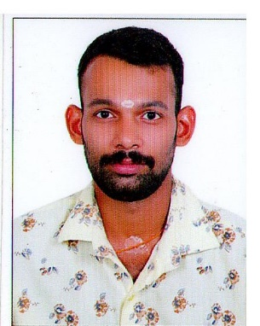 **HARIKRISHNAN H NAIR**

CHEENIVILAYIL (H)

AYTHALA P O

RANNY - 689673

PATHANAMTHITTA, KERALA

Mobile : +91 8075595269

Email : harikrishnannair@gmail.com

**CAREER OBJECTIVE**

To make a growth-oriented carrier by working with a global organization and there by applying my knowledge and skill for the benefit of the organization.

**EDUCATIONAL QUALIFICATIONS**

* BA Ecconomics from MG University

* Plus Two from SC Higher Secondary School Ranny
* SSLC from St Thomas High School Ranny

**TECHNICAL SKILL SET**

* Microsoft - Word, Excel, PowerPoint
* English Malayalam Typing

**EXPERIENCE**

Sales Executive at Kumaramangalam Agencies Ranny

**PERSONAL SKILLS**

* Good creativity.
* Good communication skills.

**PERSONAL DETAILS**

DOB : 19/01/1995

Father’s Name : Haridasan Nair

Mother’s Name : Ramadevi

Languages Known : English, Malayalam

Marital status : Single

Nationality : Indian

Hobbies : Reading, Watching Film

**DECLARATION**

I hereby declare that the above details are true as best of my knowledge.

Place: PATHANAMTHITTA **HARIKRISHNAN H NAIR**