Reguleringsteknikk eksamen
Task 1 1
a) State-space representation 1

Task 1

a) State-space representation
Differential equation describing the tank water level:
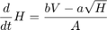
This ode is non-linear in . However, we can approximate this by a first order taylor expansion/linearization in a neighbourhood around the stationary point :
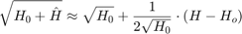
With this linearization we arrive at the linear ODE:
Published with MATLAB® R2021a

