# **LOAN APPLICATION PROCESSING SYSTEM**

# CAPGEMINI TRAINING PROGRAMME

# JEE CLOUD

# PREPARED BY

Divya

46001024

# Personal Parallel Project

**ABSTRACT**

This is an online loan application processing system where anyone can apply for loan who earns. Different types of loan exist which user can apply for based on the salary. Loan application will be automatically accepted if the required loan amount is less than or equals to the salary factor of loan type selected. After the automatic approval an interview date is allotted for the applicant on which date applicant has to be there with all required documents. After this the member of the Loan Approval Department can approve or reject the applicant’s loan request. Along with this admin has the option to add member to the Loan Approval department and add loan type and can also view loan requests. Member can view loan requests and approve or reject the pending requests.

**SCOPE**

User: 3 types of users exist:

**Admin**: login, add/update member, view loan requests, add new loan type

**Member(LAD)**: login, view loan requests, update request status

**Customer:** apply for loan, check the status of application given the application Id.

**CLASSES**

**Class: User**

**Attributes:**

* private Integer userId
* private String username
* private String password

**Methods:**

* **addMember(User): User**

This method will prompt admin to enter all the necessary details required to register the new member of Loan Approval Department.

* **addLoanType(LoanType): LoanType**

This method will prompt admin to enter all the necessary details required to add new type of Loan to the department.

* **viewLoanRequests(LoanType): List<LoanRequest>**

It will display all loan requests made for particular loan type.

* **updateLoanStatus(Integer):LoanRequest**

It will ask member of loan approval department to update the pending loan requests as approved or rejected.

**Class: Customer**

**Attributes**

* private customerId: Integer
* private customerName:String
* private phoneNumber: String
* private aadharNumber: String
* private listOfLoans: List<LoanRequest>

**Class: LoanType**

**Attributes**

* loanId: Integer
* loanType: String
* salaryFactor: Integer

**Class: LoanRequest**

**Attributes**

* applicationId: Integer
* applicantName: String
* aadharNumber: String
* phoneNumber:String
* salary:Long
* loanSelected:LoanType
* requiredLoan:Long
* applicationstatus:String
* loanStatus:String
* interviewDate: Date

**VALIDATION RULES**

* Every new member added will have unique username
* Every new loan type should have a salary factor
* As soon as the application is accepted a new customer is added to the system.
* Interview date should always be greater than 2 days.
* Aadhar number is always 16 digits
* Phone number should be 10 digits
* Loan is only accepted if it is satisfies the salary factor of the chosen loanType.

## **USE CASE DIAGRAM**

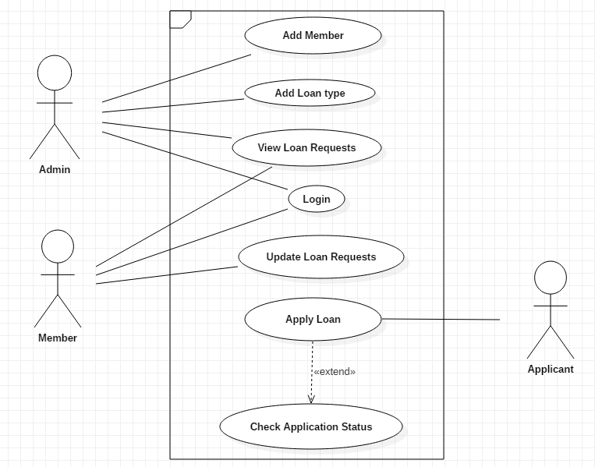

## **CLASS DIAGRAM**



