Report for Brahms Project.

House Security System

Eduardo Gutarra Velez.

Palash Verma

2010

4/28/2010

Introduction

This project aims to simulate the effectively of a House Security system to see if the sensor setup has any loophole. In this simulation the security company introduces a dummy thief, to see the effectively of the system.

In order to do a realistic simulation, we have modeled the motion detection sensors used by the security system, the 911 emergency response system and a Intelligent Home Security system.

The house security system may be activated or deactivated by entering the keypad's pin correctly. When the security system is activated a composite workframe is launched to listen for events caused by the sensors.

Before the security system can detect break-ins by Thief agents in an arbitrary house, it must be activated by its house-user. This is done through a keypad located within the House, and with a given pin it will be activated.

Geography

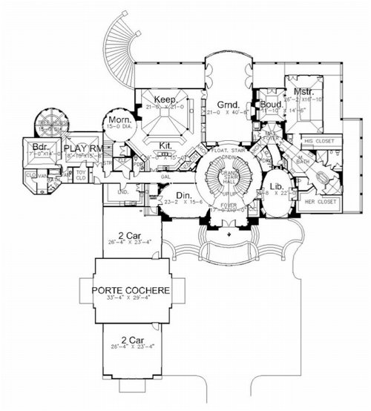House 1 - has a detailed geography with rooms (See Figure 1), House 2, House 3 – Dummy houses.

Figure : Floor Plan House1

Emergency Response Center – the 911-call center, Security Company’s Surveillance Center – Where the company monitor’s alerts from its installed systems.

Police Station1, Police Station 2 – Where the emergency response teams are stationed.

Fredericton City – Where all the things in the geography are located.

Objects

Motion Sensors, Security Keypad

Functionality

In order for a user to activate the House Security System, he/she must first move to the house where they want to activate it. After that the user initializes the keypad, which shortly after starting asks for the pin number to verify the house-user. The user then enters the pin number on the Keypad, and it is verified by the security system. If the pin is not correct then user is prompted to enter the pin again. The user can make only three attempts, and on the third attempt, the user will no longer be prompted for a pin but the security system would activate the alarm if in active state or would not get activated if in inactive mode. (See Figure 2)

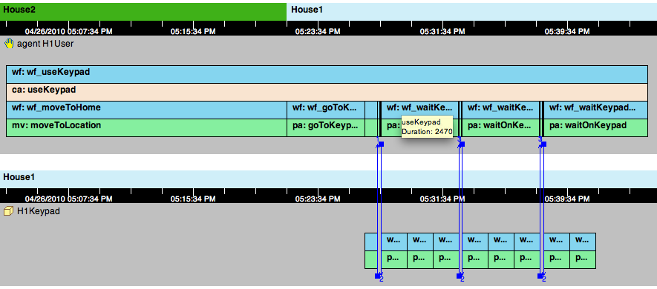

Figure : House Security System Functionality

If the user enters the correct pin then, the Security System agent gets activated if in inactive state and gets inactive if in active state, by changing a fact in the world. The Security System and Keypad communication is shown in Figure 3.

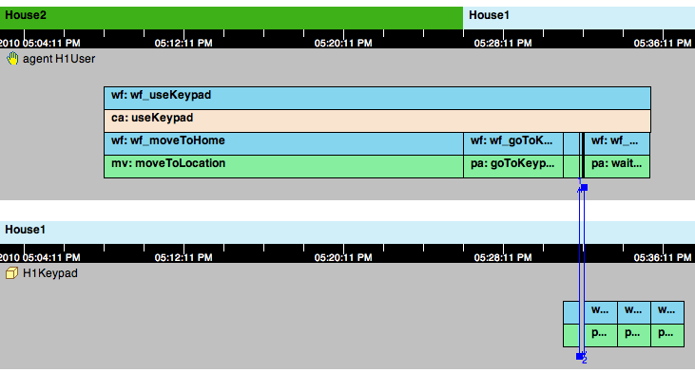

Figure : Keypad and Security System Functionality

We chose to use a composite activity for activating the system, as there are certain activities that have a precondition to make the system active. In that sense we evade checking for this in every workframe. The following illustrations Figure 4 and Figure 5 show how to activate and deactivate the system using the Keypad. The activation is actually toggled so that if the user keys in the PIN when the system is inactive, he will activate it. If he enters the code when it is active, he will deactivate it.

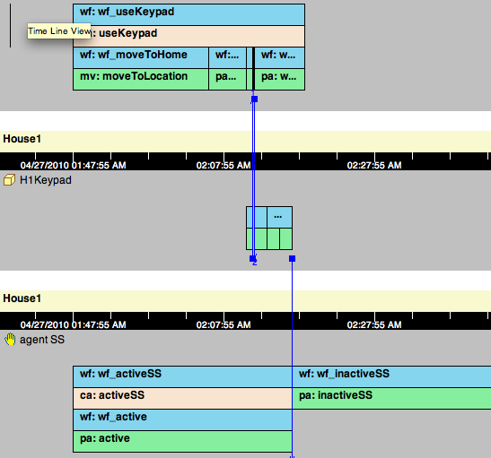

Figure : Toggling the inactive system to active state

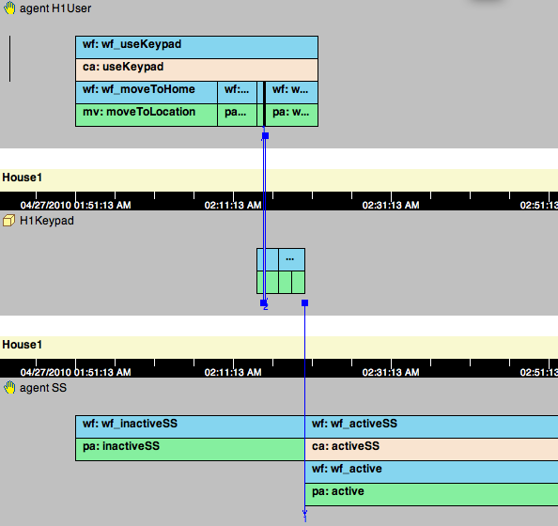

Figure : Toggling the inactive system to active state

When a sensor detects a thief it communicates with the House security system agent (SS). These events are handled by a detectable within the House Security agent that handles the sensor alarms. The house security system then triggers a procedure for handling the burglary.

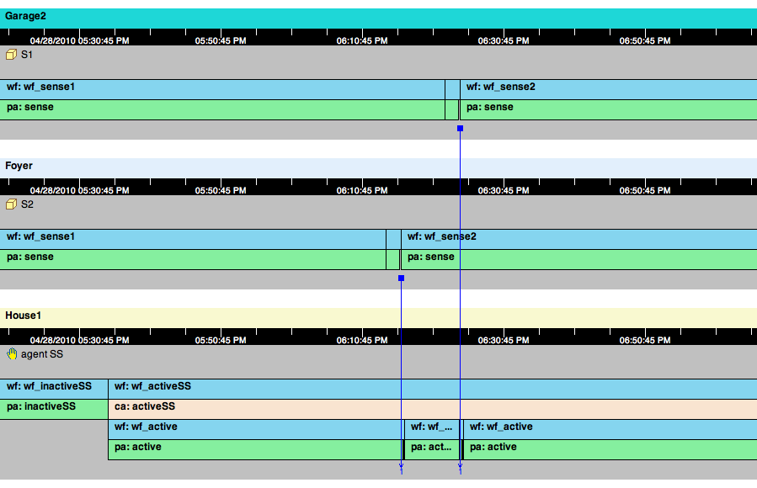

Figure : Thief being detected by the system

We have made our thief determine an arbitrary order on how to visit the rooms. We determine this arbitrary order by concluding a first location with 100 percent certainty and then overwrite this conclusion with probability of 50 percent. The thief keeps track of the rooms he has visited before, so he will not visit a room more than once. He will also learns about the sensors when the motion is detected and an alarm is sounded thus, giving him surveillance of which rooms have sensors on them. The thief in response to the alarm leaves before being caught.

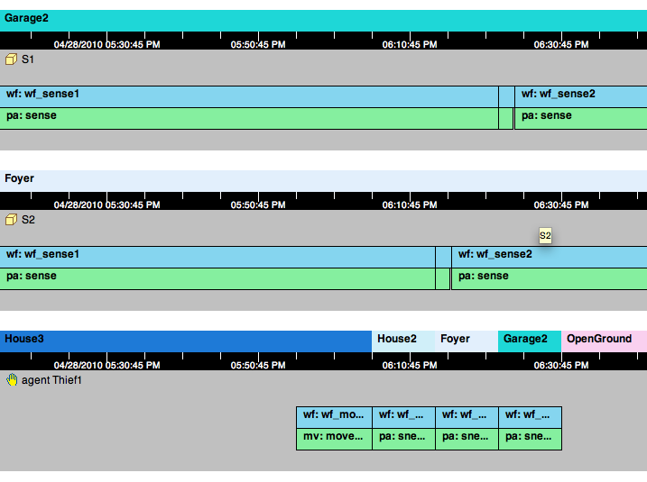

Figure : Thief moving from one location to the other

When the Security system activates the alarm that in turn activates many other workframes. To begin with the Security Officer who is monitoring the installed security system’s get alerted and he/she in turn calls the house user to verify if the alarm was a false positive. The call constitutes of a security PIN verification that is pre-selected between the house user and the security company. If the PIN is wrong the Security Officer directly calls the 911 Response system to send out the Response Teams to the location. If the PIN is verified to be correct the system checks the house user’s belief, if the user believes that alarm was a false alarm the security teams stay put, else are sent to the location.

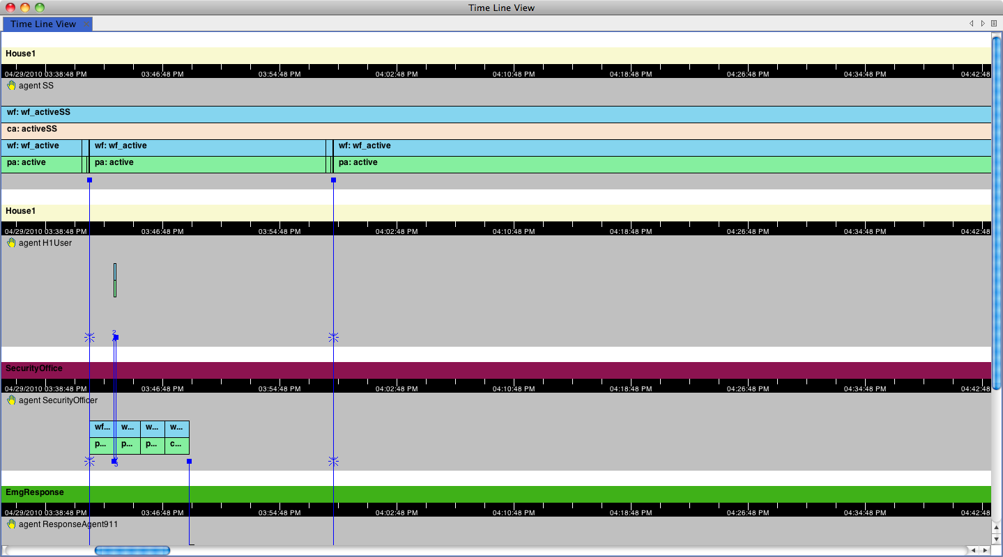On the other hand when the 911 Emergency response system gets a call from the Security Officer, it first decides where the response team needs to go, and then communicates with the response team about the location. Once the response team has the location it moves to the specified location to possibly apprehend the thief. The figure below shows this communication and the movement of the response team.

Figure : The Security Officer sees the raised alarm and calls the house user

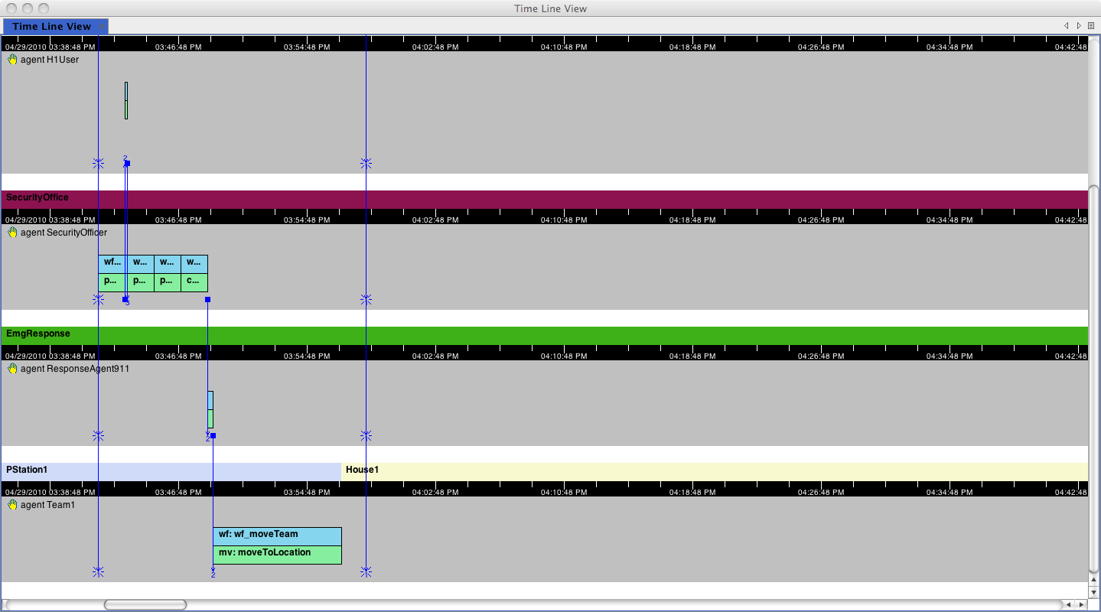

Figure : Communication between 911 Response System and Response Team