Decompressing a Projection Index with CUDA
Eduardo Gutarra Velez.
Department of Computer Science
University of New Brunswick
Fredericton, NB, Canada
g8138@unb.ca

Abstract— One of the difficulties faced when using a general purpose graphics processing on memory intensive tasks, is the considerable amount of time it takes to transfer data from a CPU to a GPU. Such is the case when one tries to upload a projection index onto the graphics processor in order to process a query. To ameliorate this problem, one may reduce the amount of data that needs to be transferred by compressing it. In this paper a Run Length Encoding (RLE) compression scheme is used to minimize the size of the data needed to be transferred. The idea is to compress a projection index using the RLE scheme and then decompress it within the GPU using a decompression algorithm. Two algorithms were designed for this purpose: one is load unbalanced and the other is load balanced. Both algorithms used the parallel prefix sum as a building block. The parallel prefix sum helps the algorithms determine how to allocate and copy the decompressed projection index within the GPU. To conclude, benchmark tests were performed comparing the two different algorithms suggested against moving the projection index uncompressed to the graphics processor’s memory. The tests were performed in two different GPUs, one with computability 1.1 and the other 1.3. It was determined from the results that the performance of the algorithms depends mostly on the GPU used and its computability, the percentage of compression of the projection index, and the nature of the data being processed including its data type. In general, for both GPUs an improvement in performance was observed. The improvement was consistent for the load balanced algorithm, but it was not for the load unbalanced algorithm.

Keywords— GP-GPU, Projection Index, RLE, high thread-level parallelism, Compression
- Introduction
GPUs are both powerful and inexpensive devices that could be used in order to obtain more computational throughput. Not only can they perform faster than CPUs in number of floating point operations per second but they also have a higher growth rate in performance. Over the last decade the growth rate of GPU performance has been higher than that of the CPU’s [4]. GPUs were primarily designed and used for performing algorithms around graphic computation, such as transforming, rendering and texturing geometric primitives such as triangles. However, many have sought techniques for using the GPU to perform tasks that are not related to graphics and that are typically handled by the CPU.
Many researchers view GPUs as today’s most powerful computational hardware for the dollar. Researchers and developers in areas not related to graphics have also become interested in harnessing this power for general-purpose computing. This effort is collectively known as GPGPU (it stands for “General-Purpose computing on the GPU”) [5]. Part of this collective effort are the database community researchers who have taken interest in using GPUs for accelerating database operations. The concerned operation in this paper is query evaluation using indices.
Indices are data structures used to accelerate search and retrieval of data. Different data structures have been proposed for use in CPUs. However, many of them are often not easily parallelizable and therefore cannot benefit from an implementation on a GPU. Indices whose performance may benefit from a GPU implementation must allow SIMD operations in parallel by several thousands of threads. The projection index supports this high thread-level parallelism and therefore could potentially make good use of a GPU. The drawback when using them is that most of the time spent when doing a query evaluation is spent in transferring it from the CPU to the GPU. Gosink et al [1], improve on this bottleneck by reducing the size of the data that needs to be transferred; they do so by changing the encoding of the data that needs to be transferred. In contrast, in this paper, to reduce the size of the data transferred from the CPU to the GPU, compression is used. The projection index is compressed with Run Length Encoding (RLE). For the RLE compression scheme to be useful in reducing the size of the data, the projection index must be created on columns that are not unique and that allow themselves to be compressed somewhat. The compressed projection indices are sent to the GPU as two separate arrays. One array is the frequencies, which represent the number of times an attribute value repeats, and the other array consists of the attribute values themselves. After the index is sent to the GPU, it is decompressed using a parallel decompression algorithm. Two algorithms were designed to perform this job in parallel.
- Related Work
Indexing is a process that involves converting a collection of data for faster search and retrieval. This process often involves creating a data structure or populating one that is already in memory. There have been various indexing structures used for CPUs. However, they are often not easily parallelizable and therefore cannot benefit from an implementation on a GPU. Indices whose performance may benefit from a GPU implementation must allow SIMD operations in parallel by several threads. Also, the time it takes to transfer the data structure from the CPU to the GPU should also be significantly less, as to make it worth using a GPU.

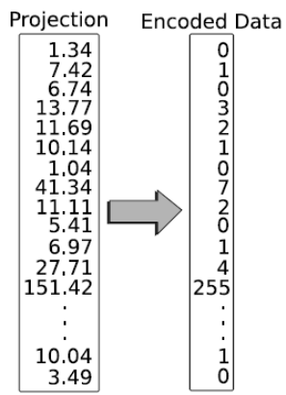
Fig. 1. Full resolution data which is encodes to low resolution data (Taken from [1])
GPUs are also limited by the amount of memory they have and there are also limitations imposed by the data buses that transfer data to the GPU. Gosink et al [1], proposed a new indexing data structure that reduces the size of the data that needs to be transferred from the CPU to the GPU. They use a binning mechanism in order to encode the data such that it takes less space. In their paper they refer to the actual data from the projected column as high resolution data, and the encoded data as low resolution data. To illustrate this idea with an example, take arbitrarily a column of integers for example where each element is four bytes long in a 32-bit Intel architecture. When each integer is encoded using their binning scheme, each element is reduced to occupy only one byte, that in all saves three bytes of space for each element that needs to be transferred to the GPU. In this case, our original integer values would be the high-resolution data, and our encoded values would be the low-resolution data (See Figure 1). When the encoding is changed information is lost and because of this one cannot completely answer a given query with low resolution date. To solve this problem, a second data structure is required to resolve the query where the encoded data is not enough to determine which attribute values fulfill and do not fulfill the condition. For these boundary bin values, they use a data structure that contains the high resolution data called the Data Parallel OrBic Structure. This structure maintains an offset table that helps it identify where each bin’s full resolution data is located. It also maintains another table that identifies the row identifiers for each of the elements in the full-resolution table (See Figure 2).
Overall the entire indexing structure is composed of encoded data tables, which contain the low resolution data and Data Parallel OrBiC tables which contain the organized full resolution data. When an index is used for a query, the encoded data tables and the Data Parallel OrBiC tables representing the boundary conditions are transferred to the GPU’s main memory. Both structures together are smaller in size than the full resolution data for 50 million rows and above.
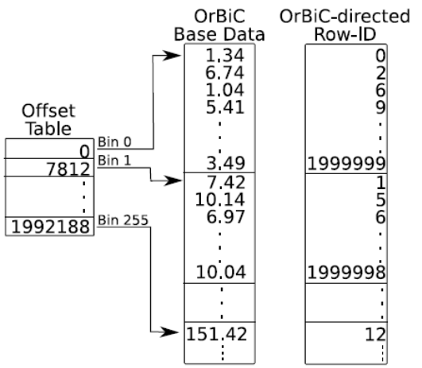
Fig. 2. Data Parallel OrBiC which allows candidate checks in parallel (Taken from [1])
- The Parallel Prefix Sum Algorithm

The prefix sum algorithm is an essential building block for uncompressing a projection index that has been previously compressed in the RLE encoding format. Harris [3], presents a method to calculate the prefix sum of an array in parallel. The article classifies two types of prefix sums, or scans as they are also called, inclusive and exclusive. The inclusive scan generates a new array in which every element j is the sum of all elements up to and including j. The exclusive scan, on the other hand, is an operation that contains the sum of all previous elements, but not j itself. Both types of scans are illustrated in Figure 3.

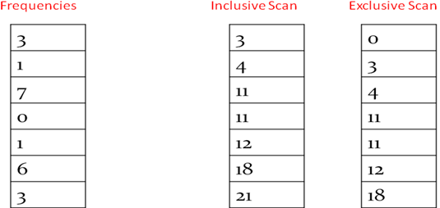
Figure 3. Illustrates both the exclusive scan and inclusive scan of an arbitrary array of frequencies.
A scan can be performed sequentially to run on a single thread. Two arrays are kept for such scan, one is the input array, and the other is the output array. The input array contains the original elements before the scan and the output array is the array generated after the scan. To perform the scan, a loop is executed over the elements in the input array where the sum of the previous element of the input array and the output array is assigned to the current element in the output array. The pseudocode for the algorithm is given in Listing 1.

Listing 1. Sequential Prefix Sum or Scan function code [3].
void scan( float* output, float* input, int length)
{
output[0] = 0; // since this is an exclusive scan
for(int j = 1; j < length; ++j)
{
output[j] = input[j-1] + output[j-1];
}
}

To perform the algorithm in parallel, Harris started with a simple naïve algorithm and moved to one more complex but with better performance. The first algorithm presented in the paper is the naïve parallel scan. This algorithm assumes that there is one processor for each data element. For a GPU running CUDA this cannot be accomplished as the number of elements will often surpass the number of processors available. To work around this problem a double-buffer array is used to prevent overwriting of results from two different wards. The warps may work on arrays of 512 elements at a time. 512 elements are processed at a time, because this is the largest block size and data can only be synchronized within the block. The algorithm is illustrated in listing 2, and an illustration of how it performs the additions is illustrated in Figure 4. It is important to note that these operations are performed within the same array; the elements are added such that the distance between the elements increases each time by a power of 2.

Listing 2. (a) Naive Parallel Prefix Sum, or scan Algorithm. (b) Double buffered version of Naive Parallel Prefix Sum (Taken from Harris [3])
(a)
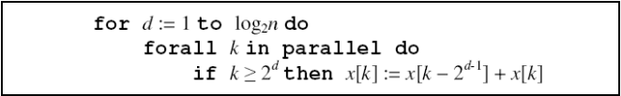
(b)
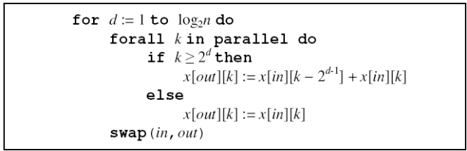

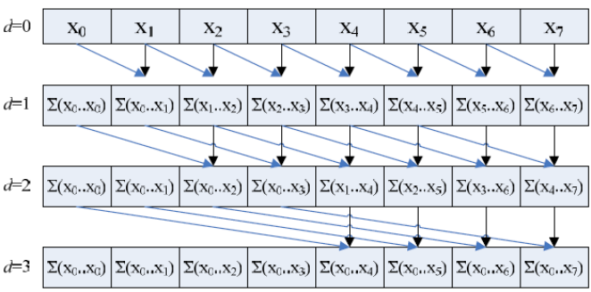

Fig. 4. Naïve parallel scan performed on 8 elements. (Taken from Harris [3])

The naïve parallel scan has a work complexity equal to 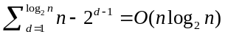addition operations. This scan's work complexity is even greater than the sequential scan which is of 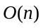and therefore it is not work-efficient. The factor of 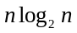 can significantly worsen the performance for the algorithm as increases.
Harris also used a work-efficient scan algorithm proposed by Blelloch [2]; to do this he employed an algorithmic pattern that is based on an algorithm used to build balanced binary trees in parallel. The algorithm consists of two phases: the reduce phase and the down-sweep phase. In the reduce phase, also called the up-sweep phase, the tree is traversed from the leaves to the root. As it traverses, it computes partial sums of neighboring nodes each time increasing the distance between them by a power of two, until reaching the root of the tree. The root of the tree would hold the sum of all the nodes in the array. Pseudocode for this phase is listed in Listing 3, and an illustration of the process is given in Figure 5.

Listing 3. Sequential scan algorithm (Taken from Harris [3])
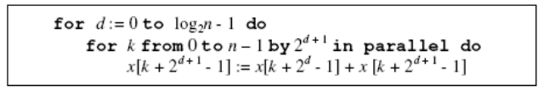

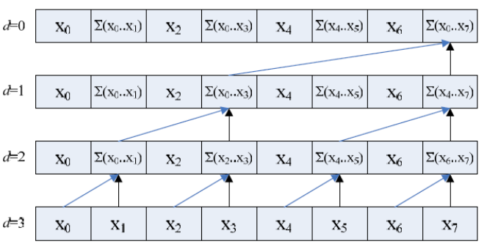

Fig. 5. Naïve parallel scan performed on 8 elements. (Taken from Harris [3])

Following the first phase of the algorithm, the second phase completes computing the scan by performing a down-sweep phase. The down-sweep phase starts from the root of the tree and uses the partial sums computed in the first phase. It discards the last sum of all elements, and replaces it with an element of value 0. A series of swap adds follows in which the sum of neighbouring elements is assigned to the rightmost element. In this phase the distance between the neighbouring elements decreases by powers of two, starting from the last distance in the up-sweep phase. The pseudocode for the algorithm is listed in Listing 4, and an illustration of its process is given in Figure 6.

Listing 4. Down-seep phase algorithm pseudocode (Taken from Harris [3])
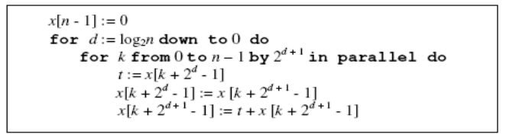

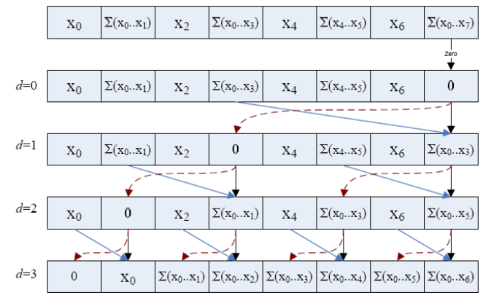

Fig. 6. The down-sweep phase of the work efficient parallel sum scan algorithm. It can be noted that the first step discards the last element of the array replacing it with a 0 (Taken from Harris [3]).

Harris finalized with this last algorithm for doing a parallel prefix sum on a set of elements. He then went on improving the implementation by dealing with aspects of the GPU itself. The direct implementation of the work efficient algorithm had bank conflicts due to its shared memory access patters. To solve this problem padding was added to each shared memory array index. A macro was added to compute the bank-conflict-free shared memory array indices. Also, the work efficient algorithm was originally designed to work only with arrays with sizes that are powers of two. They extended the algorithm to work with arrays of arbitrary sizes by having the algorithm divide the array into blocks that could be scanned by a single thread block. The total sums of those blocks are then scanned as blocks. The generated array of this scan is then used to increment the block next to the block where the sum was originated from (see Figure 7). More detail on this work can be found in the article Parallel Prefix Sum (Scan) with CUDA [3].

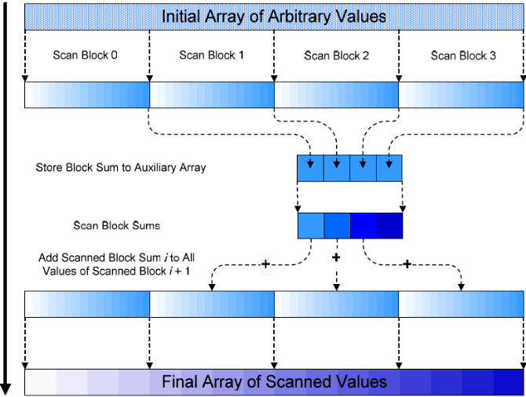

Fig. 7. Illustration of the process for performing a sum scan on a large array of arbitrary size. (Taken from Harris [3])

- Design of Algorithms for Decompression
Two algorithm design approaches are taken for decompressing a projection index in the GPU (The projection index in these terms may also be referred to be a string or sequence). Both approaches use the prefix scan differently. The first algorithm which is called the unbalanced approach uses the prefix sum algorithm as an indicator for each thread to know on what range it needs to write the elements to allocate the uncompressed index. The algorithm is performed in two phases, and it is unbalanced because the workload of each thread is different; some threads handle elements that are heavily repeated doing most of the work, while others with few elements become idle quickly.
The second algorithm, called the Load Balanced approach has five phases. In two of these phases parallel prefix sums are performed and the ending result of the last prefix sum is an array representing the uncompressed index. The algorithm is nicely load balanced because the amount of work done by each thread is the same. However, this algorithm uses almost twice as much memory as the unbalanced approach, and performs more than twice the number of kernel calls.
The input to both algorithms is a pair of arrays that represent the RLE compressed index. One array contains the symbols S, which are the different attribute values found on the projection index. The other array F, contains the frequencies or repetitions of each index in the encoded algorithm. The length of both arrays is the same, as they correspond with each other; this length is denoted as C as it is the number of elements in compressed form. The length of the uncompressed index is denoted as U. Figure 8 illustrates the process where X3Y1Z7 is uncompressed sent as two arrays with length C = 3, and once uncompressed having a length of U = 11.

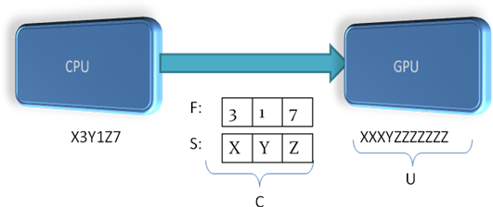
Fig. 8. Compressed projection index transferred to the GPU and decompressed within it.
- The Load Unbalanced Approach
The algorithm starts doing the decompression by appending an element of value 0 at the end of the array of frequencies, F. After doing that it obtains array X of length C+1 by performing an exclusive scan on the array of frequencies F, which also has been modified to have length of C+1. The last element of the exclusive scan X is the sum of all the frequencies, which is also the length of the decompressed array, U. It is used to allocate the amount of memory necessary in the GPU to hold the uncompressed array. The exclusive scan, array X, is then used to have each thread uncompress each element by writing it from one initial offset to where the element that is being repeated is changed. These two offsets are given by the exclusive scan and thus the decompression is performed. The workload of this algorithm is not balanced, as the amount of work a thread does depends directly on the frequency of the element it is decompressing. Threads decompressing elements with few repetitions will take considerably less time, than threads decompressing elements with various repetitions. The pseudocode for this algorithm is given in Listing 5.

Listing 5. Pseudocode for Load Unbalanced Decompression Algorithm

Phase 1: add element of value 0 at the end of array F.
get X as exclusive-scan of C+1 elements of F

Phase 2: for i:= 0 to C
forall k in parallel do
for j := X[i] to X[i+1]
result [j] = S[j]

- The Load Balanced Approach
Taking in consideration that the first algorithm was not load balanced and that it depends greatly on the on the nature of the data it handles, a second approach was taken. This algorithm starts similar to the first one by obtaining an exclusive scan of the array of frequencies. However, in this algorithm the frequencies array is not modified, and thus it has a length of C, and so the exclusive scan, X will also have length of C. Adding the last element of the exclusive scan to the last frequency; one obtains the size of the uncompressed array, U. Having this size, memory for the decompressed array is allocated in the GPU, and phase two is on track. In the second phase, the uncompressed array A is initialized by having each thread assign a value 0 to all its positions. After the second
Listing 6. Pseudocode for the Load Balanced Algorithm
Phase 1: get X as Exclusive-scan of F

Phase 2: for i = 0 to U
forall k in parallel do
write 0 to item i in array A

Phase 3: for i = 0 to C
forall k in parallel do
write a 1 to item X[i] in array A

Phase 4: overwrite A as an Inclusive-scan of array A

Phase 5: for i = 0 to U
forall k in parallel do
write item S[A[i]] to Uncompressed Index B

phase is completed, Phase three has each thread write a 1 to positions given by the elements of the exclusive scan X. In other words, X represents the positions of the uncompressed array where there will be a change in symbol. Phase four follows, and an inclusive scan is performed on the now modified array A. The output of this scan is the positions of the corresponding symbols in the uncompressed array. In the final phase, Phase 5, these positions are used to write the actual symbols onto the final uncompressed index denoted B. The pseudocode for this algorithm is given in Listing 6, and an example illustration of the process is given in Figure 9.
To improve further on the performance of this algorithm, one could possibly do away with the 5th phase by sending the query one wants to perform in the projection index in terms of the positions of the elements in S. Not only would this save time, but also memory, as array B of size U would no longer need to be created.

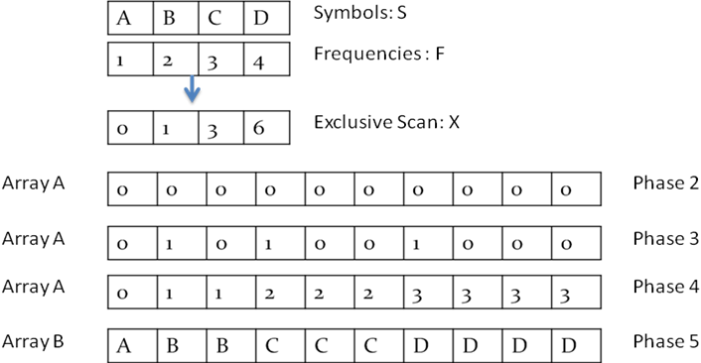
Figure 9. Illustration of the processes of each phase of the Load Balanced Algorithm.
- Data Analysed
To test the algorithms, synthetic sequences were generated in the CPU to represent a projection index after being sorted, compressed, and loaded into main memory. This was done to simplify the interpretation of the different factors influencing the performance on benchmark tests. For a compressed index, two different arrays are created, one with characters or integers representing the attribute values, and one with the number of times each of those attribute values repeat themselves. The distribution of this data was simulated in three different ways: In the first distribution, the data was generated such that the next element repeats itself once more than its previous one. Compressed sequences were generated like this first with 500 elements, and then increasing by 500 elements until reaching 5000 elements (See Figure 10.a). This type of distribution was presumed not to favor the load unbalanced algorithm much. This data distribution is also referred as the sequentially incremented data distribution. The second data distribution has 1024 different attribute values which are only repeated twice, thus having very little compression. The size of the compressed sequences always stays the same but the number of times an element repeats itself is doubled on each iteration. So essentially, one would have indices of the same size when compressed and of different sizes when they are uncompressed (See Figure 10.b). Finally, the last distribution of data consisted of an uncompressed sequence or index of fixed size; 16777216 elements in total. The number of different elements was then incremented from 1024 to 8’388,608 by doubling on each iteration. This approach does the opposite of the previous data distribution by creating uncompressed indices of the same size, but of different sizes when compressed. An illustration of the different data distributions is shown in Figure 10.
(a)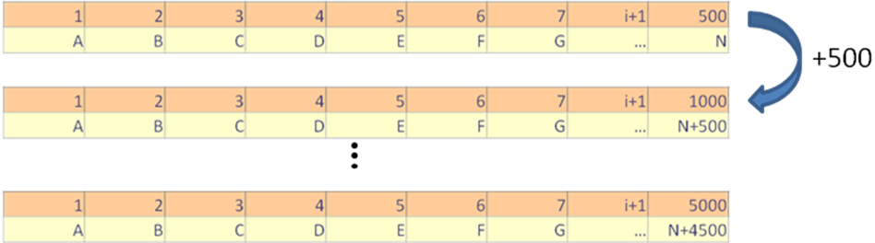
(b)
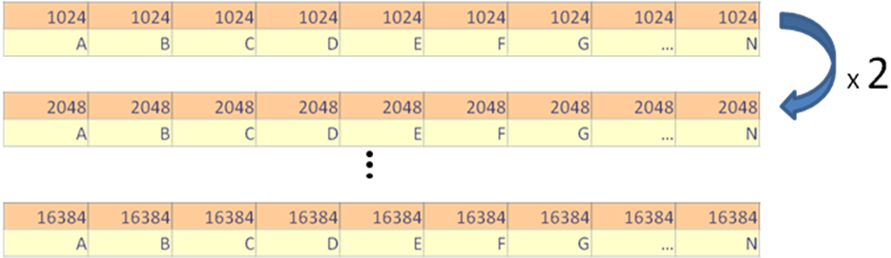
(c)
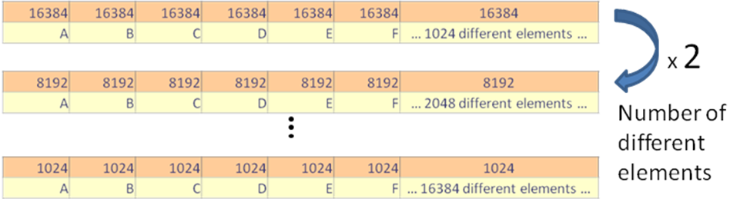
Fig. 10. Compressed form of sequences under the three different data distributions. The distributions are organized in order, so the first data distribution is at the top, and the third is at the bottom.

- Performance in GPU with Computability 1.1

Initially, tests were performed in a 9400m NVidia GPU with 16 cores and 256 Mb of video main memory. For all tests the times were measured in milliseconds (ms). Both algorithms were tested against copying the uncompressed index directly to the GPU. The first data distribution described (the sequentially incremented one) was used for this test. Characters were used as attribute values of the index. The outcome of the test in this GPU was that neither the Load Unbalanced (LU) nor Load Balanced (LB) algorithms were a good approach to improve the time it takes to transfer. Transferring the uncompressed index (UC) proved to be a better option (See Table 1 and Figure 11). The GPU did not have sufficient cores to make the computations necessary quickly enough to compensate with the speed at which the uncompressed index was being transferred. Additionally, for a GPU with computability of 1.1, it is suspected that the writes will not always coalesce if the write access patterns on the array are not organized in a sequential order. There are such writes in the Load Balanced Algorithm.
There was not much difference between the Load Balanced algorithm and the unbalanced algorithm. Each phase of the load balanced algorithm was shown in a pie chart (see Figure 12) to determine which phases took the majority of time to do the decompression. From the pie chart, it can be determined that Phase 4 takes the most time of the algorithm, presumably because the graphics processor only had 16.
TABLE I
Times with Different number of elements with both algorithms, using characters
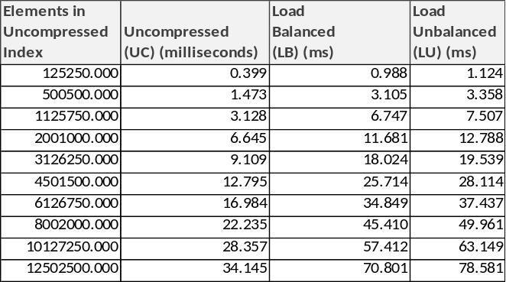

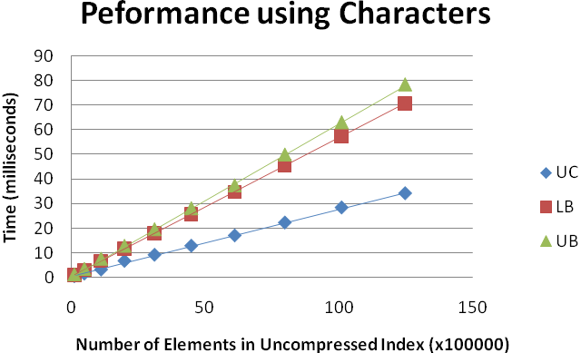
Fig. 11. Time taken to transfer a sequence of characters and decompressing using the Load Unbalanced Algorithm, and the Load Balanced Algorithm (LB) versus transferring the uncompressed index when using characters.
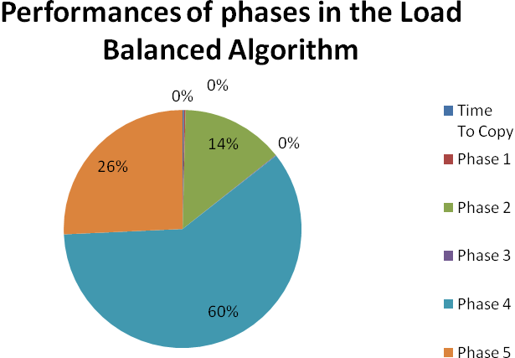
Fig. 12. Performance analysis of the different phases of the algorithm. Notice that only Phases 2, 4, and 5 were significant.
- Performance Enhancements and Performance with Integers
The fifth phase of the Load balanced algorithm involves many read/write operations. The read operations could be accelerated by bringing the array of symbols into texture memory. This would have the effect of caching this constant array and thus it would improve performance of this phase. A test to verify this was performed; using characters as attribute values, a slight improvement on performance was observed (See Figure 13).

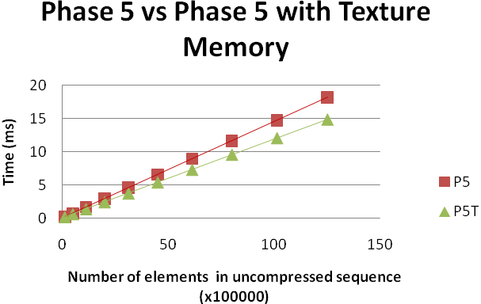
Figure 13. Performance of Phase 5 with texture memory (P5T), and without it (P5). Notice that there is a small improvement to Phase 5 when using Texture memory.
Finally, the test for this GPU with the first data distribution was repeated using integers, and the results were also very different. Sending the uncompressed index was no longer the best option, and using the Load Unbalanced and Load balanced algorithms made the index more readily available to the GPU (see Table II and Figure 14). The reason for this sharp and astonishing difference between using characters and integers could be due to the size of integers being four times that of the characters.
TABLE III
Times with different number of elements with both algorithms, using Integers
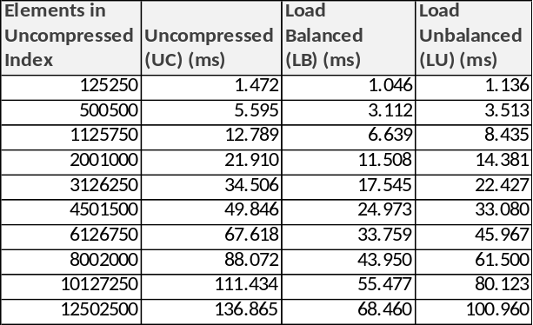

Since the uncompressed index only involved characters, the number of elements and the actual size in bytes were the same. When the attribute values of the index were changed to integers the size of the uncompressed sequences quadrupled, thus, the slope of the curve pertaining to the uncompressed index (UC) steeped by a factor of four. Moreover, the level of compression achieved when using characters was less because it took 3 additional bytes to represent the number of repetitions each element had. Overall, it was concluded that a change in data type of the attribute values of the projection index has an impact on the size of the uncompressed index, the compressibility of the index, and, as a consequence of the other two, the performance when using a decompression algorithm within the GPU.
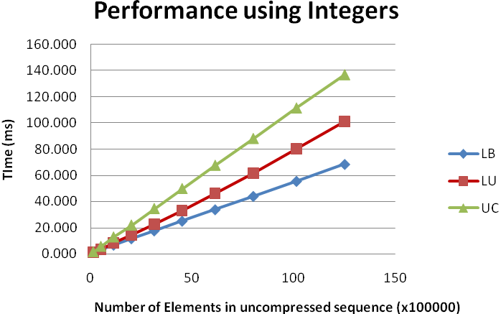
Figure 14. Time taken to transfer a sequence of characters and decompressing using the Load Unbalanced Algorithm, and the Load Balanced Algorithm (LB) versus transferring the uncompressed index when using integers.
Additional data was aggregated to this test to determine when it was not convenient to transfer the index compressed to the GPU when using integers. The additional data and outcome can be seen in Table III. When the uncompressed size of the index is approximately 176K (45150 elements) or less it was fastest to send the uncompressed index.

TABLE IIIII
Times with Smaller indices. Different number of elements with both algorithms, using Integers
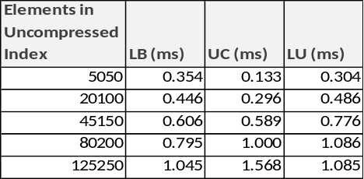

Finally, it is important to add that some of these tests had contrary results to what was seen in the CUDA profiler. For sequences with 1125750 elements, the profiler shows results that favour sending the index uncompressed. However, for sizes above 1125750 the profiler also favors the decompression algorithms for decompressing within the GPU.

- Performance in GPU with Computability 1.3
Tests were also performed in a GeForceGTX285 NVidia GPU with 240 cores and 1 GB of RAM memory. This GPU has a higher computability, 1.3 as opposed to the previous 1.1, greater number of cores, faster cores, and more memory. The original test using the data distribution of sequentially incremented attribute values was also used, but this time the attribute values were integers. The outcome of this test was similar to the last test performed on the first GPU, but the gap between sending Uncompressed and decompressing within the GPU widened. Both Load Unbalanced (LU) and Load Balanced (LB) algorithms were faster approaches to make the index available rather than transferring the uncompressed projection index (see Table IV and Figure 15). Furthermore, it was noticed that the Load Balanced algorithm was more efficient than the load unbalanced approach for this set of data. The data is not friendly to the Load Unbalanced algorithm because the last element will repeat itself more than all the other, thus the work is not well distributed among all threads (see Figure 16). The proportional performances of the different phases of the Load Balanced algorithm remained the same, with Phase 4 being the one that took the longest.
TABLE IVV
Times when Using indices . Different number of elements with both algorithms, using Integers and Computability 1.3

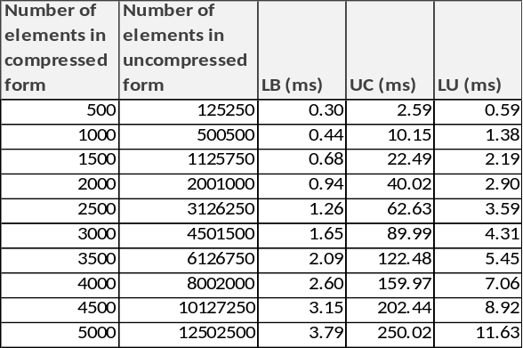

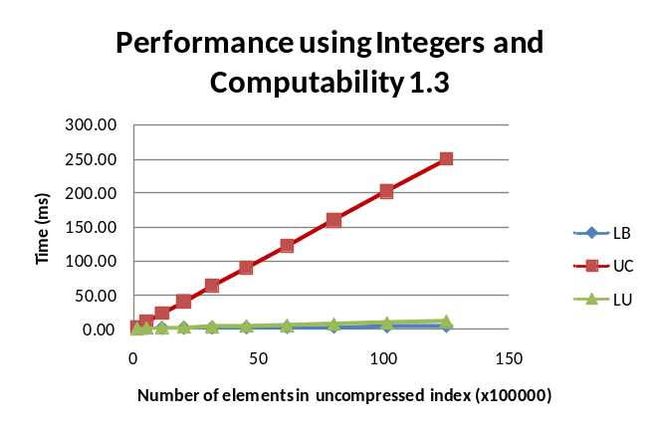
Figure 15. Time taken to transfer a sequence of characters and decompressing using the Load Unbalanced Algorithm, and the Load Balanced Algorithm (LB) versus transferring the uncompressed index when using integers.
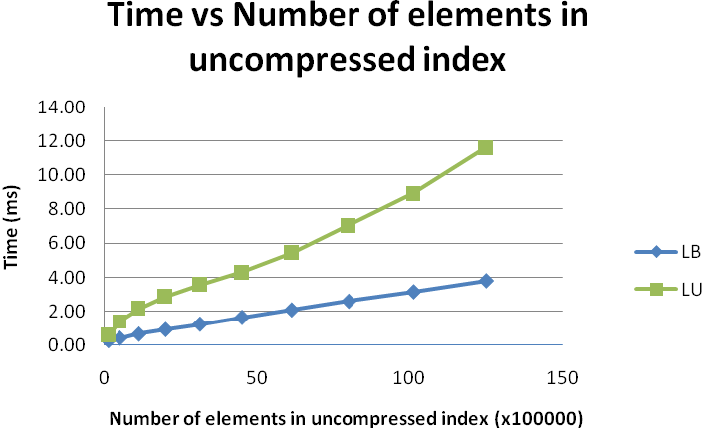
Figure 16. Comparison between the Load Balanced and Load Unbalanced Algorithm, as the number of elements in the uncompressed index is increased.

The test was also performed by maintaining the size of the compressed index constant while doubling the frequency of each element on every iteration. This way, the threads in the load unbalanced algorithm would have the same amount of work. At first the Load Unbalanced algorithm was faster than the Load Balanced algorithm, but as the amount of repetitions increased the Load Balanced algorithm took less time to decompress. The Load Balanced algorithm (LB) was only influenced by the increasing size of the uncompressed array within the GPU. On the other hand, the Load Unbalanced algorithm (LU) not only is slowed down by the fact that it has to write on a bigger array, but it also does not distribute the work among all the possible threads. Since there are only 1024 different elements, only 1024 threads do work at a time. The LU algorithm also cannot make as good use of the GPU as the LB algorithm when the elements have too many repetitions. Sending the uncompressed index (UC) was only the better option for the first cases up to where the frequency was eight. At this frequency the sequence was still fairly small with 8192 elements in its uncompressed form. Notice also that there was no compression for a frequency of only two (See Table V).
Finally, a test using the third data distribution was performed on the two algorithms. For this test the size of the index was fixed to 16777216 elements in uncompressed form, and the number of different elements in the index was varied, achieving different levels of compression. In other words, the fewer different elements the more compression achieved and the more different elements the lesser the compression. Using the previous experiment as reference, the amount of time taken to transfer the uncompressed index without an algorithm was taken to be 335.80 milliseconds. The outcome of this experiment shows that obviously when no compression is achieved, it is best to send the uncompressed index without decompressing. The compression percentage measure in our results is taken as the percentage in size of the compressed index as a fraction of the original uncompressed index. In the test results, notice that if the compression is of at least 50% on a large index, such as this one, both Load Balanced and Load Unbalanced algorithms performed better than sending the uncompressed index (See Table VI).

TABLE V
Times when Using Sequencies of fixed number of Different elements, but doubling number of repetions (frequencies)
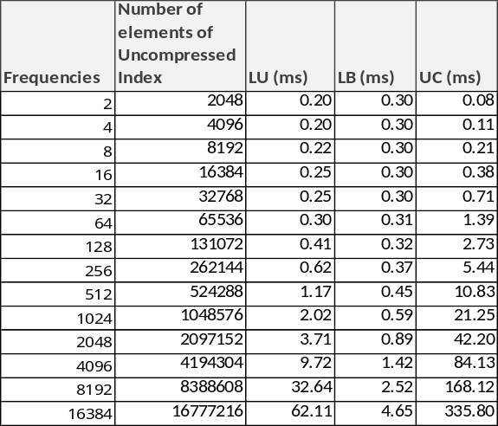

TABLE VI
Times when Using Sequences of a Fixed Uncompressed size but varying number of Different elements.
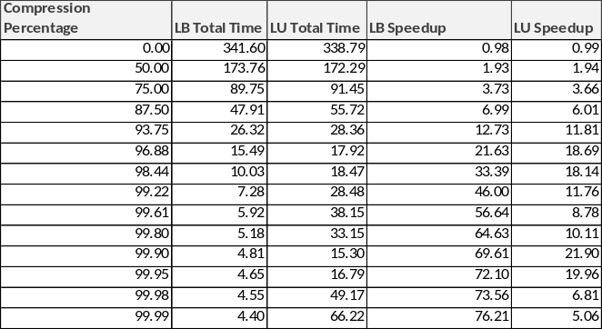

On a further look, one can also notice that the speedup for the load balanced algorithm is steady as the index becomes more and more compressed. The speed up for the load unbalanced algorithm, however, is very inconsistent (See Table VI). This is due to two competing factors: on is the decreasing time to copy a more compressed index on each iteration, and the other is the increasing time threads take by having less different elements that are repeated more frequently.
- Conclusions and Future Work
From the results, it was determined that the performance of the algorithms depends mostly on the GPU used and its computability, the level of compression of the index, and the nature of the data being processed.
Overall the percentage of compression of the index is the most important factor to determine whether the index should be sent compressed and decompressed in the GPU, or uncompressed without decompressing. This factor is inherent from the RLE compression scheme. In the tests performed, only sequences with a compression size of 50% and lower of the original size were attempted. Under these conditions it was not convenient to send the compressed index, and decompress it within the GPU for cases where the attribute values of the index were characters or when using integers with an uncompressed size of ~176K (45150 elements) and below. For the Load Balanced algorithm the speed up increased as the index became more compressed, but for the Load Unbalanced algorithm the speed up began to diminish due to its inability to make full use of the GPU.
The computability of the GPU allows for coalesced accesses for different access patterns to global memory, which were encountered in some phases of the Load Balanced algorithm. The greater number of cores and increased clockrate of this GPU allowed the decompression algorithms to accelerate in the performance tests. However, both algorithms do not take equally advantage of the higher computability of the GPU. The LU algorithm cannot take advantage of the greater number of cores when the number of elements is not varied enough as to launch a great number of threads. It also cannot take advantage of it when the repetitions are focused on a few single elements, as the threads handling those elements would be the only executing. The load balanced algorithm, on the other hand is not affected by these other factors and all its phases distribute the work evenly among all threads.
Finally, the nature of the data refers to both the way the data is distributed and the data types of the attribute values. The size of the data type of the attribute value determines how much space is saved when compressing. In the case of characters, there would be no space savings when each character repeats itself five times or less. This is because the integer necessary to specify the times it repeats would take four additional bytes. The data distribution also determines the compressibility of the index; the more varied elements in the data the lesser the compression in a sorted index. The performance of the Load Balanced algorithm was only dependent on it from this effect. In contrast, the Load Unbalanced was also affected by the number of repetitions of each element. The greater the number of repetitions each element had the higher the workload of the threads writing the elements and the more the performance gain was reduced for it.
As a final conclusion it was determined that the Load Balanced algorithm, was the best approach to send a large, highly repetitive projection index to the GPU in most of the scenarios. Much future work is possible for this problem, as many questions were left from the research, one such question is at what sizes of the index is it beneficial to send an index compressed to 50% and above of the original size, as only tests were performed with percentages below this mark.
The full potential of the load balanced algorithm was not exploited here, as it could be improved further by removing the 5th phase and sending the query one wants to perform in the projection index in terms of the positions of the elements in the symbols array. Not only would this save time, but it would also cut down the cost in memory by approximately half. This is because the array to write the attribute values themselves would be omitted and only a representation of it in integers would be kept in the GPUs global memory.
Another possible avenue of future work consists in comparing this GPU decompression algorithm against other CPU and GPU decompression algorithms. It may also be noticed that one of the problems that was not addressed here, was the fact that it is possible to have a compressed index that will not fit in the GPUs memory once it is uncompressed within the GPU. For future work, to approach this problem, the last element of the prefix sum of the algorithm must be used to determine to calculate the size of the uncompressed index. If the size is above the amount the GPU can support then the scan array is divided in half, and the last element of each half is used to calculate the size of half of the uncompressed index. If the calculated size can be supported by the GPU, then the first half of the index is uncompressed first for querying. The second half of the index is also in a similar fashion, but in order to update to the correct prefix sum, the last element of the first half of the prefix sum must be subtracted from all the elements in this second half. This process is repeated recursively depending on the size of the resulting uncompressed index.
References
- Gosink L, Wu K, Bethel W., Owens J, Joy K: Data Parallel Bin-Based Indexing for Answering Queries on Multi-core Architectures. SSDBM 2009: 110-129
- Guy E. Blelloch. “Prefix Sums and Their Applications”. In John H. Reif (Ed.), Synthesis of Parallel Algorithms, Morgan Kaufmann, 1990.
- Harris M., Sengupta S., Owens J. D.: Parallel prefix sum (scan) with CUDA. In GPU Gems 3, Nguyen H., (Ed.). Addison Wesley, Aug. 2007, ch. 31.
- NVIDIA Corporation: NVIDIA CUDA compute unified device architecture programming guide (2009), http://developer.nvidia.com/cuda
- Owens, J.D., Luebke, D., Govindaraju, N., Harris, M., Kruger, J., Lefohn, A.E., Purcell, T.: A survey of general-purpose computation on graphics hardware. Computer Graphics Forum 26 (2007) 80–113

