Uppgift 1
db.listingAndReviews.aggregate([
{$match : {
"address.country" : "Portugal",
beds : {$gte : 4},
price: {$lt : 75}
}
},
{$project : {
"address.country" : 1,
beds : 1,
price: 1
}
}
]);

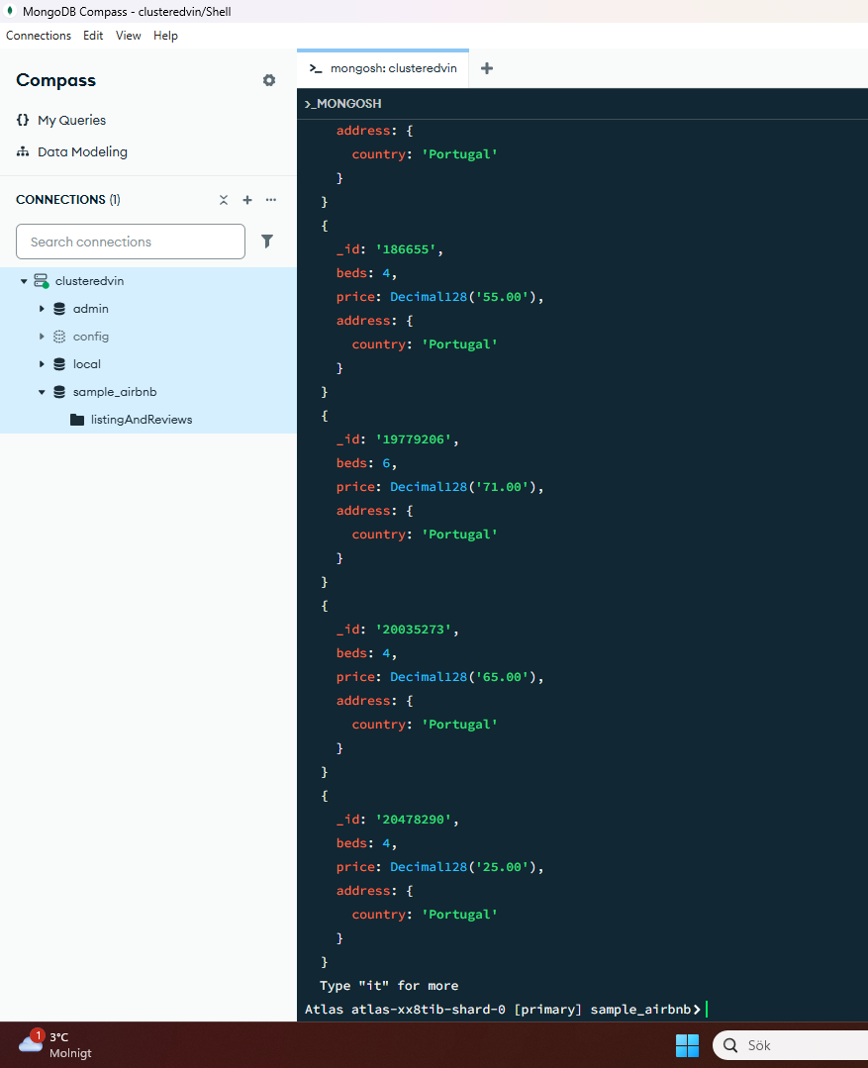

Uppgift 2
db.listingAndReviews.aggregate([
{$match : {
"review_scores.review_scores_cleanliness" : {$gte : 9}
}
},
{$project : {
"address.country" : 1,
name : 1,
price: 1,
summary : 1
}
},
{$sort : {
price : 1
}
}
]);
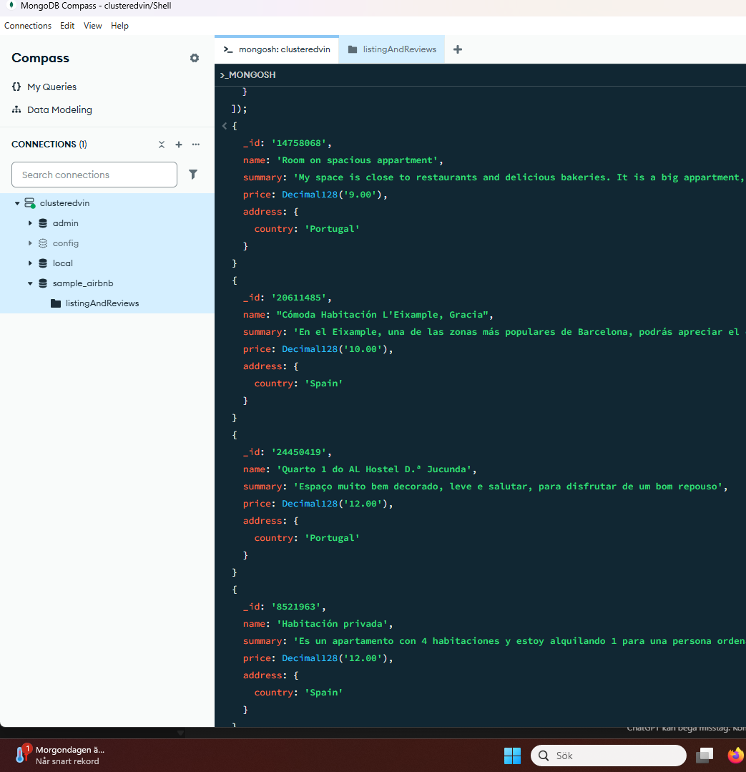
Uppgift 3
db.listingAndReviews.updateOne(
{"description" : /.*mountain view.*/},
{
$set : {price : Decimal128('90.00')}
}
)

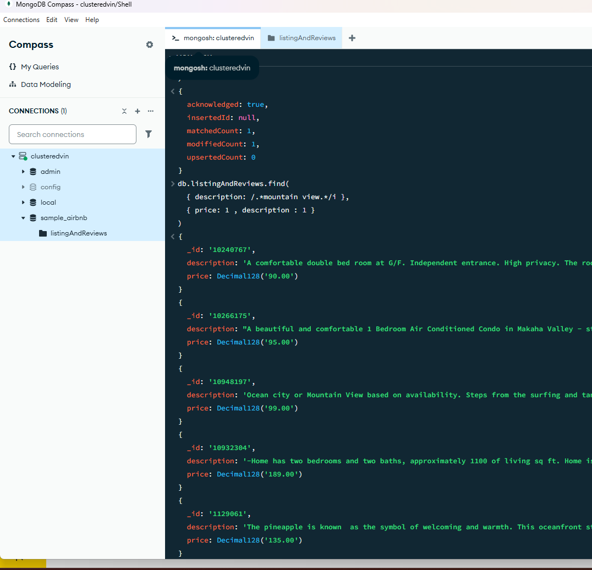
Uppgift 4
db.listingAndReviews.updateMany(
{"address.country" : "Turkey"},
{$set : {isactive : false }}
)
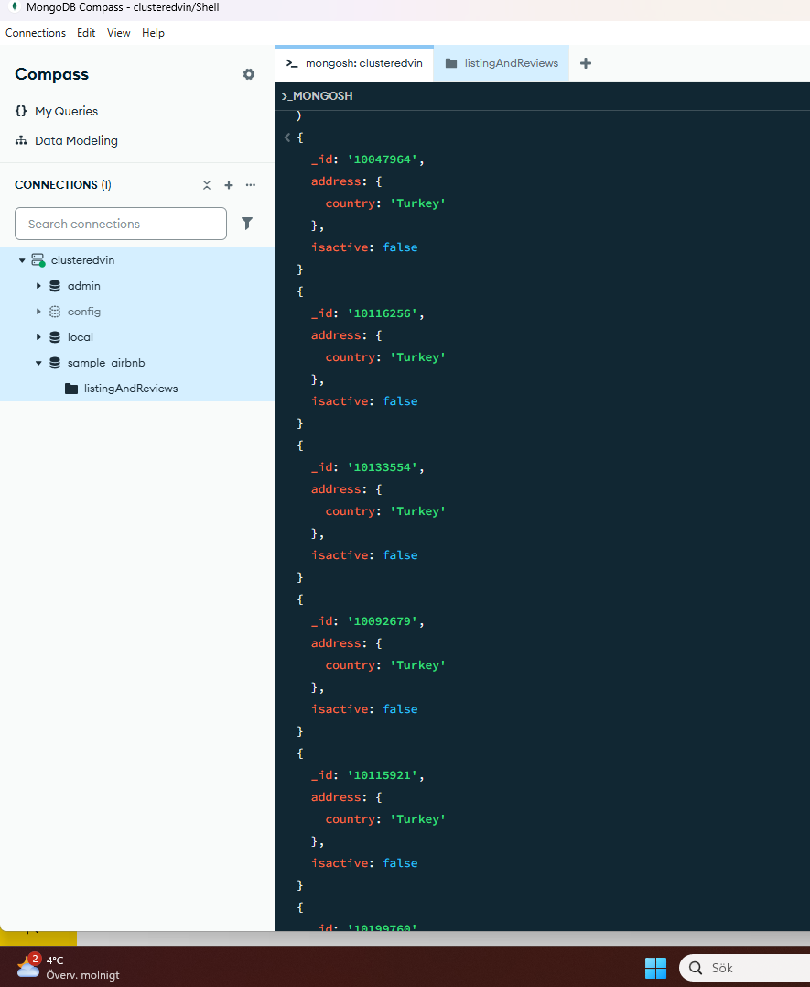

Uppgift 5
db.listingAndReviews.deleteMany(
{"review_scores.review_scores_rating" : {$lt : 21}}
)

