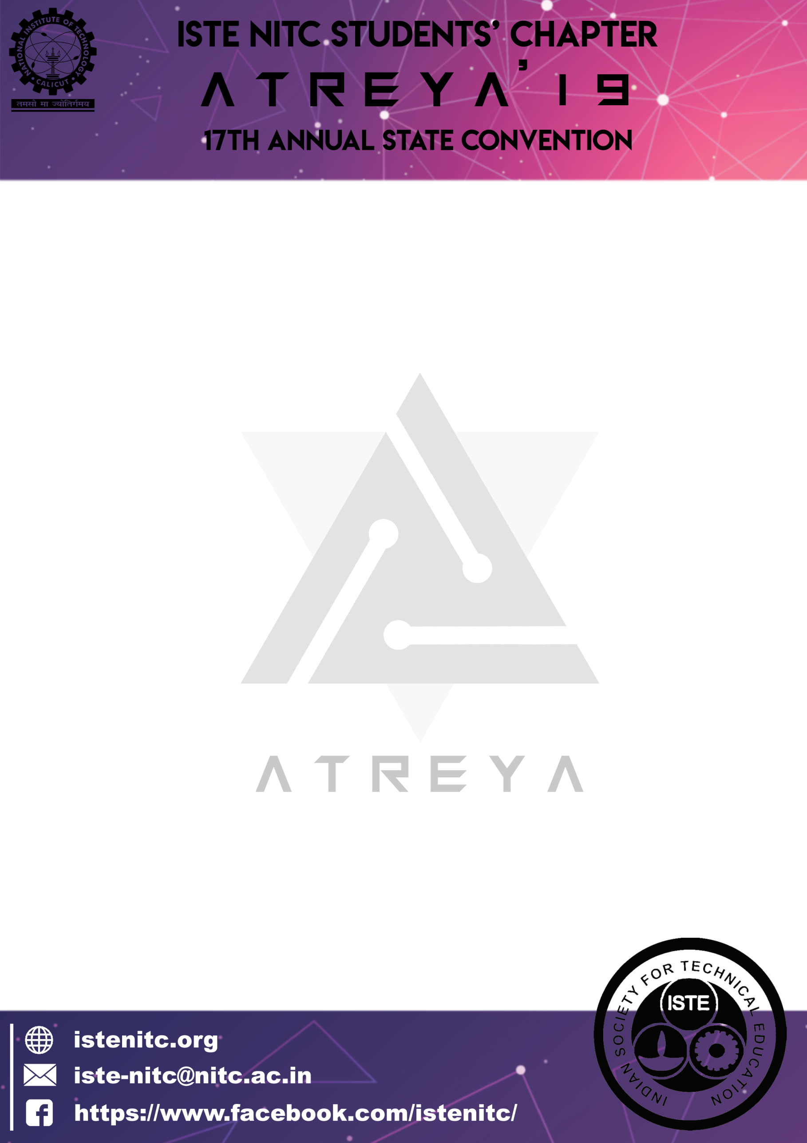

**General rules**

1. Participants must have a confirmed ATREYA’19 ID card to participate in any event. ALL ISTE MEMBERS NEED TO SHOW A VALID ISTE CARD.

2. Workshop participants will have separate workshop ID card, which cannot be used to participate in events. The payment for workshops is done online itself and participants can collect their workshop ID card at the Registration desk if they have made the complete payment online. They will need to take a separate ATREYA’19 ID card after paying the registration fees to participate in any event.

3. All participants who have registered online for ATREYA’19 should confirm their registration at the registration desk by paying registration fees and obtaining their ATREYA’19 ID card. Participants who have not registered online also can obtain their ID by reporting at the registration desk.

4. Participants with one ATREYA’19 ID can take part in any number of events by making a payment of Rs. 300 for ISTE members and Rs. 350 for non ISTE members. ( Applicable for both school and college students.)

5. Participants should have a valid institution ID or a bona fide certificate issued by the college with them as a proof of their identity. No one will be allowed to participate without the same

6. Fees for hospitality and accommodation is Rs. 200/-, of which Rs. 100/- is refundable, only when the hospitality bill is returned. Hospitality can be availed only if the applicant has a valid ATREYA’19 ID card or a Workshop ID card.

7. Participants should produce their ATREYA’19 ID cards, along with their photo ID for inspection when asked by the organisers.

8. Anyone who reports a loss of ATREYA’19 ID Card has to apply for a new ATREYA’19 ID Card with payment of money.

9. ATREYA’19 organisers are not responsible for loss of any personal property.

**Evaluation and Result Declaration Policy**

1) Every participant should abide by the rules, regulations and specifications given in the ATREYA’19 website for each event. A participant will be disqualified if their equipment is not compliant with the specifications of the event or if his/her conduct is deemed unreasonable by the event managers.

2) If the performance of an arbitrarily large number of participants is substandard, the final prize money distribution will be decided by the event coordinators.



3) If a participant wins the event but fails in any round of multiple segment events (i.e. events with multiple subsections), the prize money awarded will only be a fraction of the total prize money depending on how far the participant has progressed.

4) If the participation for any event is low, the model given below will be used as a reference for awarding the prize money: a. Only one team - Consolation prize (will be decided by the event coordinators) b. Two teams: 50% of first prize only. c. Three teams: 70% of first prize only. d. Four teams: 1st and 2nd only. The final decision regarding the prize money to be awarded will be at the discretion of the event coordinators and registration heads based on the performance of the participants and the quality of the model or robot (in events which involve models or robots).

5) In case of two first/second prizes (A tie which cannot be settled by the tie breaking rounds or any method described in the specific event rules) then the prize money will be decided as follows:

Case a: 2 first positions - (First prize money + Second prize money)/2… Second position – Third Prize money. Third position will not be declared in this case.

Case b : 2 second positions – (Second Prize money + Third prize money)/2….Third place will not be declared in this case.

Case c: 2 third positions - third prize money/2

6) *Decisions of event coordinators will be final and irrevocable.* **If the participation is very low , the event coordinators can even chuck the event.**

7) If there is any issue regarding the result, it should be resolved with the respective event managers, at the event venue itself.

8) Each college will be marked according to the performance in the respective events of the fest. The following will be the policy of evaluation : (1) If a particular event has 50 participants/teams or more, the marking scheme will be as follows: 1st Position – 50 pts 2nd Position – 40 pts 3rd Position – 30 pts (2) If a particular event has less than 50 participants/teams, the marking scheme will be as follows:

1st Position – 30 pts

2nd Position – 20 pts

3rd Position – 10 pts



On the last day of ATREYA’19, the leading college will be awarded with Best College Award.

**Awarding of prizes**

1. Winners of a particular event can collect their prizes as well as certificates from the registration desk after a minimum of 2 hours after the event is over. In urgent cases wherein the prizes need to be collected within this time period, it can be collected only on special recommendation from the event coordinators.

2. Participation Certificates will be awarded to all the participants for events with a total of 50 participants or less (not teams). For events with more than 50 participants, participation certificates will be issued only to those who have cleared the lowest level which has less than 50 participants.

3. For claiming the prize, participants should produce Valid Photo ID as well as confirmed ATREYA’19 ID (if applicable) at the registration desk. The prize money should be collected in person by the winner.

4. If there is any issue regarding the result declaration, it should be resolved with the respective event managers.

5. ATREYA’19 follows a prize money division of 60-40, in which all prizes decided for an event by the event coordinators will be given as 60% cash and 40% worth of coupons and merchandise.

6. Prize money should be collected on or before 7:00 pm, 10th February.

7. The decisions made by the registration head and the event coordinators is final and irrevocable. Any sort of unnecessary disputes will not be entertained.