NYC 311 Service Requests Big Data Analysis
Using Hadoop, Hive, and Excel 3D Map
Edward Gallegos
Department of Information Systems, California State University, Los Angeles
CIS4560: Introduction to Big Data

Abstract: This paper describes a big data workflow for analyzing NYC 311 service requests between 2020 and present day using Hadoop, HDFS, Hive, Beeline, HiveQL, and Microsoft Excel 3D Map. The project analyzes the file 311_Service_Requests_from_2020_to_Present.csv. The goal is to find the most common service request categories and show where selected high-volume requests occur over time. The raw CSV file was uploaded into HDFS, connected to Hive through an external table, queried with HiveQL, filtered for valid latitude and longitude values, and exported into smaller CSV files for mapping. The top 5 categories were Noise - Residential, HEAT/HOT WATER, Request Large Bulky Item Collection, Illegal Parking, and Blocked Driveway. The end Excel 3D Map shows the patterns of service requests by location and time with the latitude, longitude, problem type and created date.

1. Introduction
New York City receives a large number of 311 service requests from residents who call in about non-emergency issues such as noise, heat and hot water problems, illegal parking, blocked driveways, sanitation concerns, and other quality of life problems. These records are helpful because they show what residents are experiencing and which city issues are being reported time and time again. The dataset contains dates, complaint categories, boroughs and coordinates and is thus a good candidate for big data processing and tempo-spatial visualization.
I selected this project because public service data connects technical tools to a real city problem The project utilizes Hadoop and Hive to organize and query a large dataset, instead of simply looking at a small spreadsheet. The main goal is to find out the most common NYC 311 service request categories and to show some high-volume categories on a map. This gives the analysis a practical purpose: the results can help point out what issues might require more attention, staffing, or monitoring.
The project workflow starts with downloading the dataset, uploading it into HDFS, creating an external Hive table, and running HiveQL queries. After the data is cleaned and exported, Microsoft Excel 3D Map is used to show the request categories by location and time. In the rest of this paper, I discuss related work, project specifications, implementation flow, cleaning, analysis, visualization and conclusions.

2. Related Work
Wang, Qian, Kontokosta, and Sobolevsky also studied 311 service requests as a way to understand urban location. Their work shows that the mix of 311 complaint categories can serve as a kind of signature for local neighborhood context [1]. This is relevant for the current project because both works consider service request categories as meaningful city data rather than individual complaint records. However, their work focuses more on understanding urban location patterns, while this project focuses on building a Hadoop and Hive big data workflow and creating a final Excel 3D Map visualization. Chauhan and colleagues studied predictive big data analytics for service requests using government service request data. Their work focused on finding patterns and guessing what services would be needed in the future [2]. This is similar to this project because we both use data from public service requests to help make plans and decisions. Their project was more about predicting what would happen, while mine was working on building a system to process a lot of data finding out what kinds of requests are most common in New York City and making a map to show where and when these requests happen [2].
Zobel and his team studied data from 311 service requests to see how well cities are doing and how they can handle emergencies. They found out that this data can help cities understand what services are needed in areas and at different times [3]. This is similar to this project because I also use 311 data to study patterns of city services. The difference is that my work focused on big data processing using Hadoop, HDFS, Hive, and Beeline, then exports cleaned results for geospatial visualization. Compared with these existing works, my project is different because it focuses on the complete big data workflow rather than only the final analysis. I used HDFS for distributed storage, Hive and HiveQL for cleaning and aggregation, and Excel 3D Map for the final tempo-spatial visualization. The main idea was to look at the patterns of complaints that people make to NYC 311 but to show how a big dataset from a public service can be worked with using Hadoop and Hive in a way that can be replicated.

3. Background / Existing Work
NYC Open Data provides the city’s official 311 Service Requests from 2020 to Present dataset. The dataset contains service requests that can be sent to city agencies and includes fields such as created date, agency, complaint type, borough, latitude, and longitude [4]. These fields are important because they help us understand how many things are in each category and where they are on a map. HDFS is designed for storing large files across a cluster. This is important for the project because the original CSV file was too large to manage with Excel. HDFS stores the raw file in the cluster so Hive can query it without requiring the full dataset to be moved into a local application. Hive provides a SQL-like approach for reading and managing large datasets in distributed storage [5][6]. In this project, Hive was used to create an external table, preview records, count requests by problem type, filter rows with valid coordinates, and export smaller mapping files. Beeline served as the command-line interface for running the HiveQL commands. Microsoft Excel 3D Map supports geographic and time based visualization when a workbook contains fields such as latitude, longitude, and dates [7]. For this project, latitude and longitude were used to place requests on the map, problem type was used as the category, and created_date was used as the time field. I used these tools because they were good for the project. Hadoop and Hive were good for handling a lot of information and Excel 3D Map was good for making the maps.

4. Implementation Flowchart
The project was made to be a process that takes raw public data and turns it into a visualization that is easy to understand. I started with the dataset, which I downloaded and put into HDFS. Then I connected the dataset to Hive using an external table. After that I used HiveQL to query the dataset. The results were exported as cleaned CSV subsets. Finally, I opened the cleaned CSV subsets, in Excel 3D Map to get a view of the project data. Figure 1 shows the project implementation flow.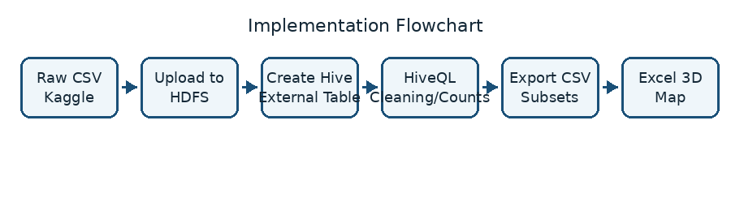
Figure 1. Implementation flowchart for the NYC 311 analysis.
This workflow was really helpful because it broke down the work into stages. HDFS took care of storage Hive handled querying and cleaning and Excel was used for visualization. This made the project easy to reproduce because each step had an input and output. The workflow also kept the big-data work from the local visualization work. Hadoop and Hive did the heavy lifting, for storage and queries while Excel was only used after filtering the dataset into smaller files. The original dataset was huge so it was important to use Hadoop and Hive for that. This way Excel only had to deal with output files, which made it easier to work with. It was good that Hadoop and Hive handled the tasks. Excel has its limits when working with datasets, so it was best to use it only for smaller files. This approach made the workflow efficient and easy to manage.

5. Data Cleaning
I had to clean the data because the final map needed geographic coordinates to work properly. The map could not show any record that did not have latitude or longitude. So we only included records in the mapping files that had latitude and longitude. I made a table in Hive using OpenCSVSerde. This was an idea because CSV files can have commas or quotation marks inside the fields. After I made the table, I used preview queries to check the fields like created_date, agency, problem, borough, latitude and longitude. I also used a count query to make sure the table was working in Hive.
Two exports were created. The first one had 10,000 records that I cleaned up for analysis. The second one was smaller with 300 records. It was the Top 5 subset for the final map. Using the Top 5 subset made the map easier to understand and it still showed the most important categories, from the HiveQL analysis

6. Analysis and Visualization
The main analysis looked at the requests by the type of problem, It put the records into groups based on the problem, counted how many were in each group and then listed them from the most to the least. The Hive code is shown here.
SELECT problem, COUNT(*) AS total_requests
FROM service_requests_311
GROUP BY problem
ORDER BY total_requests DESC
LIMIT 10;
The results with the volume are shown in Table 3. I looked at these categories for the visualization because the issues in the dataset appeared in these categories most often. The issues in the dataset that appeared in these categories are the ones I focused on..
Table 3. Highest-Volume Service Request Categories
Rank | Category | Total Requests
1 | Noise - Residential | 40,629
2 | HEAT/HOT WATER | 35,116
3 | Request Large Bulky Item Collection | 30,512
4 | Illegal Parking | 24,154
5 | Blocked Driveway | 14,994
The results show that people often complained about things that affect their life and they also asked for things to be fixed. Noise from homes was the common complaint and then people complained about the heat and hot water. A lot of people also wanted big items to be picked up which is related to keeping the community clean and making sure public services work well.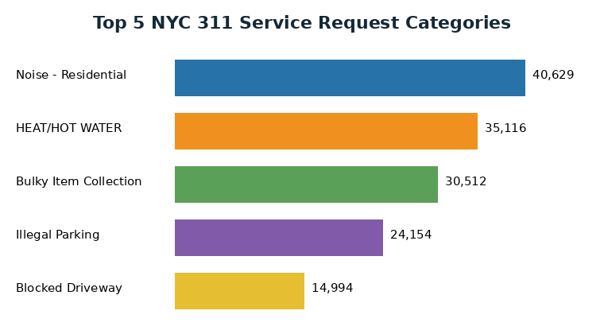
Figure 2. Top 5 service request categories from the HiveQL count query.

6.1 Excel 3D Map
I made the visualization after I downloaded the Top 5 subset to my computer and opened it in Excel. Then I saved the file as an Excel workbook. Opened it in 3D Map. In 3D Map I used the latitude and longitude as the location. The problem field was used to separate the categories so each type of service request would have its color. I also used the field to show the time. This way the visualization was not about the location, but it also showed what happened over time with the service requests. The service requests were the focus of visualization, and I wanted to see how they changed over time with the 3D Map.
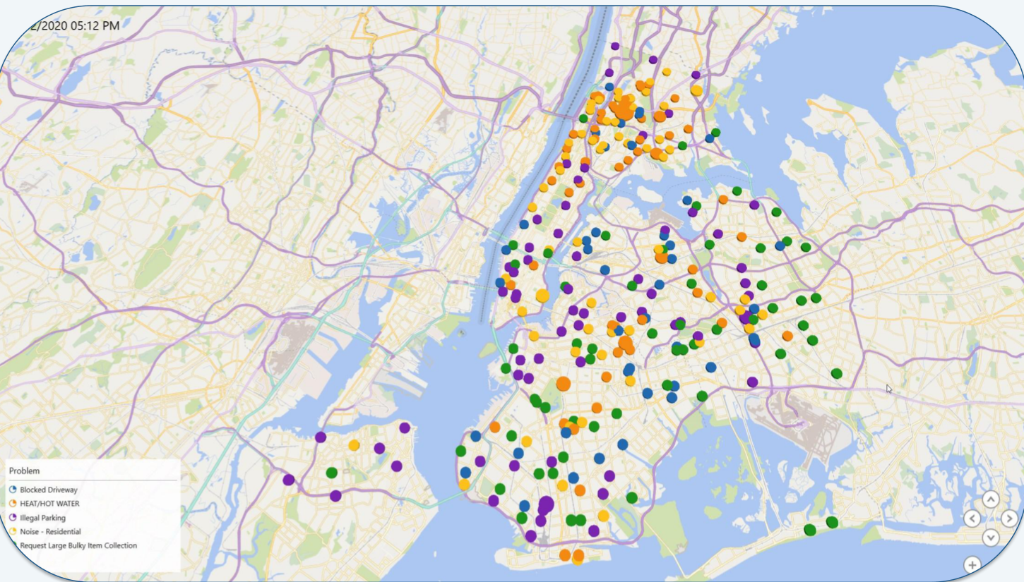
Figure 3. Excel 3D Map showing Top 5 NYC 311 request categories.
The map shows clusters in dense New York City areas. This is really helpful because it makes the results easier to understand than looking at a table. You can see where the selected requests are on the map. I only used the Top 5 categories, so the map does not get too crowded. This makes the map a lot clearer and easier to look at when looking at the locations on the map.

6.2 Findings and Recommendations
The main thing I found is that people are asking for help with things like quality of their life and where they live. Complaints about noise are the most common, which means that people are really bothered by noise near their homes. Problems with heat and hot water were the second most common and this is important because it shows that people are having issues with their homes. People are also complaining about things like picking up items, cars parked in the wrong place and blocked driveways which show that people are worried about keeping their streets clean and being able to get around.
These findings are simple: we should pay attention to the things that people are complaining about the most. We do not know which complaints are important, but we do know which ones are happening a lot and that is what we should focus on when we are deciding how to use our resources. The main idea we got from this is that we should use the things that people are complaining about the most as a way to plan what we need to do. For example, if we get a lot of complaints about noise, we can look at it as a problem with the quality of life in that area. If we get a lot of complaints about heat and hot water, we can see it as a problem with the homes in that area. If we get a lot of complaints about blocked driveways or cars parked in the wrong place, we can see it as a problem with getting around in that area. The map helps us with this because it shows us where these problems are happening, than just giving us a list of numbers.

6.3 Limitations and Future Work
One limitation is that the Excel 3D Map was created from a smaller Top 5 subset instead of every record in the 12.63 GB dataset. I used this subset because when I tried to show all the data points in the Excel 3D map it got too crowded. This smaller subset makes it easier to read. It is not a replacement for the full analysis that was done using HiveQL. The full dataset is still available in HDFS. I can still query it through Hive.
Another limitation is that this project mainly looks at how requests are made and where they are made. It does not look at how long it takes to respond to requests, how long it takes to close requests or how well agencies are performing. These are areas that would also be good to explore. Some possible future steps could be to calculate how long it takes to close requests for each type of complaint. I could also compare patterns at the borough level for each month. I could also create a dashboard that allows filtering by agency, status and date range.
A stronger version of this project could also automate the process of exporting the data and use a tool for creating larger interactive maps.

6.4 Reproducibility and Deliverables
This project was about making the work easy to repeat. The GitHub repository has a lot of things like tutorial, HiveQL source code, and instructions on how to download the dataset and presentation materials. The tutorial explains how to download the dataset, upload the file to HDFS, create the Hive external table, run the analysis queries, export the CSV files, and build the Excel 3D Map. This is important because the project is not about the final result it is also about the steps that another user can follow to get the same result.
The source code file, hive_queries.sql, has all the commands that were used in the project. This includes creating the table, preview queries, counting categories exporting 10,000 clean records and exporting the Top 5 map. The paper explains the method and results, while the GitHub repository stores the reproducible code and supporting files.

6.5 Practical Value
The results are useful because 311 data shows problems that residents report again and again. A city agency can use this analysis to find out which areas need fixing and where many requests are coming from. For example, if there are complaints about heat and hot water it might mean there are housing issues that need to be looked at closely. If there are requests about blocked driveways or illegal parking it could mean, there are problems with street access.
The map also makes the findings easier to analyze. A table is useful for ranking categories, but a map helps viewers understand where the requests are concentrated. Using both a table and a map gives an analysis: HiveQL gives exact numbers and Excel 3D Map shows where and when things happen. This combination is one of the main strengths of the project.
This approach can also grow. Since the original data is in HDFS and can be queried through Hive, additional questions can be added later without starting the entire project over. Future queries could compare complaints by month, look at areas study open versus closed requests or figure out how long it takes to resolve issues. The same process could be used for public-service data that includes time and location.

7. Conclusion
In conclusion, this project looked at NYC 311 service requests using Hadoop, HDFS, Hive, Beeline, HiveQL, and Excel 3D Map. The project started with a large 12.63 GB public-service CSV file and ended with a clean, readable, map-based visualization. The main HiveQL analysis found that Noise - Residential, HEAT/HOT WATER, Request Large Bulky Item Collection, Illegal Parking, and Blocked Driveway were the topmost service request categories.
The project is useful because it shows how big data tools can help summarize city-service problems in NYC. High-volume categories can help agencies decide where to focus attention, while map-based results can help show request hotspots. The project also shows why cleaning coordinate fields is important before creating geo- visualization. Future work could use the same framework to analyze response times, compare complaint patterns by month, or build a full dashboard by borough and agency. Overall, the project demonstrates that Hadoop and Hive are effective for processing public datasets like the NYC 311 service requests, while Excel 3D Map provides a way to communicate location and time patterns within the data.
The project also shows the value of matching tools to the task. Hive was better for summarizing and filtering the large CSV file, while Excel 3D Map was the better tool for presenting the final cleaned subset in a way that is easy for a viewer to understand. Overall, this project showed how Hadoop, Hive, and Excel 3D Map can be used together to turn a large public-service dataset into useful information and location-based insights.

References
[1] L. Wang, C. Qian, C. Kontokosta, and S. Sobolevsky, "Structure of 311 Service Requests as a Signature of Urban Location," PLOS ONE, 2017. https://journals.plos.org/plosone/article?id=10.1371/journal.pone.0186314
[2] A. S. Chauhan, A. Cuzzocrea, L. Fan, J. D. Harvey, C. K. Leung, A. G. M. Pazdor, and T. Wang, "Predictive Big Data Analytics for Service Requests: A Framework," Procedia Computer Science, 2022. https://www.sciencedirect.com/science/article/pii/S1877050921024558
[3] C. W. Zobel, M. Baghersad, and Y. Zhang, "Calling 311: Evaluating the Performance of Municipal Services After Disasters," Proceedings of the 14th ISCRAM Conference, 2017. https://idl.iscram.org/files/christopherwzobel/2017/2008_ChristopherW.Zo bel_etal2017.pdf
[4] NYC Open Data, "311 Service Requests from 2020 to Present." https://data.cityofnewyork.us/Social-Services/311-Service-Requests from-2020-to-Present/erm2-nwe9
[5] Apache Software Foundation, "Apache Hadoop 3.4.1 - HDFS Architecture." https://hadoop.apache.org/docs/r3.4.1/hadoop-project-dist/hadoop-hdfs/ HdfsDesign.html
[6] Apache Hive, "LanguageManual DDL." https://hive.apache.org/docs/latest/language/languagemanual-ddl/
[7] Microsoft Support, "Get started with 3D Maps." https://support.microsoft.com/en-us/office/get-started-with-3d maps-6b56a50d-3c3e-4a9e-a527-eea62a387030
[8] E. Gallegos, "NYC 311 Service Requests Big Data Analysis," GitHub Repository. https://github.com/edwaaardgee/311_service_requests_analysis

