NYC Taxi Trip Data Analysis Using Elasticsearch, Kibana, and Machine Learning
Authors: Ruben Chagollan, Edward Gallegos, Jordy Moreno, Giovanni Clara
Instructor: Dr. Jongwook Woo
Course: CIS 3200 – Data Processing and Analytics
Date: May 16, 2026
Lab Tutorial
NYC Taxi Trip Data Analysis Using Elasticsearch, Kibana, and Machine Learning
Objectives
In this hands-on tutorial, the user will learn how to:
- Download NYC Yellow Taxi Trip Records from the NYC Taxi and Limousine Commission website.
- Download the NYC Taxi Zone Shapefile for geographic mapping.
- Prepare and clean the original taxi dataset using Python.
- Create a smaller CSV subset that can be uploaded into Elasticsearch.
- Add geographic fields to the taxi data using the taxi zone shapefile.
- Upload the cleaned taxi dataset into Elasticsearch using Kibana Data Visualizer.
- Create Elasticsearch indexes for the regular dataset and geo-enhanced dataset.
- Build Kibana visualizations for trip count, fare amount, trip distance, and pickup location activity.
- Create a geo-temporal map of NYC taxi pickups using Kibana Maps.
- Build a Kibana machine learning regression job to predict taxi fare amount.
- View machine learning evaluation results and feature importance/influencers.
- Recreate the full project workflow from the downloaded dataset to the final dashboard.

Platform Specifications
Local Hardware Environment
The project was completed using a personal Windows computer for local data preparation and Elastic Cloud/Kibana for indexing, visualization, and machine learning.
Operating System: Windows 11
Processor: 12th Gen Intel(R) Core(TM) i7-12700K, 3600 Mhz, 12 Core(s), 20 Logical Processor(s)
Installed RAM / Memory: 32 GB
System Type: 64-bit operating system
Local Storage: Local disk storage was used for the original Parquet file and generated CSV files.
Internet Connection: Required for downloading the dataset, using Elastic Cloud, and accessing Kibana.
Software and Tools
Python Version: Python 3.13.13
Python Libraries: pandas, pyarrow, geopandas
Cloud Platform: Elastic Cloud
Visualization Tool: Kibana
Search and Analytics Engine: Elasticsearch
Elasticsearch / Kibana Environment
Elasticsearch Indexes Created:
- nyc_taxi
- nyc_taxi_geo
- nyc_taxi_fare_prediction
Kibana Tools Used:
- Data Visualizer
- Discover
- Lens Visualizations
- Dashboard
- Maps
- Machine Learning Data Frame Analytics
Dataset Information
Dataset: NYC Yellow Taxi Trip Records
Month Used: March 2026
Original Dataset Rows: 3,952,451 rows
Original Dataset Columns: 20 columns
Original Parquet File Size: approximately 64.8 MB
Cleaned CSV Subset: 150,000 rows, 12.8 MB
Geo-Enhanced CSV Subset: 100,000 rows, 28.2 MB

Step 1: Download the NYC Taxi Dataset
Purpose of This Step
This step downloads the original NYC Yellow Taxi Trip Records dataset from the official NYC Taxi and Limousine Commission website. This dataset contains real taxi trip records, including pickup and drop-off times, trip distances, fare amounts, passenger counts, and pickup/drop-off location IDs.
Instructions
- Open a web browser.
- Go to the NYC Taxi and Limousine Commission Trip Record Data page:
https://www.nyc.gov/site/tlc/about/tlc-trip-record-data.page
- Scroll to the section with trip record data download links.
- Find the Yellow Taxi Trip Records for March 2026.
- Download the Parquet file.
Expected File Name
After downloading, the file should be named:
yellow_tripdata_2026-03.parquet
File Setup
Create a new folder for the project for example “nyc taxi trip data analysis”
Place the downloaded file in this folder
Expected Output
At the end of this step, the user should have the file:
yellow_tripdata_2026-03.parquet
saved in the project folder.
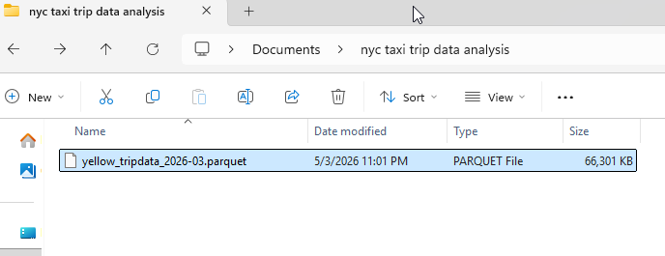
Step 2: Download the NYC Taxi Zone Shapefile
Purpose of This Step
The original taxi dataset contains pickup and drop-off location IDs, but it does not directly contain latitude and longitude coordinates. To create a map in Kibana, we need geographic coordinates. The NYC Taxi Zone Shapefile allows us to match each taxi zone ID with a geographic area and create approximate center coordinates for each zone.
Instructions
- Go to the NYC Taxi and Limousine Commission Trip Record Data page:
https://www.nyc.gov/site/tlc/about/tlc-trip-record-data.page
- Find the section for Taxi Zone Maps and Lookup Tables.
- Download the Taxi Zone Shapefile.
- Extract the ZIP file.
- Place the extracted folder inside the project folder.
Expected Folder Setup
Your project folder should look like this:
- yellow_tripdata_2026-03.parquet
- taxi_zones/
  - taxi_zones.shp
  - taxi_zones.dbf
  - taxi_zones.shx
  - taxi_zones.prj
  - other shapefile files
Expected Output
At the end of this step, the user should have an extracted folder named:
taxi_zones
inside the project folder.
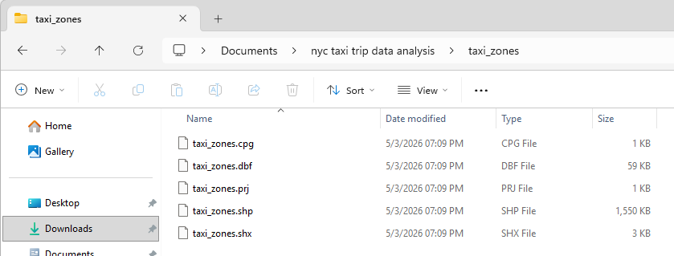
Step 3: Install Python Libraries
Purpose of This Step
This step installs the Python libraries needed to read, clean, sample, and geo-enhance the taxi dataset.
Instructions
- Open Command Prompt or PowerShell.
- Navigate to the project folder.
Example command:
cd "C:\Users\[yourname]\Documents\nyc taxi trip data analysis"
Replace [yourname] with the username on your own computer.
- Install the required Python libraries by running:
python -m pip install pandas pyarrow geopandas
Library Explanation
- pandas is used to load, clean, filter, and sample the taxi dataset.
- pyarrow is used to read the Parquet file format.
- geopandas is used to read the taxi zone shapefile and create geographic coordinates.
Expected Output
The terminal should finish installing the libraries without errors.
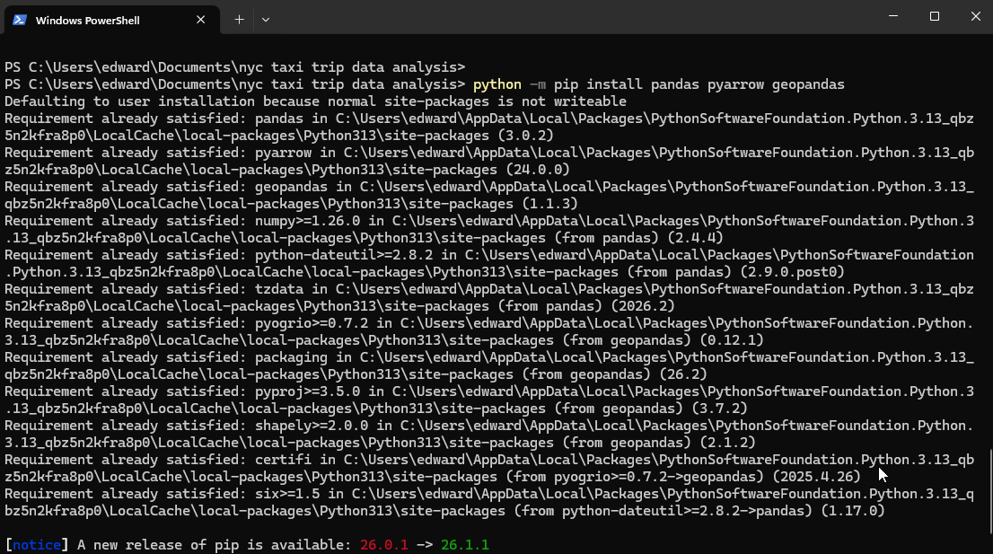
Step 4: Prepare the Taxi Data
Purpose of This Step
This step uses Python to clean the original taxi dataset and create a smaller CSV file for Elasticsearch. The original dataset contains millions of rows, so this script creates a smaller sample that is easier to upload and analyze.
Instructions
1. Open PowerShell or Command Prompt.

2. Navigate to the project folder.
Example:
cd "C:\Users\[yourname]\Documents\nyc taxi trip data analysis"
3. Confirm the dataset is inside the folder by running:
dir
You should see:
yellow_tripdata_2026-03.parquet

4. Start the Python interactive shell by typing:
python

5. The terminal should now show the Python prompt:
>>>

6. Copy and paste the following code into the Python shell.
import pandas as pd
import os
# Load the original NYC Yellow Taxi data
file_path = "yellow_tripdata_2026-03.parquet"
df = pd.read_parquet(file_path)
# Keep only the columns needed for the project
columns_needed = [
"tpep_pickup_datetime",
"tpep_dropoff_datetime",
"passenger_count",
"trip_distance",
"PULocationID",
"DOLocationID",
"payment_type",
"fare_amount",
"total_amount"
]
df = df[columns_needed]
# Remove missing values and invalid trips
df = df.dropna()
df = df[df["trip_distance"] > 0]
df = df[df["fare_amount"] > 0]
df = df[df["total_amount"] > 0]
# Create extra columns for analysis
df["pickup_hour"] = df["tpep_pickup_datetime"].dt.hour
df["pickup_day"] = df["tpep_pickup_datetime"].dt.day
df["trip_duration_minutes"] = (
df["tpep_dropoff_datetime"] - df["tpep_pickup_datetime"]
).dt.total_seconds() / 60
# Remove trips with unrealistic duration
df = df[df["trip_duration_minutes"] > 0]
df = df[df["trip_duration_minutes"] < 180]
# Create a smaller sample for Elasticsearch
df_sample = df.sample(n=150000, random_state=42)
# Save the cleaned dataset
output_file = "nyc_taxi_subset.csv"
df_sample.to_csv(output_file, index=False)
# Print final results
size_mb = os.path.getsize(output_file) / (1024 * 1024)
print("Rows:", len(df_sample))
print(f"File size: {size_mb:.2f} MB")
print("Saved file:", output_file)
Expected Output
The terminal should show output similar to:
Rows: 150000
File size: 12.80 MB
Saved file: nyc_taxi_subset.csv
Expected File Created
After running the code, the project folder should include:
nyc_taxi_subset.csv
Important:
After Step 4 is complete, stay in the Python shell if continuing directly to Step 5. If the Python shell is closed, reopen it by typing python again from the project folder.
Explanation of Important Fields Created
- pickup_hour: extracts the pickup hour from the pickup timestamp.
- pickup_day: extracts the pickup day from the pickup timestamp.
- trip_duration_minutes: calculates how long the trip lasted in minutes.
These fields are used later for Kibana charts and machine learning. 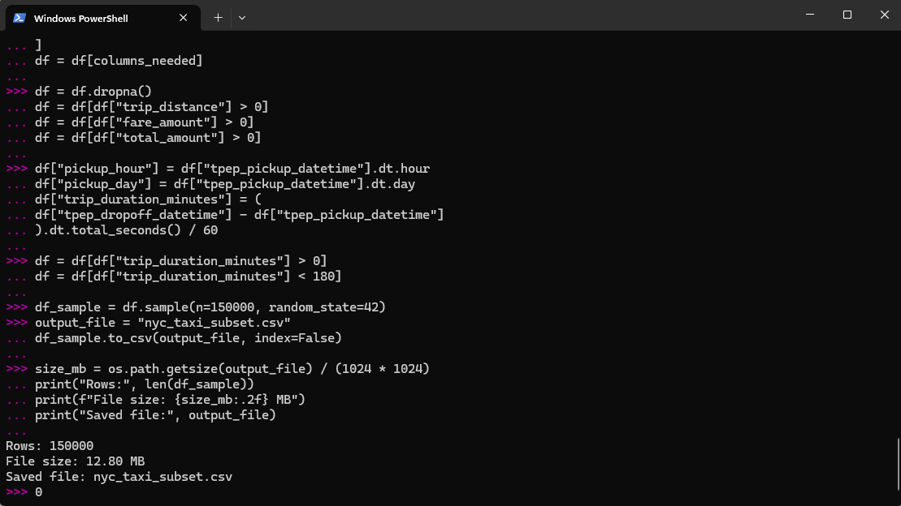
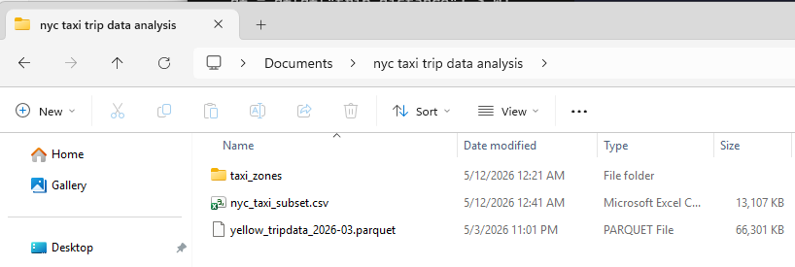

Step 5: Add Geo Fields for the Map
Purpose of This Step
This step creates geographic fields so the taxi data can be displayed on a Kibana map. The original dataset only includes PULocationID and DOLocationID, which are location ID numbers. These IDs must be joined with the NYC taxi zone shapefile to create approximate latitude and longitude coordinates.
Instructions
1. Make sure the Python shell is open and showing:
>>>
2. Make sure Step 4 already created this file:
nyc_taxi_subset.csv
3. Make sure the taxi_zones folder is inside the project folder.
4. Copy and paste the following code into the Python shell.
import pandas as pd
import geopandas as gpd
import os
# Load cleaned taxi data
taxi_file = "nyc_taxi_subset.csv"
df = pd.read_csv(taxi_file)
# Load NYC taxi zone shapefile
zones_file = "taxi_zones/taxi_zones.shp"
zones = gpd.read_file(zones_file)
# Convert taxi zones into latitude/longitude center points
zones = zones.to_crs(epsg=2263)
zones["centroid"] = zones.geometry.centroid
zone_points = gpd.GeoDataFrame(
zones[["LocationID", "zone", "borough"]],
geometry=zones["centroid"],
crs="EPSG:2263"
).to_crs(epsg=4326)
zone_points["longitude"] = zone_points.geometry.x
zone_points["latitude"] = zone_points.geometry.y
zone_points = zone_points[
["LocationID", "zone", "borough", "longitude", "latitude"]
]
# Add pickup location information
df = df.merge(
zone_points,
left_on="PULocationID",
right_on="LocationID",
how="left"
)
df = df.rename(columns={
"zone": "pickup_zone",
"borough": "pickup_borough",
"longitude": "pickup_longitude",
"latitude": "pickup_latitude"
})
df = df.drop(columns=["LocationID"])
# Add dropoff location information
df = df.merge(
zone_points,
left_on="DOLocationID",
right_on="LocationID",
how="left"
)
df = df.rename(columns={
"zone": "dropoff_zone",
"borough": "dropoff_borough",
"longitude": "dropoff_longitude",
"latitude": "dropoff_latitude"
})
df = df.drop(columns=["LocationID"])
# Remove rows without location data
df = df.dropna(subset=[
"pickup_latitude",
"pickup_longitude",
"dropoff_latitude",
"dropoff_longitude"
])
# Create geo-point fields for Kibana Maps
df["pickup_location"] = (
df["pickup_latitude"].astype(str) + "," + df["pickup_longitude"].astype(str)
)
df["dropoff_location"] = (
df["dropoff_latitude"].astype(str) + "," + df["dropoff_longitude"].astype(str)
)
# Keep file size within the project range
df = df.sample(n=100000, random_state=42)
# Save geo-enhanced file
output_file = "nyc_taxi_subset_with_geo.csv"
df.to_csv(output_file, index=False)
size_mb = os.path.getsize(output_file) / (1024 * 1024)
print("Rows:", len(df))
print(f"File size: {size_mb:.2f} MB")
print("Saved file:", output_file)

Expected Output
The Python shell should show output similar to:
Rows: 100000
File size: 28.22 MB
Saved file: nyc_taxi_subset_with_geo.csv
Expected File Created
After running the code, the project folder should include:
nyc_taxi_subset_with_geo.csv
Explanation of Geo Fields Created
- pickup_latitude: approximate latitude of the pickup taxi zone.
- pickup_longitude: approximate longitude of the pickup taxi zone.
- dropoff_latitude: approximate latitude of the drop-off taxi zone.
- dropoff_longitude: approximate longitude of the drop-off taxi zone.
- pickup_location: geo-point field for Kibana Maps.
- dropoff_location: geo-point field for Kibana Maps.
- pickup_zone: pickup zone name.
- dropoff_zone: drop-off zone name.
- pickup_borough: pickup borough.
- dropoff_borough: drop-off borough. 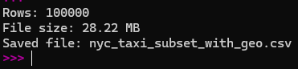
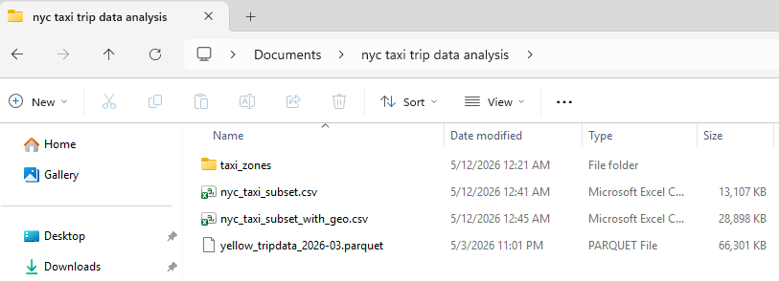

Step 6: Upload the Cleaned Dataset to Elasticsearch
Purpose of This Step
This step uploads the cleaned CSV file into Elasticsearch using Kibana Data Visualizer. Elasticsearch stores and indexes the data so it can be searched, analyzed, and visualized in Kibana.
Instructions
- Open Kibana.
- Go to your deployment
- Go to:
Machine Learning → Data Visualizer → Upload data file
- Click Select file.
- Select the file:
nyc_taxi_subset.csv
- Allow Kibana to analyze the file.
- When asked for an index name, enter:
nyc_taxi
- Click Import.
Expected Result
Kibana should show that the file was uploaded successfully and that the index was created.
Expected messages may include:
- Creating index nyc_taxi
- Index searchable
- Upload complete
- All documents searchable
Expected Elasticsearch Index
The index created should be:
nyc_taxi
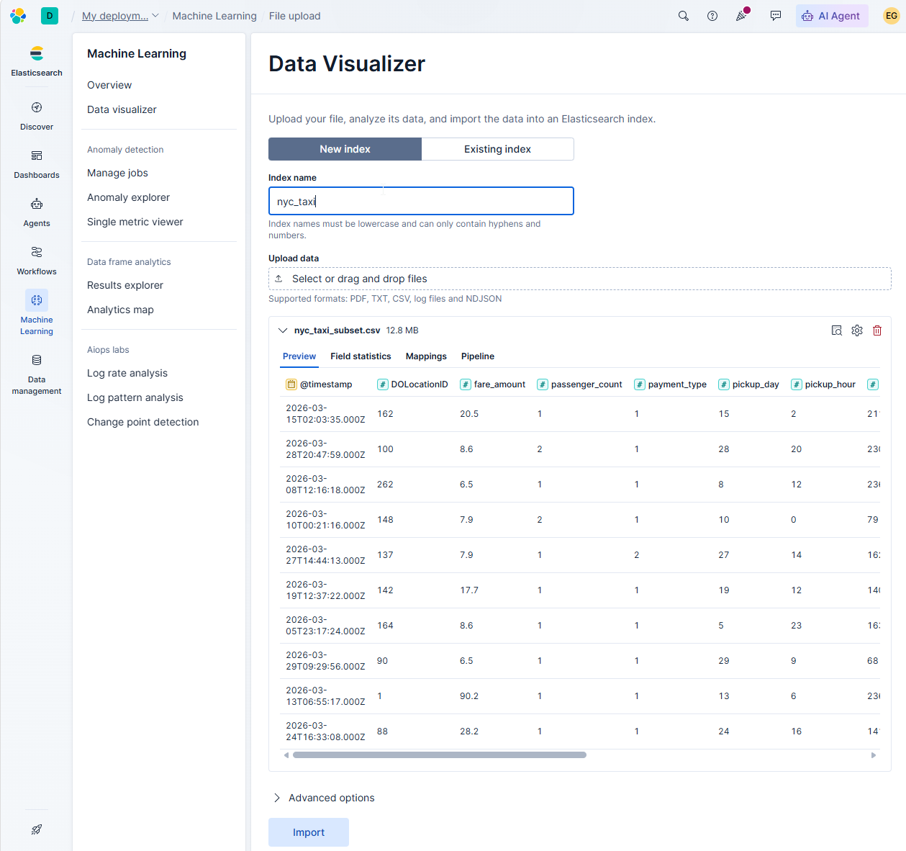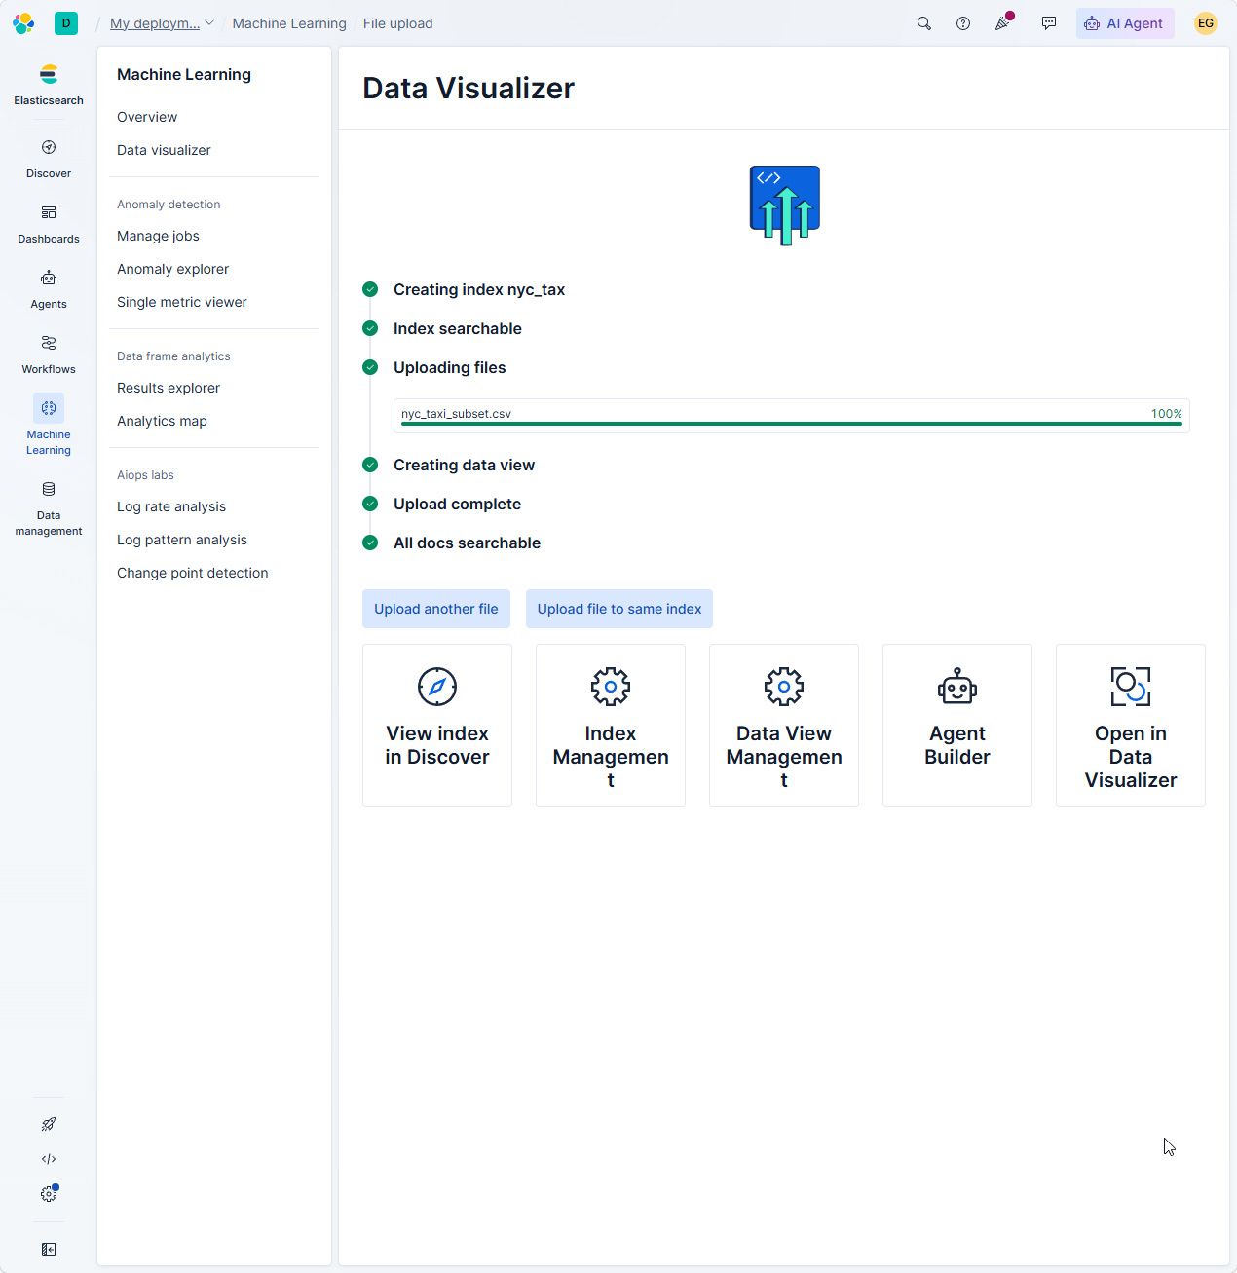
Step 7: Upload the Geo Dataset to Elasticsearch
Purpose of This Step
This step uploads the geo-enhanced CSV file into Elasticsearch. This dataset includes the pickup_location and dropoff_location fields, which are needed for Kibana Maps.
Instructions
- In Kibana, go to:
Machine Learning → Data Visualizer → Upload data file
- Click Select file.
- Select the file:
nyc_taxi_subset_with_geo.csv
- Allow Kibana to analyze the file.
- When asked for an index name, enter:
nyc_taxi_geo
- Before importing, expand Advanced Options and look at the mappings
- Find the following fields:
pickup_location
dropoff_location
- Change both fields to the type:
geo_point
Required Mapping
The mapping should include:
"pickup_location": {
"type": "geo_point"
},
"dropoff_location": {
"type": "geo_point"
}
- Click Import.
Expected Result
Kibana should successfully create the index:
nyc_taxi_geo
The fields pickup_location and dropoff_location should be available as geospatial fields.
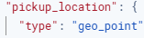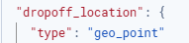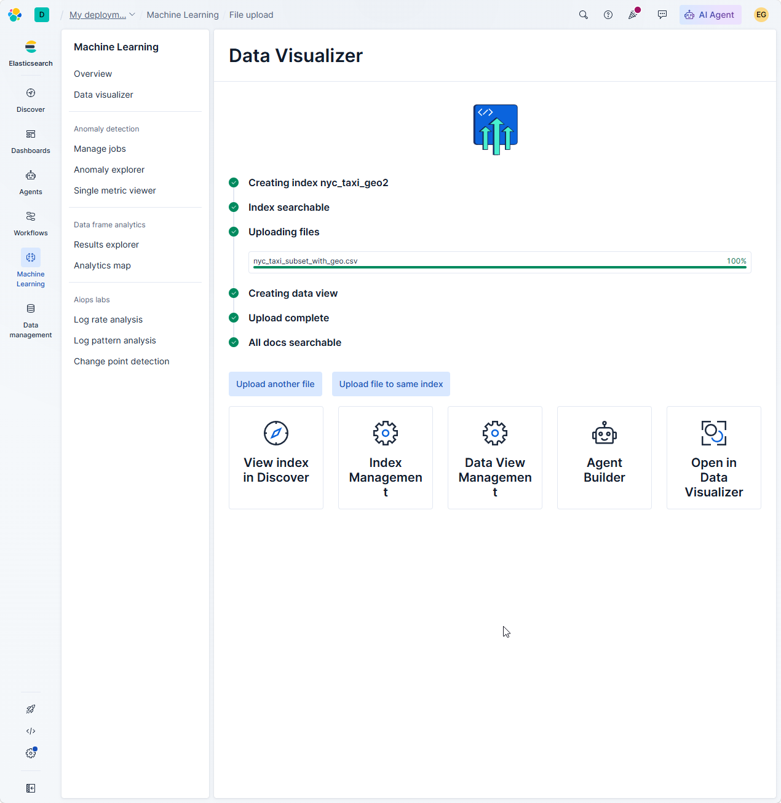

Step 8: Set the Kibana Time Range
Purpose of This Step
The dataset uses March 2026 taxi trip records. If Kibana’s time range is not set correctly, the dashboard and visualizations may appear empty.
Instructions
- After index is created, click on view index in discover
- use the time picker in the top-right corner.
- Set the time range to:
Absolute
March 1, 2026 @ 00:00 → March 31, 2026 @ 23:30
- Apply the time range.
Expected Result
Kibana should show records from the March 2026 taxi dataset.
Step 9: Create Kibana Visualization 1 — Trip Count by Pickup Hour
Purpose of This Step
This visualization shows taxi demand by hour of the day.
Instructions
- Go to Dashboard
- Click Visualizations
- Click Create new visualization.
- If prompted click on Lens
- Select the data view:
nyc_taxi
- Choose a Bar chart.
- Set the horizontal axis to:
pickup_hour
- Set the vertical axis to:
Count of records
- Click save in the top right corner and save the visualization as:
Trip Count by Pickup Hour
- Where it says add to dashboard click on new
Expected Result
The chart should show taxi trip volume by pickup hour.
Insight
This chart shows that taxi demand increases after the morning hours and peaks later in the day.
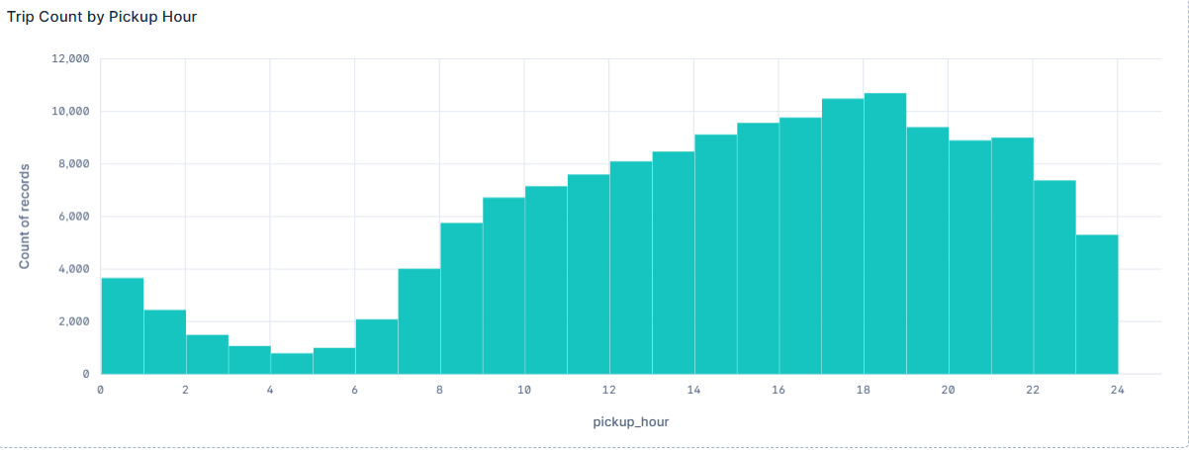
Step 10: Create Kibana Visualization 2 — Average Fare by Pickup Hour
Purpose of This Step
This visualization shows how the average taxi fare changes by hour of the day.
Instructions
- Create a new visualization by clicking on add panel in top right corner
- Select the data view:
nyc_taxi
- Choose a Line chart.
- Set the horizontal axis to:
pickup_hour
- Set the vertical axis to:
Average of fare_amount
- Save the visualization as:
Average Fare by Pickup Hour
Expected Result
The chart should show average fare values by pickup hour.
Insight
This chart shows that average fare spikes around early morning hours.
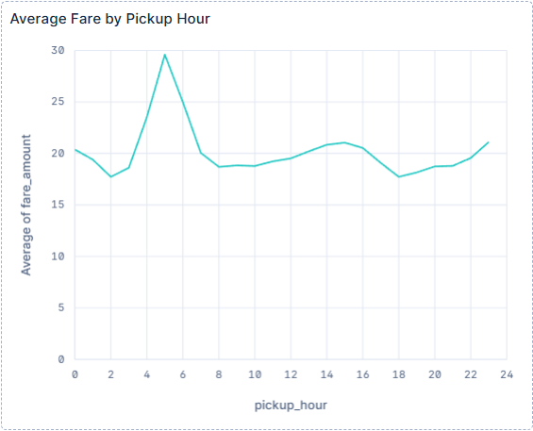
Step 11: Create Kibana Visualization 3 — Average Trip Distance by Pickup Hour
Purpose of This Step
This visualization shows how average taxi trip distance changes by pickup hour.
Instructions
- Create a new visualization.
- Select the data view:
nyc_taxi
- Choose a Line chart.
- Set the horizontal axis to:
pickup_hour
- Set the vertical axis to:
Average of trip_distance
- Save the visualization as:
Average Trip Distance by Pickup Hour
Expected Result
The chart should show average trip distance by pickup hour.
Insight
This chart shows that early morning trips have the longest average distance.
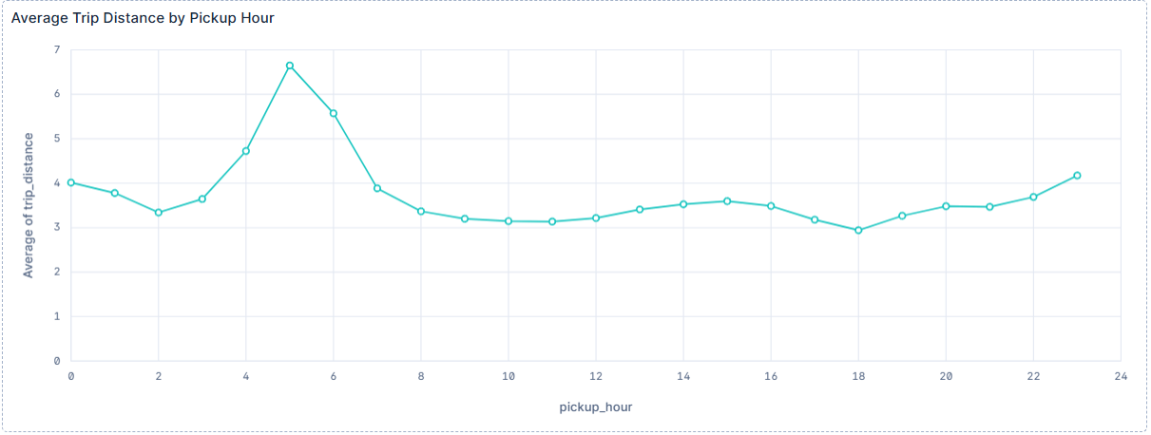
Step 12: Create Kibana Visualization 4 — Top Pickup Location IDs by Trip Count
Purpose of This Step
This visualization shows which pickup location IDs had the highest taxi activity.
Instructions
- Create a new visualization.
- Select the data view:
nyc_taxi
- Choose a Bar chart.
- Set the horizontal axis to:
Top 10 values of PULocationID
- Set the vertical axis to:
Count of records
- If Kibana shows an “Other” bucket, turn it off by clicking on advanced options and toggle off “Group remaining values as "Other"”
- Save the visualization as:
Top Pickup Location IDs by Trip Count
Expected Result
The chart should show the top pickup location IDs by number of taxi trips.
Insight
Pickup Location IDs 237, 132, 161, and 236 show high pickup activity.
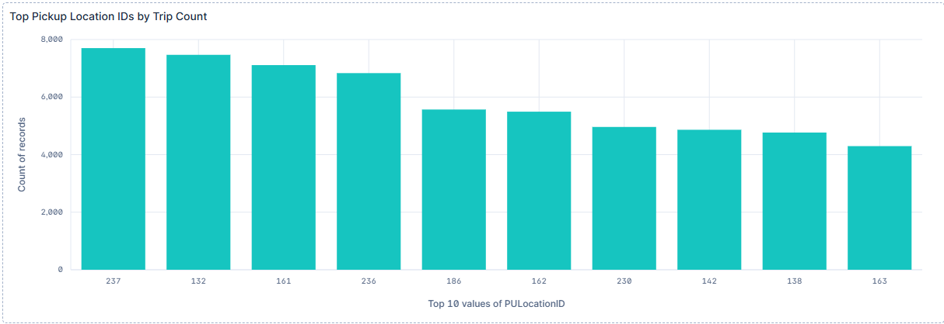
Step 13: Create the Geo-Temporal Map
Purpose of This Step
This step creates a map visualization showing taxi pickup activity across New York City. This is the geo-spatial and temporal visualization for the project because it uses both geographic pickup coordinates and the March 2026 time range.
Instructions
- Go to Maps in Kibana.
- Click Create map.
- Click Add layer.
- Choose:
Clusters
- Select the data view:
nyc_taxi_geo
- Choose the geospatial field:
pickup_location
- Make sure the time range is set to:
Absolute
March 1, 2026 @ 00:00 → March 31, 2026 @ 23:30
Click Add and close.
- Save the map as:
Geo-Temporal Map of NYC Taxi Pickups
Expected Result
The map should show clustered taxi pickup activity across New York City, with higher numbers showing areas with more pickup records.
Insight
Pickup activity is concentrated around Manhattan, Queens, Brooklyn, and airport-related zones.
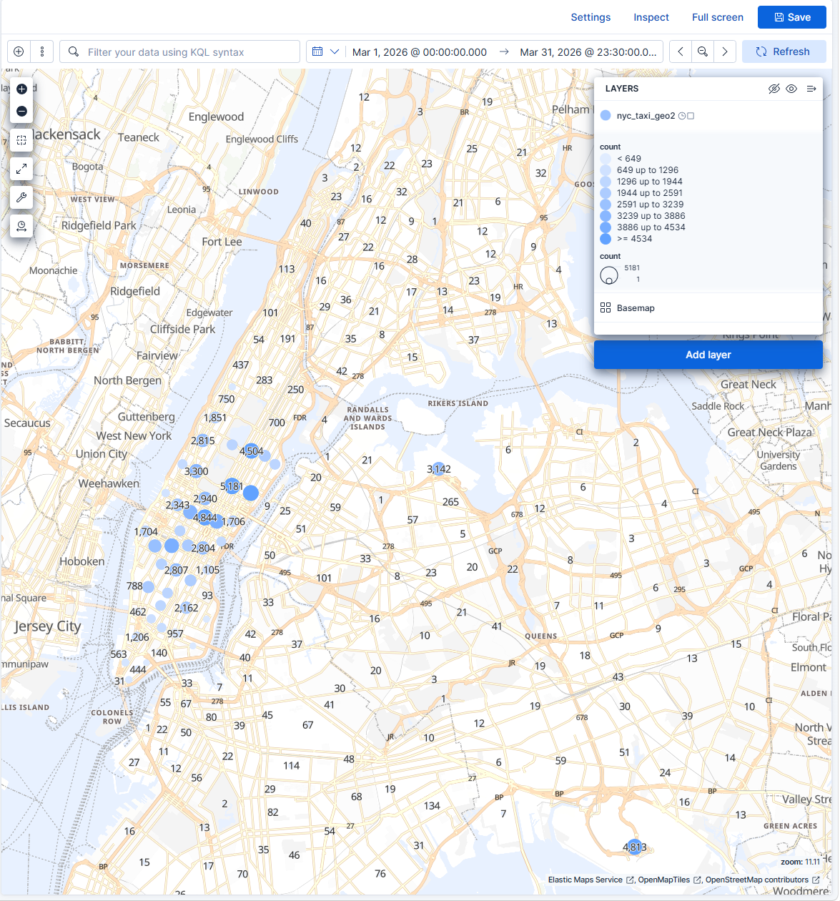
Step 14: Create the Kibana Dashboard
Purpose of This Step
This step combines all saved visualizations into one dashboard. The dashboard gives an overall view of taxi activity by time, fare, distance, location ID, and geographic pickup patterns.
Instructions
- Go to Dashboard in Kibana.
- Click Save
- Save the dashboard as:
NYC Taxi Analysis Dashboard
Expected Result
The dashboard should contain four chart visualizations and one geo-temporal map.
Dashboard Summary
The dashboard includes:
- 4 chart visualizations
- 1 geo-temporal map
- Time range: March 2026
If the visualizations were not already added to the dashboard, click Add panel and select each saved visualization and map.
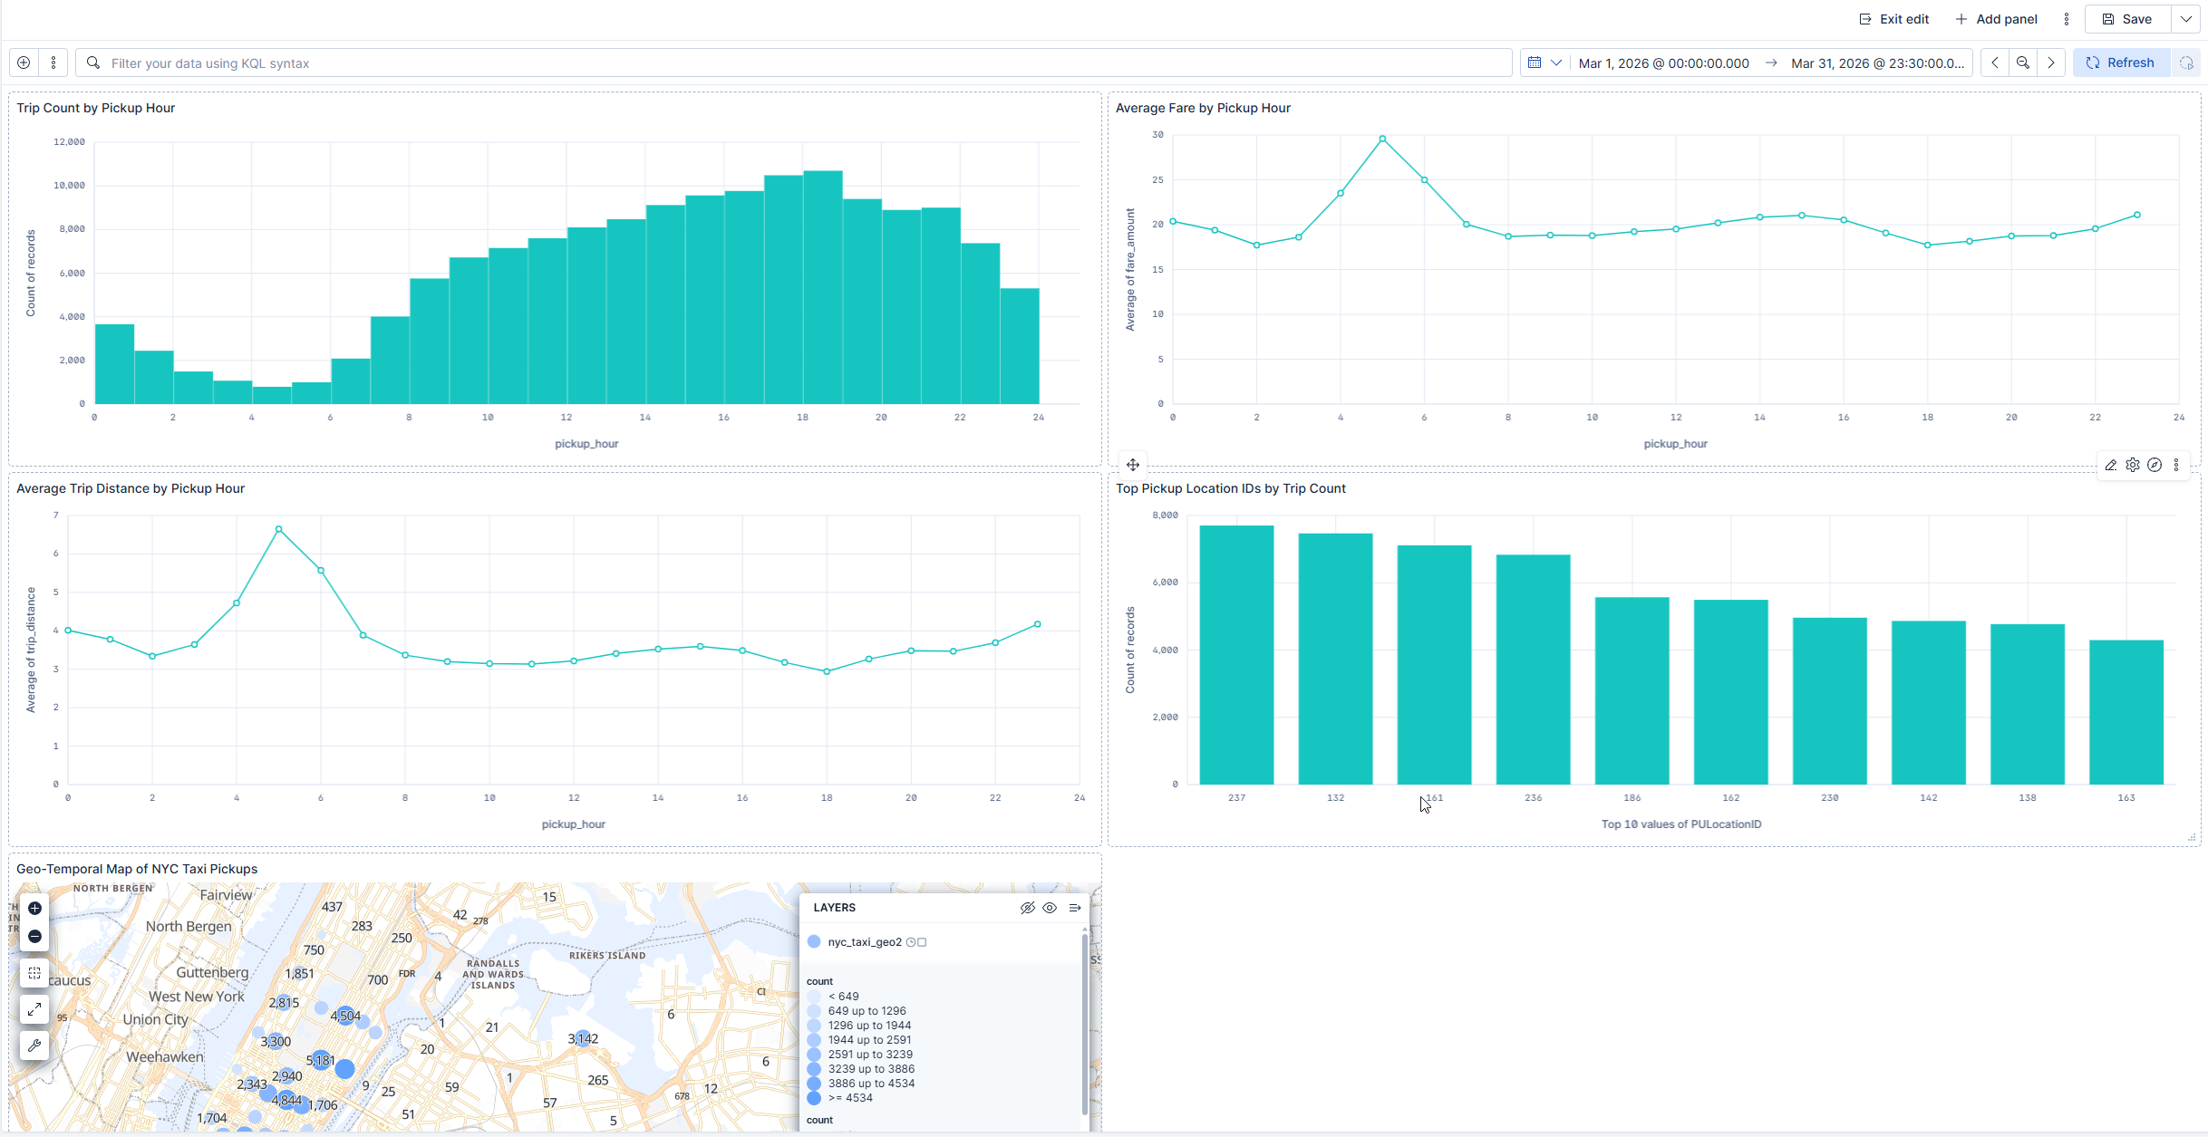
Step 15: Create the Machine Learning Regression Job
Purpose of This Step
This step creates a machine learning regression job in Kibana to predict taxi fare amount. Regression is appropriate because fare_amount is a continuous numeric value.
Instructions
- In Kibana, go to:
Machine Learning → Data Frame Analytics
- Click Create job.
- Select the data view:
nyc_taxi_geo
- Choose the job type:
Regression
- Set the dependent variable / target field to:
fare_amount
- Set the training percentage to:
80%
This means 80% of the data is used for training and 20% is used for testing.
- Use the following job ID:
nyc_taxi_fare_prediction
- Use the following destination index:
nyc_taxi_fare_prediction
- Set the prediction field name to:
fare_amount_prediction
- Include relevant input fields such as:
- trip_distance
- trip_duration_minutes
- passenger_count
- pickup_hour
- pickup_day
- PULocationID
- DOLocationID
- payment_type
- pickup_borough
- dropoff_borough
- Do not use total_amount as an input feature because it is too closely related to fare_amount and could make the prediction artificially easy.
- In additional options, set the number of top feature importance values to:
10
This allows Kibana to calculate feature importance/influencers.
- Validate the job.
- Click Create and start job.
- If prompted, allow Synchronize
Expected Result
The job should run through all phases and complete successfully.
Expected details:
- Job type: Regression
- Target field: fare_amount
- Training percent: 80%
- Training records: approximately 80,000
- Testing records: approximately 20,000
- Prediction field: ml.fare_amount_prediction
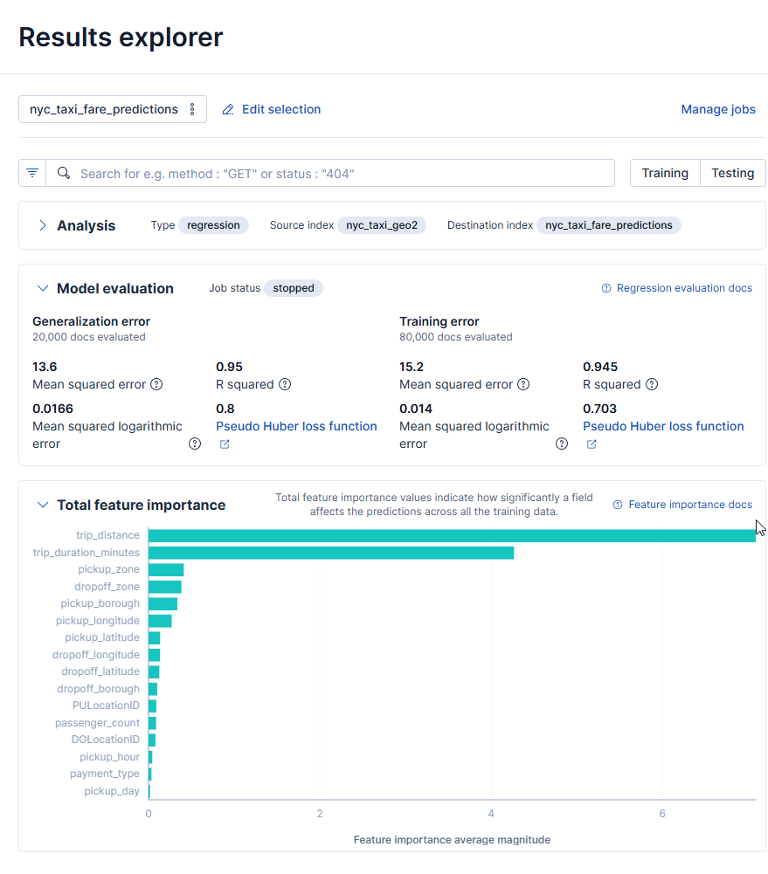

Step 16: View Machine Learning Evaluation Results
Purpose of This Step
This step checks the machine learning model’s accuracy and evaluation metrics. The model is evaluated on both training data and testing data.
Instructions
- Go to:
Machine Learning → Data Frame Analytics
- Click the job:
nyc_taxi_fare_prediction
- Open the results or evaluation page.
- Review the model evaluation metrics.
Results from This Project
The regression job produced the following results:
Training Records: 80,000
Testing Records: 20,000
Testing / Generalization Results:
- R² score: 0.95
- Mean squared error: 13.6
Training Results:
- R² score: 0.945
- Mean squared error: 15.2
RMSE Calculation
RMSE = square root of MSE
Using the testing mean squared error:
RMSE = square root of 13.6
RMSE ≈ 3.69
Interpretation
The testing R² score was 0.95. This means the model explained about 95% of the variation in taxi fare amount on the test data.
The testing RMSE was approximately 3.69. This means that the model’s fare predictions had an approximate error of $3.69 in RMSE terms.
The feature importance results showed that trip_distance and trip_duration_minutes were the strongest influencers in predicting fare amount. This makes sense because taxi fares are usually affected by how far and how long the trip is.

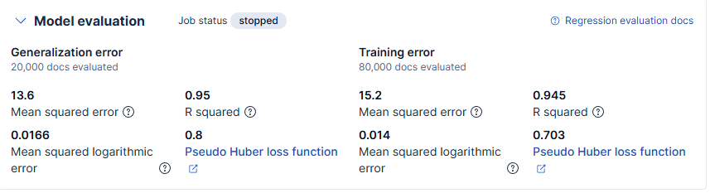
Step 17: View Feature Importance / Influencers
Purpose of This Step
Feature importance shows which fields had the strongest influence on the machine learning model’s fare predictions.
Instructions
- Open the completed Data Frame Analytics job.
- Go to the results or feature importance section.
- Review the top feature importance values.
Expected Influencers
The feature importance results showed that the strongest influencers for predicting taxi fare amount were trip distance and trip duration.
Feature Importance Table
After running the job with feature importance enabled, record the top features in the table below.
Feature | Importance / Role in Model
trip_distance | Strongest influencer; longer trips usually have higher fare amounts.
trip_duration_minutes | Second strongest influencer; longer trip duration affects fare prediction.
pickup_zone | Pickup area influences fare patterns.
dropoff_zone | Drop-off area influences fare patterns.
pickup_borough | Borough location affects fare prediction.
pickup_longitude | Helps represent pickup geography
pickup_latitude | Helps represent pickup geography.
dropoff_longitude | Helps represent drop-off geography.
dropoff_latitude | Helps represent drop-off geography.
dropoff_borough | Borough location affects fare prediction
Explanation
The two strongest influencers were trip_distance and trip_duration_minutes. This makes sense because taxi fares are usually affected by how far the passenger travels and how long the trip takes. Location-based fields such as pickup_zone, dropoff_zone, pickup_borough, and dropoff_borough also influenced the model because certain taxi zones, airport areas, and boroughs can have different fare patterns.
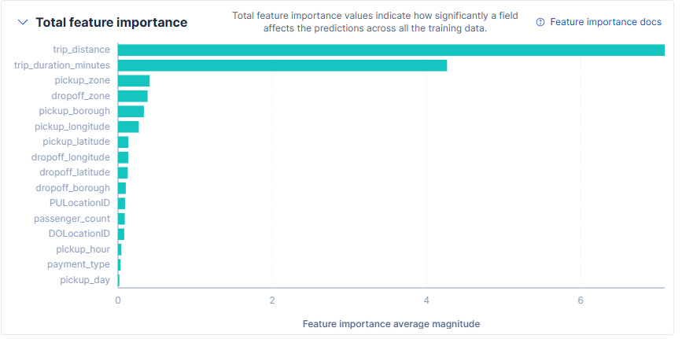 Conclusion
This tutorial demonstrated how to reproduce the NYC Taxi Trip Data Analysis project from start to finish. The project began with the NYC Yellow Taxi Trip Records dataset and used Python to clean, sample, and geo-enhance the data. The cleaned datasets were uploaded into Elasticsearch using Kibana Data Visualizer. Kibana was then used to build visualizations, create a geo-temporal map, and train a machine learning regression model.
The dashboard revealed patterns in taxi demand, trip distance, fare amount, pickup locations, and geographic activity. The geo-temporal map showed pickup activity concentrated around Manhattan, Queens, Brooklyn, and airport-related areas. The machine learning regression job predicted fare amount with a testing R² score of 0.95 and an approximate RMSE of 3.69.
The feature importance results showed that trip_distance and trip_duration_minutes were the strongest influencers in predicting taxi fare amount. This makes sense because taxi fare is closely related to how far and how long a trip is. Location-based fields such as pickup_zone, dropoff_zone, pickup_borough, and dropoff_borough also helped explain fare patterns.
Overall, this project shows how Elasticsearch, Kibana, Python, and machine learning can be combined to analyze real-world transportation data and generate useful insights.
References
- NYC Taxi & Limousine Commission. TLC Trip Record Data.
https://www.nyc.gov/site/tlc/about/tlc-trip-record-data.page
- NYC Taxi Zone Shapefile / Taxi Zone Maps and Lookup Tables.
https://www.nyc.gov/site/tlc/about/tlc-trip-record-data.page
- Elasticsearch Documentation.
https://www.elastic.co/docs
- Kibana Documentation.
https://www.elastic.co/docs
- GitHub Repository for this Project.
https://github.com/edwaaardgee/nyc-taxi-elasticsearch-project

