Section 2. Background Information

2.1

There are several goodness of fit measures that are employed in this project. Their goal is to test whether a given sample comes from a distribution where its exact cumulative distribution function (cdf) or probability density function (pdf) is known. In addition, these tests can be used to determine whether two samples come from the same distribution.

Here is the list of statistical tests and a brief description used for one dimensional sample in this project.

test | One sample test
Kolmogorov–Smirnov test | Largest distance of ecdf and cdf
Chi squared test | Sum of square of differences between the expected and actual frequencies per interval
Cramer von mises criterion | Calculates T statistics*
R squared | Coefficient of determination, a value that is closer 1 would indicate the sample better fits the given pdf.

For the first three of the above tests, a p value is calculated using the resulting statistics. The p value would be uniformly distributed if the sample is from the correct distribution. We can use this fact to conclude that sample is unlikely to have come from the distribution if the statistic produces a very small p value, but cannot infer that higher p value means it is more likely. Throughout this project, a somewhat arbitrary but commonly used critical value of 0.01 has been chosen. It will be said that a given sample has passed a given test if its associated p value is greater than 0.01 and fail the test if it is smaller. The absolute value of the statistics can also be used to compare how good different sampling algorithms are.
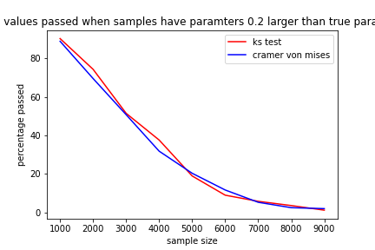

Figure 2.1.1

The above figure shows the percentage of 1000 sets of samples that the respective test (wrongly) passes with respect to different sample sizes. Theses tests were run on samples with exact cdfs with slightly different parameters. Samples were generated with the Scipy default sampling algorithm for beta distribution with alpha=2.2 and beta=3.2, which were compared with beta distribution with samples 2 and 3. As could be expected, larger sample size lead to more p values failing, where between 3 and 4 thousand sample size marks the point where more than half of tests were correct. Further note that there were no statistically significant difference between the two tests. We can conclude these tests will, roughly speaking, be equally good, through the rest of the project.

