**CASE STUDY**

**IN**

**APPLICATION DEVELOPMENT AND EMERGING TECHNOLOGIES**

Submitted by:

**Evangelista, Kaycee M.**

**Maniago, Jr. Arnel P.**

**Torres, Jerome D.**

*Bachelor of Science in Computer Science Students*

BSCS2C

Submitted to:  
  
**Mr. Arjay D. Balberan***Instructor*

October 12, 2024

**Table of Contents**

**1. Introduction ----------------------------------------------------------------------------------------** Page 3

* 1. Background of the website **------------------------------------------------------------------** Page 3
  2. Importance of a Website -------**-------------------------------------------------------------** Page 3
  3. Objectives of the Website **-------------------------------------------------------------------** Page 4
     1. General objective **--------------------------------------------------------------------** Page 4
     2. Specific objectives **-------------------------------------------------------------------** Page 4

1. **Literature Review --------------------------------------------------------------------------------** Page 5
   1. Existing Website related to Title -----------------------------**------------------------------** Page 5
   2. Relevant Technologies **----------------------------------------------------------------------** Page 5

**3. System Requirements and Design --------------------------------------------------------------** Page 6

3.1 System Requirements **-------------------------------------------------------------------------** Page 6

3.1.1 Hardware Requirements **---------------------------------------------------------------** Page 6

3.1.2 Software Requirements **----------------------------------------------------------------** Page 6

3.1.3 Network Requirements **----------------------------------------------------------------** Page 7

3.2 Functional Requirements **---------------------------------------------------------------------** Page 7

3.3 Database Design **-------------------------------------------------------------------------------** Page 8

3.3.1 Entity-Relationship Diagram (ERD) **-------------------------------------------------** Page 8

3.3.2 Data Flow Diagram (DFD) **-----------------------------------------------------------** Page 8

3.4 Database Tables **-------------------------------------------------------------------------------** Page 9

3.5 System Architecture **-------------------------------------------------------------------------** Page 9

**4. Development Process ----------------------------------------------------------------------------** Page 10

4.1 Planning **---------------------------------------------------------------------------------------** Page 10

4.2 Analysis **---------------------------------------------------------------------------------------** Page 10

4.3 Design **-----------------------------------------------------------------------------------------** Page 11

4.4 Implementation **------------------------------------------------------------------------------** Page 11

4.5 Testing **----------------------------------------------------------------------------------------** Page 12

4.6 Deployment **----------------------------------------------------------------------------------** Page 12

**5. User Testing and Feedback ---------------------------------------------------------------------** Page 13

5.1 Testing Procedures **--------------------------------------------------------------------------** Page 13

5.2 Issues Identified **------------------------------------------------------------------------------** Page 13

5.3 Solutions Implemented **----------------------------------------------------------------------** Page 13

5.4 Feedback from Users **------------------------------------------------------------------------** Page 14

5.5 Final Adjustments **---------------------------------------------------------------------------** Page 14

**6. Grades** **----------------------------------------------------------------------------------------------** Page 15

**7. References** ----------------------------------------------------------------------------------------- Page 16

**Introduction**

*Background of Nothing but Clothes*

According to **Yla Pangesti** (2021), clothing is an essential human necessity and is intricately linked to social interactions. Over time, clothing has evolved to serve various functions, including as a means of self-expression. It can be used to communicate aspects of ones identity, culture, lifestyle, and social standing. Additionally, clothing can signify economic status, gender identity, sexual orientation, and religious beliefs. Furthermore, clothing reflects the norms and values of a society. Each individual expresses themselves uniquely through their choice of attire as a way to discover and showcase their identity. The clothing people wear can convey their cultural and social affiliations.

*Importance of a Clothing Website*

According to **Hui Zhou** (2019), with the growth of the clothes market and our fashion sector, a rising number of clothing businesses place a high value on their designs and displays. In todays world, a clothing store is more than just a location to sell products; it is also a place to showcase our clothing brands personality and characteristics. In other words, a clothing store has provided clients with a beautiful and spiritual experience while purchasing and exploring their items. In this view, the objective of clothing shop designs and displays is simply to get people to enter the store, admire the clothes, choose the items, and finally buy them. As a result, clothes shop designs and displays have left a lasting impression on the apparel brand and industry.

*Objectives of the Website*

*General Objective*

The primary aim of this project is to develop a website for Nothing but Clothes that addresses existing shortcomings by enhancing inventory management and elevating the customer experience. The new system will streamline operations by automating stock tracking, reducing errors, and ensuring accurate product availability for customers. Additionally, the website will feature an intuitive, user-friendly design, making it easy for customers to browse and purchase products, whether on desktop or mobile devices.

*Specific Objectives*

This project focus on key areas that will maximize the systems impact. First, enhancing the user experience is essential. The system will feature a clean, intuitive interface designed to make product browsing, and purchasing seamless for customers, whether they are on a desktop or mobile device. By incorporating responsive design elements, the website will adapt to various screen sizes and devices, ensuring that customers can easily access products from anywhere.

Another priority is to facilitate efficient order processing. The system will streamline the checkout and order fulfillment process, enabling both customers and staff to track and manage orders seamlessly. This will enhance operational efficiency and reduce order processing times, providing a better overall shopping experience.

**Literature Review**

*Existing Websites Related to Clothing*

In the competitive landscape of online clothing retail, several websites have established

themselves as benchmarks for effective e-commerce. Websites such as Zalora, ASOS, and Shein

excel in providing seamless shopping experiences through their user-friendly interfaces and

extensive product offerings. These platforms are characterized by intuitive navigation, visually

appealing layouts, and a wide range of apparel, catering to diverse consumer preferences. For

instance, Zalora emphasizes high-quality product images and clear categorization, making it easy

for users to find what they are looking for. ASOS takes personalization a step further by

leveraging user data to provide tailored recommendations. By examining these successful websites Nothing but Clothes can identify best practices in design and functionality that will improve its customer satisfaction.

*Relevant Technologies*

To build a robust clothing website, several relevant technologies must be utilized. PHP

serves as the primary server-side scripting language, known for its flexibility and efficiency in

handling web applications. It allows for easy integration with databases and enables dynamic

content generation. MySQL is employed as the database management system, providing secure

and structured storage for user and product information. This combination allows for efficient data retrieval and management, essential for real-time inventory tracking and order processing. On the front end, HTML and CSS are essential for creating an engaging user interface, while enhances responsiveness and ensures the website is accessible on various devices. Additionally, Bootstrap can further enhance the overall shopping experience.

**System Requirements and Design**

*System Requirements*

*Hardware Requirements*

The hardware requirements for the Nothing but Clothes website include desktop and laptop computers equipped with a minimum of 2 GB of RAM, which is sufficient for this site to operate efficiently. To ensure faster data access and improved performance, Solid-State Drives (SSDs) are preferred for storage. The storage capacity will vary but starting with at least 50 GB is recommended to accommodate product images, customer data, and other essential files. These specifications will support the websites operational requirements, providing staff with reliable and responsive devices for processing orders.

*Software Requirements*

On the software side, several components will be necessary to create a robust and functional website. This includes operating systems that support web applications, web servers for hosting the site, and database management systems for handling data. Specifically, Apache will be utilized as the web server, providing a reliable platform for serving web pages. MySQL will manage the database, enabling secure storage and retrieval of user, product, and order information, while PHP will facilitate server-side scripting to handle dynamic content and user interactions. Furthermore, HTML will be employed to create an attractive and accessible landing page, and CSS will be used to enhance the visual appeal and overall design of the website, contributing to a positive user experience.

*Network Requirements*

The network requirements for the Nothing but Clothes website are crucial for ensuring smooth operation and accessibility. A reliable local network setup must be established for in-store operations, allowing staff to manage inventory and customer data securely. This setup will facilitate efficient communication between devices, support real-time updates on stock levels, and ensure that customer information is handled safely. By implementing a robust local network, Vintage Clothes Hub can enhance operational efficiency and provide a seamless experience.

*Functional Requirements*

The Nothing but Clothes website will allow customers to create accounts and log in. Order processing will be streamlined to enable customers to easily add items to their shopping cart, proceed to checkout, and complete purchases, while staff can view, manage, and fulfill orders efficiently. Additionally, staff will have the ability to add new products to the website, including details such as product names, descriptions, prices, and stock, ensuring that the inventory remains accurate and up-to-date. Customers will also have access to their order history, allowing them to view past purchases, track the status of current orders, and conveniently reorder items as needed.

*Database Design*

*Entity-Relationship Diagram*

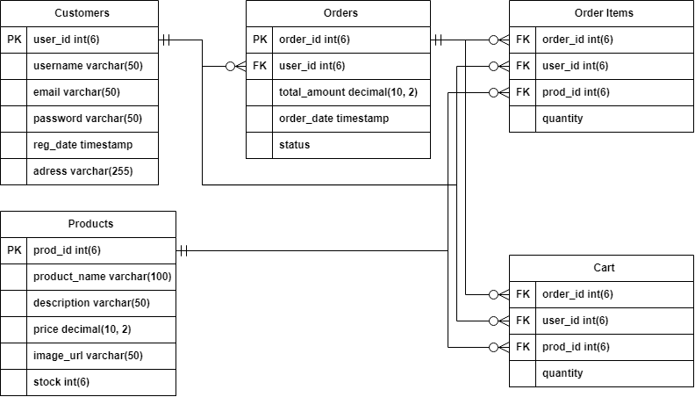

*Data Flow Diagram (DFD)*

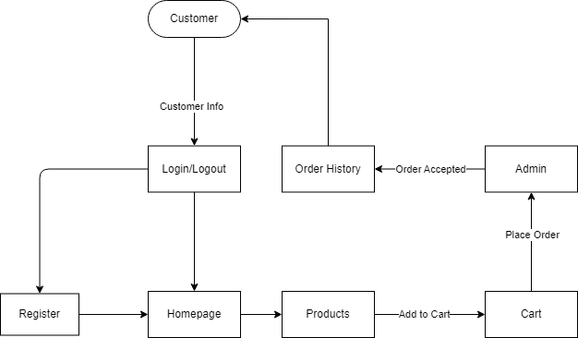

*Database Tables*

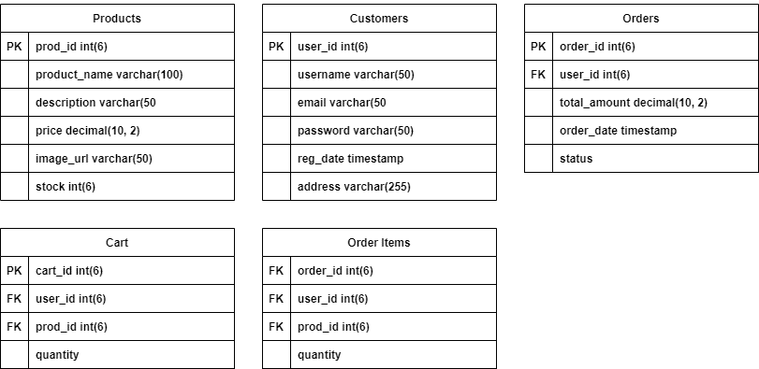

*System Architecture*

The system architecture of the Nothing but Clothes website outlines its structure and details the interaction between the frontend and backend components. It consists of two main layers: the Frontend (User-Interface), which is responsible for the user interface and overall user experience, encompassing the websites design, and layout scripting using HTML, CSS, and Bootstrap. This layer ensures that users can easily navigate the site and engage with its features. The Backend (Database and Server Side) handles data processing and business logic, consisting of a web server running PHP to manage client requests, perform database operations, and handle user sessions. This backend layer communicates with the MySQL database to store and retrieve essential data related to users, products, and orders, ensuring that all information is processed efficiently and effectively.

**Development Process**

*System Development Life Cycle Overview*

The System Development Life Cycle (SDLC) was employed in this project to ensure a structured and efficient approach to website development. The SDLC comprises several key phases: Planning, Analysis, Design, Implementation, Testing, and Deployment. In the Planning phase, the projects goals and requirements were defined. The Analysis phase involved evaluating the current website and gathering detailed requirements. During the Design phase, database structures were created to outline the websites architecture. Implementation focused on building the website, using selected technologies to develop both the frontend and backend components. Testing was conducted to identify and address any issues, ensuring the system functioned smoothly. Finally, the Deployment phase prepared the website for use, making final adjustments as necessary. By following these SDLC phases, the project aimed to deliver a reliable and user-friendly website that meets business and customer needs.

*Planning*

During the planning phase, the primary objectives of the website were defined, focusing on creating a user-friendly platform that improves inventory management and streamlines order processing. Initial research was conducted to understand user needs and market trends in the clothing industry. While project scope and resource allocation were carefully outlined, no budget or financial resources were involved in this project. The development relied solely on available tools and internal efforts, ensuring that the website could be completed without monetary costs.

*Analysis*

The analysis phase involved a thorough examination of the existing website to identify its inefficiencies and areas for improvement. This provided us some valuable insights into the necessary features and functionalities that the new website should incorporate. Additionally, competitor analysis was conducted to benchmark against successful clothing websites, ensuring that the Nothing but Clothes would remain competitive in the market.

*Design*

The overall goal of the design phase was to create a user-friendly interface that is both functional and easy to navigate with a focus on clarity and ease of use. The design balanced aesthetics and functionality, ensuring that the website would be visually appealing without compromising usability. Additionally, the database schema was created to map out the relationships between various data entities. System diagrams, including the Entity-Relationship Diagram (ERD) and Data Flow Diagram (DFD), were produced to represent data flow and system interactions, aligning the design with the project’s operational goals.

*Implementation*

The development of the website will utilize the selected technologies to ensure a robust and functional platform for Nothing but Clothes. This process involves employing a combination of PHP for server-side scripting, which will enable dynamic content generation and handle user requests efficiently. MySQL will be integrated as the database management system to securely store and manage data related to users, products, and orders. For the frontend, HTML and CSS will be used to create an attractive and user-friendly interface, while Bootstrap will enhance the designs responsiveness across various devices. By leveraging these technologies, the website will provide a seamless shopping experience for customers.

*Testing*

Testing was conducted in several stages, including unit testing, integration testing, and user acceptance testing (UAT). During unit testing, each individual component was examined to ensure it functioned as expected, while integration testing verified that all website components worked seamlessly together. User acceptance testing involved classmates acting as users to interact with the system and provide valuable feedback. This feedback helped identify any usability issues or bugs, allowing for necessary adjustments before a broader launch. The insights from classmates were instrumental in refining the website and enhancing the overall user experience.

*Deployment*

The deployment phase involved a limited launch of the website for Nothing but Clothes, allowing initial users to access and interact with the system on a smaller scale. This partial rollout provided an opportunity to monitor the websites performance and gather feedback from early users. Additionally, training sessions were conducted to familiarize staff with the new system. These sessions covered essential features, such as inventory management, order processing, and reporting tools, ensuring that staff could effectively navigate and utilize the website in preparation for a future full-scale launch.

**User Testing and Feedback**

*Testing Procedures*

The testing procedures included a comprehensive beta testing stage, during which users interacted with the system to assess its functionality and usability. This stage focused on key testing criteria such as the websites ease of use, the accuracy of updates to inventory and product details, and the effectiveness of report generation tools. These criteria ensured that the system met the needs of both customers and staff, identifying any areas for improvement before broader deployment.

*Issues Identified*

During the testing phase, several issues were identified that impacted the user experience. A common problem was user interface alignment on mobile devices, where certain elements did not display correctly, resulting in a suboptimal experience for mobile users. Additionally, performance lags were observed, particularly in functionalities such as product searches and page load times, which were more noticeable when accessing larger inventories. These issues highlighted the need for further optimization to ensure smooth and efficient website performance.

*Solutions Implemented*

To address the issues identified during testing, specific solutions were implemented to enhance the website’s functionality and user experience. For the alignment problems on mobile devices, modifications were made to the CSS to ensure responsive design, resulting in a more visually consistent and user-friendly interface across various screen sizes. To tackle the performance lags, database queries were optimized, and caching strategies were introduced, significantly improving loading times and reducing delays, particularly in product searches. These adjustments collectively contributed to a smoother and more efficient user experience.

*Feedback from Users*

The system was tested by classmates as users. They evaluated the key functionalities, including inventory management, order processing, and overall usability. Their feedback was gathered during this single round of testing. Classmates highlighted that the system significantly improved inventory tracking and streamlined the ordering process. They also noted the user-friendly design and ease of navigation, particularly on computer devices. Their input helped confirm that the website's layout was responsive and provided an improved user experience.

*Final Adjustments*

Following the user feedback and testing procedures, several final adjustments were made. This included refining reporting tools based on user requests, and conducting a final round of performance testing to ensure all functionalities operated smoothly. These final tweaks ensured that the website was fully prepared for a successfully to be capable of meeting user expectations.

**Grades**

|  |  |  |  |
| --- | --- | --- | --- |
| **SEPTEMBER 25, 2024** |  |  |  |
| **GRADER** | **TORRES** | **MANIAGO** | **EVANGELISTA** |
| **TORRES** | **100** | **98** | **100** |
| **MANIAGO** | **100** | **100** | **100** |
| **EVANGELISTA** | **100** | **98** | **98** |
| **TOTAL** | **100** | **99** | **99** |

|  |  |  |  |
| --- | --- | --- | --- |
| **SEPTEMBER 26, 2024** |  |  |  |
| **GRADER** | **TORRES** | **MANIAGO** | **EVANGELISTA** |
| **TORRES** | **100** | **97** | **96** |
| **MANIAGO** | **100** | **100** | **97** |
| **EVANGELISTA** | **100** | **97** | **100** |
| **TOTAL** | **100** | **98** | **98** |

|  |  |  |  |
| --- | --- | --- | --- |
| **SEPTEMBER 29, 2024** |  |  |  |
| **GRADER** | **TORRES** | **MANIAGO** | **EVANGELISTA** |
| **TORRES** | **100** | **96** | **96** |
| **MANIAGO** | **100** | **100** | **97** |
| **EVANGELISTA** | **100** | **96** | **100** |
| **TOTAL** | **100** | **97** | **98** |

|  |  |  |  |
| --- | --- | --- | --- |
| **OCTOBER 3, 2024** |  |  |  |
| **GRADER** | **TORRES** | **MANIAGO** | **EVANGELISTA** |
| **TORRES** | **100** | **98** | **100** |
| **MANIAGO** | **100** | **100** | **100** |
| **EVANGELISTA** | **100** | **98** | **98** |
| **TOTAL** | **100** | **99** | **99** |

|  |  |  |  |
| --- | --- | --- | --- |
| **OCTOBER 6, 2024** |  |  |  |
| **GRADER** | **TORRES** | **MANIAGO** | **EVANGELISTA** |
| **TORRES** | **100** | **97** | **96** |
| **MANIAGO** | **100** | **100** | **97** |
| **EVANGELISTA** | **100** | **97** | **100** |
| **TOTAL** | **100** | **98** | **98** |

|  |  |  |  |
| --- | --- | --- | --- |
| **OCTOBER 10, 2024** |  |  |  |
| **GRADER** | **TORRES** | **MANIAGO** | **EVANGELISTA** |
| **TORRES** | **100** | **98** | **100** |
| **MANIAGO** | **100** | **100** | **100** |
| **EVANGELISTA** | **100** | **98** | **98** |
| **TOTAL** | **100** | **99** | **99** |

**References**

Development Model Of Web Design Element For Clothing E-Commerce Based On The Concept Of Mass Customization – Tangchaiburana and Techametheekul (2019) https://doi.org/10.1016/j.kjss.2016.07.007

Kansei Engineering: A Study On Perception Of Online Clothing Websites – Anitawati and Nor Laila (2019) https://anitawati.uitm.edu.my/mypapers/11_QMOD_KEOnlineClothing.pdf

The importance of eCommerce to the fashion and apparel industry - Christian Smales. (2020) https://www.datafeedwatch.com/blog/ecommerce-and-the-fashion-industry

A Study of Clothing Purchasing Behavior – Yla Pangesti (2021)

https://repository.unika.ac.id/27106/2/15.J2.0016-Yohana%20Livia%20Ayuningtyas%20Pangesti-BAB%20I_a.pdf