**CASE STUDY**

**IN**

**APPLICATION DEVELOPMENT AND EMERGING TECHNOLOGIES**

Submitted by:

**MACALE, Aldrin C.**

**MADERAS, Kierr Dunstan Y.**

**SANTOS, Anjeanette S.**

*Bachelor of Science in Computer Science Students*

BSCS2C

Submitted to:  
**Mr. Arjay D. Balberan***Instructor*

October 12, 2024

**Table of Contents**

**1. Introduction ----------------------------------------------------------------------------------------** Page 3

* 1. Background of the website **-----------------------------------------------------------------** Page 3
  2. Importance of a Website -------**-------------------------------------------------------------** Page 5
  3. Objectives of the Website **------------------------------------------------------------------** Page 5
     1. General objective **--------------------------------------------------------------------** Page 5
     2. Specific objectives **------------------------------------------------------------------** Page 6

1. **Literature Review -------------------------------------------------------------------------------** Page 7
   1. Existing Website related to Title -----------------------------**-----------------------------** Page 7
   2. Relevant Technologies **----------------------------------------------------------------------** Page 7

**3. System Requirements and Design -------------------------------------------------------------** Page 9

3.1 System Requirements **------------------------------------------------------------------------** Page 9

3.1.1 Hardware Requirements **--------------------------------------------------------------** Page 9

3.1.2 Software Requirements **---------------------------------------------------------------** Page 9

3.1.3 Network Requirements **---------------------------------------------------------------** Page 9

3.2 Functional Requirements **------------------------------------------------------------------** Page 10

3.3 Database Design **----------------------------------------------------------------------------** Page 11

3.3.1 Entity-Relationship Diagram (ERD) **----------------------------------------------** Page 11

3.3.2 Data Flow Diagram (DFD) **---------------------------------------------------------** Page 11

3.4 Database Tables **-----------------------------------------------------------------------------** Page 12

3.5 System Architecture **------------------------------------------------------------------------** Page 13

**4. Development Process ---------------------------------------------------------------------------** Page 14

4.1 Planning **--------------------------------------------------------------------------------------** Page 14

4.2 Analysis **--------------------------------------------------------------------------------------** Page 15

4.3 Design **----------------------------------------------------------------------------------------** Page 15

4.4 Implementation **------------------------------------------------------------------------------** Page 17

4.5 Testing **----------------------------------------------------------------------------------------** Page 18

4.6 Deployment **----------------------------------------------------------------------------------** Page 20

**5. User Testing and Feedback --------------------------------------------------------------------** Page 22

5.1 Testing Procedures **-------------------------------------------------------------------------** Page 22

5.2 Issues Identified **-----------------------------------------------------------------------------** Page 23

5.3 Solutions Implemented **---------------------------------------------------------------------** Page 23

5.4 Feedback from Users **-----------------------------------------------------------------------** Page 24

5.5 Final Adjustments **--------------------------------------------------------------------------** Page 24

**6. Grades** **---------------------------------------------------------------------------------------------** Page 25

**7. References** ---------------------------------------------------------------------------------------- Page 26

**Introduction**

*Background of iclothes*

According to Chakraborty, Hoque, Jeem, Biswas, Bardhan, Lobaton (2020) One of the many methods that consumers utilize to shop these days is the internet. Customers go to numerous websites that provide a variety of goods to buy, select, order, and manufacture credit card transactions, and lastly, vendors ship their goods physically. A comparable assertion is made by, who claims that online buying is a common usage for the internet. internet-based purchasing refers to how customers purchase on websites or online stores that are used for the purpose of making purchases online. Given how quickly the internet is developing, online purchasing is growing and gaining traction as a method of shopping globally. The proportion of the percentage of consumers who shop online has significantly increased, as does their income. This study will specifically address online shopping behaviors in the online shopping category of fashion. According to Bai et al(2019)., using e-commerce platforms for fashion the popularity of shopping activities is rising. One of them is to blame for this since, in Fashion buying websites include C2C concepts in addition to B2C models. increase the variety of fashion products available, both in terms of product kinds and costs. The most promising market niche for an internet business in Indonesia is the working generation. Hassyati wrote a report for the Asian Development Bank Institute (ADBI). indicates that the primary target audiences for internet buying are those who have dealt with middle-class and upper-class clients, both male and female. This is due to the working generation is likely to spend more time online overall. The Growing popularity of internet purchasing, particularly among young adults, is accompanied by heightened rivalry between numerous established merchants and growing internet businesses who have accessed the internet as a convenient medium. Consequently, businesspeople must be fully aware of what, in an e-commerce business, is considered service convenience. Gaining an understanding of business clients' comfort might help boost customer pleasure in order to encourage repeat business.

Understanding consumers shopping behavior requires an understanding of convenience, to which they attach a substantial rise. When it comes to consumers, convenience is defined as the decrease of time and energy needed to access and use a product or service in comparison to the time and energy needed to make repeat purchases at the online store. The ease with which customers can shop online will affect multiple aspects of their lives. Pham and colleagues explicate that a consequence of consumer convenience is the perceived value.

Online sales have continued to expand due to their affordability and convenience compared to traditional purchases (Vasić et al., 2019). This shift has transformed how goods are acquired, allowing consumers to shop anytime and anywhere (Ellison et al., 2021), place orders, make payments online, and receive their purchases at preferred locations (Rita et al., 2019). As a result, aspects such as customer satisfaction and the online shopping experience have become essential for businesses, although they are often viewed as challenges in the realm of e-commerce (Mamakou et al., 2023; Rita et al., 2019). Previous research indicates that businesses can establish more effective standards by understanding the factors that influence customer happiness and refining their strategic approaches (Mofokeng, 2021; Vasić et al., 2019). An illustration of this can be seen in the industry of fashion. The sector is witnessing a rapid increase in digital platform transactions, shopping experiences, and consumer pleasure are seen as essential components for the value proposition (Kautish et al., 2022). But there are difficulties with fashion apparel brands that sell products online, particularly in regard to topics like ecological and social responsibility and the requirement to guarantee client satisfaction (Gutiérrez Rodríguez et al., 2020). Consequently, there are two goals for this study project.

The initial is to examine a structural model of satisfaction with regard to internet shopping, which incorporates a background of both rapid and slow fashion, environmental consciousness, product, and affective and online encounters. The secondary objective is to evaluate the significance and effectiveness of the three categories of online purchasing experiences contentment, employing an importance-performance matrix. Apart from the preface, the piece has an additional five sections, including a literature review, technique, findings, analysis, and recommendations.

*Importance of Website*

Website is the brain If you are running a Clothing Business then, website Is front end of your brand Providing a global 24-hour-a-day showcase for collections, designs and trends A good website boost brand recognition and help customer loyalty to increase, by offering easy navigation features with secure payments gateways while providing personalized recommendations. It also helps marketing efforts by connecting social media, email campaigns and search engine optimization (SEO) WP VLSIAGEMENT; increasing traffic and conversions. As we move to an online world, a good website is what will help you survive in the competition and also reach out markets further ahead to create loyal customers.

*General Objectives*

The researchers goal is to determine whether fashion retail websites usability affects customer satisfaction through an Irish millennial survey. Does utilizing the either the website is too complicated for young consumers, or it meets their expectations. to utilize and falls short of millennial consumers' expectations? This would benefit the Researchers comprehend why, even with the rise in internet sales, a sizable amount is wasted outside of Ireland (Retail Ireland, 2018; Retail Monitor).

The supply chain for the textile and fashion industries is extensive and intricate, spanning from the manufacture of petrochemicals and agriculture (for the production of fiber) to manufacturing, distribution, and retail. The usage of water, materials, chemicals, and energy in each stage of production has an effect on the environment. Numerous chemicals used in the textile industry are bad for customers, factory workers, and the environment. Textile waste is found worldwide, however the majority of the environmental effects are concentrated in the nations that manufacture textiles and clothing. The systems material throughput has increased as a result of fast fashion. Comparatively speaking, fashion firms are currently generating about twice as much apparel as they were before to 2000. Large volumes of textile waste are produced by current fashion-consumption practices, the majority of which is burned, dumped in landfills, or sent to underdeveloped nations.

*Specific Objectives*

The State of Fashion 2020" and subsequent reports outline industry trends, sustainability, and consumer behavior. Regularly publishes insights and analyses on fashion retail trends and strategies. Provides data and statistics on the fashion e-commerce market, including projections and trends. Their "Global Powers of Retailing" report discusses key trends in retail, including e-commerce.

**Literature Review**

*Existing Website related to iclothes*

The fashion industry has always struggled to match supply and demand. SHEIN set out to solve this problem by building a new kind of fashion business model driven by its customers. Our innovative on-demand, customer-driven model addresses customer preferences more accurately and efficiently, which means much more affordable prices—and less waste. With a global presence, SHEIN offers a full range of women’s, men’s, children’s, home, and beauty categories that are ever evolving to meet the diverse needs of our customers, from SHEIN branded apparel to products from a global network of suppliers.

*Relevant Technologies*

SHEIN website and app boast an appealing and intuitive user interface (UI) that keeps visitors engaged and encourages them to explore the vast collection of products. The front-end of SHEIN platform relies on modern web technologies such as HTML5, CSS3, and JavaScript. These technologies enable responsive design, ensuring that the platform adapts seamlessly to different devices, including desktops, smartphones, and tablets. Additionally, JavaScript frameworks like React and AngularJS provide dynamic interactivity and enhance the overall user experience.

The back-end of SHEIN platform handles crucial tasks such as inventory management, order processing, and customer data storage. At the core of the back-end lies a server-side programming language, and SHEIN primarily employs PHP for this purpose. PHP offers flexibility, scalability, and a vast array of libraries and frameworks, making it an ideal choice for large-scale e-commerce platforms. Moreover, SHEIN leverages frameworks like Laravel and Symfony to streamline development processes and ensure code modularity, enhancing maintainability and code reusability.

Efficient database management is vital for handling the vast amounts of product data, customer information, and order details that SHEIN processes daily. SHEIN technology stack relies on MySQL, an open-source relational database management system (RDBMS). MySQL provides robust data management capabilities, high performance, and excellent scalability. It enables quick retrieval and storage of data, ensuring a seamless shopping experience for users. Additionally, caching mechanisms, such as Redis or Memcached, are employed to enhance performance by reducing database load.

Apparel is one of the largest categories of retail business in which the fast fashion industry originated in the 1990s and has played a significant role over the past decade. However, it still faces a variety of unique challenges. This research aims to suggest appropriate improvements in certain aspects of the fast fashion business using the case of Shein, which is an e-commerce company with one of the fastest growth rates in the world. By analyzing the business strategies of the company using the SWOT analysis and the Marketing Mix, this study identifies three potential deficiencies in the field which hinder its further development, including the lack of sensitivity in design, insufficient corporate social responsibility, and damage to the environment in the manufacturing process.

**System Requirements and Design**

*Hardware Requirements*

When evaluating hardware requirements for operations, a variety of devices are utilized, including desktop computers, laptops, and smartphones. For optimal performance, desktop computers should be equipped with a minimum of 16 GB RAM, a multi-core processor (Intel i5 or equivalent), and a dedicated graphics card for graphic-intensive tasks. Laptops should also meet similar specifications, ensuring portability without sacrificing performance, with at least 512 GB of SSD storage. Mobile devices need to have a modern operating system and at least 4 GB of RAM to support necessary applications efficiently. Connectivity options, including Wi-Fi 6 and Bluetooth 5.0, are essential for seamless integration and communication across devices.

*Software Requirements*

In the development of the website, Sublime Text is used as the primary code editor, offering a streamlined and efficient environment for writing and editing code. For database management, XAMPP is employed to facilitate the setup of a local server and effective management of MySQL databases. Development is carried out on Windows 11, ensuring compatibility with the latest software and features, which enhances overall productivity and user experience during the development process. This combination of tools facilitates a smooth workflow from coding to database integration.

*Network Requirements*

In website development, robust network requirements are crucial for seamless communication and data transfer. A stable internet connection with a minimum speed of 20 Mbps is recommended for efficient uploading, downloading, and testing of features. Both wired and wireless connections are utilized, with a preference for wired Ethernet to ensure optimal stability during development. Secure firewall and VPN are implemented to protect sensitive data and maintain privacy during the development process. Additionally, access to a reliable domain name system (DNS) is crucial for effective domain management and ensuring that our site is accessible to users without delays.

*Functional Requirements*

When creating a clothing website, several functional requirements must be addressed to ensure a seamless user experience. The site should feature a user-friendly interface that allows customers to browse categories such as men’s, women’s, and children’s clothing. It should include a robust search functionality with filters for size, color, price, and style. Each product page must display high-quality images, detailed descriptions, customer reviews, and availability status. A secure shopping cart and checkout process are essential, including multiple payment options (credit card, PayPal, etc.) and user authentication for account management. Additionally, the website should support order tracking, returns management, and responsive design to ensure compatibility across various devices. Finally, integration with social media for sharing products and promotional features will enhance user engagement and marketing efforts.

*Database Design*

*Entity-Relationship Diagram (ERD)*

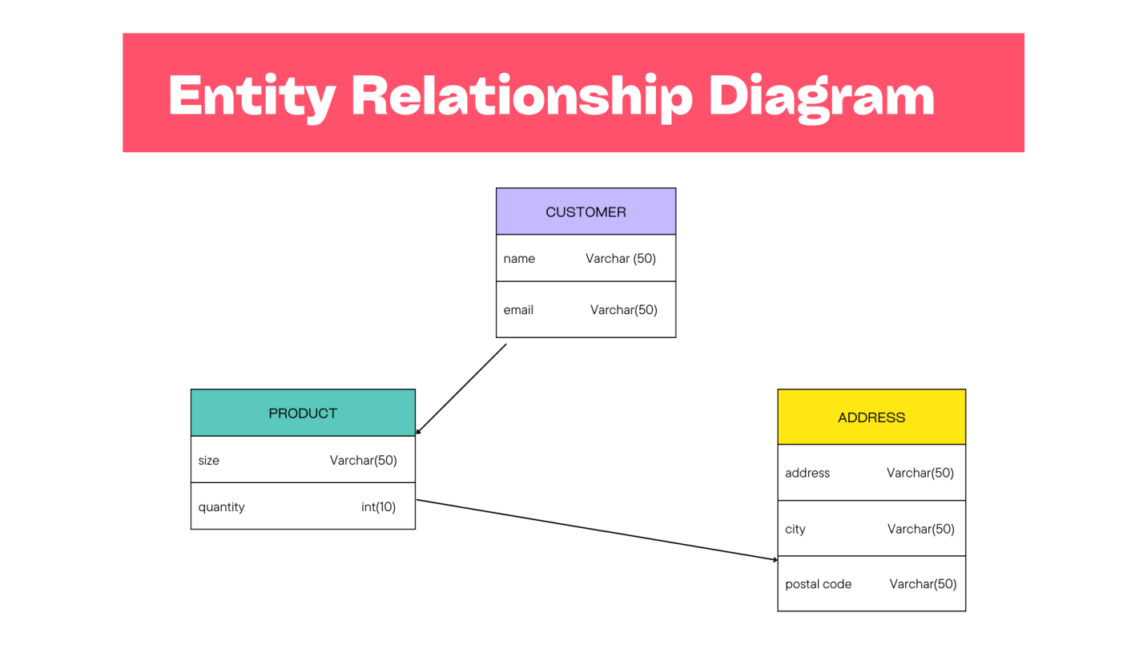

*Data Flow Diagram (DFD)*

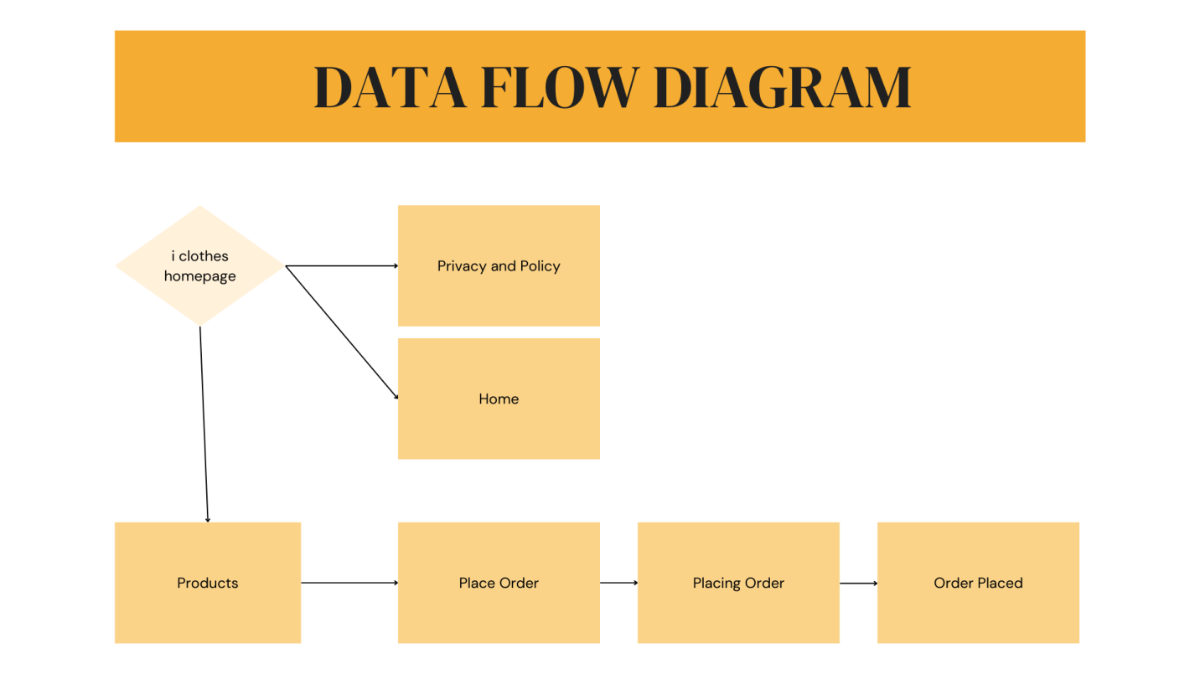

*Database Tables*

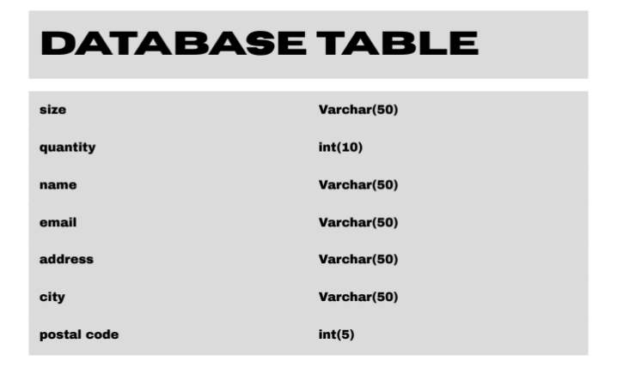

*System Architecture*

The user interface is the part of the clothing website that users interact with. It should be visually appealing, user-friendly, and responsive across various devices (desktop, tablet, and mobile).

Home Page displays featured products, categories, and promotions. Navigation menu for easy access to different sections (e.g., Men, Women, Sale). Product Pages detailed view of individual products, including images, descriptions, prices, and size/color options. Database stores all application data, including user information, product details, orders, and categories (e.g., MySQL). Organized using tables based on the ERD we discussed earlier. The architecture of a clothing website involves a well-structured frontend for user interaction and a robust backend for data management and processing. This combination ensures a seamless shopping experience while maintaining security and performance. The system is designed to scale as user demand grows, accommodating more products, users, and transactions over time.

**Development Process**

*System Development Life Cycle (SDLC) Overview*

Planning Define project scope and objectives with stakeholders. Requirements Gathering collect detailed user and functional requirements. Design create the website layout and user interface through wireframes and prototypes. Development code the website, implementing key features like product listings and payment systems. Testing conduct thorough testing to ensure functionality and fix any bugs. Deployment launch the website, ensuring proper setup of hosting and domain. Maintenance provide ongoing support, updates, and optimization.

*Planning*

The development process of a clothing website begins with thorough planning, which is crucial for ensuring a successful project outcome. During this phase, stakeholders gather to define the website purpose, target audience, and key features. This includes conducting market research to understand user needs and preferences, as well as analyzing competitor offerings. A detailed project scope is then created, outlining functional requirements such as product categories, user accounts, and payment processing. Additionally, wireframes and user journey maps are developed to visualize the layout and flow of the site. Establishing a timeline and budget at this stage helps to set clear expectations and align the team on goals, ultimately laying a strong foundation for the subsequent design and development phases.

*Analysis*

Following the planning phase, the analysis phase of the clothing website development process focuses on gathering and refining requirements to ensure a clear understanding of what needs to be built. This involves engaging with stakeholders, including potential users, to collect feedback and insights about desired features and functionalities. User personas are created to represent different segments of the target audience, helping to identify specific needs and preferences.

In this phase, a detailed requirements document is crafted, outlining both functional and non-functional requirements, such as performance expectations, security standards, and usability criteria. Additionally, technical feasibility assessments are conducted to evaluate the technology stack, including frontend and backend frameworks, database management systems, and payment gateways. This analysis phase culminates in a comprehensive specification document that serves as a reference throughout the development process, ensuring that all team members have a shared understanding of the project goals and requirements.

*Design*

In the design phase of the clothing website development process, the focus shifts to creating the visual and structural components of the site based on the requirements gathered during the analysis phase. This phase typically involves several key activities.

Wireframing designers create low-fidelity wireframes to outline the layout of key pages, including the homepage, product pages, category pages, shopping cart, and checkout process. These wireframes serve as a blueprint, illustrating the placement of elements such as navigation menus, product images, and calls to action. Prototyping once wireframes are approved, interactive prototypes are developed to provide a more realistic representation of the user experience. These prototypes allow stakeholders to navigate through the site flow, offering insights into user interactions and identifying potential usability issues.

Visual Design the visual aspects of the site are crafted, including color schemes, typography, and imagery that align with the brand identity. High-fidelity mockups are created to showcase how the final website will look, incorporating elements like buttons, icons, and product photography. Responsive Design designers ensure that the website is mobile-friendly by creating responsive layouts that adapt to various screen sizes. This involves considering touch interactions and optimizing elements for different devices.

User interface design emphasizes creating an intuitive and enjoyable experience for users. This involves designing navigation flows, form inputs, and feedback mechanisms to ensure that users can easily find and purchase products.

The design phase concludes with the delivery of comprehensive design specifications and assets, which serve as a guide for the development team to implement the website effectively. This phase is essential for aligning the visual aesthetics with user needs and business goals, setting the stage for successful development.

*Implementation*

The implementation phase of the clothing website development process involves translating the design specifications into a functional website. This phase typically includes several key activities

Frontend Development developers begin by coding the user interface based on the design mockups. This involves using HTML, CSS, and JavaScript to create responsive layouts, interactive elements, and seamless navigation. Frameworks like React, Angular, or Vue.js may be employed to enhance the user experience.

Backend Development concurrently, backend developers work on the server-side components, setting up the application logic, database connections, and APIs. They implement functionalities such as user authentication, product management, and order processing, typically using languages like PHP, Python, or Node.js, along with a database system like MySQL or PostgreSQL.

Database Integration the database schema is set up based on the ERD designed earlier. Tables are created for users, products, orders, and categories, ensuring data integrity and relationships are maintained. CRUD (Create, Read, Update, Delete) operations are implemented to manage data effectively.

Payment Gateway Integration developers integrate secure payment processing solutions, ensuring that transactions are handled safely and efficiently. This includes setting up APIs for payment gateways like Stripe or PayPal, and ensuring compliance with security standards such as PCI-DSS.

Testing and Debugging as features are developed, continuous testing is conducted to identify and resolve bugs or issues. This includes unit testing, integration testing, and user acceptance testing (UAT) to ensure that the website functions as intended and meets user expectations.

Deployment once development and testing are complete, the website is deployed to a production environment. This involves configuring the web server, migrating the database, and ensuring that the site is accessible to users.

Documentation throughout the implementation phase, documentation is created to record the codebase, setup instructions, and user guides, facilitating future maintenance and updates.

*Testing*

The testing phase of the clothing website development process is crucial for ensuring the site's functionality, usability, and performance before it goes live. This phase typically involves several types of testing to identify and resolve issues. Key activities include:

Unit Testing developers test individual components or functions of the code to ensure they work as expected. This is usually done during development and helps catch bugs early in the process.

Integration Testing this involves testing how different components of the website interact with each other. Functional Testing or instance, ensuring that the frontend communicates correctly with the backend APIs and that data flows seamlessly between the user interface and the database. Testers verify that all website features work according to the specified requirements. This includes testing user registration, product searches, cart functionality, and the checkout process to ensure that each feature operates as intended.

User Acceptance Testing (UAT**)** In this phase, real users are invited to test the website in a controlled environment. Their feedback is gathered to assess usability, design, and overall experience. UAT helps identify any issues that may not have been caught during earlier testing phases.

Performance testing assesses the website's speed, responsiveness, and stability under various conditions, including load testing to evaluate performance with multiple concurrent users and stress testing to identify limits by exceeding expected usage. Security testing involves identifying vulnerabilities through practices such as penetration testing and vulnerability assessments, ensuring sensitive user data, like payment information and personal details, is well protected. Cross-browser and cross-device testing ensures consistent functionality and appearance across various web browsers (Chrome, Firefox, Safari, etc.) and devices (desktops, tablets, smartphones). Finally, regression testing is conducted after fixing any issues to confirm that recent changes have not negatively impacted existing features

.The testing phase is essential for delivering a high-quality clothing website. It ensures that the final product is reliable, user-friendly, and secure, ultimately enhancing the overall user experience and reducing the risk of post-launch issues.

*Deployment*

The deployment phase of the clothing website development process involves making the website accessible to users and ensuring that it operates smoothly in a live environment. Key activities in this phase include.

Final Review conduct a final review of the codebase and website functionalities to ensure everything is in order. Backup create backups of the existing database and files (if applicable) to prevent data loss during the deployment process. Environment Setup server Configuration: Set up the production server environment, including the web server (e.g., Apache or Nginx), application server, and database server. Ensure that all necessary software and dependencies are installed.

Domain Setup register a domain name if not already done, and configure DNS settings to point to the server. Database Migration migrate the database from the development or staging environment to the production server. This may involve executing SQL scripts to create tables, seed data, and ensure data integrity.

Code Deployment Upload Files Transfer the website files (HTML, CSS, JavaScript, backend scripts) to the production server using FTP/SFTP or version control systems like Git. Configuration Files update configuration files to reflect the production environment settings, such as database connection details and API keys.

Testing in Production perform a final round of testing in the live environment to ensure everything functions correctly. This includes testing key features like user registration, product searches, and payment processing. Monitoring and Performance Tuning set up monitoring tools to track the website’s performance, user interactions, and error logs. This helps identify and address any issues promptly. Optimize server settings and caching mechanisms to improve website speed and responsiveness.

Security Measures Implement security best practices, such as enabling HTTPS for secure data transmission and configuring firewalls to protect against threats. Launch Announcement Announce the website launch through marketing channels, including social media, email newsletters, and press releases to attract users to the site.

Post-Launch Support Provide ongoing support to address any user feedback or issues that arise after launch. Regularly update the website with new features, security patches, and content based on user needs. The deployment phase is critical for successfully transitioning the clothing website from development to a live environment. A well-executed deployment ensures that users have a seamless and positive experience while interacting with the site.

**User Testing and Feedback**

*Testing Procedures*

Alpha and beta testing are essential stages in the website development lifecycle that offer valuable insights into the products usability and performance. Reflecting on alpha testing, it serves as a critical internal review where the development team identifies and resolves major bugs before involving external users. This phase helps to create a more stable foundation, allowing for thorough evaluation of functionality. Beta testing, on the other hand, emphasizes real-world user interactions, providing feedback from diverse perspectives that the internal team may not have considered. Together, these testing phases highlight the importance of iterative improvement, ensuring the final product is user-friendly, functional, and aligned with user expectations. This reflection underscores the necessity of comprehensive testing to enhance overall quality and satisfaction.

In website development, establishing clear testing criteria is vital to ensure quality and performance. Key criteria include functionality, which verifies that all features work as intended; usability, which assesses the user experience and ease of navigation; and compatibility, ensuring the site functions correctly across various browsers and devices. Performance testing measures loading times and responsiveness under different conditions, while security testing evaluates the site’s resilience against vulnerabilities. Additionally, accessibility testing checks compliance with standards for users with disabilities. Lastly, user acceptance testing (UAT) involves gathering feedback from real users to confirm that the site meets their needs and expectations before the final launch. These criteria collectively ensure a robust and user-centric website.

*Issues Identified*

The issues identified during the testing phases of website development often include functionality bugs, such as broken links or features that don’t work as intended. Usability concerns may arise, such as confusing navigation or unclear calls to action. Compatibility problems can occur, where the site doesn’t display correctly across different browsers or devices. Performance issues often manifest as slow loading times or unresponsive elements. Security vulnerabilities might be detected, highlighting the need for better protection against potential threats. Finally, feedback from user acceptance testing may reveal additional areas for improvement to enhance the overall user experience. Addressing these issues is essential for delivering a high-quality website.

*Solutions Implemented*

To address the identified issues during the website testing phases, several solutions were implemented. For functionality bugs, we conducted thorough code reviews and debugging sessions to fix broken links and ensure all features operate correctly. Usability improvements included redesigning navigation elements for clarity and enhancing calls to action for better visibility. Compatibility issues were resolved by optimizing the site’s responsive design and conducting cross-browser testing to ensure consistent performance. Performance enhancements involved optimizing images, minimizing code, and leveraging caching techniques to improve loading times. Security vulnerabilities were addressed by implementing stronger encryption, regular security audits, and updating software components. Finally, user feedback from acceptance testing led to additional refinements, ensuring the site meets user expectations and provides a seamless experience.

*Feedback from Users*

User feedback is crucial for refining the website and enhancing the overall experience. Many users appreciated the intuitive navigation and clean design, noting that it made browsing and finding products easier. Some highlighted the importance of clear calls to action, which improved their shopping experience. However, several users pointed out issues with the checkout process, suggesting it could be more streamlined to reduce cart abandonment. Others requested additional filters for product searches to better tailor results to their preferences. Positive comments also emerged regarding the site's mobile responsiveness, though a few users experienced slow loading times during peak hours. This feedback has been invaluable in guiding further improvements and ensuring the website meets user needs effectively.

*Final Adjustments*

To finalize adjustments, review the user interface for consistency in design and ensure all links are functional. Double-check that the site is fully responsive across devices and browsers. Implement any last-minute feedback, particularly regarding content clarity and navigation ease. Finally, conduct a final quality assurance check to confirm that all features work as intended and that the site is optimized for speed and SEO before the official launch.

**Grades**

**Day 1:**

|  |  |  |  |
| --- | --- | --- | --- |
| **Grader** | **Santos** | **Maderas** | **Macale** |
| **Santos, Anjeanette S.** | **98** | **80** | **98** |
| **Maderas, Kierr Dunstan Y.** | **97** | **90** | **98** |
| **Macale, Aldrin C.** | **97** | **85** | **98** |
| **Total:** | **97.3** | **85** | **98** |

**Day 2:**

|  |  |  |  |
| --- | --- | --- | --- |
| **Grader** | **Santos** | **Maderas** | **Macale** |
| **Santos, Anjeanette S.** | **95** | **80** | **98** |
| **Maderas, Kierr Dunstan Y.** | **94** | **90** | **98** |
| **Macale, Aldrin C.** | **95** | **85** | **98** |
| **Total:** | **94.6** | **85.6** | **98** |

**Day 3:**

|  |  |  |  |
| --- | --- | --- | --- |
| **Grader** | **Santos** | **Maderas** | **Macale** |
| **Santos, Anjeanette S.** | **98** | **85** | **98** |
| **Maderas, Kierr Dunstan Y.** | **98** | **90** | **98** |
| **Macale, Aldrin C.** | **98** | **85** | **98** |
| **Total:** | **98** | **86.6** | **98** |

**References**

# Fashion Recommendation Systems, Models and Methods: A Review - Chakraborty, Hoque, Jeem, Biswas, Bardhan, Lobaton (2021)

<https://www.mdpi.com/2227-9709/8/3/49>

Investigating how online fashion product page design affects the consumer’s clothing fit appraisal – Rosy boardman, Gianpaolo Vignali, Helen McCornick (2022)

[Investigating how online fashion product page design affects the consumer's clothing fit appraisal - Chrimes - 2022 - Journal of Consumer Behaviour - Wiley Online Library](https://onlinelibrary.wiley.com/doi/full/10.1002/cb.2100)