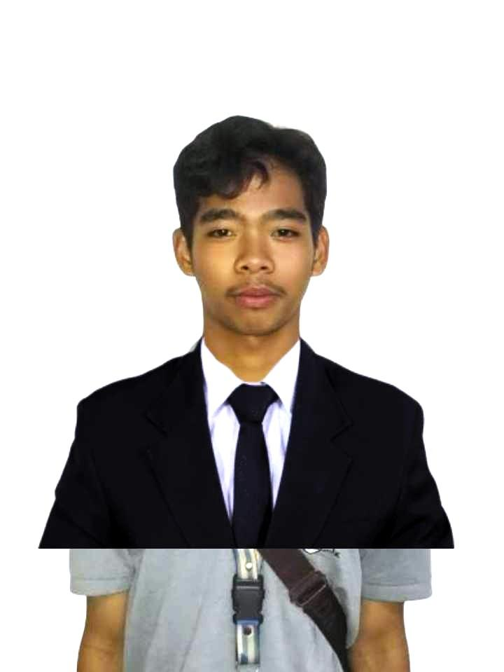**MANIAGO Jr, Arnel P.**

Cut-cut 1st , Capas, Tarlac

Email Address: arnelmaniago144@gmail.com

# 

# OBJECTIVE

* To acquire valuable knowledge and skills to complement those that I’ve learned from school in an actual job environment. In return, I offer my service and determination to be an asset to your company throughout the duration of my On-The-Job Training period.

.

# PERSONAL DATA

Date of Birth: **June 16, 2005**

Place of Birth: **Bacnotan, La Union**

Civil Status: **Single**Citizenship: **Filipino**

# EDUCATIONAL BACKGROUND

**Primary: Juan Navarro Elementary School**

Brgy. Cut-cut 1st , Capas, Tarlac, 2315

A.Y. 2011-2017

**Secondary: Capas National High School**

Sitio San Nicholas, Brgy Sto. Domingo 1st, Capas, Tarlac, 2315 A.Y. 2017-2023

**Tertiary: Concepcion Holy Cross College, Inc.**

Bachelor of Science in Computer Science

Brgy. Minane Concepcion, Tarlac

A.Y. 2023-Present

# SKILLS

* **Web development**: Understanding HTML, CSS, and JavaScript to build websites. al skills.
* **Teamwork**: Working cooperatively with others in order to achieve a common goal.
* **Adaptability**: Being able to adjust quickly to changing situations and environments.

**CHARACTER REFERENCE**

**Name: Kennylyn A. Dela Cruz**

**Address: Sitio Susuba, Capas, Tarlac**

**Contact Number: 09478194469**

**Name: Lorena Mhae P. Dela Cruz**

**Address: Sitio Susuba, Capas, Tarlac**

**Contact Number: 09098036826**