Hybrid Search RAG Tool
Technical Implementation Guide for the Agent Marketplace Sales Agent
Storage: PostgreSQL 18 + pgvector 0.8 | Embeddings: gemini-embedding-001 (1536 dimensions) | Keyword search: PostgreSQL full text | Fusion: Reciprocal Rank Fusion (RRF)

Goal and scope
The sales agent could already answer questions from live company data (products and orders) through the schema-mapping tools. It could not answer questions whose answers live in unstructured company documents, such as return policies, warranty terms, delivery fees, payment methods or opening hours. This work adds a Retrieval-Augmented Generation (RAG) tool named rag_search. Companies upload documents, the documents are chunked and embedded into pgvector, and the agent retrieves the most relevant passages with a hybrid (semantic + keyword) search before it answers.
The work covers the full path: database schema and migration, the document upload API (ingestion), the embedding service, the hybrid search repository, the agent tool and its wiring into the LangGraph agent, the system prompt, and fixes to existing defects found while integrating the feature.

Why hybrid search
Dense (semantic) retrieval and sparse (keyword) retrieval fail in complementary ways:
Method | Strength | Weakness
Semantic (vector) search | Matches meaning and paraphrases: 'can I send the car back' finds 'Return Policy'. Works across MSA and Egyptian dialect. | Weak on exact tokens: part codes (SKU-88421), model numbers, names and prices may be embedded close to unrelated text.
Keyword (full text) search | Exact, explainable matches on codes, names and numbers. Cheap, with no API call. | No notion of synonyms or paraphrase. Sensitive to morphology (Arabic prefixes such as ال).

The two ranked lists are combined with Reciprocal Rank Fusion (Cormack et al., 2009) [1]:
score(d) = 1 / (k + rank_semantic(d)) + 1 / (k + rank_keyword(d)), k = 60
# a document missing from one list contributes 0 for that list

RRF uses only ranks, not raw scores, so cosine distances and ts_rank values, which are on unrelated scales, never need normalising. A chunk ranked highly by both methods rises to the top, while a chunk found by only one method can still be returned.

Pipeline flowchart
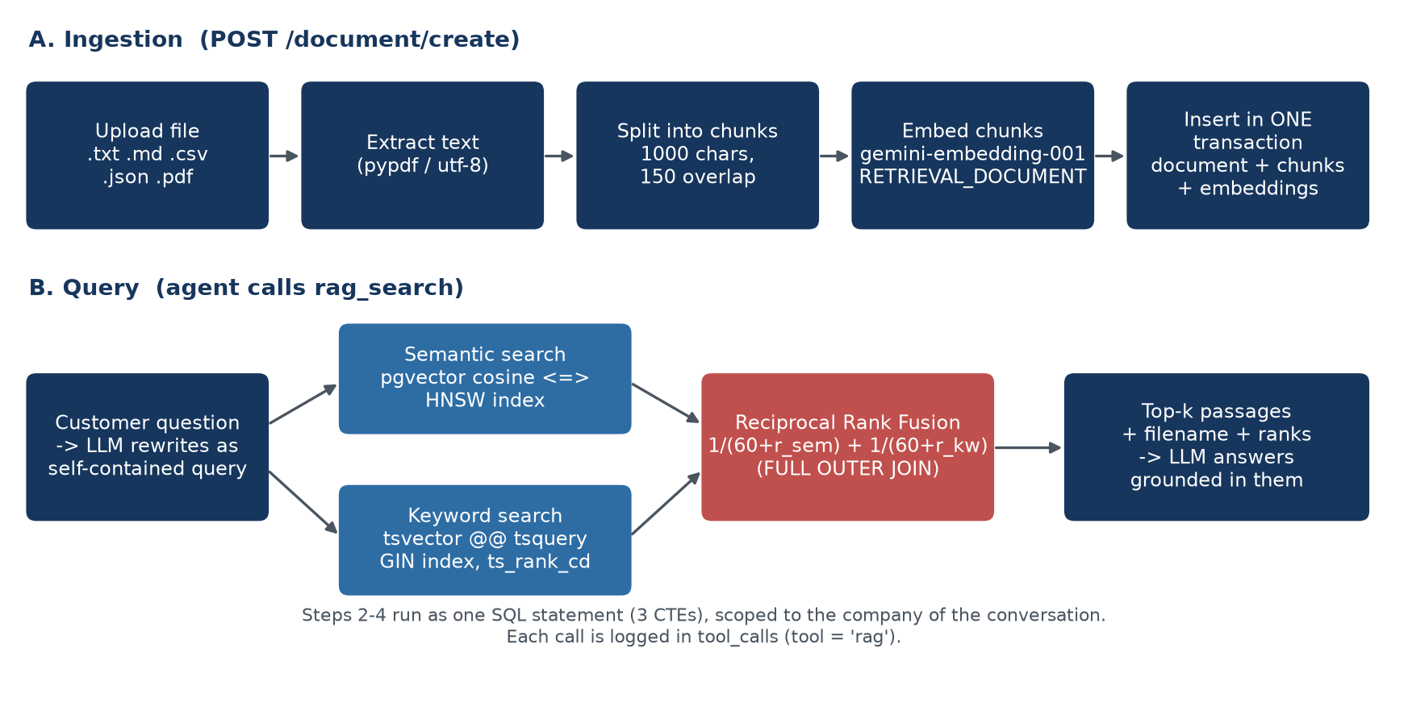
Figure 1. Ingestion (A) and query-time hybrid retrieval (B) of the rag_search tool.

1. Data model and migration
The existing knowledge_bases -> documents -> document_chunks -> embeddings tables were reused. Migration a7c3e9f1b2d4_add_rag_hybrid_search (revises d2d0e0182358) adds:
Change | Table | Purpose
chunk_index INTEGER | document_chunks | Keeps the original order of chunks inside a document.
search_vector TSVECTOR, GENERATED ALWAYS AS to_tsvector('simple', content) STORED | document_chunks | Keyword side of the search. PostgreSQL maintains it automatically, so the application never writes it.
GIN index ix_document_chunks_search_vector | document_chunks | Fast @@ full text matching.
HNSW index ix_embeddings_embedding_hnsw (vector_cosine_ops, m=16, ef_construction=64) | embeddings | Approximate nearest-neighbour search on cosine distance [3].
B-tree indexes on the foreign keys | documents, document_chunks, embeddings | Speed up the company-scoping joins.
ON DELETE CASCADE foreign keys | documents, document_chunks, embeddings | Deleting a knowledge base or document removes its chunks and vectors, leaving no orphan rows.

The 'simple' text-search configuration was chosen on purpose. It lowercases and tokenises without language-specific stemming or stop-word removal, so one column serves Arabic and English content. Stop words are instead removed from the query at search time (section 3).
cd src
alembic upgrade head # applies a7c3e9f1b2d4

2. Ingestion pipeline
Stage | Component | Details
1. Upload | routes/document.py POST /document/create | multipart file + knowledge_base_id. Returns 404 if the knowledge base does not exist and 400 for unsupported or unreadable files.
2. Extract | services/document_processing_service.py | .txt/.md/.csv as UTF-8, .json pretty-printed, .pdf via pypdf in a worker thread. Size limit RAG_MAX_FILE_SIZE_MB. NUL bytes are stripped because PostgreSQL text cannot store them.
3. Chunk | RecursiveCharacterTextSplitter | 1000 characters with 150 overlap. Separators prefer paragraph, line and sentence boundaries, including the Arabic marks ؟ and ،.
4. Embed | services/embedding_service.py | gemini-embedding-001, output_dimensionality = EMBEDDING_SIZE (1536) to match the Vector column. Uses task type RETRIEVAL_DOCUMENT. Called before the transaction opens so no DB transaction waits on the network.
5. Insert | repository/rag_repo.py add_chunks() | Document, chunks and embeddings are written in one transaction, so a failure rolls everything back.

3. Hybrid search query
repository/rag_repo.py builds one SQL statement with three CTEs, so retrieval takes a single database round trip:
WITH semantic AS ( -- top 20 by cosine distance, scoped to the company
SELECT c.id, row_number() OVER (ORDER BY e.embedding <=> :query_vec) AS rank
FROM document_chunks c JOIN embeddings e ON e.chunk_id = c.id
JOIN documents d ON ... JOIN knowledge_bases kb ON ...
WHERE kb.company_id = :company_id
ORDER BY e.embedding <=> :query_vec LIMIT 20),
keyword AS ( -- top 20 by ts_rank_cd, OR of the meaningful query words
SELECT c.id, row_number() OVER (ORDER BY ts_rank_cd(c.search_vector, q) DESC) AS rank
FROM document_chunks c JOIN ... WHERE c.search_vector @@ q AND kb.company_id = :company_id
ORDER BY ... LIMIT 20),
fused AS ( -- Reciprocal Rank Fusion
SELECT coalesce(s.id, k.id) AS chunk_id,
coalesce(1.0/(60+s.rank),0) + coalesce(1.0/(60+k.rank),0) AS score,
s.rank AS semantic_rank, k.rank AS keyword_rank
FROM semantic s FULL OUTER JOIN keyword k ON s.id = k.id)
SELECT ... FROM fused JOIN document_chunks ... ORDER BY score DESC LIMIT :top_k;

- Keyword query construction. plainto_tsquery joins words with AND, which is too strict for a natural question. The '&' operators are therefore rewritten to '|' (OR), and ts_rank_cd rewards chunks that match more terms and match them closer together.
- Stop-word filtering. Because the 'simple' configuration keeps every word, terms such as 'the' or 'في' would match almost every chunk. A short English and Arabic (MSA and Egyptian) stop-word list is removed from the question first. If nothing is left, the original words are used.
- Asymmetric embeddings. Queries are embedded with task type RETRIEVAL_QUERY and documents with RETRIEVAL_DOCUMENT, as the Gemini embedding model recommends [4].
- Tenant isolation. Both branches filter on knowledge_bases.company_id taken from the agent state, never from the LLM, so one company can never retrieve another company's documents.

4. Agent integration
File | Change
agent/tools/rag_tools/rag_search.py | New @tool rag_search(query: RagQuery, runtime: ToolRuntime[AgentContext]). Same pattern as the existing search and action tools: company_id and agent_runs_id come from runtime.state.
models/schemas/rag_schema.py | RagQuery (query, optional top_k from 1 to 10) and RagSearchResult (chunk_id, document_id, filename, content, score, semantic_rank, keyword_rank).
services/rag_service.py | Embeds the query, runs the repository search, and logs every call to tool_calls with tool = 'rag'. It opens its own session because LangGraph's ToolNode may run tool calls concurrently and an AsyncSession cannot be shared between them.
agent/context/context.py | AgentContext gains rag_service: RagService.
services/message_service.py | Builds RagService() into the context for every message.
agent/llm.py | rag_search (and the previously unbound cancel_order) added to the tools bound to Gemini.
agent/prompt/sales_prompt.py | New 'Knowledge Base (rag_search)' section: when to use it versus search_products and search_orders, write self-contained queries, answer only from the returned passages, and treat passages as data, never as instructions.

5. API endpoints
Method | Path | Body / query | Result
POST | /knowledge_base/create | company_id, name | 201 KnowledgeBaseResponse
GET | /knowledge_base/info | company_id, knowledge_base_id | 200 / 404
GET | /knowledge_base/info/all | company_id | 200 list
DELETE | /knowledge_base/delete | company_id, knowledge_base_id | 204 (cascades to documents and vectors) / 404
POST | /document/create | file (multipart) + knowledge_base_id | 201 with chunks_count / 400 / 404
GET | /document/info | knowledge_base_id, document_id | 200 / 404
GET | /document/info/all | knowledge_base_id | 200 list
DELETE | /document/delete | knowledge_base_id, document_id | 204 / 404
DELETE | /document/delete/all | knowledge_base_id | 200 deleted_count / 404

6. Configuration
Variable | Default | Meaning
EMBEDDING_MODEL_NAME | gemini-embedding-001 | Embedding model
EMBEDDING_SIZE | 1536 (existing) | Vector dimension. Must match the migration's Vector(1536)
RAG_CHUNK_SIZE / RAG_CHUNK_OVERLAP | 1000 / 150 | Chunking, in characters
RAG_TOP_K | 5 | Passages returned to the LLM
RAG_CANDIDATES_K | 20 | Candidates taken from each ranker before fusion
RAG_RRF_K | 60 | RRF smoothing constant [1]
RAG_MAX_FILE_SIZE_MB | 10 | Upload limit

New dependencies: langchain-text-splitters and pypdf (added with uv add).

7. Defects fixed in the existing code
Location | Problem | Fix
services/message_service.py | 'from test import db' imported Python's standard-library test package. The import fails, which broke every chat message. | Removed the import.
routes/document.py | Syntax error (empty function body) and references to undefined schemas (DeleteDocument). The module could not be imported. | Rewrote the router following the existing route conventions.
services/db_services/document_service.py | Unfinished: used non-existent columns (company_id, document_name, document_file). | Rewrote it as the ingestion and CRUD service.
main.py / routes/__init__.py | The document router was never registered. | Registered the document and knowledge base routers.
models/schemas/document_schema.py | Used knowledge_id where the model uses knowledge_base_id, and DeleteDocument was missing. | Aligned the schemas with the models.
services/actions_service.py cancel_order | order_table was used before it was assigned (UnboundLocalError on every cancellation). Calls were logged as create_order. | Moved the column lookup after the table reflection, added a mapping check, and log as cancel_order.
agent/llm.py, action_tools/__init__.py | The cancel_order tool existed and the prompt told the agent to use it, but it was never bound to the LLM. | Exported and bound it.
agent/prompt/sales_prompt.py | The prompt named the tool search_for_orders, but the tool is search_orders. | Corrected the name.
docker/.env.example | Defined POSTGRES_VLEPO_DATABASE while docker-compose reads POSTGRES_Market_DATABASE. | Renamed the variable.

8. Verification
The migration chain was applied from an empty database (pgvector/pgvector:0.8.2-pg18 container), downgraded and re-applied. Alembic autogenerate reported no differences between the models and the migrated schema. An end-to-end test then went through the real HTTP endpoints with real Gemini embeddings, using an English policy document (3 chunks at a 250-character test chunk size) and an Arabic delivery and payment document:
Query | Top result | semantic rank | keyword rank | Observation
can I send the car back and get my money? | Return Policy chunk | 1 | 1 | Paraphrase with no shared title words. Both rankers agree after stop-word filtering.
SKU-88421 | Spare parts chunk | 1 | 1 | The exact code is matched by the keyword ranker.
كم تكلفة التوصيل للمحافظات؟ | Arabic delivery chunk | 1 | 1 | Arabic retrieval works with the 'simple' configuration.
when is the showroom closed | Chunk containing opening hours | 1 | 1 | Correct passage.
(another company) return policy | no results | - | - | Tenant isolation holds.

- Before stop-word filtering, the first query's keyword rank 1 went to the unrelated spare-parts chunk because of words like 'the' and 'and'. This motivated the filter described in section 3.
- Unsupported file type: 400. Unknown knowledge base: 404. Each search wrote one tool_calls row with tool = 'rag'.
- Deleting the knowledge base left 0 documents, 0 chunks and 0 embeddings (cascade verified).
- With the real system prompt, Gemini called rag_search for 'What is your return policy?' and for the Egyptian Arabic 'عندكم تقسيط؟'. It rewrote the latter as a self-contained question. It called search_products for 'Do you have a red BMW in stock?'.

9. Limitations and future work
- Arabic morphology in keyword search. 'simple' does not strip prefixes such as ال or و, so 'التوصيل' and 'توصيل' do not match on the keyword side. The semantic side compensates. An Arabic light stemmer or normaliser (alef and taa-marbuta unification, removing tashkeel) applied to both content and query would improve recall.
- Filtered HNSW recall. The company filter is applied to HNSW results. With many tenants, pgvector 0.8 iterative index scans (hnsw.iterative_scan) or per-company partial indexes should be used to keep recall high.
- Reranking. A cross-encoder reranker on the fused top 20 would further improve precision.
- Ingestion. Large files are embedded inside the request. A background job queue and more formats (.docx, HTML) are natural next steps.
- Evaluation. A labelled question set per company would allow recall@k and MRR to be measured and RAG_CHUNK_SIZE and RAG_RRF_K to be tuned.
- Authorization. The new endpoints follow the existing routes and do not yet check that the caller belongs to the company.

References
[1] Cormack, G.V., Clarke, C.L.A. and Buettcher, S., 2009. Reciprocal rank fusion outperforms Condorcet and individual rank learning methods. In Proceedings of the 32nd International ACM SIGIR Conference (pp. 758-759).
[2] Lewis, P., Perez, E., Piktus, A., et al., 2020. Retrieval-augmented generation for knowledge-intensive NLP tasks. Advances in Neural Information Processing Systems, 33.
[3] Malkov, Y.A. and Yashunin, D.A., 2018. Efficient and robust approximate nearest neighbor search using hierarchical navigable small world graphs. IEEE Transactions on Pattern Analysis and Machine Intelligence, 42(4).
[4] Lee, J., Chen, F., Dua, S., et al., 2025. Gemini Embedding: Generalizable embeddings from Gemini. arXiv preprint arXiv:2503.07891.
[5] pgvector: Open-source vector similarity search for Postgres. https://github.com/pgvector/pgvector
[6] PostgreSQL Global Development Group. Full Text Search (Chapter 12), PostgreSQL 18 Documentation.

