Whisper Tiny Fine-Tuning with LoRA
Technical Implementation Guide for Egyptian Arabic Automatic Speech Recognition
Dataset: google/fleurs | Language configuration: ar_eg | Base model: openai/whisper-tiny

Goal and training boundary
Hugging Face Whisper Tiny is fine-tuned for Arabic speech transcription through Low-Rank Adaptation (LoRA). The workflow comprises environment configuration, FLEURS dataset loading, preprocessing, model adaptation, training, artifact saving, baseline comparison, evaluation, inference, and optional API/Docker deployment.
The optimization loop begins when trainer.train() is called in train.py and ends when that call returns. The adapter and processor are saved after training has completed. Model evaluation is performed separately.
Stage | Process | Output
1. Load data | The official training, validation, and test splits for google/fleurs / ar_eg are loaded. | DatasetDict
2. Prepare | Audio features are extracted at 16 kHz, and Arabic transcript token IDs are generated. | input_features + labels
3. Adapt | openai/whisper-tiny is loaded and LoRA is attached; the base-model weights remain frozen. | Trainable adapter
4. Train | LoRA parameters are updated by Seq2SeqTrainer; validation loss is evaluated and checkpoints are recorded. | Checkpoints
5. Save | The adapter and processor are saved. | outputs/whisper-tiny-fleurs-ar-eg/
6. Evaluate | The base and fine-tuned Whisper Tiny models are compared on the same held-out test split. | WER/CER report
7. Use | New audio can be transcribed; optional access can be provided through FastAPI/Docker. | CLI or API

Pipeline flowchart
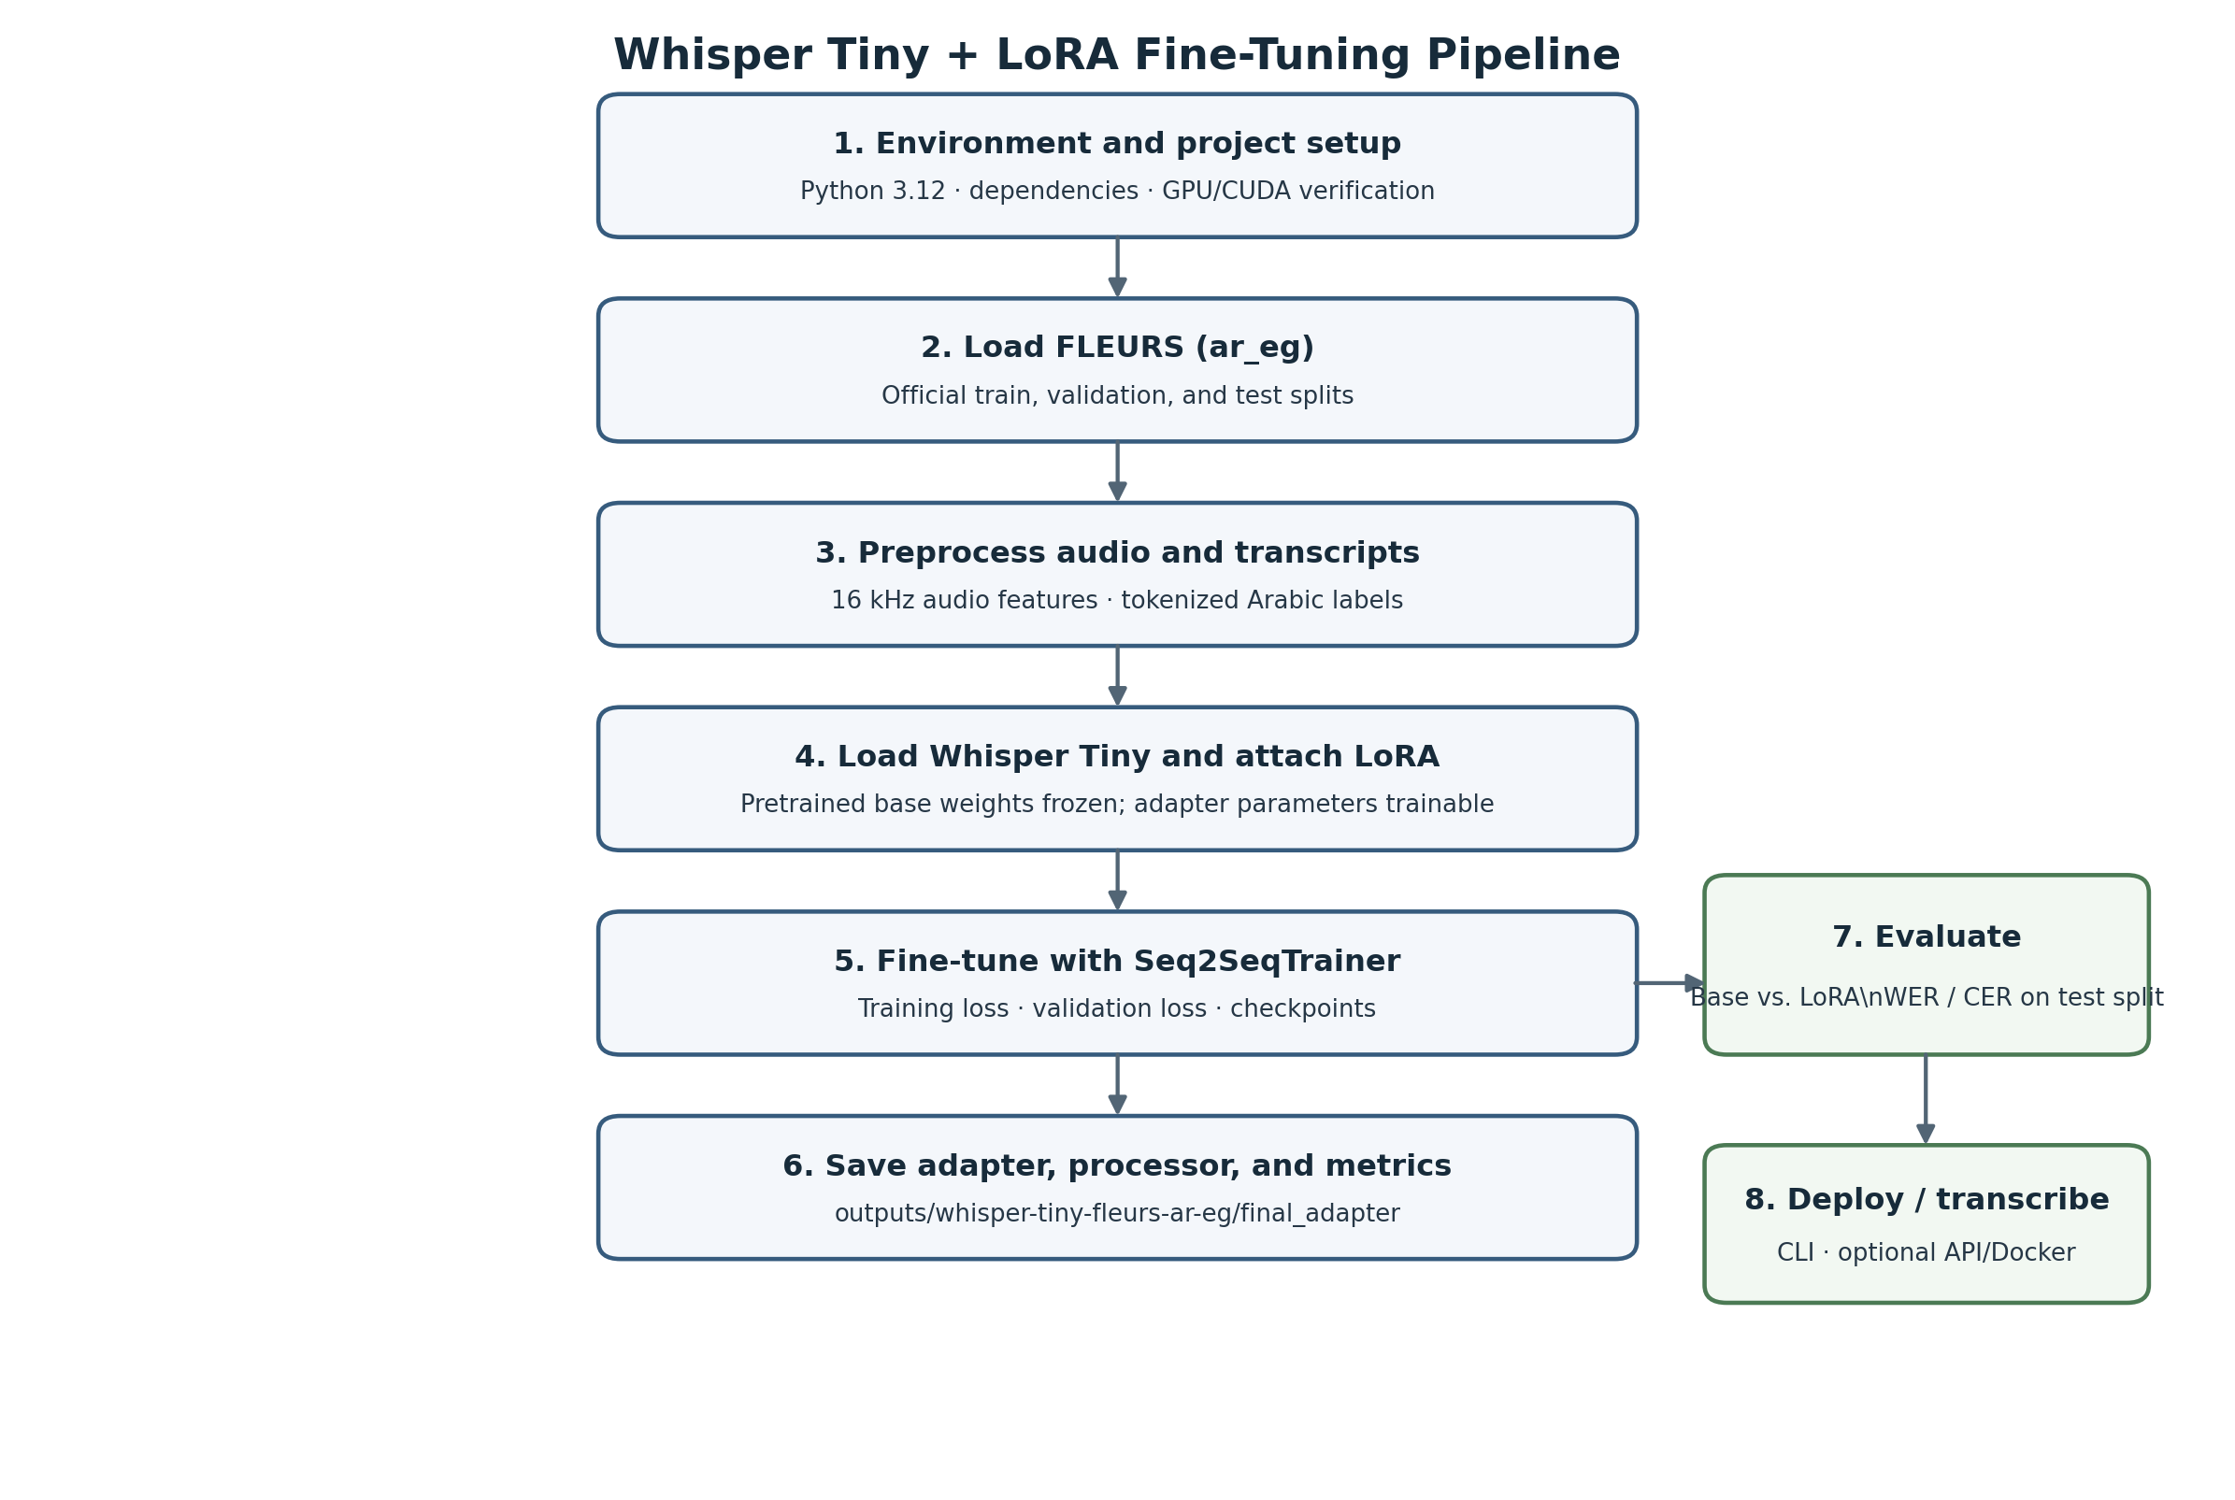
Figure 1. End-to-end workflow for Whisper Tiny fine-tuning with LoRA.

1. Create the project and environment
mkdir whisper-tiny-fleurs
cd whisper-tiny-fleurs
uv init
uv python pin 3.12
uv add torch transformers datasets peft accelerate jiwer soundfile
uv add fastapi "uvicorn[standard]" python-multipart
mkdir -p src scripts outputs
git init
FFmpeg may be installed for audio inspection or decoding when required (for example, with sudo apt install ffmpeg). A system-wide CUDA Toolkit is generally not required when PyTorch wheels are used; however, a compatible NVIDIA driver is required.
nvidia-smi
uv run python -c "import torch; print(torch.__version__); print('CUDA:', torch.cuda.is_available()); print(torch.cuda.get_device_name(0) if torch.cuda.is_available() else 'CPU')"
A full training run should not be started until CUDA availability has been confirmed as True. If CUDA is unavailable, a CUDA-enabled PyTorch build should be installed using the current PyTorch installation selector, and the availability check should then be repeated. The uv.lock file should be committed so that the environment can be reproduced.

2. Project layout
whisper-tiny-fleurs/
├── pyproject.toml
├── uv.lock
├── scripts/
│ ├── train.py
│ ├── evaluate.py
│ └── transcribe.py
└── outputs/
└── whisper-tiny-fleurs-ar-eg/
The FLEURS dataset is downloaded through Hugging Face Datasets. The official training, validation, and test splits must be retained; the test split must not be randomly reassigned to the training data.

3. Training script: scripts/train.py
The training script uses the FLEURS transcription field, the Whisper feature extractor and tokenizer, LoRA applied to attention projections, and Seq2SeqTrainer. Batch sizes and epoch settings have been kept conservative for a GPU with 8 GB of VRAM.
from dataclasses import dataclass
from pathlib import Path

import torch
from datasets import load_dataset
from peft import LoraConfig, TaskType, get_peft_model
from transformers import (
WhisperForConditionalGeneration,
WhisperProcessor,
Seq2SeqTrainer,
Seq2SeqTrainingArguments,
set_seed,
)

MODEL_ID = "openai/whisper-tiny"
DATASET_ID = "google/fleurs"
LANGUAGE_CONFIG = "ar_eg"
OUT = "outputs/whisper-tiny-fleurs-ar-eg"
SEED = 42

@dataclass
class WhisperCollator:
processor: WhisperProcessor

def __call__(self, features):
audio_features = [
{"input_features": item["input_features"]} for item in features
]
batch = self.processor.feature_extractor.pad(
audio_features, return_tensors="pt"
)

label_features = [{"input_ids": item["labels"]} for item in features]
labels_batch = self.processor.tokenizer.pad(
label_features, return_tensors="pt"
)
labels = labels_batch["input_ids"].masked_fill(
labels_batch["attention_mask"].ne(1), -100
)

# The decoder adds its start token itself.
if (labels[:, 0] == self.processor.tokenizer.bos_token_id).all().item():
labels = labels[:, 1:]

batch["labels"] = labels
return batch

def main():
set_seed(SEED)
processor = WhisperProcessor.from_pretrained(
MODEL_ID, language="Arabic", task="transcribe"
)
model = WhisperForConditionalGeneration.from_pretrained(MODEL_ID)
model.generation_config.forced_decoder_ids = None
model.config.use_cache = False
model.gradient_checkpointing_enable()

lora = LoraConfig(
task_type=TaskType.SEQ_2_SEQ_LM,
r=8,
lora_alpha=16,
lora_dropout=0.05,
target_modules=["q_proj", "v_proj"],
bias="none",
)
model = get_peft_model(model, lora)
model.print_trainable_parameters()

dataset = load_dataset(DATASET_ID, LANGUAGE_CONFIG)

def prepare(example):
audio = example["audio"] # FLEURS audio is delivered at 16 kHz.
features = processor.feature_extractor(
audio["array"], sampling_rate=audio["sampling_rate"]
).input_features[0]
labels = processor.tokenizer(example["transcription"]).input_ids
return {"input_features": features, "labels": labels}

processed = {}
for split in ("train", "validation"):
processed[split] = dataset[split].map(
prepare,
remove_columns=dataset[split].column_names,
desc=f"Preparing {split}",
)

args = Seq2SeqTrainingArguments(
output_dir=OUT,
num_train_epochs=3,
learning_rate=1e-4,
warmup_ratio=0.1,
per_device_train_batch_size=4,
per_device_eval_batch_size=2,
gradient_accumulation_steps=4,
gradient_checkpointing=True,
fp16=torch.cuda.is_available(),
eval_strategy="epoch",
save_strategy="epoch",
logging_steps=10,
save_total_limit=2,
load_best_model_at_end=True,
metric_for_best_model="eval_loss",
greater_is_better=False,
predict_with_generate=False,
dataloader_num_workers=2,
report_to="none",
seed=SEED,
data_seed=SEED,
)

trainer = Seq2SeqTrainer(
model=model,
args=args,
train_dataset=processed["train"],
eval_dataset=processed["validation"],
data_collator=WhisperCollator(processor),
processing_class=processor,
)

# TRAINING LOOP STARTS HERE.
result = trainer.train()
# TRAINING LOOP ENDS when trainer.train() returns.

trainer.save_model(f"{OUT}/final_adapter")
processor.save_pretrained(f"{OUT}/final_adapter")
trainer.save_state()
trainer.log_metrics("train", result.metrics)
trainer.save_metrics("train", result.metrics)
print(f"Saved adapter and processor to {OUT}/final_adapter")

if __name__ == "__main__":
main()
A short smoke test should be completed before full training. This can be performed by temporarily setting num_train_epochs=1 and limiting the training set, or by using the optional max_steps=50 setting in Seq2SeqTrainingArguments. Once successful completion and artifact saving have been verified, the full training run may be started.
uv run python scripts/train.py
If GPU memory is exhausted, per_device_train_batch_size should be reduced to 2, gradient checkpointing should remain enabled, and gradient_accumulation_steps should be increased to 8. If the Trainer API reports that processing_class or eval_strategy is unknown, the installed Transformers version should be checked and the argument names supported by that version should be used.

4. What the training loop actually does
- A batch of audio features and tokenized transcript labels is assembled by WhisperCollator.
- Transcript tokens are predicted by Whisper, and the resulting loss is computed against the reference labels.
- Only the LoRA adapter parameters are updated through backpropagation; the pretrained base-model weights remain frozen.
- The training split is processed repeatedly, validation loss is evaluated, and checkpoints are written by the trainer.
- After trainer.train() returns, the final adapter, processor, and training metrics are saved by the script.
WER and CER are not calculated by the training script. The separate evaluation script must be run after training.

5. Evaluate baseline and fine-tuned model: scripts/evaluate.py
The original Whisper Tiny model and the LoRA-adapted model are evaluated on the same FLEURS test split. Arabic text is normalized consistently for both reference transcripts and predictions. The normalization procedure must remain fixed when experiments are compared.
import re
import string
import torch
from datasets import load_dataset
from jiwer import wer, cer
from peft import PeftModel
from transformers import WhisperForConditionalGeneration, WhisperProcessor

MODEL_ID = "openai/whisper-tiny"
ADAPTER = "outputs/whisper-tiny-fleurs-ar-eg/final_adapter"
DEVICE = "cuda" if torch.cuda.is_available() else "cpu"

def normalize_arabic(text):
text = re.sub(r"[\u064B-\u065F\u0670\u0640]", "", text) # diacritics/tatweel
text = re.sub(r"[إأآٱ]", "ا", text)
text = re.sub(r"[ىي]", "ي", text)
text = re.sub(r"[^\w\s]", " ", text, flags=re.UNICODE)
return " ".join(text.split())

def evaluate_model(model, processor, test_data, name):
refs, hyps = [], []
model.eval()
for example in test_data:
audio = example["audio"]
inputs = processor.feature_extractor(
audio["array"], sampling_rate=audio["sampling_rate"],
return_tensors="pt"
)
input_features = inputs.input_features.to(DEVICE)
with torch.no_grad():
generated = model.generate(
input_features,
language="arabic",
task="transcribe",
max_new_tokens=225,
)
prediction = processor.batch_decode(generated, skip_special_tokens=True)[0]
refs.append(normalize_arabic(example["transcription"]))
hyps.append(normalize_arabic(prediction))

print(f"\n{name}")
print(f"WER: {wer(refs, hyps):.4f}")
print(f"CER: {cer(refs, hyps):.4f}")
return refs, hyps

def main():
processor = WhisperProcessor.from_pretrained(
MODEL_ID, language="Arabic", task="transcribe"
)
dataset = load_dataset("google/fleurs", "ar_eg", split="test")

base = WhisperForConditionalGeneration.from_pretrained(MODEL_ID).to(DEVICE)
base.generation_config.forced_decoder_ids = None
evaluate_model(base, processor, dataset, "BASE WHISPER TINY")
del base
if torch.cuda.is_available():
torch.cuda.empty_cache()

base = WhisperForConditionalGeneration.from_pretrained(MODEL_ID).to(DEVICE)
tuned = PeftModel.from_pretrained(base, ADAPTER).to(DEVICE)
tuned.generation_config.forced_decoder_ids = None
evaluate_model(tuned, processor, dataset, "WHISPER TINY + LoRA")

if __name__ == "__main__":
main()
uv run python scripts/evaluate.py
Lower WER and CER values indicate better performance. Both metrics should be reported for the baseline and fine-tuned models. Decisions must not be tuned against the test split; validation results should be used for model-selection decisions, while test results should be reserved for final reporting.

6. Transcribe a new audio file: scripts/transcribe.py
import argparse
import torch
from peft import PeftModel
from transformers import WhisperForConditionalGeneration, WhisperProcessor

MODEL_ID = "openai/whisper-tiny"
ADAPTER = "outputs/whisper-tiny-fleurs-ar-eg/final_adapter"

def main():
parser = argparse.ArgumentParser()
parser.add_argument("audio", help="Path to an audio file")
args = parser.parse_args()

import soundfile as sf
import librosa

audio, sr = sf.read(args.audio)
if audio.ndim == 2:
audio = audio.mean(axis=1)
if sr != 16000:
audio = librosa.resample(audio, orig_sr=sr, target_sr=16000)

device = "cuda" if torch.cuda.is_available() else "cpu"
processor = WhisperProcessor.from_pretrained(ADAPTER)
base = WhisperForConditionalGeneration.from_pretrained(MODEL_ID).to(device)
model = PeftModel.from_pretrained(base, ADAPTER).to(device)
model.eval()
features = processor.feature_extractor(
audio, sampling_rate=16000, return_tensors="pt"
).input_features.to(device)

with torch.no_grad():
tokens = model.generate(
features, language="arabic", task="transcribe", max_new_tokens=225
)
print(processor.batch_decode(tokens, skip_special_tokens=True)[0])

if __name__ == "__main__":
main()
uv run python scripts/transcribe.py path/to/audio.wav
This example is intended for short audio clips within Whisper's 30-second input window. Longer recordings should be divided into chunks before transcription.

7. Optional API and Docker deployment
API/Docker deployment should be undertaken only after training and evaluation have been completed. The base model and adapter should be loaded once during API startup, and the same transcription function should be reused. Upload duration and file size should be limited, and audio or transcript content should not be logged.

Minimal FastAPI outline
# src/api.py
from fastapi import FastAPI, UploadFile, File, HTTPException
app = FastAPI(title="Whisper Tiny Arabic ASR")

@app.get("/health")
def health():
return {"status": "ok"}

# Add POST /transcribe by reusing the loading and transcription logic
# from scripts/transcribe.py. Load the model once at startup, not per request.
For Docker deployment, a PyTorch/CUDA-compatible runtime should be used, the locked dependencies should be installed, and a persistent Hugging Face cache should be mounted. NVIDIA Container Toolkit should be configured on the host. GPU access within the container should be verified with nvidia-smi before traffic is served.

8. Troubleshooting checklist
Symptom | First action
CUDA is False | The PyTorch/CUDA installation and driver should be corrected before training.
CUDA out of memory | The batch size should be set to 2, gradient accumulation to 8, and gradient checkpointing kept enabled; other GPU processes should be closed.
Loss is NaN | The learning rate should be reduced to 5e-5, and empty/corrupt samples and labels should be inspected.
Bad or English output | The language should be forced to 'arabic' and the task to 'transcribe'; the audio-transcript correspondence should be checked.
WER/CER seems implausible | Several references and predictions should be printed, and the same Arabic normalizer should be confirmed for both.
Adapter cannot load | The adapter should be loaded with the exact base model, openai/whisper-tiny; the presence of adapter_config.json in final_adapter should be verified.
No improvement over baseline | A decrease in training loss should be confirmed, predictions should be inspected, and only one change should be tested at a time.

9. Reproducibility and final checklist
- ☐ Python and package versions should be recorded, and uv.lock should be committed.
- ☐ The official FLEURS training, validation, and test splits should be retained unchanged.
- ☐ The same Arabic normalization procedure should be used for baseline and fine-tuned evaluation.
- ☐ A short smoke test should be completed before the full training run.
- ☐ The adapter, processor, training configuration, logs, and WER/CER results should be saved.
- ☐ Whisper Tiny and Whisper Tiny + LoRA should be compared on the same test examples.
- ☐ A copy of the exact code and configuration used for the reported result should be retained.

Key references
FLEURS dataset card: https://huggingface.co/datasets/google/fleurs
Whisper Tiny model: https://huggingface.co/openai/whisper-tiny
Transformers PEFT/LoRA guide: https://huggingface.co/docs/transformers/main/peft
Transformers Whisper documentation: https://huggingface.co/docs/transformers/model_doc/whisper

