**Antdrive V1.0**

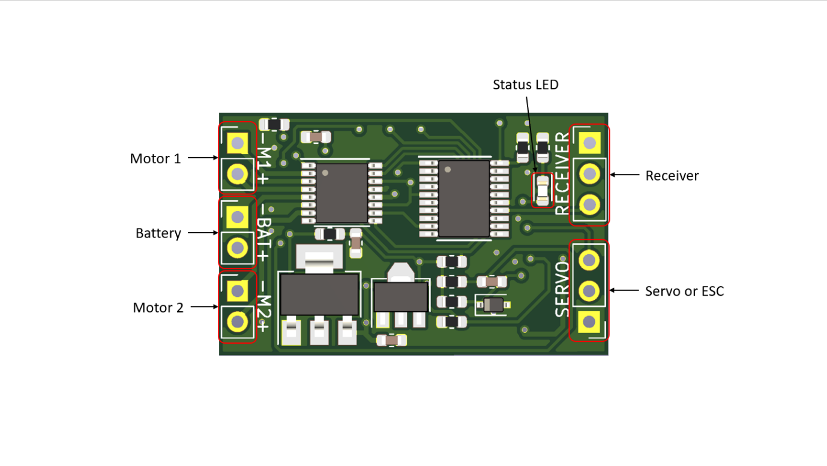

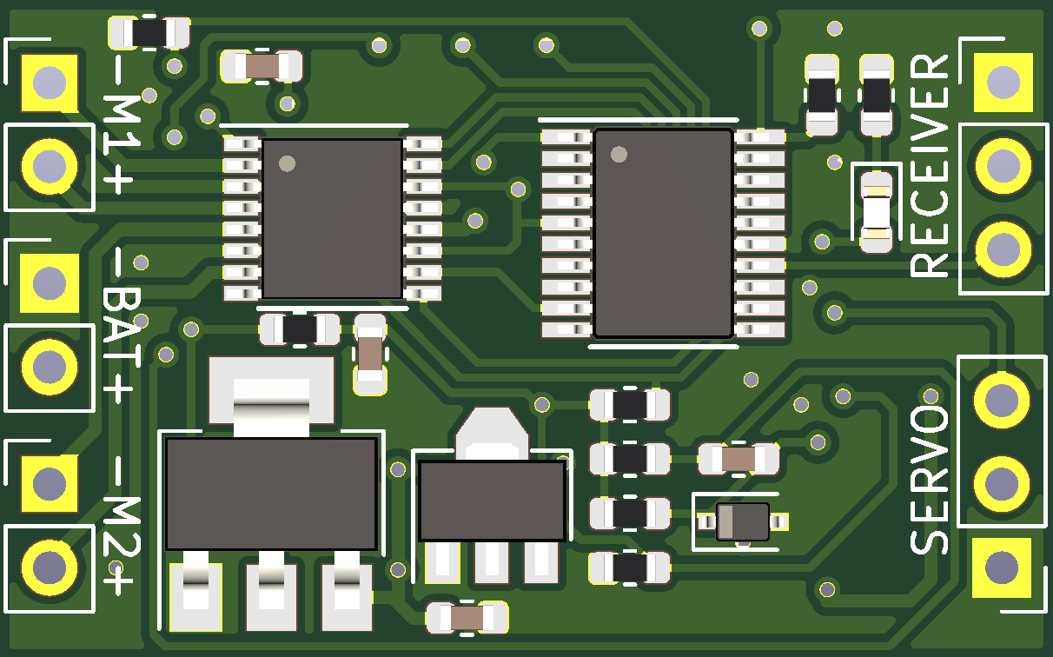

GND

VCC

SIGNAL

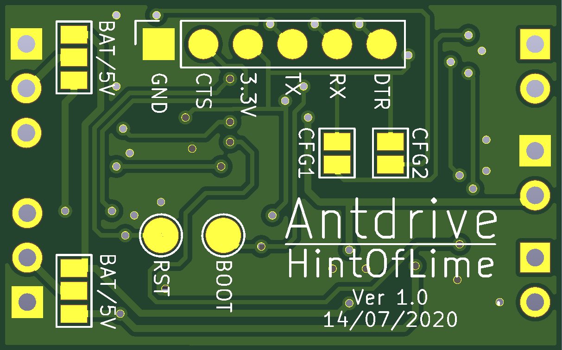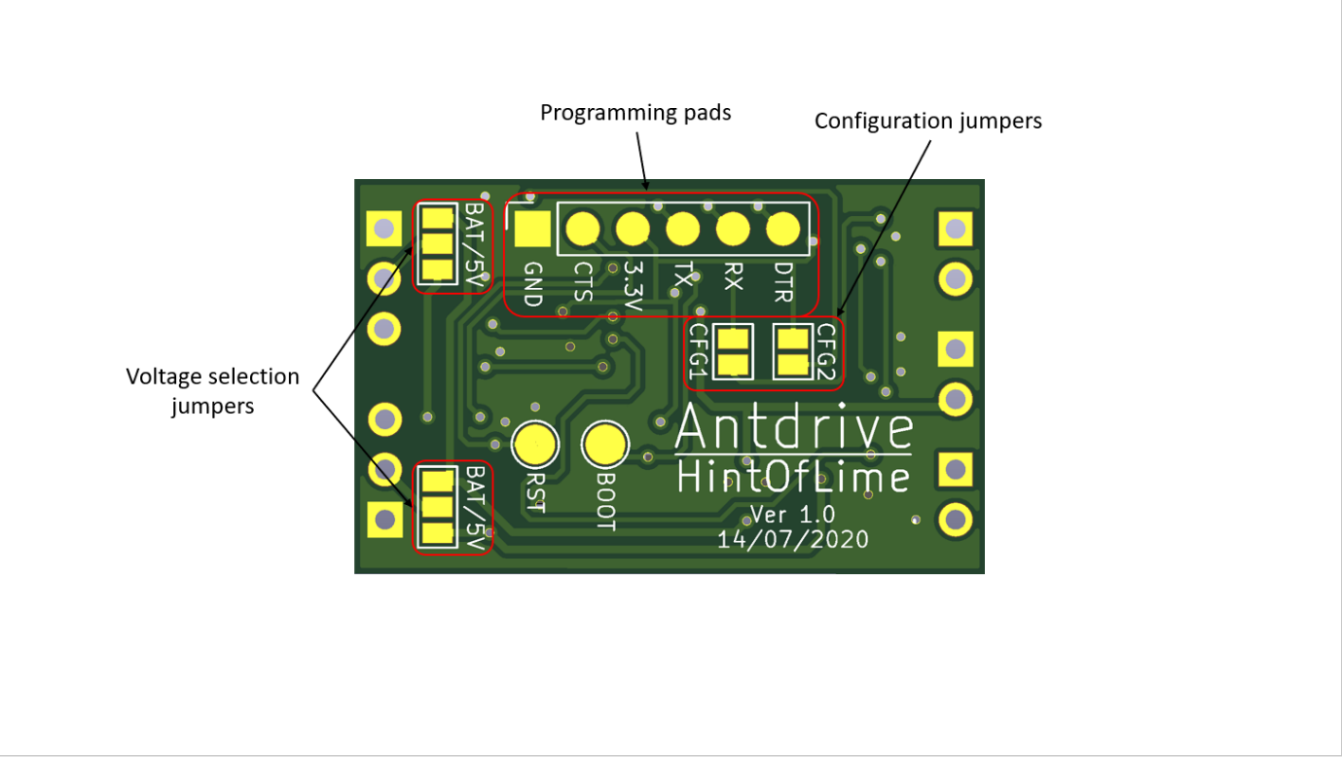

**CFG1** selects the board’s input mode. By default the board will use PPM mode, if jumpered it will use PWM mode.

**CFG2** controls whether to mix the input channels. By default mixing is not enabled, if jumpered the channels will be mixed.

Both receiver and servo ports have **voltage selection jumpers**. These jumpers select whether to output battery voltage or regulated 5V on each port. If in doubt set these to 5V.

In **PPM mode** the board will take the PPM signal from the receiver port and use channels 1 and 2 to control the motors. Channel 3 will be output as PWM on the servo port to control either a servo or an ESC.

In **PWM mode** the board the board will take PWM signals from both the receiver and servo ports to control the motors.

The **Status LED** will blink twice on power up. When receiving a valid control signal the LED will be solid on. If a fault is detected the LED will flash rapidly.

Battery voltage selected

5V selected

Ensure positive and negative battery wires are the correct way around before connecting to the board for the first time, there is **no reverse polarity protection** built in.

**Source files available here:**

<https://github.com/edwardatki/Antdrive>

**Input voltage:** 6.5V to 15V

**Motor current:** 2A per channel

**BEC current:** 1A

**Dimensions:** 32x20x3mm

**Weight:** 1.8g