**Analysis – Sudoku Maker/Solver**

## Introduction

Sudoku is a puzzle game. The game is played on a square grid with 81 small boxes separated by lines divided into 9 rows, 9 columns and into 9 larger boxes (arranged in a 3x3 pattern) that are indicated by a darker line as shown below.

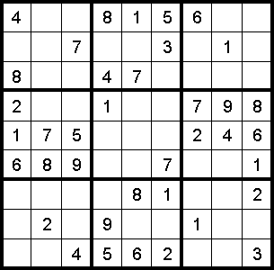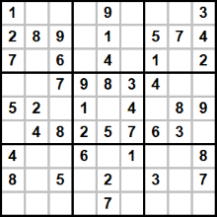

The puzzle is completed by the person filling each row, column and larger boxes with the numbers 1 through 9, without repeating a number in each row, column or box

## Aims

My solution aims to create Sudoku puzzles for the user to solve with a GUI. The program should also be able to solve the problems in a step by step manner to provide hints to the user and to check if the puzzle is solvable. (This is broken down more on the flow chart on page 3(Hyperlink))

My solution will be written in python as it is an easy to code a simple project, it is also very easy to read for me as my IDLE has automatic syntax highlighting and indentation.

## Background

I chose this problem because I have enjoyed Sudoku problems and solving them, and I thought that creating a program to generate them and autonomously solving them would be interesting.

## Objectives

1. To create a program to generate Sudoku problems which are solvable with only one solution
2. To be able to solve Sudoku problems step by step, in order to provide the user tips in an understandable way
3. To be able to tell if a Sudoku problem is solvable with only one solution from user input
4. To catalogue different difficulties of Sudoku problems and be able to tell the difficulty of a Sudoku problem from a user input
5. To create a database of high scores (moves/mistakes/time taken) and allow the users to compare how well they did on different difficulties
6. To create a wireless way to share high scores over internet

## Model