This project is a hybrid phone app that will enable parents to track their children’s location and send help to them if needed using the SafeTrek API. The parents and children will both register for accounts and then the parents will be able to see the location of each of their registered children and if they are moving to a new location. They will be able to see alerts and track specific movement and receive warnings if their children move to certain locations as well as send help based off their child’s location. A general outline for the major features is listed below along with some additional features that may be useful.

**Features:**

1. **Panic Button**- a button that can be used to contact emergency services/ the police on command and be sent to the child’s location
2. First asked the user if they are sure the want to contact emergency services
3. If they confirm they are, the SafeTrek api will notify the police with the user’s information
4. If not, it returns them to the home screen
5. This can be done from either the child’s phone or the parents phone, but both will be notified if services are called
6. This feature can also be used directly from a child’s phone
7. **Medical Button**- a button that can be used to contact medical services on command
8. Functions the same as the panic button, but contacts medical services
9. **User accounts-** a user account that tracks user history and stores information that can be used to help emergency services locate and assist clients
10. Keeps track of information about the user for both account and communication purposes and information to send to emergency services in the event of an emergency
11. Allows parents to add additional children to monitor through accounts
12. **Monitoring information**- tracks a child’s locations and speed and sends the information to the parent
13. Alerts the parents if the children access transportation
14. Gives the parent the child’s current location
15. Supports multiple children on one parent’s account

**Future ideas:**

1. Map feature/ routeplanning – uses the google maps api to track the children’s location and display it on screen as they move
2. Allows the parent to track where there children can go and send alerts when the children go to areas they should not
3. Can see the child’s route and recent places displayed on a map
4. Chat server - allows parents and children to communicate over the app
5. provides a cheap alternative to texting that would not require a mobile phone or the use of sms messaging and would limit the child to only being able to contact specific people
6. UBER/LIFT API- allows the parent to call their child a ride home in the event they would need one
7. Use of Twilio or another messaging-based API to support sms based messages or calls from the app
8. Video calls or access to the other user’s camera

**Project Plan:**

1. Add in server-side accounts
2. Track location, time and, speed of children
3. Store the data in a database
4. Read in values from the database to the parent’s side
5. Integrate SafeTrek API and other functionality
6. Update and stylize the UI
7. Move the web interface to PhoneGap
8. Break test the app
9. Add in any additional features and fix any bugs
10. Present solution

Wire Framed UI (screen sized to a Samsung Galaxy S5):

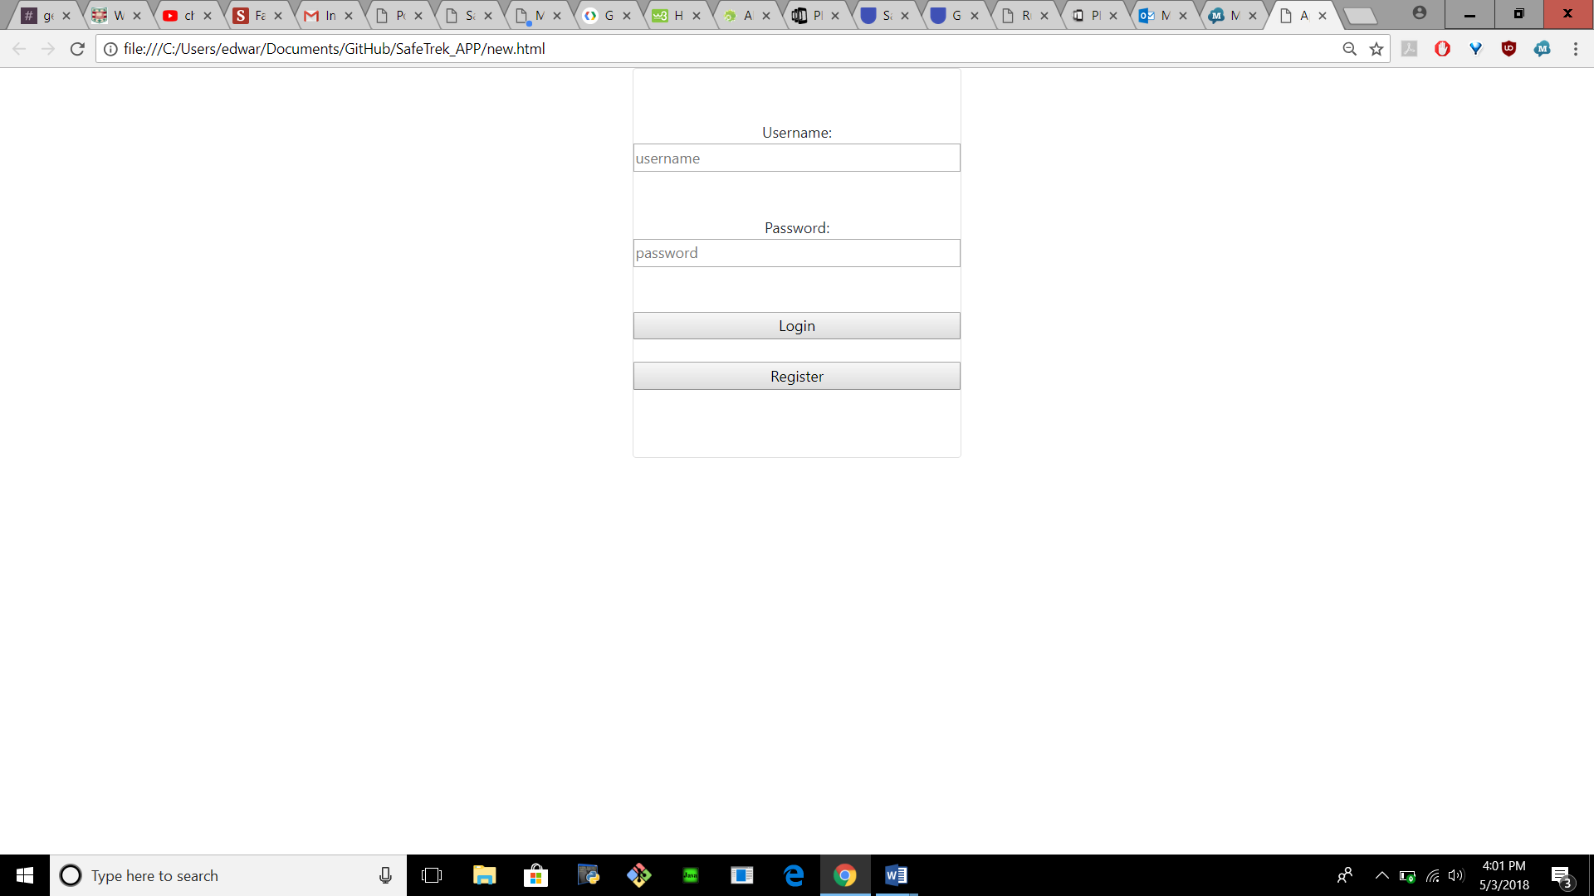

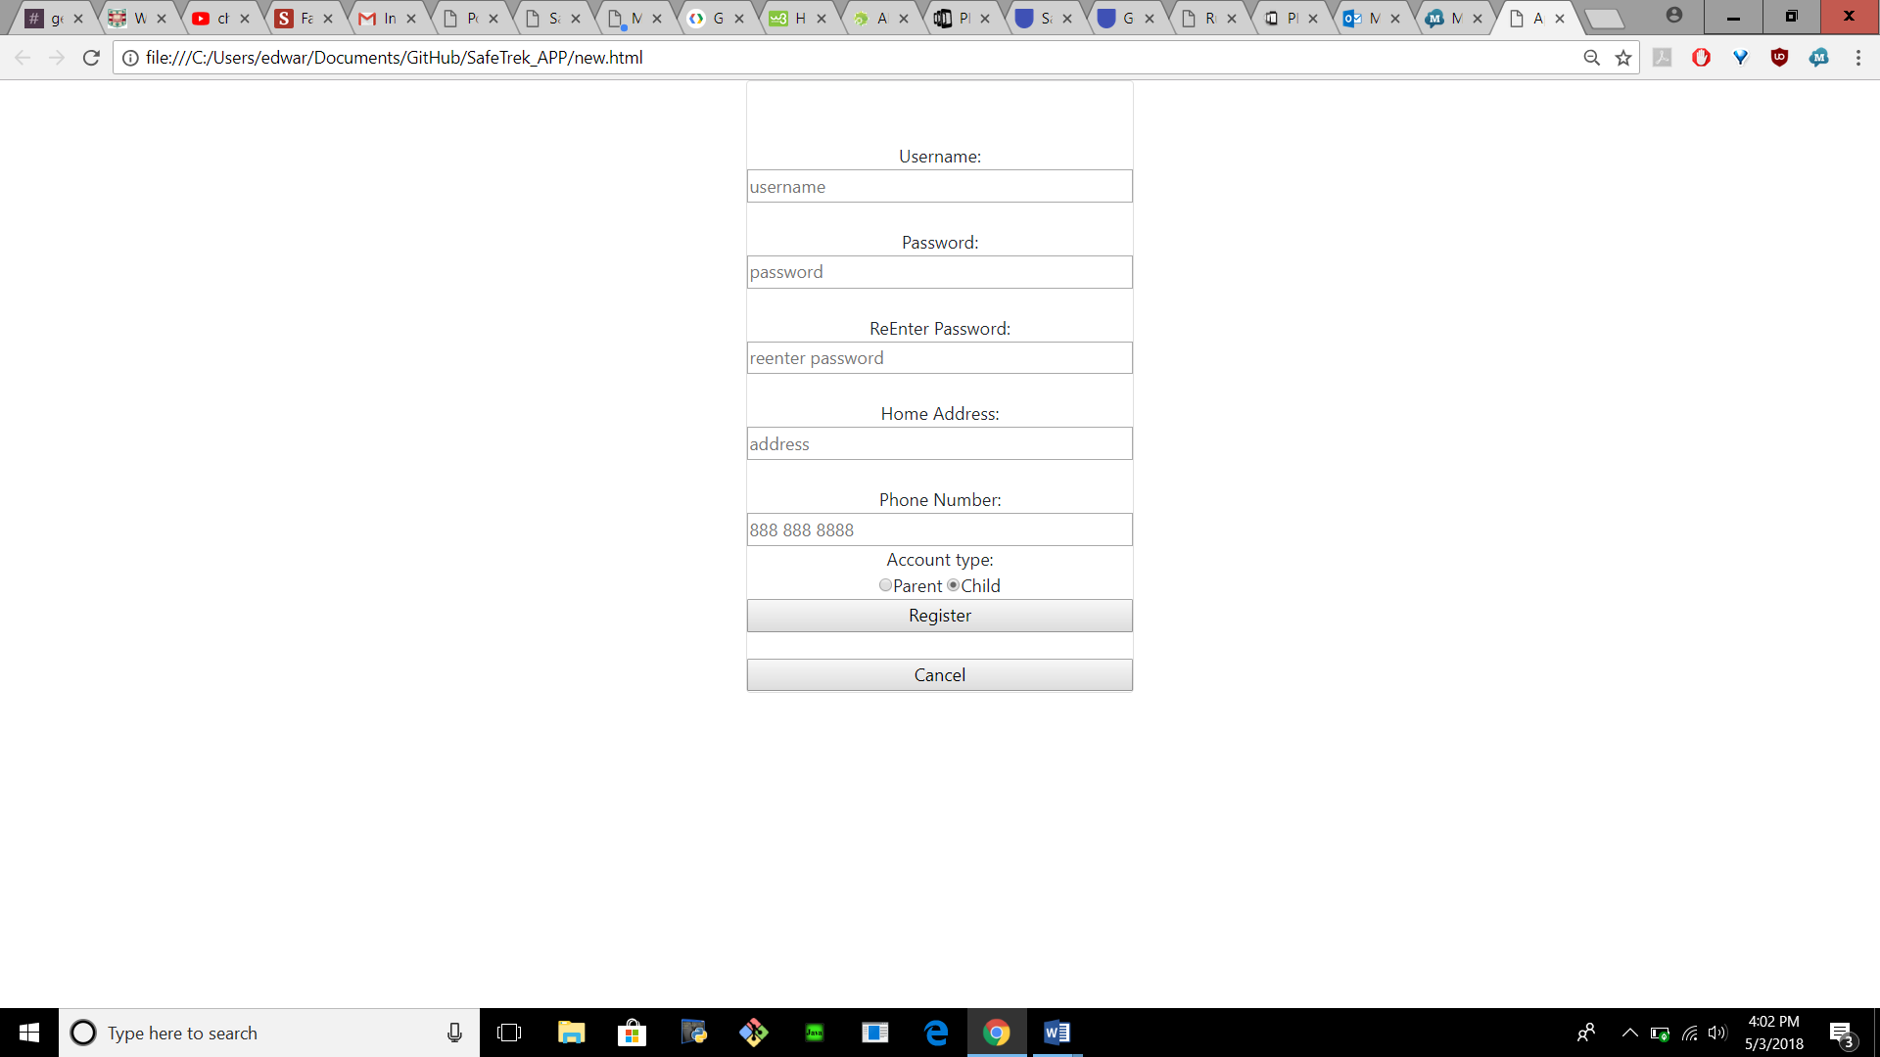

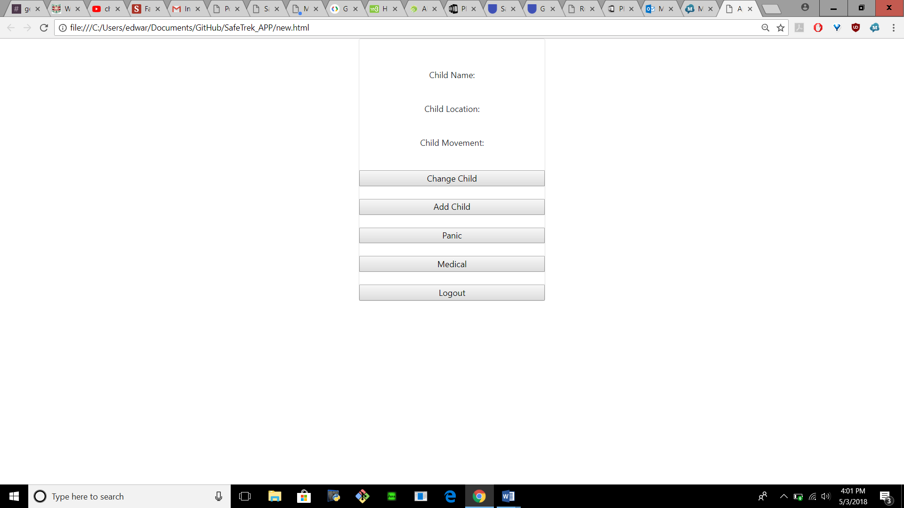

Note: this ui is very basic and will ne stylized further after major features are implemented