Evidence Assessment Report
BSI Configuration Management – 2026 RCSA Testing
Controls: BSI.IT.10.C11 Vendor Defaults · BSI.IT.10.C13 Config Authentication · BSI.IT.10.C19 Server Protection
Evidence assessed: OneDrive_1_11-4-2026.zip (provided 11/04/2026) against Configuration_Management_Protection_Request.zip (items requested)
Report date: 11/04/2026

Contents
- 1. Purpose, scope and method (overall conclusion)
- 2. RCSA policy requirements applied
- 3. BSI.IT.10.C11 Vendor Defaults
- 4. BSI.IT.10.C13 Config Authentication
- 5. BSI.IT.10.C19 Server Protection
- 6. Appendix – file inventory
Each control section contains: scope and testing period · what was requested · what was provided on 11/04/2026 · why the evidence is correct or not correct · what is still needed · conclusion.

1. Purpose, scope and method
This report states, for each of the three controls, whether the evidence the process owner provided on 11/04/2026 is correct (sufficient and appropriate for 2026 RCSA testing) and why, compared with what was requested in the Configuration_Management_Protection_Request package. Each control is reported separately with its scope and testing period, what was requested, what has already been provided, the assessment, and what is still needed.

How the evidence was inspected
- Every file in OneDrive_1_11-4-2026.zip (28 files) was opened and read in full: Word documents including every embedded screenshot, security exports line by line, spreadsheets including hidden sheets and file properties, and PDFs page by page.
- Every file was compared byte-for-byte (MD5) with the 2025 request package, including the nested C13.05 and C13.06 sample zips, and with the 11/03/2026 delivery. Three uploads named OneDrive_1_11-4-2026.zip were received; all three are byte-identical.
- Benchmarks read in full: Windows Server Hardening Guide v4.0 (07/15/2024), RHEL Server Hardening Guide v2.0 (10/16/2024), Authentication & Authorization Standard v12.0 (05/28/2025), Secure Build & Configuration Management Standard v6.0 (05/28/2024), Virus & Malware Protection Standard v5.2 (05/28/2025).
- Policy: Risk and Control Self-Assessment (RCSA) Testing Procedure (CUSO) v1.0, 07.17.2026, and the RCSA CDA Testing Job Aid. Testing periods: Configuration_Management-Coverage-_Period.xlsx.

Overall conclusion
The Control Performance Assessment (CPA) cannot be concluded for any of the three controls. The evidence is insufficient under the RCSA Testing Procedure, mainly because no complete population for the testing period has been provided and no sample has been selected by RCSA. This is a scope limitation, not a control failure: no exception was found in any evidence inspected.
Control | Conclusion | Main reason
BSI.IT.10.C11 Vendor Defaults  07/01/2025 – 06/30/2026 | Cannot conclude | No population of servers placed into production in the period. Every server with a known build date went live before 07/01/2025; all 20 servers were chosen by the owner.
BSI.IT.10.C13 Config Authentication  07/05/2025 – 01/04/2026 | Cannot conclude | No population for the period. Windows exports are the June-2025 files or owner-chosen servers; Linux evidence covers 1 of 9 settings. Settings seen meet the Standard.
BSI.IT.10.C19 Server Protection  07/05/2025 – 07/04/2026 | Cannot conclude | No population of servers built in the period (the CMDB file provided is 5 pre-period, non-production records). Design evidence (BigFix) is good but dated after the period.

2. RCSA policy requirements applied
The table lists the requirements of the RCSA Testing Procedure (07.17.2026) that determine whether evidence is acceptable. Each finding later in this report refers to these sections.
Section | Requirement (summary) | What it means for this evidence
§4.1.2 | Controls mitigating High risk are tested semi-annually; a control that fails reverts to semi-annual until effective for 4 consecutive cycles. | C13 (Weak on 12/19/2025) keeps a 6-month period: 07/05/2025 – 01/04/2026.
§4.1.3 | Controls with open Action Drivers cannot be tested for CDA or CPA until remediation is complete. | C13: the coverage file shows an open Action Driver (target 09/30/2026). It is tested here as an effective, regular control; confirm the Action Driver is closed before rating.
§4.4.2 | Population timeframe starts the day after the previous timeframe: 12 months (annual) or 6 months (semi-annual). Sample sizes from the RCSA table or the As-Needed calculator. | Evidence must come from the 2026 population for each control's period. Servers outside the period are not population items.
§4.4.3 | Automated controls: a single instance may be enough if the logic is shown to operate as designed. No population in the period = CPA cannot be performed. | C19 BigFix action can be tested as a test of one if logic is shown unchanged across the period.
§4.4.4 | Random sampling must be used when the population exceeds the sample size; the method must be objective, reproducible and free from judgment. | Servers chosen by the owner cannot be RCSA samples.
§4.4.6 | Evidence must be sufficient, appropriate and traceable to the items tested; every key attribute assessed Pass/Fail. | Exports without hostname or run date are not traceable; screenshots must identify the server and the date.
App. F §8.6.2–8.6.3 | Population reports: document parameters (date range, system, filters) aligned to the period and the owner's completeness validation. | CMDB extracts need the query/filter, run date, record count and a completeness check.
App. F §8.6.4 | If automated control logic changes, an additional design assessment and walkthrough are required. | C19: actions issued during the period must be explained.
CDA Job Aid §1 | Do not copy prior testing responses or conclusions without current analysis and supporting evidence. | 2025 files re-sent cannot be used as 2026 evidence; only as prior-period reference or baseline.

3. BSI.IT.10.C11 Vendor Defaults

3.1 Scope and testing period
Control statement | In every operation, Infrastructure teams change vendor defaults on systems where applicable (Operating System, Database) and Infrastructure products prior to production implementation. 2026 scope: operating-system root / administrator accounts only (database defaults moved to BSI.IT.10.C10).
Testing period (coverage) | 07/01/2025 – 06/30/2026 (Annual; prior timeframe ended 06/30/2025)
Nature / frequency | Semi-automated; in every operation (As-Needed sampling calculator, §4.4.2 / App. H)
Last rating | 12/22/2025 – Satisfactory
2025 WP2 baseline | Test date 07/10/2025; population 454 (10/1/2024 – 6/30/2025); 29 judgmental samples of 45/yr: 10 Windows, 5 Linux, 3 Oracle, 11 SQL. Attributes: Windows Administrator and Guest renamed; Linux PermitRootLogin = no and root cannot log in.
Benchmarks | Secure Build & Configuration Std SUS.SBS.4.2.3.4 (remove/change/disable all default accounts); Windows Server Hardening Guide v4.0 rules 2.3.1.4 / 2.3.1.5 (rename Administrator / Guest); RHEL Hardening Guide v2.0.

3.2 What was requested (Configuration_Management_Protection_Request)
The request package contains the 2025 WP2 workpaper and the evidence obtained in 2025. For 2026 the same evidence types are requested for the 2026 testing period, following the WP2 test procedure and RCSA policy.
WP2 step | Requested (2025 package reference) | Required for 2026
CDA – policy alignment | BSI.IT.10.C11.04a Standard (Secure Build v6.0) | Version of the Standard in force 07/01/2025 – 06/30/2026
CDA – benchmarks | C11.01 Windows and C11.02 Linux hardening guides; C11.03 / C11.04 Oracle and SQL guides | Windows and Linux guides (Oracle / SQL no longer in C11 scope)
CPA step 1 – population | C11.05 Windows server.xlsx; C11.06 Linux servers.xlsx (CMDB, 417 rows, query tab empty) | CMDB extract of servers placed into production in the period + query, run date, count + completeness check (App. F)
CPA step 2 – Windows samples | Security exports for 10 servers (secedit) | secedit exports for RCSA-selected 2026 samples, with hostname, run date and production date
CPA step 3 – Linux samples | PermitRootLogin evidence for 5 servers | Root-account evidence for RCSA-selected 2026 samples
CPA – Oracle / SQL | C11.07 Oracle sample; C11.08 SQL evidence; C11.09 SQL Qualys scan | Not required for C11 in 2026 (BSI.IT.10.C10)
CDA Q5 – exceptions | — | CISO-approved exceptions in the period or confirmation of none

3.3 What was provided on 11/04/2026
File | First received | What is inside (inspected) | Assessment
BSI.IT.10.C11.01 Windows Sever Hardening guide.pdf | 2025 package (identical) | v4.0, 07/15/2024, 71 pages; rules 2.3.1.4 / 2.3.1.5 rename Administrator and Guest | Reference only
BSI.IT.10.C11.02 Linux Server hardening.pdf | 2025 package (identical) | v2.0, 10/16/2024, 100 pages; PermitRootLogin listed as OUT OF SCOPE (root managed by CyberArk) | Reference only
BSI.IT.10.C11.03 Oracle / C11.04 SQL guides | 2025 package (identical) | Database CIS guides | Not in 2026 scope
BSI.IT.10.C11.04a Standard.pdf | 2025 package (identical) | Secure Build Std v6.0, approved 05/28/2024 | Not correct
BSI.IT.10.C11.08 SQL hardening evidence.docx | 2025 package (identical) | 8 screenshots, created 12/11/2024 (SQL 'sa') | Not in 2026 scope
BSI.IT.10.C11.09 SQL servers.xlsx | 2025 package (identical) | Qualys SQL scan 05/04/2025 | Not in 2026 scope
PermitRootLogin_settings_20261030.docx | 11/03/2026 (identical) | 5 Linux screenshots dated 10/30/2026: PermitRootLogin no | Partially correct
MIA-DC-SPFAM1 / SPFAM2 / SQLPECS / SQLPRD01 / SPOINTIQ _SecExport.txt | 11/04/2026 (new) | 5 Windows secedit exports: Administrator = BSITADM, Guest = BSITGST, Guest disabled | Not correct
C13 Linux-evidenceNov2026.docx | 11/03/2026 (identical) | C13 evidence filed in the C11 folder – see section 4 | Reference only
10 C13 security exports (same 10 servers as 2025 C11 Windows samples) | 2025 package (identical) | Administrator / Guest renamed; exported 06/25/2025 | Not correct

3.4 Why the evidence is correct or not correct

A. Population (CPA step 1)
Assessment: Not received
- No CMDB extract for 07/01/2025 – 06/30/2026 was provided; the 2025 lists C11.05 / C11.06 were not re-sent.
- Policy: §4.4.2 requires the population for the period; App. F §8.6.3 requires the report parameters (date range, filters), run date and the owner's completeness validation. Without it, §4.4.4 random selection cannot be performed.

B. Windows samples – 5 new security exports (11/04/2026)
Assessment: Not correct
- Content: on all 5 servers the built-in Administrator is renamed to BSITADM and Guest to BSITGST, and Guest is disabled. The attribute itself would pass the Windows Hardening Guide 2.3.1.4 / 2.3.1.5.
- MIA-DC-SQLPECS and MIA-DC-SQLPRD01 exports contain their own server name inside the file (SQL Browser service account), so they genuinely come from those servers. These 5 files also show 'Allow Administrator account lockout' = 1, which 9 of the 10 June-2025 files did not; this shows they are recent exports, not copies.
- Why not correct: (1) every server went live before the period – SPOINTIQ and SQLPECS in 2021, SPFAM2 10/2024 (Pre-Production), SPFAM1 11/2024, SQLPRD01 05/14/2025 – so none is in the population of servers placed into production 07/01/2025 – 06/30/2026 (§4.4.2); (2) chosen by the owner, not by RCSA random selection (§4.4.4); (3) no run date and, for 3 files, no hostname inside – not traceable (§4.4.6); (4) SPFAM1 and SPFAM2 are byte-identical, so one file cannot be tied to its server; (5) SQLPECS was already a 2025 sample.
Server | CMDB created / environment | Admin / Guest | Inside period? | Result
MIA-DC-SPFAM1 | 11/07/2024 – Production | BSITADM / BSITGST | No | Not correct
MIA-DC-SPFAM2 | 10/03/2024 – Pre-Production | BSITADM / BSITGST | No | Not correct
MIA-DC-SQLPECS | 03/15/2021 – Production | BSITADM / BSITGST | No (2025 sample) | Not correct
MIA-DC-SQLPRD01 | 05/14/2025 – Production | BSITADM / BSITGST | No | Not correct
MIA_DC_SPOINTIQ | 03/15/2021 – Production (Win 2012 R2) | BSITADM / BSITGST | No | Not correct

C. Windows samples – 10 security exports re-sent
Assessment: Not correct
- Byte-identical to the 2025 'C13.05 Windows samples' (zip entries dated 06/25/2025) – the same 10 servers tested as the 2025 C11 Windows samples.
- Exported before the period start (07/01/2025) and already used for the 2025 conclusion. CDA Job Aid: prior evidence cannot be reused as current evidence. The MIA-DC-TOFS and MIADCCTXLIC01 files are identical to each other.

D. Linux samples – PermitRootLogin_settings_20261030.docx
Assessment: Partially correct
- Correct: genuine screenshots with hostname in the prompt and date/time on the taskbar (10/30/2026, 11:54 AM – 12:03 PM); every server shows PermitRootLogin no.
- Not correct: taken after the period end; servers chosen by the owner (§4.4.4); miadcpositconn01, miadcpositdata and miadcpositwork02 were built 02/2025 (before the period) and were 2025 C19 samples; ashbastion and mia-dc-analytics are not in the 2025 CMDB and their environment is unknown; shows the config file value only, not the effective setting (`sshd -T`).
- Important: the RHEL Hardening Guide v2.0 lists 'Ensure sshd PermitRootLogin is disabled' under OUT OF SCOPE – an exception because root is managed through CyberArk. The 2026 Linux attribute should therefore test that the root default password was changed and vaulted in CyberArk (plus `passwd -S root`), not PermitRootLogin alone.
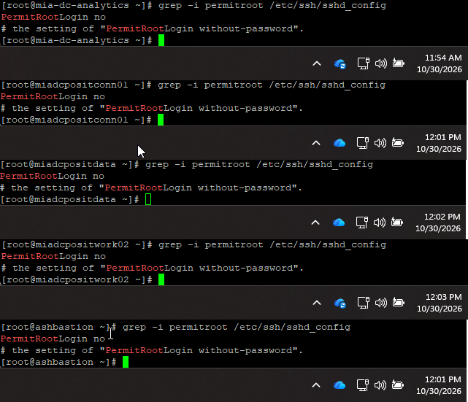
Figure 1 – PermitRootLogin_settings_20261030.docx: the five embedded screenshots (10/30/2026).

E. Standard and guides
Assessment: Partially correct
- Windows (v4.0) and Linux (v2.0) hardening guides were approved before the period and are the versions in force – usable as benchmarks (reference only, re-sent unchanged).
- C11.04a is the Secure Build Standard v6.0 (05/28/2024), superseded by v6.1 (05/28/2025). A v8.0 approved 07/28/2026 was received under C12 – after the period. The version in force during 07/01/2025 – 06/30/2026 must be confirmed (Job Aid: record document name, version and date).
- Oracle / SQL items (C11.03, .04, .08, .09) are 2025 scope; database defaults are tested under BSI.IT.10.C10 in 2026.

3.5 What is still needed
Item still needed | Why (policy / WP2) | When
CMDB extract of all BSI Windows and RHEL servers placed into production 07/01/2025 – 06/30/2026 (name, CI, OS, environment, created and go-live date) with query/filter screenshot, run date and record count | §4.4.2; App. F §8.6.3; WP2 step 1 | Now
Completeness check of that population (reconciliation to BigFix / CrowdStrike / Qualys, or owner's validation) | App. F §8.6.2 – §8.6.3 | Now
Windows: `secedit /export` for each RCSA-selected server, with `hostname` and date of the run, plus production date | §4.4.4, §4.4.6; WP2 step 2 | After RCSA selects samples
Linux: evidence the root default password was changed and vaulted in CyberArk, `passwd -S root`, `sshd -T | grep permitrootlogin`, with hostname and date | §4.4.6; RHEL guide (CyberArk exception); WP2 step 3 | After RCSA selects samples
Environment, CMDB CI and go-live date of the 5 Linux servers already sent | §4.4.2 eligibility | Now
CISO-approved exceptions for vendor default accounts in the period, or confirmation of none | CDA Q5; Secure Build Std exceptions | Now
Version history of the Secure Build & Configuration Standard (v6.1 → v8.0) to confirm the version in force | CDA Job Aid; CDA Q3 | Now

3.6 Conclusion
Conclusion: CPA cannot be concluded. None of the evidence provided can be used as 2026 sample evidence because no population for 07/01/2025 – 06/30/2026 has been provided, every server with a known build date went live before the period (ashbastion and mia-dc-analytics are unknown), and the servers were not selected by RCSA.
No exception was noted: on all 20 servers evidenced (15 Windows, 5 Linux) the vendor default accounts were changed. This supports the design, but it is not period evidence.

4. BSI.IT.10.C13 Config Authentication

4.1 Scope and testing period
Control statement | In every operation, Infrastructure Engineering have configured strong authentication settings/policies for operating systems on premise to align with the Authentication and Authorization Standard. Exception to authentication configurations must be approved by the CISO.
Testing period (coverage) | 07/05/2025 – 01/04/2026 (Semi-Annual; prior timeframe ended 07/04/2025)
Testing approach | Tested as an effective control – regular CPA (population for the period and RCSA random sample). Per §4.1.3 confirm the Action Driver shown in the coverage file (target 09/30/2026) is closed before the rating is issued.
Last rating | 12/19/2025 – Weak (2025 Cycle 2). §4.1.2: stays semi-annual until effective for 4 consecutive cycles.
2025 WP2 baseline | Test date 07/10/2025; population 416 (10/01/2024 – 7/4/2025); 15 samples (10 Windows, 5 RHEL). 2025 exception: Windows lockout duration -1; Linux miadevlxmq01 minimum age 7.
Benchmarks | Authentication & Authorization Standard v12.0 (05/28/2025): 12 characters, 12 history, age ≥ 1 day, expiry 45 days, lockout after ≤ 5 attempts for ≥ 30 minutes or until an administrator unlocks. Windows Hardening Guide v4.0 (14 / 24 / 1 / ≤ 5 / ≥ 15 min). RHEL Hardening Guide v2.0 (minlen 14, maxrepeat 3, remember 24, deny ≤ 5, PASS_MIN_DAYS 1).

4.2 What was requested (Configuration_Management_Protection_Request)
The request package contains the 2025 WP2 workpaper and the evidence obtained in 2025. For 2026 the same evidence types are requested for the 2026 testing period, following the WP2 test procedure and RCSA policy.
WP2 step | Requested (2025 package reference) | Required for 2026
CDA – policy alignment | C13.03 A&A Standard v12.0; C13.01 / C13.02 hardening guides | Confirm the versions in force for 07/05/2025 – 01/04/2026
CPA step 1 – population | C13.04 Server inventory samples query.xlsx (417 rows, query tab empty) | CMDB extract of servers in production in the period + query, run date, count + completeness
CPA steps 2–3 – Windows | C13.05 Windows samples.zip: 10 secedit exports (06/25/2025) | secedit / gpresult for RCSA-selected servers, with hostname and run date
CPA steps 2–3 – Linux | C13.06 Linux samples.zip: login.defs, pwquality.conf, pam files for 5 servers | Same files for RCSA-selected servers, with hostname and date
Prior exception | Exception form RCSA … C13 … v2.docx | Reference only (C13 tested as effective)
CDA Q5 – exceptions | — | CISO-approved exceptions in the period or confirmation of none

4.3 What was provided on 11/04/2026
File | First received | What is inside (inspected) | Assessment
10 security_export_*.txt (MIA-DC-PRINT1, SNOWMID1, SQL3, SWDB, TOFS, WEBIIS, MIA-HQ-FNAPP, MIADCCTXLIC01, MIADCRDSTABLEAU, MIADEVRDSGW01) | 2025 package (identical; sent 3 times) | Password and lockout policy – see Table 4.1 | Not correct
C13 Linux-evidenceNov2026.docx (filed in C11 folder) | 11/03/2026 (identical) | 4 screenshots 11/03/2026: pwquality d/u/l/ocredit = -1 | Partially correct
5 new C11 SecExport.txt files (password section) | 11/04/2026 (new) | Same password/lockout values as the 2025 files | Reference only
Hardening guides (in C11 folder) | 2025 package (identical) | Windows v4.0, Linux v2.0 | Reference only

4.4 Why the evidence is correct or not correct

A. Population (CPA step 1)
Assessment: Not received
- No server list for 07/05/2025 – 01/04/2026 was provided (C13.04 not re-sent). §4.4.2 and App. F §8.6.3 apply as for C11.

B. Windows – 10 security exports
Assessment: Not correct
- All 10 files are byte-identical to the 2025 C13.05 exports (zip entries dated 06/25/2025) – exported before the period start (07/05/2025), for the 2025 samples. They cannot be 2026 evidence (§4.4.2; CDA Job Aid).
- Content is consistent with the Standard (Table 4.1). Lockout duration = -1: in secedit format -1 means the account stays locked until an administrator unlocks it. The A&A Standard SUS.AAS.4.2.2.7 requires accounts to 'remain locked for at least 30 minutes, or until an administrator unlocks the account', so the setting complies. The 2025 exception on this setting appears to be a misreading of -1; this supports treating C13 as effective. Confirm with a `net accounts` screenshot ('Lockout duration: Never') on the 2026 samples.
- The 5 new exports received under C11 (11/04/2026) show the same values, plus 'Allow Administrator account lockout' enabled, so the policy is still in place and was tightened after June 2025. They are not RCSA samples and have no run date.
Table 4.1 – Windows password and lockout settings in the exports vs. the benchmarks
Setting | Value in exports | A&A Standard v12.0 | Windows Guide v4.0 | Result
Minimum password length | 14 | ≥ 12 | ≥ 14 | Correct
Password complexity | Enabled | 3 of 4 types | Enabled | Correct
Minimum password age | 1 day | ≥ 1 day | ≥ 1 day | Correct
Maximum password age | 45 days | 45 days | ≤ 60 (CyberArk) | Correct
Password history | 24 | ≥ 12 | ≥ 24 | Correct
Lockout threshold | 5 | ≤ 5 | ≤ 5, not 0 | Correct
Lockout duration | -1 (until admin unlocks) | ≥ 30 min or admin unlock | ≥ 15 min | Correct
Reset lockout counter | 30 min | — | ≥ 15 min | Correct
Idle session timeout | 900 s (15 min) | 10 min (workstations) | ≤ 15 min | Correct

C. Linux – C13 Linux-evidenceNov2026.docx
Assessment: Partially correct
- Correct: genuine screenshots with hostname and date (11/03/2026, 12:01 – 12:09 PM) on mia-dc-nb01-fs, miaecowas, miadevlxmq01 and mia-posit-app; dcredit, ucredit, lcredit and ocredit = -1 meets the RHEL guide.
- Not correct: 1 of the 9 WP2 Linux settings only – no minimum length, password age (login.defs), max repeat, history (pam_pwhistory) or lockout (pam_faillock); the 4 servers are the 2025 samples chosen by the owner (mia-dc-selene missing); taken after the period end; filed under the wrong control (C11).
- The 2025 exception on miadevlxmq01 (PASS_MIN_DAYS 7) is not shown either way.
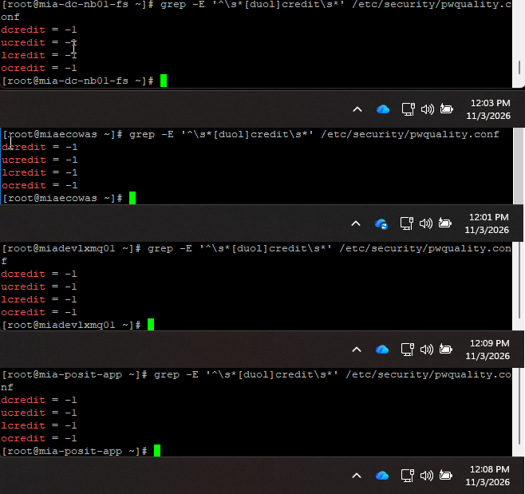
Figure 2 – C13 Linux-evidenceNov2026.docx: the four embedded screenshots (11/03/2026).

4.5 What is still needed
Item still needed | Why (policy / WP2) | When
CMDB extract of all BSI Windows and RHEL servers in production 07/05/2025 – 01/04/2026 with query, run date, record count | §4.4.2; App. F §8.6.3; WP2 step 1 | Now
Completeness check of that population | App. F §8.6.2 – §8.6.3 | Now
Windows: `secedit /export` (or `gpresult`) and `net accounts` for each RCSA-selected server, with hostname and run date | §4.4.4, §4.4.6; WP2 steps 2–3 | After RCSA selects samples
Linux: /etc/login.defs, /etc/security/pwquality.conf, /etc/pam.d/system-auth and password-auth for each RCSA-selected server, with hostname and date | §4.4.6; WP2 steps 2–3 (9 attributes) | After RCSA selects samples
Confirmation that Action Driver 005056BCA24E1FD0B4A6A1173BF00BA4 is closed (or rationale for testing as effective) | §4.1.3 | Now
CISO-approved authentication exceptions in the period, or confirmation of none | Control statement; CDA Q5 | Now
Confirmation that A&A Standard v12.0 and the hardening guides were in force in the period; date of the GPO change that enabled Administrator lockout | CDA Job Aid; CDA Q3 | Now

4.6 Conclusion
Conclusion: CPA cannot be concluded. The Windows evidence is the June-2025 files (before the period) or owner-chosen servers without a run date, and the Linux evidence covers one setting only; no population or RCSA sample exists for 07/05/2025 – 01/04/2026.
No exception was noted: every Windows setting seen meets the Authentication & Authorization Standard v12.0, including lockout duration (-1 = locked until an administrator unlocks). The evidence supports the control being designed and operating as intended, pending period samples.

5. BSI.IT.10.C19 Server Protection

5.1 Scope and testing period
Control statement | In every operation and upon imaging of a server, Infrastructure Engineering installs Endpoint Protection on the server to mitigate the risk of any malicious software. Exceptions to disable malware protections on server are approved by the CISO (or delegate).
Testing period (coverage) | 07/05/2025 – 07/04/2026 (Annual; population pulled through the request date per the coverage file)
Nature | Windows: automated (BigFix permanent action) – test of one with logic unchanged (§4.4.3, App. F §8.6.4). Linux: manual install at build – sample of new servers.
Last rating | 08/14/2025 – Satisfactory
2025 WP2 baseline | Test date 07/10/2025; population 10/01/2024 – 7/4/2025; 1 BigFix configuration (actions 00-126994 / 00-126995) + 7 new Linux servers.
Benchmarks | Virus & Malware Protection Standard v5.2 SUS.VMPS.4.2.3.3 (EDR must continuously run on all servers); RHEL Hardening Guide v2.0 §4.1 (CrowdStrike installed).

5.2 What was requested (Configuration_Management_Protection_Request)
The request package contains the 2025 WP2 workpaper and the evidence obtained in 2025. For 2026 the same evidence types are requested for the 2026 testing period, following the WP2 test procedure and RCSA policy.
WP2 step | Requested (2025 package reference) | Required for 2026
CDA – policy alignment | C19.01 Standard (Virus & Malware v5.2) | Version in force 07/05/2025 – 07/04/2026
CPA step 1 – BigFix configuration | C19.02 BigFix.docx (screenshot 07/02/2025) | BigFix actions 00-126994 / 00-126995 dated within the period + evidence the logic did not change
CPA step 2 – new-server population | C19.03 CMDB.xlsx (49 servers created 10/03/2024 – 05/14/2025, query tab empty) | Servers built in the period + query, run date, count + completeness
CPA step 3 – Linux samples | C19.04 Linux Build.docx (procedure); 2025 Falcon evidence for 7 servers | Falcon installed / version / install date for RCSA-selected new Linux servers
CDA Q5 – escalation | — | ServiceNow tickets for servers missing the agent; CISO exceptions

5.3 What was provided on 11/04/2026
File | First received | What is inside (inspected) | Assessment
BSI.IT.10.C19.01 Standard.pdf | 2025 package (identical) | Virus & Malware Protection Std v5.2, 05/28/2025 | Correct
BSI.IT.10.C19.02 BigFix - CrowdStrike permanent action - 2026-11-03.docx | 11/04/2026 (new) | BigFix console screenshot 11/03/2026 7:44 PM, action group 00-126993 | Partially correct
BSI.IT.10.C19.04 Linux Build.docx | 2025 package (identical) | Manual CrowdStrike install procedure (07/11/2025) | Reference only
cmdb_11-04-26.xlsx | 11/04/2026 (new) | ServiceNow export, 5 rows | Not correct

5.4 Why the evidence is correct or not correct

A. BigFix configuration – C19.02 (new)
Assessment: Partially correct
- Correct: genuine BigFix console capture on mia-dc-netops dated 11/03/2026 7:44 PM. Action group 00-126993 'PERMANENT ACTION – SOFTWARE_DEPLOYMENT_CROWDSTRIKE_WINDOWS_SENSOR' is Open, issued 11/19/2024, never expires, is reapplied as a policy an unlimited number of times, retries 5 times, and is 100% complete (25 of 25 applicable). Members: 00-126994 Servers (Miami), 00-126995 Servers (Virginia), 00-126996 Workstations & Laptops.
- Because the action was issued 11/19/2024 and is still open, it was not re-created during the period – this supports the logic being unchanged (App. F §8.6.4).
- Not correct / open: (1) captured after the period end (07/04/2026); (2) member actions 00-126994 / 00-126995 are only listed – their own status and computers are not shown (WP2 step 1 tests these two); (3) the same screen shows two other CrowdStrike actions issued during the period – 07/02/2025 'SOFTWARE_DEPLOYMENT_CROWDSTRIKE_WINDOWS_SENSOR' and 09/02/2025 'CrowdStrike Windows Sensor – SERVERS (MIAMI Group)' (3 of 3 completed) – which must be explained under App. F §8.6.4 (a logic change requires a new design assessment); (4) a BigFix 'License Issue' banner is displayed.
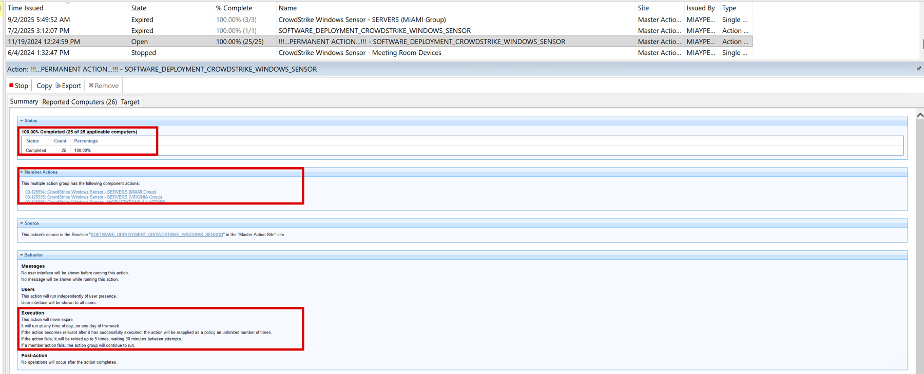
Figure 3 – BigFix console (detail): action list and action group 00-126993 status, member actions and execution settings.
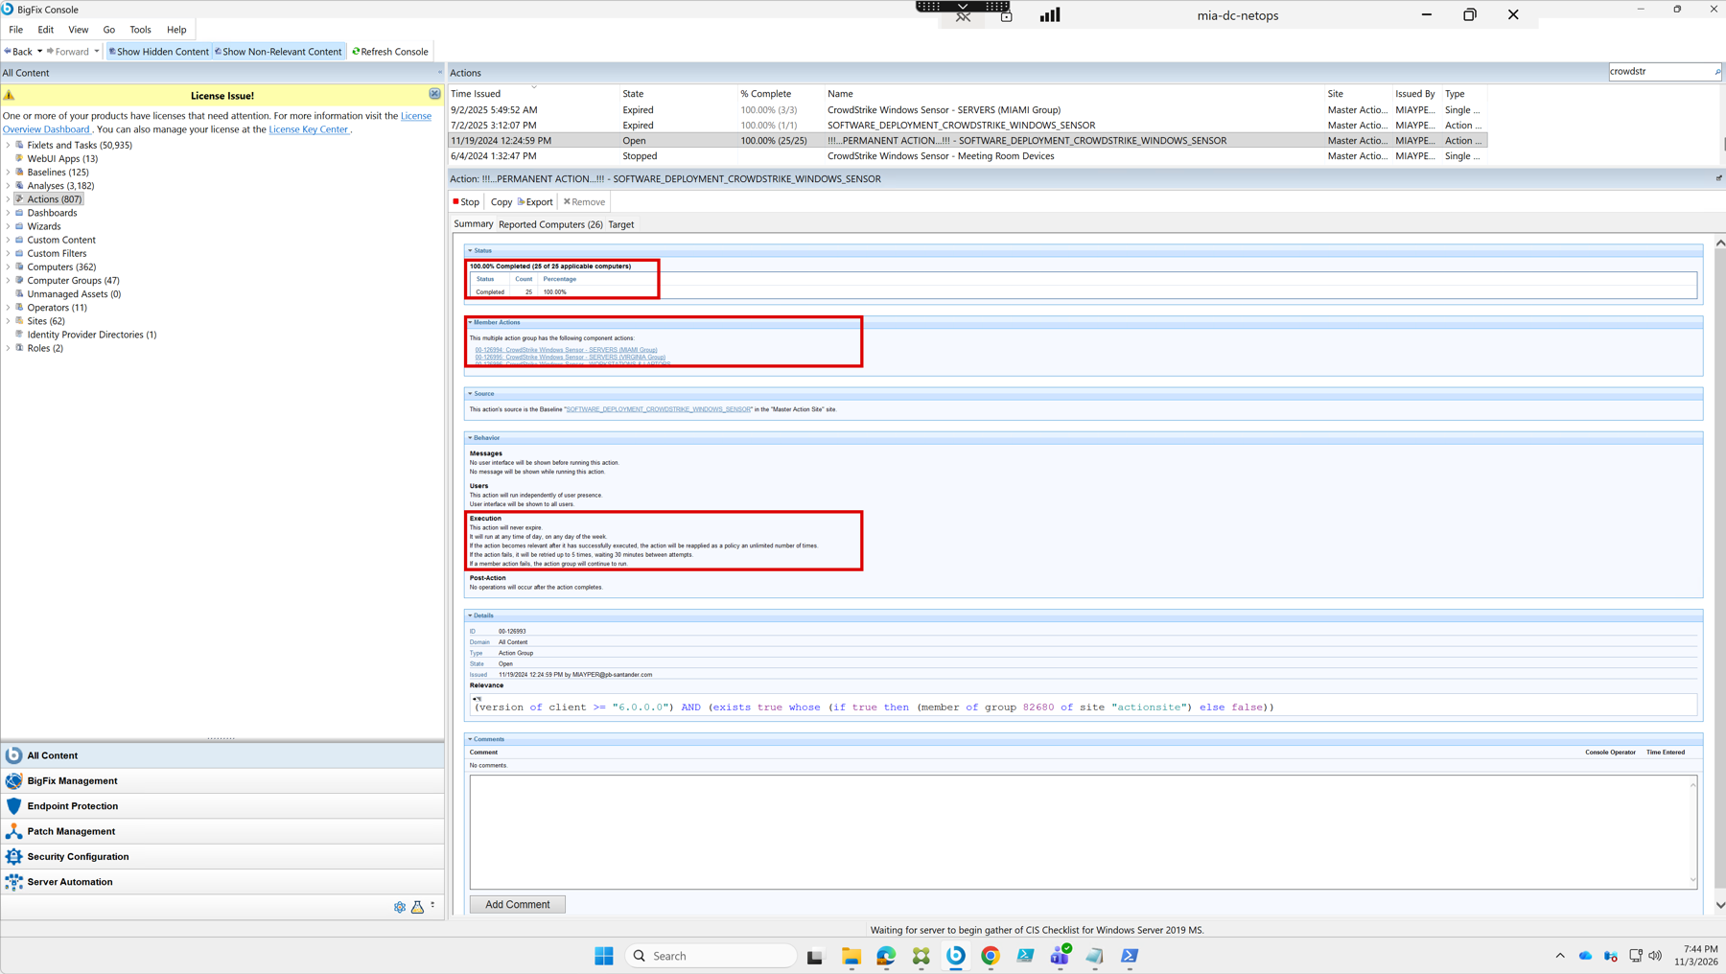
Figure 4 – BigFix console full screenshot on mia-dc-netops, 11/03/2026 7:44 PM, including the 'License Issue' banner.

B. New-server population – cmdb_11-04-26.xlsx (new)
Assessment: Not correct
- File properties: ServiceNow export (Apache POI), created 11/04/2026 14:25 by Andres Guzman and modified one minute later.
- Why not correct: all 5 records were created 04/03/2025 – 04/15/2025, before the period start (07/05/2025); none is Production (Pre-Production / Contingency, DRT VA); ashocp-xhktf-master-1 and ashocp-xhktf-worker-1 each appear twice under different CIs; there is no query, filter, run date or record count, so it cannot be shown to be the complete population of servers built in the period (§4.4.2; App. F §8.6.3).
Name | CI | Created | Environment | Inside period?
ASH-DC-BSI-ALGOSEC-RA-01 | CI0421936189 | 04/03/2025 | Pre-Production | No
ashocp-xhktf-master-1 | CI0421936199 | 04/03/2025 | Contingency | No
ashocp-xhktf-master-1 | CI0424250767 | 04/15/2025 | Contingency | No
ashocp-xhktf-worker-1 | CI0424255737 | 04/15/2025 | Contingency | No
ashocp-xhktf-worker-1 | CI0421936198 | 04/03/2025 | Contingency | No

C. Linux samples and escalation
Assessment: Not received
- No Falcon evidence for new Linux servers and no ServiceNow tickets or exceptions were provided. The Linux install procedure (C19.04) is the 2025 document and remains a valid reference.
- The posit servers in the C11 PermitRootLogin document were 2025 C19 samples built 02/2025 – not in the 2026 population.

D. Standard
Assessment: Correct
- Virus & Malware Protection Standard v5.2 (05/28/2025) was approved before the period start and is the version in force; v6.0 (received under C18) was approved 07/28/2026, after the period end. Confirm no intermediate version.

5.5 What is still needed
Item still needed | Why (policy / WP2) | When
List of all servers (Windows and Linux) built 07/05/2025 – 07/04/2026 (or through the request date) with build date, OS, environment + query, run date, record count | §4.4.2; App. F §8.6.3; WP2 step 2 | Now
Completeness check of that list (BigFix / CrowdStrike / Qualys) | App. F §8.6.2 – §8.6.3 | Now
BigFix Summary and Reported Computers screens for 00-126994 and 00-126995, ideally dated within the period | WP2 step 1; §4.4.3 | Now
BigFix action history / audit log for 00-126993/94/95/96 and an explanation of the actions issued 07/02/2025 and 09/02/2025 | App. F §8.6.4 (logic change) | Now
Confirmation that the BigFix licence issue did not stop CrowdStrike deployment during the period | §4.4.7 (reliability of the system used) | Now
For each RCSA-selected new Linux server: `rpm -qa | grep falcon`, `falconctl -g --cid --version`, install date vs build date | §4.4.4, §4.4.6; WP2 step 3 | After RCSA selects samples
ServiceNow tickets for servers missing CrowdStrike and CISO exceptions in the period, or confirmation of none | CDA Q5; V&M Standard §6 | Now

5.6 Conclusion
Conclusion: CPA cannot be concluded. The design of the Windows control is well evidenced (permanent BigFix action in place since 11/19/2024, never expires, 100% complete), but the screenshot is dated after the period, the server member actions are not shown, two in-period actions are unexplained, and there is no population or sample evidence for new Linux servers.
No exception was noted in the evidence inspected.

6. Appendix – file inventory for C11, C13 and C19
All files in OneDrive_1_11-4-2026.zip for the three controls, with where they were first received. 'Identical' means byte-for-byte the same file (MD5).
Folder | File | First received | New?
C11 | BSI.IT.10.C11.01 Windows Sever Hardening guide.pdf | 2025 request package | No
C11 | BSI.IT.10.C11.02 Linux Server hardening.pdf | 2025 request package | No
C11 | BSI.IT.10.C11.03 Oracle Hardening Guide.pdf | 2025 request package | No
C11 | BSI.IT.10.C11.04 Microsoft SQL Server Hardening Guide.pdf | 2025 request package | No
C11 | BSI.IT.10.C11.04a Standard.pdf | 2025 request package | No
C11 | BSI.IT.10.C11.08 SQL hardening evidence.docx | 2025 request package | No
C11 | BSI.IT.10.C11.09 SQL servers.xlsx | 2025 request package | No
C11 | C13 Linux-evidenceNov2026.docx | 11/03/2026 | No
C11 | PermitRootLogin_settings_20261030.docx | 11/03/2026 | No
C11 | MIA-DC-SPFAM1_SecExport.txt | 11/04/2026 | Yes
C11 | MIA-DC-SPFAM2_SecExport.txt (identical to SPFAM1) | 11/04/2026 | Yes
C11 | MIA-DC-SQLPECS_SecExport.txt | 11/04/2026 | Yes
C11 | MIA-DC-SQLPRD01_SecExport.txt | 11/04/2026 | Yes
C11 | MIA_DC_SPOINTIQ_SecExport.txt | 11/04/2026 | Yes
C13 | 10 × security_export_*.txt | 2025 request package (C13.05) | No
C19 | BSI.IT.10.C19.01 Standard.pdf | 2025 request package | No
C19 | BSI.IT.10.C19.02 BigFix - CrowdStrike permanent action - 2026-11-03.docx | 11/04/2026 | Yes
C19 | BSI.IT.10.C19.04 Linux Build.docx | 2025 request package | No
C19 | cmdb_11-04-26.xlsx | 11/04/2026 | Yes
Totals for these three controls: 28 files – 19 re-sent from the 2025 request package, 2 repeated from 11/03/2026, 7 new.

