BSI.IT.27.C7 Network Device Admin Account Review
Account Testing Report - 10 Sampled Accounts, Evidence and Conclusions
Item | Detail
Control | At least semiannually, InfoSec initiates account reviews for network device administrators, users and service accounts that will be performed by managers or account owners. Inappropriate access is revoked by the PAM/IAM team within SLA.
Entity / process | Banco Santander International (BSI - Miami) / Privileged Access Management
Testing period | 07/01/2025 - 06/30/2026
Samples | Sample 1: 2025 Q3 PAM BSI SOX certification (decisions 08/28/2025). Sample 2: 2026 Q1 PAM BSI SOX certification (decisions 04/30/2026). 2026 Q2 certifications (07/27/2026, 08/17/2026) used as supporting evidence only.
Accounts tested | MIA25142, MIA25172, MIA25175, X453396, MIA25103, MIA25104, MIA25105, MIA25106, MIA25249, MIA25250
Prepared by / date | Edward Morfa, IT RCSA Testing - 11/02/2026
Reviewer | Mingo Cordova, Mirna Roxana

1. Summary of results
Result: 3 PASS, 7 FAIL. Each account was re-tested against the source data: the SanIAM decision exports, the Active Directory (AD) extracts, the Netwrix audit captures and the Fieldglass e-mail. The Fieldglass report clears the incorrect termination date in SanIAM. It does not clear any of the seven failures, because those failures are about the access itself, not about whether the person was still a contractor.
# | Account | Name | Result | Reason in one line
1 | MIA25142 | Miguel Nieves Nieves | FAIL | Access revoked 08/28/2025 was put back (Netwrix: re-added to ISEAdmin 09/10/2025) and approved again 04/30/2026. No approved request provided.
2 | MIA25172 | Juan Hernandez Ruiz | FAIL | Access revoked 08/28/2025, then added to ISEAdmin 09/10/2025 and back in Cisco Network Administrators by 11/25/2025. Approved 04/30/2026. No request.
3 | MIA25175 | Carlos Hernandez Acevedo | FAIL | Same as MIA25172.
4 | X453396 | Juan Fernando Perez Peralta | FAIL | Removed from ISEAdmin 09/08/2025 and re-added about 40 hours later (09/10/2025). Approved 04/30/2026. No request.
5 | MIA25103 | Ivan Ramirez Gonzalez | FAIL | No logon since October 2023, yet admin access was approved on 08/28/2025 and 04/30/2026.
6 | MIA25104 | Jefferson Paez Venegas | PASS | Active contractor, account enabled and in use. Approval was appropriate.
7 | MIA25105 | David Serrano Aguirre | PASS | Same as MIA25104.
8 | MIA25106 | Maiko Vazquez Arias | PASS | Same as MIA25104.
9 | MIA25249 | Richard Harris | FAIL | Sample 1 passes. On 04/30/2026, approved while the account was disabled for 90+ days of inactivity; later re-enabled with no request.
10 | MIA25250 | Kevin Ackley | FAIL | Same as MIA25249; HR fields (employeeID and employeeNumber) also blank after re-enable.

2. Why the accounts still fail although Fieldglass was provided
The Fieldglass report answers one question: is this person still an active contractor? For all the workers in scope the answer is yes. That proves the SanIAM termination date of 12/31/2024 is wrong. It is a data-quality observation, not an exception.
The control asks two different questions:
- Did the manager keep only access that is still appropriate? Being employed does not mean a person needs network administrator access. An account that has not been used for months, or that was disabled, should not keep it (SUS.IAMS.4.2.5.1, 4.2.3.1).
- Was inappropriate access revoked, and did it stay revoked? Once the manager denies access, it stays denied unless a new request is approved (SUS.IAMS.4.2.5.7, 4.2.3.4). Fieldglass has nothing to do with this question.

Account group | What Fieldglass proves | Why the account still fails
MIA25103 | He is an active contractor. | His account has not been used since 10/2023. Admin access that is unused for 2 years is not needed.
MIA25249, MIA25250 | They are active contractors. | Their accounts were disabled in April 2026 for 90+ days of inactivity. The manager approved their admin access anyway on 04/30/2026, and the accounts were later re-enabled with no request.
MIA25142, MIA25172, MIA25175, X453396 | Not applicable (Fieldglass was not about these accounts). | The manager revoked their access; it was removed on time and then put back with no approved request.
MIA25104, MIA25105, MIA25106 | They are active contractors. | They PASS: active, enabled and in use, so the approval was correct.

3. Detailed findings and evidence

3.1 Revoked access that came back - MIA25142, MIA25172, MIA25175, X453396
What happened, step by step:
Date | Event | Evidence
08/28/2025 | Manager (Borges, Dayam) REVOKED privileged network access for all four accounts in the 2025 Q3 SOX Manager certification. | E04 tab 2_Cisco Network Administrators, certification rows: MIA25142 2537-2539; MIA25172 2540-2541; MIA25175 2546-2547; X453396 2486-2489
09/02/2025 | Netwrix: MIA25142 removed from Cisco Network Administrators and ISEAdmin; MIA25172 removed from Cisco Network Administrators. 2 business days - within SLA. | Exhibits A2, A3, A6
09/08/2025 | Netwrix: X453396 removed from Cisco Network Administrators and ISEAdmin; MIA25175 removed from Cisco Network Administrators. 6 business days - within SLA. | Exhibits A1, A4, A5
09/10/2025 2:33 AM | Netwrix: all four ADDED to ISEAdmin by 'system'. MIA25142 and X453396 were re-added to a group they had just lost; MIA25172 and MIA25175 were added to ISEAdmin for the first time. | Exhibit A7
10/10/2025 | SLA deadline (30 business days after 08/28/2025). The ISEAdmin re-add happened before this date. | Re-performed; see section 3.5
11/25/2025 | AD extract: all four are members of Cisco Network Administrators AND ISEAdmin again. | E04 AD extract, MemberOf column; rows: MIA25142 1639, MIA25172 1660, MIA25175 1661, X453396 1853
04/30/2026 | Manager APPROVED the same access in the 2026 Q1 certification. WorkItemID and comment are blank - no request linked. | E05 tab 2.Cisco Network Administrators, 2026 Q1 SOX Manager certification section
07/27/2026 and 08/17/2026 | Approved again in the 2026 Q2 SOX and CyberArk certifications (after the period). | E07 SOX Manager rows 98-100, 140-145, 110-112; CyberArk Manager rows 431-433, 467-471, 443-445

What Netwrix proves and what it does not: Netwrix is an AD audit log. It records what changed, when and by which account. It does NOT record approvals. Netwrix proves the access was removed on time and then put back on 09/10/2025. The statement 'no approved request' comes from the absence of evidence: no ServiceNow request was provided for any re-add (requested, still open), and the 2026 Q1 and Q2 certification rows have no WorkItemID or comment. The actor 'system' at 2:33 AM suggests an automated job rather than a person working an approved ticket; this is an inference that management must confirm.

Why this fails: Under SUS.IAMS.4.2.5.7, access is denied when the manager denies it. Putting it back required a new request, manager validation and second-level approval (SUS.IAMS.4.2.3.4), and none was provided. The review must confirm that all access marked for removal was removed (SUS.IAMS.4.2.5.10), and PAM Procedure 4.2 requires escalation when rejected access is retained; no escalation was evidenced. The manager then approved the re-granted access on 04/30/2026.
Process owner response: 'SanIAM shows no change, mover or leaver events' and the access is approved in 2026 Q2. Not accepted - this confirms the access is still held but does not explain how revoked access came back.
Additional points: MIA25172 was in the 'Inactive AD Accounts' folder when it was removed (Exhibit A3) and when it was added to ISEAdmin (Exhibit A7), yet it was enabled with a logon on 11/24/2025; the re-enable is unexplained. MIA25172 and MIA25175 appear in SanIAM as uncorrelated accounts (Identity = account name) in 2026 Q1/Q2, although AD carries employeeNumbers 100546248 and 100546251. For X453396, the separate Network_support revocation did stay removed.

3.2 Account unused since 2023 - MIA25103 (Ivan Ramirez Gonzalez)
Evidence point | Value | Source
2025 Q3 decision | APPROVED 08/28/2025 10:39 AM by Borges, Dayam | E04 tab 2, rows 2523-2525
Last logon | 10/15/2023 (lastLogonDate) - 683 days before the 08/28/2025 decision | E04 AD extract 11/25/2025, row 1617
Account status 11/25/2025 | Disabled; still a member of Cisco Network Administrators and ISEAdmin | E04 AD extract row 1617 (MemberOf)
2026 Q1 decision | APPROVED 04/30/2026 1:47 PM | E05 2026 Q1 SOX Manager certification
Account status 05/15/2026 | Disabled; in OU=Inactive AD Accounts; last logon 10/10/2023 - 928 days before the decision | E05 AD extract row 1614
Account status 10/10/2026 | Disabled; still approved in 2026 Q2 (SOX rows 86-88, CyberArk rows 419-421) | E07 Oct10_2026Users
Fieldglass | Worker SANWK00016501 Open 2024-01-01 to 2027-02-28 - active contractor | Exhibit B1
Why this fails: The review must confirm that access remains valid and follows least privilege (SUS.IAMS.4.2.5.1). Network administrator access that has not been used in about two years is not needed. Accounts unused for 90 days must be disabled or removed (SUS.IAMS.4.2.3.1): the account was disabled, but its privileged group memberships were kept and approved again in every review. Fieldglass proves employment only. The 2025 Q3 AD extract is dated three months after the decision, so the exception is based on non-use, which is provable at both decision dates, rather than on the disabled flag.

3.3 Accounts disabled for inactivity, then approved - MIA25249 (Richard Harris), MIA25250 (Kevin Ackley)
Evidence point | MIA25249 - Richard Harris | MIA25250 - Kevin Ackley | Source
2025 Q3 (Sample 1) | APPROVED 08/28/2025; enabled; last logon 11/17/2025 - PASS | APPROVED 08/28/2025; enabled - PASS (see note) | E04 rows 2549-2554; AD rows 1804, 1802
Last logon before disable | 12/10/2025 | 11/07/2025 09:00:30 (same second as password set - likely a password reset, not real use) | E05 AD extract; E04 AD extract
Disabled on | 04/02/2026 17:52:08 - moved to OU=Inactive AD Accounts | 04/03/2026 00:38:34 - moved to OU=Inactive AD Accounts | E05 AD extract (whenChanged, DistinguishedName) rows 1799, 1798
Days without logon at disable | 113 | 147 | Calculated
2026 Q1 decision | APPROVED 04/30/2026 while disabled (141 days unused) | APPROVED 04/30/2026 while disabled (174 days unused) | E05 2026 Q1 SOX Manager certification
10/10/2026 | ENABLED again - no request on file | ENABLED again - employeeID and employeeNumber blank (were x375759 on 11/25/2025) | E07 Oct10_2026Users
2026 Q2 | Approved (SOX 104-106; CyberArk 437-439) | Approved (SOX 101-103; CyberArk 434-436) | E07
Fieldglass | SANWK00016311 Open 2023-12-28 to 2027-02-28 | SANWK00016313 Open 2023-12-28 to 2027-02-28 | Exhibits B5, B6

Why the accounts were disabled: The evidence points to the 90-day inactivity process, not to a contract gap. Both accounts were moved to 'Inactive AD Accounts' after 113-147 days without a logon, and MIA25249 changed in the same second as MIA25103 (04/02/2026 17:52:08), which indicates a batch inactivity job. Fieldglass shows no termination, which is consistent with this.

Why this fails: On 04/30/2026 the manager approved network administrator access for accounts that had been unused for more than 90 days and disabled because of it. The review did not confirm the access remained valid (SUS.IAMS.4.2.5.1). The accounts were then re-enabled, restoring privileged access, with no request or approval provided (SUS.IAMS.4.2.3.4). For MIA25250 the blank HR fields mean the account is not synchronized with HR (SUS.IAMS.4.2.1.1).

3.4 Accounts that pass - MIA25104, MIA25105, MIA25106
Account | 2025 Q3 | 2026 Q1 | AD evidence | Fieldglass
MIA25104 Jefferson Paez Venegas | Approved 08/28/2025 | Approved 04/30/2026 | Enabled at all three extracts; last logons 11/20/2025 and 04/28/2026; AD expiry extended 01/01/2026 to 06/01/2026 | SANWK00016508 Open 2024-01-01 to 2027-02-28 (Exhibit B2)
MIA25105 David Serrano Aguirre | Approved 08/28/2025 | Approved 04/30/2026 | Enabled; last logons 11/18/2025 and 04/17/2026; expiry extended | SANWK00016502 Open (Exhibit B3)
MIA25106 Maiko Vazquez Arias | Approved 08/28/2025 | Approved 04/30/2026 | Enabled; last logons 11/18/2025 and 05/13/2026; expiry extended | SANWK00016503 Open (Exhibit B4)
Why these pass: Three independent sources agree that each person is an active, extended consultant who uses the account: Fieldglass (the authoritative source for external workers, SUS.IAMS.4.2.1.1), the AD expiry extension and recent AD logons. The access was valid, so the manager's approval was appropriate (SUS.IAMS.4.2.5.1, 4.2.5.6). No revocation occurred, so the SLA does not apply. The 12/31/2024 termination date in SanIAM is a data-quality observation.

3.5 SLA re-performance (2025 Q3 revocations)
30 business days from the close of the review (SUS.IAMS.4.2.5.21), excluding US bank holidays (Labor Day 09/01/2025, Columbus Day 10/13/2025). Deadline: 10/10/2025.
Account | Group | Removed (Netwrix) | Business days | Within SLA? | Re-added (Netwrix) | Present 11/25/2025?
MIA25142 | Cisco Network Administrators | 09/02/2025 | 2 | Yes | Not in package | Yes
MIA25142 | ISEAdmin | 09/02/2025 | 2 | Yes | 09/10/2025 (day 8) | Yes
MIA25172 | Cisco Network Administrators | 09/02/2025 | 2 | Yes | Not in package | Yes
MIA25175 | Cisco Network Administrators | 09/08/2025 | 6 | Yes | Not in package | Yes
X453396 | Cisco Network Administrators | 09/08/2025 | 6 | Yes | Not in package | Yes
X453396 | ISEAdmin | 09/08/2025 | 6 | Yes | 09/10/2025 (day 8) | Yes
Conclusion: Every removal met the SLA, but none stayed removed, and for ISEAdmin the access was restored before the SLA deadline. Timeliness passes; persistence fails.

4. Fieldglass evidence review (E10)
E-mail chain: request sent 10/14/2026 4:48 PM to L. Carballea and N. De Castro; reminder 10/23/2026 9:31 AM to BSI Procurement; reply 10/29/2026 9:52 AM EDT (13:52 UTC) from Ana Belloso, BSI Procurement, with one Fieldglass search screenshot per worker (images 001-007). The source is independent of the control owner.
Account | Worker ID / status | Worker period | Buyer ref = SanIAM identity? | Current work order | Job seeker submitted
MIA25103 | SANWK00016501 Open | 2024-01-01 - 2027-02-28 | 100531048 - Yes | SANWO00017798 Rev.18, from 2026-09-29 | 2026-09-29 12:04 PM
MIA25104 | SANWK00016508 Open | 2024-01-01 - 2027-02-28 | 100531049 - Yes | SANWO00017799 Rev.18 | 2026-09-29 12:05 PM
MIA25105 | SANWK00016502 Open | 2024-01-01 - 2027-02-28 | 100531050 - Yes | SANWO00017797 Rev.18 | 2026-09-29 12:04 PM
MIA25106 | SANWK00016503 Open | 2024-01-01 - 2027-02-28 | 100531051 - Yes | SANWO00017800 Rev.18 | 2026-09-29 12:05 PM
MIA25249 | SANWK00016311 Open | 2023-12-28 - 2027-02-28 | 100592069 - Yes | SANWO00017821 Rev.18 | 2026-09-29 12:05 PM
MIA25250 | SANWK00016313 Open | 2023-12-28 - 2027-02-28 | 100592068 - Yes | SANWO00017820 Rev.18 | 2026-09-29 12:05 PM
MIA25251* | SANWK00016312 Open | 2023-12-28 - 2027-02-28 | 100592070 - Yes | SANWO00017819 Rev.18 | 2026-09-29 12:05 PM
* MIA25251 (Ashish Rimal) was included in the request but is not one of the 10 sampled accounts.

Requested versus received
Requested | Received?
System-generated extract with report date and parameters | No - search-result screenshots pasted in the e-mail; no run date or parameters
Original engagement start and end dates | Partly - worker period shown; 2023 records only for MIA25103-06
Extensions with approval date and approver | No - only the revision count (Rev.18) is visible
Status as of 08/28/2025, 04/30/2026, 07/27/2026 | Not stated - inferred from the Open worker period
Any interruption or gap in April 2026 | Not answered

Assessment
- Consistent and credible: all buyer references match SanIAM; AD creation dates (12/30-12/31/2023) agree with the Harris/Ackley worker start (12/28/2023); the 2023 records for MIA25103-06 end 12/31/2023 and the current worker records start 01/01/2024, so there is no gap.
- Limitations: four of the seven screenshots show 'More Results: Next >>', so results are truncated. All seven job seeker records were submitted on 09/29/2026 between 12:04 and 12:05 PM, and every current work order starts that day. This is unexplained. The work order covering 2024 to 09/28/2026 is not shown.
- Identity question: Richard Harris, Kevin Ackley and Ashish Rimal also appear as ACTIVE Santander US employees (n222712, n67450, n600486; Hiring Manager, ISB00_73097). IAM should confirm whether these are the same people.
- Conclusion: Fieldglass clears the SanIAM termination date issue (observation). It cannot clear the failures in section 3.

5. What the process owner must provide
Account(s) | Evidence required | Best possible result
MIA25142, MIA25172, MIA25175, X453396 | 1. Approved ServiceNow access request for each re-grant: requester, manager validation and second-level approval (SUS.IAMS.4.2.3.4).  2. Dated before 09/10/2025 (ISEAdmin) and before 11/25/2025 (Cisco Network Administrators).  3. Explanation of the Netwrix 'system' change at 2:33 AM on 09/10/2025: which job or tool made it, and was it running an approved request?  4. MIA25172 only: who moved the account out of 'Inactive AD Accounts' and re-enabled it, with approval. | PASS with observation (removal not sustained remains an observation)
MIA25249, MIA25250 | 1. Business justification documented on or before 04/30/2026 for keeping privileged access on accounts disabled for inactivity. A document created after the fact is not acceptable.  2. Approved re-enable request for each account (ServiceNow + Netwrix/AD event), dated between 05/15/2026 and 10/10/2026.  3. MIA25250: reason employeeID / employeeNumber are blank, and proof they were restored. | Observation at best; stays FAIL without item 1
MIA25103 | No evidence can make this pass: the account shows no use during the period.  Provide remediation instead: removal from Cisco Network Administrators and ISEAdmin (ServiceNow ticket + Netwrix event), and a management response accepting the exception. | Stays FAIL
MIA25104, MIA25105, MIA25106 | Nothing required. Optional: Fieldglass 'Go to Details' view with report date and extension history to strengthen the file. | PASS

Effect on the control result: Under the RCSA rule for a quarterly control, any remaining exception fails the sample. Because MIA25103 cannot be cleared, both samples remain FAIL even if all other evidence is provided. The additional evidence would reduce the severity of the finding, not change the overall result.

6. Other observations
- Bulk approvals: the reviewer decided all person-account items in single bursts - 08/28/2025 10:25-10:40 AM (130 rows), 04/30/2026 1:47 PM (all 69 memberships), 07/27/2026 12:45 PM and 08/17/2026 9:22-9:23 AM. This is the likely root cause of the approvals above.
- Concentration of roles: Dayam Borges is the BSI CISO (PAM Procedure p.13), the control owner, the line manager/host of all sampled accounts, the reviewer, and the approver of procedure exceptions (PAM Procedure sec. 5).
- Policy versions: IAM Standard v10.0 was approved 09/29/2025, after the 2025 Q3 decisions, so v9.0 applied to Sample 1. PAM Procedure v2.0 was approved 04/22/2026; v1.0 (04/22/2025) applied to Sample 1. Both older versions should be obtained for the file.
- Frequency: 245 days between the 2025 Q3 and 2026 Q1 decisions; 2025 Q4 not evidenced. The IAM Standard (4.2.5.6) and PAM Procedure (sec. 2) require quarterly review of PAM/SOX privileged access.
- CyberArk_Alero_Users: also revoked for the four accounts on 08/28/2025, but never removed (present 11/25/2025 and 05/15/2026). Outside this control's scope; refer to the CyberArk control owner.
- Data quality: SanIAM termination date 12/31/2024 for seven contractors versus Fieldglass open to 02/28/2027; 2026 Q1 export rows repeated five times; 'Account Removed' shown on every 2026 Q2 row.

7. Policy criteria (verbatim)
Requirement | Text
SUS.IAMS.4.2.5.1 (IAM Std p.14) | 'The recertification process shall be performed as a formal review of information assets to confirm that all granted access rights entitlements remain valid, updated, and in full compliance with the SoD rules and Principle of Least Privilege.'
SUS.IAMS.4.2.3.1 (p.10) | 'User Active Directory accounts unused for the previous 90 calendar days shall be reviewed for inactivity and, if confirmed to be inactive, disabled or removed.'
SUS.IAMS.4.2.3.4 (p.11) | 'Access rights must be provisioned only when requested by an Access Requestor via an approved request mechanism, validated by the proper manager, and authorized by a second level approver.'
SUS.IAMS.4.2.5.7 (p.18) | 'Access is denied if any of the minimum required reviewers ... deny access to a workforce member.' 'Any revocations of access rights shall be completed within 30 business days per the SLA.'
SUS.IAMS.4.2.5.10 (p.19) | Review processes for network devices must include 'Review of script outputs to confirm that all access marked for removal was removed.'
SUS.IAMS.4.2.5.21 (p.22) | 'Any revocation of privileged access rights resulting from the privileged access review outcomes shall be completed within 30 business days of the close of the review per the SLA.'
SUS.IAMS.4.2.1.1 (p.6-7) | 'For external users, HR shall be the authoritative source for all external user account information.' 'Personal accounts must be fully synchronized with Santander US HR Systems.'
SUS.IAMS.4.2.5.6 (p.17) | 'Managers shall be responsible for attesting to the entitlements and roles assigned to their direct employees, contractors, and other workforce members.' 'User access to privileged accounts enrolled in PAMS must be recertified quarterly.'
PAM Procedure 4.1.1 C4 (p.6) | 'When the ServiceNow ticket is closed, the PAM Team confirms that access is de-provisioned correctly.'
PAM Procedure 4.2 (p.7) | 'If PAM US Team identifies that a user whose access was rejected during a quarterly certification but maintained their privileges this finding will be escalated to senior management if the issue is not remediated.'
Page numbers refer to IAM Standard v10.0 (E01a) and PAM Recertification Procedure v2.0 (E02).

Appendix A - Netwrix evidence (from E04_Q3_2025.xlsx)
Each capture is a Netwrix Auditor entry for the mia.usa.sinvest Active Directory domain. 'Removed' and 'Added' show the change to group membership; the date and time are at the top right. Netwrix records changes only, not approvals.
Exhibit A1 - X453396 Perez Peralta removed from Cisco Network Administrators - 09/08/2025 10:30:21 AM
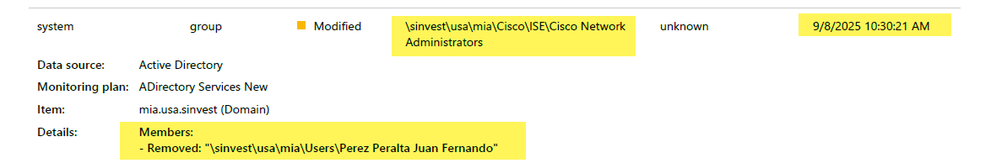
Source: BSI.IT.27.C7_E04_Q3_2025.xlsx, tab 2_Cisco Network Administrators, REVOCATION EVIDENCE, row 2964
Exhibit A2 - MIA25142 Nieves Nieves removed from Cisco Network Administrators - 09/02/2025 12:15:24 PM
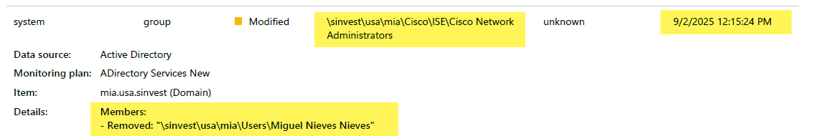
Source: BSI.IT.27.C7_E04_Q3_2025.xlsx, tab 2_Cisco Network Administrators, REVOCATION EVIDENCE, row 2977
Exhibit A3 - MIA25172 Hernandez Ruiz removed from Cisco Network Administrators - 09/02/2025 12:25:24 PM (account in 'Inactive AD Accounts')
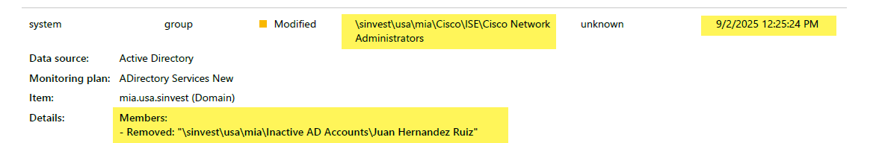
Source: BSI.IT.27.C7_E04_Q3_2025.xlsx, tab 2_Cisco Network Administrators, REVOCATION EVIDENCE, row 2991
Exhibit A4 - MIA25175 Hernandez Acevedo removed from Cisco Network Administrators - 09/08/2025 10:18:22 AM
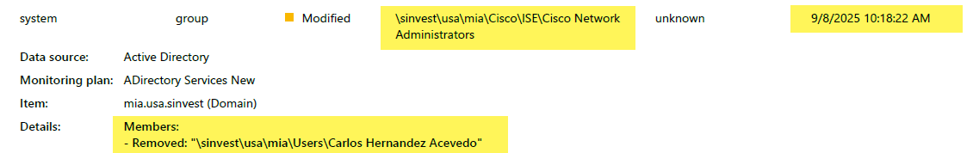
Source: BSI.IT.27.C7_E04_Q3_2025.xlsx, tab 2_Cisco Network Administrators, REVOCATION EVIDENCE, row 3005
Exhibit A5 - X453396 Perez Peralta removed from ISEAdmin - 09/08/2025 10:30:21 AM
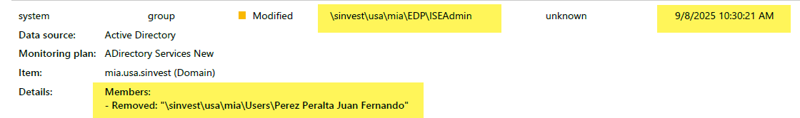
Source: BSI.IT.27.C7_E04_Q3_2025.xlsx, tab 3_ISEAdmin, REVOCATION EVIDENCE, row 2965
Exhibit A6 - MIA25142 Nieves Nieves removed from ISEAdmin - 09/02/2025 12:15:24 PM
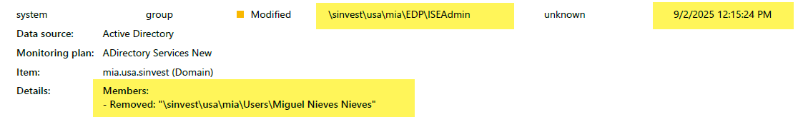
Source: BSI.IT.27.C7_E04_Q3_2025.xlsx, tab 3_ISEAdmin, REVOCATION EVIDENCE, row 2977
Exhibit A7 - KEY EXHIBIT - All four ADDED to ISEAdmin by 'system' - 09/10/2025 2:33:04 AM
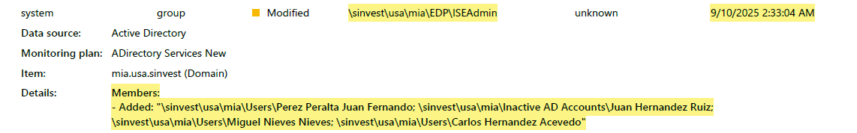
Source: BSI.IT.27.C7_E04_Q3_2025.xlsx, tab 3_ISEAdmin, REVOCATION EVIDENCE, row 3108 (management note in cell A3107)
Reading Exhibit A7: 'Members: - Added' lists Perez Peralta Juan Fernando (X453396), Juan Hernandez Ruiz (MIA25172, still in 'Inactive AD Accounts'), Miguel Nieves Nieves (MIA25142) and Carlos Hernandez Acevedo (MIA25175). The change was made by 'system' from an 'unknown' workstation at 2:33 AM, eight business days after the revocation decision.
Exhibit A8 - Comparison - same 'system' account adding X842395 (Fernandez Yanez Xochitl) to Cisco Network Administrators at 2:32:54 AM on 08/30/2025
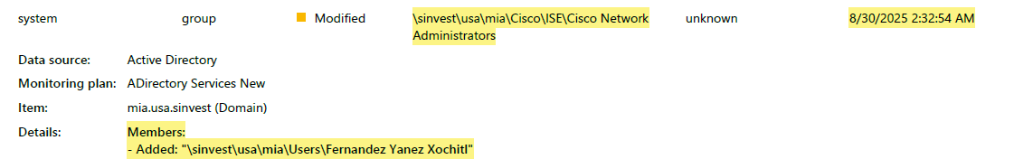
Source: BSI.IT.27.C7_E04_Q3_2025.xlsx, tab 2_Cisco Network Administrators, REVOCATION EVIDENCE, row 3152
Exhibit A8 shows the same pattern (actor 'system', about 2:30 AM) on another date. Together with A7 this suggests a scheduled process adds members to these privileged groups. Management to identify it.

Appendix B - Fieldglass evidence (E10)
Screenshots received from Ana Belloso (BSI Procurement) on 10/29/2026 9:52 AM EDT, embedded in the e-mail 'RE: Request for Fieldglass Evidence - BSI.IT.27.C7 Testing'. The first card in each screenshot is the current Worker record (Status, Worker ID, Period, Reference). Note the Job Seeker 'Submitted 2026-09-29' and the Rev.18 work orders starting 2026-09-29.
Exhibit B1 - MIA25103 - Ramirez Gonzalez, Ivan: worker SANWK00016501 Open 2024-01-01 to 2027-02-28; ref 100531048
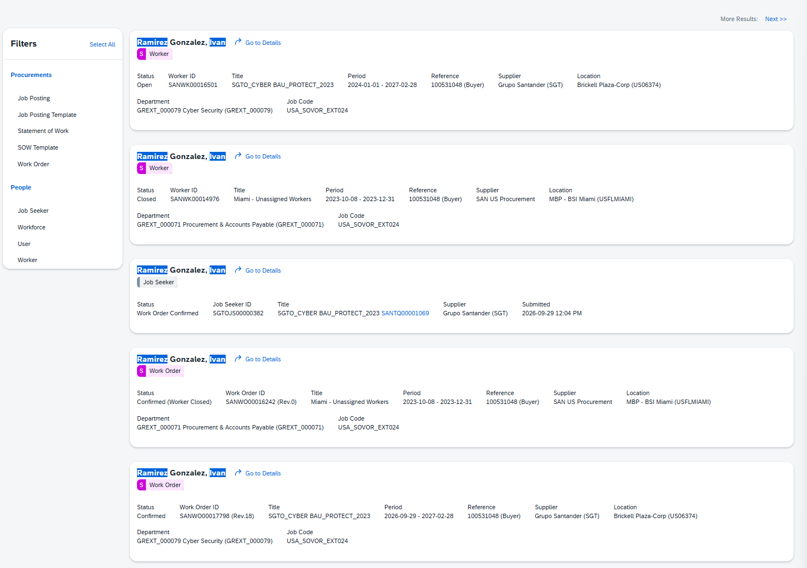
Source: BSI.IT.27.C7_E10_Fieldglass Evidence 10-29-2026.msg, inline image001.png
Exhibit B2 - MIA25104 - Paez Venegas, Jefferson: worker SANWK00016508 Open 2024-01-01 to 2027-02-28; ref 100531049
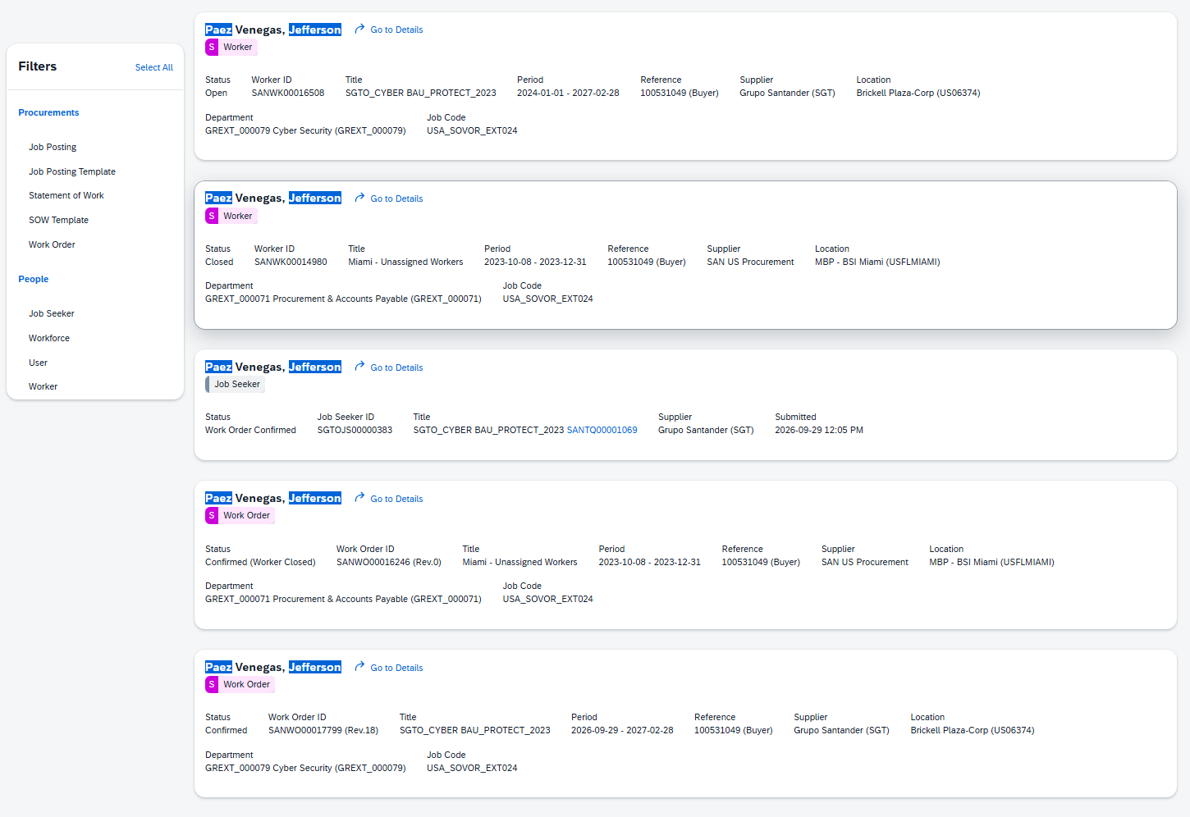
Source: BSI.IT.27.C7_E10_Fieldglass Evidence 10-29-2026.msg, inline image002.png
Exhibit B3 - MIA25105 - Serrano Aguirre, David: worker SANWK00016502 Open 2024-01-01 to 2027-02-28; ref 100531050
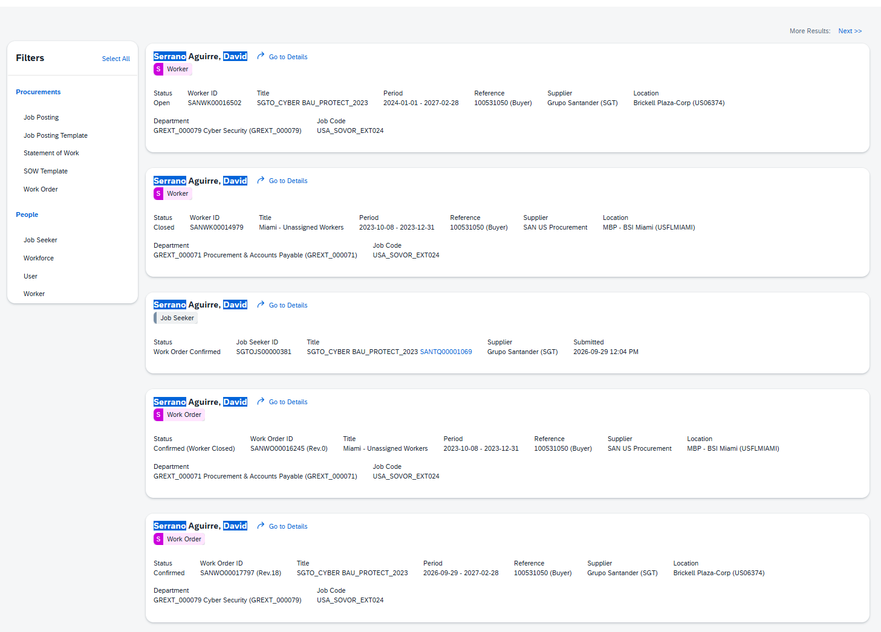
Source: BSI.IT.27.C7_E10_Fieldglass Evidence 10-29-2026.msg, inline image003.png
Exhibit B4 - MIA25106 - Vazquez Arias, Maiko: worker SANWK00016503 Open 2024-01-01 to 2027-02-28; ref 100531051
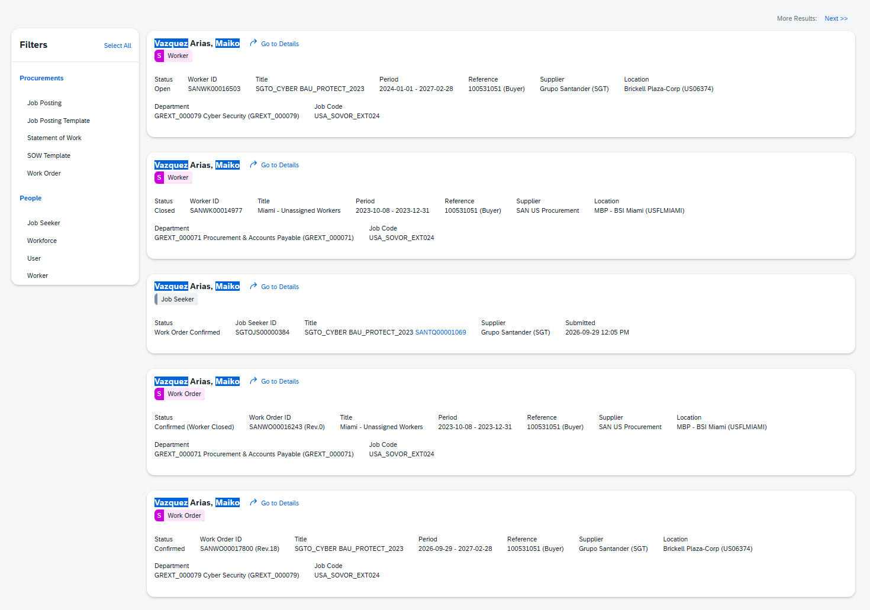
Source: BSI.IT.27.C7_E10_Fieldglass Evidence 10-29-2026.msg, inline image004.png
Exhibit B5 - MIA25249 - Harris, Richard: worker SANWK00016311 Open 2023-12-28 to 2027-02-28; ref 100592069; also Employee n222712
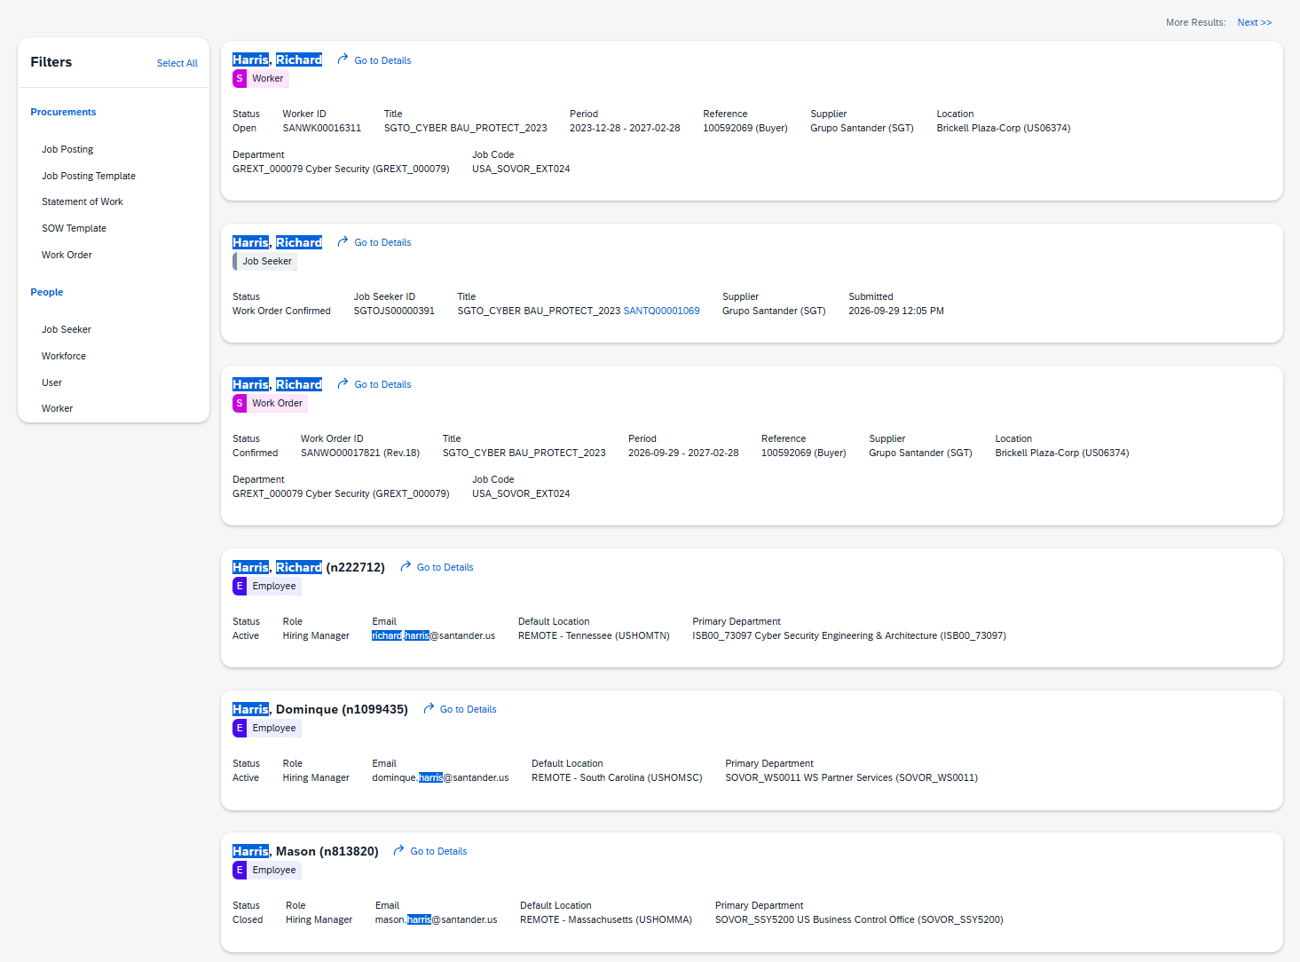
Source: BSI.IT.27.C7_E10_Fieldglass Evidence 10-29-2026.msg, inline image005.png
Exhibit B6 - MIA25250 - Ackley, Kevin: worker SANWK00016313 Open 2023-12-28 to 2027-02-28; ref 100592068; also Employee n67450
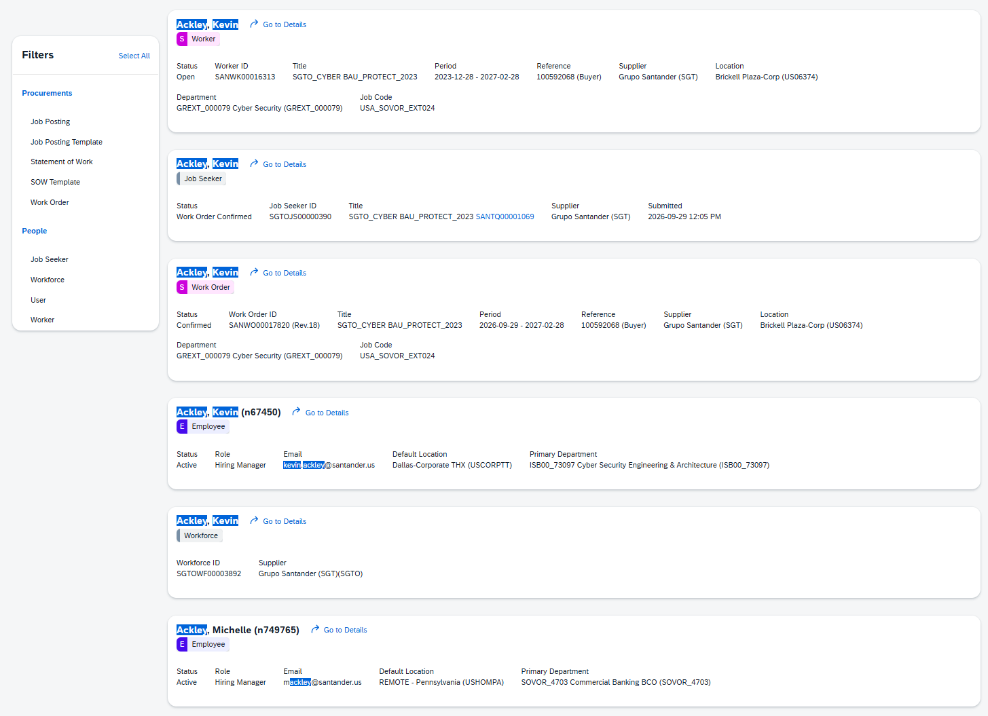
Source: BSI.IT.27.C7_E10_Fieldglass Evidence 10-29-2026.msg, inline image006.png

Appendix C - Evidence locator
Ref | File | What it contains
E01a | BSI.IT.27.C7_E01a_IAM Standard v10.0.pdf | IAM Standard approved 09/29/2025 (policy criteria)
E02 | BSI.IT.27.C7_E02_PAM Recertification Procedure (BSI) 04.22.26.pdf | PAM Procedure v2.0; CISO contact p.13
E04 | BSI.IT.27.C7_E04_Q3_2025.xlsx | 2025 Q3 SanIAM decisions; AD extract 11/25/2025 (with MemberOf); Netwrix captures
E05 | BSI.IT.27.C7_E05_Q1 2026 Cert.xlsx | 2026 Q1 SanIAM decisions; AD extract 05/15/2026 (OU, whenChanged, lastLogon, Description, MemberOf)
E07 | BSI.IT.27.C7_E07_C7.Sample.xlsx | Management response: 2026 Q2 SOX and CyberArk certifications; AD users 10/10/2026
E10 | BSI.IT.27.C7_E10_Fieldglass Evidence 10-29-2026.msg | Fieldglass e-mail and screenshots
WP | BSI.IT.27.C7_Reperformance_Final_Conclusions_10_Accounts.xlsx | Re-performance workbook: conclusions, SLA formulas, corrections, observations

