BSI.IT.27.C19 Break Glass Authorization
Analysis of the reviewer's proposed finding: evidence, C7 cross-reference, policy and RCSA methodology
Item | Detail
Control | BSI.IT.27.C19 Break Glass Authorization (Key, Manual, frequency: In every operation)
Control statement | Prior to creation of a break glass account or entitlements by the access management team, either the S-CISO, CIO, Head of Infrastructure or delegate approves break glass access and invocation of the break glass procedure.
Risk | BSI.IT.27.R6 Emergency Access: the inability to recover systems or operations due to a failure to manage emergency accounts may result in prolonged business disruptions, financial loss, and regulatory noncompliance. Inherent risk: Critical. Residual: High.
Control owner / executor | Dayam Borges (S-CISO). AD owner: Zoila Rosario.
Test period under review | 03/31/2026 – 08/30/2026 (WP2 population timeframe)
Methodology applied | CUSO RCSA Testing Procedure v1.0 (approved 07/17/2026) and CUSO RCSA CDA Testing Job Aid v1.0
Prepared | 11/02/2026, for the tester's response to reviewer challenge

1. Conclusion: is it appropriate for the reviewer to say there is a finding?
Yes. A finding is appropriate and supported by evidence. It should not be based on the assumption that unidentified break glass accounts were created. It should be based on what the C7 evidence shows.
• Break glass account used during the test period. The AD extracts in the BSI.IT.27.C7 package (C7 E05, Q1 2026 Cert) show that miabackup, a break glass account on management's own list, recorded a logon on 05/09/2026 at 18:31:57 (a Saturday). This is inside the C19 test period. Management confirmed that "No Break Glass event has occurred at BSI for the period 03/31/2026 – 8/31/2026". There is no ServiceNow incident and no CISO/CIO approval for this activity, and the Splunk query did not detect it.
• Password not rotated. The same extract shows the miabackup password was last set on 06/08/2023, with password never expires = True. Break Glass Procedure v6.0 §4.3 requires quarterly rotation even if no event occurs, and a reset after every event. IAM Standard SUS.IAMS.4.2.1.10 requires service account passwords to be rotated regularly and held in the PAMS.
• Break glass account also used for routine work. miabackup is described in AD as "Generic account - User Account for System Backups" and is in Backup Operators, Service_Accounts, Exchange groups, Domain Admins and Enterprise Admins. Because it doubles as a routine service account, a break glass use cannot be told apart from routine activity. That makes the IAM Standard SUS.IAMS.4.2.1.6 requirement that "Break glass activity must be monitored" impossible to meet, and is why the Splunk and ServiceNow evidence came back empty.
Under the RCSA Testing Procedure:
• the zero population cannot be accepted (§4.4.1: inquiry cannot be the sole basis; Appendix G §8.7.2.4: the approach must "reasonably detect an issue if one existed"), and
• the 05/09/2026 activity is a potential testing exception. The tester must evaluate its nature and root cause (§4.4.8.1) and communicate it to the BU BCO and Control Owner within 5 business days (§4.4.8.4, §4.8.1.3).

1.1 What the finding should and should not say
Reviewer position | Supported by evidence? | Basis
Break glass accounts were created in the period but cannot be identified | No | All four listed accounts existed before the period: miabackup created 11/19/2004, MIAEAVAULT 05/28/2020, and pws_root certified in SanIAM in 2025 Q2. No evidence shows a new break glass account was created. An exception cannot rest on an assumption (RCSA §4.4.6: exceptions must be supported by evidence; §4.4.8.4: document the nature, evidence and root cause).
Splunk and ServiceNow evidence does not identify the break glass accounts | Yes | Splunk filters on EventCode 4720 (account creation) and user_name="*$*", which no break glass account name matches. ServiceNow searched sc_req_item, but Procedure §4.2(2) requires an incident. Under RCSA Appendix F, these are custom reports with "incorrect logic or filters" and an incomplete population.
There is a finding | Yes, reframed | There is direct system evidence of break glass account activity in the period (05/09/2026) with no approval or incident. There is also documented non-compliance with the procedure's password rotation and monitoring requirements. See section 7 for how the finding should be worded under each root cause.

2. Evidence reviewed

2.1 C19 evidence (process owner and cyber)
Ref | Document | Source / date | Period covered
C19-A | CyberArk Break Glass Procedure, Version 6.0 (3 identical copies; MD5 c30961e7…) | Information Security; v6.0 dated 10/06/2025 | Current
C19-B | Email "CyberArk Break Glass – RCSA Evidence" (attestation, account list, PAM0023 screenshot) | Zoila Rosario to Edward Morfa, 09/16/2026 | 03/31/2026 – 08/31/2026
C19-C | PAM0023 metric screenshot (BSI.IT.27.C19.03-PAM002_1) | Value Submissions; Provider O. Ortiz; Approver R. Burden | As-of 12/31/2025 – 08/31/2026
C19-D | Email "RE: Request for Splunk Screenshots – Break Glass Account Review" (2 Splunk screenshots) | E. Heredia 10/19/2026; O. Ortiz 10/22/2026 | 07/01–09/30/2026 and 09/01/2025–09/30/2026
C19-E | BSI.IT.27.C19 – ServiceNow Query (Additional Supporting Evidence), 3 screenshots | Run by O. Ortiz, 10/15/2026, 12:59–1:08 AM | 04/2025–09/2026; 07/2025–06/2026; 07/2026–10/15/2026
C19-F | WP2 BSI.IT.27.C19 Break Glass Authorization v2.xlsm (prior cycle CDA and CPA) | A. Rojas / A. Munoz Henry; test date 06/26/2025 | 10/01/2024 – 04/30/2025

2.2 Policies and procedures
Ref | Document | Version / date | Relevant requirement
P1 | CUSO Identity and Access Management Standard | v10.0 (09/29/2025), in force for most of the period; v11.0 (07/28/2026) | SUS.IAMS.4.2.1.6 Temporary Access (break glass); 4.2.1.10 Service Accounts; 4.2.5 Privileged Access Review; 4.2.6.1 Access Logging
P2 | CyberArk Break Glass Procedure | v6.0 (10/06/2025) | §4.1 pre-authorization; §4.2 incident and monitoring; §4.3 reset and quarterly rotation; §6 exceptions; §7.2 sign-off
P3 | PAM Definition of Privilege (BSI) | Current | "The office of CIO / CISO will review and approve break glass requests based on the incident." KPI reporting (PAM0023)
P4 | PAM Recertification Procedure (BSI) | 04/22/2026 | Quarterly entitlement-owner certification of non-person (service) accounts via SanIAM
R1 | CUSO RCSA Testing Procedure | v1.0, approved 07/17/2026 | §4.1.3, 4.3.1, 4.3.3, 4.4.1, 4.4.3, 4.4.6–4.4.8, 4.6.1, 4.7.1, 4.8, Appendix F, Appendix G
R2 | CUSO RCSA CDA Testing Job Aid | v1.0 (approved 07/17/2026; owner L. Femiano 08/27/2026) | §2.2 CDA readiness, §2.3 prior testing, §4.2 HERACLES questions, §4.7 Weak CDA, Appendix B EASE "CDA – No Population"

2.3 Cross-referenced BSI.IT.27.C7 evidence (PAM recertification package)
These system-generated files were already obtained by RCTT for BSI.IT.27.C7. They contain Active Directory attributes and SanIAM certification decisions for the same break glass accounts. Under RCSA §4.4.7, testers must consider all relevant information when evaluating performance.
Ref | C7 file | What it contains
C7-E04 | BSI.IT.27.C7_E04_Q3_2025.xlsx (tabs 1–4) | AD user extract: whenCreated, lastlogondate, PasswordLastSet, MemberOf
C7-E05 | BSI.IT.27.C7_E05_Q1 2026 Cert.xlsx (tabs 1–4) | AD user extract taken after 05/15/2026: whenChanged, lastLogon, passwordlastset, passwordneverexpires, Description, MemberOf; plus SanIAM Q1 2026 SOX entitlement-owner decisions (04/30/2026)
C7-E06.12 | SanIAM source files S10, S12, S14, S16 | 2025 Q2 and 2026 Q2 PAM BSI SOX and CyberArk entitlement-owner certifications (miabackup, MIAEAVAULT, PWS_ROOT)
C7-E07 | BSI.IT.27.C7_E07_C7.Sample.xlsx, tab Oct10_2026Users | AD enabled status at 10/10/2026, with the employeeNumber of the owner

3. Inspection of each C19 evidence item
Ref | What it shows | What it does not show | Reliance under RCSA
C19-B Attestation | Four break glass accounts: miabackup (Domain Admin), MIAEVAULT (Enterprise Admin), pws_root (Miasx1/T24), root (miaecowas/e-Banking). Same as last year. No new accounts. No break glass event 03/31–08/31/2026. | Inquiry only. The account name "MIAEVAULT" does not exist in AD. The AD account is MIAEAVAULT ("CyberArk EnterpriseAdmins"). The email does not mention that miabackup is also a routine backup service account. | §4.4.1: "Inquiry… must not be relied upon as the sole basis for concluding on operating effectiveness." Contradicted by C7-E05 (logon 05/09/2026).
C19-C PAM0023 | "Privileged production installed break glass provisioning events which are not de-provisioned within SLA": numerator 0, Green, approved, for each month-end 12/31/2025 – 08/31/2026. | The denominator (V2) is blank, so the number of events is not shown. The metric measures de-provisioning timeliness, not approval. Use of standing accounts, where nothing is provisioned, is outside what it measures. | Corroborative only. Not designed to detect use of standing break glass accounts.
C19-D Splunk | index="siem-na-authentication" ac="SPB Miami*" EventCode=4720 user_name="*$*". 0 events for 07/01–09/30/2026 and for 09/01/2025–09/30/2026. | 4720 is "user account created", not logon (4624/4648/4672) or privileged group addition (4728/4732/4756). The *$* filter cannot match miabackup, MIAEAVAULT, pws_root or root. The Windows index does not cover the Unix root and pws_root accounts. Run after the period, with no reviewer evidence. | Appendix F: custom report with "incorrect logic or filters applied". Appendix G §8.7.2.4: the approach would not "reasonably detect an issue if one existed". It cannot be relied on to show completeness.
C19-E ServiceNow | Requested Items (sc_req_item) for company SPB Miami with keyword variants of "break glass", or item name Breakglass. No records in any of the 3 date ranges. Filter, user and timestamp are visible. | Procedure v6.0 §4.2(2) and §4.3(3) require a ServiceNow incident, which is a different table. No search on account names or "CyberArk outage". | Parameters are documented (meets Appendix F step 4), but the source table does not match the control (fails step 5).
C19-A Procedure v6.0 | Owner: CISO. Pre-authorization of IT Ops Manager. ServiceNow incident. IAM/PAM monitoring. Reset after event. Quarterly rotation. Exceptions approved by CISO. | §7.2 sign-off table is blank. Does not address creation of new break glass accounts or entitlements. Passwords are kept on the CISO, CIO and IT Ops Manager mobile phones. | Job Aid §2.3: record version, date, section and location. CDA Q3 alignment is assessed in section 5.
C19-F Prior WP2 (2025) | CPA "Not Tested" with population 0. CDA Satisfactory. Relied on Netwrix (C19.04) and Linux account tickets (C19.05) for completeness. | The CDA narrative describes a superseded procedure ("email or any kind of written authorization from the CISO or CIO"; two network scenarios). The current cycle has no Netwrix or Linux equivalent. | Job Aid §1: "Do not copy prior testing responses, or prior testing conclusions without current analysis and supporting evidence."

4. Cross-reference to BSI.IT.27.C7 evidence: break glass account facts
The table compares AD attributes and SanIAM decisions for each break glass account across the C7 files. Cells shaded red contradict the C19 attestation or the procedure.
Account | Attribute | C7 source | Value | Significance for C19
miabackup | lastLogon | C7-E05 (Q1 2026 Cert, tabs 1–4) | 2026-05-09 18:31:57 (Saturday); whenChanged 2026-05-09 17:47:34 | Activity on a break glass account inside the test period (03/31–08/30/2026). No incident, approval or Splunk hit, and the attestation says no event.
miabackup | passwordlastset / passwordneverexpires | C7-E04 and C7-E05 | 2023-06-08 09:39:06 in both the Q3 2025 and Q1 2026 extracts; PNE = True | No rotation for about 3 years. Breaches Procedure v6.0 §4.3 (quarterly rotation, and reset after each event) and IAM SUS.IAMS.4.2.1.10. If the 05/09/2026 activity was a break glass invocation, the password was not reset afterwards.
miabackup | Description / MemberOf | C7-E05 | "Disabled via SANIAM - TERM on 2021-08-08 | Generic account - User Account for System Backups". Groups: Service_Accounts, Backup Operators, Administrators, Enterprise Admins, vSphere Administrators, Exchange Services, Organization Management | Same account is both a break glass account and a routine backup service account, so break glass use cannot be isolated or monitored. It was disabled at termination in 2021 and later re-enabled; approval for re-enablement is not evidenced.
miabackup | lastlogondate | C7-E04 (Q3 2025) | 2025-11-23 12:04:47 (Sunday) | Shows recurring use outside business hours. This is consistent with backup jobs, or undocumented break glass use.
miabackup | AD manager / SanIAM owner | C7-E05, C7-E06.12, C7-E07 | AD manager: Guillermo Fuentes (OU=Separated Employees). SanIAM owner: Ian Rojo (IT Ops Manager), Approved 06/04/2025 and 07/28/2026 | Account is certified as needed. IAM 4.2.5 says "Each system or service account must be the responsibility of one workforce member", but the AD ownership attribute is stale.
miabackup / PWS_ROOT / MIAEAVAULT | SanIAM Account Status | C7-E06.12 S14, S16 (2026 Q2) | "Account Removed", yet the decision is Approved. C7-E07 shows miabackup and MIAEAVAULT enabled on 10/10/2026 | Inconsistency between SanIAM and AD. Clarify with PAM team. Affects the reliability of the C7 population too.
MIAEAVAULT (listed as "MIAEVAULT") | Description / password / logon | C7-E04, C7-E05 | "CyberArk EnterpriseAdmins – Service account used in CyberArk to connect with Enterprise Admins rights". pwdLastSet 2025-11-20 and then 2026-04-30; lastLogon 2026-04-23 | Used and rotated by CyberArk, which is expected for a CPM or reconcile account. Account name in the attestation is wrong. The gap between rotations (11/20/2025 to 04/30/2026, 161 days) exceeds a quarter.
pws_root (Miasx1, T24) | SanIAM entitlements | C7-E05, C7-E06.12 S10/S14/S16 | UID 0 / GID 0 / root group. Certified Approved by Dayam Borges (04/30/2026, 07/27/2026). CyberArk safe Globus_Managed_Accounts_Root (E. Heredia) | Vaulted in CyberArk. No logon or password data in C7. Unix logs are needed. The CISO who approves break glass use is also the entitlement owner who certifies this account (segregation-of-duties observation).
root (miaecowas, e-Banking) | - | Not in C7 files | Only CyberArk sudo entitlements (miacark ALL=(root)) appear | No evidence either way. Unix logs are needed.

Caveat to state in the workpaper. AD lastLogon is recorded per domain controller. It records network, batch and service logons as well as interactive ones. The 05/09/2026 entry proves the account authenticated in the period, but it does not on its own prove a human break glass invocation. Under RCSA §4.4.8.1 the tester must establish the nature and cause before rating. The decisive evidence is the domain controller security log (EventCode 4624) for 05/09/2026, showing logon type (2/10 = interactive or RDP; 4/5 = batch or service) and the source host.

5. Policy and procedure inspection: requirement against evidence
Requirement (quoted) | Source | Evidence | Assessment
"Break glass access must be approved by s-CISO or Chief Information Officer ("CIO") Infrastructure or delegate through a ticket request or incident ticket." | P1 SUS.IAMS.4.2.1.6 (v10.0 and v11.0) | Procedure §4.1 gives standing pre-authorization to the IT Ops Manager. The CISO/CIO is only notified. No ticket or incident for the 05/09/2026 activity. | Not aligned. Per-ticket approval is not designed into the procedure.
"Break glass activity must be monitored." | P1 SUS.IAMS.4.2.1.6; P2 §4.2(3) | The Splunk query does not target the accounts. miabackup's routine backup use masks break glass use. The 05/09/2026 logon was not identified by cyber. | Not met in practice.
"Access must be removed when it is no longer needed." | P1 SUS.IAMS.4.2.1.6 | Break glass accounts are standing and always enabled. miabackup has been enabled since re-enablement after its 2021 TERM disable. | Design accepts standing accounts. Acceptable only if vaulted, rotated and monitored, which is not the case here.
"The IAM/PAM Information Security representative will reset the passwords for all accounts… Breakglass accounts passwords will be rotated on a quarterly basis even if no event occurs." | P2 §4.3(2), introduced v5.0 05/20/2024 | miabackup pwdLastSet = 06/08/2023, unchanged through the Q1 2026 extract (after 05/15/2026). | Non-compliant. No rotation for about 12 quarters, and no reset after the 05/09/2026 activity.
"The password of the account must be rotated regularly and must be custody through the approved PAMS." | P1 SUS.IAMS.4.2.1.10 Service Accounts | miabackup is vaulted in CyberArk safe Windows_Servers_Accounts (C7-E06.12 S12/S16), but the CPM has not changed the password since 2023. PNE = True. | Non-compliant.
"The IT Operations representative will create an incident on ServiceNow to document the BreakGlass event." | P2 §4.2(2), §4.3(3) | The incident table was not queried. No incident is known for 05/09/2026. | Cannot be confirmed. Request an incident-table query.
"The office of CIO / CISO will review and approve break glass requests based on the incident." | P3 Reporting & Escalation | Same as above. KPI PAM0023 is reported as 0. | Not evidenced for 05/09/2026.
"Exceptions to this Procedure will be approved by the CISO… Evidence of approval of the exception by the CISO." | P2 §6 | No documented exception for using miabackup as a backup service account, or for keeping its password static. | If management says this is accepted, ask for the CISO exception approval.
Procedure "approved by the Santander BSI CISO and CIO" and reviewed annually | P2 §1.3, §7.2 | The §7.2 sign-off table (CISO, CIO, IT Ops Manager) is blank on v6.0. | Approval not evidenced. Request it.
"Each system or service account must be the responsibility of one workforce member." "All privileged access generic accounts must be assigned to a supervisor… The user behind each access must be identified." | P1 §4.2.5 (Privileged Access Review) | SanIAM owner is Ian Rojo, but the AD manager is a separated employee. Passwords are on three mobile phones, so the individual using the account is not identifiable from AD. | Partially met. Individual accountability for break glass use is not traceable.
Account creation, removal and entitlement changes "must be logged and kept for future audit… including approvals". | P1 SUS.IAMS.4.2.6.1 | No Netwrix or AD change log was provided for the period. In the prior cycle these were provided as C19.04 and C19.05. | Not evidenced this cycle.

6. RCSA methodology: what the guidelines require for this situation
RCSA requirement | Reference | Application to C19
"Inquiry may be used to support understanding but must not be relied upon as the sole basis for concluding on operating effectiveness." | R1 §4.4.1 | The zero population rests on the 09/16/2026 email. The corroborating Splunk and ServiceNow items do not test the right events, so the conclusion is effectively inquiry-only.
"The population is complete, accurate, and aligned to the control scope and testing period… The overall approach would reasonably detect an issue if one existed. If the population… is not appropriate, the results of testing cannot be relied upon." | R1 App. G §8.7.2.4 | The reviewer is correct to challenge. The C7 AD extract shows an event the C19 approach missed.
Custom reports: "Understand how the report logic aligns to the control objective… Identify key filters". Risk: "Incorrect logic or filters applied". Population risk: "Incomplete population or missing records". | R1 App. F §8.6.1, §8.6.3 | Splunk (EventCode 4720, *$*) and ServiceNow (sc_req_item) both fail the logic and filter test for this control.
"In cases where control has no population during the testing period, CPA cannot be performed. The absence of a population should be documented, and prior testing results may be considered where appropriate." EASE status "CDA – No Population". | R1 §4.4.3, §4.1.3, §4.3.1; R2 §2.2, App. B | Available only if the absence of a population is supported. It is contradicted here, so "No Population" is not an appropriate status until the 05/09/2026 activity is explained.
"If testing exceptions are identified… Testers must evaluate… the nature and cause… frequency and extent… whether isolated… impact." "A thorough understanding of the root cause… is required." | R1 §4.4.8.1 | Obtain the 4624 logon details for 05/09/2026 and management's explanation before the rating is final.
"All testing exceptions must be documented… and communicated to the BU BCO and Control Owner for review and agreement prior to initiation of the Issue Management process." SLA: RCTT communicates within 5 business days; BCO/FLoD responds within 5 business days. | R1 §4.4.8.4, §4.3.6, §4.8.1.3 | Send a formal potential-exception notice to Dayam Borges (Control Owner) and the BU BCO, citing C7-E05 and the procedure clauses. Get written agreement before logging.
"If any of the first three (3) HERACLES questions are answered 'No', testers must assign a Weak design rating." | R1 §4.3.3; R2 §4.2 | Q2 (audit trail): break glass use is not distinguishable or evidenced. Q3 (policy alignment): procedure pre-authorization versus SUS.IAMS.4.2.1.6 per-ticket approval, and rotation not performed. Either "No" gives a Weak CDA.
"Where the CDA was rated Weak, the tester should mark the CPA workpapers 'Not Tested – Pending Remediation.'" | R1 §4.3.6 | Applies if the finding is raised as a design deficiency (scenario B in section 7).
"Do not copy prior testing responses, or prior testing conclusions without current analysis and supporting evidence." | R2 §1 | The 2025 CDA narrative and the "considered Effective based on prior testing" wording must not be carried forward unchanged.
Escalate "Insufficient or unavailable evidence to support testing conclusions" and "Disagreements with Control Owners or BU BCOs regarding control design… or control ratings". | R1 §4.6.1 | If management cannot produce logon or incident evidence, or disputes the finding, escalate to RCTT management (and ORWG/ORC if unresolved).
QA "Does Not Conform": "Insufficient or inappropriate evidence to support conclusions"; "Incorrect population… impacting testing validity"; "Errors that would result in an incorrect control rating." | R1 §4.7.1 | A No Population / Effective conclusion on the current evidence would likely be rated Does Not Conform at QA.
Population timeframe: semi-annual for Critical or High inherent risk. "The start date of the timeframe would be the next day after the last day of the previous testing timeframe." | R1 §4.1.2, §4.4.2 | The prior timeframe ended 04/30/2025. The current one starts 03/31/2026. Confirm a cycle covered 05/01/2025 – 03/30/2026. If not, extend the population and evidence to that range. The C7-E04 logon on 11/23/2025 falls in that gap.

7. How to conclude: root-cause scenarios and resulting rating
Scenario (based on 4624 log for 05/09/2026) | Finding type | CDA | CPA | Issue / Action Driver
A. Human break glass use (logon type 2/10, an admin workstation source, no incident or approval) | Operating exception. Break glass invocation without prior CISO/CIO approval or a ServiceNow incident, and no password reset afterwards. | Q3 "No" (pre-authorization design versus SUS.IAMS.4.2.1.6). Weak. | Population ≥ 1, sample fails key attribute "CISO/CIO approval of invocation". Weak (event-driven control; for population ≤ 1, any exception fails, per the §4.4.8.2 table). | Action Driver: approve and evidence each invocation; incident-table discipline; reset after use; monitoring alert.
B. Routine backup or service logon (logon type 4/5 from the backup server) | Design deficiency. A break glass account is also used for BAU, its password has not been rotated since 06/08/2023 (PNE), and break glass use cannot be monitored or separated from routine use. | Q2 "No" (no audit trail separating break glass use); Q3 "No" (Procedure §4.3, IAM 4.2.1.6 and 4.2.1.10). Weak per §4.3.3. | "Not Tested – Pending Remediation" (§4.3.6). | Action Driver: dedicated break glass accounts not used for BAU; CPM quarterly rotation; Splunk alert on all break glass logons; procedure aligned to the IAM Standard and signed off.
C. Management cannot explain or evidence the logon | Insufficient evidence and a monitoring failure. The required monitoring (SUS.IAMS.4.2.1.6, Procedure §4.2(3)) is not operating. | Q2 "No". Weak. | Cannot conclude. Escalate under §4.6.1. | Action Driver on monitoring, plus escalation.

In every scenario a finding exists. The miabackup password rotation breach (06/08/2023) is a documented, system-evidenced non-compliance with Procedure v6.0 §4.3 that does not depend on the 05/09/2026 root cause. Which scenario applies determines whether the finding is an operating exception (A) or a design deficiency (B or C). It does not determine whether there is a finding.

7.1 Observations to report with the finding (not separate exceptions)
- Account name inaccuracy. The attestation lists "MIAEVAULT". AD holds MIAEAVAULT ("CyberArk EnterpriseAdmins"), which is a CyberArk-used service account. Confirm it is a break glass account and not the CPM reconcile account.
- Procedure sign-off. The v6.0 §7.2 approval table is blank.
- Account creation not covered. The procedure has no approval step for creating new break glass accounts or entitlements, which is the first trigger in the control statement.
- Credential custody. Passwords are stored on three corporate mobile phones (CISO, CIO, IT Ops Manager), so the user of each session cannot be individually identified (IAM §4.2.5).
- Segregation of duties. The S-CISO approves break glass use (C19) and is also the SanIAM entitlement owner who certifies MIAEAVAULT and pws_root (C7-E06.12).
- SanIAM / AD inconsistency. The 2026 Q2 certification shows "Account Removed" for accounts that AD shows enabled on 10/10/2026. This also affects BSI.IT.27.C7 reliance.
- Re-enablement after termination. miabackup was "Disabled via SANIAM - TERM on 2021-08-08" and later re-enabled. Approval for the re-enablement is not evidenced.

8. Evidence to request to finalize (SLA: 5 business days for evidence, 2 for follow-ups; RCSA §4.8.1.1)
# | Request | Owner | Purpose
1 | Domain controller Security log, EventCodes 4624, 4625, 4648, 4672, for miabackup on 05/09/2026 (and 11/23/2025): logon type, source workstation or IP, target host | Security Ops (E. Heredia) | Determines scenario A, B or C
2 | Same query for miabackup and MIAEAVAULT for the full period 03/31/2026 – 08/30/2026 (no *$* filter); EventCodes 4720, 4728, 4732, 4756 for privileged groups | Security Ops | Completeness of use and creation population
3 | ServiceNow incident table query: SPB Miami, 03/31–08/30/2026, keywords plus account names plus "CyberArk outage/unavailable". Also the incident or change record for 05/09/2026 if one exists | IT Ops / Cyber | Procedure §4.2(2)
4 | CyberArk: activity report for miabackup, MIAEAVAULT, pws_root and root (retrieve/show/use); CPM password change history; any CyberArk outage in the period | PAM team (O. Ortiz) | Shows whether credentials left the vault; rotation compliance
5 | Unix: `last root pws_root`, UID-0 list, sudoers for Miasx1 and miaecowas, 03/31–08/30/2026 | Unix admin | Coverage of Unix break glass accounts
6 | Management explanation of miabackup's dual use as a backup service account, the static password since 06/08/2023, and any CISO exception approval (Procedure §6) | Control Owner (D. Borges) | Root cause (RCSA §4.4.8.1)
7 | Signed approval of Break Glass Procedure v6.0 (CISO, CIO, IT Ops Manager) | InfoSec GRC (Z. Rosario) | CDA Q3
8 | Confirmation of testing coverage for 05/01/2025 – 03/30/2026 | RCTT lead | RCSA §4.4.2 continuity

9. Draft wording

9.1 Reply to the reviewer
Agreed that a finding is warranted. We recommend framing it on the system evidence rather than on assumed account creation. No new break glass account was created in the period: all four accounts pre-date it (miabackup 11/19/2004, MIAEAVAULT 05/28/2020; pws_root was already certified in 2025 Q2). However, the AD extract in the BSI.IT.27.C7 package (E05, Q1 2026 Cert) shows break glass account miabackup with a logon on 05/09/2026 18:31:57, inside the test period. That contradicts management's 09/16/2026 attestation of no break glass event and was not detected by the Splunk (EventCode 4720, *$*) or ServiceNow (sc_req_item) queries. The same extract shows the miabackup password has not been changed since 06/08/2023 (password never expires), contrary to CyberArk Break Glass Procedure v6.0 §4.3 (quarterly rotation and reset after use) and IAM Standard SUS.IAMS.4.2.1.10. Under RCSA Testing Procedure §4.4.1 and Appendix G §8.7.2.4, the zero population cannot be relied on. We are requesting the 05/09/2026 4624 logon details to set the root cause (§4.4.8.1) and will issue the potential-exception notice to the Control Owner and BU BCO within 5 business days (§4.4.8.4, §4.8.1.3).

9.2 Potential exception notice to Control Owner and BU BCO
Subject: BSI.IT.27.C19 Break Glass Authorization – potential testing exception (response due in 5 business days)
During testing of BSI.IT.27.C19 for 03/31/2026 – 08/30/2026, RCTT identified the following:
1. Break glass account miabackup (Domain/Enterprise Admin) recorded a logon on 05/09/2026 at 18:31:57 (AD extract, BSI.IT.27.C7 E05). No ServiceNow incident or CISO/CIO approval was provided for this activity. Management's confirmation dated 09/16/2026 states no break glass event occurred.
2. The miabackup password was last set on 06/08/2023 and is set to never expire. CyberArk Break Glass Procedure v6.0 §4.3 requires quarterly rotation and a reset after each event. IAM Standard SUS.IAMS.4.2.1.10 requires regular rotation through the PAMS.
3. miabackup is also used as the system backup service account, so break glass use cannot be told apart from routine activity. Break glass activity therefore cannot be monitored as required by SUS.IAMS.4.2.1.6 and Procedure §4.2(3).
Please provide: (a) domain controller 4624 events for miabackup on 05/09/2026 with logon type and source; (b) any related ServiceNow incident and CISO/CIO approval; (c) CyberArk CPM password history; (d) any CISO-approved exception under Procedure §6; (e) signed approval of Procedure v6.0.

9.3 CPA Summary of Results (use once the scenario is confirmed)
Testing method: Inspection (primary), supported by inquiry. Control type: Manual.
Management confirmed via email on 09/16/2026 that no break glass account was created and no break glass event occurred. RCTT did not rely on inquiry alone (RCSA §4.4.1). The supporting Splunk query (EventCode 4720, user_name containing "$") and ServiceNow query (Requested Items table) were not designed to detect use of the existing break glass accounts or break glass incidents. Cross-referencing to the Active Directory extract obtained for BSI.IT.27.C7 (E05) showed that break glass account miabackup logged on on 05/09/2026, within the test period, with no associated ServiceNow incident or CISO/CIO approval, and that its password has not been changed since 06/08/2023, contrary to CyberArk Break Glass Procedure v6.0 §4.3. [Scenario A: The logon was confirmed as interactive break glass use without prior approval; the key attribute 'CISO/CIO approval of invocation' failed and the control is rated Weak.] [Scenario B: The logon relates to routine backup activity; the break glass account is used for BAU and cannot be monitored as a break glass account; the CDA is rated Weak (Q2/Q3 'No') and the CPA is Not Tested – Pending Remediation.] The exception was communicated to the Control Owner and BU BCO on [date], agreed on [date], and Action Driver [ID] was raised.

Appendix A. C19 evidence screenshots
C19-D Splunk (E. Heredia, 10/19/2026), 07/01/2026 – 09/30/2026: EventCode=4720 user_name="*$*", 0 events
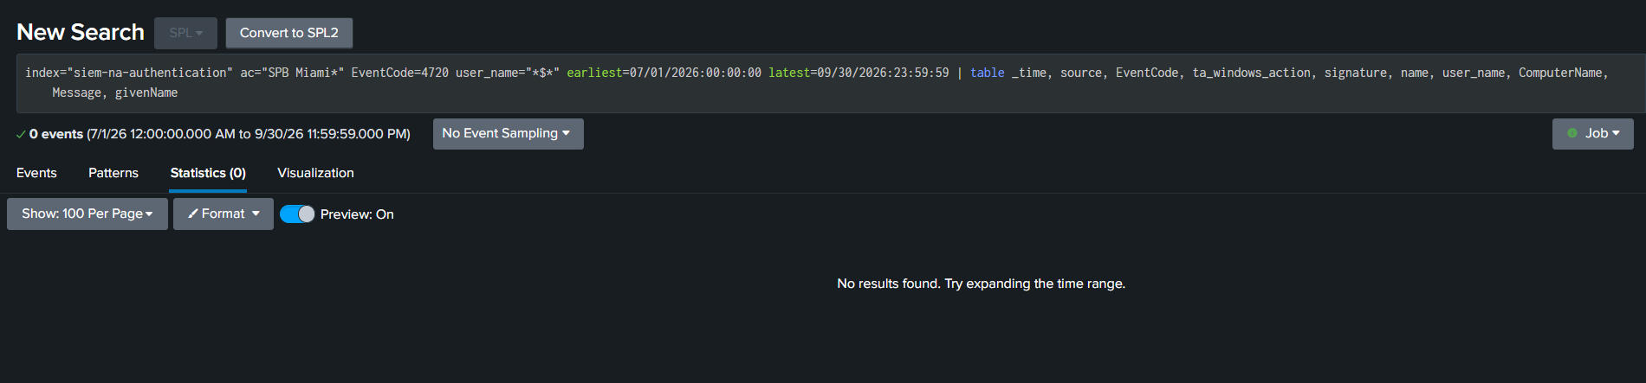

C19-D Splunk (O. Ortiz, 10/22/2026), 09/01/2025 – 09/30/2026: same filter, 0 events
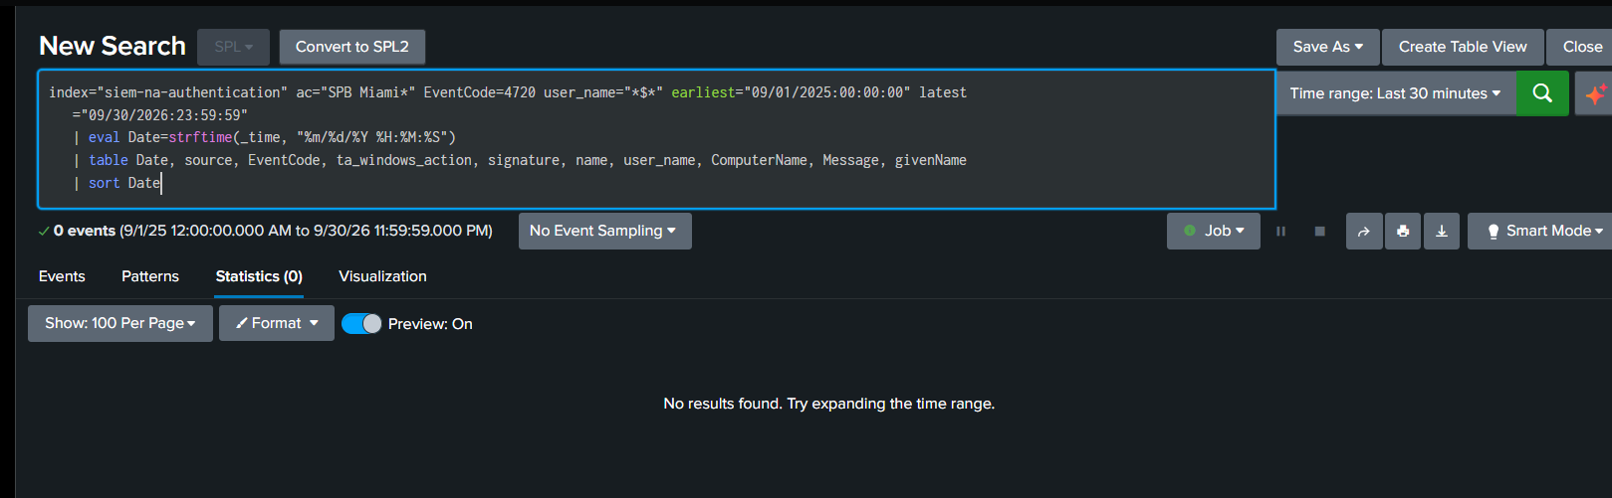

C19-C PAM0023 metric: numerator 0, Green, as-of 12/31/2025 – 08/31/2026; denominator blank
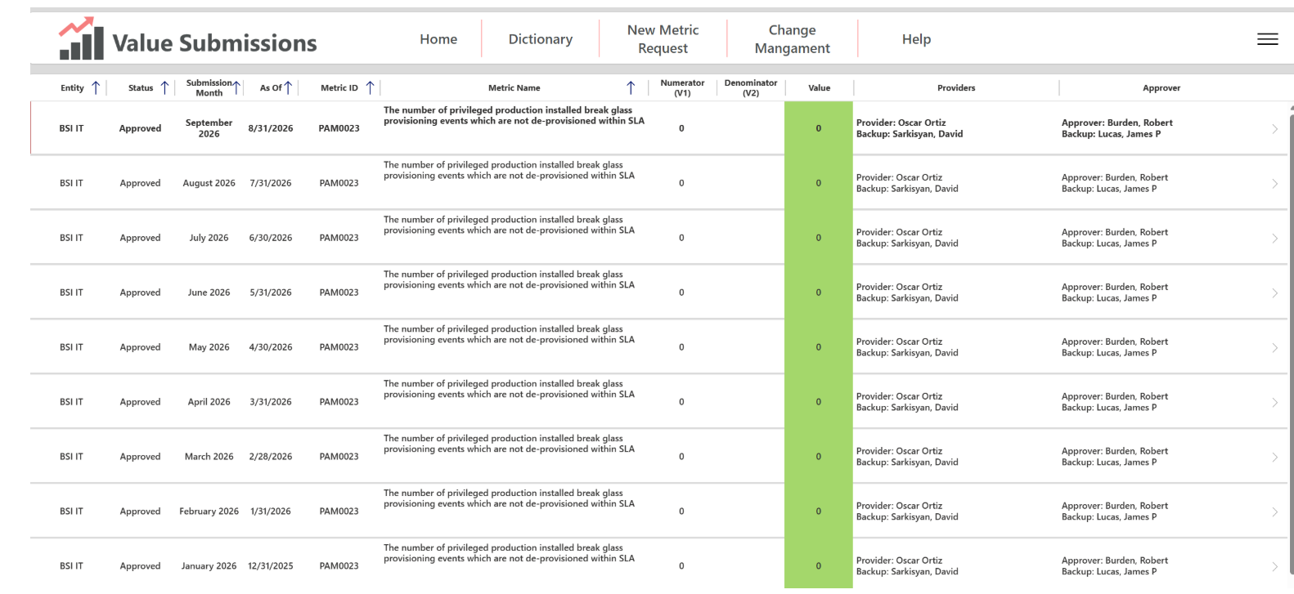

C19-E ServiceNow sc_req_item query, 04/01/2025 – 09/30/2026, run 10/15/2026: no records
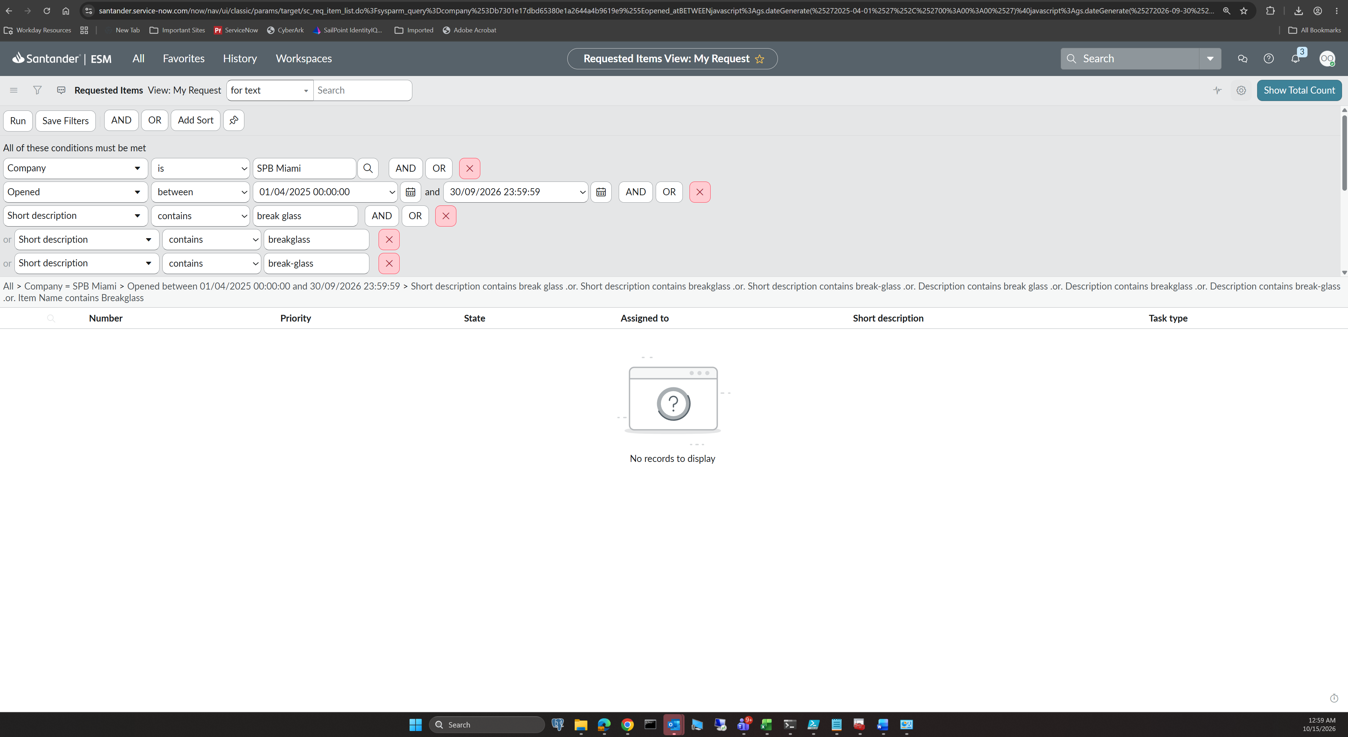

Appendix B. Key C7 data rows (verbatim extract)
File / tab | sAMAccountName | whenCreated | whenChanged | passwordlastset | PNE | lastLogon | Description
C7-E05 Q1 2026 Cert / tabs 1–4 | MIABACKUP | 2004-11-19 15:45:15 | 2026-05-09 17:47:34 | 2023-06-08 09:39:06 | True | 2026-05-09 18:31:57 | Disabled via SANIAM - TERM on 2021-08-08 | Generic account - User Account for System Backups
C7-E04 Q3 2025 / tabs 1–4 | MIABACKUP | 2004-11-19 15:45:15 | - | 2023-06-08 09:39:06 | - | 2025-11-23 12:04:47 (lastlogondate) | -
C7-E05 Q1 2026 Cert / tabs 1–4 | MIAEAVAULT | 2020-05-28 10:21:48 | 2026-05-15 10:08:07 | 2026-04-30 10:05:58 | True | 2026-04-23 10:05:01 | Generic Account - Service account used in CyberArk to connect with Enterprise Admins rights
C7-E04 Q3 2025 / tabs 1–4 | MIAEAVAULT | 2020-05-28 10:21:48 | - | 2025-11-20 08:59:41 | - | 2025-11-19 08:59:36 (lastlogondate) | -
C7-E07 Oct10_2026Users | MIABACKUP / MIAEAVAULT | - | - | - | - | - | enabled = True / True (owner employeeNumber 100046302 Rojo / 100046297 Borges)

