BSI.IT.27.C7 – Network Device Admin Account Review – Testing Procedures
Control type: Key, Semi-Automated (Hybrid), Quarterly (Heracles) | Review period: 07/01/2025 – 06/30/2026 | Entity: Banco Santander Intl (BSI – Miami) | Process: Privilege Access Management (PAM) | Control Owner / Executor: Dayam Borges | Control AD Owner: Zoila Rosario Rosario | Prepared by: Edward Morfa | Reviewed by: Mingo Cordova, Mirna Roxana | Test date: 10/29/2026
Control statement: [BSI.IT.27.C7 Network Device Admin Account Review] At least semiannually, InfoSec initiates accounts reviews for network device administrators, users and service accounts that will be performed by managers or account owners. Inappropriate access is revoked by PAM/IAM team, within SLA.
Risk: [BSI.IT.27.R2 Access Review] Inappropriate user access to systems and/or data due to a failure to perform privileged access reviews, may result in disruption of business processes, financial loss and regulatory noncompliance. Inherent risk: High; residual risk: Moderate. Regulation: Gramm-Leach-Bliley Act (GLBA) 501(b) – § 314.3.
Status at 10/29/2026: Design – Satisfactory (with observations). Performance – Needs Improvement (2 of 2 samples fail; exceptions E1 and E3 not cleared). The Fieldglass evidence received on 10/29/2026 (E10) confirms the IAMS termination date issue (E2) is a data-quality observation, not an exception; it does not change the performance conclusion.

Test of Design (CDA)

Walkthrough / Test of One summary
On [walkthrough date – to be confirmed; the design document (DOC) records "October 23, 202[ ]"], IT RCSA (Edward Morfa) conducted a CDA walkthrough with Evelio Heredia (CyberSecurity Manager), Zoila Rosario (Cybersecurity Compliance Officer) and Oscar Ortiz (CyberSecurity Specialist) for BSI.IT.27.C7 Network Device Admin Account Review. The walkthrough included inquiry and inspection of one execution: account MIA25142 (Miguel Nieves Nieves, identity 100546241) in the 2025 Q3 PAM BSI SOX Manager Certification, selected from the certifications performed between 07/01/2025 and 06/30/2026 because it was a revoked decision and therefore exercised every step of the control (review, decision, revocation, SLA).
The control is triggered each quarter by the PAM US Team (InfoSec), which builds the PAM BSI SOX certification from the four privileged network AD groups in the PAM Definition of Privilege sec. 3.3 (CISCO ISE Administrators, CISCO Network Administrators, ISEAdmin, F5FullAdmin) and loads it into SanIAM / SailPoint (E02 sec. 2, 4.1.1 C1, sec. 8 steps 1–7). The line manager reviews person accounts and the account owner reviews service accounts (E02 4.1.1 C2; E01 SUS.IAMS.4.2.5.6). A Revoked decision generates a ServiceNow revocation ticket; IT Application Support removes the AD group membership and the PAM team confirms de-provisioning (E02 4.1.1 C3–C4, step 10) within 30 business days of the close of the review (E01 SUS.IAMS.4.2.5.21). An Approved decision ends the process for that entitlement (E02 step 9).
The tester reviewed the SanIAM decision export for MIA25142 (E04 rows 2538–2539: Revoked 08/28/2025 by Borges, Dayam, line manager), the Netwrix removal log (removed 09/02/2025, 2 business days after the close of the review) and the AD extract of 11/25/2025 (E04 AD row 1639). The evidence demonstrated that the review was initiated by InfoSec, performed by the authorized manager, documented in SanIAM and that removal occurred within the SLA. Evidence is retained in SanIAM / SailPoint (decisions), Netwrix (removal events), ServiceNow (tickets) and Active Directory (membership). The certification population is generated by SanIAM from the AD group memberships; completeness was supported by reconciling the certified memberships to the AD extracts at the review dates (E06 tab 2_Step-by-Step steps 2–2.1).
When a reviewer does not complete the certification, SanIAM sends reminders and the item is escalated to the reviewer's manager and the BSI CIO; if a user whose access was rejected keeps the privileges, the PAM US Team escalates to senior management (E02 sec. 4.2). Additional iterations reviewed: the 2026 Q1 certification (E05) and the 2026 Q2 certifications (E07, subsequent period).
Based on the walkthrough and evidence reviewed, the following design observations were identified: (1) the procedure confirms removal once (step 10) but has no step to confirm that revoked access stays removed between reviews – the gap that caused the sample-of-one exception (MIA25142 was back in both groups on 11/25/2025); (2) the 30-business-day SLA is defined only in the IAM Standard (SUS.IAMS.4.2.5.21), not in the PAM procedure; (3) IAMS termination dates are not kept in line with Fieldglass / HR (confirmed by E10); (4) the SailPoint "Account Status" / "SOX" fields and the AD user export (no group membership) are not reliable as audit evidence. The control is appropriately designed to mitigate BSI.IT.27.R2 because every privileged network membership is certified by an independent manager or owner at least semiannually and rejected access is removed within a defined SLA; the observations affect sustainability of the removal and data quality, not the design of the review itself.
Competency of control owner: Based on inquiry and the walkthrough, the control owner (Dayam Borges) and the InfoSec participants (Cybersecurity Manager and Cybersecurity Compliance Officer) demonstrated an appropriate understanding of the purpose of the review (removing inappropriate privileged network access), the campaign set-up in SanIAM, the reviewer responsibilities, the revocation workflow and the escalation to senior management for retained rejected access. The individuals hold management and compliance roles within BSI Cybersecurity with authority to approve or revoke access. Note: performance testing showed the same reviewer approved accounts that were disabled in AD and access previously revoked (A5) – a performance, not a competency-of-design, concern, to be raised with the control owner.
1. Is the control designed with an appropriate frequency or trigger?
Yes. The control is designed with a quarterly trigger (PAM BSI SOX certification, E02 sec. 2 and 8.1 C7), which exceeds the semiannual minimum in the control statement and the IAM Standard (SUS.IAMS.4.2.5.6, 4.2.5.19). The timing is appropriate to timely detect privileged network access that is no longer required because every membership of the four privileged groups is re-certified at least every six months, and each review has a closing date from which the 30-business-day revocation SLA runs. Observation: the control statement says "semiannually" while Heracles and the procedure say quarterly; 8.3 months elapsed between the 2025 Q3 (08/01/2025) and 2026 Q1 (04/09/2026) launches and 2025 Q4 was not evidenced (OI-01).
References: E01 IAM Standard v11.0 SUS.IAMS.4.2.5.6 (p.17), 4.2.5.19 (p.22); E02 PAM Recertification Procedure (BSI) v2.0 04/22/2026 sec. 2, 8.1 C7; E06 tab 2_Step-by-Step 4.1.
2. Is there a defined audit trail/evidence which supports the execution of the control being performed?
Yes. The defined audit trail is the SanIAM / SailPoint certification decision export (Manager and Entitlement Owner certifications: decision, decision maker, decision and sign-off dates), the Netwrix "member removed" events for revoked access, the ServiceNow revocation ticket and the AD group-membership extract. For the sample of one, the decision, the decision maker and the removal date were traced to SanIAM and Netwrix. The evidence demonstrates the review, the approval/revocation decision and the removal and is sufficient to validate execution. Observation: the ServiceNow revocation ticket for the sample was not provided (removal evidenced by Netwrix).
References: E04 rows 2538–2539, Netwrix tab, AD row 1639; E05; E06 tab 4_Item Detail rows 19, 57; E09.
3. Is the control aligned with internal policies and/or applicable regulations?
Yes. The control is aligned with the Identity and Access Management Standard (v10.0 approved 09/29/2025, in force during the period; v11.0 E01), SUS.IAMS.4.2.5.6 (recertification at least semiannually by the manager/owner), 4.2.5.10 (confirm all access marked for removal was removed), 4.2.5.21 (privileged revocations within 30 business days of the close of the review), and with the PAM Recertification Procedure (BSI) v2.0 sec. 4.1.1 C1–C4, sec. 4.2 and sec. 8 steps 1–10, where this control is listed as 8.1 C7. The documented steps match how the control was demonstrated. It supports GLBA 501(b) § 314.3 (safeguarding customer information). Documentation gap (observation, does not affect consistent execution of the review): the procedure has no step to verify that revoked access stays removed and does not restate the 30-business-day SLA.
References: E01 (pp.14–22); E01a v10.0 (6_Sources S1); E02 pp.6–10; E03 sec. 3.3.
4. Are the thresholds for execution/resolution appropriate?
Not required – the control is a Key control (the template requires this question for SMC Group / SMC Local only). For information: the resolution threshold is the 30-business-day revocation SLA (SUS.IAMS.4.2.5.21), which is precise enough to trigger removal of rejected access.
5. To what level is the issue escalation process defined and implemented?
Partial. The escalation process is partially defined and implemented. SanIAM sends automatic reminders, incomplete reviews are escalated to the approver's manager and the BSI CIO, and the procedure requires the PAM US Team to escalate to senior management when a user whose access was rejected keeps the privileges (E02 sec. 4.2); exceptions to the procedure are approved by the BSI CISO (E02 sec. 5). However, there is no defined step, timeframe or evidence for detecting access that was revoked and later re-granted or retained, and no escalation record was produced for the six revoked memberships found back in AD on 11/25/2025 or for the approvals of AD-disabled accounts. (Prior cycle answer "Full" revised based on current evidence.)
References: E02 sec. 4.2, 5 (p.7); E06 tabs 5_Exceptions, 7_Evidence Status #2, #12.
6. How reliable is the information which the control is dependent upon?
Moderately Reliable. The control relies on system-generated SanIAM / SailPoint certification extracts built from Active Directory group memberships, Netwrix logs and ServiceNow tickets; reliability therefore depends on the ITGC environment and on manual handling (campaign set-up, ticket creation). The certified populations reconciled to the AD extracts of 11/25/2025 and 05/15/2026 and to the source SanIAM CSVs (MD5 in 6_Sources), and the Fieldglass worker references agree with the SanIAM identities for 7 of 7 contingent workers (E10 vs E06.12 tab S13 rows 88–111). Limitations: IAMS termination dates are stale (12/31/2024 vs Fieldglass worker records open to 02/28/2027); the Account Status field shows "Account Removed" on every row; 2026 Q1 export rows are repeated 5x; the AD user export has no group membership.
References: E06 tabs 6_Sources, 2_Step-by-Step 2.2, R3 step 2; E06.12 S13; E10.
7. Is the process to obtain evidence of the control execution simple?
Yes. Certification decisions can be searched and exported from SanIAM / SailPoint by the PAM team, Netwrix events and AD extracts can be produced by InfoSec / IT Ops, and contingent-worker status can be obtained from Fieldglass through BSI Procurement; the evidence is easy to trace to each membership. Observation (revisited during CPA): evidence for the revocation and re-grant steps (ServiceNow tickets, Netwrix source logs, access requests) was requested in October 2026 and is still pending, and the Fieldglass evidence required a reminder (10/14/2026 request, 10/23/2026 reminder, received 10/29/2026) and was provided as screenshots without the report date and parameters requested.
References: E08; E10; E06 tab 7_Evidence Status.
Overall Control Design Assessment Rating – 10. Comment:
The control is appropriately designed to mitigate BSI.IT.27.R2 Access Review. The quarterly trigger is appropriate because every member of the four privileged network AD groups is re-certified at least every six months. Execution is evidenced by SanIAM / SailPoint certification decisions, Netwrix removal events and ServiceNow tickets, and the evidence process is clear and practical, although revocation-step evidence is slow to obtain. The control is aligned with the IAM Standard (SUS.IAMS.4.2.5.6, 4.2.5.10, 4.2.5.21) and the PAM Recertification Procedure v2.0 (8.1 C7). Escalation is partially defined and implemented (no step to detect retained or re-granted revoked access). The information used is moderately reliable because it is system-generated from AD but depends on ITGCs and manual handling, with known IAMS data-quality gaps. The control nature of Semi-Automated (Hybrid) is appropriate because the manager/owner performs the review in SanIAM, after which the campaign, reminders and revocation tickets are generated by the system. Based on the walkthrough and evidence, the design rating is Satisfactory, with the four design observations listed above.

Sampling Rationale
The population is the PAM BSI SOX certifications performed between 07/01/2025 and 06/30/2026 (quarterly control; 4 expected occurrences). Two in-period certifications were evidenced: 2025 Q3 (launched 08/01/2025 Manager / 08/04/2025 Owner; decisions 08/06–08/28/2025) and 2026 Q1 (launched 04/09/2026; decisions 04/10–04/30/2026). 2025 Q4 was not provided (OI-01); the 2026 Q2 certifications (launched 07/22/2026 and 08/13/2026) are after the period and were used only as subsequent evidence.
Per the RCSA sample size matrix (quarterly control, High inherent risk – medium assurance = 2), a judgmental sample of 2 certifications was selected – one per half-year of the period. Within each sample, 100% of the memberships of the four privileged network AD groups were tested (2025 Q3: 88; 2026 Q1: 61), including all 36 revocation decisions. A follow-up sample of 10 accounts (E08) was selected from the exceptions to test revocation persistence and account status, and the 7 contingent workers with an IAMS termination date of 12/31/2024 were validated against Fieldglass (E10).
Result rule: an AD group fails if any key attribute fails for any membership; a sample fails if any group fails (RCSA Testing Procedure 4.4.1, 4.4.6). For a quarterly control, one exception in the original sample means the control fails – no additional sample is available (RCSA Testing Procedure 4.4.8.2, retesting table).

Testing Procedures
The RCSA team performed the following testing procedures:
1. Obtain Evidence
Obtain the population of PAM BSI SOX certifications performed during the testing period, the SanIAM / SailPoint Manager and Entitlement Owner decision exports, the AD extracts of the privileged network groups at each review date, the Netwrix removal logs and ServiceNow revocation tickets for revoked access, the IAM Standard, the PAM Recertification Procedure and PAM Definition of Privilege, and – for contingent workers – the Fieldglass engagement records.
2. Validate Report Completeness and Accuracy
Validate that each certification export is generated from SanIAM and is complete and accurate by reconciling the certified memberships of the four privileged network AD groups to the AD extract at the review date, tying the export to the SanIAM source CSVs (MD5), and agreeing identity attributes (identity number, status, termination date) to the authoritative HR / Fieldglass record.
3. Validate Population and Scope
Verify the population includes every person and service account in the privileged network AD groups defined in the PAM Definition of Privilege sec. 3.3, and select the sample in accordance with the RCSA sample size matrix.
4. Verify Control Execution
For each sampled certification, verify that InfoSec / PAM initiated the campaign, that each membership was reviewed by the line manager (person accounts) or account owner (service accounts) and not by the account holder, that every membership has a recorded and signed-off decision, and that access no longer valid (disabled / terminated accounts, access previously revoked) was identified and not approved.
5. Validate Control Results
For each Revoked decision, verify that the PAM / IAM team removed the membership within 30 business days of the close of the review (re-performed with NETWORKDAYS over US bank holidays) and that the access stayed removed in the next AD extract.
6. Verify Exception Handling
Identify sampled memberships with late or unsustained removals or inappropriate approvals, and review whether the exception was identified, documented and managed by the PAM / IAM team per the procedure.
7. Verify Escalation and Remediation
Verify identified exceptions were escalated (PAM Procedure sec. 4.2 – senior management; sec. 5 – BSI CISO approval) and that remediation, owner and due date were documented and tracked.
8. Assess Risk Mitigation
Assess whether the review identifies inappropriate privileged network access and drives timely and lasting revocation, mitigating BSI.IT.27.R2.
9. Summarize Testing Coverage
Document the population, samples, memberships and attributes tested, exceptions, management responses and open items, and conclude on operating effectiveness.

Execution of the testing procedures
1. IT RCSA obtained the following evidence for the period 07/01/2025 – 06/30/2026:
- Criteria: IAM Standard v10.0 (09/29/2025) and v11.0 (E01), PAM Recertification Procedure (BSI) v2.0 04/22/2026 (E02), PAM Definition of Privilege v10.0 sec. 3.3 (E03).
- Certifications: 2025 Q3 (E04) and 2026 Q1 (E05) SanIAM Manager / Entitlement Owner decision exports with AD extracts dated 11/25/2025 and 05/15/2026 and Netwrix removal logs; 2026 Q2 SOX and CyberArk certifications and AD user export of 10/10/2026 from the control owner (E07, subsequent period); SanIAM source CSVs (E06.12).
- Requests: A6 / account-status request for 10 accounts to the control owner (E08); Fieldglass request to BSI Procurement for 7 contingent workers sent 10/14/2026, reminder 10/23/2026, response received 10/29/2026 from Ana Belloso (BSI Procurement) with 7 Fieldglass captures (E10).
- Not received: 2025 Q4 certification (OI-01); ServiceNow revocation tickets and exception / escalation records (OI-06); approved requests and Netwrix "member added" events for the re-grants (OI-03); Netwrix source logs (OI-09); AD group-membership export (OI-07).
Test Result: Partially completed. Certification, AD and Netwrix evidence for both samples and the Fieldglass response were obtained; the items listed as not received remain open.
Reference: E01–E10; E06 tabs 6_Sources, 7_Evidence Status
2. IT RCSA validated the completeness and accuracy of the certification reports:
- Completeness. Certified memberships were reconciled to the BSI AD extracts. 2025 Q3: all approved members in AD except N584407 (left after the review); AD members not certified – X842395 (added 08/30/2025) and MIA25172 / MIA25175 ISEAdmin (added 09/10/2025) – were added after launch and certified in 2026 Q1. 2026 Q1: 58 of 58 AD members certified; 3 extra = revoked and removed.
- Accuracy. The exports tie to the SanIAM source CSVs (MD5, E06 tab 6_Sources). The Fieldglass worker "Reference" for each of the 7 contingent workers agrees with the SanIAM identity in the 2026 Q2 SOX Manager certification (100531048–100531051, 100592068–100592070; E06.12 tab S13 rows 88–111); this also supports the identity 100592068 used for MIA25250 in the SAMPLE tab (R4 #7).
- Report observations: IAMS Termination Date 12/31/2024 contradicts the open Fieldglass worker records (E10); 2026 Q1 export rows repeated 5x (de-duplicated); Account Status = "Account Removed" on every 2026 Q2 row; AD user export without group membership.
Test Result: Pass (observation). The populations are complete and accurate for testing; data-quality observations recorded under A7 (OBS-03, OBS-04).
Reference: E04; E05; E06 tabs 2_Step-by-Step 2–2.2, 6_Sources, S13; E10
3. IT RCSA confirmed scope and selected the samples:
- Scope = the 4 privileged network AD groups in the PAM Definition of Privilege sec. 3.3. Person and service accounts are included; no in-scope account was excluded. Observation: Network_support (sec. 3.2) is not in scope – management to confirm (OBS-07).

Sample | Certification | Decision dates | Memberships tested
1 – 2025 Q3 | 2025 Q3 PAM BSI SOX Manager (launched 08/01/2025) + Entitlement Owner (08/04/2025) | 08/06 – 08/28/2025 | 88 (ISE Admins 3, Cisco Net Admins 44, ISEAdmin 36, F5FullAdmin 5)
2 – 2026 Q1 | 2026 Q1 PAM BSI SOX Manager + Entitlement Owner (launched 04/09/2026) | 04/10 – 04/30/2026 | 61 (ISE Admins 3, Cisco Net Admins 29, ISEAdmin 24, F5FullAdmin 5)
Test Result: Pass. Two in-period samples (one per half-year) cover 100% of the in-scope memberships of each certification.
Reference: E03 sec. 3.3; E06 tabs 1_Control & Approach, 2_Step-by-Step 3–3.2, 4.2
4. IT RCSA tested initiation, reviewer, decision and appropriateness for every membership:
- Initiation (A1): both campaigns launched in SanIAM / SailPoint by the PAM / IAM team (08/01 and 08/04/2025; 04/09/2026) – Pass.
- Reviewer (A3): line managers / owners in both samples (Borges, Dayam for person accounts); no self-review – Pass.
- Decision (A4): 88 of 88 and 61 of 61 memberships decided and signed off – Pass.
- Appropriateness (A5): reviewers approved access that should have been revoked – Fail. E1 (account disabled in AD at the decision date): MIA25103 in both samples (disabled, last logon 10/15/2023); 9 accounts in 2026 Q1 approved on 04/30/2026 while disabled since 04/02–04/03/2026 (MIA25103, MIA25249, MIA25250, MIA25251, X533062, X688027, X689040, X689379, X690623). E3 (re-approval of access revoked in 2025 Q3 without an approved request): MIA25142, MIA25172, MIA25175, X453396 in 2026 Q1. E2 (IAMS termination 12/31/2024) is an observation – see Additional attribute testing.

Sample | AD group | Memb. | A5 Appropriateness | A6 Revocation within SLA | Result
2025 Q3 | CISCO ISE Administrators | 3 | PASS | N/A | PASS
2025 Q3 | CISCO Network Administrators | 44 | FAIL – E1 MIA25103 | FAIL – 4 not sustained | FAIL
2025 Q3 | ISEAdmin | 36 | FAIL – E1 MIA25103 | FAIL – 2 not sustained | FAIL
2025 Q3 | F5FullAdmin | 5 | PASS | N/A | PASS
2026 Q1 | CISCO ISE Administrators | 3 | PASS | N/A | PASS
2026 Q1 | CISCO Network Administrators | 29 | FAIL – E1 9 accts; E3 4 accts | PASS – N596764 | FAIL
2026 Q1 | ISEAdmin | 24 | FAIL – E1 9 accts; E3 2 accts | PASS – N596764 | FAIL
2026 Q1 | F5FullAdmin | 5 | PASS | PASS – MIAYPER | PASS
A1, A2, A3 and A4 passed for all 8 group results (A1 with the 2025 Q4 observation).
Test Result: Fail (A5). Initiation, reviewer and decisions operated; appropriateness failed in both samples (CISCO Network Administrators and ISEAdmin).
Reference: E04; E05; E06 tabs 3_Attribute Matrix rows 5–12, 4_Item Detail, 5_Exceptions rows 4–19
5. IT RCSA re-performed the revocation SLA and tested persistence:
- 2025 Q3: 33 memberships revoked on 08/28/2025 (Cisco Net Admins 18, ISEAdmin 15) and removed 09/02–09/08/2025 per Netwrix = 2 to 6 business days; SLA deadline 10/10/2025 – all within SLA. 2026 Q1: N596764 (x2) removed 04/24/2026 and MIAYPER removed 04/17/2026 – within SLA and absent from AD on 05/15/2026.
- Persistence: 6 memberships removed in 2025 Q3 were members again in AD on 11/25/2025 with no approved request, Netwrix "member added" event or escalation:

Account | Group(s) | Revoked / removed | Bus. days | Deadline | Stayed removed?
MIA25142 | Cisco Net Admins, ISEAdmin | 08/28/2025 / 09/02/2025 | 2 | 10/10/2025 | No – in AD 11/25/2025
MIA25172 | Cisco Net Admins | 08/28/2025 / 09/02/2025 | 2 | 10/10/2025 | No – in AD 11/25/2025
MIA25175 | Cisco Net Admins | 08/28/2025 / 09/08/2025 | 6 | 10/10/2025 | No – in AD 11/25/2025
X453396 | Cisco Net Admins, ISEAdmin | 08/28/2025 / 09/08/2025 | 6 | 10/10/2025 | No – in AD 11/25/2025
- Process owner position "the SLA only starts if the access is revoked" – AGREED (SUS.IAMS.4.2.5.21; PAM Procedure step 9). The six approved consultants (MIA25103–06, MIA25249, MIA25250) are A6 N/A.
Test Result: Fail (A6 – 2025 Q3 persistence). Timeliness met for all 36 revocations; removal was not sustained for 6 memberships (4 accounts), contrary to SUS.IAMS.4.2.5.10 and PAM Procedure 4.1.1 C4 / sec. 4.2. All four were still approved in 2026 Q2 (E07).
Reference: E04 Netwrix tab, AD rows; E05; E06 tabs R1 rows 4–7, R7_SLA Re-performance, Holidays; E01 SUS.IAMS.4.2.5.21 (p.22)
6. IT RCSA reviewed whether the exceptions were identified and managed:
- No incomplete reviews and no reviewer-authorization issues were found.
- The A5 and A6 exceptions were not identified, documented or managed by the PAM / IAM team: no exception record, ticket or comment exists (WorkItemID / WorkItemComment blank for all 59 sample rows in E07; the 2025 Q3 AD extract shows the revoked members without comment).
Test Result: Fail (not evidenced). Exception records requested (OI-06).
Reference: E06 tabs 5_Exceptions, 7_Evidence Status #2, #12, R3 step 6
7. IT RCSA reviewed escalation and remediation:
- Per PAM Procedure sec. 4.2, rejected access that is retained must be escalated to senior management. No escalation, remediation plan, owner or tracking was provided; the same accounts were approved again in 2026 Q1 and 2026 Q2 (third consecutive review). MIA25249 / MIA25250 went from disabled (05/15/2026) to enabled (10/10/2026) without explanation.
- IT RCSA communicated the exceptions to the control owner (E08; E06 tab R5 follow-up). Per RCSA Testing Procedure 4.4.8.4 / 4.8.1.3, the exceptions must be formally communicated to the Control Owner and BU BCO (5 business days for the response) and written agreement obtained before Issue Management (OI-10).
Test Result: Fail (not evidenced). To be re-assessed if management provides escalation / remediation records.
Reference: E02 sec. 4.2, 5 (p.7); E06 tabs R4, R5; E08
8. IT RCSA assessed risk mitigation (BSI.IT.27.R2):
- The review is initiated, complete and performed by the right reviewers, and revocations raised were removed on time. However, it did not identify AD-disabled accounts (E1) or access re-granted after revocation (E3) in CISCO Network Administrators and ISEAdmin in either review, and removals were not sustained, so the risk of inappropriate privileged network access is not fully mitigated. No compensating control was identified for persistence of revoked access.
Test Result: Fail – Needs Improvement. The control does not consistently mitigate BSI.IT.27.R2 for the two failing groups.
Reference: E06 tabs 3_Attribute Matrix, 8_Procedure Coverage
9. Summarize Testing Coverage
IT RCSA tested the Network Device Admin Account Review for the period 07/01/2025 – 06/30/2026:
- Population: quarterly PAM BSI SOX certifications (4 expected; 2 evidenced in period). Sample: 2 certifications (medium assurance), 149 memberships (100% of each), 36 revocations; follow-up of 10 accounts; Fieldglass validation of 7 contingent workers.
- A1 Frequency & initiation – Pass (observation: 2025 Q4 not evidenced). A2 Completeness – Pass. A3 Reviewer – Pass. A4 Decision – Pass. A5 Appropriateness – Fail (E1, E3). A6 Revocation within SLA – timeliness Pass, persistence Fail (2025 Q3). A7 Information reliability – Observation.
- Exceptions: 16 accounts – 2025 Q3: 20 memberships (A5 14, A6 6); 2026 Q1: 30 memberships (A5 30). After the Fieldglass response: E1 and E3 confirmed; E2 confirmed as an observation (not an exception).
- Group results: 4 of 8 fail – Sample 1 FAIL, Sample 2 FAIL (CISCO Network Administrators, ISEAdmin). CISCO ISE Administrators and F5FullAdmin pass in both.
- Ratings: Design – Satisfactory. Performance – Needs Improvement. Per RCSA Testing Procedure 4.4.8.2, a quarterly control with an exception in the original sample fails and no retest applies; reviewer to confirm Needs Improvement versus Weak given that exceptions recur in every review (OI-10).
Test Result: Completed – pending open items. Testing coverage is sufficient to conclude. Open items can only clear individual exceptions (E3 via approved re-grant requests; E1 via approved re-enable / business justification); they cannot change the 2 of 2 sample failure on their own.
Reference: E06 (start at tab 0_Read Me); WP2 BSI.IT.27.C7 tabs Control Design Assessment, Control Performance Assessment

Additional attribute testing – Fieldglass validation (E2)
Were the contingent workers whose IAMS record shows Termination Date 12/31/2024 engaged on the review dates (08/28/2025, 04/30/2026, 07/27/2026)?
Procedure. On 10/14/2026 IT RCSA requested from BSI Procurement a system-generated Fieldglass extract or screenshot, with report date and parameters visible, showing for each of 7 contingent workers: original engagement start and end dates; extensions with approval date and approver; status on 08/28/2025, 04/30/2026 and 07/27/2026; and any termination, interruption or gap in April 2026. A reminder was sent on 10/23/2026. On 10/29/2026 (9:52 AM) Ana Belloso (BSI Procurement) replied with one Fieldglass search-results capture per worker (E10, Exhibits B1–B7). IT RCSA compared each capture with the SanIAM identity (E06.12 S13), the IAMS termination date and the AD status history (E06 tabs 5_Exceptions, R1).

Account / identity | Fieldglass worker record | Current work order / job seeker | AD status (E06) | Assessment
MIA25103 Ramirez Gonzalez, Ivan (100531048) | SANWK00016501 Open 01/01/2024 – 02/28/2027. Prior SANWK00014976 Closed 10/08/2023 – 12/31/2023 | SANWO00017798 Rev.18 Confirmed 09/29/2026 – 02/28/2027; Job Seeker SGTOJS00000382 submitted 09/29/2026 | Disabled 11/25/2025, 05/15/2026, 10/10/2026; last logon 10/15/2023 | E2 → Observation. E1 not cleared: engaged per Fieldglass but no BSI logon since 10/2023 – privileged access not needed (SUS.IAMS.4.2.5.1).
MIA25104 Paez Venegas, Jefferson (100531049) | SANWK00016508 Open 01/01/2024 – 02/28/2027. Prior SANWK00014980 Closed 2023 | SANWO00017799 Rev.18 09/29/2026 – 02/28/2027; SGTOJS00000383 09/29/2026 | Enabled 11/25/2025, 05/15/2026, 10/10/2026 | E2 → Observation (cleared as exception).
MIA25105 Serrano Aguirre, David (100531050) | SANWK00016502 Open 01/01/2024 – 02/28/2027. Prior SANWK00014979 Closed 2023 | SANWO00017797 Rev.18 09/29/2026 – 02/28/2027; SGTOJS00000381 09/29/2026 | Enabled 11/25/2025, 05/15/2026, 10/10/2026 | E2 → Observation (cleared as exception).
MIA25106 Vazquez Arias, Maiko (100531051) | SANWK00016503 Open 01/01/2024 – 02/28/2027. Prior SANWK00014977 Closed 2023 | SANWO00017800 Rev.18 09/29/2026 – 02/28/2027; SGTOJS00000384 09/29/2026 | Enabled 11/25/2025, 05/15/2026, 10/10/2026 | E2 → Observation (cleared as exception).
MIA25249 Harris, Richard (100592069) | SANWK00016311 Open 12/28/2023 – 02/28/2027. Also Employee n222712 Active – Hiring Manager, ISB00_73097 | SANWO00017821 Rev.18 09/29/2026 – 02/28/2027; SGTOJS00000391 09/29/2026 | Enabled 11/25/2025; disabled 05/15/2026 (changed 04/02/2026); enabled 10/10/2026 | E2 → Observation. E1 (2026 Q1) not cleared: April 2026 disable / re-enable not explained.
MIA25250 Ackley, Kevin (100592068) | SANWK00016313 Open 12/28/2023 – 02/28/2027. Also Employee n67450 Active – Hiring Manager, ISB00_73097; Workforce SGTOWF00003892 | SANWO00017820 Rev.18 09/29/2026 – 02/28/2027; SGTOJS00000390 09/29/2026 | Enabled 11/25/2025; disabled 05/15/2026 (changed 04/03/2026); enabled 10/10/2026 | E2 → Observation. E1 (2026 Q1) not cleared.
MIA25251 Rimal, Ashish (100592070) | SANWK00016312 Open 12/28/2023 – 02/28/2027. Also Employee n600486 Active – Hiring Manager, ISB00_73097 | SANWO00017819 Rev.18 09/29/2026 – 02/28/2027; SGTOJS00000389 09/29/2026 | Enabled 11/25/2025; disabled 05/15/2026 (changed 04/03/2026) | E2 → Observation. E1 (2026 Q1) not cleared.
All 7 workers: title SGTO_CYBER BAU_PROTECT_2023, supplier Grupo Santander (SGT), department GREXT_000079 Cyber Security, location Brickell Plaza-Corp (US06374), job code USA_SOVOR_EXT024. Prior (2023) records for MIA25103–06: Miami – Unassigned Workers, SAN US Procurement, work orders SANWO00016242–16246 Rev.0, Confirmed (Worker Closed).
Results:
- Engagement active on the review dates – supported. 7 of 7 Fieldglass worker records are Open with a period that starts on 12/28/2023 or 01/01/2024 and ends on 02/28/2027, which covers 08/28/2025, 04/30/2026 and 07/27/2026. The IAMS Termination Date of 12/31/2024 is therefore not supported by Fieldglass. E2 is confirmed as an IAMS data-quality observation (A7, OBS-03), not an exception, and process owner dispute item 2 ("these consultants were extended") moves from Partially supported to Supported.
- Identity correlation – supported. 7 of 7 Fieldglass "Reference" numbers agree with the SanIAM identities (E06.12 S13 rows 88–111).
- Requested items not provided. The captures are search-result screenshots pasted in the e-mail body without report date or parameters, and do not show: extension approval dates and approvers; the work order revision history (Rev.0 – Rev.17); explicit status on the three dates; or any statement on an April 2026 interruption.
- Possible interruption not ruled out. Each current work order (SANWO00017797–17800, 17819–17821, Rev.18) has a period starting 09/29/2026, and each job seeker record was submitted on 09/29/2026 at 12:04–12:05 PM – after the period and after the 2026 Q2 certifications. The work order supporting the engagement between 2024 and 09/28/2026 is not shown. The timing coincides with the AD disables of MIA25249 / MIA25250 / MIA25251 on 04/02–04/03/2026 and the re-enable of MIA25249 / MIA25250 by 10/10/2026 (OI-04, OI-05).
- Does not clear E1 or E3. An active Fieldglass engagement does not justify approving privileged access on an account that is disabled in AD at the decision date (E1) – MIA25103 has had no BSI logon since 10/15/2023 – and has no bearing on access re-granted after revocation (E3).
- New observation (OBS-05). For MIA25249, MIA25250 and MIA25251 Fieldglass also returns active Santander US Employee records with the same names (n222712, n67450, n600486; Hiring Manager, ISB00_73097 Cyber Security Engineering & Architecture). IAM to confirm whether these are the same individuals and how the BSI MIA accounts are linked to the primary identity for leaver processing (MIA25250 also has a blank employeeID in AD).
- Scope gap. MIA25142 (IAMS Termination Date 12/31/2024) and X453396 were in the E2 list (E06 tab 7_Evidence Status #4) but not in the Fieldglass request – to be added to the follow-up (OI-04).
Test Result: Pass – E2 is an observation, not an exception / Open – Fieldglass evidence incomplete. Overall conclusion unchanged: 2 of 2 samples fail on E1 / E3 (A5) and A6 persistence.
Reference: E10 Exhibits B1–B7; E06.12 tab S13 rows 88–111; E06 tabs 3_Attribute Matrix table C #2, 5_Exceptions rows 4–7, 11–13, R1 rows 8–13, 7_Evidence Status #4, #13

Open items and observations
Ref | Description | Owner | Effect
OI-01 | 2025 Q4 certification decision reports, or written confirmation from PAM / IAM that it was not performed (E06 #1). | IAM / PAM team | Decides whether A1 is an observation or an exception against the quarterly procedure.
OI-02 | Management response: why AD-disabled accounts were approved and revoked access re-granted; root cause and remediation (removal + Netwrix). | Control owner | Required to finalize exceptions and raise the action driver.
OI-03 | Approved access requests and Netwrix "member added" events for the re-grants of MIA25142, MIA25172, MIA25175, X453396 (09/08/2025 – 11/25/2025). | PAM / IAM; InfoSec | Only evidence that can clear E3.
OI-04 | Fieldglass follow-up: system-generated report with run date and parameters; work order revision history (Rev.0 – Rev.18) with extension dates and approvers; the work order covering 08/28/2025 – 09/28/2026; reason for the new job seeker / work orders of 09/29/2026; confirmation of any April 2026 interruption; add MIA25142 and X453396. | BSI Procurement | Confirms E2 stays an observation and dates any gap in service.
OI-05 | AD / Netwrix disable and re-enable events and approved requests for MIA25249, MIA25250 (04/2026 → 10/2026) and MIA25251; reason MIA25103 (disabled since 10/2023) keeps privileged network access. | IT Ops / InfoSec; control owner | Only evidence that could clear E1.
OI-06 | ServiceNow revocation tickets (2025 Q3, 2026 Q1) and any exception / escalation record (owner, due date, tracking). | PAM / IAM; control owner | Steps 6–7 remain Fail without it.
OI-07 | Get-ADGroupMember export of the 4 in-scope groups and CYBERARK_ALERO_USERS with command screenshot (date / time). | IT Ops / InfoSec | Confirms current membership of the 10 follow-up accounts.
OI-08 | Confirm the walkthrough date and attendees (design document shows "October 23, 202[ ]"). | IT RCSA | Required by RCSA Testing Procedure 4.3.4.1.
OI-09 | Netwrix source logs behind the 09/02–09/08/2025 and 04/17–04/24/2026 removal dates. | InfoSec (Netwrix) | Confirms SLA results from source.
OI-10 | Formal communication of exceptions to the Control Owner and BU BCO, written agreement, and reviewer decision on the CPA rating (Needs Improvement vs Weak) before Issue Management. | IT RCSA / reviewer | RCSA Testing Procedure 4.4.8.4, 4.8.1.3 (5 business days).

Ref | Observation | Action
OBS-01 | PAM Procedure confirms removal once (step 10) but has no step to confirm revoked access stays removed between reviews. | Add a post-revocation membership check to the procedure (design).
OBS-02 | 30-business-day SLA defined only in the IAM Standard (SUS.IAMS.4.2.5.21), not in the PAM Procedure. | Restate the SLA in the procedure.
OBS-03 | IAMS Termination Date 12/31/2024 for 7 contingent workers contradicts open Fieldglass worker records to 02/28/2027 (E10). | IAM to sync IAMS with Fieldglass; confirm leaver controls use the correct date.
OBS-04 | SailPoint Account Status ("Account Removed" on every row) and SOX flags unreliable; 2026 Q1 rows repeated 5x; AD user export lacks group data. | IAM to correct report fields.
OBS-05 | MIA25249 / MIA25250 / MIA25251 have same-name active Santander US employee identities (n222712, n67450, n600486) in Fieldglass. | IAM to confirm identity correlation.
OBS-06 | 8.3 months between the 2025 Q3 and 2026 Q1 launches; control statement says semiannual, Heracles / procedure quarterly. | Align the control statement with the quarterly frequency.
OBS-07 | Network_support (Definition of Privilege sec. 3.2) not in scope. | Management to confirm scope.

Evidence references
Ref | Document
E00 | BSI.IT.27.C7_E00_Evidence Index.xlsx (start here)
E01 | BSI.IT.27.C7_E01_IAM Standard v11.0 (BSIIT21).pdf (v11.0 07/28/2026 – after the period; cited for clause wording and page numbers)
E01a | BSI.IT.27.C7_E01a_IAM Standard v10.0.pdf – IAM Standard v10.0 approved 09/29/2025, in force during the period
E02 | BSI.IT.27.C7_E02_PAM Recertification Procedure (BSI) 04.22.26.pdf
E03 | BSI.IT.27.C7_E03_PAM Definition of Privilege.pdf
E04 | BSI.IT.27.C7_E04_Q3_2025.xlsx – 2025 Q3 certification, AD extract 11/25/2025, Netwrix
E05 | BSI.IT.27.C7_E05_Q1 2026 Cert.xlsx – 2026 Q1 certification, AD extract 05/15/2026, Netwrix
E06 | BSI.IT.27.C7_E06_Testing Walkthrough - Combined with 2026 Q2 Sample.xlsx (tabs E06.1 – E06.13; E06.12 = SanIAM source CSVs S9–S16, also in subfolder BSI.IT.27.C7_E06.12_SanIAM source files)
E07 | BSI.IT.27.C7_E07_C7.Sample.xlsx – management response: 2026 Q2 certifications, AD export 10/10/2026, screenshots
E08 | BSI.IT.27.C7_E08_Sample step taken.docx – A6 / account-status request to the control owner
E09 | BSI.IT.27.C7_E09_Sample of 1 MIA25142 Workpaper.xlsx
E10 | BSI.IT.27.C7_E10_Fieldglass Evidence 10-29-2026.msg – e-mail "RE: Request for Fieldglass Evidence-Samples – BSI.IT.27.C7 Testing", BSI Procurement response 10/29/2026 9:52 AM (Ana Belloso) with 7 Fieldglass captures; request 10/14/2026 and reminder 10/23/2026 (Edward Morfa)
DOC | BSI.IT.27.C7_Design_WT_Sample_of_1_MIA25142.docx – design assessment and sample of one
WP2 | WP2 BSI.IT.27.C7 Network Device Admin Accoun.xlsm – tabs Control Metadata, Control Design Assessment, Control Performance Assessment

Appendix B – Fieldglass evidence (E10)
Source: e-mail "RE: Request for Fieldglass Evidence – BSI.IT.27.C7 Testing" from Ana Belloso (BSI Procurement) to Edward Morfa and BSI Procurement, 10/29/2026 9:52 AM. Captures are Fieldglass global search results; report date and parameters are not visible (OI-04).
Exhibit B1: MIA25103 – Ramirez Gonzalez, Ivan
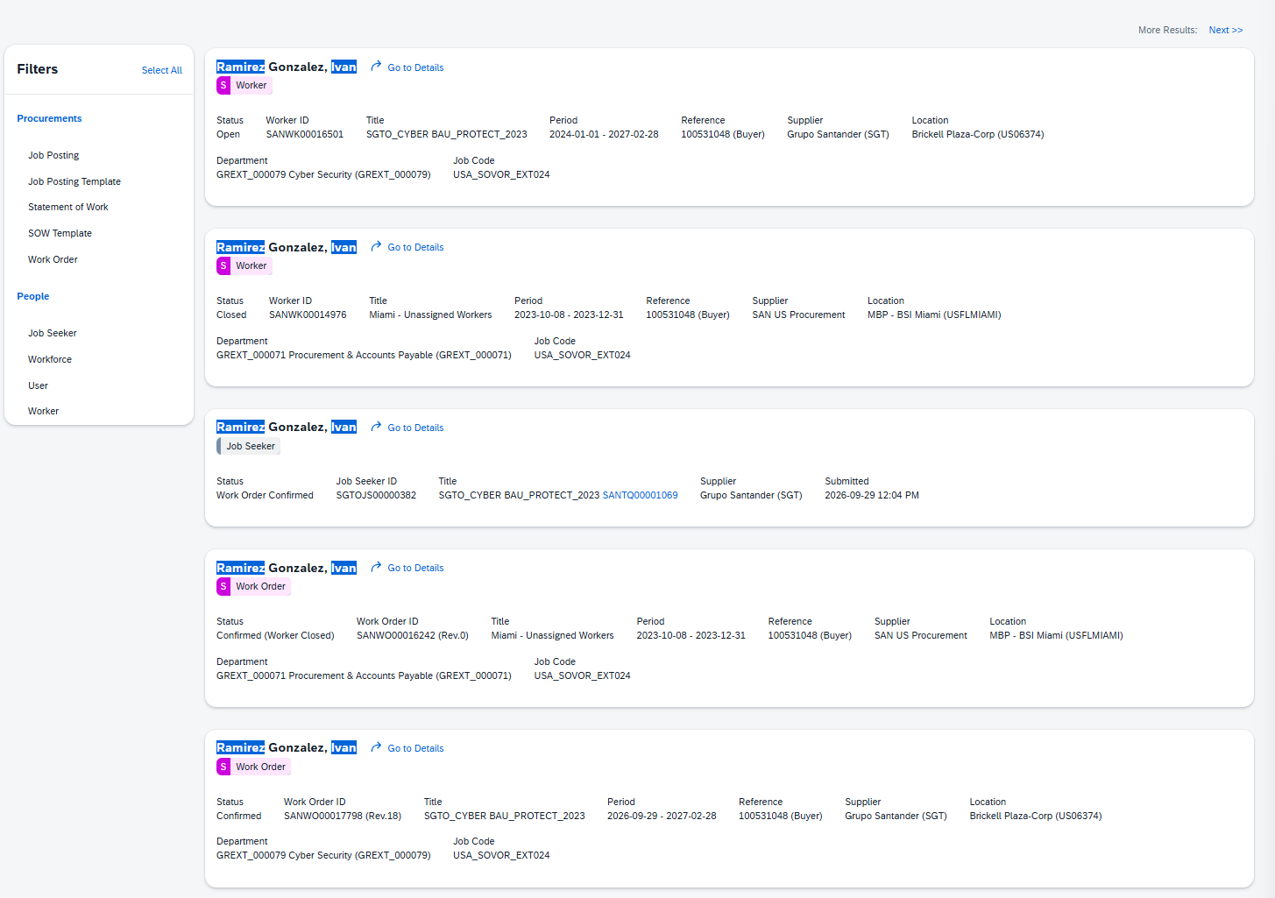
Exhibit B2: MIA25104 – Paez Venegas, Jefferson
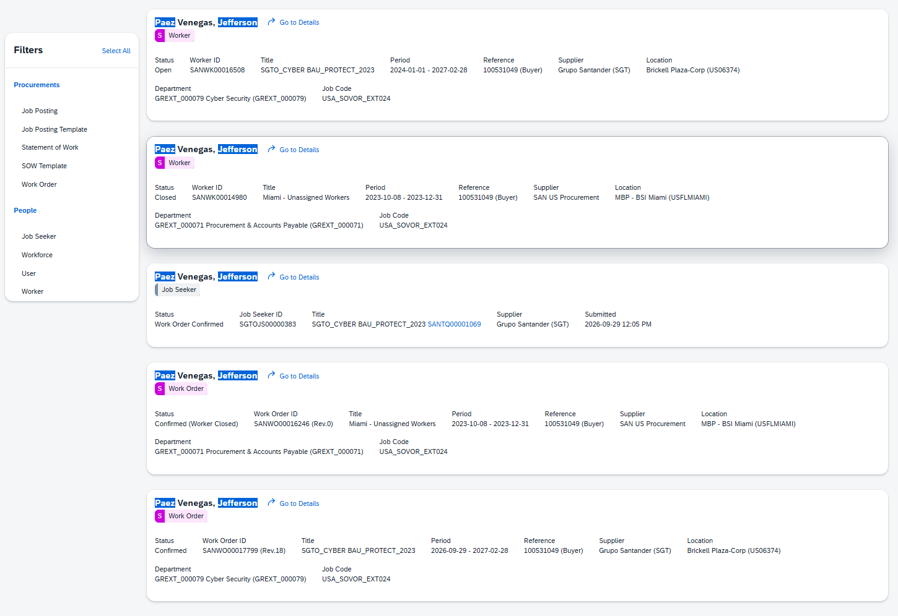
Exhibit B3: MIA25105 – Serrano Aguirre, David
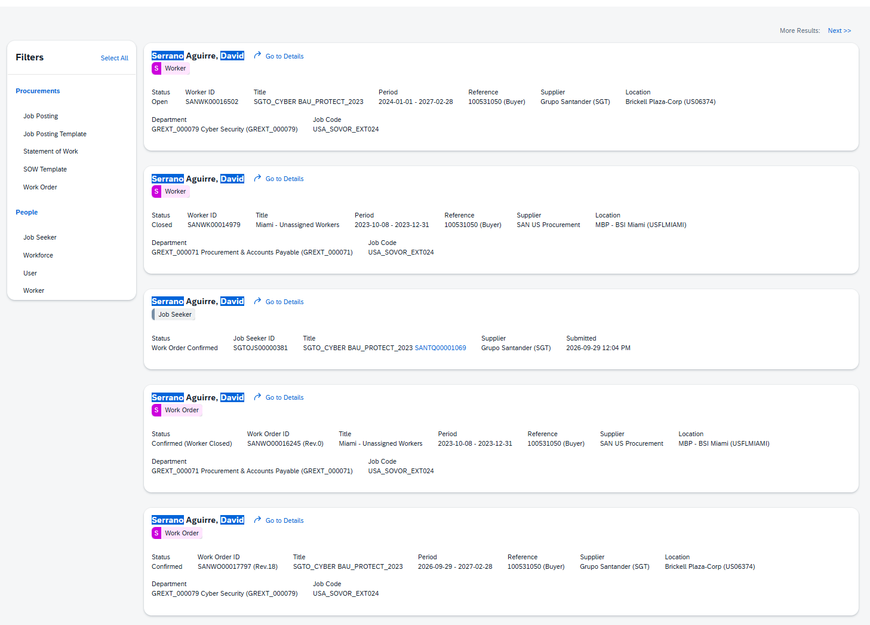
Exhibit B4: MIA25106 – Vazquez Arias, Maiko
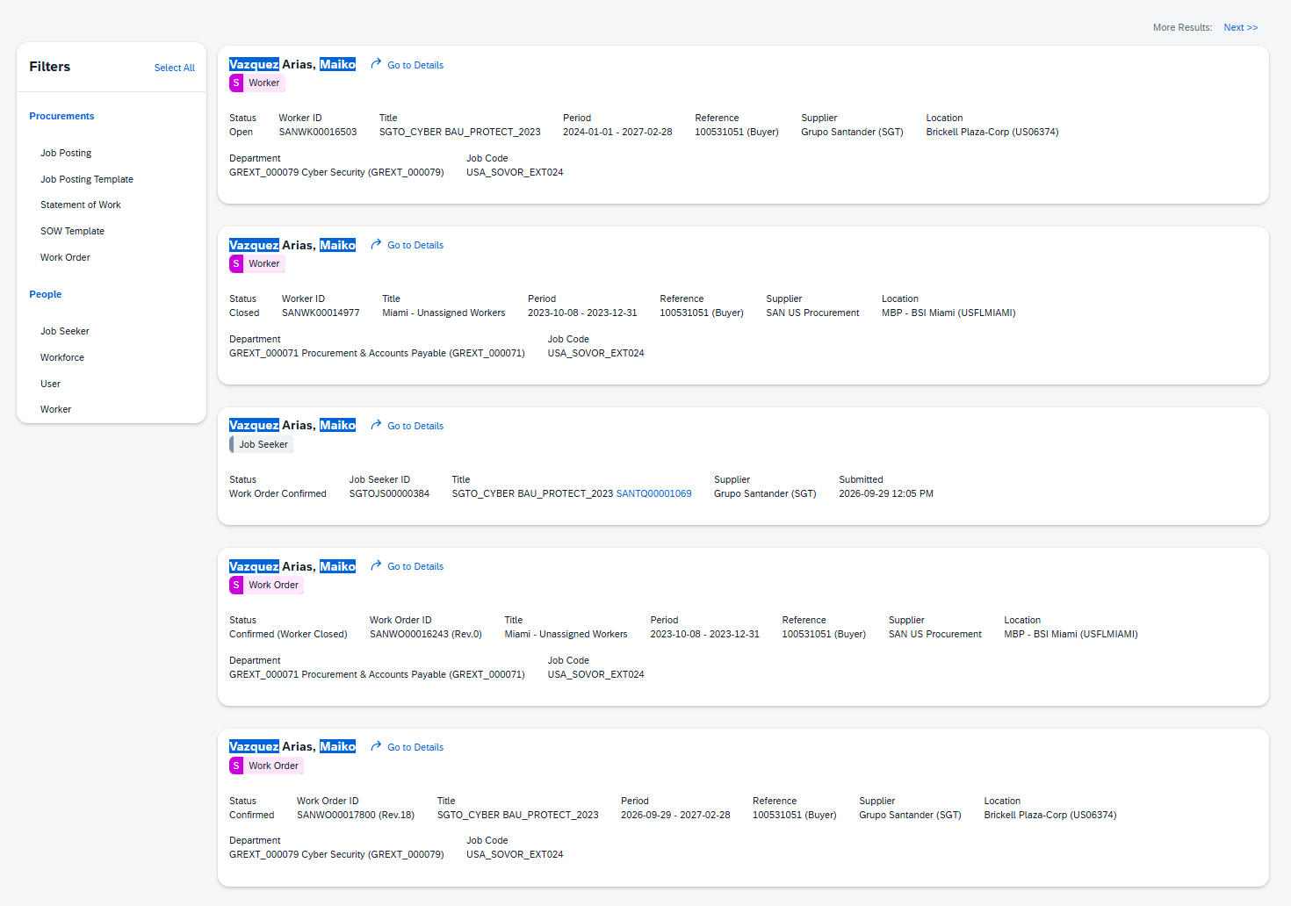
Exhibit B5: MIA25249 – Harris, Richard
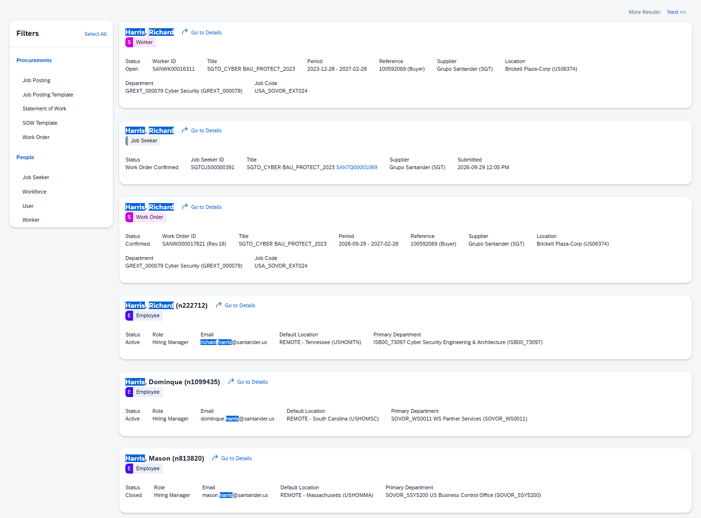
Exhibit B6: MIA25250 – Ackley, Kevin
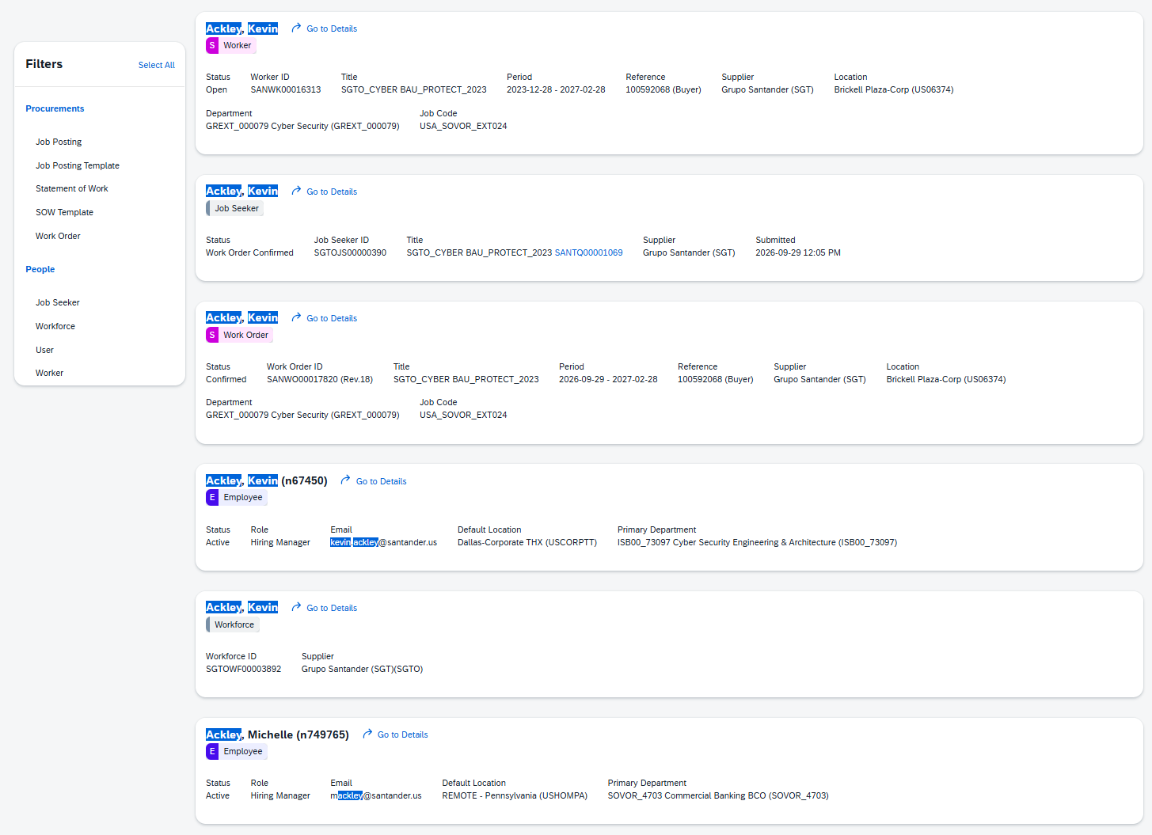
Exhibit B7: MIA25251 – Rimal, Ashish
