Action Driver Closure Package

Validation Memo – AD 50427831 BSI Proactive Obsolescence Governance
Action Driver Information
Legal Entity: | Banco Santander International (BSI) – ServiceNow company: SPB Miami
Division: | BSI IT – IT Operations / Infrastructure (ITOPS)
Action Driver ID: | 50427831 [confirm full Heracles AD ID]
Action Driver Name: | [BSI IT – Proactive Obsolescence Governance] [confirm AD title per Heracles]
Issue Source: | Audit finding coverage – obsolescence governance [confirm source: IA recommendation / MSII / self-identified, and issue number]
Scope: | BSI datacenter technology obsolescence – 24 KRIs (aggregated, hardware, software and zero tolerance), approximately 840 software assets plus hardware lifecycle population, reported through KRISP.
RCSA Linkage: | BSI.IT.5.R4 – Obsolescence and Disposal (ID 50434969)
Accountable Executive: | Jose Oliveros [Title – confirm]
Governance Owner: | ITOPS – IT Obsolescence Management (Infrastructure owner: Ian Rojo)
Action Driver Target Date: | [MM/DD/YYYY]
Test Period: | July 2026 and August 2026 reporting cycles (IT Working Group meetings 8/21/2026 and 9/18/2026), with outcome confirmed against the 9/30/2026 KRISP evidence.
Testing Performed by: | IT RCSA Control Assessment Team
Executive Summary | IT RCSA performed validation testing to support closure of Action Driver 50427831 – BSI proactive obsolescence governance. The Action Driver required BSI IT to move from reactive remediation of obsolete assets to a governed, forward-looking process: a formal governance forum, an 18–24 month forward view of end-of-life (EOL) exposure, per-asset remediation tracking, funding traceability and a defined escalation path.  IT RCSA inspected the obsolescence management materials presented to the BSI IT Working Group for the July and August 2026 reporting cycles and agreed the reported results to the 9/30/2026 KRISP evidence. All four test steps passed, subject to the disclosures noted below.  The process operated over two consecutive cycles and handled a real breach: when CI23514 (obsolete databases) moved to Red in July 2026, the issue was escalated, decommissions were committed and dependencies were tracked, and CI23514 returned to Green (9.259%) by the September and October 2026 submissions. Based on the test results, the governance gap is considered Remediated and the Action Driver is recommended for closure.
Action Driver Description: | Issue: BSI IT did not govern technology obsolescence proactively. Assets reached vendor end of life without a forward view, committed remediation dates or funding visibility, and dependencies on InfoSec, application owners and vendors were not consistently escalated. This contributed to sustained KRI breaches, notably CI23514 – Percentage of obsolete database instances.  Remediation objective: demonstrate that (1) a formal forum reviews obsolescence monthly with minutes, owners and dates; (2) an 18–24 month forward EOL view is rebuilt each cycle from KRISP asset-level data; (3) every planned asset is tracked with owner, action, target date and status; (4) funding is traceable each reporting period; and (5) dependencies and breaches are escalated and reported.  Root Cause (Level 1 / Level 2): [Root cause per action driver record]  Tools: KRISP (Value Submissions and evidence workbook), ServiceNow CMDB, ITOPS 24-month remediation register, BSI IT Working Group.
Sampling Rationale: | Governance is evidenced per monthly cycle. IT RCSA tested both IT Working Group cycles available after the remediation was implemented (July 2026 and August 2026 reporting periods) – the full population for the period – and confirmed the outcome against the subsequent 9/30/2026 KRISP evidence.

AD 50427831 Closure Validation – Testing Performed
1. |  | 2.
  Test Step: | 1 – Formal Governance Forum
  Attribute: | Obtain evidence that obsolescence is reviewed monthly in a formal forum, with minutes recording named owners and dates, and that results are reported to senior IT management.
  Population / Sample: | Two monthly cycles: July 2026 (IT WG 8/21/2026) and August 2026 (IT WG 9/18/2026).
  Business Artifacts: | - 50427831.01 IT Working Group – August 2026 (obsolescence section, slides 63–69)  - 50427831.02 IT Working Group – September 2026 (obsolescence section, slides 60–67)
  Review: | - A dedicated “IT Obsolescence Management” section was presented to the BSI IT Working Group in both cycles: executive summary, portfolio dashboard, roadmap, KRI detail and forward EOL view.  - August 2026 deck records the governance control “Formal governance forum – monthly ITOPS obsolescence review running; 6 Aug 2026 minutes filed with named owners and dates.”  - Both decks report status, escalations and planned actions for the cycle; the IT Working Group includes the Accountable Executive and IT domain owners.
  Result: | Pass
  Test Step: | 2 – 18–24 Month Forward EOL View
  Attribute: | Validate that a forward-looking view of EOL exposure covering at least 18–24 months is produced each cycle from KRISP asset-level dates.
  Population / Sample: | Forward EOL view in each of the two cycles.
  Business Artifacts: | - 50427831.01 slide 69 – 24-Month Forward-Looking EOL View (July 2026)  - 50427831.02 slide 67 – 24-Month Forward-Looking EOL View (August 2026)
  Review: | - Horizon rebuilt each month, derived from KRISP asset-level obsolescence dates and de-duplicated by CI ID.  - July 2026 (through July 2028): 35 already EOL, 68 due ≤6 months, 27 in 7–12 months, 53 in 13–24 months – 183 software assets (+57 hardware).  - August 2026 (through August 2028): 27 already EOL, 59 due ≤6 months, 28 in 7–12 months, 52 in 13–24 months – 166 software assets (+59 hardware).  - Next wave identified in advance: 59 Windows Server 2016 / IIS 10 assets reaching vendor EOL on 12 Jan 2027.
  Result: | Pass
3. |  | 4.
  Test Step: | 3 – Per-Asset Tracking and Funding
  Attribute: | Validate that planned assets are tracked with owner, action, target date and status, and that the funding position is stated each reporting period.
  Population / Sample: | Remediation roadmap in each of the two cycles.
  Business Artifacts: | - 50427831.01 slide 65 – Remediation Roadmap (240 assets)  - 50427831.02 slides 61 and 63 – Governance controls; Remediation Roadmap (225 assets)
  Review: | - August 2026 deck records “Per-asset remediation tracking – register of the 225 planned assets with owner, action, target date and status.”  - Roadmap allocates every planned asset to a remediation lane and half-year (H2 2026: 32, H1 2027: 84, H2 2027: 55, H1 2028: 54 = 225), with net change vs the prior plan (−57).  - Funding stated on the roadmap in both cycles: “approved IT budget · additional requested this period: none · pending approval: none.”
  Result: | Pass
  Test Step: | 4 – Escalation and Outcome
  Attribute: | Validate that breaches and remediation dependencies are escalated and reported every cycle and that the process produces measurable improvement.
  Population / Sample: | Escalations reported in both cycles; outcome agreed to 9/30/2026 KRISP evidence.
  Business Artifacts: | - 50427831.01 / 50427831.02 executive summaries  - 50427831.03 09.30.2026 Miami Obsolescence KRISP evidence v3.xlsx (TWG Metrics)  - 50427831.04 KRISP Value Submissions screenshot – CI23514
  Review: | - July cycle: CI23514 Red (19.35%) escalated – 7 instances reached vendor EOL 14 Jul; 4 August decommissions committed; Varonis and CyberArk database decommissions escalated to InfoSec.  - August cycle: dependencies recorded – Varonis (InfoSec decommission date), Tableau PostgreSQL and xmfax MySQL (application owner / vendor dates).  - Outcome: obsolete software assets 35 (4.13%) July → 27 (3.22%) August → 20 (AOB0001.D 2.378%, Green) at 9/30/2026.  - CI23514 Red (Aug 2026 submission) → Green 9.259% (Sep and Oct 2026 submissions); all 9 zero tolerance KRIs at 0.00% throughout.
  Result: | Pass

Obsolescence Outcome by Reporting Cycle
Measure | July 2026 (as of 7/31) | August 2026 (as of 8/31) | September 2026 (as of 9/30)
Obsolete software assets (AOB0001.D) | 35 / 847 (4.13%) | 27 / 838 (3.22%) | 20 / 841 (2.378%)
KRIs Green (of 24) | 23 (1 Red: CI23514) | 23 (1 Amber per ITOPS deck: CI23514) | 24 (CI23514 Green)
CI23514 – obsolete database instances | 12 / 62 (19.355%) Red | 5 / 54 (9.259%) Green (KRISP) | 5 / 54 (9.259%) Green
Zero tolerance KRIs at 0.00% | 9 / 9 | 9 / 9 | 9 / 9
Assets in 24-month plan | 240 (183 SW + 57 HW) | 225 (166 SW + 59 HW) | n/a – next IT WG cycle
Sources: IT Working Group decks (50427831.01 / .02), KRISP evidence 9/30/2026 (50427831.03), KRISP screenshot (50427831.04).
24-Month Remediation Roadmap – August 2026 Cycle (assets reaching EOL per period)
Lane | Action | H2 2026 | H1 2027 | H2 2027 | H1 2028 | Total | vs June
Windows Servers | In-place OS upgrade / rebuild | 6 | 39 | – | – | 45 | −21
Linux Servers | In-place OS upgrade | 6 | – | – | – | 6 | −24
Web Servers | IIS upgrade / app migration | 5 | 16 | – | – | 21 | −6
Databases | Engine upgrade / migration | 8 | 4 | 6 | – | 18 | −4
Hypervisors | ESXi upgrade (accelerated to H2 2026) | – | – | 31 | – | 31 | +1
Network Devices | Firmware / HW refresh | 2 | 13 | 8 | – | 23 | −2
App Servers (WAS) | Runtime upgrade / migration | – | 12 | 8 | – | 20 | 0
Physical Servers | Hardware replacement | 3 | – | – | 48 | 51 | −1
Storage | Controller / array refresh | 2 | – | 2 | 6 | 10 | 0
Total assets in plan |  | 32 | 84 | 55 | 54 | 225 | −57
Funding: approved IT budget · Additional requested this period: none · Pending approval: none. Source: 50427831.02 slide 63.
Points Noted During Testing
Disclosures: | - The ITOPS monthly obsolescence review minutes (6 Aug 2026) and the 225-asset remediation register are referenced in the IT Working Group deck but were not provided with this package. [Obtain and attach as 50427831.05 / 50427831.06 if 2LoD/TRM or IA require direct evidence.]  - Two operating cycles were tested (July and August 2026). The September 2026 cycle (IT Working Group October 2026) was not available; the 9/30/2026 KRISP evidence confirms the outcome trend continued.  - Reporting inconsistency: the September 18, 2026 deck reports CI23514 for August 2026 as Amber at 14.04% (8 / 57), while the approved KRISP September 2026 submission (as of 8/31/2026) and the KRI table in the same deck report 9.259% (5 / 54) Green. [Obtain management explanation – e.g., snapshot taken before CMDB record clean-up.] Consistency between the ITOPS deck and KRISP should be checked each cycle.  - Open dependencies remain outside ITOPS control – Varonis databases (InfoSec decommission date), Tableau PostgreSQL and xmfax MySQL (application owner / vendor dates). They are recorded and reported every cycle, which is the governance expectation; remediation of the assets themselves continues under the roadmap.  - The August 2026 IT Working Group KRI commentary listed “proactive obsolescence governance” among past-due BSI Technology action drivers pending validation. [Confirm current due date and whether IA / InfoSec validation is required for this AD.]

Closure Package – Artifact Index
Reference | Artifact | Supports
50427831.01 | IT Working Group - August 2026 2 (50427831).pptx – reporting period July 2026, meeting 8/21/2026 | Forum, forward EOL view, roadmap, July escalations (steps 1–4)
50427831.02 | IT Working Group - September 20269 (50427831).pptx – reporting period August 2026, meeting 9/18/2026 | Governance controls, per-asset register, funding, escalations, progress (steps 1–4)
50427831.03 | 09.30.2026 Miami Obsolescence KRISP evidence v3.xlsx (TWG Metrics) – attached to “BSI Miami - September KRISP metrics evidence file” email, 10/02/2026 | Outcome at 9/30/2026: AOB0001.D 2.378%, CI23514 9.259%, zero tolerance 0.00% (step 4)
50427831.04 | KRISP Value Submissions screenshot – CI23514 history (captured 10/19/2026) | CI23514 Red → Green after escalation (step 4)
Related | BSI.IT.5.R4 CI23514 Obsolete Databases Closure Package (separate) | Closure of the CI23514 KRI breach AD 50389731

Validation Results
Results | Justification
Overview of Remediation Timeline/Status
Overall Target Date: | [MM/DD/YYYY]
Remediation Status: | Remediated
Control Performance Rating: | Satisfactory
Overall Validation Remediation Conclusion
IT RCSA reviewed Action Driver 50427831 – BSI proactive obsolescence governance – including the IT Obsolescence Management materials presented to the BSI IT Working Group for the July and August 2026 reporting cycles and the 9/30/2026 KRISP evidence. Testing confirmed that obsolescence is reviewed monthly in a formal forum with minutes, owners and dates; that a 24-month forward EOL view is rebuilt each cycle from KRISP asset-level dates; that planned assets are tracked in a per-asset register and allocated to a dated remediation roadmap with the funding position stated; and that breaches and dependencies are escalated and reported each cycle. The process produced measurable improvement – obsolete software assets fell from 35 to 20 and CI23514 returned from Red to Green. Based on the test results the control performance is rated Satisfactory, and Action Driver 50427831 is considered Remediated, subject to resolution of the disclosures noted above.
Status: | [Validation Complete. No further action needed.]
Completed by: | [Name]
Validation Date: | [MM/DD/YYYY]

Manager Review
Status: | [Validation Complete. No further action needed.]
Completed by: | [Name]
Validation Date: | [MM/DD/YYYY]

Appendix – Evidence Screenshots

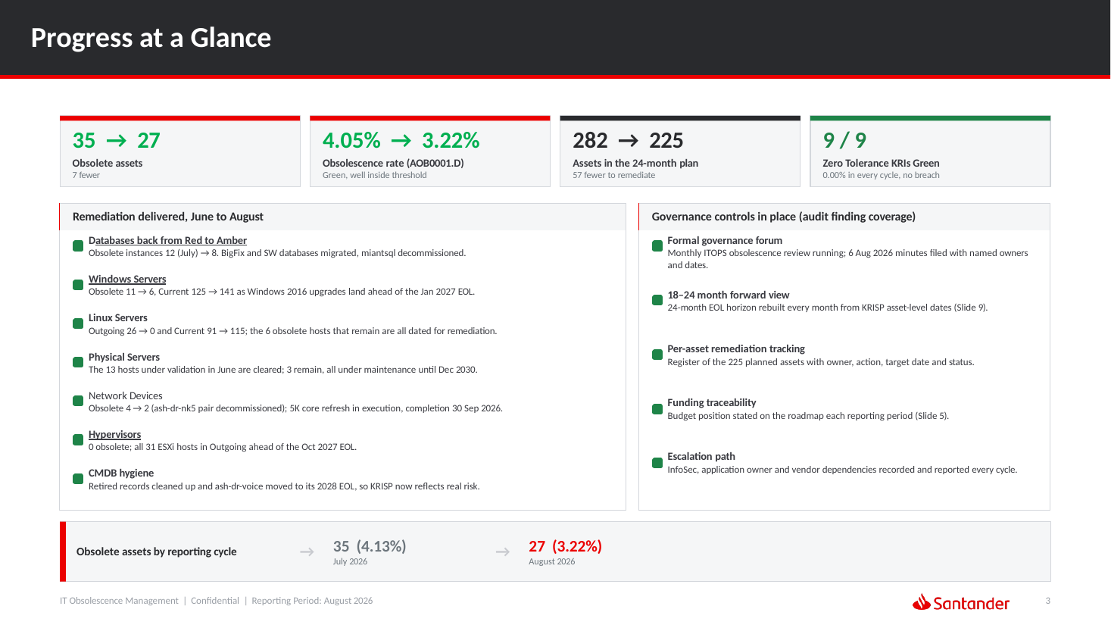
Figure A1 – IT Working Group 9/18/2026, “Progress at a Glance”: governance controls in place (forum, forward view, per-asset tracking, funding, escalation) (50427831.02)
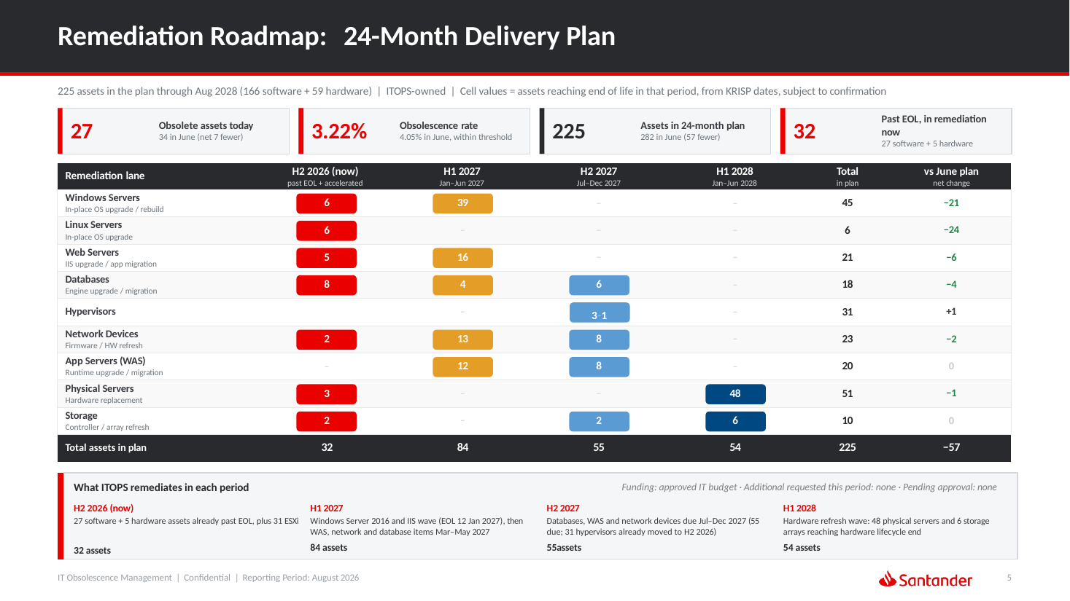
Figure A2 – IT Working Group 9/18/2026, “Remediation Roadmap: 24-Month Delivery Plan” with funding position (50427831.02)
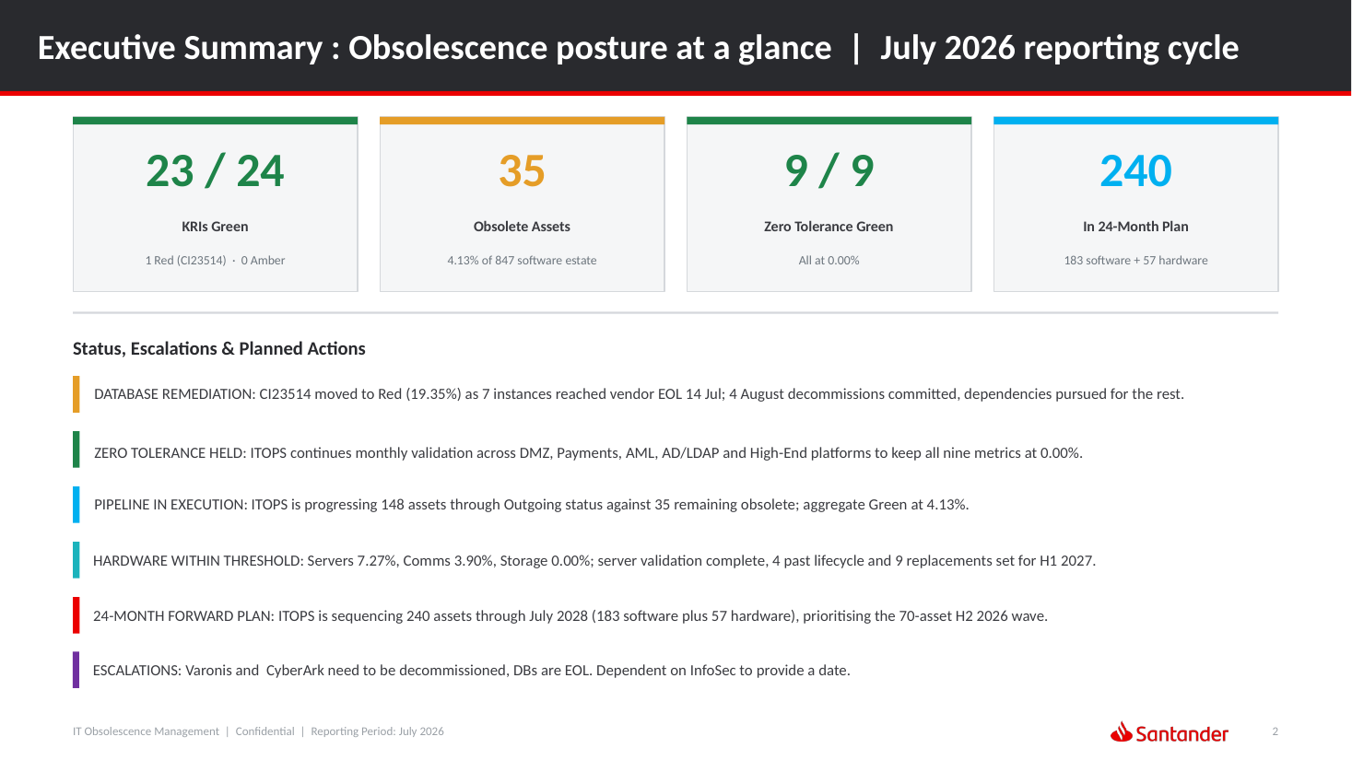
Figure A3 – IT Working Group 8/21/2026, Executive Summary for July 2026 cycle: CI23514 Red escalation and InfoSec dependencies (50427831.01)

