Evidence Package Access Instructions
BSI.IT.6.C7.3 – DR Data Integrity Validation (DIV) · Workpaper and evidence package
This manual explains how a reviewer downloads the workpaper and the evidence zip file, extracts the evidence to the Downloads folder, and uses the hyperlinks in the workpaper to open every evidence file. Follow the steps in order. It takes about five minutes.

What you receive
File | What it is
BSI.IT.6.C7.3_E00_Workpaper_DR_DIV_INTEGRATED_APPLICATION_13_1.xlsx | The workpaper (Excel). Every evidence reference in it is a clickable hyperlink.
BSI.IT.6.C7.3-Evidences.7z | The evidence zip file (7-Zip format, about 17.5 MB). It contains one folder, BSI.IT.6.C7.3-Evidences, with 32 evidence files in four numbered folders, plus a README.md index.
This manual | Access and hyperlink instructions.

The one rule that makes the hyperlinks work
The workpaper and the extracted BSI.IT.6.C7.3-Evidences folder must sit side by side in the same folder. This manual uses the Downloads folder.
The workpaper builds each link from its own location, so no path needs to be typed in. If the two are side by side, every link opens its file.

After you finish Steps 1 to 3, your Downloads folder must look like this:
C:\Users\<your name>\Downloads\
├── BSI.IT.6.C7.3_E00_Workpaper_DR_DIV_INTEGRATED_APPLICATION_13_1.xlsx
├── BSI.IT.6.C7.3-Evidences.7z
└── BSI.IT.6.C7.3-Evidences\
├── 01_Management_Attestation_In-Scope_Applications\ (MA01, 2 files)
├── 02_Business_Line_Approval_Results_Email\ (BLA01-BLA06, 6 files)
├── 03_DIV_Manager_Attestation_Email_Approvals\ (DMA01-DMA13, 13 files)
├── 04_Data_Integrity_and_Email_Testing_Evidence\ (E01-E16b, 11 files)
└── README.md

Step 1 – Download both files to the Downloads folder
- Download BSI.IT.6.C7.3_E00_Workpaper_DR_DIV_INTEGRATED_APPLICATION_13_1.xlsx and BSI.IT.6.C7.3-Evidences.7z.
  - From an email: right-click each attachment, select Save As, choose Downloads, and click Save.
  - From SharePoint, Teams or OneDrive: select the file and click Download. The browser saves it to Downloads.
- Open File Explorer and click Downloads in the left pane. Confirm that both files are there.
- Keep the file names as they are. The workpaper may be renamed if needed, but the evidence folder must stay named BSI.IT.6.C7.3-Evidences.
Use the local Downloads folder
Save to C:\Users\<your name>\Downloads, not to a OneDrive or SharePoint synced folder and not inside other subfolders.
Windows and Excel limit a hyperlink to about 255 characters. The longest evidence path in the package is 213 characters, so a short location such as Downloads keeps every link inside the limit.

Step 2 – Extract the evidence zip file
7-Zip is required for the .7z file. It is free (7-zip.org) and is usually available from the company software center. After it is installed, a 7-Zip entry appears in the right-click menu.
- In File Explorer, open Downloads.
- Right-click BSI.IT.6.C7.3-Evidences.7z. On Windows 11, click Show more options first if the 7-Zip entry is not shown.
- Point to 7-Zip and click Extract Here.
- Wait for the extraction to finish.
- Confirm that a folder named BSI.IT.6.C7.3-Evidences now appears in Downloads, next to the workpaper.
- Double-click BSI.IT.6.C7.3-Evidences. You must see the four numbered folders (01_ to 04_) and README.md directly inside it.
Use "Extract Here", not "Extract to"
The zip file already contains the BSI.IT.6.C7.3-Evidences folder. Choosing Extract to "BSI.IT.6.C7.3-Evidences\" can create a doubled folder (BSI.IT.6.C7.3-Evidences\BSI.IT.6.C7.3-Evidences\01_...), and then the hyperlinks cannot find the files.
If that happened: open the outer BSI.IT.6.C7.3-Evidences folder, cut the inner BSI.IT.6.C7.3-Evidences folder, go back to Downloads and paste it there, then delete the empty outer folder.

The screenshot below shows the 7-Zip menu. It opens when you right-click the evidence package, and the workpaper and the extracted BSI.IT.6.C7.3-Evidences folder sit side by side in the same folder. Do the same in your Downloads folder and click Extract Here.
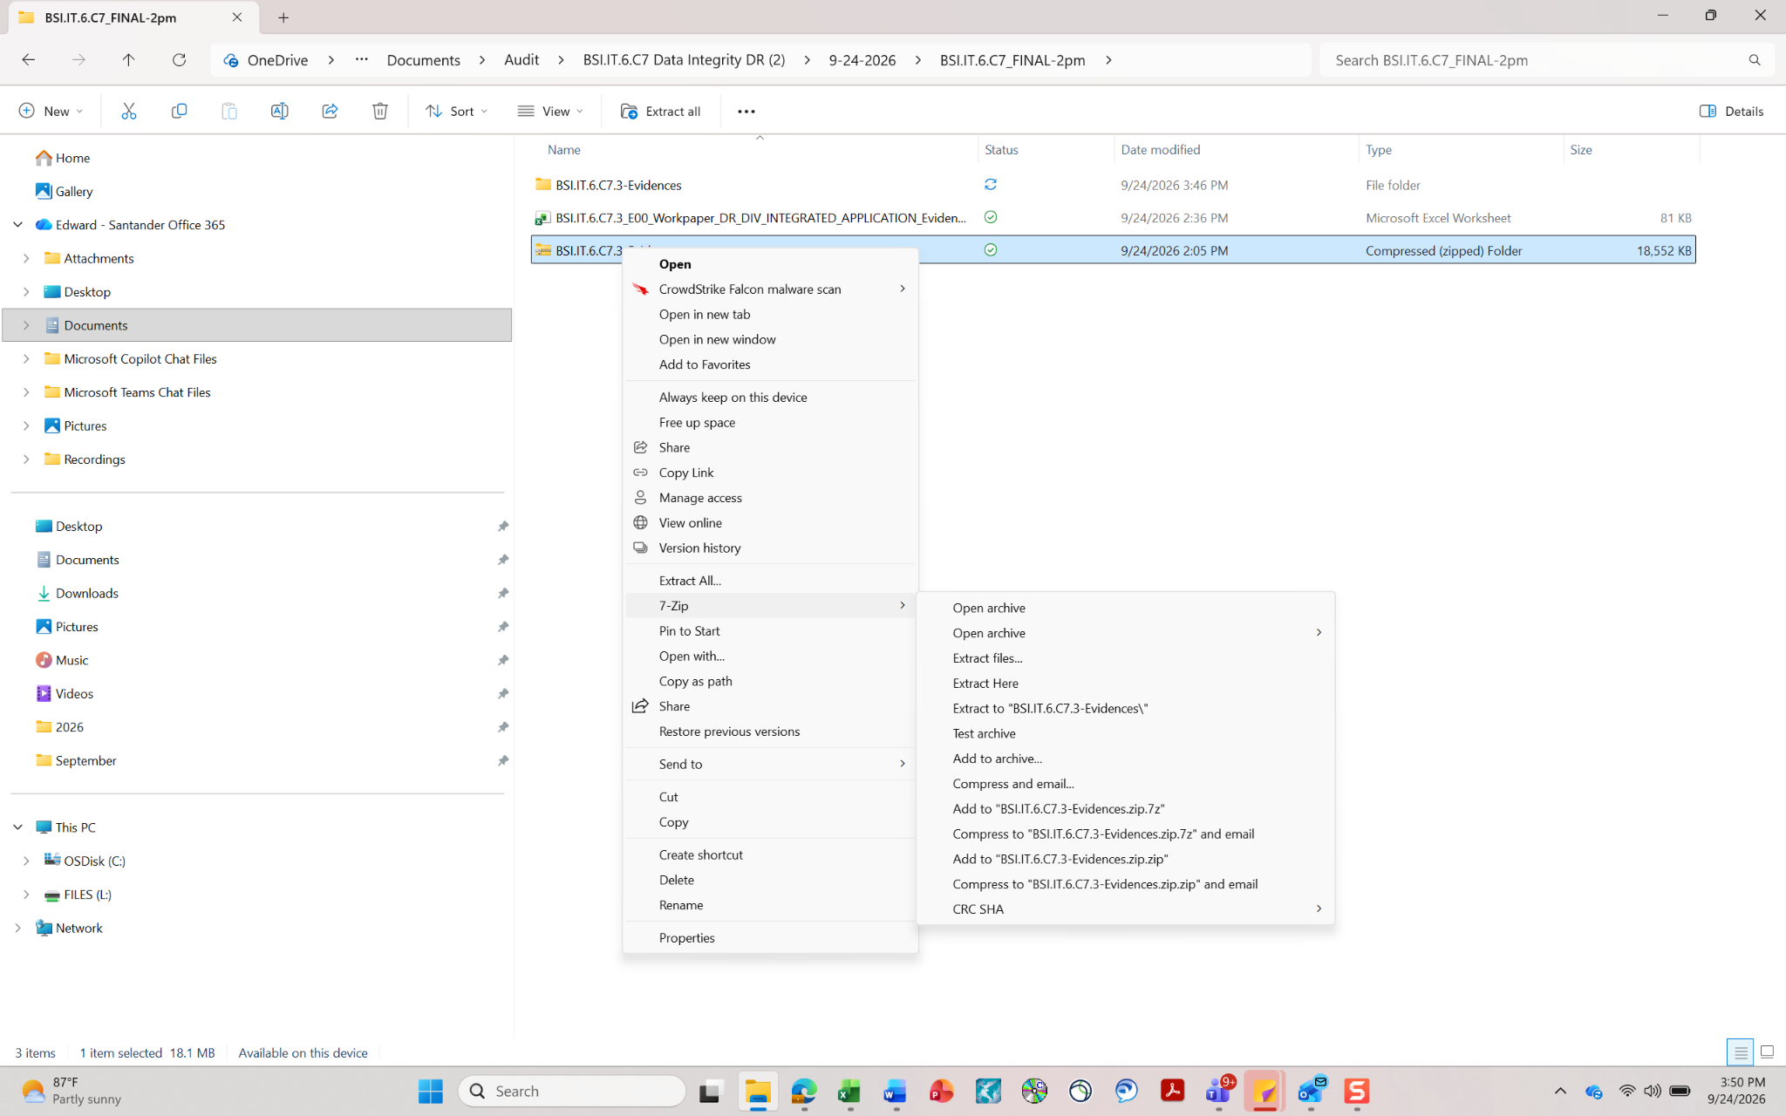
Screenshot: evidence package extracted into the same folder as the workpaper.
Do not open evidence files from inside the zip file (double-clicking the .7z and browsing into it). Always extract first. Files opened from inside the zip are temporary copies, and the workpaper hyperlinks do not point to them.

Step 3 – Open the workpaper and check the links
- In Downloads, double-click BSI.IT.6.C7.3_E00_Workpaper_DR_DIV_INTEGRATED_APPLICATION_13_1.xlsx. Open it from Downloads, not from the email or the browser download bar.
- If a yellow Protected View bar appears, click Enable Editing. If a Security Warning bar appears, click Enable Content. The links work out their location only after editing is enabled.
- Go to the WP Summary tab, row 28 ("Links resolve to"). Cell B28 must show your Downloads path ending in \BSI.IT.6.C7.3-Evidences\.
- Click Test: open the evidence folder (cell F28). File Explorer must open the evidence folder. If it does, every hyperlink in the workpaper will work.
- If B28 is blank, shows an old path or shows an error, press Ctrl + Alt + F9 to recalculate all formulas. Also check Formulas > Calculation Options > Automatic.

Step 4 – Use the hyperlinks
There are two kinds of links. File links open an evidence file from the extracted folder. Navigation links jump to another place in the workpaper so the reviewer can follow each attribute from the sample to the evidence and back.
Tab | Click on | What happens
Application Attribute Testing-1 | Attribute header, row 2 (columns B to P) | Jumps to that attribute's evidence review section in Application Attribute Testing (sections 1 to 15 follow the same column order).
Application Attribute Testing-1 | Sample ID, column A | Jumps to that sample's conclusion row.
Application Attribute Testing-1 | Supporting Evidence, column R | Jumps to the evidence file reviews (folders 02, 03, 01 and 04).
Application Attribute Testing and Testing Attributes Testing -2 | Evidence file path, column B | Opens the evidence file (PDF, email, Excel, image or Word).
Application Attribute Testing and Testing Attributes Testing -2 | Ref, column A (for example E03) | Jumps to the review row for that evidence file.
Application Attribute Testing and Testing Attributes Testing -2 | Section title (for example "4. IT DR exercise name...") | Returns to that column header on Application Attribute Testing-1.
Application Attribute Testing | App ID in the conclusion table | Returns to the sample row on Application Attribute Testing-1.
Evidence reference table | Evidence file path, column B | Opens the evidence file.
BSI.IT.6.C7.3 Evidence Index | Column B / column C | Opens the evidence file / opens its folder.
WP Summary | Cell F28 | Opens the BSI.IT.6.C7.3-Evidences folder.

When you click a file link
- Excel may ask "Microsoft Office has identified a potential security concern… Do you want to continue?". Click Yes. The file then opens in its normal program.
- .msg and .eml files (emails) open in Outlook desktop. The signed attestations and the E07 / E08 report files are attachments inside those emails. Double-click the attachment in the open email to view it.
- .pdf files open in a PDF reader, .xls / .xlsx in Excel, .jpg / .png in the Photos app and .docx in Word.
- Hold the mouse over a file link to see the full path it will open.

Optional – evidence kept somewhere else
If the BSI.IT.6.C7.3-Evidences folder cannot sit next to the workpaper (for example, it is kept on a network drive or SharePoint), paste the folder's full path into the yellow cell B27 on the WP Summary tab. For example: \\server\share\Audit\BSI.IT.6.C7.3-Evidences or the SharePoint folder link. B28 then shows the new location, and all links follow it. Leave B27 blank for the normal side-by-side setup.

Troubleshooting
Problem | What to do
Clicking a link does nothing, or shows "Cannot open the specified file" | Check the folder layout against the folder diagram under "What you receive". The workpaper and BSI.IT.6.C7.3-Evidences must be in the same folder, and 01_ to 04_ must be directly inside BSI.IT.6.C7.3-Evidences (not doubled).  Check that you clicked Enable Editing and that WP Summary B28 shows the Downloads path.
Links point to an https:// address | The workpaper was opened from OneDrive or SharePoint. Download both files to the local Downloads folder and repeat Steps 2 and 3. Alternatively, enter the evidence folder path in WP Summary B27.
Some links work but the longest names do not | The folder location is too deep and the path exceeds the Windows limit. Move the workpaper and the evidence folder directly into Downloads (or C:\Audit).
A file will not open, or opens blank | Copy the file to your Desktop and open the copy. If it still does not open, copy the whole BSI.IT.6.C7.3-Evidences folder to the Desktop and open the file from there.  If Windows blocked the download: right-click the file, select Properties, tick Unblock and click OK.
An email (.msg / .eml) will not open | Outlook desktop is required. Open Outlook first, then click the link again, or drag the file into Outlook.
B28 shows an error (#VALUE!) | The workbook has not been saved on this computer. Save it once to Downloads, then press Ctrl + Alt + F9.

A full list of every evidence file, with its reference, owner, date and content, is in README.md inside the BSI.IT.6.C7.3-Evidences folder and on the BSI.IT.6.C7.3 Evidence Index tab of the workpaper.

