IT RCSA Audit Documentation
DR Data Integrity Validation – BSI.IT.6.C7.3
  - Design Assessment, Walkthrough and Sample of One (1822 – ACH Express)
DESIGN RATING  SATISFACTORY | SAMPLE 1822  PASS | OBSERVATIONS  NONE
Control | BSI.IT.6.C7.3 – DR Data Integrity Validation (DIV)
Review period | 08/01/2025 – 06/01/2026
Walkthrough | 09/10/2026 – Cesar Vidal; 09/23/2026 – Michael Sacilotto, Melissa Forrester
Sample of one | 1822 – ACH Express, BSI DR exercise – 12/11/2025
Evidence folder | BSI.IT.6.C7.3 (E01 – E17) and Management_Attestation

1. Design Effectiveness Summary
The control design is effective. The control is designed with an "Annual" frequency, which is appropriate because every in-scope BSI application is validated during the yearly DR exercise (November 15, 2025 and February 21, 2026 for this cycle). The nature of the control is manual: business-line testers validate the recovered data and the Business Department Manager approves the results, with the IT Resiliency & DR team coordinating and overseeing the process. Evidence is stored in the business continuity management system, BC in the Cloud (BCiC/BCMS), and can be easily retrieved (Refer to E03/E04). The control is formally documented in an application-level Data Integrity Validation (DIV) Procedure attached to each test record (Refer to E03, "Data Integrity Validation Procedures" column). The information supporting execution is reliable because the population, results and approvals are exported directly from BCiC. Overall Rating: Satisfactory.

2. WT Summary
We met with Cesar Vidal (IT Governance Risk & Control Associate, IT Governance & PMO) on September 10, 2026, who confirmed that the process remains unchanged from the previous cycle. The IT RCSA team conducted a walkthrough with Michael Sacilotto, Director, Business Continuity, and Melissa Forrester, Senior Associate, Business Continuity, on September 23, 2026, to gain an understanding of the process, including the control's frequency and the events that trigger its execution.
Data integrity testing lets the business verify the completeness and accuracy of critical data in a recovery scenario involving corrupted or lost data (e.g. technology failure, malware, ransomware or DDoS). IT restores data from the previous night's backup, so up to one day of data may be lost. Validation covers three categories, and all three must be positive for the test to be successful:
- Domain Integrity: data types, formats and field lengths conform to requirements.
- Entity Integrity: no prohibited duplicate or blank records; data headers are accurate.
- Referential Integrity: recovered data matches historical source data in content and volume (same number of fields and records).
After the business tester executes the test, the IT DR team sends the results to the business, which completes a Yes/No checklist for Domain, Entity and Referential Integrity and returns it. The IT DR team then obtains formal approval from the Business Line Manager. The results are recorded in the BCMS with the completed DIV Procedure, test type and scope, the three integrity results, comments, the manager's name and approval date, and IT Resiliency confirmation that all test criteria were met.
Sample of one: during the walkthrough, sample 1822 (ACH Express) was traced end to end – DR scope in BCiC (E01/E02), DIV results and manager approval in BCiC (E03/E04), and the Business Line Manager approval email (E09). Results are in Section 3.
Based on the walkthrough and our understanding of the process, the control appears to be designed appropriately and implemented as described, and it is adequate to mitigate the risk of recovered data being incomplete or inaccurate after a DR event.

3. Sample of One – 1822 ACH Express
Workpaper column | Value / conclusion | Evidence reference | Result
IT DR exercise name | BSI DR exercise – 12/11/2025 | E01 (row 3); E02; E03 (row 47) | Pass
Application Name | ACH Express | E01 (row 3); E02; E03 (row 47); E04 | Pass
Business Tester | Andreina De Stefano | E03 (row 47); E04 | Pass
Business Data validation | 11/15/2025 | E03 (row 47); E04; E09 | Pass
Business line manager name | Claudia Romero | E03 (row 47); E04 | Pass
Business line manager approval dates | 05/05/2026 | E03 (row 47); E04 | Pass
DIV Test procedures listed within the Test results document | FED Inclearing (ACH & Cash Letters) ACH Express DIV Procedure | E03 (row 47) – Procedures column; E04 | Pass
Emails showing Business line manager approval of DIV testing results | Claudia Romero – "Approved." 05/05/2026 | E09 | Pass
All evidence of Data Integrity DR test in BCIC | Valid – record and scope maintained in BCiC | E01; E02; E03; E04 | Pass
Annual Testing Executed | In the 2025/2026 DR / DIV population; tested within the period | E01 (row 3) – Exercise Date / DR Test Scope; E03 (row 47) | Pass
Data Integrity Validation Performed by IT DR Team | IT DR facilitated; tester validated Format, Headers, Content = Y | E03 (row 47) – Y/N columns; E09 | Pass
Applications in Scope Identified | In scope via BCM/BIA process (Elizabeth Noda) and BCiC DR-scope view | E01 (row 3); E02; E05; E06; Management_Attestation folder | Pass
Business Line Approval of Results | Approved by Claudia Romero 05/05/2026, after validation | E03 (row 47) – Manager / Approval Date; E09 | Pass
Results Documented in BCMS | DIV record, results and approval held in BCiC/BCMS | E04; E02; E03; E01 | Pass

Conclusion: Sample 1822 (ACH Express) passed all five control attributes; no exceptions were identified.
Evidence references (BSI.IT.6.C7.3 folder)
Ref | Evidence | What it shows for 1822
E01 | Applications In Scope for DR Test BSI (13).xlsx | Row 3: exercise 12/11/25; 2026/2025 DR scope True; Backup/Restore DIV scope True
E02 | screenshot BCiC apps in scope for DR Testing.jpg | ACH Express in the BCiC DR-scope view (Exhibit A1)
E03 | All Data Integrity Validation Testing_FV.xls | Row 47: tester, 11/15/2025, Y/Y/Y, Claudia Romero 05/05/2026 (Exhibit A2)
E04 | BCiC_Screenshot for Data Integrity Validation report.jpg | BCiC DIV report and control fields (Exhibit A3)
E05 / E06 | IT BIA Results Review and preparation for DR | Elizabeth Noda, 09/15/2025: 2025 BIA results and applications list
E09 | RE: Yearly Backup and restore exercise – client back office sign off | Claudia Romero "Approved." 05/05/2026 (Exhibit A4)

Appendix A - Sample 1822 Evidence
Exhibit A1: BCiC "Applications In Scope for DR Test BSI" (ACH Express outlined)
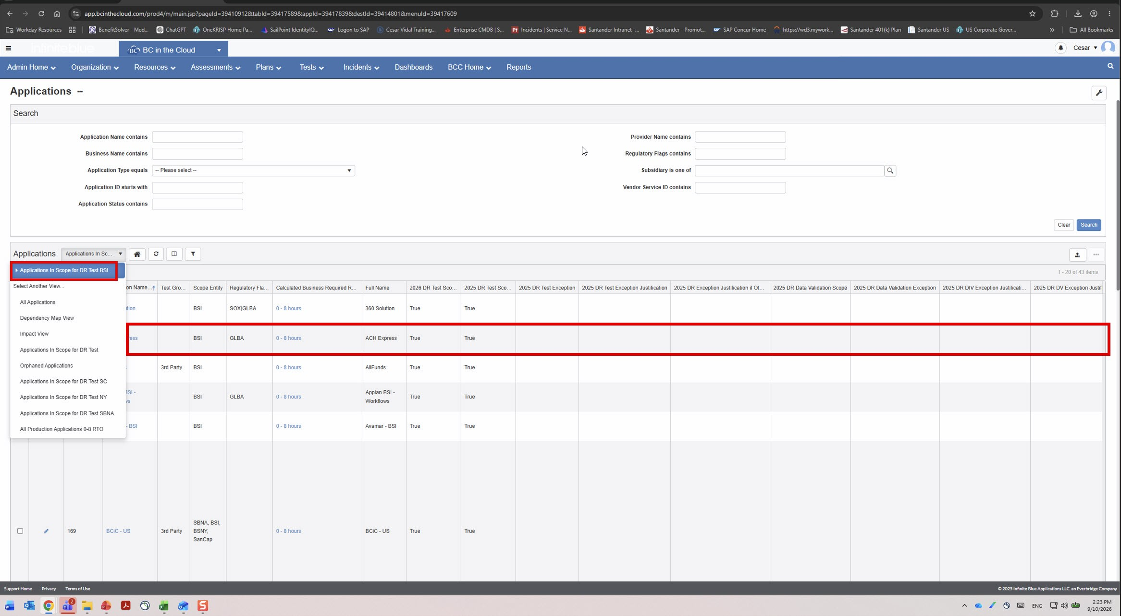
Source: E02 – screenshot BCiC apps in scope for DR Testing.jpg. Red outline added by IT RCSA.
Exhibit A2: BCiC DIV record for ACH Express (E03, row 47)
Department / Dependency | Client Back Office / FED Inclearing (ACH & Cash Letters) - ACH Express
DIV Procedure / Test Type | FED Inclearing (ACH & Cash Letters) ACH Express DIV Procedure / Disaster Recovery
Business Tester / Validation Date | Andreina De Stefano / 11/15/2025
Y/N Format / Headers / Content | Y / Y / Y
Department Manager / Approval Date | Claudia Romero / 05/05/2026
Attestation Date / By; Last App DR Test | 08/18/2026 / Claudia Romero; 12/11/2025

Exhibit A3: BCiC "Data Integrity Validation Testing" report screen
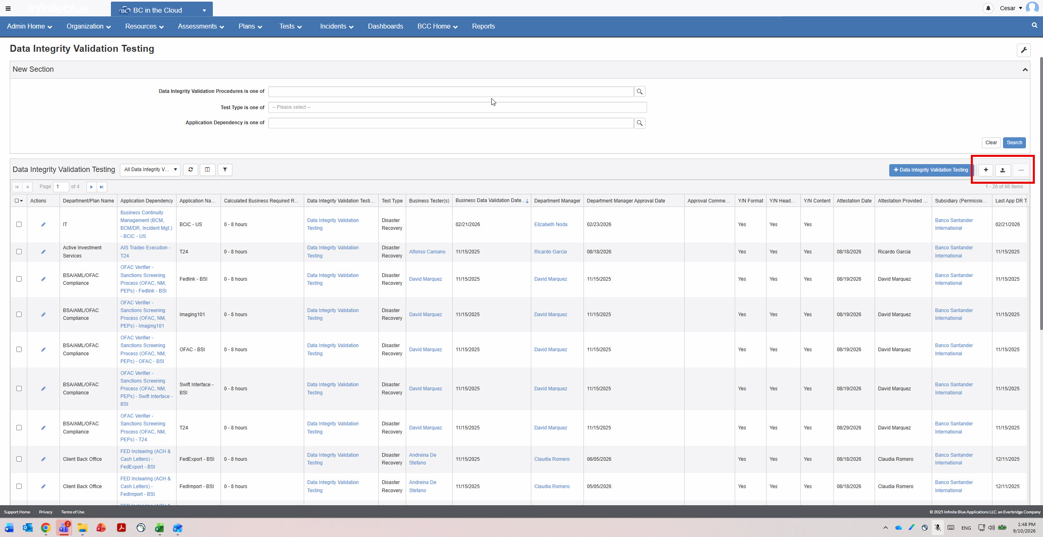
Source: E04 – BCiC_Screenshot for Data Integrity Validation report.jpg (page 1 of 4; the ACH Express record is on a later page and is reproduced in Exhibit A2).
Exhibit A4: Business Line Manager approval email (E09)
From / Sent | Claudia Romero, Client Back Office Manager VP / May 5, 2026
To | Elizabeth Noda (cc: R. Bonilla, M. Morales, I. Rodriguez, D. Rosabal, C. Rubio, J. Cuadra)
Message | "Approved." – in reply to E. Noda: "For your review and approval, of the results of the backup and restore test. No issues report and within RTO."
Scope link | Original invite lists ACH Express – Client Back Office – FED Inclearing (ACH & Cash Letters) – Claudia Romero
Referenced workbook: BSI.IT.6.C7.3_E00_Workpaper_DR_DIV_INTEGRATED_APPLICATION_Evidence_Mapped.xlsx, tab "Application + Attribute Testing", row 5.

