BSI.IT.27.C7 – Network Device Admin Account Review (Heracles ID 50537489) – Testing Procedures
Control type: Key, Hybrid, Quarterly (control statement: at least semiannually) | Inherent risk: High | Review period: 07/01/2025 – 06/30/2026 (2026 Cycle 2) | Control Owner / Executor: Dayam Borges | Control AD Owner: Zoila Rosario Rosario | Prepared by: Edward Morfa | Reviewed by: Munoz Henry, Amanda | Test date: 10/29/2026
Control statement: [BSI.IT.27.C7 Network Device Admin Account Review] At least semiannually, InfoSec initiates accounts reviews for network device administrators, users and service accounts that will be performed by managers or account owners. Inappropriate access is revoked by PAM/IAM team, within SLA.
Risk: [BSI.IT.27.R2 Access Review] Inappropriate user access to systems and/or data due to a failure to perform privileged access reviews, may result in disruption of business processes, financial loss and regulatory noncompliance.
Linked regulation: Gramm-Leach-Bliley Act (GLBA) 501(b) – 16 CFR 314.3 Standards for safeguarding customer information.
Design (CDA) | Performance (CPA) | Samples | Exceptions | Fieldglass (E10)
Satisfactory | Weak – 2 of 2 samples fail | 2025 Q3 (88 memberships), 2026 Q1 (61 memberships) | A5: E1 disabled accounts approved, E3 revoked access re-approved; A6: 6 removals not sustained | Received 10/29/2026 – E2 confirmed as observation (7 workers active)

This document follows the format of the BSI.IT.23.C1 Business Requirement testing procedures and the CUSO RCSA Testing Procedure (07/17/2026) and CDA Testing Job Aid (v1.0). Every result names its evidence (E-number, see Evidence references); "E06.x" are tabs of the testing workbook, and the WP2 workpaper holds the HERACLES CDA / CPA entries.

Test of Design

1. Is the control designed with an appropriate frequency or trigger?
Yes. The control is designed with a quarterly trigger, which is appropriate to mitigate BSI.IT.27.R2 because inappropriate privileged network access is detected and removed within one quarter at most. The PAM Recertification Procedure (BSI) v2.0 (E02, sec. 2 and 8.1 C7) requires a quarterly SOX privileged access recertification, which is more frequent than the "at least semiannually" requirement in the control statement and in the IAM Standard (E01, SUS.IAMS.4.2.5.6 and 4.2.5.19). The PAM US Team (InfoSec) launches each campaign in SanIAM / SailPoint from the membership of the four privileged network AD groups in the PAM Definition of Privilege sec. 3.3 (E03): CISCO ISE Administrators, CISCO Network Administrators, ISEAdmin and F5FullAdmin.
In the review period IT RCSA confirmed the 2025 Q3 campaign (launched 08/01/2025 Manager, 08/04/2025 Entitlement Owner) and the 2026 Q1 campaign (launched 04/09/2026), i.e. one review in each half-year. Observation: the 2025 Q4 campaign was not provided, leaving 8.3 months between launches against the quarterly procedure (OI-01). The control statement still says "semiannually" while the procedure and HERACLES frequency are quarterly; the statement should be aligned at the next RCM refresh.
References:
- E01 IAM Standard – SUS.IAMS.4.2.5.6 (p.17), 4.2.5.19 (p.22)
- E02 PAM Recertification Procedure v2.0 – sec. 2, 4.1.1 C1, 8.1 C7, sec. 8 steps 1–7
- E04 Q3_2025.xlsx; E05 Q1 2026 Cert.xlsx; E06.2 step 4.1

2. Is there a defined audit trail/evidence which supports the execution of the control being performed?
Yes. The defined audit trail is the SanIAM / SailPoint certification decision report (Manager and Entitlement Owner certifications), which shows for every membership the decision (Approved / Revoked), the decision maker and the sign-off date, together with the Netwrix AD change log that evidences the removal of revoked memberships and the AD group extracts used to reconcile the certified population. The evidence demonstrates the review, the decision and the removal and is sufficient to validate execution. For the sample of one (MIA25142) the 2025 Q3 Revoked decision of 08/28/2025, the Netwrix removal of 09/02/2025 and the AD extract of 11/25/2025 were traced end to end (E09).
Observation: the ServiceNow revocation tickets described in E02 4.1.1 C3 were not provided for any revocation (OI-05).
References:
- E04; E05 – certification exports, AD extracts, Netwrix logs
- E06.4 4_Item Detail; E06.6 6_Sources
- E09 Sample of 1 MIA25142 Workpaper

3. Is the control aligned with internal policies and/or applicable regulations?
Yes. The control is aligned with the CUSO Identity and Access Management Standard v10.0 (approved 09/29/2025, in force during the period; v11.0 of 07/28/2026 is E01 and is used for page references) SUS.IAMS.4.2.5.1, 4.2.5.6, 4.2.5.7, 4.2.5.10, 4.2.5.19 and 4.2.5.21; the PAM Recertification Procedure (BSI) v2.0 04/22/2026 (E02) sec. 2, 4.1.1 C1–C4, 4.2 and sec. 8 steps 1–10; the PAM Definition of Privilege v10.0 sec. 3.3 (E03); and GLBA 501(b). The documented requirements support a quarterly manager / owner review of every privileged network membership and removal of revoked access within 30 business days of the close of the review.
Documentation gaps (observations, not design failures): the 30-business-day SLA is defined only in the IAM Standard (SUS.IAMS.4.2.5.21) and not in the PAM procedure, and the procedure confirms the removal once (step 10) but has no step to confirm that revoked access stays removed until the next review (OBS-03).
References:
- E01 SUS.IAMS.4.2.5.1 (p.14), 4.2.5.7 (p.18), 4.2.5.10 (p.19), 4.2.5.21 (p.22)
- E02 sec. 4.1.1 C3–C4 (p.6), 4.2 (p.7), sec. 8 steps 9–10 (p.10)
- E06.1 1_Control & Approach

4. Are the thresholds for execution/resolution appropriate?
Not required – the question applies to SMC Group / SMC Local controls; BSI.IT.27.C7 is a Key control. No quantitative threshold is associated with this control. This is appropriate because every member of the four privileged network groups is reviewed, and the resolution criterion is the 30-business-day removal SLA for revoked access.

5. To what level is the issue escalation process defined and implemented?
Partial. SanIAM / SailPoint sends automatic notifications and reminders to reviewers; if a reviewer does not complete the review by the deadline the item is escalated to the reviewer's manager and, if required, to the BSI CIO, and access without a final decision is revoked. The PAM procedure sec. 4.2 requires escalation to senior management when a user whose access was rejected keeps the privileges. However, no trigger, owner or timeframe is defined to detect and escalate access that is added back after removal, or disabled / terminated accounts presented for approval. In the period none of the exceptions found by testing were identified, recorded or escalated by the PAM / IAM team.
References:
- E02 sec. 4.2, sec. 8 steps 9–10
- E06.2 steps 6–7; E06.5 5_Exceptions; E06.7 #2, #12

6. How reliable is the information which the control is dependent upon?
Moderately Reliable. The control relies on system-generated SanIAM / SailPoint certification extracts built from AD group membership and on Netwrix AD change logs; revocation tickets are raised manually in ServiceNow, so reliability depends on the underlying ITGCs and manual steps. IT RCSA reconciled both certifications to the AD extracts (11/25/2025 and 05/15/2026) and the 2026 Q2 SanIAM CSVs to the management file (E06.6). Data-quality limitations: IAMS Termination Date 12/31/2024 on contingent workers whose Fieldglass engagements were open to 02/28/2027 (confirmed by Procurement on 10/29/2026, E10); "Account Status" = "Account Removed" on every row of the 2026 Q2 exports; 2026 Q1 export rows repeated five times; AD user export of 10/10/2026 without group membership.
References:
- E06.6 6_Sources; E06.9 9_Sample Tab Review; E06.12 tabs S9–S16
- E07 C7.Sample.xlsx; E10 Fieldglass response

7. Is the process to obtain evidence of the control execution simple?
Yes. The PAM team exports the certification decision reports from SanIAM / SailPoint, IT Operations / InfoSec provide AD group extracts and Netwrix logs on request, and Procurement provides Fieldglass worker records. The evidence can be traced to each certified membership. Observation: several items needed repeated requests during CPA (2025 Q4 campaign, ServiceNow tickets, Netwrix source logs), and the Fieldglass evidence was provided as screenshots in an e-mail without the report date and parameters visible.
References:
- E06.7 7_Evidence Status
- E08 request to the control owner; E10 Fieldglass response

Walkthrough / Test of One summary
IT RCSA conducted a CDA walkthrough with Evelio Heredia (CyberSecurity Manager), Zoila Rosario (Cybersecurity Compliance Officer) and Oscar Ortiz (CyberSecurity Specialist) for BSI.IT.27.C7 (the Design / WT document records the date as "October 23, 202_" – to be completed, OI-08). The walkthrough included inquiry and inspection of sample MIA25142 (Miguel Nieves Nieves, CISCO Network Administrators and ISEAdmin), selected from the 2025 Q3 PAM BSI SOX Manager Certification because it contained a Revoked decision and therefore the full process from review to removal.
The control is triggered quarterly by the PAM US Team launching the SOX privileged access recertification in SanIAM / SailPoint and is performed by the line manager (person accounts) or account owner (service accounts). The tester reviewed the certification export (Revoked 08/28/2025 by Dayam Borges, line manager), the Netwrix removal log (09/02/2025, 2 business days after the close of the review, within the 30-business-day SLA) and the AD extract of 11/25/2025, which showed the account back in both groups. Evidence is retained in SanIAM / SailPoint, Netwrix and AD and provided by the PAM team on request; the population is the AD membership of the four groups and was reconciled to the AD extracts.
When a rejected user keeps the privileges, the PAM team escalates to senior management (E02 sec. 4.2); no escalation was evidenced for MIA25142. Based on the walkthrough and evidence reviewed, the design observations are the missing persistence check after removal, the SLA defined only in the IAM Standard, unreliable IAMS termination dates and the Account Status / SOX fields. The control is appropriately designed to mitigate BSI.IT.27.R2 because every privileged network membership is reviewed quarterly by an independent manager or owner and revoked access is removed by PAM / IAM.
Competency: Based on inquiry and the walkthrough, the Cybersecurity Manager and Compliance Officer demonstrated an appropriate understanding of the control purpose (preventing inappropriate privileged network access), the campaign steps in SanIAM, the evidence retained and the escalation for non-responding reviewers; they have the authority and system access to oversee the control as designed.

Overall Control Design Assessment Rating
The control is appropriately designed to mitigate BSI.IT.27.R2 Access Review. The quarterly trigger exceeds the "at least semiannually" statement and the IAM Standard. Execution is evidenced by SanIAM / SailPoint certification decision reports, AD extracts and Netwrix logs retained by the PAM team, and the evidence process is clear and practical. The control is aligned with the IAM Standard v10.0, the PAM Recertification Procedure v2.0 and the PAM Definition of Privilege v10.0. No threshold applies. Escalation is partially defined and implemented. The information used is moderately reliable because it is system generated from AD but has known data-quality limitations. The control nature of Hybrid is appropriate because the line manager / account owner makes the review decision, after which SanIAM records the decision and the removal is executed in AD and logged by Netwrix.
Overall Rating: Satisfactory (calculated rating; Questions 1–3 = Yes, Question 5 = Partial, Question 6 = Moderately Reliable). A hybrid control cannot be rated higher than Satisfactory.

Sampling Rationale
BSI.IT.27.C7 is a quarterly key control mitigating a High inherent risk; per the RCSA Sample Size Matrix (quarterly, medium assurance) 2 samples are required. The population is the quarterly PAM BSI SOX certifications launched in the period 07/01/2025 – 06/30/2026. Two campaigns were evidenced – 2025 Q3 (launched 08/01/2025) and 2026 Q1 (launched 04/09/2026); the 2025 Q4 campaign was not provided (OI-01) and the 2026 Q2 campaign (launched 07/22/2026) is after the period and was used only as subsequent evidence. Both evidenced campaigns were selected judgmentally, one per half-year, giving coverage of both halves of the period.
Within each sample IT RCSA tested 100% of the privileged network memberships – 88 in 2025 Q3 and 61 in 2026 Q1 – including all 36 revocation decisions, person and service accounts. A sample fails if any group fails, and a group fails if any key attribute fails for any of its memberships.

Testing procedures
The RCSA team performed the following testing procedures:
1. Obtain Evidence
Obtain, for the testing period, the SanIAM / SailPoint Manager and Entitlement Owner certification decision reports for each quarterly PAM BSI SOX campaign, the AD group extracts of the four privileged network groups, the Netwrix removal logs, the ServiceNow revocation tickets, the governing policy / procedure, and (for contingent workers) the Procurement / Fieldglass worker records.
2. Validate Report Completeness and Accuracy
Validate that the certified population is complete and accurate by reconciling the certified memberships to the AD group extracts (authoritative source) and investigating every difference.
3. Validate Population and Scope
Verify that every person and service account in the four groups defined in the PAM Definition of Privilege sec. 3.3 is included and none is excluded, and select the samples in accordance with the RCSA sampling methodology.
4. Verify Control Execution
For each sampled campaign verify that it was initiated by InfoSec / PAM (A1), all in-scope memberships were included (A2), each item was reviewed by the line manager or account owner and not by the holder (A3), every item received a documented final decision (A4), and approved access was appropriate – not disabled, terminated or previously revoked (A5).
5. Validate Control Results
Verify that revoked access was removed by PAM / IAM within 30 business days of the close of the review, consistent with the decision, and that it stayed removed (absent from the next AD extract) (A6).
6. Verify Exception Handling
Identify late removals, incomplete reviews and inappropriate approvals and review whether they were documented and managed per procedure.
7. Verify Escalation and Remediation
Verify that exceptions were escalated (PAM procedure sec. 4.2) and that remediation was documented, assigned and tracked.
8. Assess Risk Mitigation
Assess whether the review identifies inappropriate privileged network access and drives its timely and sustained removal (BSI.IT.27.R2).
9. Summarize Testing Coverage
Document the population, samples, memberships and attributes tested, exceptions and remediation, and conclude on operating effectiveness.

Execution of the testing procedures
1. IT RCSA obtained the following evidence for the period July 1, 2025 through June 30, 2026:
- Certifications: 2025 Q3 and 2026 Q1 SanIAM / SailPoint Manager and Entitlement Owner certification exports (decision, decision maker, sign-off date) (E04, E05).
- AD extracts: BSI AD extracts of 11/25/2025 and 05/15/2026 for the four privileged network groups (E04, E05).
- Netwrix: Netwrix removal logs for the 2025 Q3 revocations (09/02 – 09/08/2025) and the 2026 Q1 revocations (04/16 – 04/24/2026) (E04, E05).
- Criteria: IAM Standard (E01), PAM Recertification Procedure v2.0 (E02), PAM Definition of Privilege v10.0 (E03).
- Management response: C7.Sample.xlsx with 2026 Q2 certifications and AD export of 10/10/2026 (E07) and the 8 SanIAM source CSVs (E06.12) – subsequent evidence only.
- Fieldglass: Fieldglass worker / work order records for MIA25103–06 and MIA25249–51, provided by Ana Belloso (BSI Procurement) on 10/29/2026 in reply to the requests of 10/14/2026 and 10/23/2026 (E10).
Test Result: Partially completed. Not provided: 2025 Q4 certification (OI-01), ServiceNow revocation tickets (OI-05), Netwrix source logs (OI-07) and the 2026 Q1 campaign completion screenshot.
Reference: E01 – E10; E06.7 7_Evidence Status
2. IT RCSA validated the completeness and accuracy of the certified population:
- Reconciliation: 2025 Q3: all approved members are in the AD extract of 11/25/2025 except N584407 (left after the review); AD members not certified (X842395 added 08/30/2025; MIA25172 / MIA25175 ISEAdmin added 09/10/2025) were added after the launch and certified in 2026 Q1.
- 2026 Q1: all 58 AD members were certified; the 3 extra items are revoked memberships that were removed.
- Report observations: 2026 Q1 export rows repeated five times (de-duplicated); IAMS Termination Date inconsistent with AD expiration and with Fieldglass (E10); Account Status field not reliable.
Test Result: Pass (observation). The certified populations reconcile to AD.
Reference: E04; E05; E06.2 steps 2–2.2; E06.6
3. IT RCSA confirmed the scope and selected the samples:
- Scope = the four privileged network groups in the PAM Definition of Privilege sec. 3.3. 88 memberships in 2025 Q3 (ISE Administrators 3, CISCO Network Administrators 44, ISEAdmin 36, F5FullAdmin 5) and 61 in 2026 Q1 (3, 29, 24, 5); 100% tested; no in-scope account excluded.
- Observation: sec. 3.2 also lists Network_support, which is not in the campaign – management to confirm scope (OBS-05).
Sample | Certification | Launched / decisions | Memberships | AD extract
1 | 2025 Q3 PAM BSI SOX Manager + Entitlement Owner | 08/01 & 08/04/2025 / 08/06 – 08/28/2025 | 88 (33 revoked) | 11/25/2025
2 | 2026 Q1 PAM BSI SOX Manager + Entitlement Owner | 04/09/2026 / 04/10 – 04/30/2026 | 61 (3 revoked) | 05/15/2026

Test Result: Pass (observation). The samples cover both halves of the review period.
Reference: E03 sec. 3.3; E06.1; E06.2 steps 3–4.2
4. IT RCSA verified the execution of each sampled certification:
- A1 Initiation / frequency – Pass (observation): Both campaigns were launched in SanIAM / SailPoint by the PAM / IAM team (08/01 and 08/04/2025; 04/09/2026). One review in each half-year; 2025 Q4 not evidenced.
- A2 Completeness – Pass: Every person and service account of the four groups was in the campaign.
- A3 Reviewer – Pass: Line managers reviewed person accounts and owners reviewed service accounts; no self-review.
- A4 Decision – Pass: 88/88 and 61/61 memberships decided and signed off.
- A5 Appropriateness – Fail: CISCO Network Administrators and ISEAdmin fail in both samples:
- E1 – accounts disabled in AD were approved: MIA25103 in 2025 Q3 and 2026 Q1 (disabled, last logon 10/15/2023) and 9 accounts on 04/30/2026 that were disabled in AD on 04/02 – 04/03/2026 (MIA25103, MIA25249, MIA25250, MIA25251, X533062, X688027, X689040, X689379, X690623).
- E3 – MIA25142, MIA25172, MIA25175 and X453396, revoked in 2025 Q3, were approved again on 04/30/2026 without an approved re-grant request.
- E2 – IAMS Termination Date 12/31/2024 on MIA25103–06 and MIA25249–51: Fieldglass (E10) confirms the engagements were open on every review date – observation, not an exception (see Additional attribute testing).
Test Result: Fail (A5). A1–A4 pass; A5 fails for CISCO Network Administrators and ISEAdmin in both samples. CISCO ISE Administrators and F5FullAdmin pass.
Reference: E04; E05; E06.3 rows 5–12; E06.4 cols S–U; E06.5 rows 4–19; E10
5. IT RCSA validated the removal of revoked access (A6):
- 2025 Q3: 33 memberships revoked on 08/28/2025 were removed on 09/02 – 09/08/2025 per Netwrix (2–6 business days; deadline 10/10/2025) – within SLA. However 6 memberships (MIA25142 x2, MIA25172, MIA25175, X453396 x2) were members again in AD on 11/25/2025 – removal not sustained, no approved request or escalation.
- 2026 Q1: N596764 (x2) removed 04/24/2026 and MIAYPER removed 04/17/2026 – within SLA and absent from the AD extract of 05/15/2026.
- Approved access is not subject to the SLA (process owner position agreed, E06.3 table C #1).
Test Result: Fail (A6 – 2025 Q3). The 30-business-day SLA was met for all 36 revocations; persistence failed in 2025 Q3.
Reference: E01 SUS.IAMS.4.2.5.21, 4.2.5.10; E04; E05; E06.4 col V; E06.11 R7
6. IT RCSA reviewed whether the exceptions were identified and handled:
- No incomplete reviews or reviewer authorization issues were found.
- The exceptions found by testing (disabled accounts approved; access back after removal; re-approval without request) were not identified, documented or managed by the PAM / IAM team – no exception record, ticket or comment exists in the evidence.
Test Result: Fail (not evidenced). To be reconsidered only if management provides exception records (OI-02, OI-05).
Reference: E06.2 step 6; E06.5; E06.7 #2, #12
7. IT RCSA reviewed escalation and remediation:
- No escalation, remediation plan, owner or tracking was provided. The same accounts were approved again in the next review (2025 Q3 → 2026 Q1) and in 2026 Q2 (E07), showing they were not remediated.
Test Result: Fail (not evidenced). Management response and Action Driver required.
Reference: E02 sec. 4.2; E06.2 step 7; E06.9; E07
8. IT RCSA assessed whether the control mitigates BSI.IT.27.R2:
- The review is initiated, complete and performed by the right reviewers, and revocations that were raised were removed on time.
- However it did not identify disabled accounts in CISCO Network Administrators and ISEAdmin in either review, re-approved revoked access without a request, and removals were not sustained. No compensating control was identified.
Test Result: Fail. The risk of inappropriate privileged network access is not fully mitigated.
Reference: E06.3 table A–B; E06.2 step 8
9. Summarize Testing Coverage
IT RCSA tested the Network Device Admin Account Review control for the period July 1, 2025 through June 30, 2026:
Attribute | 2025 Q3 | 2026 Q1 | Result
A1 Frequency & initiation | Launched 08/01/2025 | Launched 04/09/2026 | Pass (obs. – 2025 Q4 not evidenced)
A2 Completeness | 88 reconcile to AD | 61 reconcile to AD | Pass
A3 Reviewer | Managers / owners | Managers / owners | Pass
A4 Decision | 88 / 88 | 61 / 61 | Pass
A5 Appropriateness | E1 MIA25103 | E1 9 accounts; E3 4 accounts | Fail
A6 Revocation within SLA | 33 within SLA; 6 not sustained | 3 within SLA, sustained | Fail (2025 Q3)
A7 Information reliability | Reconciled | Reconciled; duplicates | Observation
Exception handling / escalation | Not evidenced | Not evidenced | Fail

- Population: 2 quarterly certifications evidenced in the period (2025 Q4 not provided).
- Samples: 2 of 2 (100%) – 149 memberships, 36 revocations.
- Group results: 4 of 8 fail (CISCO Network Administrators and ISEAdmin in both samples). Sample 1: Fail. Sample 2: Fail.
- Ratings: Design – Satisfactory. Performance – Weak.
Test Result: Completed – Fail. Per the CUSO RCSA Testing Procedure sec. 4.4.8.2, a quarterly control with exceptions in the original sample of 2 fails; additional sampling cannot cure it. The control performance is rated Weak (the procedure's rating scale is Strong / Satisfactory / Weak; the earlier "Needs Improvement" label in E06 has been aligned). The exceptions must be agreed with the Control Owner and BU BCO, logged through Issue Management (proposed Action Driver in WP2) and followed by sustainability testing.
Reference: E06.3; E06.8; WP2 tabs Control Design Assessment and Control Performance Assessment

Additional attribute testing – Fieldglass engagement status of contingent workers (E2)
Question: Were the contingent workers shown in IAMS with Termination Date 12/31/2024 active engagements on the review dates (08/28/2025, 04/30/2026 and 07/27/2026), with no termination or gap in April 2026?
Request and response: On 10/14/2026 IT RCSA asked BSI Procurement (Lazaro Carballea, Nadina De Castro; cc IT Governance, Mirna Mingo Cordova, Elizabeth Noda, Cesar Vidal) for a system-generated Fieldglass extract with report date and parameters for MIA25103–06 and MIA25249–51, showing original start / end dates, extensions with approval date and approver, status on the three dates and any termination or gap in April 2026; a reminder was sent on 10/23/2026. Ana Belloso (BSI Procurement) replied on 10/29/2026 with seven Fieldglass search-result screenshots, one per worker (E10.1 – E10.7).
For each worker IT RCSA inspected the Worker record (status, worker ID, period), the Work Order records and the Job Seeker record, and compared the engagement period with the review dates and with the AD status in E04 / E05:
Account / worker | Fieldglass worker (status, period) | Current work order | Prior engagement | AD at 04/30/2026 | Status 08/28/25 – 04/30/26 – 07/27/26
MIA25103 Ramirez Gonzalez, Ivan | SANWK00016501 Open, 2024-01-01 – 2027-02-28 | SANWO00017798 Rev.18, 2026-09-29 – 2027-02-28 | SANWK00014976 Closed, 2023-10-08 – 2023-12-31 | Disabled (04/02/2026) | Active
MIA25104 Paez Venegas, Jefferson | SANWK00016508 Open, 2024-01-01 – 2027-02-28 | SANWO00017799 Rev.18, 2026-09-29 – 2027-02-28 | SANWK00014980 Closed, 2023-10-08 – 2023-12-31 | Enabled | Active
MIA25105 Serrano Aguirre, David | SANWK00016502 Open, 2024-01-01 – 2027-02-28 | SANWO00017797 Rev.18, 2026-09-29 – 2027-02-28 | SANWK00014979 Closed, 2023-10-08 – 2023-12-31 | Enabled | Active
MIA25106 Vazquez Arias, Maiko | SANWK00016503 Open, 2024-01-01 – 2027-02-28 | SANWO00017800 Rev.18, 2026-09-29 – 2027-02-28 | SANWK00014977 Closed, 2023-10-08 – 2023-12-31 | Enabled | Active
MIA25249 Harris, Richard | SANWK00016311 Open, 2023-12-28 – 2027-02-28 | SANWO00017821 Rev.18, 2026-09-29 – 2027-02-28 | – | Disabled (04/02/2026) | Active
MIA25250 Ackley, Kevin | SANWK00016313 Open, 2023-12-28 – 2027-02-28 | SANWO00017820 Rev.18, 2026-09-29 – 2027-02-28 | – | Disabled (04/03/2026) | Active
MIA25251 Rimal, Ashish | SANWK00016312 Open, 2023-12-28 – 2027-02-28 | SANWO00017819 Rev.18, 2026-09-29 – 2027-02-28 | – | Disabled (04/03/2026) | Active

All seven workers are engaged through Grupo Santander (SGT) as SGTO_CYBER BAU_PROTECT_2023, department GREXT_000079 Cyber Security, location Brickell Plaza-Corp; each has a Job Seeker record (requisition SANTQ00001069) "Work Order Confirmed", submitted 09/29/2026.
Conclusions:
- E2 – observation confirmed: Each Worker record is Open with a single continuous period that covers 08/28/2025, 04/30/2026 and 07/27/2026, and no closed record, termination or gap is shown for April 2026. The IAMS Termination Date 12/31/2024 is therefore not a real end of engagement: E2 is confirmed as an IAMS data-quality observation (OBS-01) and the process owner's position that the consultants were extended is supported (E06.3 table C #2 closed).
- E1 – unchanged: Fieldglass does not clear the E1 exceptions. Because the engagements did not end, the AD disablement of MIA25103 / MIA25249 / MIA25250 / MIA25251 on 04/02 – 04/03/2026 was not a leaver event and remains unexplained; MIA25103 has not logged on since 10/15/2023 and its privileged access was still approved. The disable / re-enable events and approved requests are still required (OI-04).
- Limitations: The responses are screenshots of Fieldglass search results pasted in an e-mail: the report date and parameters are not visible (provenance relies on the Procurement e-mail of 10/29/2026); extension approval dates and approvers and the work order revision history (Rev.18) were not shown; status on each date is inferred from the Worker period rather than a point-in-time report. The work orders show a current revision period starting 09/29/2026, the same date as the Job Seeker submissions, which indicates the engagements were re-processed on 09/29/2026 (after the review period) (OI-06).
- New observation: For MIA25249, MIA25250 and MIA25251 the same search also returns active Santander US employee records with the same names (Harris, Richard n222712; Ackley, Kevin n67450; Rimal, Ashish n600486 – role Hiring Manager, ISB00_73097 Cyber Security Engineering & Architecture). IAM should confirm whether these are the same individuals holding both an employee and a contingent identity (OBS-02).
- Not covered: MIA25142 (IAMS Termination Date 12/31/2024, sample of one) was not part of the Fieldglass request; its extension evidence remains open (OI-06).
Test Result: Pass (observation). E2 cleared as an exception for MIA25103–06 and MIA25249–51; overall CPA conclusion unchanged (E1, E3 and A6 exceptions stand).
Reference: E10; E10.1 – E10.7; E06.5 rows 4–7, 11–13; E06.7 #4, #13; E06.11 R7

Open items and observations
Ref | Description | Action / owner
OI-01 | 2025 Q4 PAM BSI SOX certification not provided (8.3 months between the 2025 Q3 and 2026 Q1 launches). | Obtain the decision reports or written confirmation it was not performed – IAM / PAM.
OI-02 | Management response on the E1 / E3 / A6 exceptions (root cause, remediation) and agreement with the Control Owner and BU BCO. | Send exceptions formally (5 business days); obtain written agreement before Issue Management – Control owner / BU BCO.
OI-03 | Approved re-grant requests and Netwrix "member added" events for MIA25142, MIA25172, MIA25175, X453396 (between 09/08/2025 and 11/25/2025). | PAM / IAM; InfoSec (Netwrix). Only evidence that could clear E3.
OI-04 | AD / Netwrix disable and re-enable events and approved requests for MIA25249 / MIA25250 / MIA25251 (04/2026 → 10/2026); reason MIA25103 (disabled since 10/2023) keeps privileged access. Fieldglass shows the engagements did not end. | IT Ops / InfoSec; control owner.
OI-05 | ServiceNow revocation tickets and any exception / escalation record for the 2025 Q3 and 2026 Q1 revocations. | PAM / IAM; control owner.
OI-06 | Fieldglass follow-up: system report with report date and parameters, extension approval dates and approvers, work order revision history (confirm the 09/29/2026 re-issue caused no interruption); Fieldglass record for MIA25142. | BSI Procurement (Ana Belloso).
OI-07 | Netwrix source logs behind the 09/02 – 09/08/2025 and 04/16 – 04/24/2026 removal dates. | InfoSec (Netwrix).
OI-08 | Walkthrough date in the Design / WT document is incomplete ("October 23, 202_"). | Tester to complete.
OBS-01 | IAMS Termination Date 12/31/2024 not updated for extended contingent workers (Fieldglass engagements open to 02/28/2027). | IAM / Procurement to correct and add a Fieldglass → IAMS update control.
OBS-02 | Harris, Ackley and Rimal also appear in Fieldglass as active Santander US employees (Hiring Manager). | IAM to confirm identity correlation / duplicate identities.
OBS-03 | PAM procedure has no step to confirm revoked access stays removed; the 30-business-day SLA is only in the IAM Standard. | Share with control owner – procedure update.
OBS-04 | Report reliability: Account Status = "Account Removed" on every row; Q1 2026 rows repeated 5x; AD user export without group data; MIA25172 / MIA25175 not correlated to an identity. | IAM.
OBS-05 | Network_support (PAM Definition of Privilege sec. 3.2) not in the campaign scope. | InfoSec / control owner to confirm.
OBS-06 | Control statement says "at least semiannually"; the procedure and HERACLES frequency are quarterly. | Align at the next RCM refresh.

Evidence references
Ref | Document
E00 | BSI.IT.27.C7_E00_Evidence Index.xlsx (index with MD5)
E01 | BSI.IT.27.C7_E01_IAM Standard v11.0 (BSIIT21).pdf (v10.0 of 09/29/2025 in force during the period – original walkthrough folder)
E02 | BSI.IT.27.C7_E02_PAM Recertification Procedure (BSI) 04.22.26.pdf
E03 | BSI.IT.27.C7.03 PAM Definition of Privilege.pdf (original walkthrough folder)
E04 | BSI.IT.27.C7.02 Q3_2025.xlsx – Sample 1 (original walkthrough folder)
E05 | BSI.IT.27.C7.02 Q1 2026 Cert.xlsx – Sample 2 (original walkthrough folder)
E06 | BSI.IT.27.C7_E06_Testing Walkthrough - Combined with 2026 Q2 Sample.xlsx (E06.1 – E06.13 = tabs; updated 10/29/2026 for E10)
E07 | BSI.IT.27.C7_E07_C7.Sample.xlsx – management response (subsequent evidence)
E08 | BSI.IT.27.C7_E08_Sample step taken.docx – A6 request to the control owner
E09 | BSI.IT.27.C7_E09_Sample of 1 MIA25142 Workpaper.xlsx
E10 | BSI.IT.27.C7_E10_RE Request for Fieldglass Evidence 10-29-2026.msg – Procurement response (Ana Belloso, 10/29/2026) with requests of 10/14/2026 and 10/23/2026
E10.1 – E10.7 | BSI.IT.27.C7_E10_Fieldglass screenshots/E10.1 MIA25103 … E10.7 MIA25251 (attachments extracted from E10)
DOC | BSI.IT.27.C7_Design_WT_Sample_of_1_MIA25142.docx – design, walkthrough and sample of one
WP2 | WP2 BSI.IT.27.C7 Network Device Admin Accoun.xlsm (tabs Control Metadata, Control Design Assessment, Control Performance Assessment)

Appendix A – Fieldglass evidence (E10.1 – E10.7)
Screenshots as received from BSI Procurement on 10/29/2026 (E10). Report date and parameters are not visible in the source (OI-06).
Exhibit E10.1 – MIA25103 Ramirez Gonzalez
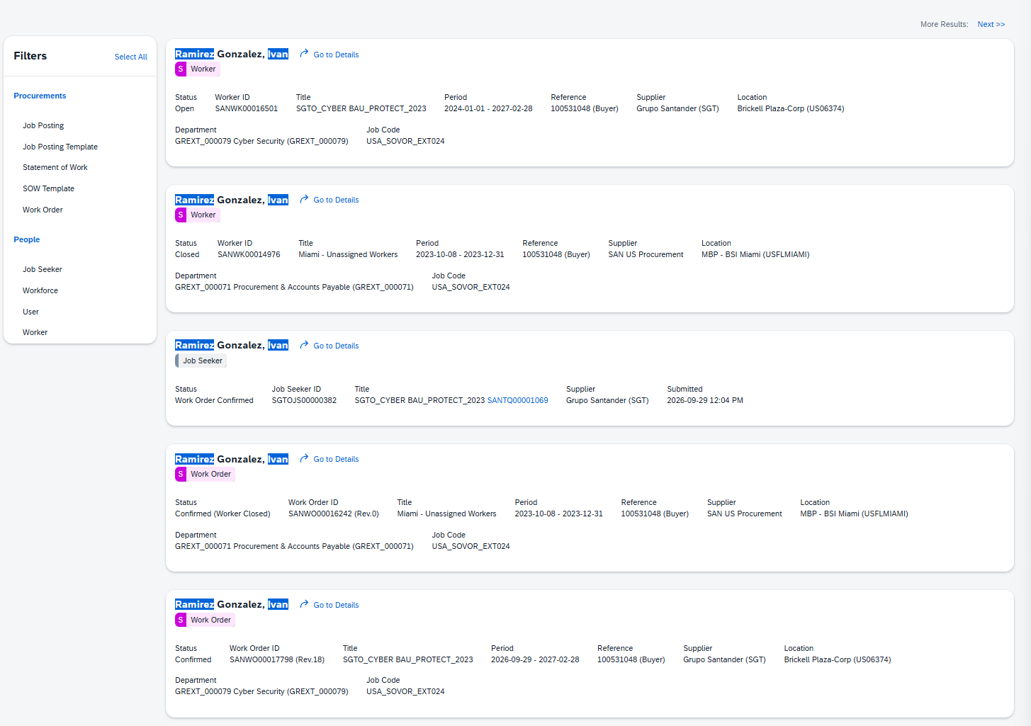
Exhibit E10.2 – MIA25104 Paez Venegas
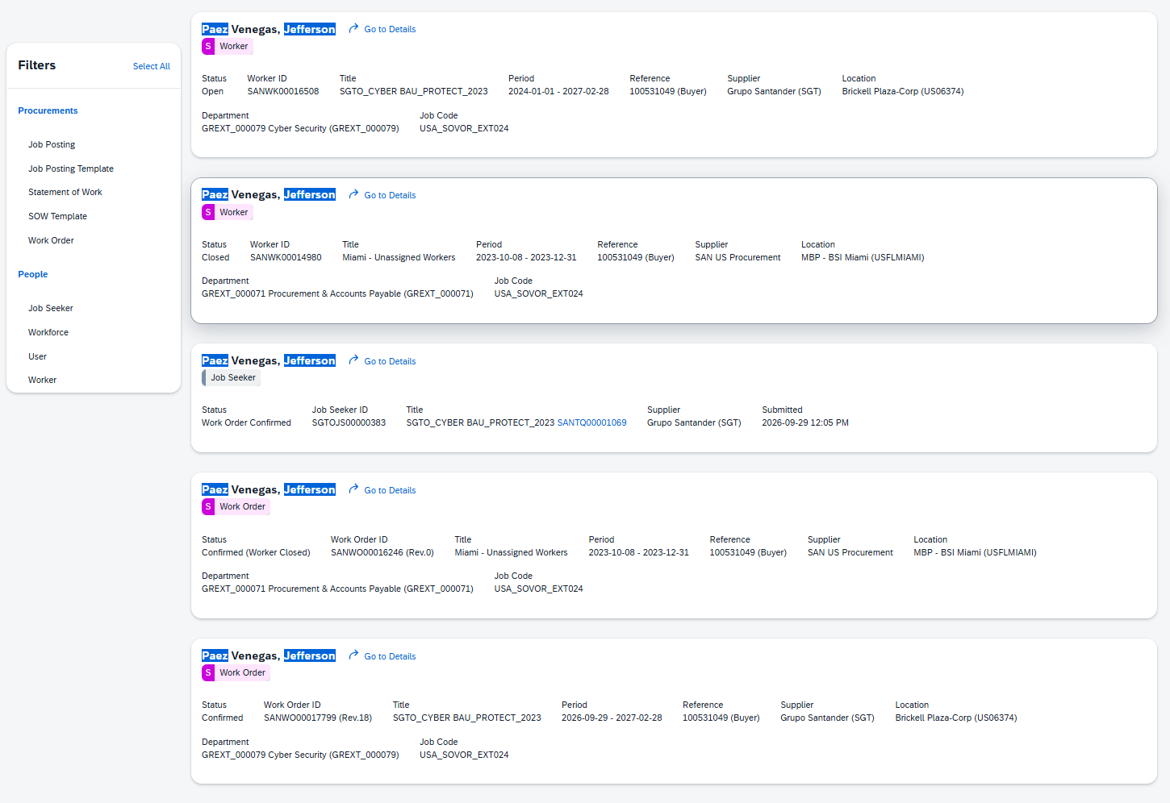
Exhibit E10.3 – MIA25105 Serrano Aguirre
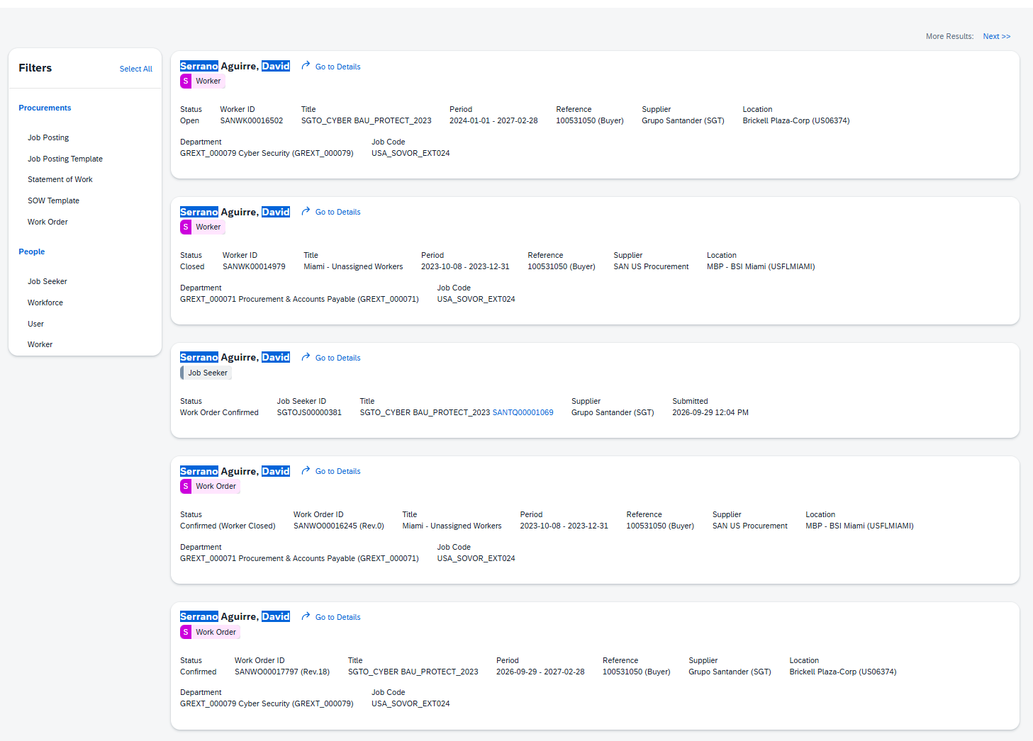
Exhibit E10.4 – MIA25106 Vazquez Arias
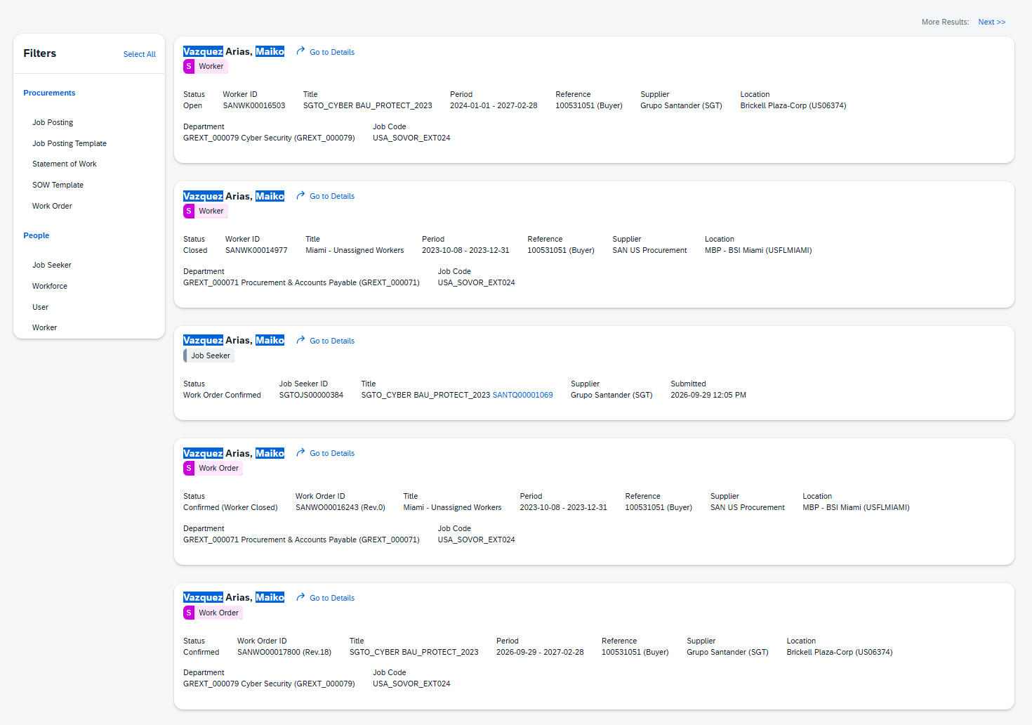
Exhibit E10.5 – MIA25249 Harris
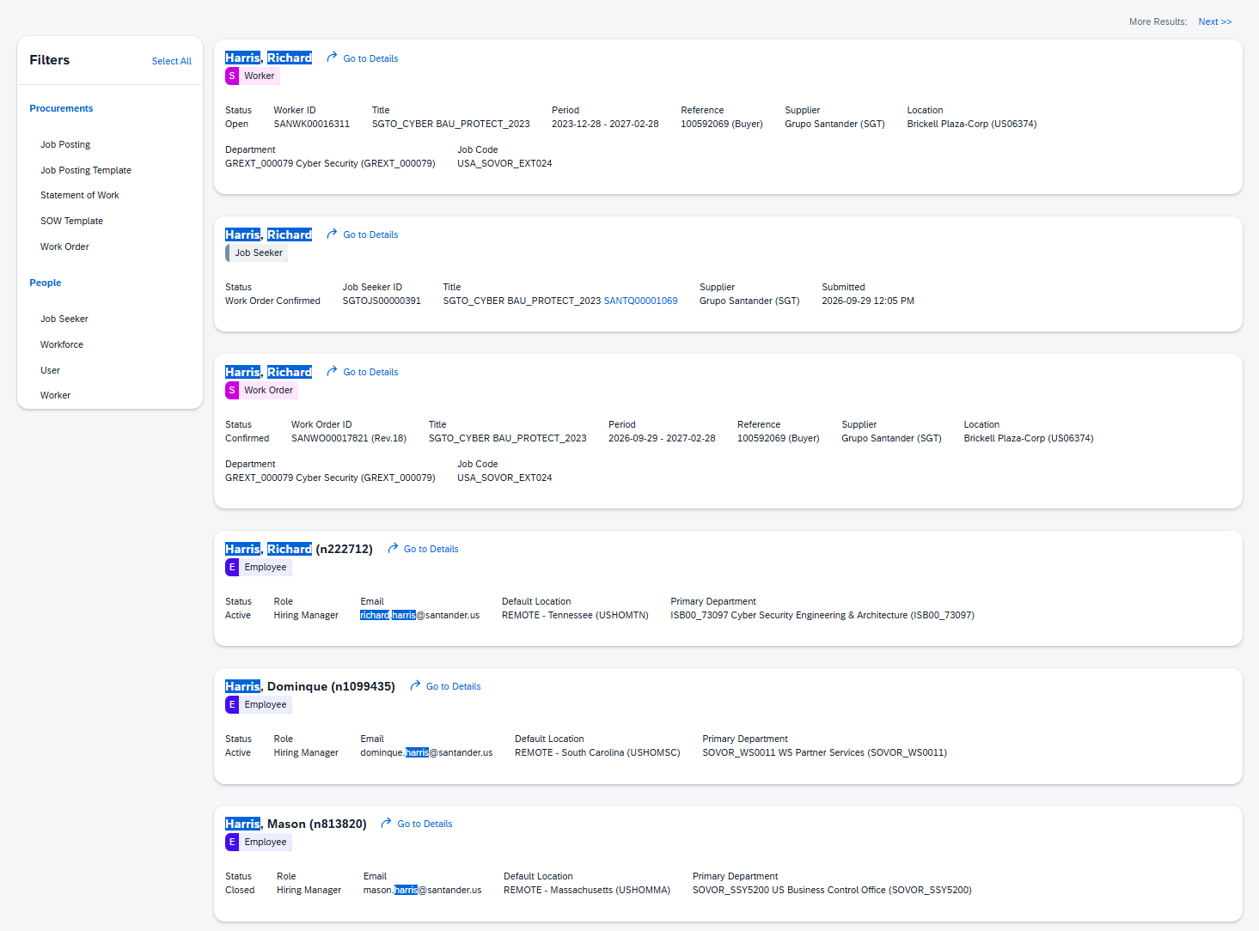
Exhibit E10.6 – MIA25250 Ackley
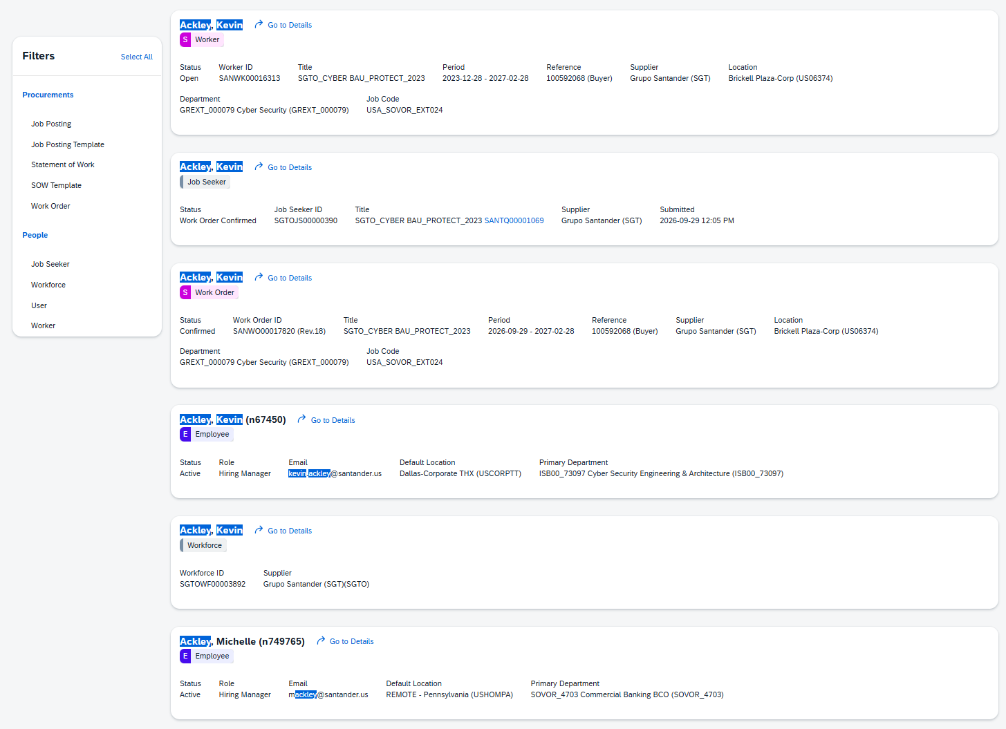
Exhibit E10.7 – MIA25251 Rimal
