BSI.IT.27.C19: Source evidence for MIABACKUP and MIAEAVAULT
Account creation date (whenCreated) and last logon (lastLogon / lastlogondate), as recorded in the Active Directory extracts provided by management for BSI.IT.27.C7
Prepared 11/02/2026 by IT RCSA Testing in response to the process owner's request for the source documents.

1. Answer
Account | Created (whenCreated) | Last logon in Q3 2025 extract | Last logon in Q1 2026 extract | Password last set (latest extract)
MIABACKUP | 2004-11-19 15:45:15 | 2025-11-23 12:04:47 (lastlogondate) | 2026-05-09 18:31:57 (lastLogon) | 2023-06-08 09:39:06
MIAEAVAULT (CyberArk EnterpriseAdmins) | 2020-05-28 10:21:48 | 2025-11-19 08:59:36 (lastlogondate) | 2026-04-23 10:05:01 (lastLogon) | 2026-04-30 10:05:58

2. Source documents
Both source files are Active Directory extracts included in the PAM / network device admin certification evidence that management provided for BSI.IT.27.C7. RCTT did not generate or alter them. The MD5 hashes allow the process owner to confirm these are the same files.
RCTT ref | File name as submitted | File name in C7 package | Workbook author (file properties) | MD5 | Tab used
C7-E04 | BSI.IT.27.C7.02 Q3_2025.xlsx | BSI.IT.27.C7_E04_Q3_2025.xlsx | Ferrer Rivera, Joel | 9df232d76e15d4e56a5f55da1d84aa4a | 1_Cisco ISE Administrators (same rows in tabs 2_, 3_, 4_)
C7-E05 | BSI.IT.27.C7.02 Q1 2026 Cert.xlsx | BSI.IT.27.C7_E05_Q1 2026 Cert.xlsx | Ferrer Rivera, Joel | 8d338a2151c9c28eff23af70e6583695 | 1.Cisco ISE Administrators (same rows in tabs 2., 3., 4.)
C7-E07 | C7.Sample.xlsx | BSI.IT.27.C7_E07_C7.Sample.xlsx | n/a | 5338b068e48afaf6f3d7b185ac6cf12e | Oct10_2026Users (enabled status only; no date columns)

3. Exact cell references
Source | Account | Data row | whenCreated | Last logon | Other columns
C7-E04 / 1_Cisco ISE Administrators (header row 13) | MIABACKUP | Row 15 | I15 = 2004-11-19 15:45:15 | J15 (lastlogondate) = 2025-11-23 12:04:47 | D15 SamAccountName; K15 PasswordLastSet = 2023-06-08 09:39:06; L15 enabled = True
C7-E04 / 1_Cisco ISE Administrators (header row 13) | MIAEAVAULT | Row 37 | I37 = 2020-05-28 10:21:48 | J37 (lastlogondate) = 2025-11-19 08:59:36 | D37 SamAccountName; K37 PasswordLastSet = 2025-11-20 08:59:41; L37 enabled = True
C7-E05 / 1.Cisco ISE Administrators (header row 13) | MIABACKUP | Row 17 | L17 = 2004-11-19 15:45:15 | R17 (lastLogon) = 2026-05-09 18:31:57 | M17 whenChanged = 2026-05-09 17:47:34; N17 passwordlastset = 2023-06-08 09:39:06; F17 enabled = True; S17 Description
C7-E05 / 1.Cisco ISE Administrators (header row 13) | MIAEAVAULT | Row 924 | L924 = 2020-05-28 10:21:48 | R924 (lastLogon) = 2026-04-23 10:05:01 | M924 whenChanged = 2026-05-15 10:08:07; N924 passwordlastset = 2026-04-30 10:05:58; F924 enabled = True; S924 Description
C7-E07 / Oct10_2026Users | MIABACKUP / MIAEAVAULT | Row 3 / Row 27 | not in extract | not in extract | enabled = True for both on 10/10/2026

4. Images of the source rows (verbatim)
C7-E04 BSI.IT.27.C7_E04_Q3_2025.xlsx, tab 1_Cisco ISE Administrators
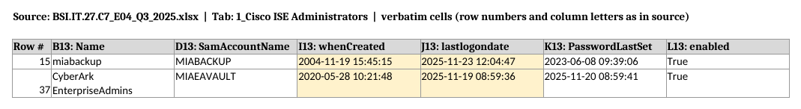
C7-E05 BSI.IT.27.C7_E05_Q1 2026 Cert.xlsx, tab 1.Cisco ISE Administrators
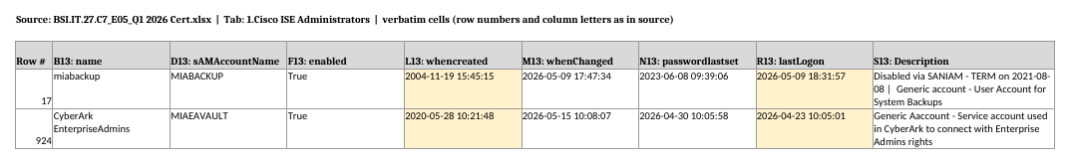

5. What the AD fields mean, and limitations
- whenCreated: the date and time the AD object was created. It is replicated to all domain controllers and does not change.
- lastLogon (E05): the last time the account authenticated against the domain controller that answered the query. It is not replicated, so another domain controller may hold a later time.
- lastlogondate (E04): PowerShell's converted value of lastLogonTimestamp. It is replicated, but only updated roughly every 9–14 days.
- Both fields record interactive, network, batch and service logons. They confirm the account authenticated, but not who used it or why. The domain controller Security log (EventCode 4624: logon type and source host) for 05/09/2026 is needed to tell break glass use apart from a scheduled backup job.
- These are the latest values in the extracts. The E05 extract was taken after 05/15/2026 (its latest whenChanged timestamp). Later logons would need a new AD query.

6. How the process owner can re-confirm directly from AD
Get-ADUser -Identity miabackup,MIAEAVAULT -Properties whenCreated,whenChanged,lastLogonTimestamp,pwdLastSet,Enabled |
Select SamAccountName,Enabled,whenCreated,whenChanged,
@{n='LastLogonTimestamp';e={[datetime]::FromFileTime($_.lastLogonTimestamp)}},
@{n='PwdLastSet';e={[datetime]::FromFileTime($_.pwdLastSet)}}
# Per-DC lastLogon (non-replicated): run against each domain controller
Get-ADDomainController -Filter * | ForEach-Object { Get-ADUser miabackup -Server $_.HostName -Properties lastLogon |
Select @{n='DC';e={$_.DistinguishedName}},@{n='lastLogon';e={[datetime]::FromFileTime($_.lastLogon)}} }
Please provide the output as a screenshot that shows the command, the run date/time and the user who ran it, along with the 4624 events for miabackup on 05/09/2026.

