Action Driver Closure Package

Validation Memo – CI23514 Percentage of Obsolete Database Instances – AD 36BA1
Action Driver Information
Legal Entity: | Banco Santander International (BSI) – ServiceNow company: SPB Miami
Division: | BSI IT (KRISP entity: BSI IT) – IT Operations / Infrastructure
Action Driver ID: | 005056BCA24E1FD0AEE7F6D7CD136BA1 (36BA1)
Action Driver Name: | [CI23514 – Percentage of Obsolete Database Instances] KRI Breach Remediation
KRI / Thresholds: | CI23514 – Percentage of obsolete database instances (monthly). Green <10% | Amber 10%–15% | Red >15%.
Regulatory Flag / Criticality: | Sarbanes-Oxley Act (SOX) | Overall Criticality: Moderate
RCSA Linkage / Root Cause: | BSI.IT.5.R4 – Obsolescence and Disposal (ID 50434969) | Root Cause C.3 – Ineffective Process Performance (inconsistent database lifecycle and decommissioning execution)
KRI Provider / Approver: | Provider: Jorge Cuadra | Approver: Ian Rojo | Backup Approver: Jose Oliveros
Accountable Executive: | Jose Oliveros [Title – confirm]
Action Driver Target Date: | [MM/DD/YYYY]
Test Period: | KRI: August 2025 – October 2026 KRISP submissions (as of 9/30/2026). Governance evidence: IT Working Group meetings 8/21/2026 and 9/18/2026 (July and August 2026 reporting periods).
Testing Performed by: | IT RCSA Control Assessment Team
Executive Summary | IT RCSA performed validation testing over KRI CI23514 – Percentage of Obsolete Database Instances to support closure of the KRI breach Action Driver 005056BCA24E1FD0AEE7F6D7CD136BA1 (36BA1). The assessment applies to BSI and covers the full population of 54 BSI database instances reported in KRISP as of September 30, 2026.  IT RCSA inspected the KRISP Value Submissions history for CI23514, independently recalculated the October 2026 submission from the 09.30.2026 Miami Obsolescence KRISP evidence workbook, inspected the monthly evidence review and submission email of October 2, 2026, and inspected the IT Working Group materials for July and August 2026 for evidence that database obsolescence is governed, tracked and escalated on an ongoing basis. All four test steps passed.  CI23514 is Green at 9.259% (5 obsolete / 54 total) for both the September 2026 and October 2026 approved KRISP submissions, after a relapse to Red in the August 2026 submission. Based on the test results, the KRI breach is considered Remediated and Action Driver 36BA1 is recommended for closure, subject to 2LoD/TRM review of the disclosures noted below.
Action Driver Description: | CI23514 was reported Red (>15%) in the August, September and October 2025 KRISP submissions (18.03%, 22.73%, 16.92%). Under the Santander US T&O KRI Management Procedure an Action Driver is required when a KRI is in breach for more than three consecutive months. The issue was identified through the October 2025 KRISP notification (October 22, 2025).  Root cause: obsolete database instances accumulated because lifecycle, decommissioning and remediation activities were not executed consistently. Remediation reduced the obsolete population and put recurring governance in place: a monthly obsolescence review, a forward view of end-of-life (EOL) dates, per-asset remediation tracking with owners and dates, and escalation of dependencies.  Remediation objective: demonstrate that CI23514 is back within tolerance on an accurate, approved KRISP submission, that the metric is supported by asset-level evidence, and that ongoing governance identifies, tracks and escalates database obsolescence before it causes a breach.  Tools: KRISP (Value Submissions), ServiceNow CMDB, Miami Obsolescence KRISP evidence workbook, IT Working Group (ITOPS obsolescence review).
Sampling Rationale: | No sampling was applied. The KRI was tested over the full population of 54 database instances in the 09/30/2026 evidence workbook and every monthly CI23514 KRISP submission from August 2025 to October 2026 (15 submissions). Governance was tested over both IT Working Group meetings held after the July 2026 relapse (8/21/2026 and 9/18/2026), which together cover the July and August 2026 reporting periods.

CI23514 Closure Validation – Testing Performed
1. |  | 2.
  Test Step: | 1 – KRI Returned Within Tolerance
  Attribute: | Obtain the KRISP submission history for CI23514 and validate that the latest approved submissions are within the Green threshold (<10%) and that the original Red breach is no longer present.
  Population / Sample: | All CI23514 KRISP submissions, August 2025 – October 2026 (15 months).
  Business Artifacts: | - CI23514.01 KRISP Value Submissions screenshot (captured 10/19/2026)  - Prior closure package CI23514_AD_Closure_Package (July 1, 2026) for Aug–Dec 2025 values
  Review: | - October 2026 submission (as of 9/30/2026): Approved – 5 / 54 = 9.259% – Green.  - September 2026 submission (as of 8/31/2026): Approved – 5 / 54 = 9.259% – Green.  - Sub-metric CI23514.A (obsolete databases 24 months without budgeted plan), October 2026: 5 / 54 = 9.259% – Green.  - August 2026 submission was Red (12 / 62 = 19.355%) after 7 instances reached vendor EOL on 7/14/2026; KRI has since been Green for two consecutive submissions.  - Provider Jorge Cuadra; Approver Ian Rojo; all submissions in status Approved.
  Result: | Pass
  Test Step: | 2 – Recalculation From Source Evidence
  Attribute: | Agree the KRISP numerator and denominator to the asset-level evidence workbook and independently recalculate the metric.
  Population / Sample: | Full population – 54 database instances (CI23514 tab).
  Business Artifacts: | - CI23514.02 09.30.2026 Miami Obsolescence KRISP evidence v3.xlsx (tabs TWG Metrics, CI23514)
  Review: | - TWG Metrics tab: CI23514 Green, 9.259% – Obsolete 5, Extended Support 0, Outgoing 10, Current 35, Under Research 4, Total 54.  - IT RCSA recount of the CI23514 tab by SW obsolescence status: Obsolete 5, Outgoing 10, Current 35, Researching 4 = 54 – agrees to TWG Metrics and KRISP.  - Recalculated 5 / 54 = 9.259% – agrees to KRISP; below the 10% Green threshold.  - All 54 records are Type Database, company SPB Miami, status Installed / In Use.
  Result: | Pass
3. |  | 4.
  Test Step: | 3 – Monthly Review and Submission
  Attribute: | Validate that the monthly KRI evidence is circulated by IT Operations for review and validation by the metric provider before upload to KRISP, and that the submission is approved.
  Population / Sample: | October 2026 submission (September 2026 evidence cycle).
  Business Artifacts: | - CI23514.03 Email “BSI Miami - September KRISP metrics evidence file” (.eml)  - CI23514.01 KRISP screenshot (status Approved)
  Review: | - Email sent 10/02/2026 by Andrés Guzmán (SPBI IT Operations) to the metric provider Jorge Cuadra and IT owners; cc Ian Rojo (approver), Jose Oliveros (AE) and Santander US risk representatives.  - Email requests review and validation of the attached evidence file before upload to KRISP, and attaches 09.30.2026 Miami Obsolescence KRISP evidence v3.xlsx.  - KRISP shows the October 2026 CI23514 submission as Approved by Ian Rojo.
  Result: | Pass
  Test Step: | 4 – Obsolescence Governance and Escalation
  Attribute: | Obtain evidence that a formal governance forum reviews obsolescence monthly with a forward-looking EOL view, per-asset tracking with owners and dates, funding traceability and escalation of dependencies.
  Population / Sample: | IT Working Group meetings 8/21/2026 (July 2026 period) and 9/18/2026 (August 2026 period).
  Business Artifacts: | - CI23514.04 IT Working Group – August 2026.pptx (obsolescence section)  - CI23514.05 IT Working Group – September 2026.pptx (obsolescence section)
  Review: | - Governance forum: monthly ITOPS obsolescence review; 6 Aug 2026 minutes filed with named owners and dates; results reported to the IT Working Group.  - Forward view: 24-month EOL horizon rebuilt monthly from KRISP asset-level dates (27 already EOL, 59 due ≤6 months, 28 in 7–12 months, 52 in 13–24 months).  - Per-asset tracking: register of 225 planned assets (166 software + 59 hardware) with owner, action, target date and status; databases lane 18 assets.  - Funding: approved IT budget; no additional funding requested or pending.  - Escalation: July Red breach escalated (4 August decommissions committed); open dependencies tracked – Varonis (InfoSec decommission date), Tableau PostgreSQL and xmfax MySQL (application owner / vendor).  - Outcome: obsolete DB instances 12 (Jul) → 5 (Sep); BigFix and SW databases migrated, miantsql decommissioned.
  Result: | Pass

CI23514 KRISP Submission History
Submission Month | As Of | Numerator (Obsolete) | Denominator (Total) | Value | RAG
August 2025 | 7/31/2025 | 11 | 61 | 18.033% | Red
September 2025 | 8/31/2025 | 15 | 66 | 22.727% | Red
October 2025 | 9/30/2025 | 11 | 65 | 16.923% | Red
November 2025 | 10/31/2025 | 13 | 64 | 20.313% | Red
December 2025 | 11/30/2025 | 10 | 65 | 15.385% | Red
January 2026 | 12/31/2025 | 7 | 60 | 11.667% | Amber
February 2026 | 1/31/2026 | 7 | 60 | 11.667% | Amber
March 2026 | 2/28/2026 | 9 | 61 | 14.754% | Amber
April 2026 | 3/31/2026 | 11 | 65 | 16.923% | Red
May 2026 | 4/30/2026 | 9 | 64 | 14.063% | Amber
June 2026 | 5/31/2026 | 6 | 62 | 9.677% | Green
July 2026 | 6/30/2026 | 7 | 58 | 12.069% | Amber
August 2026 | 7/31/2026 | 12 | 62 | 19.355% | Red
September 2026 | 8/31/2026 | 5 | 54 | 9.259% | Green
October 2026 | 9/30/2026 | 5 | 54 | 9.259% | Green
Thresholds: Green <10% | Amber 10%–15% | Red >15%. Source: KRISP Value Submissions (CI23514.01); August–December 2025 values per the July 1, 2026 closure package.
Residual Obsolete Database Instances – 09/30/2026
CI ID | Instance / Version | Application | SW EOL Date | SOX | Planned Work / Status
CI0160280235 | MSSQLSERVER@mia-dc-sql3 – SQL Server 2016 | Appian Workflows – BSI | 7/14/2026 | Yes | BoW 2026 – ITOPS upgrade H2 2026
CI0248016049 | MSSQLSERVER@miadcimg01 – SQL Server 2016 | Imaging101 | 7/14/2026 | No | BoW 2026 – ITOPS upgrade H2 2026
CI0160280439 | PostgreSQL@mia-dc-tableau – PostgreSQL 9.6.17 | Tableau – BSI | 4/3/2025 | No | “2025” – app owner / vendor date pending
CI0160279668 | MSSQLSERVER@mia-varonis-sql – SQL Server 2014 | Varonis (MEGA app: OFAC – BSI) | 7/9/2024 | No | “2025” – InfoSec decommission date pending
CI0500108885 | LOCALDB@mia-varonis-coll – SQL Server 2012 | Varonis | 7/12/2022 | No | “missing” – InfoSec decommission date pending

Points Noted During Testing
Disclosures: | - Relapse after the prior closure attempt: the July 1, 2026 package relied on the June 2026 Green result (9.677%). CI23514 then moved to Amber (July 2026, 12.069%) and Red (August 2026, 19.355%) when 7 database instances reached vendor EOL on 7/14/2026. The KRI has been Green for two consecutive approved submissions (September and October 2026). [2LoD/TRM to confirm whether two Green submissions are sufficient or whether the November 2026 submission (as of 10/31/2026) should be appended.]  - Reporting inconsistency to reconcile: the ITOPS obsolescence section of the September 18, 2026 IT Working Group deck reports CI23514 for August 2026 as Amber at 14.04% (8 / 57), while the approved KRISP September 2026 submission (as of 8/31/2026) and the KRI table in the same deck report 9.259% (5 / 54) Green. [Obtain management explanation – e.g., snapshot taken before CMDB record clean-up.]  - The September and October 2026 submissions report identical values (5 / 54). Only the 09.30.2026 evidence workbook is included in this package; the 08.31.2026 workbook supporting the September 2026 submission was not provided.  - Five obsolete instances remain (see Residual Obsolete Database Instances below), including one SOX in-scope instance (mia-dc-sql3). Three have stale (“2025”) or missing planned-work dates and depend on InfoSec, an application owner or a vendor; these are tracked and escalated through the governance forum.  - Forward risk: 3 Outgoing instances reach EOL on 1/12/2027. If none is remediated and the population is unchanged, CI23514 would move to Amber (8 / 54 = 14.8%). These are included in the H1 2027 remediation wave.  - 4 instances are Under Research (no vendor EOL date published); they are included in the denominator and excluded from the numerator, consistent with the KRISP methodology.

Closure Package – Artifact Index
Reference | Artifact | Supports
CI23514.01 | KRISP Value Submissions screenshot – CI23514 / CI23514.A history (captured 10/19/2026) – image (2).png | KRI trend, Green status, provider/approver, Approved status (steps 1, 3)
CI23514.02 | 09.30.2026 Miami Obsolescence KRISP evidence v3.xlsx (tabs TWG Metrics, CI23514) | Numerator / denominator and recalculation of 5 / 54 = 9.259% (step 2)
CI23514.03 | BSI Miami - September KRISP metrics evidence file (.eml), 10/02/2026 | Monthly review and validation before KRISP upload (step 3)
CI23514.04 | IT Working Group - August 2026 (50427831).pptx – reporting period July 2026, meeting 8/21/2026 | Governance forum, Red escalation, 24-month roadmap and forward EOL view (step 4)
CI23514.05 | IT Working Group - September 2026 (50427831).pptx – reporting period August 2026, meeting 9/18/2026 | Governance controls, per-asset register, funding, escalations, Red→Green trend (step 4)
Reference | CI23514_AD_Closure_Package (1).docx – prior package dated July 1, 2026 | Original breach, root cause, risk assessment and Aug–Dec 2025 trend

Validation Results
Results | Justification
Overview of Remediation Timeline/Status
Overall Target Date: | [MM/DD/YYYY]
Remediation Status: | Remediated
Current KRI Result: | Green – 5 / 54 = 9.259% (September and October 2026 approved submissions)
Control Performance Rating: | Satisfactory
Overall Validation Remediation Conclusion
IT RCSA reviewed Action Driver 005056BCA24E1FD0AEE7F6D7CD136BA1 (36BA1) – KRI breach of CI23514 Percentage of Obsolete Database Instances – including the CI23514 KRISP submission history from August 2025 to October 2026, the 09/30/2026 asset-level evidence workbook, the monthly evidence review and submission email, and the July and August 2026 IT Working Group obsolescence materials. Testing confirmed that CI23514 is within the Green threshold at 9.259% (5 obsolete / 54 total) for two consecutive approved submissions, that the reported value agrees to an independent recalculation of the full database population, that monthly KRI evidence is reviewed and validated before upload and approval in KRISP, and that a monthly governance forum maintains a 24-month forward EOL view, a per-asset remediation register with owners and target dates, funding traceability and escalation of dependencies. Based on the test results the control performance is rated Satisfactory, and Action Driver 005056BCA24E1FD0AEE7F6D7CD136BA1 (36BA1) is considered Remediated, subject to resolution of the disclosures noted above.
Status: | [Validation Complete. No further action needed.]
Completed by: | [Name]
Validation Date: | [MM/DD/YYYY]

Manager Review
Status: | [Validation Complete. No further action needed.]
Completed by: | [Name]
Validation Date: | [MM/DD/YYYY]

Appendix – Evidence Screenshots

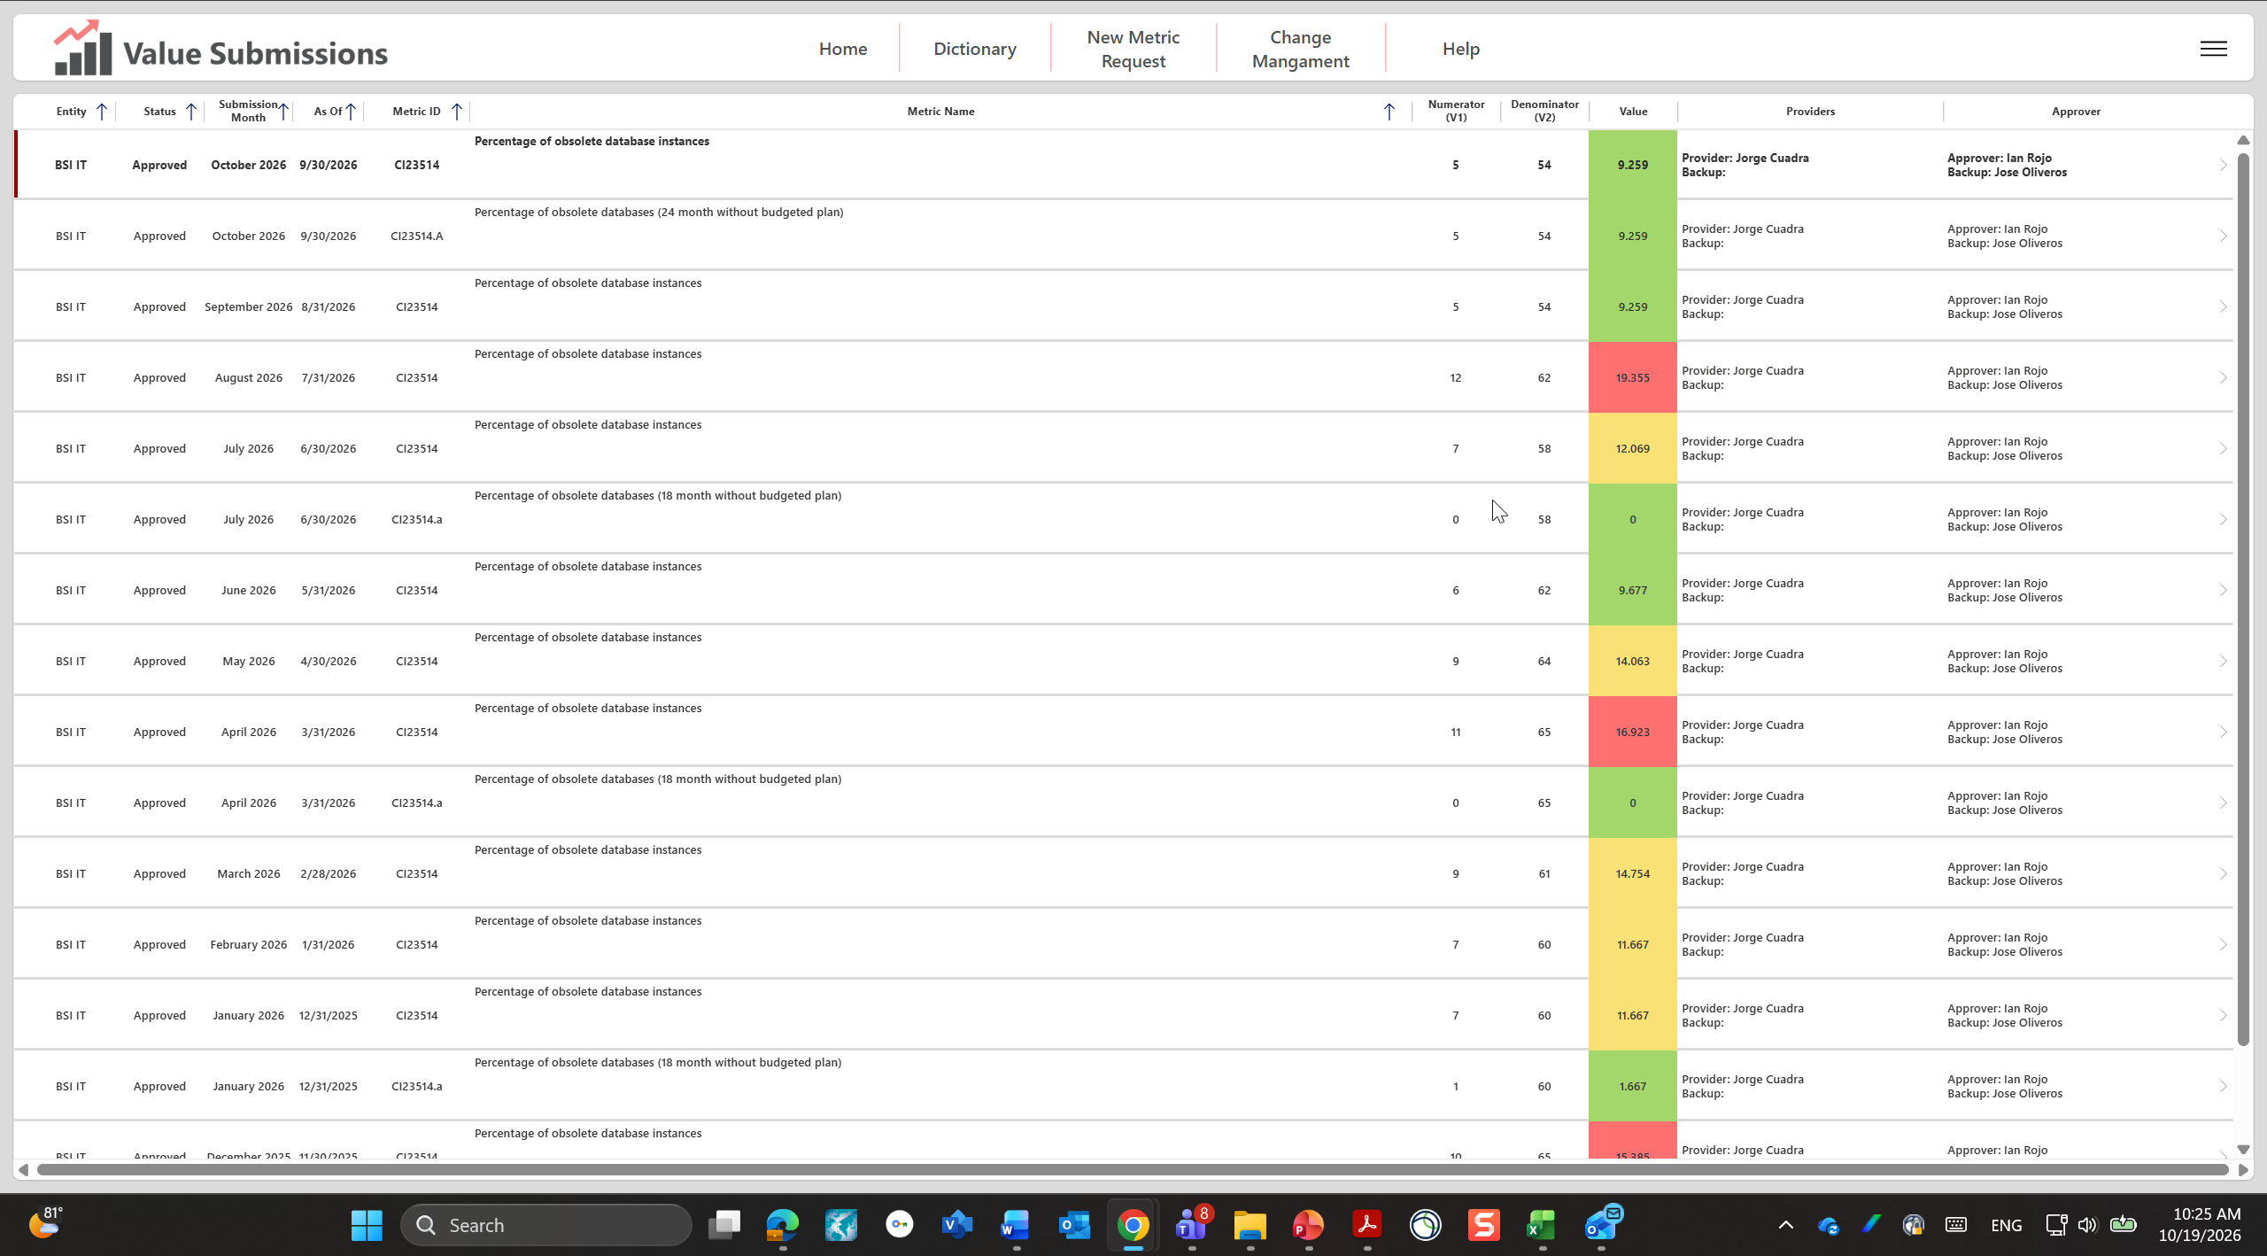
Figure A1 – KRISP Value Submissions: CI23514 history, October 2026 submission Approved, 5 / 54 = 9.259% Green (CI23514.01)
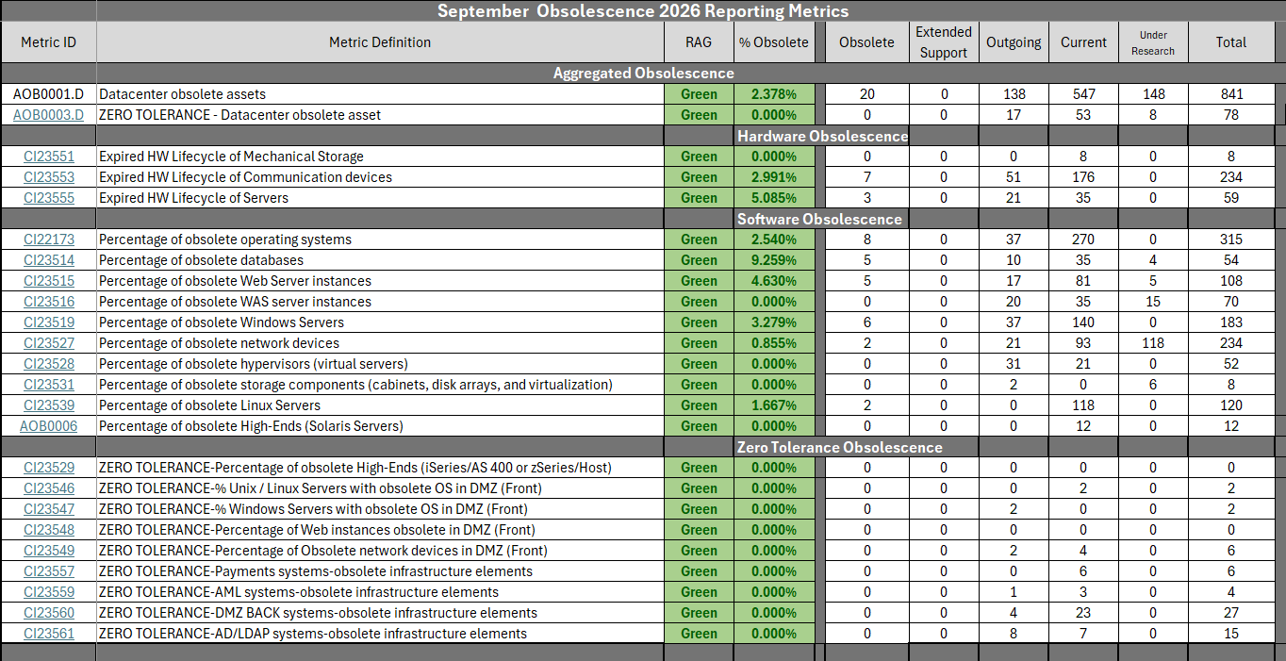
Figure A2 – September 2026 Obsolescence Reporting Metrics (TWG Metrics tab): CI23514 Green 9.259%, 5 obsolete / 54 total (CI23514.02 / CI23514.03)

