BSI.IT.27.C7 – Network Device Admin Account Review – Testing Procedures
This workpaper documents IT RCSA's testing of BSI.IT.27.C7, a key, semi-automated (hybrid) control that runs quarterly according to Heracles. The review period is 07/01/2025 to 06/30/2026 and the entity is Banco Santander International (BSI – Miami), within the Privilege Access Management (PAM) process. Dayam Borges is the control owner and executor, and Zoila Rosario Rosario is the control AD owner. The testing was prepared by Edward Morfa and reviewed by Mirna Roxana Mingo Cordova, with a test date of 10/29/2026.
Control statement: [BSI.IT.27.C7 Network Device Admin Account Review] At least semiannually, InfoSec initiates accounts reviews for network device administrators, users and service accounts that will be performed by managers or account owners. Inappropriate access is revoked by PAM/IAM team, within SLA.
Risk: [BSI.IT.27.R2 Access Review] Inappropriate user access to systems and/or data due to a failure to perform privileged access reviews, may result in disruption of business processes, financial loss and regulatory noncompliance. The inherent risk is High and the residual risk is Moderate. The related regulation is the Gramm-Leach-Bliley Act (GLBA) 501(b), § 314.3.
Where things stand: The control is well designed, and we rated the design Satisfactory with a few observations. It did not operate effectively. Both samples failed, and the exceptions for disabled accounts (E1) and re-granted access (E3) have not been cleared. The CUSO RCSA Testing Procedure v1.0 (approved 07/17/2026) rates performance as Strong, Satisfactory or Weak, so the proposed performance rating is Weak. The WP2 template still offers Needs Improvement, and the reviewer will confirm the final rating (OI-10). The Fieldglass evidence received on 10/29/2026 (E10) shows that the termination-date issue (E2) is a data-quality observation rather than an exception, and it does not change the performance conclusion.

Test of Design (CDA)

Walkthrough / Test of One summary
IT RCSA (Edward Morfa) held the CDA walkthrough for BSI.IT.27.C7 with Evelio Heredia (CyberSecurity Manager), Zoila Rosario (Cybersecurity Compliance Officer) and Oscar Ortiz (CyberSecurity Specialist). The date still needs to be confirmed, because the design document records it as "October 23, 202[ ]" (OI-08). We used inquiry and inspection on one execution of the control: account MIA25142 (Miguel Nieves Nieves, identity 100546241) in the 2025 Q3 PAM BSI SOX Manager Certification. We picked it because it was a revoked decision, so it took us through every step of the control: the review, the decision, the revocation and the SLA.
Each quarter the PAM US Team (InfoSec) builds the PAM BSI SOX certification from the four privileged network AD groups listed in section 3.3 of the PAM Definition of Privilege: CISCO ISE Administrators, CISCO Network Administrators, ISEAdmin and F5FullAdmin. The team then loads it into SanIAM / SailPoint (E02 sec. 2, 4.1.1 C1, sec. 8 steps 1–7). Line managers review person accounts and account owners review service accounts (E02 4.1.1 C2; E01 SUS.IAMS.4.2.5.6). When a reviewer revokes access, a ServiceNow revocation ticket is raised, IT Application Support removes the AD group membership, and the PAM team confirms the de-provisioning (E02 4.1.1 C3–C4, step 10). All of this must happen within 30 business days of the close of the review (E01 SUS.IAMS.4.2.5.21). When a reviewer approves access, the process ends for that entitlement (E02 step 9).
For MIA25142 we looked at three pieces of evidence. The first was the SanIAM decision export, which shows the access revoked on 08/28/2025 by Dayam Borges as line manager (E04 tab 2_Cisco Network Administrators, rows 2538–2539). The second was the Netwrix removal log, which shows the account removed on 09/02/2025, two business days after the review closed (E04 tabs 2_Cisco Network Administrators and 3_ISEAdmin, REVOCATION EVIDENCE section). The third was the AD extract of 11/25/2025 (same tabs, row 1639). Together they showed that InfoSec started the review, the authorized manager performed it, the decision was recorded in SanIAM, and the removal happened within the SLA. Decisions are kept in SanIAM / SailPoint, removal events in Netwrix, tickets in ServiceNow and memberships in Active Directory. SanIAM builds the certification population from the AD group memberships, and we confirmed completeness by reconciling the certified memberships to the AD extracts at the review dates (E06 tab 2_Step-by-Step, steps 2–2.1).
If a reviewer does not finish the certification, SanIAM sends reminders and escalates the item to the reviewer's manager and the BSI CIO. If someone whose access was rejected still keeps the privileges, the PAM US Team is required to escalate to senior management (E02 sec. 4.2). We also looked at the 2026 Q1 certification (E05, all four group tabs) and the 2026 Q2 certifications, which fall after the period (E07).
The walkthrough raised four design observations, none of which changes the design rating:
- The procedure confirms the removal once (step 10) but has no step to check that revoked access stays removed between reviews. This is what went wrong with the sample of one. Netwrix shows MIA25142 added back to ISEAdmin on 09/10/2025, and by 11/25/2025 it was back in both groups.
- The 30-business-day SLA appears only in the IAM Standard (SUS.IAMS.4.2.5.21), not in the PAM procedure.
- IAMS termination dates are not kept in line with Fieldglass and HR, as E10 confirmed.
- The SailPoint "Account Status" and "SOX" fields, and the AD user export (which has no group membership), are not reliable enough to use as audit evidence.
Even with these points, the control is appropriately designed to mitigate BSI.IT.27.R2. An independent manager or owner certifies every privileged network membership at least every six months, and rejected access has to be removed within a defined SLA. The observations affect how well removals stick and the quality of the data, not the design of the review itself.
Competency of the control owner: From our inquiries and the walkthrough, the control owner (Dayam Borges) and the InfoSec participants (the Cybersecurity Manager and the Cybersecurity Compliance Officer) clearly understood the purpose of the review, which is to remove inappropriate privileged network access. They also understood how the campaign is set up in SanIAM, what reviewers are responsible for, how revocations work, and when retained rejected access must be escalated to senior management. All of them hold management or compliance roles in BSI Cybersecurity with the authority to approve or revoke access. Performance testing later showed that the same reviewer approved disabled accounts and previously revoked access. We treat that as a performance issue rather than a gap in competency or design, and we will raise it with the control owner.
1. Is the control designed with an appropriate frequency or trigger?
Yes. The control runs on a quarterly trigger (the PAM BSI SOX certification, E02 sec. 2 and 8.1 C7), which is more often than the semiannual minimum in the control statement and the IAM Standard (SUS.IAMS.4.2.5.6, 4.2.5.19). That timing is good enough to catch privileged network access that is no longer needed. Every membership in the four privileged groups is re-certified at least every six months, and each review has a closing date from which the 30-business-day revocation SLA runs. One observation: the control statement says "semiannually" while Heracles and the procedure say quarterly. We also noted that 8.3 months passed between the 2025 Q3 launch (08/01/2025) and the 2026 Q1 launch (04/09/2026), and the 2025 Q4 review has not been evidenced (OI-01).
References: BSI.IT.27.C7_CDA_Evidence; E01 IAM Standard v11.0 SUS.IAMS.4.2.5.6 (p.17), 4.2.5.19 (p.22); E02 PAM Recertification Procedure (BSI) v2.0 04/22/2026 sec. 2, 8.1 C7
2. Is there a defined audit trail/evidence which supports the execution of the control being performed?
Yes. The audit trail has four parts: the SanIAM / SailPoint certification decision export (Manager and Entitlement Owner certifications, showing the decision, who made it, and the decision and sign-off dates), the Netwrix "member removed" events for revoked access, the ServiceNow revocation ticket, and the AD group-membership extract. For the sample of one we traced the decision, the decision maker and the removal date to SanIAM and Netwrix. That evidence shows the review, the decision and the removal, and it is enough to confirm the control was performed. One observation: we did not receive the ServiceNow revocation ticket for the sample, although Netwrix evidences the removal.
References: BSI.IT.27.C7_CDA_Evidence; E04 tab 2_Cisco Network Administrators, rows 2538–2539 (decisions); E04 tabs 2_Cisco Network Administrators and 3_ISEAdmin, REVOCATION EVIDENCE section (Netwrix log); E04 AD extract 11/25/2025, row 1639; E05 tab 2.Cisco Network Administrators, rows 3260 and 3265
3. Is the control aligned with internal policies and/or applicable regulations?
Yes. The control follows the Identity and Access Management Standard, in particular SUS.IAMS.4.2.5.6 (recertification at least semiannually by the manager or owner), 4.2.5.10 (confirm that all access marked for removal was removed) and 4.2.5.21 (privileged revocations within 30 business days of the close of the review). It also follows the PAM Recertification Procedure (BSI), sec. 4.1.1 C1–C4, sec. 4.2 and sec. 8 steps 1–10, where this control appears as 8.1 C7. The documented steps match what we saw in the walkthrough, and the control supports GLBA 501(b) § 314.3 (safeguarding customer information). One point on versions: IAM Standard v10.0 was approved on 09/29/2025 and applies to the 2026 Q1 sample. The 2025 Q3 decisions (08/28/2025) came before that date, so v9.0 applied to that sample. Likewise, PAM Procedure v2.0 was approved on 04/22/2026, and v1.0 (04/22/2025) applied before then. We have asked for both earlier versions (OI-11). We also note a documentation gap that does not affect how consistently the review is performed: the procedure has no step to check that revoked access stays removed, and it does not restate the 30-business-day SLA.
References: BSI.IT.27.C7_CDA_Evidence; E01 (pp.14–22); E01a v10.0 (6_Sources S1); E02 pp.6–10; E03 sec. 3.3
4. Are the thresholds for execution/resolution appropriate?
This question is not required, because the template asks it only for SMC Group and SMC Local controls and this is a Key control. For information, the resolution threshold is the 30-business-day revocation SLA (SUS.IAMS.4.2.5.21), which is specific enough to trigger the removal of rejected access.
5. To what level is the issue escalation process defined and implemented?
Partial. Escalation is only partly defined and implemented. SanIAM sends automatic reminders, incomplete reviews go to the approver's manager and the BSI CIO, and the procedure requires the PAM US Team to escalate to senior management when someone whose access was rejected keeps the privileges (E02 sec. 4.2). Exceptions to the procedure are approved by the BSI CISO (E02 sec. 5). What is missing is a defined step, timeframe or evidence trail for spotting access that was revoked and later given back or kept.
References: BSI.IT.27.C7_CDA_Evidence; E02 sec. 4.2 and 5 (p.7)
6. How reliable is the information which the control is dependent upon?
Moderately Reliable. The control depends on system-generated SanIAM / SailPoint certification extracts built from Active Directory group memberships, together with Netwrix logs and ServiceNow tickets. Its reliability therefore depends on the ITGC environment and on manual steps such as setting up the campaign and creating tickets. The certified populations reconciled to the AD extracts of 11/25/2025 and 05/15/2026 and to the source SanIAM CSVs.
References: BSI.IT.27.C7_CDA_Evidence; E012 – AD extracts – Screenshot
7. Is the process to obtain evidence of the control execution simple?
Yes. The PAM team can search and export certification decisions from SanIAM / SailPoint, InfoSec and IT Ops can produce the Netwrix events and AD extracts, and BSI Procurement can confirm a contingent worker's status in Fieldglass. Each piece of evidence is easy to trace back to the membership it relates to.
References: BSI.IT.27.C7_CDA_Evidence; E012 – AD extracts – Screenshot
Overall Control Design Assessment Rating – 10. Comment:
The control is appropriately designed to mitigate BSI.IT.27.R2 Access Review. The quarterly trigger works because every member of the four privileged network AD groups is re-certified at least every six months. SanIAM / SailPoint decisions, Netwrix removal events and ServiceNow tickets evidence each execution, and the evidence process is clear and practical, although evidence for the revocation step is slow to obtain. The control follows the IAM Standard (SUS.IAMS.4.2.5.6, 4.2.5.10, 4.2.5.21) and the PAM Recertification Procedure (8.1 C7). Escalation is only partly defined, because nothing detects revoked access that has been kept or given back. The information used is moderately reliable: it is system-generated from AD but depends on ITGCs and manual handling, and there are known data-quality gaps in IAMS. A semi-automated (hybrid) nature fits the control, since the manager or owner performs the review in SanIAM and the system then generates the campaign, reminders and revocation tickets. Based on the walkthrough and the evidence, the design rating is Satisfactory, with the four design observations noted above.

Sampling Rationale
The population is the PAM BSI SOX certifications performed between 07/01/2025 and 06/30/2026. Because the control is quarterly, we expected four. Two in-period certifications were evidenced. The 2025 Q3 certification was launched on 08/01/2025 (Manager) and 08/04/2025 (Owner), with decisions made between 08/06 and 08/28/2025. The 2026 Q1 certification was launched on 04/09/2026, with decisions made between 04/10 and 04/30/2026. We did not receive the 2025 Q4 certification (OI-01). The 2026 Q2 certifications, launched on 07/22/2026 and 08/13/2026, fall after the period, so we used them only as supporting evidence.
Under the RCSA sample size matrix, a quarterly control with High inherent risk at medium assurance needs a sample of two. We therefore selected two certifications, one from each half of the period, and tested every membership of the four privileged network AD groups in each. Sample 1 (2025 Q3) covered 88 memberships: 3 in CISCO ISE Administrators, 44 in CISCO Network Administrators, 36 in ISEAdmin and 5 in F5FullAdmin. Sample 2 (2026 Q1) covered 61 memberships: 3, 29, 24 and 5 in the same groups. Together the two samples included all 36 revocation decisions. We then followed up 10 accounts from the exceptions to test whether revocations stuck and what state the accounts were in (E08), and we checked the 7 contingent workers with an IAMS termination date of 12/31/2024 against Fieldglass (E10).
The RCSA Testing Procedure says that a failed key attribute in a sample fails that sample (sec. 4.4.1), and a sample can only pass if all key attributes are met (sec. 4.4.6). We applied this at the group level: a group fails if any membership in it fails a key attribute, and the sample fails if any group fails. For a quarterly control, the retesting table in sec. 4.4.8.2 shows that one exception in the original sample means the control fails, and no additional sample is available.

Testing Procedures
The RCSA team performed the following testing procedures.
1. Obtain evidence. We obtained the population of PAM BSI SOX certifications performed during the period, together with:
- the SanIAM / SailPoint Manager and Entitlement Owner decision exports;
- the AD extracts of the privileged network groups at each review date;
- the Netwrix removal logs and ServiceNow revocation tickets for revoked access;
- the IAM Standard, the PAM Recertification Procedure and the PAM Definition of Privilege;
- for contingent workers, the Fieldglass engagement records.
2. Validate report completeness and accuracy. We checked that each certification export came from SanIAM and was complete and accurate in three ways. We reconciled the certified memberships of the four groups to the AD extract at the review date, tied the export to the SanIAM source CSVs using MD5 hashes, and agreed identity details (identity number, status and termination date) to the HR or Fieldglass record.
3. Validate population and scope. We checked that the population included every person and service account in the privileged network AD groups defined in section 3.3 of the PAM Definition of Privilege, and selected the sample using the RCSA sample size matrix.
4. Verify control execution. For each sampled certification we checked four things:
- InfoSec / PAM started the campaign;
- each membership was reviewed by the line manager (person accounts) or the account owner (service accounts), never by the account holder;
- every membership had a recorded, signed-off decision;
- access that was no longer valid, such as disabled or terminated accounts or access previously revoked, was identified and not approved.
5. Validate control results. For each revoked decision, we checked that the PAM / IAM team removed the membership within 30 business days of the close of the review, re-performing the count with NETWORKDAYS over US bank holidays. We also checked that the access was still gone in the next AD extract.
6. Verify exception handling. We identified late or unsustained removals and inappropriate approvals, and checked whether the PAM / IAM team had identified, documented and managed each one as the procedure requires.
7. Verify escalation and remediation. We checked whether the exceptions were escalated as the PAM Procedure requires (sec. 4.2 to senior management; sec. 5 for BSI CISO approval), and whether a remediation plan with an owner and due date was documented and tracked.
8. Assess risk mitigation. We assessed whether the review finds inappropriate privileged network access and leads to timely revocations that last, which is how it mitigates BSI.IT.27.R2.
9. Summarize testing coverage. We recorded the population, samples, memberships and attributes tested, the exceptions, management's responses and the open items, and concluded on operating effectiveness.

Execution of the testing procedures
1. Evidence obtained. IT RCSA gathered the following evidence for 07/01/2025 to 06/30/2026.
- Criteria. IAM Standard v10.0 (09/29/2025) and v11.0 (E01); PAM Recertification Procedure (BSI) v2.0 dated 04/22/2026 (E02); PAM Definition of Privilege v10.0, sec. 3.3 (E03).
- Certifications. The 2025 Q3 (E04) and 2026 Q1 (E05) SanIAM Manager and Entitlement Owner decision exports, with AD extracts dated 11/25/2025 and 05/15/2026 and the Netwrix removal logs. From the control owner, the 2026 Q2 SOX and CyberArk certifications and the AD user export of 10/10/2026 (E07, after the period). The SanIAM source CSVs (E06.12).
- Requests. We sent the control owner an A6 / account-status request covering 10 accounts (E08). We asked BSI Procurement for Fieldglass records on 7 contingent workers on 10/14/2026, followed up on 10/23/2026, and received Ana Belloso's reply with 7 Fieldglass captures on 10/29/2026 (E10).
- Still outstanding. The 2025 Q4 certification (OI-01); the ServiceNow revocation tickets and any exception or escalation records (OI-06); approved requests for the re-grants and the Netwrix events that put the accounts back into CISCO Network Administrators (OI-03); the Netwrix source logs (OI-09); an AD group-membership export (OI-07); and IAM Standard v9.0 and PAM Procedure v1.0 (OI-11).
Test Result: Partially completed. We have the certification, AD and Netwrix evidence for both samples and the Fieldglass response. The items listed as outstanding remain open.
Reference: E01–E10; E06 tabs 6_Sources, 7_Evidence Status
2. Completeness and accuracy of the certification reports.
- Completeness. We reconciled the certified memberships to the BSI AD extracts. In 2025 Q3 every approved member was in AD except N584407, who left after the review. Three AD members were not certified because they were added after launch: X842395 (added 08/30/2025), and MIA25172 and MIA25175 in ISEAdmin (added 09/10/2025). All three were certified in 2026 Q1. In 2026 Q1 all 58 AD members were certified, and the three extra rows were revoked and removed.
- Accuracy. The exports tie to the SanIAM source CSVs by MD5 (E06 tab 6_Sources). The Fieldglass "Reference" for each of the 7 contingent workers matches the SanIAM identity in the 2026 Q2 SOX Manager certification (100531048–100531051 and 100592068–100592070; E06.12 tab S13 rows 88–111). This also supports identity 100592068 for MIA25250 in the SAMPLE tab (R4 #7).
- What we noticed in the reports. The IAMS termination date of 12/31/2024 conflicts with the open Fieldglass worker records (E10). The 2026 Q1 export repeats every row five times, so we de-duplicated it. Every 2026 Q2 row shows Account Status as "Account Removed", and the 10/10/2026 AD user export has no group membership.
Test Result: Pass (observation). The populations are complete and accurate enough to test. The data-quality points are recorded under A7 (OBS-03, OBS-04).
Reference: E04 and E05, all four group tabs; E06 tabs 2_Step-by-Step 2–2.2, 6_Sources, S13; E10
3. Scope and sample selection. The scope is the four privileged network AD groups in section 3.3 of the PAM Definition of Privilege. Both person and service accounts are included, and no in-scope account was left out. Network_support (sec. 3.2) is not in scope, and management should confirm that this is intended (OBS-07). As described under Sampling Rationale, Sample 1 is the 2025 Q3 Manager and Entitlement Owner certification (decisions 08/06–08/28/2025, 88 memberships) and Sample 2 is the 2026 Q1 certification (decisions 04/10–04/30/2026, 61 memberships).
Test Result: Pass. The two in-period samples, one per half-year, cover every in-scope membership in each certification.
Reference: E03 sec. 3.3; E06 tabs 1_Control & Approach, 2_Step-by-Step 3–3.2, 4.2
4. Initiation, reviewer, decision and appropriateness. We tested these for every membership.
- Initiation (A1) – Pass. The PAM / IAM team launched both campaigns in SanIAM / SailPoint (08/01 and 08/04/2025; 04/09/2026).
- Reviewer (A3) – Pass. Line managers and owners did the reviews in both samples (Dayam Borges for person accounts), and nobody reviewed their own access.
- Decision (A4) – Pass. All 88 memberships in Sample 1 and all 61 in Sample 2 were decided and signed off.
- Appropriateness (A5) – Fail. Reviewers approved access that should have been revoked:
  - MIA25103 was approved in both samples although it was disabled and had not logged on since 10/15/2023 (E1).
  - Nine accounts were approved on 04/30/2026 while disabled in AD: MIA25103, MIA25249, MIA25250, MIA25251, X533062, X688027, X689040, X689379 and X690623 (E1). The 05/15/2026 extract shows these accounts in the "Inactive AD Accounts" OU, changed on 04/02–04/03/2026. For MIA25249, MIA25250 and MIA25251 the last logon was 113 to 147 days earlier, which points to the 90-day inactivity process (SUS.IAMS.4.2.3.1).
  - MIA25142, MIA25172, MIA25175 and X453396 had their 2025 Q3 revoked access approved again in 2026 Q1 with no approved request (E3).
  - E2 (IAMS termination date of 12/31/2024) is an observation; see the Fieldglass section below.
By group, CISCO Network Administrators and ISEAdmin failed in both samples, while CISCO ISE Administrators and F5FullAdmin passed in both. In 2025 Q3 the two failing groups failed A5 on MIA25103. They also failed A6 because removals did not hold: four in CISCO Network Administrators and two in ISEAdmin. In 2026 Q1 they failed A5 on the nine disabled accounts (E1), plus the re-granted access (E3) for four accounts in CISCO Network Administrators and two in ISEAdmin. The 2026 Q1 revocations themselves were handled within SLA (N596764, and MIAYPER in F5FullAdmin). A1 to A4 passed for all eight group results, with A1 carrying the 2025 Q4 observation.
Test Result: Fail (A5). Initiation, reviewer and decisions all worked. Appropriateness failed in both samples, in CISCO Network Administrators and ISEAdmin.
Reference: E04 and E05, all four group tabs; E06 tabs 3_Attribute Matrix rows 5–12, 4_Item Detail, 5_Exceptions rows 4–19
5. Revocation SLA and persistence. In 2025 Q3, 33 memberships were revoked on 08/28/2025 (18 in CISCO Network Administrators, 15 in ISEAdmin). Netwrix shows them removed between 09/02 and 09/08/2025, two to six business days later, well before the SLA deadline of 10/10/2025. In 2026 Q1, N596764 was removed from two groups on 04/24/2026 and MIAYPER on 04/17/2026, both within SLA and both absent from AD on 05/15/2026.
The problem is that six of the 2025 Q3 removals did not last. MIA25142 was revoked from CISCO Network Administrators and ISEAdmin and removed on 09/02/2025 (two business days). MIA25172 was revoked from CISCO Network Administrators and removed the same day. MIA25175 was revoked from CISCO Network Administrators and removed on 09/08/2025 (six business days). X453396 was revoked from both groups and removed on 09/08/2025. A Netwrix entry in E04 (tab 3_ISEAdmin, row 3108) shows that on 09/10/2025 at 2:33 AM an account recorded as "system" added all four back to ISEAdmin. For MIA25142 and X453396 this was a re-add, and it happened before the SLA deadline. MIA25172 and MIA25175 had never been in ISEAdmin, so for them it was a new grant. By 11/25/2025 all four were back in CISCO Network Administrators as well. We found no approved request, Netwrix event for the CISCO Network Administrators re-adds, or escalation for any of this.
The process owner's position is that the SLA only starts if access is revoked. We agree (SUS.IAMS.4.2.5.21; PAM Procedure step 9), so A6 does not apply to the six approved consultants (MIA25103–06, MIA25249 and MIA25250).
Test Result: Fail (A6 – 2025 Q3 persistence). All 36 revocations were made on time, but six memberships across four accounts did not stay removed. That is contrary to SUS.IAMS.4.2.5.10 and PAM Procedure 4.1.1 C4 and sec. 4.2. All four accounts were still approved in 2026 Q2 (E07).
Reference: E04 tabs 2_Cisco Network Administrators and 3_ISEAdmin, REVOCATION EVIDENCE (Netwrix captures) and AD extract rows; E05 group tabs; E06 tabs R1 rows 4–7, R7_SLA Re-performance, Holidays; E01 SUS.IAMS.4.2.5.21 (p.22)
6. Exception handling. We found no incomplete reviews and no problems with reviewer authorization. However, the PAM / IAM team did not identify, document or manage the A5 and A6 exceptions. There is no exception record, ticket or comment: WorkItemID and WorkItemComment are blank on all 59 sample rows in E07, and the 2025 Q3 AD extract lists the revoked members with no comment.
Test Result: Fail (not evidenced). We have requested the exception records (OI-06).
Reference: E06 tabs 5_Exceptions, 7_Evidence Status #2 and #12, R3 step 6
7. Escalation and remediation. PAM Procedure sec. 4.2 requires rejected access that is kept to be escalated to senior management. We received no escalation, remediation plan, owner or tracking, and the same accounts were approved again in 2026 Q1 and 2026 Q2, which makes three reviews in a row. MIA25249 and MIA25250 were disabled for inactivity in April 2026 and were enabled again by 10/10/2026, with no request or explanation on file.
We have told the control owner about the exceptions (E08; E06 tab R5 follow-up). Under the RCSA Testing Procedure (sec. 4.4.8.4 and 4.8.1.3), we still need to send the exceptions formally to the Control Owner and the BU BCO, allow five business days for a response, and get written agreement before the issue goes to Issue Management (OI-10).
Test Result: Fail (not evidenced). We will re-assess this if management provides escalation or remediation records.
Reference: E02 sec. 4.2 and 5 (p.7); E06 tabs R4, R5; E08
8. Risk mitigation (BSI.IT.27.R2). The review is started on time, covers the full population, is done by the right reviewers, and revocations were made on time. However, in neither review did it catch disabled accounts (E1) or access given back after revocation (E3) in CISCO Network Administrators and ISEAdmin. Removals also did not last, so the risk of inappropriate privileged network access is not fully mitigated. We found no compensating control that keeps revoked access removed.
Test Result: Fail. The control does not consistently mitigate BSI.IT.27.R2 for the two failing groups.
Reference: E06 tabs 3_Attribute Matrix, 8_Procedure Coverage
9. Testing coverage. IT RCSA tested the Network Device Admin Account Review for 07/01/2025 to 06/30/2026. Of the four quarterly certifications we expected, two were evidenced in the period. We tested both, covering 149 memberships (all of them) and 36 revocations, then followed up 10 accounts and checked 7 contingent workers against Fieldglass.
By attribute, A1 (frequency and initiation) passed with the observation that 2025 Q4 was not evidenced. A2 (completeness), A3 (reviewer) and A4 (decision) passed. A5 (appropriateness) failed because of E1 and E3. A6 (revocation within SLA) passed on timeliness but failed on persistence in 2025 Q3. A7 (information reliability) is an observation.
Exceptions affected 16 accounts: 20 memberships in 2025 Q3 (14 for A5, 6 for A6) and 30 memberships in 2026 Q1 (all A5). The Fieldglass response confirmed E1 and E3 and showed that E2 is an observation, not an exception. Four of the eight group results failed, so both samples failed. The failures were in CISCO Network Administrators and ISEAdmin; CISCO ISE Administrators and F5FullAdmin passed in both.
The design rating is Satisfactory. For performance, sec. 4.4.8.2 of the RCSA Testing Procedure says a quarterly control with an exception in the original sample fails and cannot be retested. Because the CUSO RCSA Testing Procedure v1.0 uses a Strong / Satisfactory / Weak scale, the proposed performance rating is Weak. The reviewer will confirm this against the WP2 template, which still offers Needs Improvement (OI-10).
Test Result: Completed, pending open items. The testing gives us enough coverage to conclude. The open items can only clear individual exceptions: approved re-grant requests would clear E3, and approved re-enable requests or a business justification could clear E1. They cannot reverse the failure of both samples on their own. In particular, MIA25103 fails A5 in both samples and no further evidence can clear it.
Reference: E06 (start at tab 0_Read Me); WP2 BSI.IT.27.C7 tabs Control Design Assessment, Control Performance Assessment

Additional attribute testing – Fieldglass validation (E2)
The question: were the contingent workers whose IAMS record shows a termination date of 12/31/2024 still engaged on the review dates of 08/28/2025, 04/30/2026 and 07/27/2026?
What we did. On 10/14/2026 we asked BSI Procurement for a system-generated Fieldglass extract or screenshot, with the report date and parameters visible, for 7 contingent workers. For each worker we asked for four things: the original engagement start and end dates; any extensions, with approval date and approver; the status on 08/28/2025, 04/30/2026 and 07/27/2026; and any termination, interruption or gap in April 2026. We sent a reminder on 10/23/2026. On 10/29/2026 at 9:52 AM, Ana Belloso (BSI Procurement) replied with one Fieldglass search-results capture per worker (E10, Exhibits B1–B7). We compared each capture with the SanIAM identity (E06.12 S13), the IAMS termination date and the account's AD history (E06 tabs 5_Exceptions, R1).
What Fieldglass shows for each worker. All seven workers share the same title (SGTO_CYBER BAU_PROTECT_2023), supplier (Grupo Santander (SGT)), department (GREXT_000079 Cyber Security), location (Brickell Plaza-Corp, US06374) and job code (USA_SOVOR_EXT024). Each one also has a job seeker record submitted on 09/29/2026 at 12:04–12:05 PM and a current Rev.18 work order that runs from 09/29/2026 to 02/28/2027.
- MIA25103, Ivan Ramirez Gonzalez (100531048). Worker SANWK00016501 is open from 01/01/2024 to 02/28/2027, following an earlier record (SANWK00014976) that closed on 12/31/2023. Current work order SANWO00017798. The AD account was disabled at all three extracts (11/25/2025, 05/15/2026 and 10/10/2026) and has not logged on since 10/15/2023. Fieldglass turns E2 into an observation, but it does not clear E1: he is engaged, yet his privileged access has not been used since 2023 and is not needed (SUS.IAMS.4.2.5.1).
- MIA25104, Jefferson Paez Venegas (100531049). Worker SANWK00016508 is open from 01/01/2024 to 02/28/2027 (previous record SANWK00014980 closed in 2023). Current work order SANWO00017799. The account was enabled at all three extracts. E2 becomes an observation and the exception is cleared.
- MIA25105, David Serrano Aguirre (100531050). Worker SANWK00016502 is open from 01/01/2024 to 02/28/2027 (previous record SANWK00014979). Current work order SANWO00017797. The account was enabled throughout. E2 is cleared as an exception.
- MIA25106, Maiko Vazquez Arias (100531051). Worker SANWK00016503 is open from 01/01/2024 to 02/28/2027 (previous record SANWK00014977). Current work order SANWO00017800. The account was enabled throughout. E2 is cleared as an exception.
- MIA25249, Richard Harris (100592069). Worker SANWK00016311 is open from 12/28/2023 to 02/28/2027. Fieldglass also lists an active Santander US employee with the same name (n222712, Hiring Manager, ISB00_73097). Current work order SANWO00017821. The account was enabled on 11/25/2025, disabled for inactivity on 04/02/2026, and enabled again by 10/10/2026. E2 becomes an observation, but E1 for 2026 Q1 is not cleared.
- MIA25250, Kevin Ackley (100592068). Worker SANWK00016313 is open from 12/28/2023 to 02/28/2027. Fieldglass also lists an active employee record (n67450, Hiring Manager, ISB00_73097) and workforce record SGTOWF00003892. Current work order SANWO00017820. The account was enabled on 11/25/2025, disabled on 04/03/2026, and enabled again by 10/10/2026 with employeeID and employeeNumber both blank. E2 becomes an observation, but E1 for 2026 Q1 is not cleared.
- MIA25251, Ashish Rimal (100592070). Worker SANWK00016312 is open from 12/28/2023 to 02/28/2027, and there is an active employee record (n600486). Current work order SANWO00017819. The account was enabled on 11/25/2025 and disabled on 04/03/2026. E2 becomes an observation, but E1 for 2026 Q1 is not cleared.
The earlier 2023 records for MIA25103–06 were under "Miami – Unassigned Workers" with SAN US Procurement, on work orders SANWO00016242–16246 (Rev.0, Confirmed, Worker Closed).
What we concluded:
- The workers were engaged on the review dates. All seven worker records are open, starting on 12/28/2023 or 01/01/2024 and ending on 02/28/2027, which covers all three review dates. The IAMS termination date of 12/31/2024 is therefore wrong. E2 is an IAMS data-quality observation (A7, OBS-03), not an exception. The process owner's point that "these consultants were extended" is now supported.
- The identities match. All seven Fieldglass references agree with the SanIAM identities (E06.12 S13 rows 88–111).
- Some of what we asked for did not come. The captures are search-result screenshots pasted into the email, with no report date or parameters. They do not show extension approval dates or approvers, the work order revision history (Rev.0 to Rev.17), the status on the three dates, or any statement about April 2026. Four of the seven captures also show "More Results: Next >>", so the results were cut off.
- The 09/29/2026 activity still needs an explanation. Every current work order starts on 09/29/2026 and every job seeker record was submitted that day, after the period and after the 2026 Q2 certifications. The work order covering 2024 to 09/28/2026 is not shown, although it may simply be on the next page of results. The April 2026 disablements are a separate matter: the AD evidence points to the 90-day inactivity process, not to a break in the engagement (OI-04, OI-05).
- Fieldglass does not clear E1 or E3. Being actively engaged does not justify approving privileged access on an account that is disabled or unused at the decision date (E1). MIA25103 has had no BSI logon since 10/15/2023. Fieldglass also says nothing about access given back after revocation (E3).
- A new observation (OBS-05). For MIA25249, MIA25250 and MIA25251, Fieldglass also returns active Santander US employee records with the same names (n222712, n67450 and n600486; Hiring Manager, ISB00_73097 Cyber Security Engineering & Architecture). IAM should confirm whether these are the same people, and how the BSI MIA accounts are linked to the primary identity for leaver processing. MIA25250 and MIA25251 also have blank employeeID and employeeNumber in AD.
- One account is missing from the request. MIA25142 also has an IAMS termination date of 12/31/2024 but was not included in the Fieldglass request. We will add it to the follow-up (OI-04). X453396 has no termination date and does not need to be checked.
Test Result: Pass. E2 is an observation, not an exception. The Fieldglass evidence is incomplete and remains open. The overall conclusion does not change: both samples fail on E1 and E3 (A5) and on A6 persistence.
Reference: E10 Exhibits B1–B7; E06.12 tab S13 rows 88–111; E06 tabs 3_Attribute Matrix table C #2, 5_Exceptions rows 4–7 and 11–13, R1 rows 8–13, 7_Evidence Status #4 and #13

Open items and observations

Open items
OI-01. We need the 2025 Q4 certification decision reports, or written confirmation from PAM / IAM that the review was not performed (E06 #1). Owner: IAM / PAM team. This decides whether A1 is an observation or an exception against the quarterly procedure.
OI-02. We need management's response explaining why disabled accounts were approved and revoked access was given back, with the root cause and remediation, including the removal and the Netwrix evidence. Owner: control owner. We need this to finalize the exceptions and raise the action driver.
OI-03. We need the approved access requests behind the re-grants of MIA25142, MIA25172, MIA25175 and X453396 between 09/08/2025 and 11/25/2025. We also need the Netwrix events for the CISCO Network Administrators re-adds, and an explanation of the "system" change at 2:33 AM on 09/10/2025 that added the four accounts to ISEAdmin. Owner: PAM / IAM and InfoSec. This is the only evidence that can clear E3.
OI-04. We need a Fieldglass follow-up from BSI Procurement. It should be a system-generated report with run date and parameters, showing the work order revision history (Rev.0 to Rev.18) with extension dates and approvers, the work order covering 08/28/2025 to 09/28/2026, the reason for the new job seeker records and work orders of 09/29/2026, and confirmation of any April 2026 interruption. MIA25142 should be added. This confirms that E2 stays an observation and dates any gap in service.
OI-05. We need the AD / Netwrix disable and re-enable events, and the approved requests, for MIA25249 and MIA25250 (April to October 2026) and MIA25251. We also need any business justification, dated on or before 04/30/2026, for keeping their privileged access, and the reason MIA25103 (unused since 10/2023) still has privileged network access. Owner: IT Ops / InfoSec and the control owner. This is the only evidence that could clear E1.
OI-06. We need the ServiceNow revocation tickets for 2025 Q3 and 2026 Q1, and any exception or escalation record with an owner, due date and tracking. Owner: PAM / IAM and the control owner. Steps 6 and 7 remain a fail without it.
OI-07. We need a Get-ADGroupMember export of the four in-scope groups and CYBERARK_ALERO_USERS, with a screenshot of the command showing date and time. Owner: IT Ops / InfoSec. This confirms the current membership of the 10 follow-up accounts.
OI-08. We need to confirm the walkthrough date and attendees, because the design document shows "October 23, 202[ ]". Owner: IT RCSA. This is required by RCSA Testing Procedure 4.3.4.1.
OI-09. We need the Netwrix source logs behind the removal dates of 09/02–09/08/2025 and 04/17–04/24/2026. Owner: InfoSec (Netwrix). This confirms the SLA results from the source.
OI-10. We need to send the exceptions formally to the Control Owner and BU BCO, get their written agreement, and have the reviewer confirm the performance rating (Weak under the current procedure, or Needs Improvement under the WP2 template) before Issue Management. Owner: IT RCSA and the reviewer. This is required by RCSA Testing Procedure 4.4.8.4 and 4.8.1.3, which allow five business days for the response.
OI-11. We need IAM Standard v9.0 and PAM Recertification Procedure v1.0, the versions in force for the 2025 Q3 sample, or confirmation that the requirements cited here did not change. Owner: Technology Policy Administration. This confirms the criteria used for Sample 1.

Observations
OBS-01. The PAM Procedure confirms a removal once (step 10) but never checks that revoked access stays removed between reviews. We recommend adding a post-revocation membership check to the procedure.
OBS-02. The 30-business-day SLA is set out only in the IAM Standard (SUS.IAMS.4.2.5.21), not in the PAM Procedure. The procedure should restate it.
OBS-03. The IAMS termination date of 12/31/2024 for seven contingent workers conflicts with Fieldglass records that are open to 02/28/2027 (E10). IAM should bring IAMS into line with Fieldglass and confirm that leaver controls use the correct date.
OBS-04. The SailPoint Account Status field ("Account Removed" on every row) and the SOX flags are unreliable, the 2026 Q1 export repeats every row five times, and the AD user export has no group data. IAM should correct these report fields.
OBS-05. MIA25249, MIA25250 and MIA25251 have active Santander US employee identities with the same names in Fieldglass (n222712, n67450 and n600486). IAM should confirm how these identities are correlated.
OBS-06. 8.3 months passed between the 2025 Q3 and 2026 Q1 launches, and the control statement says semiannual while Heracles and the procedure say quarterly. The control statement should be aligned with the quarterly frequency.
OBS-07. Network_support (Definition of Privilege sec. 3.2) is not in scope. Management should confirm this is intended.
OBS-08. All person-account decisions were made by one reviewer in single bursts: 08/28/2025 between 10:25 and 10:40 AM, and all 69 memberships at once on 04/30/2026 at 1:47 PM. The reviewer is also the BSI CISO, the control owner and the approver of procedure exceptions. This is the likely root cause of E1 and E3. We recommend item-level review evidence and an independent second approver for the CISO's own hosted accounts.
OBS-09. Netwrix shows privileged group members being added at around 2:30 AM by "system" (08/30/2025 and 09/10/2025). This suggests a scheduled job adds members outside the request process. InfoSec should identify the job and bring it under the access request process.

Evidence references
- E00: BSI.IT.27.C7_E00_Evidence Index.xlsx. Start here.
- E01: BSI.IT.27.C7_E01_IAM Standard v11.0 (BSIIT21).pdf. Version 11.0 was approved on 07/28/2026, after the period, and is cited for clause wording and page numbers.
- E01a: BSI.IT.27.C7_E01a_IAM Standard v10.0.pdf. Version 10.0, approved 09/29/2025, which applies to the 2026 Q1 sample.
- E02: BSI.IT.27.C7_E02_PAM Recertification Procedure (BSI) 04.22.26.pdf.
- E03: BSI.IT.27.C7_E03_PAM Definition of Privilege.pdf.
- E04: BSI.IT.27.C7_E04_Q3_2025.xlsx. The 2025 Q3 certification, the AD extract of 11/25/2025 and the Netwrix captures (tabs 1_Cisco ISE Administrators, 2_Cisco Network Administrators, 3_ISEAdmin and 4_F5FullAdmin; Netwrix in the REVOCATION EVIDENCE section of tabs 2 and 3; 5-SailPoint Reports).
- E05: BSI.IT.27.C7_E05_Q1 2026 Cert.xlsx. The 2026 Q1 certification, the AD extract of 05/15/2026 and Netwrix (tabs 1.Cisco ISE Administrators, 2.Cisco Network Administrators, 3.ISEAdmin and 4.F5FullAdmin; 5-SailPoint Reports).
- E06: BSI.IT.27.C7_E06_Testing Walkthrough - Combined with 2026 Q2 Sample.xlsx (tabs E06.1 to E06.13). E06.12 holds the SanIAM source CSVs S9 to S16, also in the subfolder BSI.IT.27.C7_E06.12_SanIAM source files.
- E07: BSI.IT.27.C7_E07_C7.Sample.xlsx. Management's response: the 2026 Q2 certifications, the AD export of 10/10/2026 and screenshots.
- E08: BSI.IT.27.C7_E08_Sample step taken.docx. The A6 / account-status request to the control owner.
- E09: BSI.IT.27.C7_E09_Sample of 1 MIA25142 Workpaper.xlsx.
- E10: BSI.IT.27.C7_E10_Fieldglass Evidence 10-29-2026.msg. The email "RE: Request for Fieldglass Evidence-Samples – BSI.IT.27.C7 Testing": BSI Procurement's response of 10/29/2026 at 9:52 AM (Ana Belloso) with 7 Fieldglass captures, plus Edward Morfa's request of 10/14/2026 and reminder of 10/23/2026.
- DOC: BSI.IT.27.C7_Design_WT_Sample_of_1_MIA25142.docx. The design assessment and sample of one.
- WP2: WP2 BSI.IT.27.C7 Network Device Admin Accoun.xlsm. Tabs Control Metadata, Control Design Assessment and Control Performance Assessment.

Appendix B – Fieldglass evidence (E10)
Source: the email "RE: Request for Fieldglass Evidence – BSI.IT.27.C7 Testing" from Ana Belloso (BSI Procurement) to Edward Morfa and BSI Procurement, 10/29/2026 at 9:52 AM. The captures are Fieldglass global search results, and the report date and parameters are not visible (OI-04).
Exhibit B1: MIA25103 – Ramirez Gonzalez, Ivan
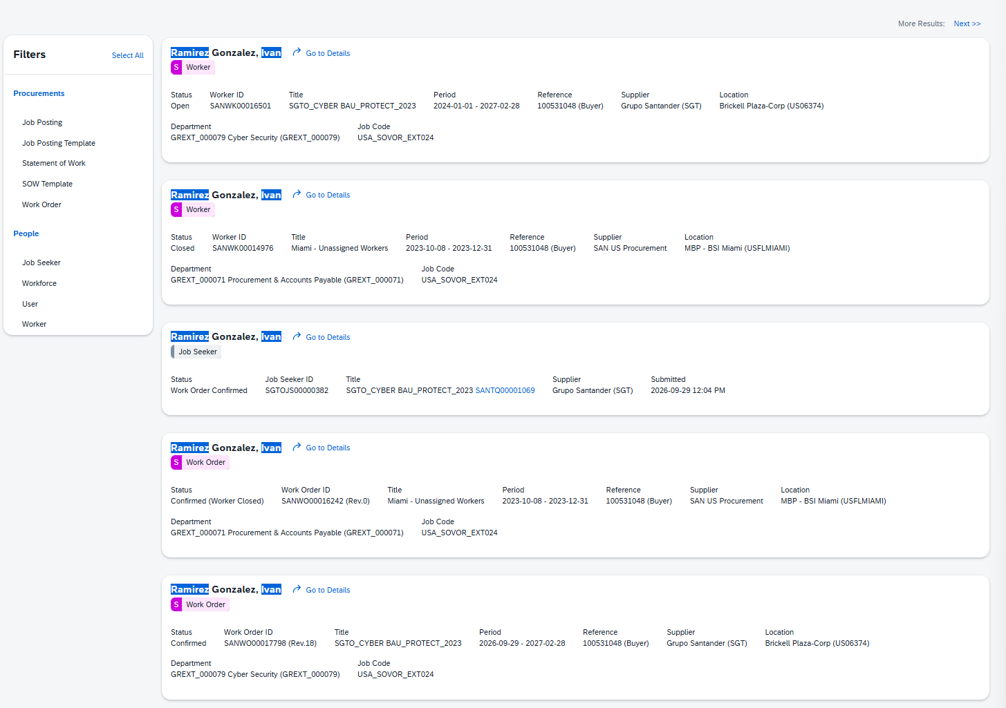
Exhibit B2: MIA25104 – Paez Venegas, Jefferson
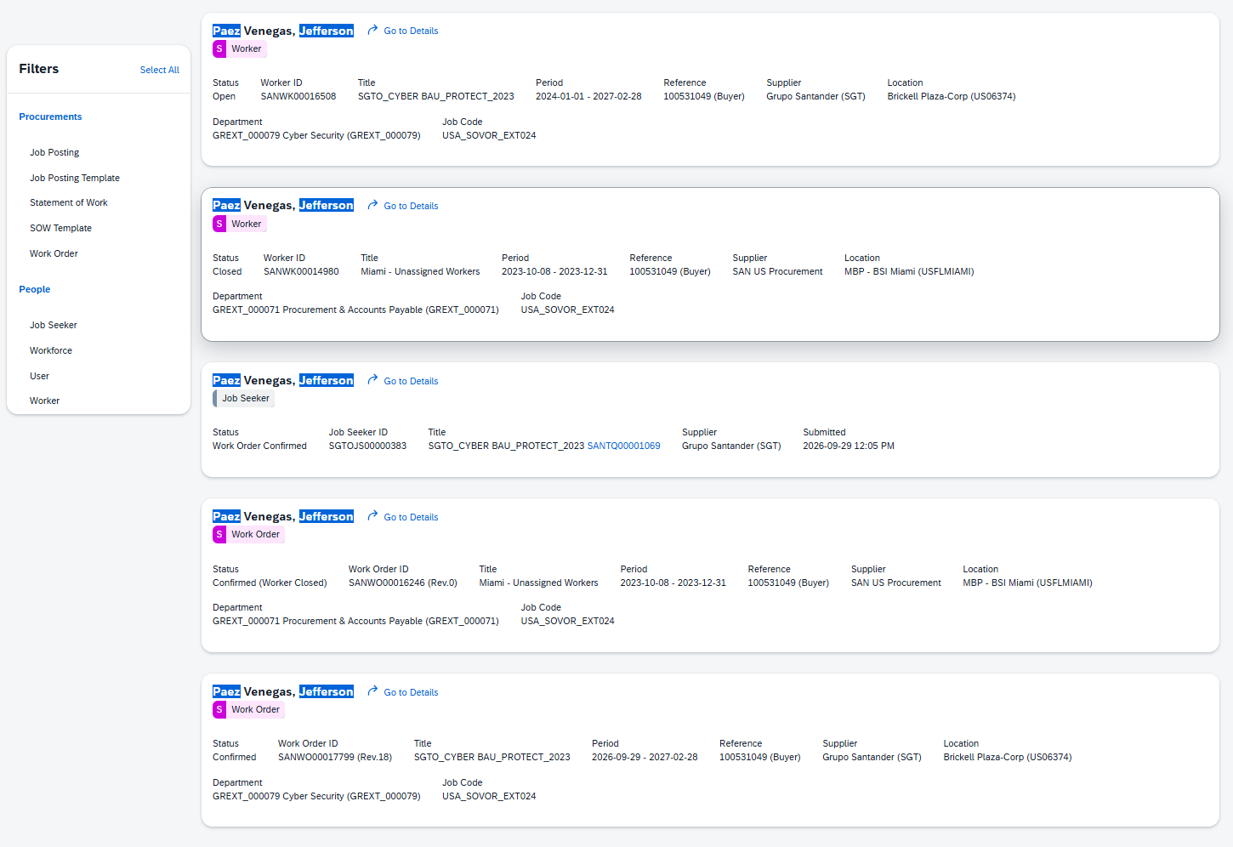
Exhibit B3: MIA25105 – Serrano Aguirre, David
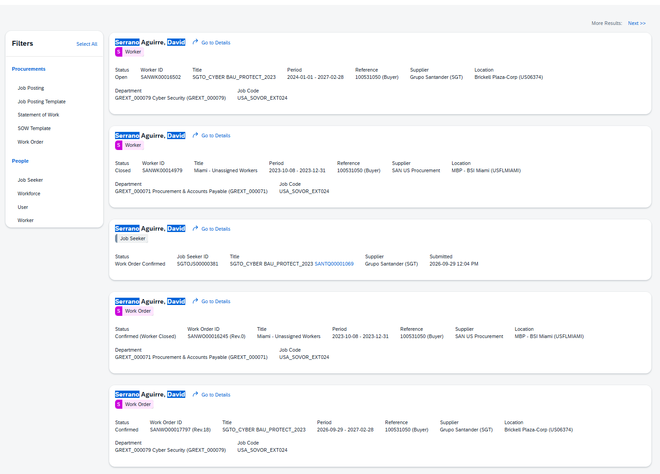
Exhibit B4: MIA25106 – Vazquez Arias, Maiko
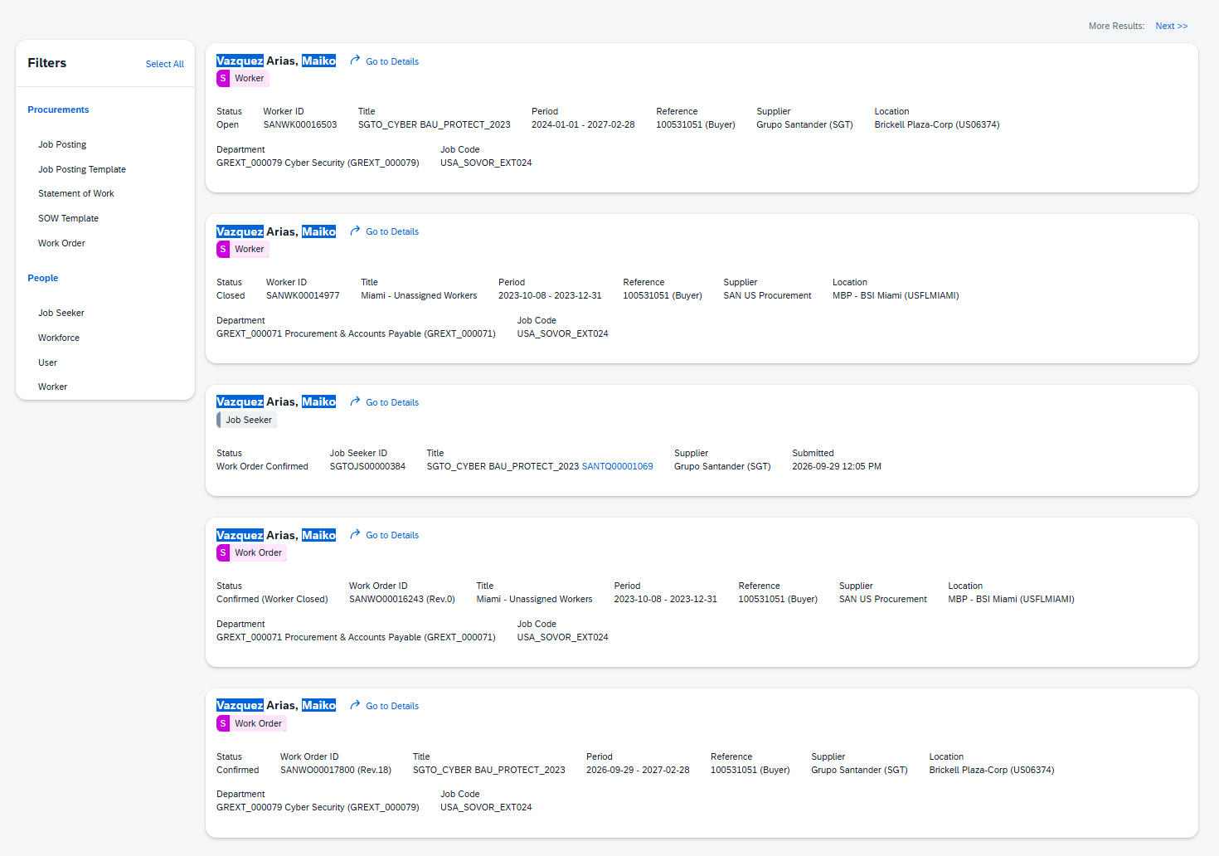
Exhibit B5: MIA25249 – Harris, Richard
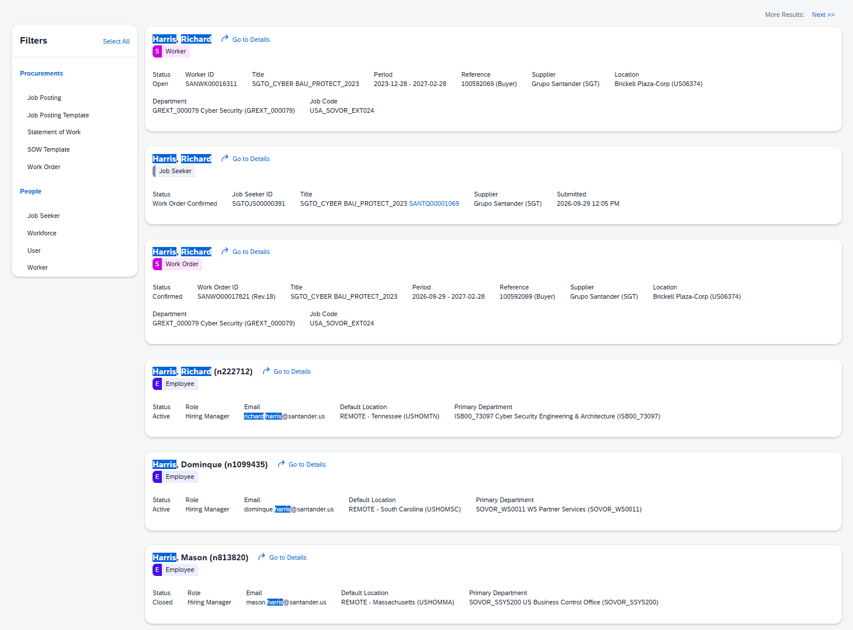
Exhibit B6: MIA25250 – Ackley, Kevin
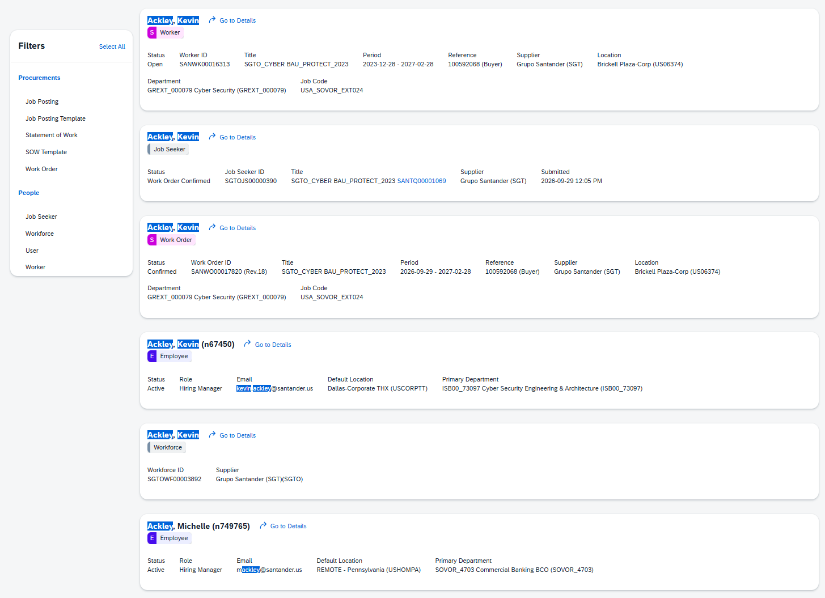
Exhibit B7: MIA25251 – Rimal, Ashish


