**Client Handbook**

**Cotton Leaf Detection Application**

**Group: COMP2003-2023-7**

|  |  |
| --- | --- |
| Team Member | Role |
| David Penfold | Team Leader |
| Ben Keeping | Innovator |
| Edward Gaston | Architect |
| Morgan Hodge | Architect |



This document provides the complete user manual on how to maintain the system and any appropriate information needed.

**How developer can access and update features**

The application was created within android studio, if developers want to go and update some features, they will have to first download all the needed software. Such as android studio and GitHub, and then clone the repository.

Before making any changes, developers must locate the where their python is stored through the use of the command “where python” in their computers command line.



They should then copy the link and paste it into the buildpython part of the “build.gradle.kts (Module:app)” gradle script. Currently it will have a current developers python location which doesn’t work across developers.

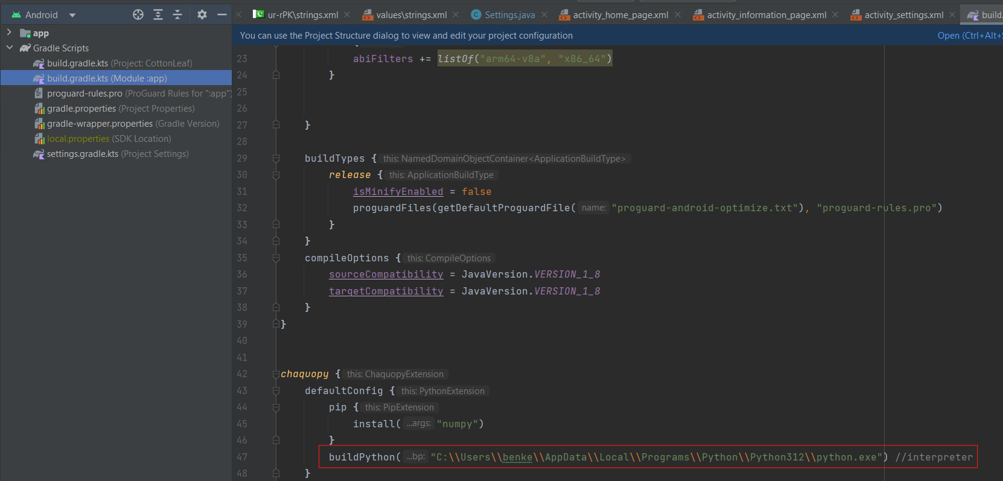

From there, developers will have access to the source code for the project and can update and add whatever they like to the project.

**How it can be accessed on a mobile device**

There are multiple ways the application can be accessed on mobile devices. The first being downloading it from the android store. To be able to do this it means the application would have to be published and then wait for confirmation from android to be listed on the android store.

The other way the app could be accessed on a mobile device is to publish the application on a website and have the users download it from the web. This is a more complex approach than the first opt

**Firebase System**

The Firebase authentication system stores the users of the application. The firebase users' email, user UID (unique user identifier), date they created their account and the last time that were signed in. The client can access all this information through the firebase dashboard on the firebase website. The client has received the login information to access the dashboard from a meeting.

Step by step instructions on how to access the firebase dashboard are as follows.

* The client opens an internet browser (e.g. Google Chrome)
* The client does a search for “Google Firebase”
* The client enters the website and signs into the cotton leaf project account with the provided email and password (transferred to the client in a meeting)
* Once the client has signed in, they will then sign on firebase authentication
* Next the client will be taken to a page of the projects connected to that email, the client will find the “cotton leaf project”
* After clicking on that button, the client will open into the dashboard.