Lab 2: Naïve Bayes Text Classification
© Edward Hunter, 2014

- Introduction

In this lab, we develop simple code to train and test Naïve Bayes classifiers on text categorization problems as described in lecture. You are provided a Python project that contains a supervised learning template file and utilities to download and manage the test datasets. The template file provides all the routine Python plumbing for importing required components and parsing command line options. We have clearly identified a few places in the code you can customize to make your algorithms using the toolkit scikit-learn, that provides pre-made functions for this and other learning tasks. Following code development, we make training and testing runs against our test corpora and show common ways to evaluate supervised learning performance. You will see that using tools like scikit can save enormous time and allow researchers to focus on substantive questions without requiring extensive background in programming machine learning algorithms.

Note: In the sections to follow, examples are given that show work using a Linux command shell in Mac OS X. If you use a different OS than this, the precise appearance and command line instructions for listing files and the like may be slightly different. Please see the instructor or TA if you need any assistance determining the comparable commands in your OS. The Python code and commands for running our programs should be identical.

- Downloading the Lab Repository and Test Data

The class project code is kept in an online repository accessed by the git program. Open a command line window and from your home directory issue the git clone command with the URL of the repository as the argument. Here is the exact git clone command (first line) along with the output (your output may differ slightly)

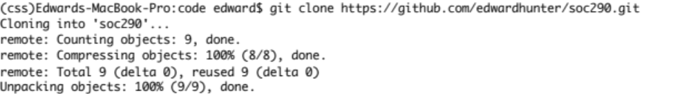

Now, when you list the files in the current directory you will see a new directory present called /soc290. Switch to this new directory and list the files there and confirm you have the following files

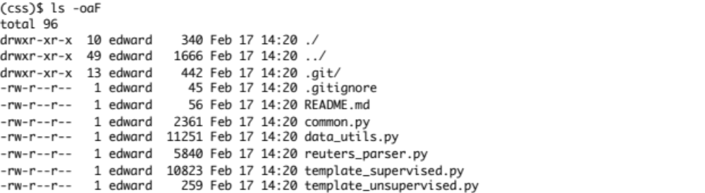
If you prefer, you can always use a file browser to inspect these directories instead of using the command line. Notice that you have a set of Python source files with the extension .py, and a readme used to describe the project contents.

We will add code and run our experiments in this directory to try out various learning methods, beginning with Naïve Bayes. First off, lets download our experimental datasets. We have included a Python program called data_utils.py to make this easy for you. Remember that Python programs can be run from the command line by running the Python interpreter program with the name of the program to run as the argument. First lets run the help option to see what options are available

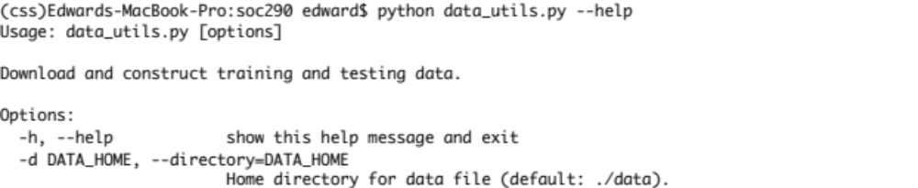

We see that there are no mandatory arguments, and only one option to specify a directory for the data. The default is ./data. The initial period is syntax for the current directory we are in, /soc290, so running this command with default options will create a new directory, /soc290/data where the data files will be created. We will use this default so go ahead and run data_utils.py (note that this will take a few minutes)

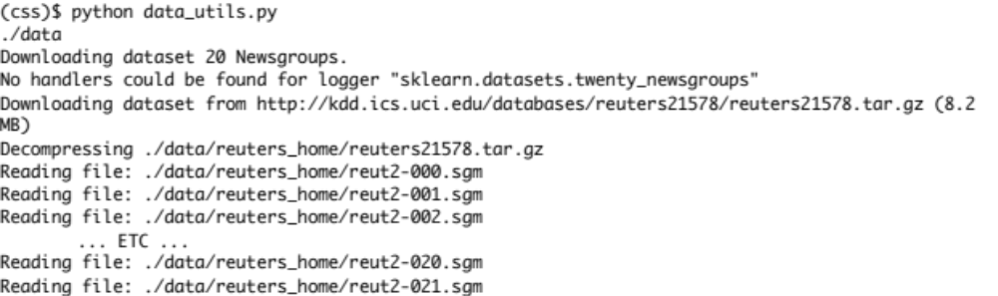
Now if we list files in /soc290 we see

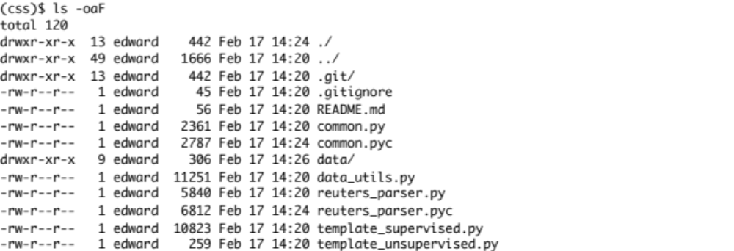
So we now have the new directory /soc290/data/. Also notice that some files with the extension .pyc have appeared. These are complied byte code files created by Python as input to the Python virtual machine as an intermediate step as the source files (with extension .py) are processed. You don’t have to be concerned with manipulating these. If we list the files in our new data directory we see our experimental data files

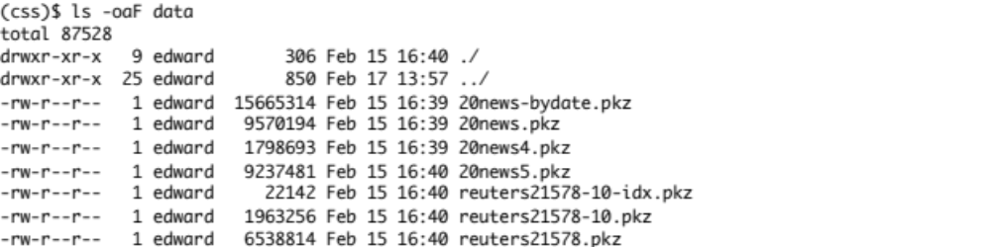
You’ll notice various files for the 20 Newsgroups data, the Reuters newswire data and others. When we run our experiments we’ll specify which dataset to use. The .pkz extension tells us these are “pickled” Python object files. That is, they are on-disk representations of Python data easy for our programs to read in and use and are portable across computer chip architectures. The templates we have constructed take care of all of that for you.

- The Supervised Learning Template File

To make life as easy as possible while exposing you to the best open source tools, we have prepared template files for supervised and unsupervised learning programs that take care of lots of routine plumbing and housekeeping. This minimizes the amount of Python details you have to master before running experiments. Let’s take a few moments and study the one we will adapt for this and the next two labs; it’s called template_supervised.py. Go ahead and open it in your editor and start at the top of the file.

The first thing you will see is this

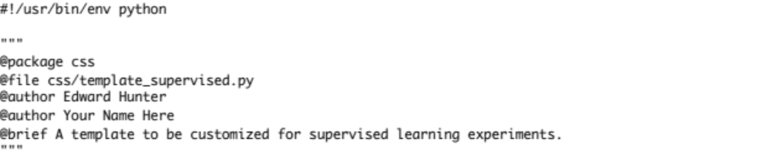

Any line or portion of a line that starts with # is a comment that is ignored by Python. In this case the first line is a comment, #!/usr/bin/env python, that is a Unix convention telling the operating system that this is a Python script. The text enclosed by triple quotes “”” is a multiline comment. This is a prelude that gives some useful information about the file, such as the package, the filename, the author and so on. It tells the Python help command what to display and also is used by automatic documentation generating programs. It is good practice to keep such information in your files and we will do so as we extend the template for our own use.

The next thing you will notice in the template_supervised.py file are these lines

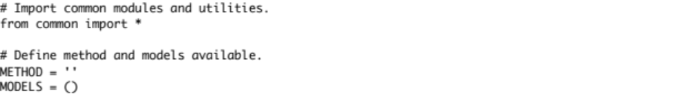

The # comments are here to tell us what the intent is of the code. The line from common import * is a Python module import. Remember there is a file in the directory called common.py. This line of code tells us to “import” all of the code objects from that file and make them available to the logic in this file, just as if that file’s contents were directly written here. The common.py file contains lots of things that all of our programs use, so for convenience we collect them in a separate file and import them all at once wherever they are needed. Feel free to check out what is in common.py. It is mostly additional import statements, bringing in parts of the Python standard library that we use, and also the pieces of the scikit-learn package that provide many of the learning algorithms and supporting utilities like feature extractors and evaluation tools.

The next two code lines define an empty string variable METHOD and an empty tuple variable MODELS. When we customize the template we use these variables to hold the name of the method and model options it supports, respectively. We’ll do this in a few minutes when we start customizing the template for Naïve Bayes.

The bulk of the template_supervised.py file are the definitions for 3 functions called train, predict and eval. A function definition begins with the def statement followed by the function name and a “signature” of parameters enclosed in parentheses and ending in a colon, like this def train(data, dataset, model, **kwargs):

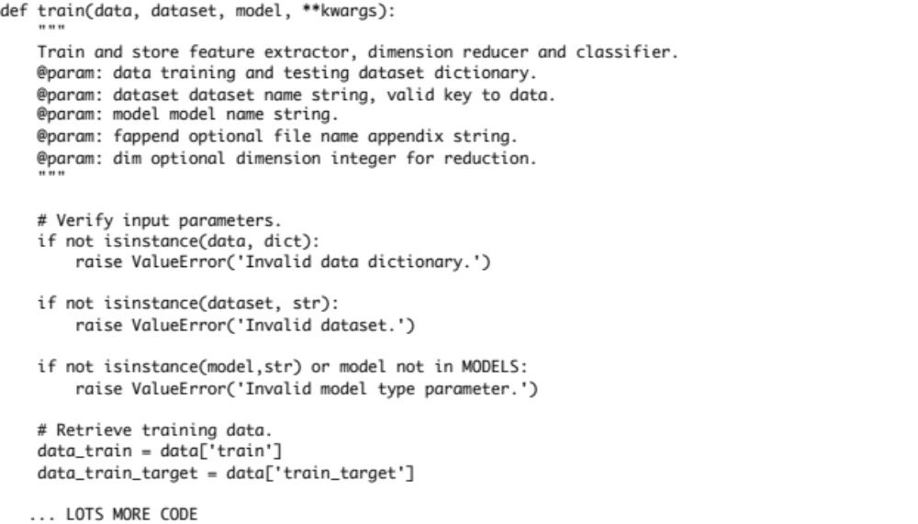

All the following lines that are indented comprise the function logic that is executed when the function is called. The triple quoted comment right under the def statement is another docstring like the prelude at the beginning of the file, but it applies to the train function specifically, telling what it does and what its parameters are. Scroll down and you will see similar definitions for the predict and eval functions. Together these three make up the framework for our supervised learning methods and experiments. If it is not yet obvious, we use the train function to train a particular supervised learning model given training data, the predict function to classify new data with a trained model and the eval(uate) function to run a set of performance evaluations on a trained model and compute a report.

Another thing to notice is that in a few places in template_supervised.py you will see “to-do” comments that look like this one inside the train function

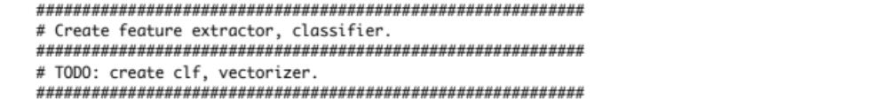

These to-do comments will be replaced by code you write using scikit to quickly develop programs based on the methods we covered in lecture. We will walk you though exactly how to do this so that you quickly gain experience with scikit and the machine learning development process, without first becoming a Python expert. All the surrounding code in these functions is common to all the methods and takes care of housekeeping chores like saving the trained models out to disk or reading in experiment data for training or testing, printing evaluation reports and the like. Studying this code is a good way to familiarize yourself with how the Python language works, and you can use these files in the future as models for your own work. If you have any questions about what the different pieces do, feel free to browse the Python documentation and ask the instructor or TA.

Finally, toward the end of the file you will notice a section of code that begins like this

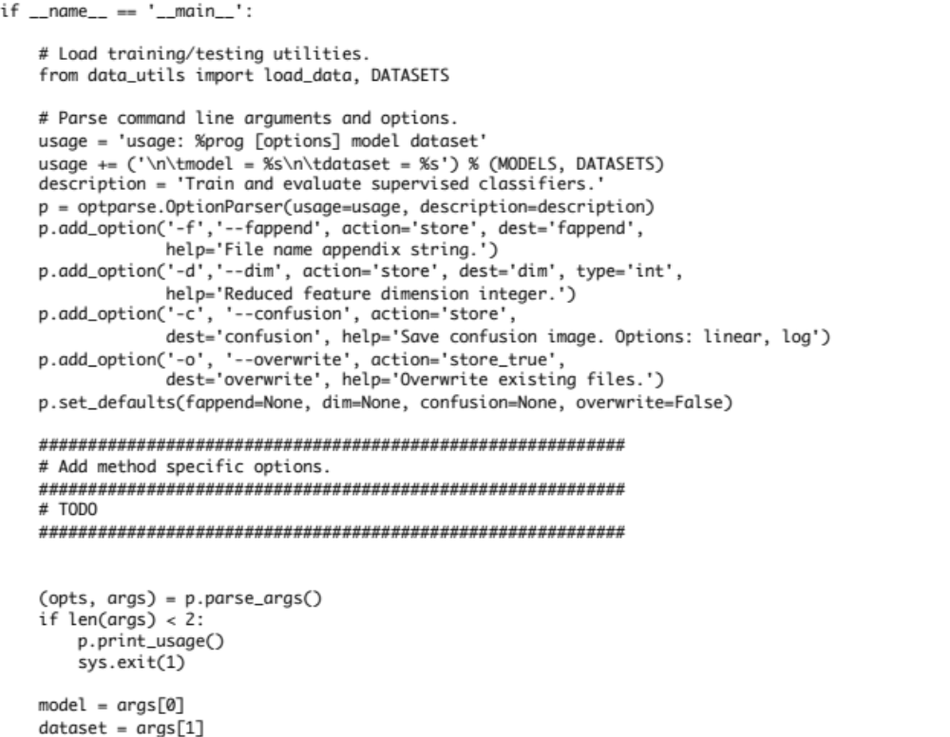
This is called the program entry point. When a Python program is run using the python command, the interpreter automatically defines a global variable called __name__ and assigns it the string value ‘__main__’. The program is executed line by line, but all that is done up until now is import some external code, define some global variables, and define three functions; there is no actual running of anything. This entry point says, in essence, if I am running as a Python program then take these steps following the if clause. The distinction here is that this file template_supervised.py, instead of being run directly, might be imported into another file so the train, predict and eval functions could be used in this other program file. In that case, the __name__ variable would be the name of the calling program file and so this entry point code would not be run. This allows the program file to be run as a stand-alone program or imported into other programs to use and build on the functions defined here.

The first thing the entry point logic does is import the load_data function and the DATASETS variable that holds the names of all the available data from data_utils.py. This tells our program what data is available to it. Then an OptionParser object is created and used to extract all of the command line arguments that are specified when the program is run. This parser also provides help text that describes the parameters for you. For example, when I run the file template_supervised.py with the --help option we see

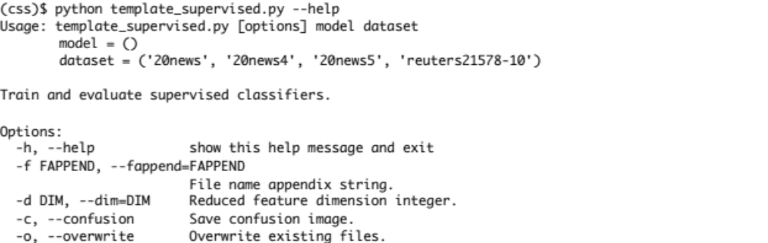

The model and dataset arguments are mandatory (in that order). The help text already knows about the datasets we have available through load_utils.py. The model parameter options are empty because they are not yet defined. In addition, we have options for appending file names, dimension reduction, saving a confusion matrix image and overwriting existing model files.

Finally at the end of the file we have

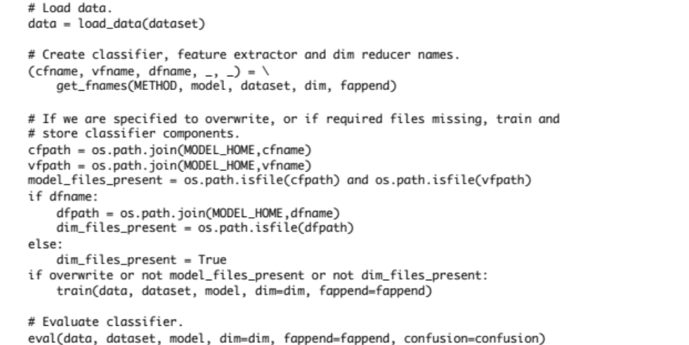

This is the logic that uses the functions we defined above to train and evaluate our learning models. First the specified dataset is loaded. Then we determine if the specified model is present on disk and assign a Boolean to model_files_present.
If the files are not present, or if an overwrite option is specified, then we first call the train function to train the model. Training can be an expensive process so once models are trained we skip this step unless told to overwrite and retrain. Then the eval function is called to test the trained model and generate a report. The predict function is used by eval to carry out this performance evaluation. After you have trained and validated a model this way, you could then use it in real world classification tasks by importing the predict function from this file into another program that was collecting and classifying your new, unseen data. So these templates and the programs we create from them can be used directly in real research tasks.

- Create the Naïve Bayes Program

Make a copy of the template_supervised.py file in the same /soc290 directory and call it naive_bayes.py. Edit the beginning of the file to modify the prelude docstring and define the global variables this way

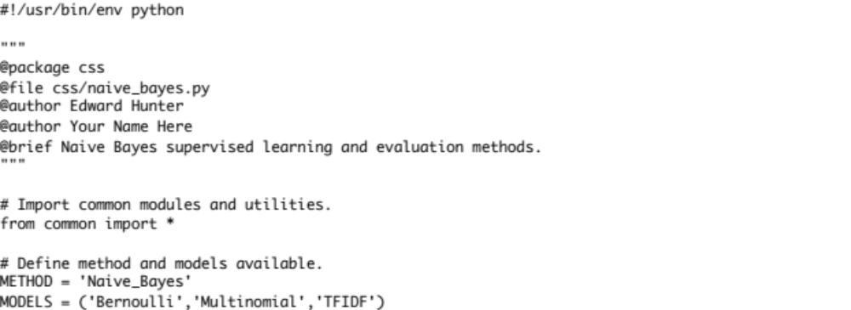

Now the docstring carries the brief description for the Naïve Bayes program and the file is updated to the correct name. Add your name as an @author. Then define the METHOD variable as the string ‘Naive_Bayes’ and the MODELS variable to be a tuple of strings (‘Bernoulli’, ‘Multinomial’, ‘TFIDF’) defining the three model options we will make available in this program.

Customizing the train() Function for Naïve Bayes

We first fill out the train function. Replace the first to-do comment with the following

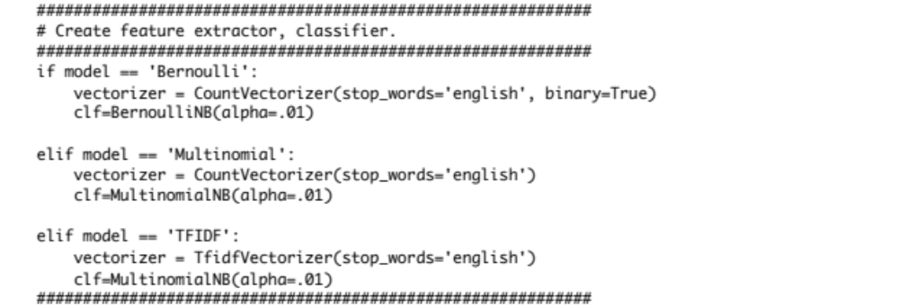

This is an if-clause with three conditions that you recognize as the three models we will support, as defined in the global at the top of the file. Now we will call on scikit’s methods to build the various flavors of Naïve Bayes text classifiers. There are two variables that are defined differently depending which model we select: vectorizer and clf. vectorizer is the “feature extractor” that converts the text documents into feature vectors of various kinds. clf is the actual supervised model that we will train and then does the predictions for us. These are the three cases

- Bernoulli Model: the vectorizer is a scikit CountVectorizer object, which returns the word frequencies as the vector over the entire vocabulary seen in the training set. The parameter stop_words=’english’ has the effect of filtering out English “stop words” that are very common and functional in nature so bear little information in classification (e.g. as, the, is, it, which, on, …). The second parameter binary=True tells the vectorizer to return present/absent values rather than an actual word frequency. This is the Bernoulli model discussed in class. Then a Bernoulli Naïve Bayes classifier is created with the scikit BernoulliNB object. The parameter alpha=0.1 is the smoothing factor that avoids zero probability estimates and allows the Naïve Bayes model to function reasonably well when it encounters terms not seen in training.
- Multinomial Model: Here the vectorizer is the same as before except the binary=True parameter is omitted, allowing a full word frequency count to be computed as the document representation. The classifier is an instance of the scikit object MultinomialNB that implements the Multinomial Naïve Bayes model discussed in class. The alpha parameter has the same function as above.
- TFIDF Model: In this case we construct a scikit TfidfVectorizer using English stop word filtering to return TFIDF weighted values for each document term as discussed in class. The classifier is the same Multinomial Naïve Bayes used above.

The scikit objects we create, CountVectorizer, TfidfVectorizer, BernoulliNB, and MultinomialNB are not part of the native Python language. How is it we can call these classes to construct the vectorizer and clf variables above? In common.py, the set of common objects we import at the beginning of the file contains imports from scikit for these classes so they are available to us in our template program.

The feature dimension reducer to-do is filled out like this

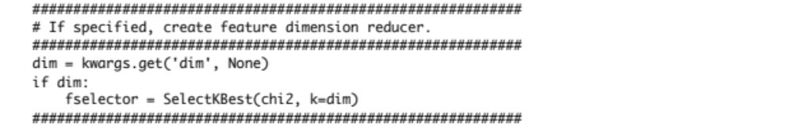

This code looks for the dim argument in the parameters passed to train and, if present, uses it to construct a scikit dimension reducer object. The SelectKBest object is constructed, using chi2 as the method for selecting specified number of dimensions k=dim. The dim is parameter is an optional parameter specified at the program command line as we saw in the help output above and forwarded to train if it is present. As before, SelectKBest and chi2 are scikit imports defined in common.py.

Next we fill in the feature extraction to-do. Add code so that the to-do section looks like this

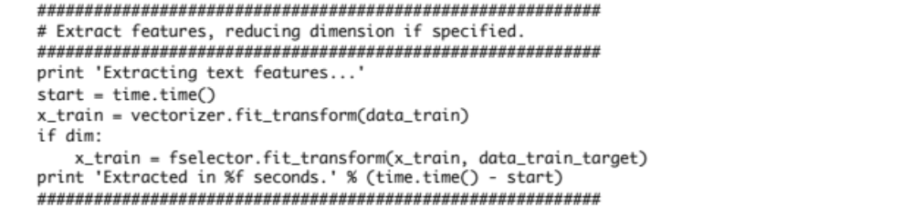

The vectorizer object we just defined has a function called fit_transform. When you pass the raw text training data contained in data_train to this function, a set of training vectors is returned from whichever vectorizer you are using as specified above (Bernoulli, Multinomial, TFIDF). This is the code that transforms the raw text into binary, frequency or TFIDF weights. If the dim option is specified, then the above constructed fselector SelectKBest object is used to reduce the feature dimension as specified. Note the use of the time module to record the start time and print out the total time taken for feature extraction. The time module is part of the Python standard library and is imported by common.py like the scikit classes. We’ll see this time report as we run the program.

Now we have constructed feature extractor and classifier objects according to the model choice. We have also constructed a dimension reducer, if specified, and converted the raw text to numerical form. All that remains is to train the classifier object. Fill out the train classifier to-do like this

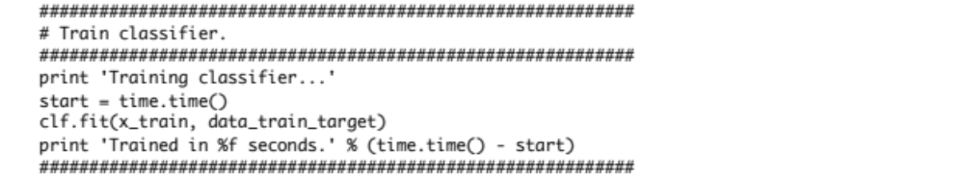

Every scikit classifier object has a fit function that takes as parameters the numeric feature vectors just extracted and the supervised class labels for these training cases to calculate the Naïve Bayes model parameters as we discussed in class. Here the time required is also calculated and reported as we go.

Filling out the predict() Function

Next we fill out the predict function to-do section. The template program takes care of loading the vectorizer and classifier from disk that were computed and saved by train. To predict new data we need to extract the features from raw text using the vectorizer and then classify the documents using the classifier. The code looks like this

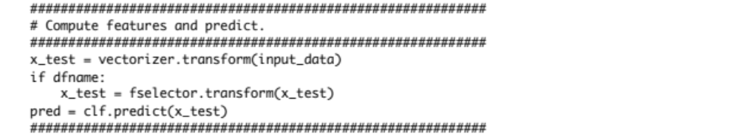

An important thing to notice here is that there is no reference to the specific type of objects used for feature extraction or classification. No matter which vectorizer or classifier was constructed and saved by train, they all make the same set of functions available to us. This is a programming concept known as polymorphism. Although they do them in different ways, the different vectorizers and classifiers each do the same kinds of things, either extract a feature vector or classify new document vectors. So we do not need to make the code explicit about the model or feature types. This means that this same predict code will be used again in other labs that construct different models within train, so there is less work to do in the future.

Filling out the eval() Function

Similar to the predict function, we fill in the eval to-do section with scikit code that does not depend on the model or feature types. Here we want to use the scikit metrics module to compute a classification report and a confusion matrix by passing in the predicted document categories along with the true categories from our test dataset. The code looks like this

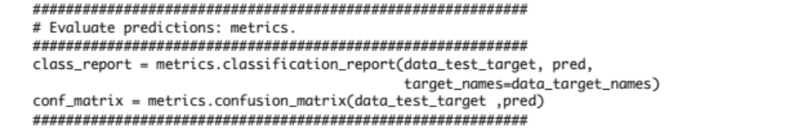

As we will see when we run our experiments, the classification report gives us a table of categorical statistics that tell us how well our model is performing. The confusion matrix is an KxK table, with K the number of document categories, showing the number of correctly classified documents of each class as well as which categories misclassified documents were assigned to. This helps us easily see which document categories are difficult for the model to discriminate between and can guide us as we refine our model, features and document categorization scheme. The remainder of the eval function prints these statistics to the screen as the program runs and saves a report file to disk. If the optional argument –c or --confusion is specified when the program is run, then a png image of the confusion matrix is generated using a visualization library called matplotlib. matplotlib is imported in common.py and provides powerful set of plotting and visualization tools worthy of many lectures and exercises of its own. It has a programming interface that closely follows the popular MATLAB software, which you may be familiar with.

Editing the Entry Point

The entry point also has two to-do sections. These sections need to be filled out when the classifier model we are building requires special command line parameters beyond the model specification. For example, support vector machines we study in lab 4 have parameters that have to be set for proper performance. Since we have no method specific options in the Naïve Bayes model we can remove them. Edit the entry point code to remove these two unneeded to-dos

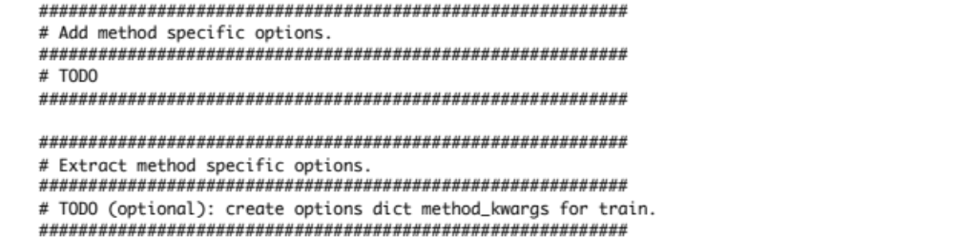

- Experimenting with the 20 Newsgroups Data

We are now ready to run some experiments. Now that we’ve constructed our naïve_bayes.py program file lets see what the command line syntax is. Ask for help for the program as before

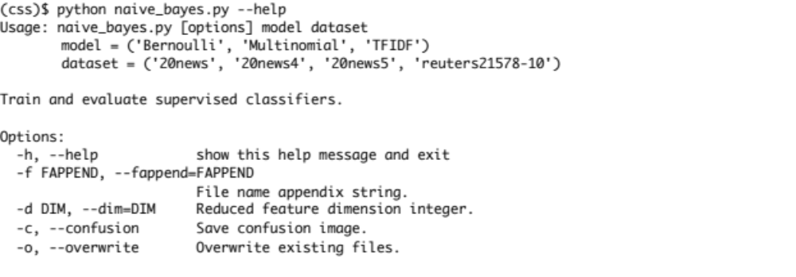

Now we see that we have three models to select from as well as our choice of datasets. We’ll start with the full 20 Newsgroups data described in lecture. Very quickly though, let’s explain what happens when an error is encountered and what to do about it.

Dealing with Errors

It is almost never the case that code you write runs correctly the first time. The exception might be these labs where we tell you exactly what to do, but even here you might make a typo. For example, let’s say that when you were filling out the train function we used Countvectorizer instead of CountVectorizer, forgetting to capitalize the V when constructing the feature extractor. Since Countvectorizer with a lower-case “v” is not defined anywhere this will result in an error. But how will it present when the code runs and how do we go about finding and fixing it? Let’s run the program with this mistake and look at the output

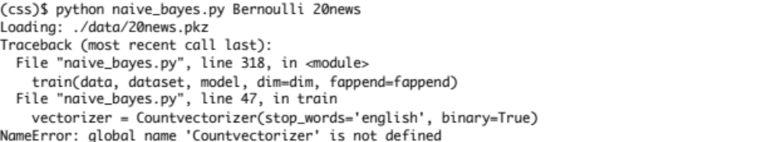

So as the program runs we see our 20news.pkz data getting loaded, and then we see a traceback followed by an error message. The last line is the error message and gives us information on the type of error that was encountered. It tells us there is an undefined name ‘Countvectorizer’ that the interpreter cannot resolve. This is our typo of course. The traceback lines tell us, recursively, where the error is. The traceback is organized as a call stack. The first two lines specify that the error occurred when the entry point called the train function (line 318). The next two lines show where in the train function the actual offending code is (line 47). When we run our program the entry point calls train, and the train function encounters the undefined name error, so there only two steps in the traceback. More complex programs will have longer tracebacks. Where in the traceback the mistake is located depends on if the error being thrown is in your own code or in a function you are using but didn’t write yourself. For example, you may have passed a bad parameter to some Python built-in, standard library or scikit function. Although all the information you need to find the bug is usually there, it takes a little practice to develop good debugging skills. If you see output like this when running your program, see if you can identify and fix your errors yourself. Then, if you need assistance, just ask the instructor or the TA.

Analyzing the Data

The 20 newsgroups data contains short text documents from online newsgroups in approximately equal distributions, split into approximately equal training and testing sets. The full 20 newgroups categories are

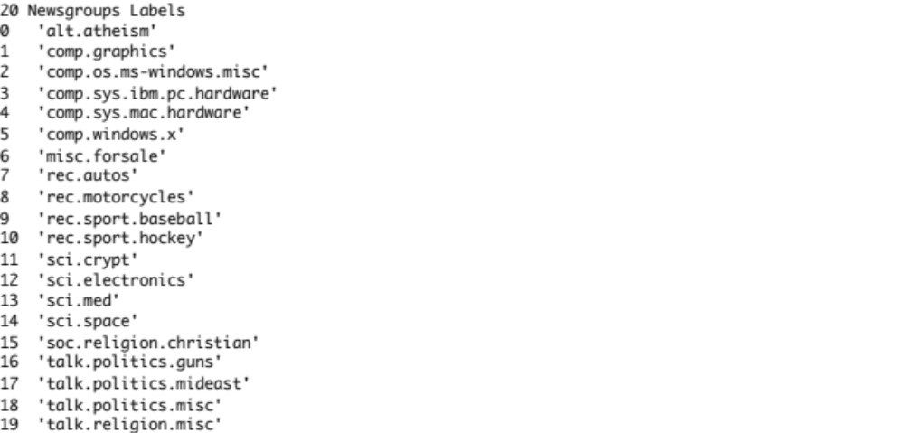

So we will try training Naïve Bayes classifier to discriminate these documents based on our three bag-of-words models. Note that some of these categories are “closer” to each other than others. For example, the documents in the “comp” newsgroup categories will likely have lots of overlapping terms with each other, but less so with documents from the “rec” categories. The number of documents in the training and test classes are in the low hundreds, roughly 250-400 for each category, which is certainly not a large amount of data considering the vocabulary space.

We’re now ready to put Naïve Bayes to the test. Let’s run the Bernoulli model against the 20 newgroups data. The command line syntax and output looks like this

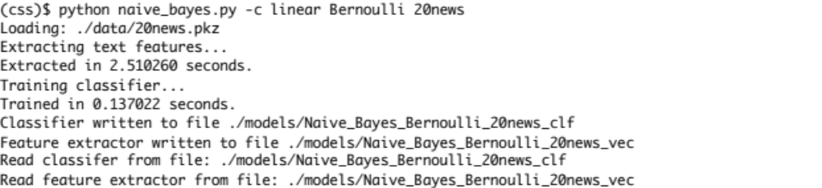
The output tells us what happens. We loaded the 20news.pkz data, then extracted the Bernoulli feature vectors from the documents, then trained the Bernoulli classifier and wrote the classifier and feature extractor to disk. When the eval and predict functions are called, those are read back from disk and an evaluation is run. Finally, the classification report and confusion matrix and printed to the screen (not shown above) and also saved to disk. If you look at your /soc290 directory contents, you will notice two new subdirectories have appeared: /soc290/models and /soc290/reports. The trained feature extractors and classifiers are stored in the models directory and our classification reports are stored in the reports directory. For example we see this in /soc290/reports

The txt file contains the same report output that was written to the screen. In addition a confusion image with the extension png is here. This was created because we used the –c option when we ran the program. Confusion matrix images are useful when the number of categories starts to get big, because they allow us to gain a quick feel for how errors are distributed across complex categories. Open and examine both files. You will collect these report files and confusion images (for the full 20 news and Reuters data) to turn in with your lab report.

We will now repeat this process for the full 20 newsgroups data using Multinomial and TFIDF models (omitting the report outputs)

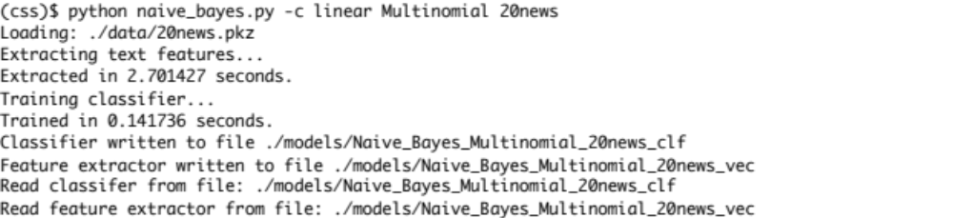

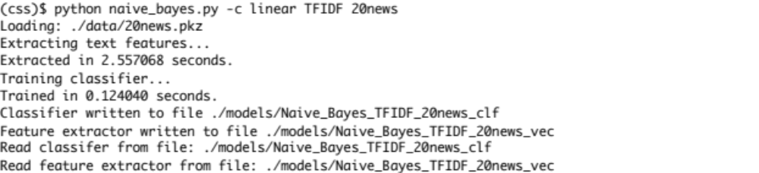
Our reports directory now has six files in it, summarizing our work so far

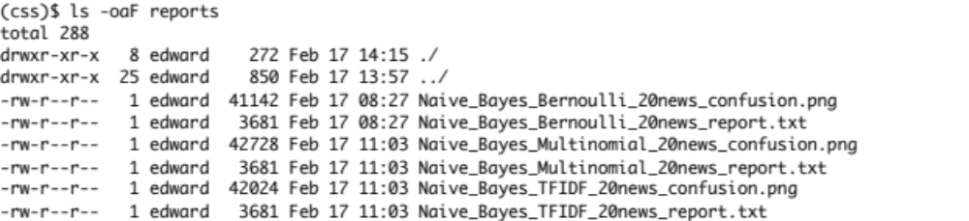
The 20news4 and 20news5 Datasets

So far we have collected report evaluation data for three Naïve Bayes models for the full 20 newsgroups dataset. To gain a sense of how performance can vary with the variables in problem formulation, we are going to repeat these analysis on two additional datasets based of the full 20 newsgroups data.

The 20news4 dataset is just the newsgroup data but with only for four non-similar document categories included. The categories are

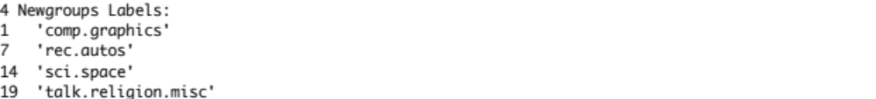
So if we limit the focus of the classification task to fewer, less similar document categories will we see any performance differences?

The 20news5 dataset is interesting in a different way. Here we collapse document categories that are similar into 5 super-categories. This increases the training/testing data for each category and reduces the complexity of the classification problem. The super-categories for this dataset are

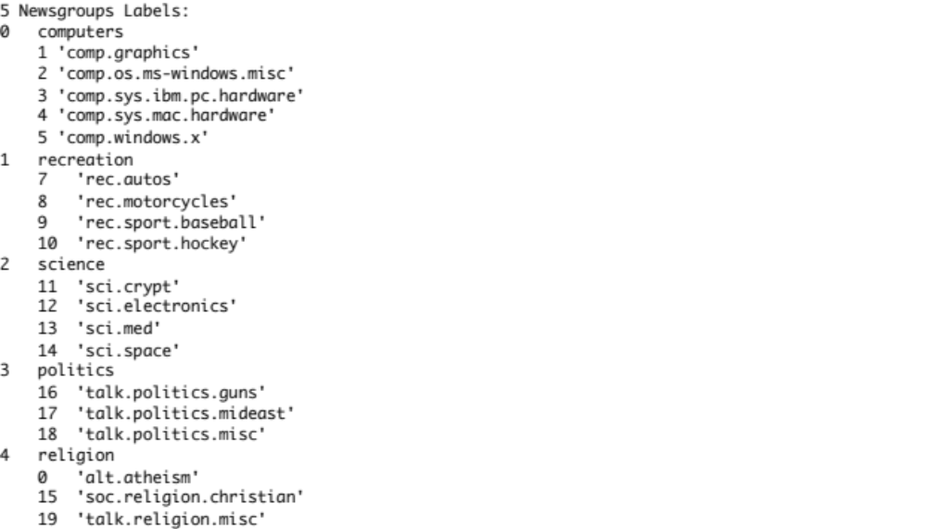

In both cases code in the data_utils.py program has already created these datasets for you and you only need to specify which you want to use when you run the Naïve Bayes program. Let’s run all three Naïve Bayes models on both of these datasets, so that with our previous results we have a total of nine sets of results to look at. For these cases, we won’t bother creating a confusion matrix image since the number of categories is small enough to just use the matrix directly. The command line syntax for each case is just as above, and done six times for each combination of one of the models with one of these two new datasets. When done the data in /soc290/reports now looks like

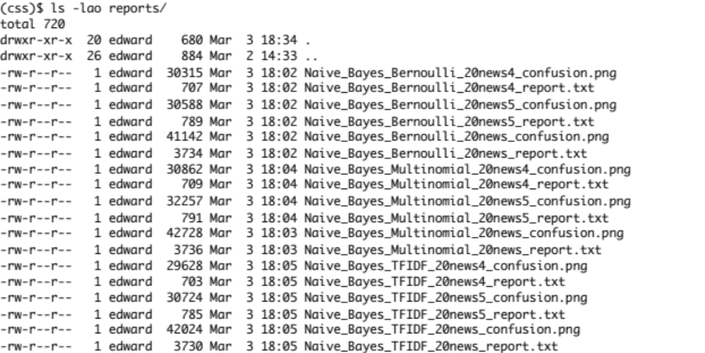
So we have 18 files: nine report txt files, and nine confusion images, one for each model-dataset combination used used.

- Experimenting with the Reuters Data

In this section we repeat our experiments with the Reuters dataset. The full dataset is composed of 21,578 newswire texts that have been hand categorized by Reuters personnel. However, the full dataset is problematic since many of the texts are labeled into multiple categories and some categories have very few documents. To overcome this, our data_utils.py program parses the full dataset and extracts the documents that are labeled with a single category, retaining the ten categories with the most example documents. The top categories and the number of documents in each are

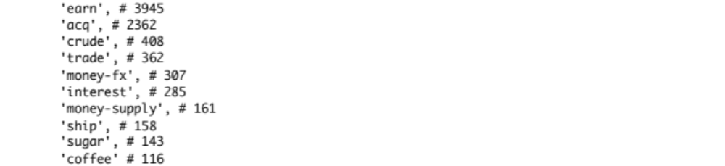
So one difference we immediately see with the Reuters data is that it is “unbalanced” in the sense that there are large differences in the number of examples in the top categories.

Lets run our three Naïve Bayes models with the Reuters data and see how they do. This is done just like before, only we will use a logarithmic confusion image since there is so much range in the number of training and testing samples. The three commands are (we have omitted the output)

As before additional report files show up in our /soc290/reports folder. In addition to the 18 20 newsgroups files, we have three reports and three log confusion images for the Reuters data.

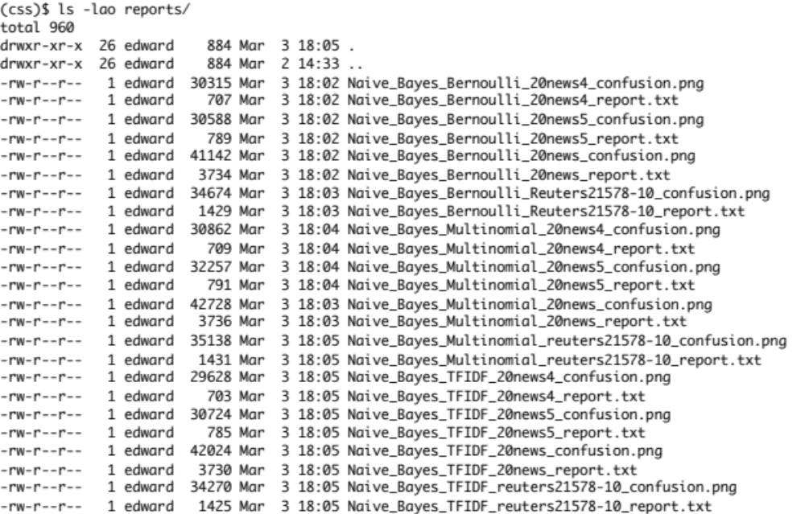
To prepare for the analysis and report, you should now assemble these data into a Word document with the report output and confusion images on the same pages as shown in the example in class. The results section of the lab report should have the following 9 pages, titled as below. We will add our analysis and a cover page to the beginning of this document in the next section.

- Data 1: Bernoulli, 20news
- Data 2: Bernoulli, 20news5 and 20news4
- Data 3: Multinomial, 20news
- Data 4: Multinomial, 20news5 and 20news4
- Data 5: TFIDF, 20news
- Data 6: TFIDF, 20news5 and 20news4
- Data 7: Bernoulli, Reuters
- Data 8: Multinomial, Reuters
- Data 9: TFIDF, Reuters

- Analyzing the Data and Preparing the Lab Report

We have now collected a good set of results to examine Naïve Bayes performance on some standard datasets. In the analysis section at the beginning of the report, provide the following sections with discussion of the following questions. When done, add a cover page with your name, email and lab title. Save the document as lab_2_your_last_name.pdf and email to the instructor and TA.

Performance Measures

Our reports summarize classifier performance in terms of precision, recall and the F1 score. Look up these statistics on the internet (or elsewhere) and in your own words provide a description of what each of these statistics measures.

20news Datasets

- How would you characterize the performance Naïve Bayes overall in these 9 tests? Justify your argument with specific references to the average precision and recall and their distributions across document categories in each case. How is performance compared to blind guessing in the best and worst cases?
- How does the distribution of errors as shown in the confusion matrix and full classification report (i.e. precision, recall and F1 for each category) change depending on the model and dataset?
- Which model(s) are preferred in each case? Explain why. Do the preferred model(s) change or remain the same across datasets?
- In general, what impact does changing the problem by structuring the 20news data in the three different ways have on performance and error distribution? Provide your explanation or suspicions about why you make your observations.
- Up to a point, performance could be improved by increasing the size of the training set. Based on our discussion in class, why would this be so, and why would there be a fundamental limit beyond which performance cannot improve with increasing sample size?

Reuters Dataset

- How would you characterize the performance Naïve Bayes overall in these 3 tests? Justify your argument with specific references to the average precision and recall and their distributions across document categories in each case. How is performance compared to blind guessing?
- How does the distribution of errors as shown in the confusion matrix and full classification report (i.e. precision, recall and F1 for each category) change depending on the model and dataset?
- Which model(s) are preferred in each case? Explain why. Do the preferred model(s) change or remain the same across datasets?
- Describe performance differences you see between the Returers data and the 20news data. Explain why you think this might be so.
- Although we can’t know definitively without more data and experiments, what might be the result of dramatically increasing the sample size in the Reuters cases?

Lab reports and submission

When you have completed your report, title the file soc290_lab2_your_last_name.pdf and email to the instructor and TA by 12:00 Noon the day before the next lecture following the lab assignment. After you are done, you will probably want to move these files out of your /soc290/reports directory so it does not become too cluttered as you carry out new lab exercises.

