**Data 1: Bernoulli, 20news**



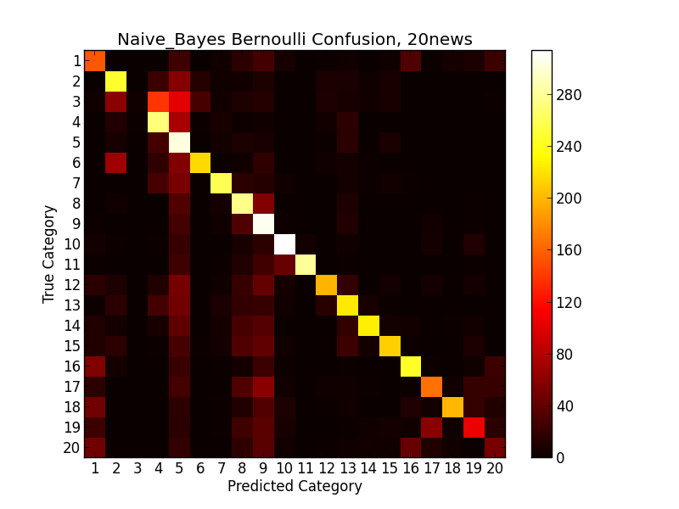

**Data 2: Bernoulli, 20news5 and 20news4**





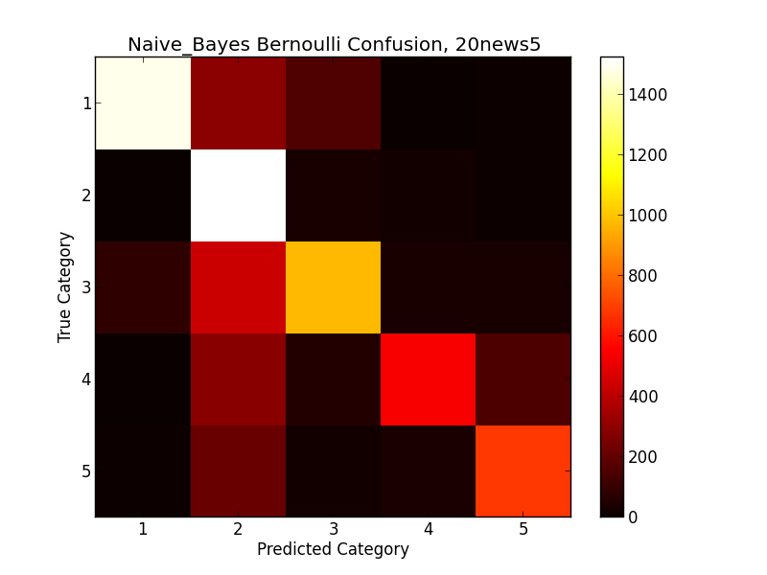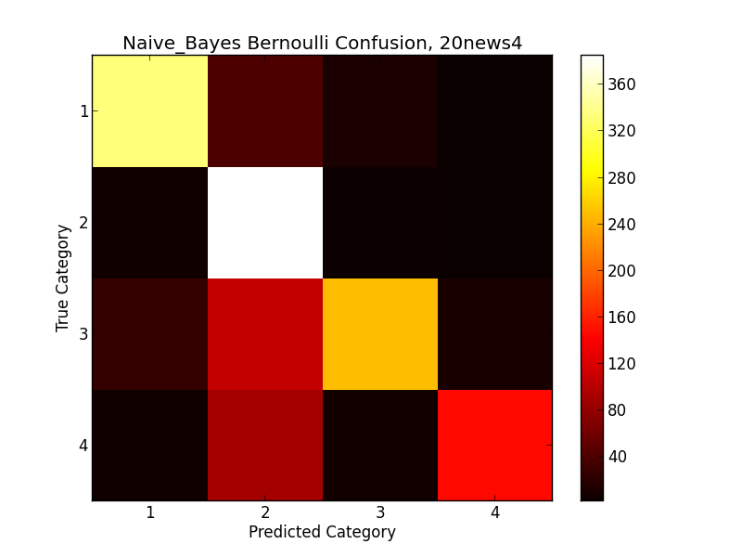

**Data 3: Multinomial, 20news**



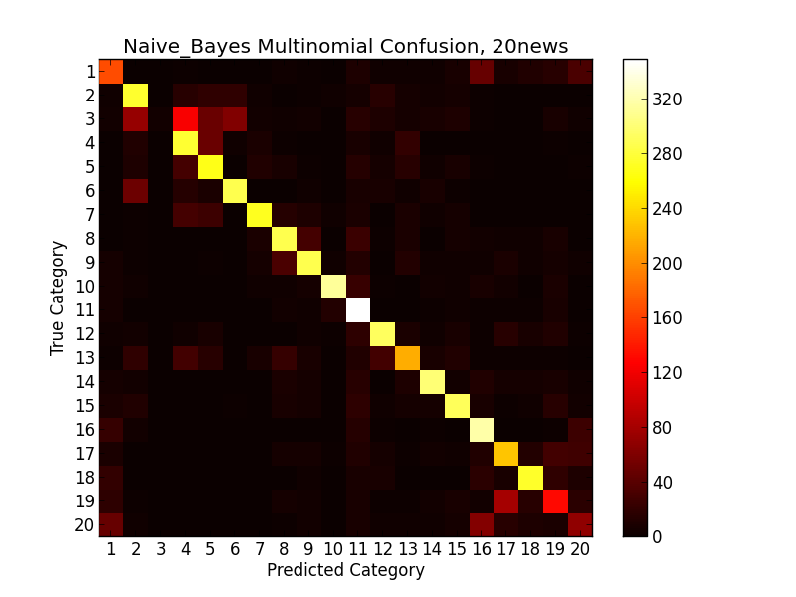

**Data 4: Multinomial, 20news5 and 20news4**





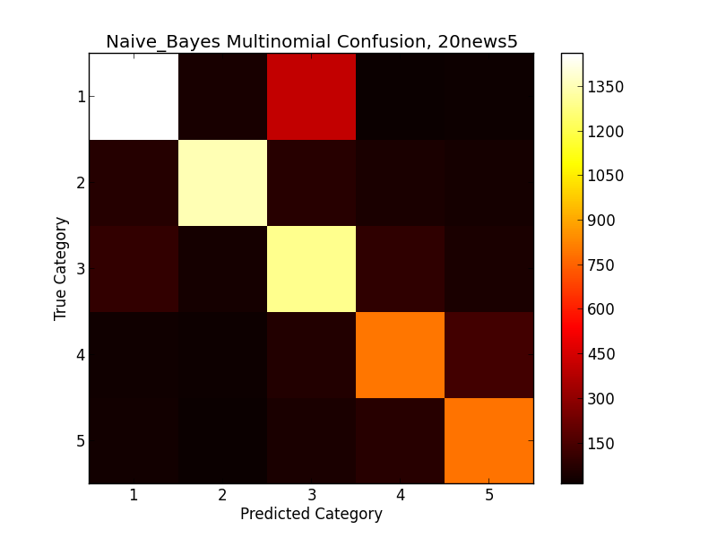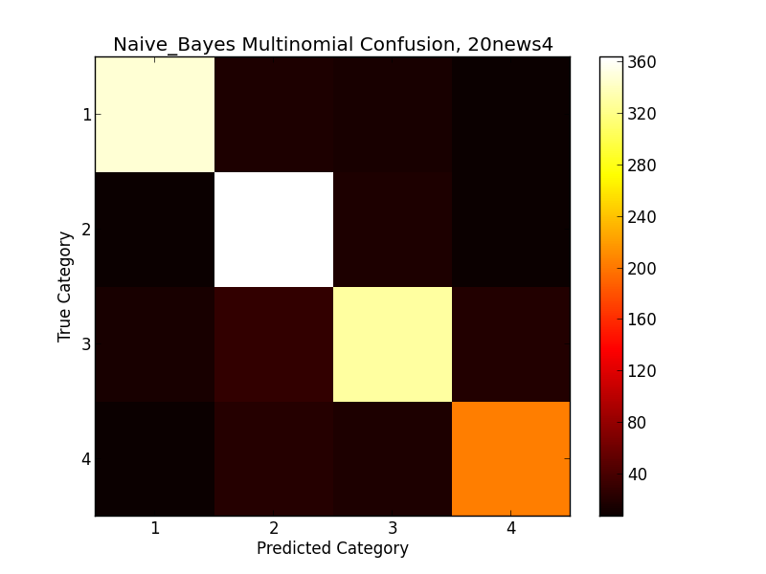

**Data 5: TFIDF, 20news**



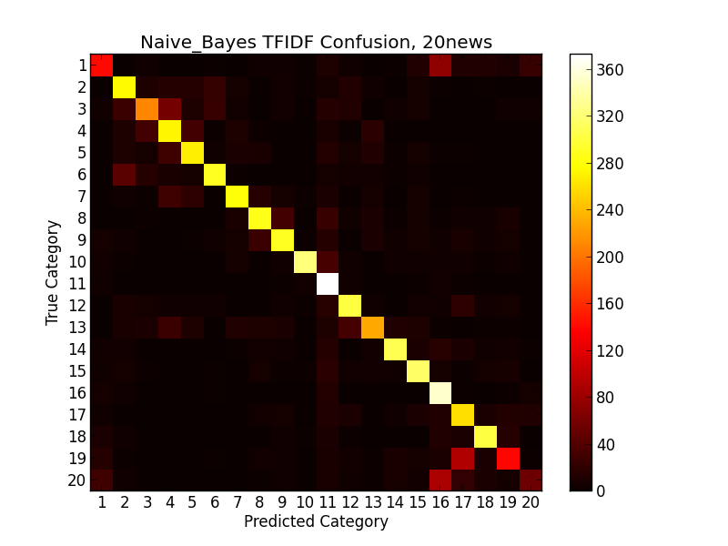

**Data 6: TFIDF, 20news5 and 20news4**





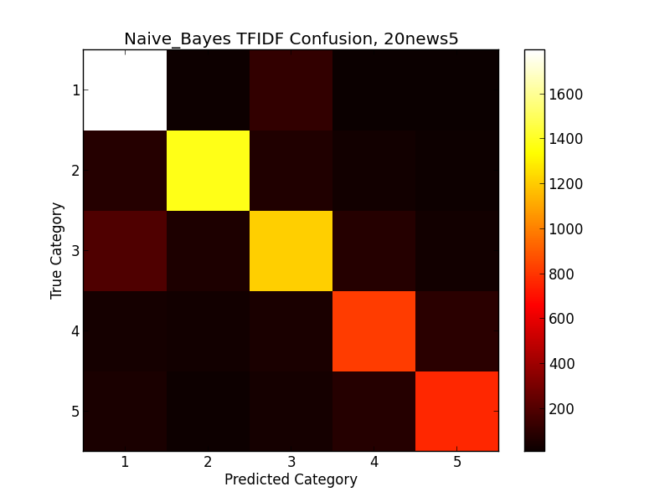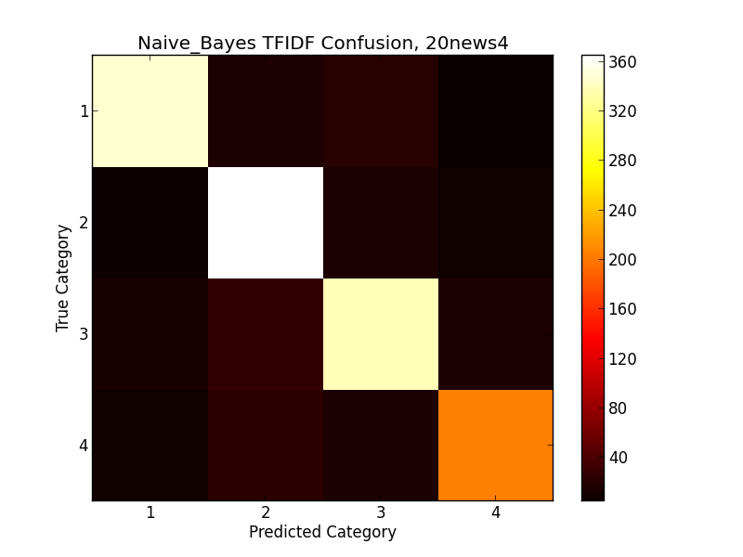

**Data 7: Bernoulli, Reuters**



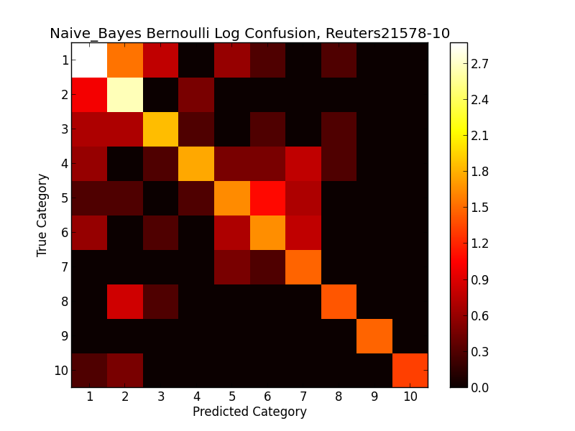

**Data 8: Multinomial, Reuters**



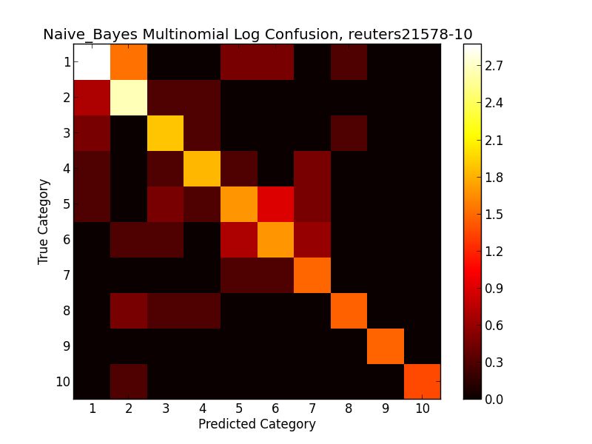

**Data 9: TFIDF, Reuters**



