**Data 1: KNN 20news**



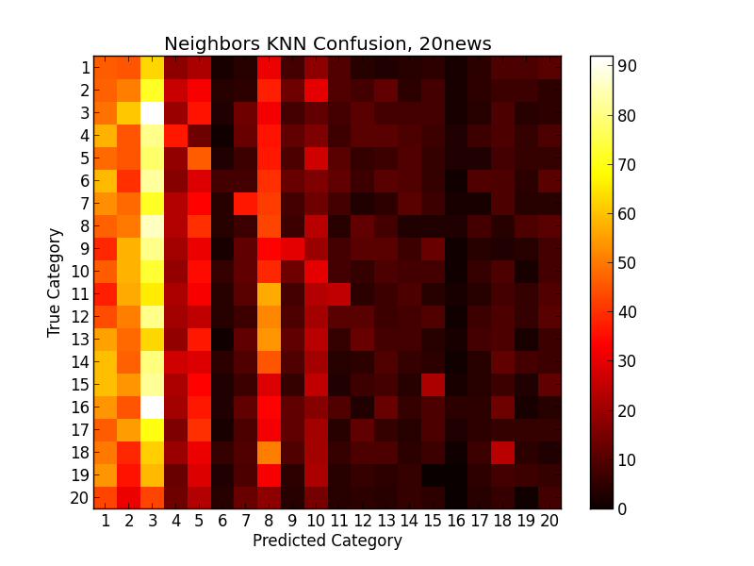

**Data 2: KNN 20news5 and 20news4**





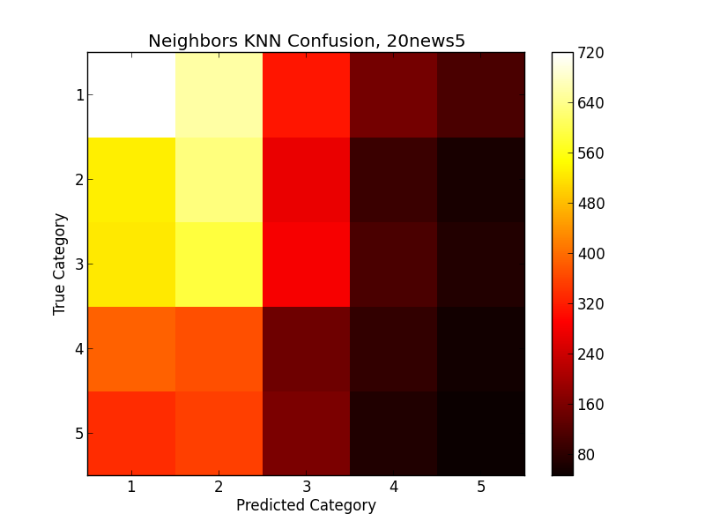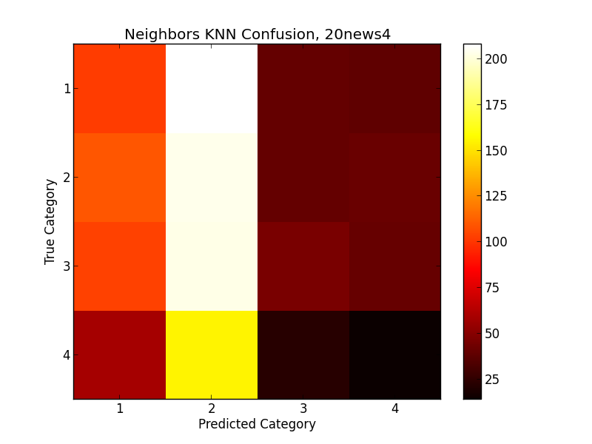

**Data 3: KNN 20news, dim=500**



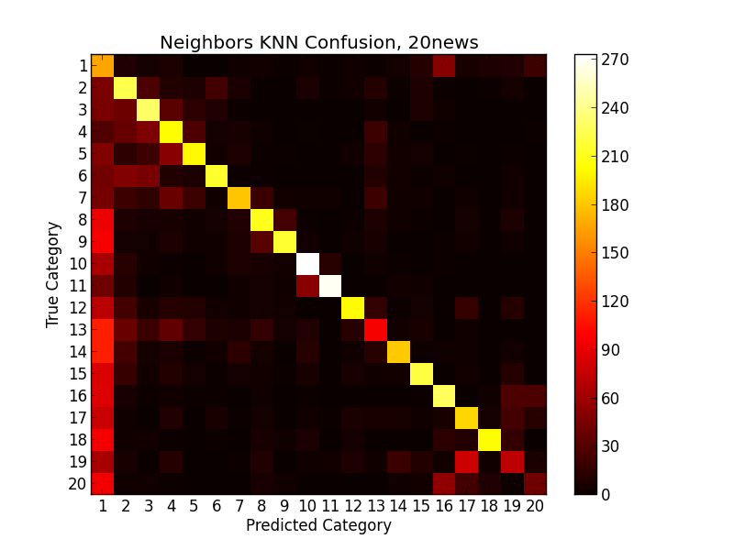

**Data 4: KNN 20news5 dim=500, 20news4 dim=100**





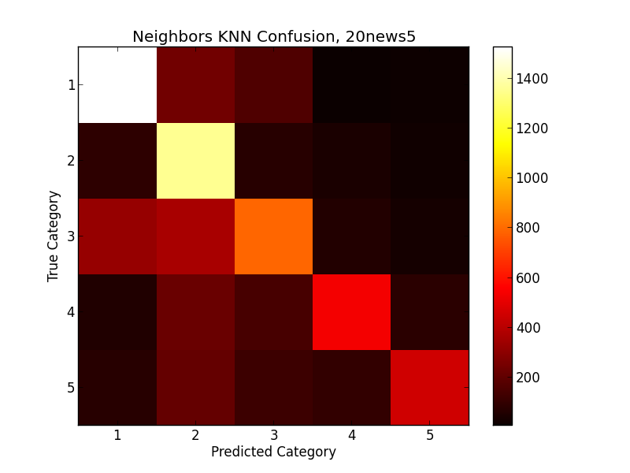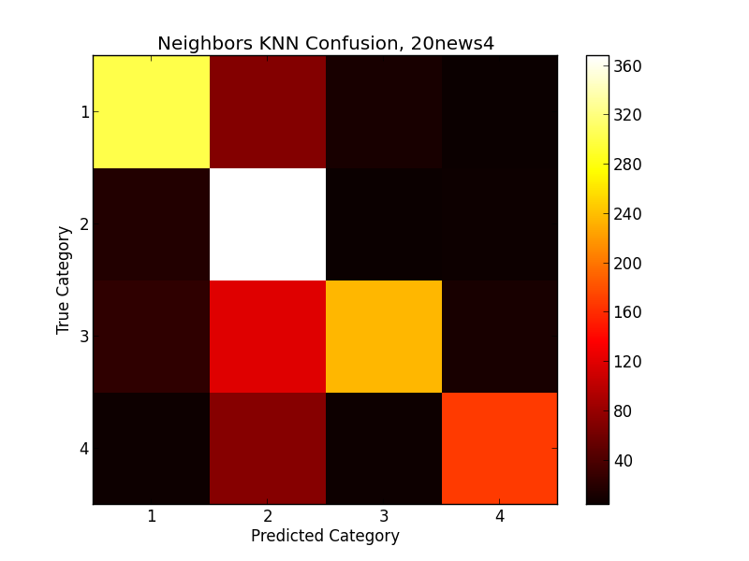

**Data 5: KNN Reuters**



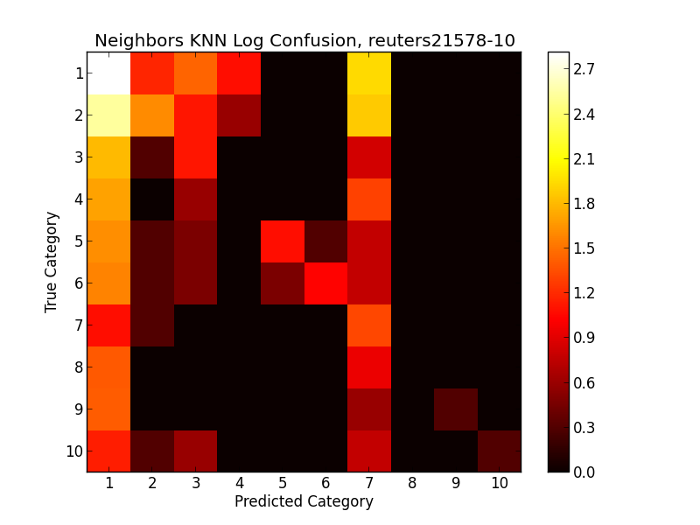

**Data 6: KNN Reuters, dim=200**



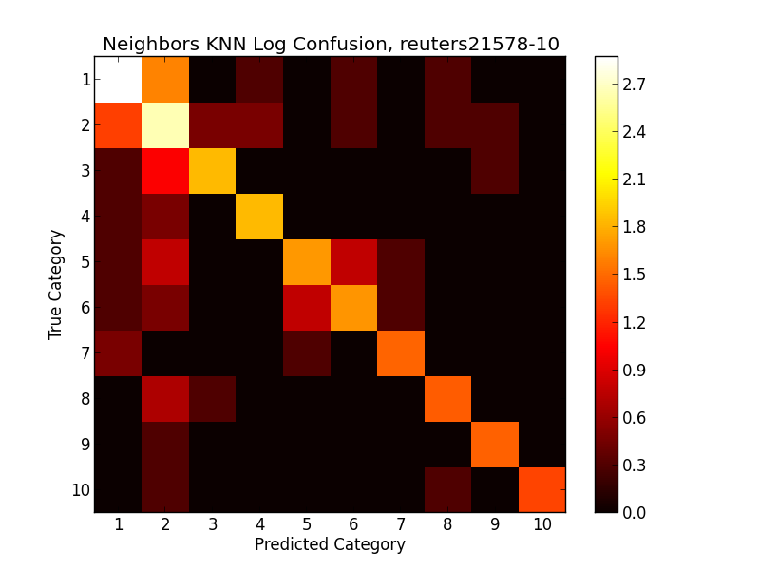

**Data 7: Nearest Centroid, 20news**



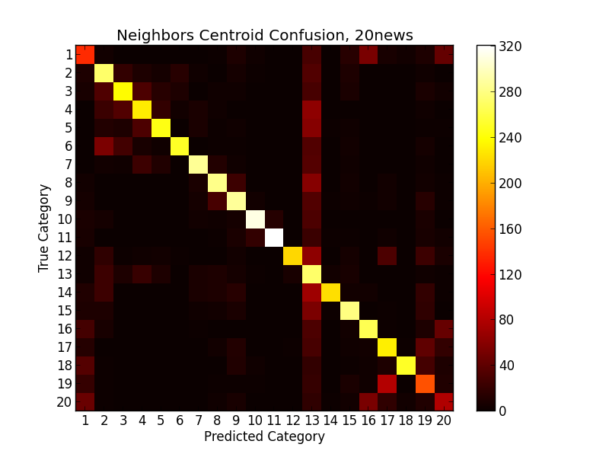

**Data 8: Nearest Centroid, 20news5 and 20news4**





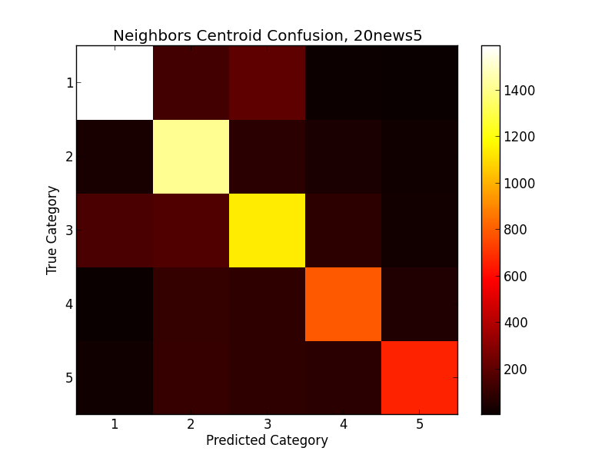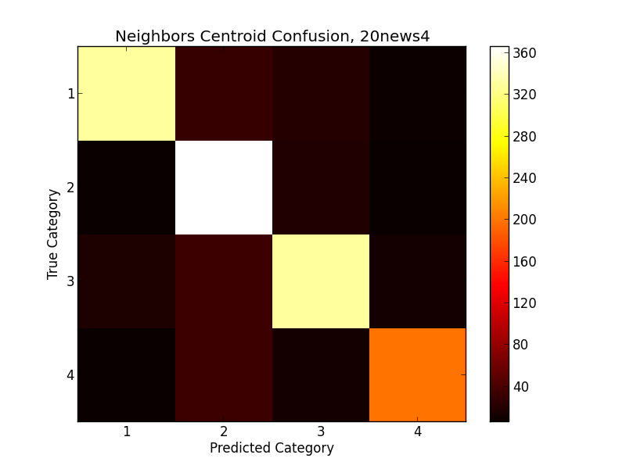

**Data 9: Nearest Centroid, Reuters**



