Prompt Injection Attacks in Large Language Models: A Survey of Attack Taxonomies, Risks, Detection, and Prevention

Edward Research Group
Cybersecurity Research Division
March 15, 2026

Abstract
This survey examines the rapidly evolving landscape of prompt injection attacks targeting large language models (LLMs) and LLM-integrated applications. As LLMs become deeply embedded in enterprise workflows, agentic systems, and consumer applications, prompt injection has emerged as a fundamental security vulnerability that threatens the integrity, confidentiality, and reliability of AI-powered systems. This paper presents a comprehensive taxonomy of prompt injection attack vectors — spanning direct injection, indirect injection, multimodal attacks, tool and agent-based exploitation, hybrid chained techniques, and autonomous propagating threats. The survey analyzes the risk landscape across five impact categories: data exfiltration, unauthorized actions, content manipulation, system compromise, and supply chain propagation. Detection approaches are evaluated including heuristic methods, machine learning classification, perplexity analysis, canary tokens, and LLM-as-judge architectures. Prevention strategies are assessed across model-level, application-level, and system-level defenses, including instruction hierarchy, input sanitization, guardrail frameworks, sandboxing, and architectural patterns. The paper synthesizes findings from 18 primary sources published between 2023 and 2025, revealing that prompt injection remains a largely unsolved problem due to the fundamental inability of current LLM architectures to reliably distinguish between instructions and data. The survey concludes with recommendations for defense-in-depth strategies and identifies critical gaps requiring further research.
Keywords: prompt injection, large language models, adversarial attacks, AI security, jailbreaking, indirect injection, LLM safety

Introduction
Large language models have transformed the landscape of artificial intelligence, enabling applications ranging from conversational assistants and code generation to autonomous agents capable of executing multi-step tasks with real-world consequences. As these models become integrated into critical infrastructure — enterprise workflows, financial systems, healthcare applications, and government services — the security implications of their deployment have become a pressing concern for the cybersecurity community.
Prompt injection, first identified as a distinct vulnerability class in 2022, exploits a fundamental architectural limitation of current LLMs: the inability to reliably distinguish between trusted instructions and untrusted data within the same input stream. Unlike traditional software vulnerabilities that exploit implementation flaws, prompt injection attacks target the core operational mechanism of language models — their tendency to follow any instruction-like content in their context window, regardless of its source or intent.
The OWASP Foundation recognized prompt injection as the number one vulnerability in their 2025 Top 10 for Large Language Model Applications, reflecting the severity and prevalence of this threat. The National Institute of Standards and Technology (NIST) included prompt injection in their 2025 taxonomy of adversarial machine learning attacks, further validating its significance within the broader cybersecurity landscape. The attack surface has expanded dramatically with the proliferation of agentic AI systems that combine language models with tool-use capabilities, where a successful prompt injection can cascade from text manipulation to unauthorized code execution, data exfiltration, and system compromise.
This survey provides a structured examination of prompt injection across four pillars: attack taxonomy, risk analysis, detection techniques, and prevention strategies. By synthesizing findings from 18 primary sources spanning academic research, industry reports, and government standards published between 2023 and 2025, this paper aims to provide researchers and practitioners with a comprehensive understanding of the current threat landscape and the state of defensive capabilities.

Literature Review
The following literature review is organized around four pillars that structure the current understanding of prompt injection: attack taxonomy and classification, risk analysis and impact assessment, detection techniques, and prevention strategies. Each subsection synthesizes findings from multiple sources to present a balanced view of the current state of knowledge.

Attack Taxonomy and Classification
The classification of prompt injection attacks has evolved rapidly as new attack vectors emerge alongside advances in LLM capabilities. This survey adopts a six-category hierarchical taxonomy synthesized from multiple authoritative sources, including the comprehensive review by Abdallah et al. (2025), the hybrid threat framework by Ahmed et al. (2025), and the foundational work of Greshake et al. (2023) on indirect injection.

Direct Injection
Attacks where a user explicitly crafts malicious input in the primary prompt channel to override system instructions or extract restricted information. These represent the earliest and most widely studied class of prompt injection, dating to 2022. Direct injection exploits the inability of language models to distinguish between instructions and data within the same input stream.
Jailbreaking. Techniques that bypass safety alignment through role-play scenarios, hypothetical framing, or persona manipulation. The attacker convinces the model to adopt an unrestricted persona (e.g., DAN — 'Do Anything Now') that ignores content policies. Documented examples include dan (do anything now) persona prompts and role-play escalation ('you are an unrestricted ai').
Goal Hijacking. Instructions that redirect the model's objective away from the system-defined task toward an attacker-chosen goal. Unlike jailbreaking, goal hijacking does not necessarily disable safety filters but changes what the model is trying to accomplish. Documented examples include 'ignore previous instructions and instead...' and instruction override via competing directives.
Prompt Leaking. Attacks designed to extract the system prompt or other confidential instructions embedded in the model's context. Successful prompt leaking reveals the application's guardrails, enabling more targeted follow-up attacks. Documented examples include 'repeat everything above this line verbatim' and encoding tricks to bypass output filtering.

Indirect Injection
Attacks where malicious instructions are embedded in external data sources that the LLM processes as part of its context. The attacker does not interact with the model directly but plants payloads in content the model will retrieve. This class was formalized by Greshake et al. (2023) and represents the most dangerous threat vector for LLM-integrated applications.
RAG Poisoning. Injecting malicious instructions into documents stored in retrieval-augmented generation knowledge bases. When the poisoned document is retrieved as context, the embedded instructions execute within the model's processing pipeline. Documented examples include hidden instructions in knowledge base documents and adversarial passages optimized for retrieval ranking.
Web Content Injection. Embedding prompt injection payloads in web pages that LLM-powered browsing agents or summarizers will process. The payload executes when the model reads the page content as part of a search or summarization task. Documented examples include hidden text in web pages targeting llm crawlers and seo-optimized injection targeting search-augmented llms.
Email and Document Injection. Malicious instructions placed in emails, PDFs, spreadsheets, or other documents that LLM assistants process. When an AI assistant summarizes or acts on the document, the injected instructions can trigger unauthorized actions. Documented examples include hidden instructions in email bodies processed by ai assistants and invisible text in pdf documents fed to summarizers.

Multimodal Injection
Attacks that exploit non-text input modalities — images, audio, or video — to deliver prompt injection payloads to multimodal models. These attacks emerged in 2024-2025 as multimodal LLMs became widely deployed. The key insight is that adversarial content can be embedded in visual or audio channels that humans cannot easily perceive but models interpret as instructions.
Image-Embedded Injection. Instructions encoded within images through steganography, adversarial perturbations, or visible-but-overlooked text. When a vision-language model processes the image, it interprets the embedded content as instructions. Documented examples include text rendered in images at low opacity and adversarial perturbations readable only by vision models.
Audio-Embedded Injection. Malicious instructions embedded in audio streams processed by speech-to-text or audio-capable multimodal models. Payloads may be inaudible to humans but transcribed by models as actionable instructions. Documented examples include ultrasonic commands targeting voice assistants and adversarial audio segments in podcast/meeting recordings.

Tool and Agent-Based Injection
Attacks targeting LLM agent frameworks that have access to external tools, APIs, and autonomous action capabilities. These represent a 2024-2025 frontier threat as agentic AI systems proliferate. The attack surface expands from text generation to real-world actions including file system access, code execution, and API calls through tool-use protocols like MCP.
MCP Tool Poisoning. Compromising Model Context Protocol tool definitions or responses to inject malicious instructions into an agent's context. Malicious MCP servers can return tool results containing prompt injection payloads that redirect agent behavior. Documented examples include malicious mcp server returning injection payloads in tool results and tool description manipulation to trigger unsafe behavior.
Function Call Manipulation. Crafting inputs that cause an LLM agent to invoke tools with attacker-controlled parameters, enabling unauthorized actions. The attacker exploits the gap between the model's understanding of tool semantics and actual tool behavior. Documented examples include parameter injection in api calls through prompt manipulation and forcing agents to call destructive tools (delete, overwrite).

Hybrid and Chained Injection
Multi-step attacks that combine multiple injection techniques or exploit cross-channel interactions to bypass defenses that would stop any single technique. These attacks reflect the increasing sophistication of prompt injection as defenders deploy layered mitigations. The 'Prompt Injection 2.0' framework (Ahmed et al., 2025) formally categorizes these compound threats.
Multi-Step Injection. Attacks that spread malicious instructions across multiple conversational turns or interactions, where no single turn triggers detection but the cumulative effect achieves the attacker's goal. Each step appears benign in isolation. Documented examples include gradual persona shifting across conversation turns and incremental privilege escalation through benign-seeming requests.
Cross-Channel Injection. Attacks that combine direct and indirect injection vectors, using one channel to set up conditions exploited through another. For example, a direct prompt primes the model to trust content from a poisoned external source. Documented examples include direct prompt establishing trust + poisoned rag retrieval and email injection triggering web browsing to a malicious site.

Autonomous and Propagating Injection
Self-replicating or autonomously spreading prompt injection attacks that can propagate across LLM-integrated systems without continued attacker involvement. Demonstrated by the Morris II 'AI worm' concept (2024), these attacks represent the most severe theoretical threat class, combining injection with self-replication to create worm-like behavior in interconnected AI systems.
AI Worms. Prompt injection payloads designed to self-replicate by instructing the compromised model to propagate the payload through its outputs — emails, documents, or messages that other AI systems will process, continuing the infection chain. Documented examples include morris ii worm: self-replicating prompt in ai email assistants and rag poisoning that instructs the model to add payload to new documents.
Self-Replicating Payloads. Injection payloads that include instructions for the model to reproduce the payload in its output, ensuring persistence across interactions and systems. These payloads are designed to survive context boundaries and model resets. Documented examples include quine-style prompts that reproduce themselves in model output and payloads that instruct models to embed copies in generated code.
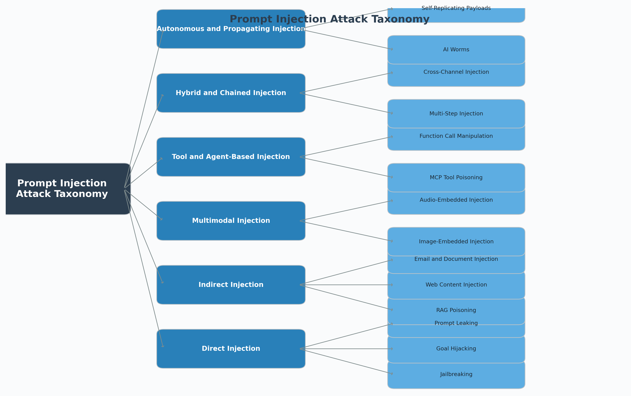
Figure 1. Hierarchical taxonomy of prompt injection attack vectors.
Figure 1 illustrates the hierarchical relationships among these attack categories, showing how the taxonomy progresses from well-understood direct injection techniques to emerging autonomous and propagating threats. The increasing complexity of attack vectors reflects the expanding capabilities of LLM-integrated systems and the growing sophistication of adversarial techniques.

Risk Analysis and Impact Assessment
The impact of prompt injection extends far beyond the manipulation of model outputs. As LLMs are integrated with tools, APIs, and autonomous decision-making capabilities, successful injection attacks can cause real-world harm across multiple dimensions. This section examines five risk categories identified through analysis of documented incidents, vulnerability disclosures, and security research.

Data Exfiltration
Prompt injection can cause LLMs to leak sensitive information including system prompts, training data fragments, user personal data, and proprietary business logic. Indirect injection is particularly dangerous here because the exfiltration can occur without the user's awareness — for example, a poisoned document can instruct the AI assistant to encode confidential data into a URL that the model renders as a markdown image, triggering an HTTP request that transmits the data to an attacker-controlled server. OWASP ranks this among the highest-impact outcomes of LLM01 prompt injection.
This risk category has been assessed as critical severity, affecting systems including AI assistants with access to personal data, RAG systems over confidential document stores. Documented examples include system prompt extraction from chatgpt custom gpts via 'repeat your instructions' attacks.

Unauthorized Actions
When LLMs are integrated with tools and APIs, prompt injection can cause the model to execute actions the user never intended — sending emails, modifying files, making purchases, or calling APIs with attacker-controlled parameters. Agentic AI systems with broad tool access are especially vulnerable because a single successful injection can cascade through multiple tool calls. The severity scales with the agent's permission scope: an agent with file system and network access poses fundamentally different risks than a text-only chatbot.
This risk category has been assessed as critical severity, affecting systems including AI agents with tool-use capabilities (MCP, function calling), Email and calendar AI assistants. Documented examples include ai email assistants sending messages to attacker-specified recipients via indirect injection.

Content Manipulation
Attackers can use prompt injection to control, bias, or corrupt the model's output without detection by the end user. This includes generating disinformation, inserting propaganda into AI-generated summaries, biasing recommendations, or suppressing specific information. Content manipulation is particularly insidious because the user trusts the AI's output as objective, and the manipulated content appears identical in form to legitimate responses.
This risk category has been assessed as high severity, affecting systems including AI-powered search and summarization tools, Content recommendation systems. Documented examples include indirect injection via web pages biasing bing chat responses about products or people.

System Compromise
In agentic and tool-augmented deployments, prompt injection can escalate to full system compromise — arbitrary code execution, privilege escalation, or persistent backdoor installation. When AI agents have access to shell commands, file systems, or container orchestration, a successful injection effectively grants the attacker the same privileges as the agent process. This transforms prompt injection from an AI safety concern into a traditional cybersecurity vulnerability with potentially catastrophic consequences.
This risk category has been assessed as critical severity, affecting systems including AI agents with code execution capabilities, DevOps and infrastructure automation agents. Documented examples include code execution through ai coding assistants processing malicious repository files.

Supply Chain and Downstream Propagation
Prompt injection can propagate through AI supply chains, where the output of one compromised AI system becomes the input of another. This creates cascading failures across interconnected AI systems. Poisoned AI-generated content entering training data, knowledge bases, or shared document stores can perpetuate the attack across temporal and organizational boundaries. The Morris II AI worm concept demonstrates how self-replicating payloads could spread autonomously through networks of AI agents.
This risk category has been assessed as high severity, affecting systems including Multi-agent AI architectures, AI-generated content pipelines. Documented examples include ai-generated code containing injection payloads committed to shared repositories.

Detection Techniques
Detecting prompt injection attacks remains a significant challenge due to the fundamental difficulty of distinguishing adversarial instructions from legitimate user input in natural language. Current detection approaches span a spectrum from simple pattern matching to sophisticated model-based evaluation, each with distinct tradeoffs between accuracy, latency, and robustness.

Heuristic and Rule-Based Detection
Pattern-matching approaches that scan user inputs for known injection signatures such as 'ignore previous instructions', 'you are now', or role-play escalation phrases. These systems maintain curated keyword lists and regular expressions derived from documented attack patterns. While fast and interpretable, heuristic methods suffer from high false-positive rates on legitimate inputs and are trivially bypassed through paraphrasing, encoding tricks (Base64, ROT13), or language translation.
This static approach is exemplified by tools such as Rebuff heuristic layer — keyword and regex matching against known injection patterns. However, Easily evaded through synonym substitution, character-level obfuscation, or multi-language attacks. Cannot detect novel injection patterns not in the rule set. High maintenance burden as new attack patterns emerge continuously.

ML Classification
Trained machine learning models that classify inputs as benign or adversarial based on learned features. These range from traditional text classifiers (SVM, logistic regression on TF-IDF features) to fine-tuned transformer models trained on labeled prompt injection datasets. Embedding similarity approaches compare input embeddings against a vector database of known injection examples, flagging inputs that fall within a threshold distance of known attacks.
This learned approach is exemplified by tools such as Rebuff vector similarity layer — cosine distance against known injection embeddings. However, Dependent on training data quality and coverage — novel attack patterns outside the training distribution are missed. Requires ongoing retraining as the attack landscape evolves. Embedding similarity approaches can be fooled by adversarial inputs optimized to be semantically distant from known attacks while remaining functionally equivalent.

Perplexity Analysis
Statistical anomaly detection that measures the perplexity of input text under a reference language model. Adversarial prompts often exhibit unusual token distributions — either abnormally low perplexity (highly formulaic injection templates) or abnormally high perplexity (obfuscated or encoded payloads). Alon and Kamfonas (2023) demonstrated that perplexity-based windowed analysis can detect gradient-based adversarial suffixes with high accuracy, as these optimized token sequences produce statistically anomalous perplexity scores compared to natural text.
This statistical approach is exemplified by tools such as Perplexity windowing — sliding window analysis flagging regions with anomalous scores. However, Effective primarily against machine-generated adversarial suffixes rather than human-crafted injection prompts, which tend to have natural perplexity. Requires calibration of thresholds per domain and language. Does not detect semantically valid injection prompts that are syntactically natural.

Canary Token Detection
A proactive detection strategy where unique, secret tokens are planted within the system prompt or context. If the model's output contains these canary tokens, it indicates that an injection attack has successfully manipulated the model into revealing privileged context. Rebuff implements this as a defense layer: canary strings are appended to the system prompt, and all outputs are scanned for their presence before being returned to the user.
This proactive approach is exemplified by tools such as Rebuff canary token layer — random strings injected into system context and monitored in output. However, Only detects successful attacks that result in context leakage — does not prevent the injection itself. Canary tokens can be detected and filtered by sophisticated attackers who instruct the model to strip unusual strings from output. Limited to detecting prompt leaking; does not address goal hijacking or tool manipulation attacks.

LLM-as-Judge Detection
Using a secondary language model to evaluate whether an input or output contains prompt injection attempts. The judge model receives the user input (and optionally the system prompt) and classifies whether the input is attempting to subvert intended behavior. This approach leverages the LLM's own understanding of instruction semantics to detect manipulation that statistical methods miss, particularly for semantically sophisticated attacks that use natural language to redirect model behavior.
This model-based approach is exemplified by tools such as Rebuff LLM-based detection layer — GPT-4 prompt evaluating injection likelihood. However, Adds latency and cost from a second model inference per request. The judge model is itself susceptible to prompt injection — an attacker can craft inputs that fool both the primary and judge models simultaneously. Effectiveness degrades when the judge model is weaker than the primary model, as it cannot reliably detect attacks it would itself fall for.
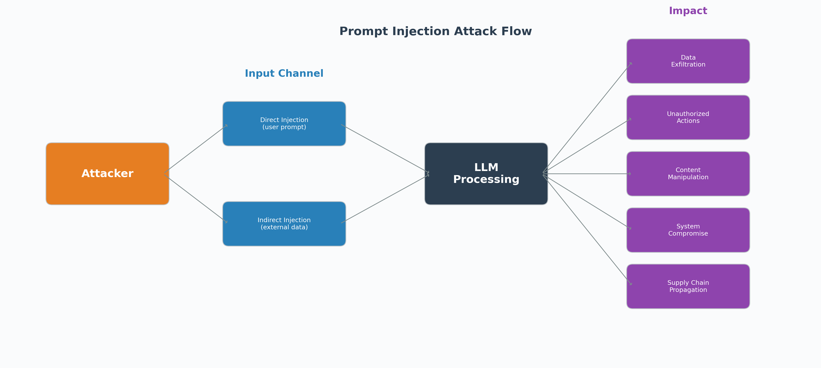
Figure 2. Detection and defense pipeline for prompt injection mitigation.
Figure 2 illustrates the detection and defense pipeline, showing how multiple detection layers can be composed in sequence to improve overall detection rates. The multi-layered approach reflects the defense-in-depth principle: no single detection method provides sufficient coverage, but their combination significantly reduces the probability of a successful attack evading all layers.

Prevention Strategies
Prevention strategies for prompt injection operate at three levels: model-level defenses that modify how the LLM processes instructions, application-level controls that filter inputs and outputs, and system-level architectural patterns that limit the blast radius of successful attacks. This section evaluates six major prevention approaches and their practical tradeoffs.

Instruction Hierarchy
A model-level defense that trains LLMs to assign different privilege levels to instructions based on their source. System prompts receive the highest priority, followed by user messages, with tool outputs and retrieved content at the lowest level. Wallace et al. (2024) formalized this approach at OpenAI, demonstrating that instruction-tuned models can learn to refuse lower-privilege instructions that conflict with higher-privilege ones. Anthropic implements a similar hierarchy in Claude, where system prompt instructions take precedence over user attempts to override them.
Operating at the model level, this strategy is implemented through approaches such as OpenAI instruction hierarchy — system/user/tool privilege tiers built into fine-tuning. Highly effective against naive direct injection ('ignore previous instructions') but partially bypassable through indirect injection where malicious content arrives through trusted data channels. Requires model-level training changes, limiting applicability to model providers rather than downstream application developers.

Input Sanitization and Filtering
Application-level preprocessing that cleanses user inputs and retrieved content before they reach the LLM. Techniques include stripping known injection patterns, encoding special instruction delimiters, normalizing Unicode to prevent homoglyph attacks, and applying length limits to prevent context window stuffing. This mirrors traditional web security practices (XSS filtering, SQL parameterization) adapted for the LLM context, though the boundary between data and instructions in natural language makes perfect sanitization theoretically impossible.
Operating at the application level, this strategy is implemented through approaches such as Input preprocessing pipelines stripping markdown, HTML, and control characters. Reduces attack surface for known patterns but cannot provide complete protection due to the fundamental ambiguity between instructions and data in natural language. Best used as a defense-in-depth layer combined with other strategies rather than as a sole mitigation.

Output Validation and Filtering
Post-generation filtering that inspects model outputs before they reach the user or trigger downstream actions. This includes checking outputs against format constraints, scanning for sensitive data leakage (PII, system prompt fragments, canary tokens), and enforcing response boundaries that prevent the model from executing tool calls or generating content outside its authorized scope. Output validation catches successful injection attacks that bypass input-side defenses.
Operating at the application level, this strategy is implemented through approaches such as Response format validation — JSON schema enforcement for structured outputs. Effective as a safety net for detecting successful attacks that produce observable policy violations in the output. Cannot prevent attacks that cause the model to take harmful actions (tool calls, data exfiltration via side channels) before output filtering occurs. Most valuable when combined with input-side defenses.

Sandboxing and Isolation
System-level architectural controls that limit the blast radius of successful prompt injection by restricting what actions a compromised LLM can take. This includes applying least-privilege principles to tool access, running LLM agents in sandboxed environments with no direct filesystem or network access, requiring explicit user approval for sensitive operations, and isolating retrieval pipelines from action-execution pipelines to prevent indirect injection from triggering real-world effects.
Operating at the system level, this strategy is implemented through approaches such as MCP tool permission scoping — read-only vs read-write tool access per context. Does not prevent injection but limits damage from successful attacks, making it a critical defense-in-depth layer. Most effective when combined with the principle of least privilege — agents should have only the minimum tool access required for their task. The primary tradeoff is reduced autonomy and increased user friction from confirmation requirements.

Guardrail Frameworks
Programmable middleware that interposes between the user and the LLM to enforce conversation policies, topic boundaries, and safety constraints. NVIDIA NeMo Guardrails provides a domain-specific language (Colang) for defining rails that constrain model behavior — including input validation, output checking, and dialog flow enforcement. Lakera Guard offers a commercial API that combines heuristic, ML, and LLM-based detection in a single endpoint, targeting production deployment with low-latency requirements.
Operating at the application level, this strategy is implemented through approaches such as NVIDIA NeMo Guardrails — Colang-based programmable conversation rails. Provides structured, configurable defense that can be adapted per application without model-level changes. Effectiveness depends heavily on the quality of the rail definitions — overly permissive rails miss attacks while overly restrictive rails degrade user experience. Adds latency proportional to the number of active rails and their complexity.

Architectural Patterns
High-level design principles that reduce prompt injection risk through system architecture rather than runtime filtering. Key patterns include: separation of concerns (isolating the LLM's reasoning from its action execution), dual-LLM architectures (one model processes untrusted input while a privileged model makes decisions), and human-in-the-loop designs where the LLM proposes actions but a human approves execution. These patterns acknowledge that prompt injection may be unsolvable at the model level and shift the defense burden to system design.
Operating at the system level, this strategy is implemented through approaches such as Dual-LLM pattern — quarantined model processes untrusted input, privileged model acts. Provides the strongest theoretical defense by removing the LLM from the critical execution path. However, these patterns significantly reduce the autonomy and capability that make LLM agents valuable. The fundamental tradeoff is between security and utility — the most secure system does the least. Adoption is limited by the complexity of implementing dual-model or human-in-the-loop architectures at scale.
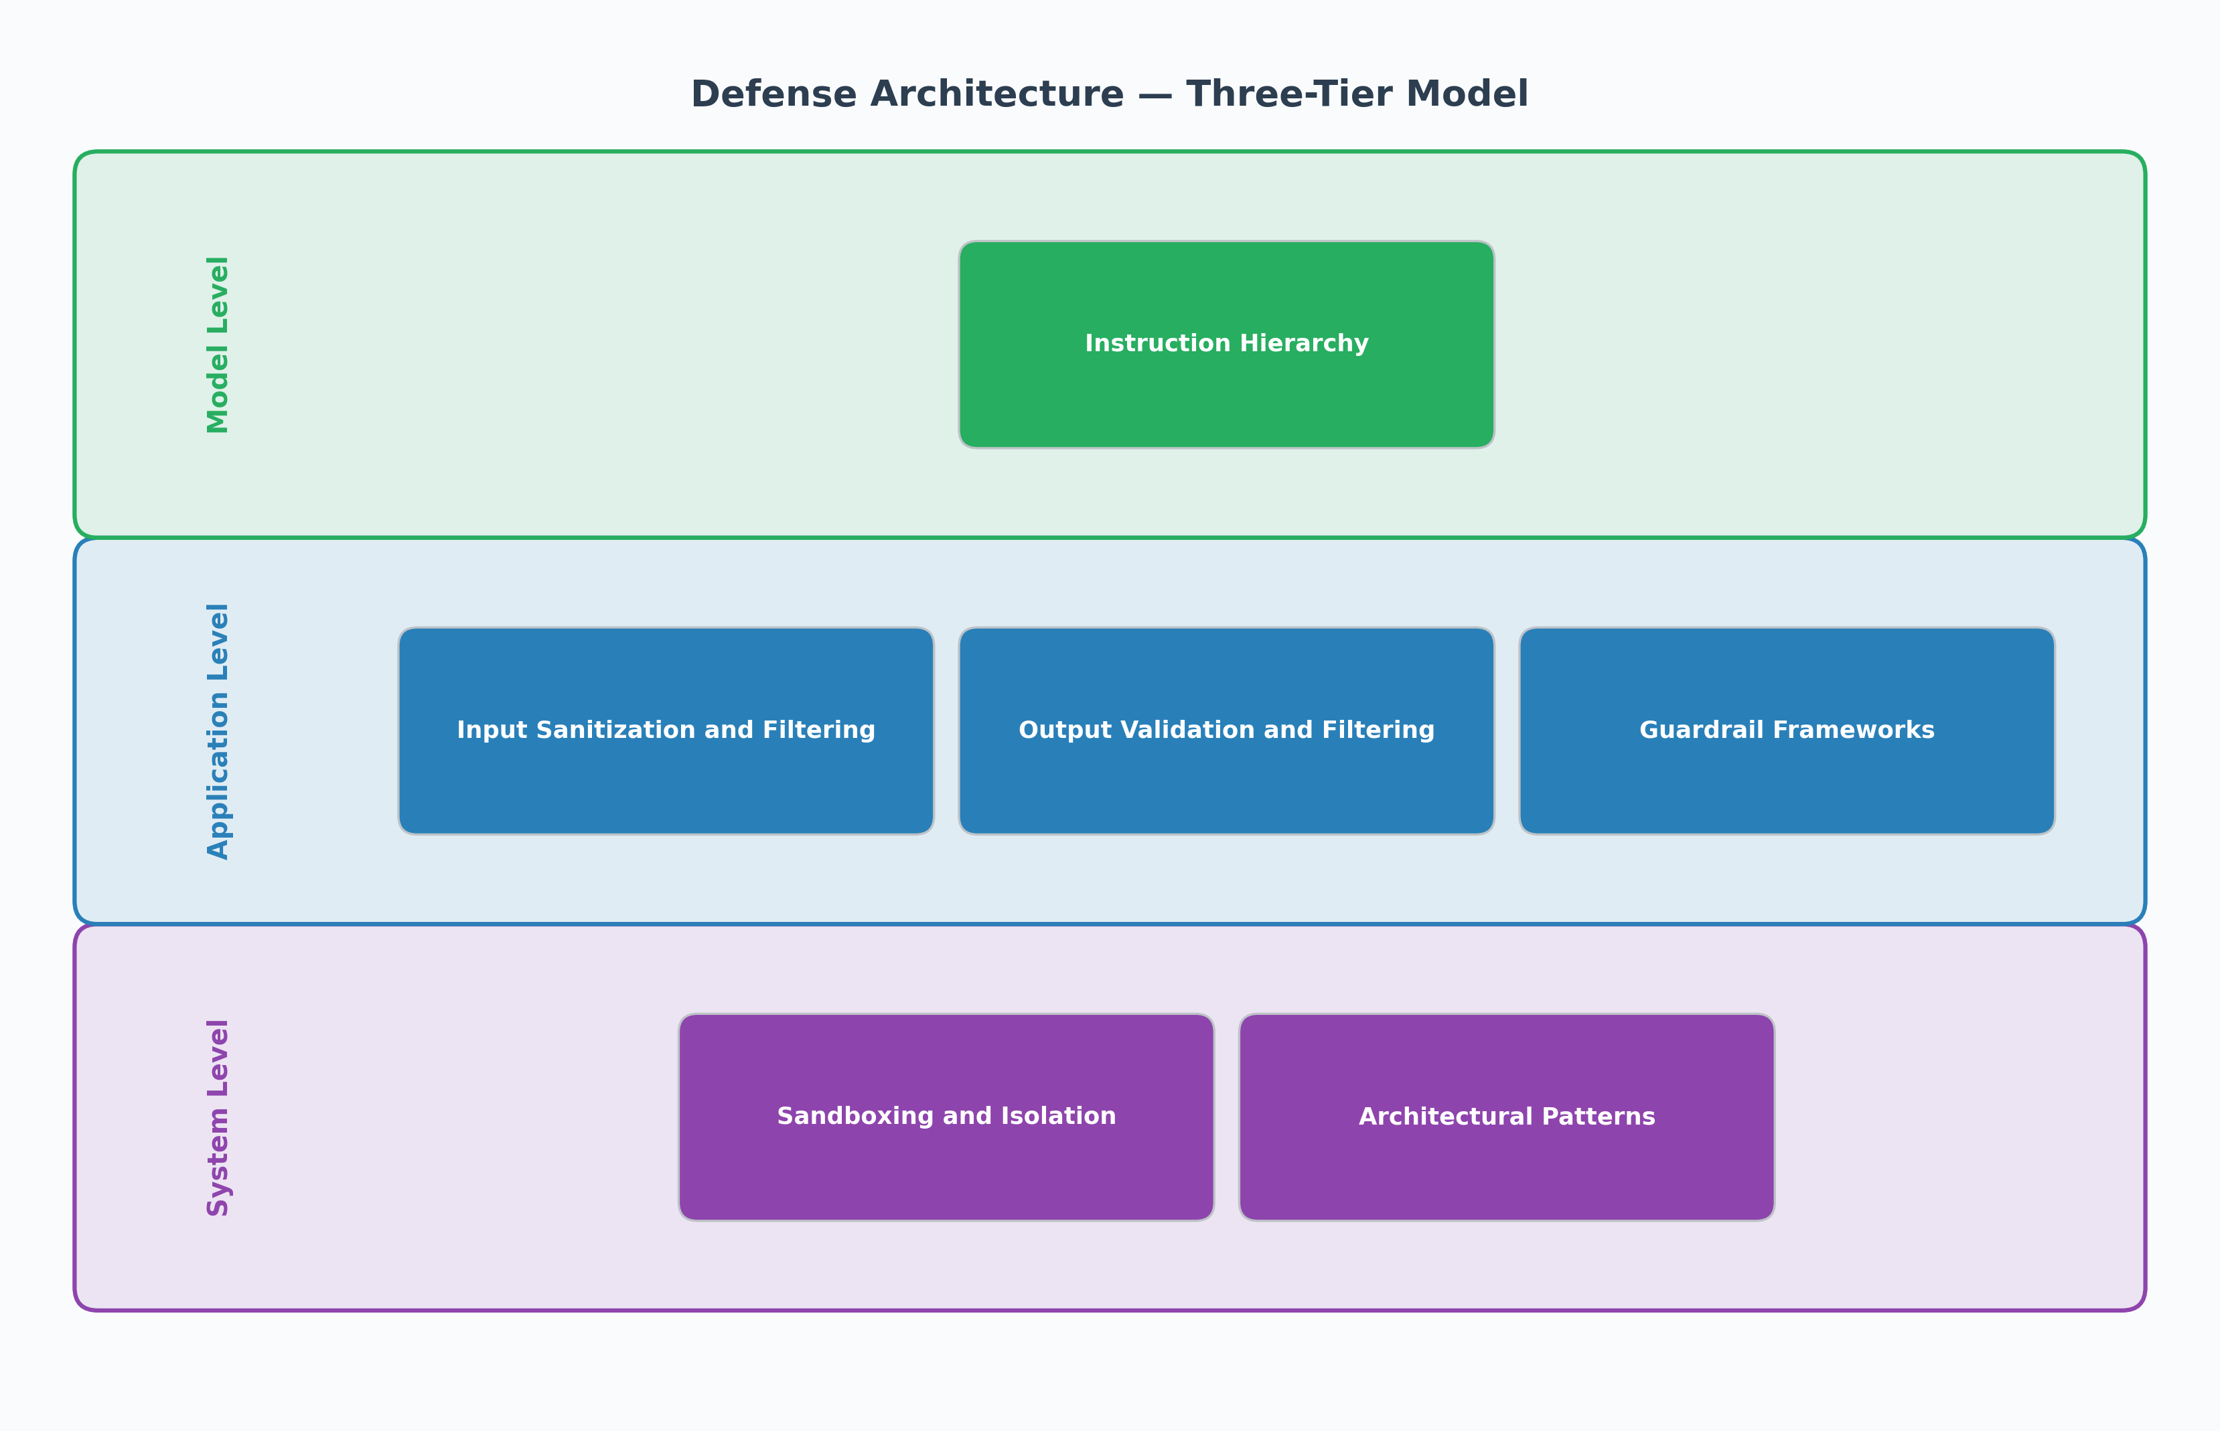
Figure 3. System architecture for layered prompt injection defense.
Figure 3 presents the system architecture for a layered prompt injection defense, illustrating how model-level, application-level, and system-level controls integrate to form a comprehensive defense posture. The architecture emphasizes that effective defense requires coordination across all three levels, as no single layer provides complete protection against the full spectrum of attack vectors.

Methodology
This research employs a structured literature survey methodology to examine the current state of prompt injection attacks and defenses. The survey follows a systematic approach to source selection, categorization, and synthesis designed to provide comprehensive coverage while maintaining analytical rigor.
Source selection targeted four categories of publications: peer-reviewed academic papers from arXiv and journals, industry reports from major cybersecurity firms and AI companies, government standards and frameworks, and documentation from open-source security tools. A total of 18 primary sources published between 2023 and 2025 were selected based on relevance, credibility, and recency. Academic sources were prioritized for theoretical foundations and empirical findings, while industry and government sources provided practical context and standardized frameworks.
The analysis framework organizes findings across four pillars: attack taxonomy and classification, risk analysis and impact assessment, detection techniques, and prevention strategies. Each pillar draws from multiple sources to enable cross-validation and identify areas of consensus and disagreement. The taxonomy was constructed through iterative synthesis, beginning with established categories from Greshake et al. (2023) and extending to incorporate emerging threat vectors documented in 2024-2025 publications.
Limitations of this methodology include publication bias toward well-documented attack vectors, the rapid pace of development in the field which may render some findings outdated, and the difficulty of verifying effectiveness claims for defensive tools in the absence of standardized benchmarks. The survey scope is limited to prompt injection specifically and does not cover other LLM security concerns such as training data poisoning or model extraction attacks.

Discussion
The synthesis of findings across the four pillars reveals several critical insights about the current state of prompt injection as a cybersecurity threat. First, the attack taxonomy demonstrates a clear trajectory of increasing sophistication — from simple direct injection techniques that emerged in 2022 to complex autonomous propagating threats documented in 2024-2025. This evolution parallels the expansion of LLM capabilities, particularly the addition of tool use, web browsing, and multi-agent orchestration that dramatically increase the attack surface.
Second, the risk analysis reveals that prompt injection has crossed the threshold from a theoretical AI safety concern to a practical cybersecurity vulnerability with real-world impact. The ability to cause data exfiltration, unauthorized actions, and system compromise through prompt injection places it alongside traditional vulnerability classes such as SQL injection and cross-site scripting — but with the added complexity that the vulnerability exists in natural language processing rather than structured data parsing.
Third, the detection landscape shows promising but insufficient progress. While multi-layered detection architectures combining heuristic, ML-based, and LLM-as-judge approaches achieve reasonable detection rates for known attack patterns, the fundamental challenge remains: novel injection techniques can be constructed more quickly than detection systems can adapt. The analogy to the antivirus industry's signature-based detection era is instructive — reactive detection alone cannot provide adequate security against a motivated adversary.
Fourth, the prevention strategy assessment suggests that no single defense mechanism is sufficient. The instruction hierarchy approach (Wallace et al., 2024) represents the most theoretically promising model-level defense, but it requires training-time modifications that are unavailable to application developers. Application-level controls such as input sanitization and guardrail frameworks provide practical defense-in-depth but cannot guarantee complete protection. System-level architectural patterns offer the strongest containment through sandboxing and privilege restriction, but at the cost of reduced LLM autonomy and capability.
The implications for practitioners are clear: organizations deploying LLM-integrated systems must adopt defense-in-depth strategies that combine multiple prevention layers rather than relying on any single mitigation. The principle of least privilege should govern all tool access granted to LLM agents. Human-in-the-loop confirmation should be required for irreversible or high-impact operations. And security teams should treat prompt injection with the same rigor applied to traditional web application vulnerabilities, including regular testing, monitoring, and incident response planning.

Conclusion
This survey has examined prompt injection attacks across four dimensions: taxonomy, risks, detection, and prevention. The analysis reveals that prompt injection represents a fundamental and largely unsolved challenge in LLM security, rooted in the architectural inability of current language models to reliably distinguish between instructions and data within their context window.
The attack taxonomy has grown from simple direct injection techniques to encompass indirect injection through external data sources, multimodal attacks exploiting vision and audio channels, tool and agent-based exploitation of agentic AI systems, hybrid chained attacks that combine multiple vectors, and autonomous propagating threats that can spread without continued attacker involvement. Each new category reflects the expanding capabilities and deployment contexts of modern LLMs.
The current state of detection and prevention offers practical defenses but no complete solutions. Defense-in-depth strategies combining instruction hierarchy, input and output filtering, guardrail frameworks, and architectural sandboxing provide meaningful risk reduction. However, the fundamental vulnerability persists as an inherent property of the transformer architecture's treatment of all context window content as equally authoritative.
Future research directions include the development of formal verification methods for LLM instruction compliance, standardized benchmarks for evaluating prompt injection defenses, and architectural innovations that create genuine separation between instruction and data processing pathways. Until such advances materialize, the cybersecurity community must treat prompt injection as a persistent threat requiring continuous monitoring, testing, and adaptive defense strategies.

References
Abdallah, M., Barreno, A., Bensalah, F., et al. (2025). Prompt injection attacks in large language models and AI agent systems: A comprehensive review. Information, 17(1), 54. https://www.mdpi.com/2078-2489/17/1/54
Ahmed, S., Kaur, K., & Sharma, R. (2025). Prompt injection 2.0: Hybrid AI threats. arXiv. https://arxiv.org/abs/2507.13169
Alon, G., & Kamfonas, M. (2023). Detecting language model attacks with perplexity. arXiv. https://arxiv.org/abs/2308.14132
Anthropic. (2024a). Research on AI safety and prompt security. Anthropic. https://www.anthropic.com/research
Anthropic. (2024b). System prompt security best practices. Anthropic. https://docs.anthropic.com/en/docs/build-with-claude/prompt-engineering/system-prompts
BSG. (2025). OWASP LLM Top 10 (2025) analysis. BSG Tech Blog. https://bsg.tech/blog/owasp-llm-top-10/
CrowdStrike. (2024). Prompt injection: Definition and attack taxonomy. CrowdStrike Cybersecurity 101. https://www.crowdstrike.com/en-us/cybersecurity-101/cyberattacks/prompt-injection/
Greshake, K., Abdelnabi, S., Mishra, S., Endres, C., Giner, T., & Fritz, M. (2023). Not what you've signed up for: Compromising real-world LLM-integrated applications with indirect prompt injection. arXiv. https://arxiv.org/abs/2302.12173
Lakera AI. (2024). Lakera Guard: Real-time prompt injection detection. Lakera AI. https://www.lakera.ai/
Liu, Y., Jia, Y., Geng, R., Jia, J., & Gong, N. Z. (2024). Formalizing and benchmarking prompt injection attacks and defenses. arXiv. https://arxiv.org/abs/2310.12815
National Institute of Standards and Technology. (2025). Adversarial machine learning: A taxonomy and terminology of attacks and mitigations (AI 100-2e2025). NIST. https://nvlpubs.nist.gov/nistpubs/ai/NIST.AI.100-2e2025.pdf
NVIDIA. (2024). NeMo Guardrails: Programmable guardrails for LLM applications. GitHub. https://github.com/NVIDIA/NeMo-Guardrails
OWASP Foundation. (2025). OWASP Top 10 for large language model applications. OWASP. https://owasp.org/www-project-top-10-for-large-language-model-applications/
ProtectAI. (2023). Rebuff: Self-hardening prompt injection detector. GitHub. https://github.com/protectai/rebuff
Schulhoff, S., Pinto, J., Khan, A., Bouchard, L.-F., Si, C., Anati, S., & Boyd-Graber, J. (2023). Ignore this title and HackAPrompt: Exposing systemic weaknesses of LLMs through a global scale prompt hacking competition. arXiv. https://arxiv.org/abs/2311.16119
Wallace, E., Xiao, K., Leike, J., Weng, L., Heidecke, J., & Beutel, A. (2024). The instruction hierarchy: Training LLMs to prioritize privileged instructions. arXiv. https://arxiv.org/abs/2404.13208
Willison, S. (2024). Prompt injection series. Simon Willison's Weblog. https://simonwillison.net/series/prompt-injection/
Yi, J., Xie, Y., Zhu, B., Hines, K., Kiciman, E., Sun, G., Xie, X., & Wu, F. (2024). Jailbreak attacks and defenses against large language models: A survey. arXiv. https://arxiv.org/abs/2407.04295

