Environment

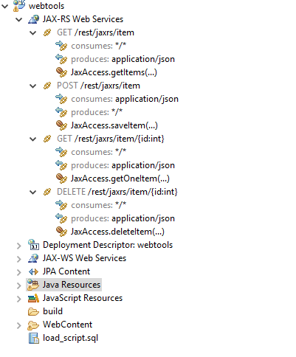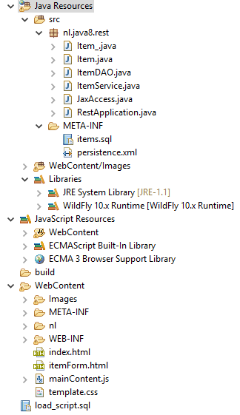

**JAX-RS**

**DAO**

**rest**

**Wildfly**

**json**

Presentation

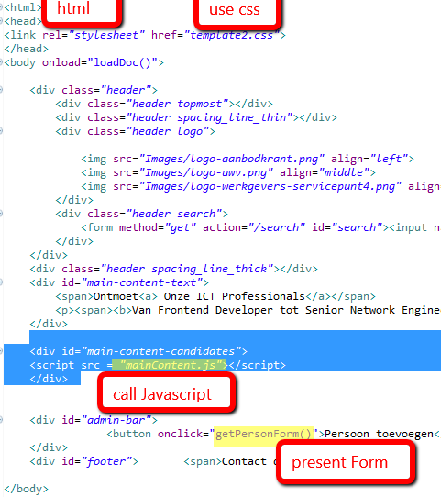 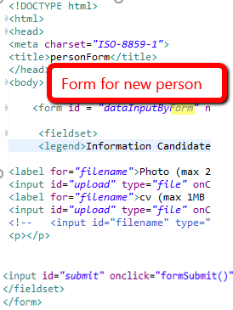 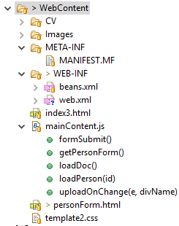

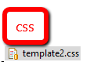 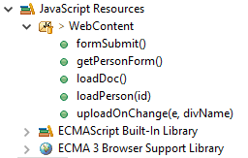

Persistence

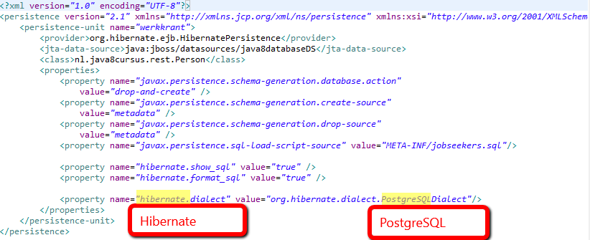

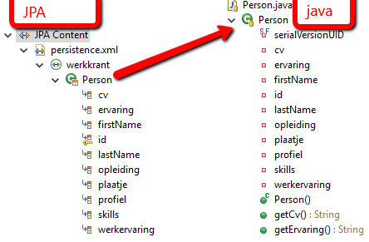

**REST : Representational State Transfer**

**RESTful**[**web services**](https://en.wikipedia.org/wiki/Web_service)**are one way of providing interoperability between computer systems on the**[**Internet**](https://en.wikipedia.org/wiki/Internet)**,** REST-compliant Web services allow requesting systems to access and manipulate textual representations of [Web resources](https://en.wikipedia.org/wiki/Web_resource) using a uniform and predefined set of [stateless](https://en.wikipedia.org/wiki/Stateless_protocol) operations. Using [HTTP](https://en.wikipedia.org/wiki/HTTP), as is most common, the kind of operations available include those predefined by the [HTTP verbs](https://en.wikipedia.org/wiki/HTTP_verbs) GET, POST, PUT, DELETE and so on.

**JAX-RS : Java API for RESTful Web Services** is a [Java programming language](https://en.wikipedia.org/wiki/Java_(programming_language)) [API](https://en.wikipedia.org/wiki/Application_programming_interface) spec that provides support in creating [web services](https://en.wikipedia.org/wiki/Web_service) according to the [Representational State Transfer](https://en.wikipedia.org/wiki/Representational_State_Transfer) (REST) architectural pattern.[[](https://en.wikipedia.org/wiki/Java_API_for_RESTful_Web_Services#cite_note-1)

**JAX-WS : Java API for XML Web Services**

**URI : Uniform Resource Identifier**

**URL : Uniform Resource Locator**

**CSS : Cascading Style Sheets**

**HTML : HyperText Markup Language -** creating [web pages](https://en.wikipedia.org/wiki/Web_page) and [web applications](https://en.wikipedia.org/wiki/Web_application)

**AJAX : Asynchronous JavaScript and XML – a collection of related technologies based on JavaScript, XML and the DOM.** Ajax is the ability to retrieve new data from the server without unloading the current page.

**DOM : Document Object Model -** The DOM enables Ajax because, once new data is retrieved, it can be used to insert the data into the page.

[**JSON**](https://en.wikipedia.org/wiki/JSON) **: JavaScript Object Notation - JSON: The Fat-Free Alternative to XML**

**XML** : **Extensible Markup Language** is a [markup language](https://en.wikipedia.org/wiki/Markup_language) that defines a set of rules for encoding [documents](https://en.wikipedia.org/wiki/Electronic_document) in a [format](https://en.wikipedia.org/wiki/File_format) that is both [human-readable](https://en.wikipedia.org/wiki/Human-readable_medium) and [machine-readable](https://en.wikipedia.org/wiki/Machine-readable_data).

**JavaScript : the programming language of HTML and the Web - is a high-level, dynamic, untyped, and interpreted programming language.**

**Java Platforms, Enterprise Edition** or **Java EE** is a widely used [computing platform](https://en.wikipedia.org/wiki/Computing_platform) for [enterprise software](https://en.wikipedia.org/wiki/Enterprise_software).

**Java : an Object-Oriented programing language with its own runtime environment**

**DAO : Data Access Object** is an [object](https://en.wikipedia.org/wiki/Object_(computer_science)) that provides an abstract [interface](https://en.wikipedia.org/wiki/Interface_(computer_science)) to some type of [database](https://en.wikipedia.org/wiki/Database) or other persistence mechanism.

**Hibernate : provides a**[**framework**](https://en.wikipedia.org/wiki/Software_framework)**for mapping an**[**object-oriented**](https://en.wikipedia.org/wiki/Object-oriented_programming)**domain model to a**[**relational database**](https://en.wikipedia.org/wiki/Relational_database)

**JPA : Java Persistence API** is a [Java](https://en.wikipedia.org/wiki/Java_(programming_language)) [application programming interface](https://en.wikipedia.org/wiki/Application_programming_interface) specification that describes the management of [relational data](https://en.wikipedia.org/wiki/Relational_data_model) in applications using [Java Platform](https://en.wikipedia.org/wiki/Java_Platform,_Standard_Edition) **SE / EE**

**Java Transaction API** (**JTA**), one of the [Java Enterprise Edition](https://en.wikipedia.org/wiki/Java_EE) (Java EE) [APIs](https://en.wikipedia.org/wiki/Application_programming_interface), enables [distributed transactions](https://en.wikipedia.org/wiki/Distributed_transaction) to be done across multiple [X/Open XA](https://en.wikipedia.org/wiki/X/Open_XA) resources in a [Java](https://en.wikipedia.org/wiki/Java_(programming_language)) environment.

**PostgreSQL :  an**[**object-relational database**](https://en.wikipedia.org/wiki/Object-relational_database)**(ORDBMS) – i.e. a**[**RDBMS**](https://en.wikipedia.org/wiki/RDBMS)**, with additional "object" features**

**Wildfly : (JBoss) Application Server** authored by JBoss, now developed by Red Hat. WildFly is written in Java

The **Spring Framework** is an [application framework](https://en.wikipedia.org/wiki/Application_framework) and [inversion of control](https://en.wikipedia.org/wiki/Inversion_of_control)[container](https://en.wikipedia.org/wiki/Servlet_container) for the [Java platform](https://en.wikipedia.org/wiki/Java_platform). The framework's core features can be used by any Java application, but there are extensions for building web applications on top of the [Java EE](https://en.wikipedia.org/wiki/Java_EE) platform.

**Java Platform, Enterprise Edition** or **Java EE** is a widely used [computing platform](https://en.wikipedia.org/wiki/Computing_platform) for development and deployment of [enterprise software](https://en.wikipedia.org/wiki/Enterprise_software) ([network](https://en.wikipedia.org/wiki/Network_service) and [web services](https://en.wikipedia.org/wiki/Web_service)).[[1]](https://en.wikipedia.org/wiki/Java_Platform,_Enterprise_Edition#cite_note-1) Java EE was formerly known as **Java 2 Platform, Enterprise Edition** or **J2EE**.