“Magical Programming that's PERFECT
for your spacial event!”

“... awesome show last night... very good
at your craft... I'm still amazed!”
-Dan Yokum
Dublin, Ohio
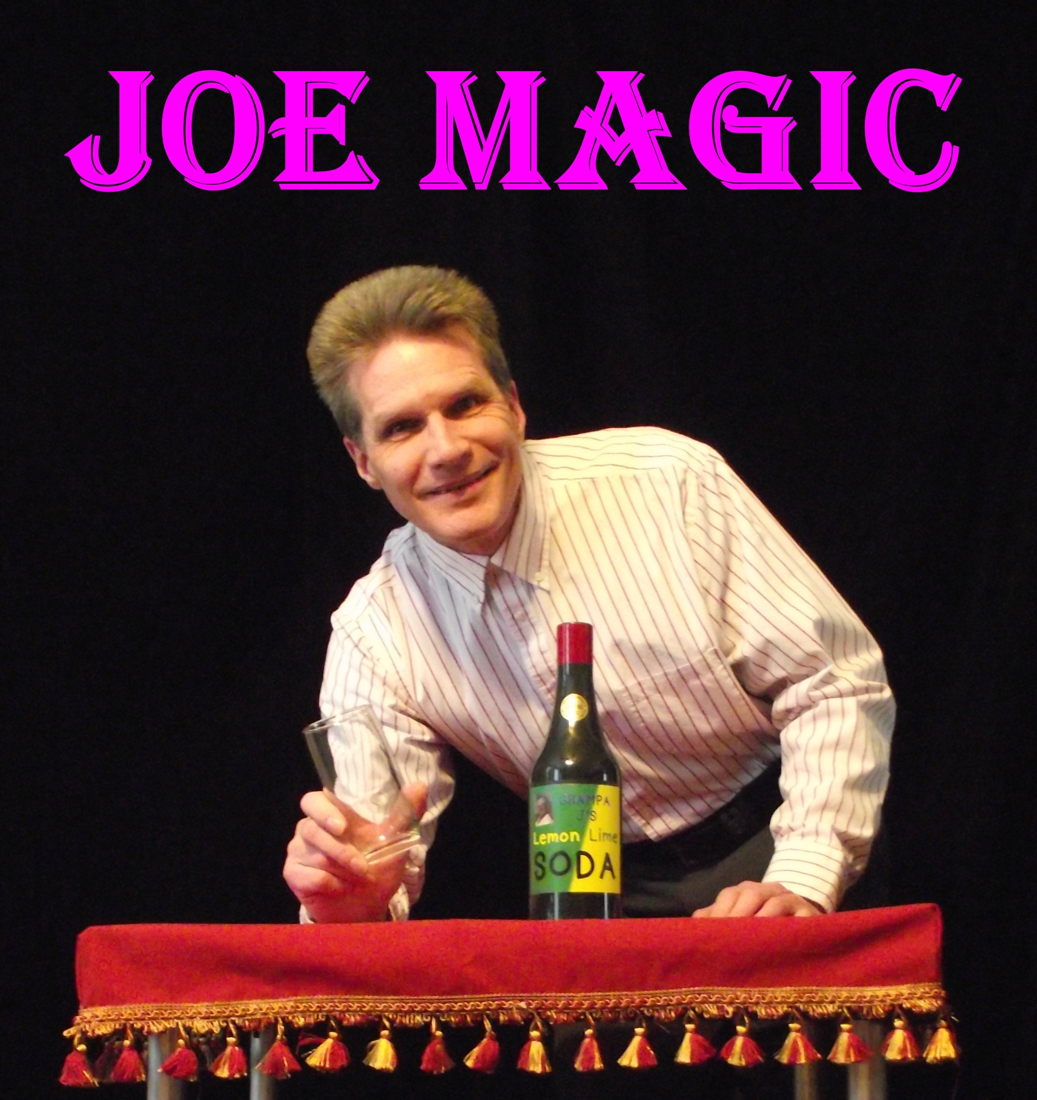
The fun, friendly way to add excitement to your special event!

Folks of all ages will share in the magic and experience the wonder during this musical mix of fun and illusion! Audience participation, family friendly comedy, music, magic, a story or two from grand dad's dairy farm, PLUS the astounding appearance of old time milk bottles (full of milk) from thin air!!!

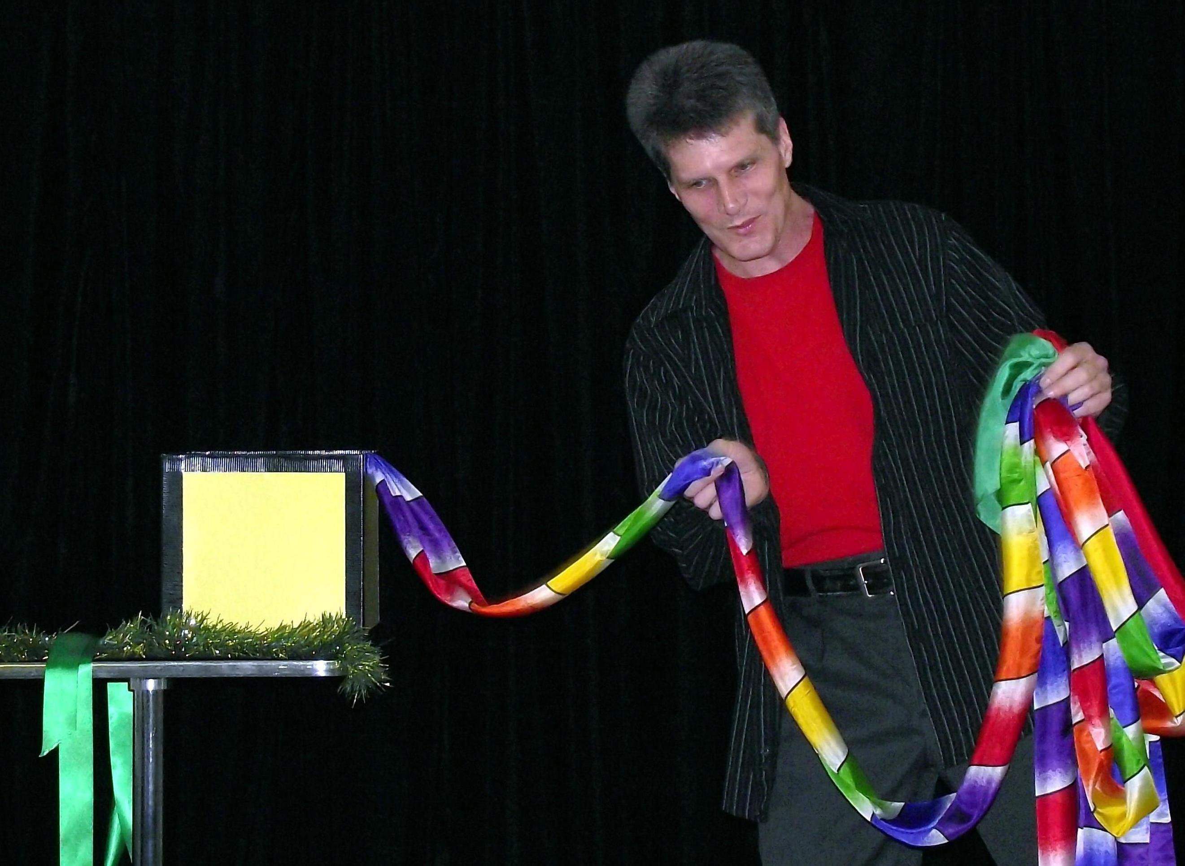

“I would recommend the show
to anyone... What a hoot!”
-Leslie Haignere
Columbus, Ohio

For Availability:
call: (614) 777-7632
or email: joe@heyjoemagic.com
www.heyjoemagic.com

