EDWARD MONTEVERDE / NAGENDRA NEPAL

1) SELECT COUNT(PaperId), TIME_SLOT.StartTime, TIME_SLOT.EndTime
FROM SESSION_ROOM_CHAIR, PAPER, TIME_SLOT
WHERE PAPER.SessionId = SESSION_ROOM_CHAIR.SessionId
AND SESSION_ROOM_CHAIR.TimeSlotId = TIME_SLOT.TimeSlotId
AND TIME_SLOT.TimeSlotId = '1';
/* 1 as a sample entry */

COUNT(DISTINCT PaperId) | StartTime | EndTime
117 | 09:00 AM | 10:30 AM

2) SELECT BUILDING.Name, COUNT(PAPER.paperId)
FROM PAPER, BUILDING, SESSION_ROOM_CHAIR, ROOM
WHERE BUILDING.ID= ROOM.BuildingID
AND PAPER.SessionId = SESSION_ROOM_CHAIR.SessionId
AND SESSION_ROOM_CHAIR.RoomId = ROOM.RoomId
AND BUILDING.Name = 'Tower';
/* Tower as a sample entry */

Name | COUNT(PAPER.paperId)
Tower | 63

3) SELECT * FROM PAPER, SUBJECT_CATEGORY
WHERE SUBJECT_CATEGORY.Description = 'Biology'
AND SUBJECT_CATEGORY.SubjectId = PAPER.SubjectId
GROUP BY PaperId LIMIT 10;
/* Biology as a sample entry */

PaperId | Title | ContactAuthorId | SubjectId | SessionId | StartTime | EndTime | SubjectId | Description
8 | BIO 201 Class Project ? Mapping e(r), Transgenes o... | 959 | 4 | 3 | 01:15 PM | 01:45 PM | 4 | Biology
9 | Analysis of the Regulatory Region of the e(r) Gene... | 1040 | 4 | 3 | 01:45 PM | 02:15 PM | 4 | Biology
69 | Characterization of in vitro Enzymatic Activity of... | 269 | 4 | 4 | 02:30 PM | 2:45 PM | 4 | Biology
70 | A Novel Trypanosome Cytoplasmic Protein Interacts ... | 1048 | 4 | 4 | 02:45 PM | 03:00 PM | 4 | Biology
71 | Cloning of the KitA Gene From Zebrafish | 965 | 4 | 4 | 03:00 PM | 03:15 PM | 4 | Biology
72 | Expression and Characterization of a Mutant of the... | 270 | 4 | 4 | 03:15 PM | 03:30 PM | 4 | Biology
106 | Nuclear Encoded Protiens Important in Mitochondria... | 284 | 4 | 5 | 3:45 PM | 4:00 PM | 4 | Biology
107 | The Benefits of Preventative Medicin in Zoo's: A R... | 165 | 4 | 5 | 4:00 PM | 4:15 PM | 4 | Biology
2007 | How Cells Respond to an Appetite Hormone: The Mole... | 1096 | 4 | 1 | 9:00 AM | 9:20 AM | 4 | Biology
2008 | Characterization of Melanin-concentrating Hormone ... | 179 | 4 | 1 | 9:20 AM | 9:40 AM | 4 | Biology

4) SELECT COUNT(DISTINCT PaperId)
FROM PAPER, SUBJECT_CATEGORY
WHERE PAPER.SubjectId = SUBJECT_CATEGORY.SubjectId
AND SUBJECT_CATEGORY.Description = 'Biology';
/* Biology as a sample entry */

COUNT(DISTINCT PaperId)
15

5) SELECT SESSION_CHAIR.SessionChairId, PERSON.LastName, PERSON.FirstName
FROM PERSON, SESSION_CHAIR
WHERE PERSON.PersonId = SESSION_CHAIR.SessionChairId
ORDER BY PERSON.LastName;

SessionChairId | LastName | FirstName
909 | Argetsinger | Gail
911 | Bacheler | Virginia
914 | Balog | Linda
916 | Banerjee | Priya
811 | Bilinski | Kim
932 | Black | Ralph
819 | Bloom | Davida
948 | Brown | Michael
963 | Canbolat | Mustafa
6 | Cho | Oh-Kon
984 | Conti | Brooke
802 | Cook | Laurie
818 | Dauenhauer | Jason
1019 | David | Tamala
1017 | DeGuzman | Melchor
1020 | Dicker | Georges
1047 | Ducey | Marsha
1046 | Esara | Pilapa
1018 | Fallon | Moira
817 | Forzano | Lori-Ann
821 | Gokhale | Virginia
812 | Haibach | Pamela
1059 | Hartnett | Dale
1064 | Hasnat | Baban
1070 | Haynes | James
1068 | Haytock | Jennifer
804 | He | LeRong
814 | Heavey | Elizabeth
1069 | Hecker | Jennifer
1066 | Herrmann Jr. | Ken

6) SELECT SessionId, RoomId, Name
FROM SESSION_ROOM_CHAIR, BUILDING
WHERE BUILDING.Id = SESSION_ROOM_CHAIR.BuildingId
ORDER BY SESSION_ROOM_CHAIR.SessionId LIMIT 10;

SessionId | RoomId | Name
1 | 102 | Edwards
2 | 105 | Edwards
101 | 102 | Edwards
102 | Outside NE Corner | Tower
103 | 105 | Edwards
104 | 217 | Hartwell
105 | 120 | Hartwell
106 | Dance Theater | Hartwell
107 | 122 | Hartwell
108 | 219 | Hartwell

7) SELECT PAPER.Title, PERSON.LastName, PERSON.FirstName, SUBJECT_CATEGORY.Description, SESSION_ROOM_CHAIR.SessionId, PAPER.StartTime, PAPER.EndTime
FROM PERSON, PAPER, SUBJECT_CATEGORY, CONTACT_AUTHOR, SESSION_ROOM_CHAIR
WHERE SESSION_ROOM_CHAIR.SESSIONID = PAPER.SESSIONID AND
SUBJECT_CATEGORY.SUBJECTID = PAPER.SUBJECTID AND
CONTACT_AUTHOR.CONTACTAUTHORID = PERSON.PERSONID AND
PAPER.CONTACTAUTHORID = CONTACT_AUTHOR.CONTACTAUTHORID AND
PERSON.lastName = 'Ryan' AND PERSON.firstName = 'Nicole';
/* Nicole Ryan as a sample entry */

Title | LastName | FirstName | Description | SessionId | StartTime | EndTime
Indian Residential School Syndrome and the Interge... | Ryan | Nicole | Anthropology | 1 | 9:40 AM | 10:00 AM

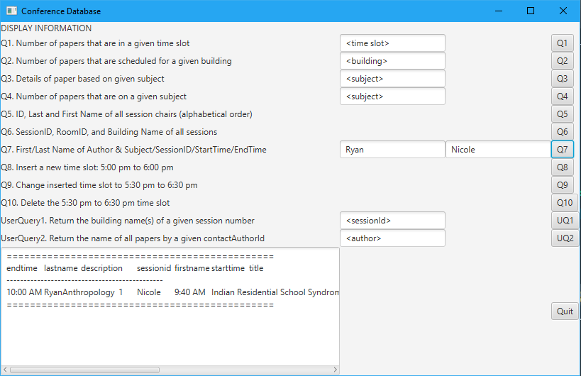

8) INSERT INTO TIME_SLOT VALUES (6, '05:00 PM', '06:00 PM');

1 row inserted. (Query took 0.0135 sec)

Table after insertion:

TimeSlotId | StartTime | EndTime
1 | 09:00 AM | 10:30 AM
2 | 10:45 AM | 11:45 AM
3 | 01:15 PM | 02:15 PM
4 | 02:30 PM | 03:30 PM
5 | 03:45 PM | 04:45 PM
6 | 05:00 PM | 06:00 PM
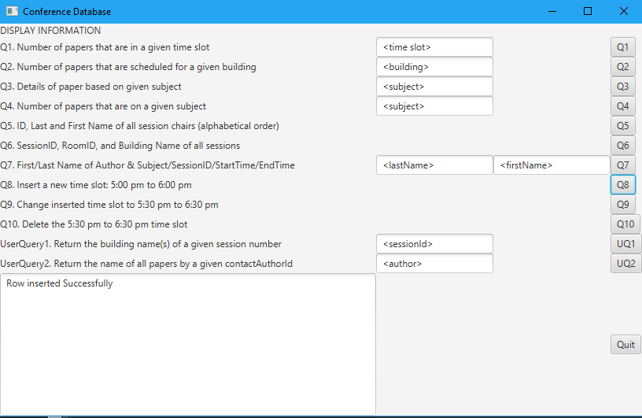

9) UPDATE TIME_SLOT SET StartTime = '05:30 PM', EndTime = '06:30 PM'
WHERE TimeSlotId = '6';
1 row affected. (Query took 0.0041 sec)

Table after update:

TimeSlotId | StartTime | EndTime
1 | 09:00 AM | 10:30 AM
2 | 10:45 AM | 11:45 AM
3 | 01:15 PM | 02:15 PM
4 | 02:30 PM | 03:30 PM
5 | 03:45 PM | 04:45 PM
6 | 05:30 PM | 06:30 PM

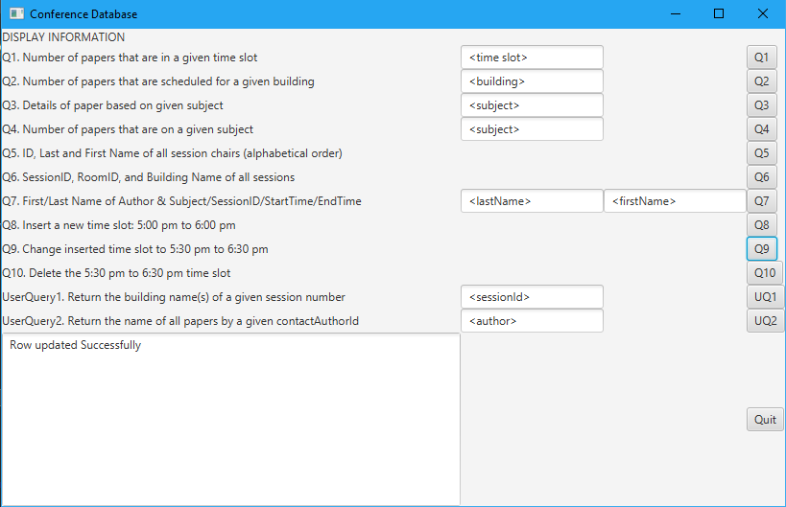

10) DELETE FROM TIME_SLOT WHERE TimeSlotId = '6';
1 row deleted. (Query took 0.0036 sec)

Table after deletion:

TimeSlotId | StartTime | EndTime
1 | 09:00 AM | 10:30 AM
2 | 10:45 AM | 11:45 AM
3 | 01:15 PM | 02:15 PM
4 | 02:30 PM | 03:30 PM
5 | 03:45 PM | 04:45 PM

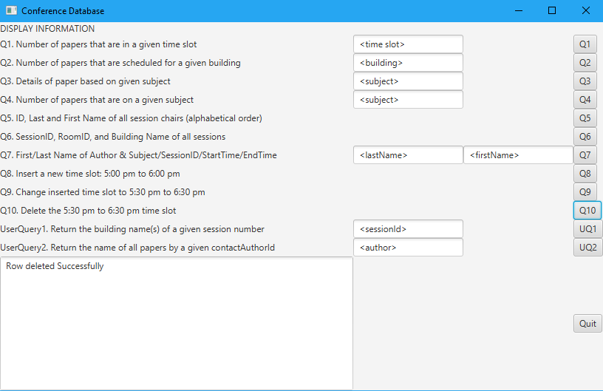

User Generated Queries:

- Return all the building names of a given session number

SELECT BUILDING.NAME, SESSION_ROOM_CHAIR.SessionId
FROM BUILDING, SESSION_ROOM_CHAIR
WHERE SESSIONID = '104'
AND SESSION_ROOM_CHAIR.BUILDINGID = BUILDING.ID;
/* 104 as a sample query */

NAME | SessionId
Hartwell | 104

- Return the name of all papers written by a given CONTACT_AUTHORID

SELECT PAPER.TITLE, CONTACT_AUTHOR.CONTACTAUTHORID
FROM PAPER, CONTACT_AUTHOR
WHERE PAPER.CONTACTAUTHORID = CONTACT_AUTHOR.CONTACTAUTHORID
AND PAPER.CONTACTAUTHORID = '5';
/* 5 as a sample entry */

TITLE | CONTACTAUTHORID
Indian Residential School Syndrome and the Interge... | 5

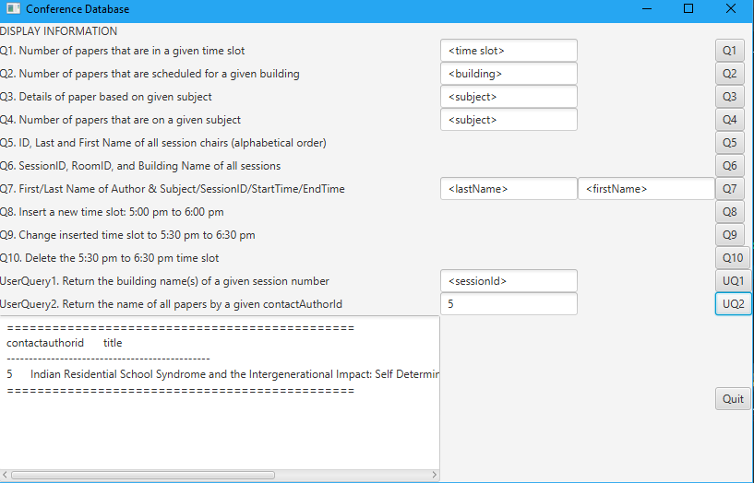

JAVA CODE FOR CONFERENCEDBTESTERGUI.JAVA

import java.util.Enumeration;
import java.util.Properties;
import java.util.Vector;

import javafx.application.Application;
import javafx.event.ActionEvent;
import javafx.event.EventHandler;
import javafx.geometry.Pos;
import javafx.scene.Scene;
import javafx.scene.control.Button;
import javafx.scene.control.Label;
import javafx.scene.control.TextArea;
import javafx.scene.control.TextField;
import javafx.scene.layout.GridPane;
import javafx.stage.Stage;

/**
* For CSC/CIS 422 class
*
* @author Edward MonteVerde / Nagendra Nepal (BARELY)
* @version Spring 2018
*/
// ----------------------------------------------------------
public class ConferenceDBTesterGUI extends Application {
// Declare all the GUI components as instance variables.
// Don't create the objects at this point.
// First we need a GridPane
private GridPane pane;

// We need 10 labels
private Label displayLabel;
private Label q1Label;
private Label q2Label;
private Label q3Label;
private Label q4Label;
private Label q5Label;
private Label q6Label;
private Label q7Label;
private Label q8Label;
private Label q9Label;
private Label q10Label;
private Label uq1Label;
private Label uq2Label;

// We need 6 text fields
private TextField timeSlot1TF;
private TextField building2TF;
private TextField subject3TF;
private TextField subject4TF;
private TextField lastName7TF;
private TextField firstName7TF;
private TextField sessionId11TF;
private TextField author12TF;
// private TextArea textArea;

// We need a button
private Button q1;
private Button q2;
private Button q3;
private Button q4;
private Button q5;
private Button q6;
private Button q7;
private Button q8;
private Button q9;
private Button q10;
// user query buttons
private Button uq1;
private Button uq2;
private Button quit;

private TextArea results;

// We need a scene
private Scene scene;

// ----------------------------------------------------------
// crtate GUI components
private void createGUIComponents() {
// Create GUI Objects
pane = new GridPane();

// ----------------------------------------------------------
// Create Labels
displayLabel = new Label("DISPLAY INFORMATION");
q1Label = new Label("Q1. Number of papers that are in a given time slot ");
q2Label = new Label("Q2. Number of papers that are scheduled for a given building ");
q3Label = new Label("Q3. Details of paper based on given subject ");
q4Label = new Label("Q4. Number of papers that are on a given subject ");
q5Label = new Label("Q5. ID, Last and First Name of all session chairs (alphabetical order) ");
q6Label = new Label("Q6. SessionID, RoomID, and Building Name of all sessions ");
q7Label = new Label("Q7. First/Last Name of Author & Subject/SessionID/StartTime/EndTime ");
q8Label = new Label("Q8. Insert a new time slot: 5:00 pm to 6:00 pm ");
q9Label = new Label("Q9. Change inserted time slot to 5:30 pm to 6:30 pm ");
q10Label = new Label("Q10. Delete the 5:30 pm to 6:30 pm time slot ");
// user query labels
uq1Label = new Label("UserQuery1. Return the building name(s) of a given session number ");
uq2Label = new Label("UserQuery2. Return the name of all papers by a given contactAuthorId ");

// ----------------------------------------------------------
// Create the text fields

timeSlot1TF = new TextField("<time slot>");
building2TF = new TextField("<building>");
subject3TF = new TextField("<subject>");
subject4TF = new TextField("<subject>");
lastName7TF = new TextField("<lastName>");
firstName7TF = new TextField("<firstName>");
// user query text fields
sessionId11TF = new TextField("<sessionId>");
author12TF = new TextField("<author>");

// ----------------------------------------------------------
// Create the buttons
q1 = new Button("Q1");
q2 = new Button("Q2");
q3 = new Button("Q3");
q4 = new Button("Q4");
q5 = new Button("Q5");
q6 = new Button("Q6");
q7 = new Button("Q7");
q8 = new Button("Q8");
q9 = new Button("Q9");
q10 = new Button("Q10");
// user query buttons
uq1 = new Button("UQ1");
uq2 = new Button("UQ2");
quit = new Button("Quit");

// ----------------------------------------------------------
// Create the text area to display results
results = new TextArea();

// ----------------------------------------------------------
// Add the components to the pane
pane.add(displayLabel, 0, 0);

pane.add(q1Label, 0, 1);
pane.add(timeSlot1TF, 1, 1);
pane.add(q1, 3, 1);

pane.add(q2Label, 0, 2);
pane.add(building2TF, 1, 2);
pane.add(q2, 3, 2);

pane.add(q3Label, 0, 3);
pane.add(subject3TF, 1, 3);
pane.add(q3, 3, 3);

pane.add(q4Label, 0, 4);
pane.add(subject4TF, 1, 4);
pane.add(q4, 3, 4);

pane.add(q5Label, 0, 5);
pane.add(q5, 3, 5);

pane.add(q6Label, 0, 6);
pane.add(q6, 3, 6);

pane.add(q7Label, 0, 7);
pane.add(lastName7TF, 1, 7);
pane.add(firstName7TF, 2, 7);
pane.add(q7, 3, 7);

pane.add(q8Label, 0, 8);
pane.add(q8, 3, 8);

pane.add(q9Label, 0, 9);
pane.add(q9, 3, 9);

pane.add(q10Label, 0, 10);
pane.add(q10, 3, 10);

// start user queries
pane.add(uq1Label, 0, 11);
pane.add(sessionId11TF, 1, 11);
pane.add(uq1, 3, 11);

pane.add(uq2Label, 0, 12);
pane.add(author12TF, 1, 12);
pane.add(uq2, 3, 12);

// quit
pane.add(quit, 3, 13);
pane.add(results, 0, 13);

// Set Properties
pane.setAlignment(Pos.CENTER);

}

// ----------------------------------------------------------
// Attach handlers
public void attachHandlers() {
// ----------------------------------------------------------

q1.setOnAction(new EventHandler<ActionEvent>() {
public void handle(ActionEvent e) {
String timeSlot = timeSlot1TF.getText();
String query = "SELECT COUNT(PaperId), TIME_SLOT.StartTime, TIME_SLOT.EndTime "
+ "FROM SESSION_ROOM_CHAIR, PAPER, TIME_SLOT "
+ "WHERE PAPER.SessionId = SESSION_ROOM_CHAIR.SessionId "
+ "AND SESSION_ROOM_CHAIR.TimeSlotId = TIME_SLOT.TimeSlotId " + "AND TIME_SLOT.TimeSlotId = '"
+ timeSlot + "';";
System.out.println(query);

String displayString = retrieveFromTable(query);
results.setText(displayString);
}
});
// ----------------------------------------------------------

q2.setOnAction(new EventHandler<ActionEvent>() {
public void handle(ActionEvent e) {

String building = building2TF.getText();
String query = "SELECT BUILDING.Name, COUNT(PAPER.paperId) "
+ "FROM PAPER, BUILDING, SESSION_ROOM_CHAIR, ROOM " + "WHERE BUILDING.ID= ROOM.BuildingID "
+ "AND PAPER.SessionId = SESSION_ROOM_CHAIR.SessionId "
+ "AND SESSION_ROOM_CHAIR.RoomId = ROOM.RoomId " + "AND BUILDING.Name = '" + building + "';";
System.out.println(query);

String displayString = retrieveFromTable(query);
results.setText(displayString);
}
});
// ----------------------------------------------------------

q3.setOnAction(new EventHandler<ActionEvent>() {
public void handle(ActionEvent e) {
String subject = subject3TF.getText();
String query = "SELECT * FROM PAPER, SUBJECT_CATEGORY " + "WHERE SUBJECT_CATEGORY.Description = '"
+ subject + "'AND SUBJECT_CATEGORY.SubjectId = PAPER.SubjectId "
+ " GROUP BY PaperId LIMIT 10;";
System.out.println(query);

String displayString = retrieveFromTable(query);
results.setText(displayString);
}
});
// ----------------------------------------------------------

q4.setOnAction(new EventHandler<ActionEvent>() {
public void handle(ActionEvent e) {

String subject = subject4TF.getText();
String query = "SELECT COUNT(PAPER.PaperId) FROM PAPER, SUBJECT_CATEGORY WHERE "
+ "SUBJECT_CATEGORY.Description = '" + subject + "';";
System.out.println(query);

String displayString = retrieveFromTable(query);
results.setText(displayString);
}
});
// ----------------------------------------------------------
// Attach handlers to button using anonymous class
q5.setOnAction(new EventHandler<ActionEvent>() {
public void handle(ActionEvent e) {

String query = "SELECT SESSION_CHAIR.SessionChairId, PERSON.LastName, PERSON.FirstName "
+ "FROM PERSON, SESSION_CHAIR " + "WHERE PERSON.PersonId = SESSION_CHAIR.SessionChairId "
+ "ORDER BY PERSON.LastName;";
System.out.println(query);

String displayString = retrieveFromTable(query);
results.setText(displayString);
}
});
// ----------------------------------------------------------
// Attach handlers to button using anonymous class
q6.setOnAction(new EventHandler<ActionEvent>() {
public void handle(ActionEvent e) {
String query = "SELECT SessionId, RoomId, Name" + "FROM SESSION_ROOM_CHAIR, BUILDING"
+ "WHERE BUILDING.Id = SESSION_ROOM_CHAIR.BuildingId" + "ORDER BY SESSION_ROOM_CHAIR.SessionId"
+ "LIMIT 10;";
System.out.println(query);

String displayString = retrieveFromTable(query);
results.setText(displayString);
}
});
// ----------------------------------------------------------
// Attach handlers to button using anonymous class
q7.setOnAction(new EventHandler<ActionEvent>() {
public void handle(ActionEvent e) {
String lastName = lastName7TF.getText();
String firstName = firstName7TF.getText();
String query = "SELECT PAPER.Title, PERSON.LastName, PERSON.FirstName, SUBJECT_CATEGORY.Description, "
+ "SESSION_ROOM_CHAIR.SessionId, PAPER.StartTime, PAPER.EndTime "
+ "FROM PERSON, PAPER, SUBJECT_CATEGORY, CONTACT_AUTHOR, SESSION_ROOM_CHAIR "
+ "WHERE SESSION_ROOM_CHAIR.SESSIONID = PAPER.SESSIONID AND "
+ "SUBJECT_CATEGORY.SUBJECTID = PAPER.SUBJECTID AND "
+ "CONTACT_AUTHOR.CONTACTAUTHORID = PERSON.PERSONID AND "
+ "PAPER.CONTACTAUTHORID = CONTACT_AUTHOR.CONTACTAUTHORID AND " + "PERSON.lastName = '"
+ lastName + "' AND PERSON.firstName = '" + firstName + "';";
System.out.println(query);

String displayString = retrieveFromTable(query);
results.setText(displayString);
}
});
// ----------------------------------------------------------
// Attach handlers to button using anonymous class
q8.setOnAction(new EventHandler<ActionEvent>() {
public void handle(ActionEvent e) {
String query = "INSERT INTO TIME_SLOT VALUES (6, '05:00 PM', '06:00 PM');";
System.out.println(query);
insertIntoTable(query);

String displayString = "Row inserted Successfully";
results.setText(displayString);
}
});
// ----------------------------------------------------------
// Attach handlers to button using anonymous class
q9.setOnAction(new EventHandler<ActionEvent>() {
public void handle(ActionEvent e) {
String query = "UPDATE TIME_SLOT SET StartTime = '05:30 PM', EndTime = '06:30 PM' WHERE TimeSlotId = '6';";
System.out.println(query);
updateTable(query);

String displayString = "Row updated Successfully";
results.setText(displayString);
}
});
// ----------------------------------------------------------
// Attach handlers to button using anonymous class
q10.setOnAction(new EventHandler<ActionEvent>() {
public void handle(ActionEvent e) {
String query = "DELETE FROM TIME_SLOT WHERE TimeSlotId = '6';";
System.out.println(query);
deleteFromTable(query);

String displayString = "Row deleted Successfully";
results.setText(displayString);
}
});
// ----------------------------------------------------------
// Attach handlers to button using anonymous class
uq1.setOnAction(new EventHandler<ActionEvent>() {
public void handle(ActionEvent e) {

String session = sessionId11TF.getText();
String query = "SELECT BUILDING.NAME, SESSION_ROOM_CHAIR.SessionId "
+ "FROM BUILDING, SESSION_ROOM_CHAIR " + "WHERE SESSIONID = '" + session + "' "
+ "AND SESSION_ROOM_CHAIR.BUILDINGID = BUILDING.ID;";
System.out.println(query);

String displayString = retrieveFromTable(query);
results.setText(displayString);
}
});
// ----------------------------------------------------------
// Attach handlers to button using anonymous class
uq2.setOnAction(new EventHandler<ActionEvent>() {
public void handle(ActionEvent e) {

String author = author12TF.getText();
String query = "SELECT PAPER.TITLE, CONTACT_AUTHOR.CONTACTAUTHORID " + "FROM PAPER, CONTACT_AUTHOR "
+ "WHERE PAPER.CONTACTAUTHORID = CONTACT_AUTHOR.CONTACTAUTHORID "
+ "AND PAPER.CONTACTAUTHORID = '" + author + "';";
System.out.println(query);

String displayString = retrieveFromTable(query);
results.setText(displayString);
}
});

quit.setOnAction(new EventHandler<ActionEvent>() {
public void handle(ActionEvent e) {
System.exit(0);
}
});
}

// ----------------------------------------------------------
public void start(Stage primaryStage) {
createGUIComponents();
attachHandlers();

// Create a scene and place it on stage
scene = new Scene(pane);
primaryStage.setTitle("Conference Database");
primaryStage.setScene(scene);
primaryStage.show();
}

// ----------------------------------------------------------
public static void main(String[] args) {
Application.launch(args);
}

// ----------------------------------------------------------
/**
* Converts a Vector of properties to a printable String
*
* @param data
* @return
*/
private static String vecToString(Vector<Properties> data) {
String result = "";
// Now, we have to print out these rows in a user-understandable form
if ((data == null) || (data.size() == 0)) {
return ("No results were returned from database for this query");
} else {
// Print the headers
result = ("==============================================\n");
Properties p1 = data.firstElement();
Enumeration props1 = p1.propertyNames();
while (props1.hasMoreElements())
result += (props1.nextElement() + "\t");
result += "\n";
result += ("----------------------------------------------\n");

// Now go thru the entire 'data' Vector, get each Properties object
// out of it
// and print out the contents of the Properties object
for (Properties p : data) {
Enumeration props = p.propertyNames();
while (props.hasMoreElements())
result += (p.getProperty((String) (props.nextElement())) + "\t");
result += "\n";
}
result += ("==============================================");
}
return result;
}

// ----------------------------------------------------------------------------
// -------------------------------------------------------------------------------
public static String retrieveFromTable(String queryString) {
// First, set up an instance of the DatabaseAccessor class
DatabaseAccessor dbAcc = new DatabaseAccessor();

// Now that you have created the query string, you set that on the
// DatabaseAccessor
// object you created using the 'setSQLStatement()' method as shown
// below
dbAcc.setSQLStatement(queryString);

// Then invoke the method 'executeSQLSelectStatement()' on the
// DatabaseAccessor object
// as shown below to run the query. The result of running this query is
// a Vector of
// Properties objects. Each Properties object in this Vector contains
// the data from
// one of the db table rows matching the query
Vector<Properties> returnedValues = dbAcc.executeSQLSelectStatement();

return vecToString(returnedValues);
// Print the results
// printValues(returnedValues);
}

// ----------------------------------------------------------------------------

public static void insertIntoTable(String insertQueryString) {
DatabaseMutator dbMut = new DatabaseMutator();

dbMut.setSQLStatement(insertQueryString);
Integer returnedValue = dbMut.executeSQLMutateStatement();

if (returnedValue != 1)
System.out.println("Error in db insertion");
else
System.out.println("Row inserted successfully");
}

// ----------------------------------------------------------------------------
public static void updateTable(String updateQueryString) {
DatabaseMutator dbMut = new DatabaseMutator();

dbMut.setSQLStatement(updateQueryString);
Integer returnedValue = dbMut.executeSQLMutateStatement();

if (returnedValue < 0)
System.out.println("Error in db update");
else
System.out.println("Row updated successfully");
}

// ------------------------------------------------------------------------
public static void deleteFromTable(String deleteQueryString) {
DatabaseMutator dbMut = new DatabaseMutator();

dbMut.setSQLStatement(deleteQueryString);
Integer returnedValue = dbMut.executeSQLMutateStatement();

if (returnedValue < 0)
System.out.println("Error in db Delete");
else
System.out.println("Row deleted successfully");
}

}

// ----------------------------------------------------------

