CRM Guide: Deposit Management
Recording, Allocating, and Transferring Tenant Deposits
A step-by-step visual guide covering bank reconciliation, deposit receipt allocation, adding deposits, and transfer to protection schemes

Overview
Deposit management in the CRM involves three main processes: recording deposit receipts when funds arrive from tenants, allocating those receipts to the correct tenancy records, and transferring deposits to approved protection schemes (such as the Deposit Protection Service or My Deposits). This guide covers two primary workflows:
- Workflow 1: Allocating unallocated bank receipts to deposits via the Find and allocate dialog (used when a deposit payment appears on your bank statement but has not yet been matched to a tenancy).
- Workflow 2: Adding deposits directly from the property or receivables pages when you already know which tenancy the deposit belongs to.
Both workflows ensure that deposit funds are properly recorded in the system, attributed to the correct tenant and property, and eventually transferred to a deposit protection scheme as required by law. The final section covers managing and transferring deposits from the Deposits page.

Workflow 1: Allocate Unallocated Bank Receipt to Deposit
When a deposit payment arrives in your bank account and has been imported via your bank statement feed, it initially appears as an unallocated credit transaction. You need to allocate this transaction to the correct tenancy deposit record so the system knows which property and tenant the deposit relates to.
Step 1: Open Banking & Reconciliation → Bank Statement
From the left-hand menu, click Finance → Banking & Reconciliation. The page will load showing any imported bank statements. At the top you'll see tabs: Bank Account, Bank Statement, Unallocated Receipts, Unallocated Payments, and others.
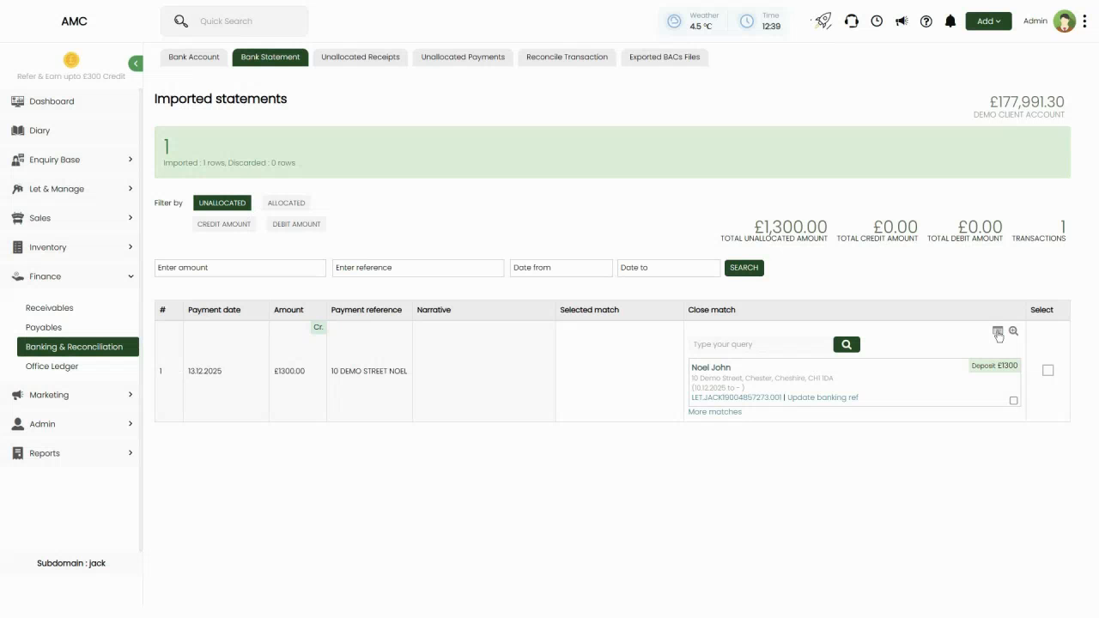
Figure 1: Imported statements page showing 1 row imported (1 new, 0 discarded). Balance displayed: £177,991.30 for Demo Client Account. The green status bar confirms '1 imported - 1 rows, Discarded - 0 rows'. Tabs at top: Bank Account, Bank Statement, Unallocated Receipts, Unallocated Payments
Step 2: Filter to Show Unallocated Transactions
Click the Bank Statement tab if not already selected. Use the Filter by dropdown and select UNALLOCATED. This will show only transactions that have not yet been matched to any invoice, receipt, or deposit. You'll see a list with columns: # (row number), Payment date, Amount, Payment reference, Narrative, Selected match, Close match, and Select.
In the Amount column, transactions are marked with 'Cr' (Credit - money in) or 'Dr' (Debit - money out). Deposit receipts will always be credits.
Figure 2: Bank Statement list filtered to UNALLOCATED showing one transaction: £1300.00 (Cr) dated 13.12.2025, payment reference '10 DEMO STREET NOEL', with a 'Selected match' card showing 'Noel John' at '10 Demo Street, Chester, Cheshire, CH1 1DA' and a 'Deposit £1300' label. 'Type your query' search box visible in Close match column
📌 Note: The system automatically searches for matching records and suggests them in the 'Selected match' column. In this example, it has identified Noel John's tenancy at 10 Demo Street as the most likely match for the £1300 deposit receipt.
Step 3: Open the Find and Allocate Dialog
Click anywhere on the transaction row (or click the green 'Cr' badge) to open the Find and allocate dialog. This dialog has multiple tabs at the top representing different allocation types. The tabs are: Due / Overdue Receivables, Pre-banked Receipts, Bank transfer, Map with a letting (Deposit return), Proceed as unallocated, Property receipt, Office income, and Offer Progression.
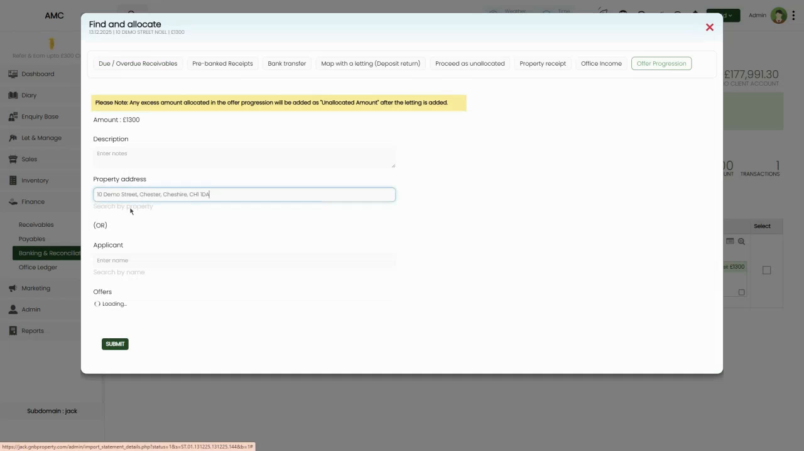
Figure 3: Find and allocate dialog opened for the £1300 transaction (13.12.2025 | 10 DEMO STREET NOEL). Tabs visible at top with 'Map with a letting (Deposit return)' tab active. Dialog shows: Amount (£1300), Description field, Property address search (10 Demo Street, Chester, Cheshire, CH1 1DA already entered), (OR) divider, Applicant name search, and Offers section showing '( ) Loading...'. Yellow warning banner at top: 'Please Note: Any excess amount allocated in the offer progression will be added as "Unallocated Amount" after the letting is added'. SUBMIT button at bottom
Step 4: Select the Map with a Letting (Deposit return) Tab
Click the 'Map with a letting (Deposit return)' tab. This tab is used specifically for allocating deposit receipts. The dialog will show fields for Amount (pre-filled with £1300), Description (optional notes), and search fields for either Property address or Applicant name.
If the system has already identified a match (as in the Selected match suggestion), the Property address field will be pre-filled. Otherwise, type the property address or applicant name to search for the correct tenancy.
📌 Note: The yellow warning banner explains that if the allocated amount exceeds the expected deposit for the selected letting, the excess will be added as an 'Unallocated Amount' — useful if a tenant has overpaid or if the receipt includes both deposit and first rent.
Step 5: Confirm the Property/Applicant and Submit
Verify that the correct property address and applicant are selected. The Offers section below will show any pending lettings or applications for that property. If the letting has already been set up, it will appear here and you can select it. If not, the system will still allow you to allocate the deposit to the property.
Click the green SUBMIT button at the bottom of the dialog. The system will allocate the £1300 bank receipt to the deposit record for that tenancy, moving the transaction from 'unallocated' to 'allocated' status.
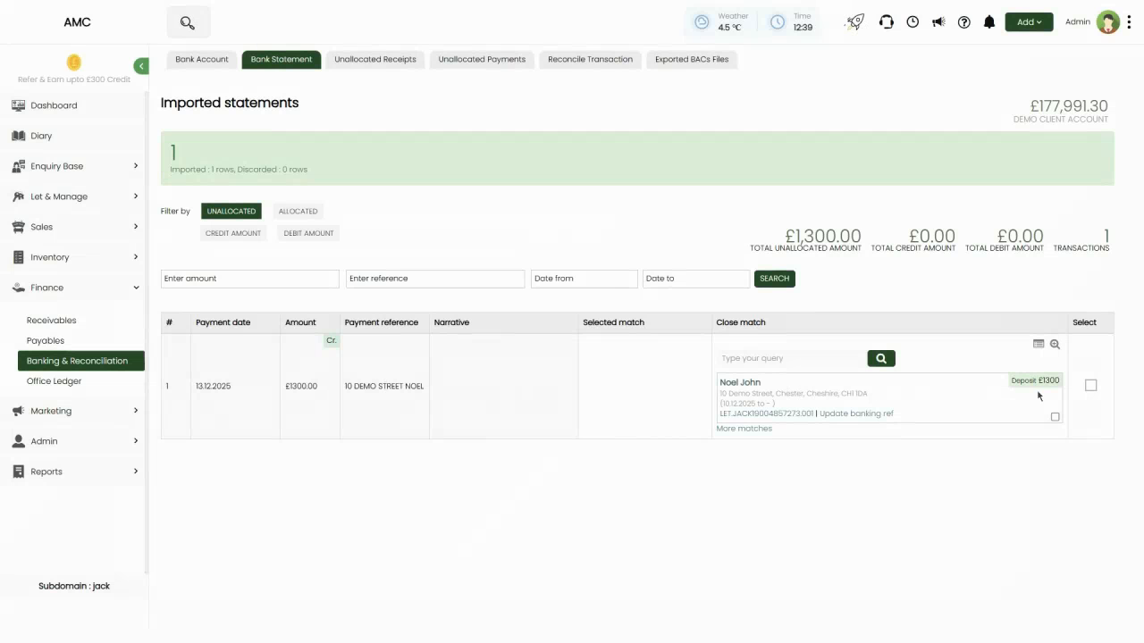
Figure 4: Returned to Bank Statement page after allocation. The transaction is no longer visible because it has been allocated and the filter is still set to UNALLOCATED. Notice 'Allocating 1/1' indicator in top-right, confirming the allocation was processed
📌 Note: After submission, you'll be returned to the Bank Statement page. Since your filter is set to UNALLOCATED, the newly allocated transaction will disappear from the list — this is expected and confirms the allocation was successful.

Workflow 2: Add Deposit Receipt from Receivables
If you know a deposit is due and want to record its receipt without waiting for the bank statement import (or if the deposit has been paid but hasn't appeared in the statement yet), you can add the receipt directly from the Receivables page. This is particularly useful for deposits that have been paid in advance or recorded in a scheduled receivable.
Step 1: Navigate to Finance → Receivables
From the left-hand menu, click Finance → Receivables. At the top of the page, you'll see tabs: Scheduled Receivables, Rent Arrears, Advance Payments, and Pre Banked Receipts. Click Scheduled Receivables.
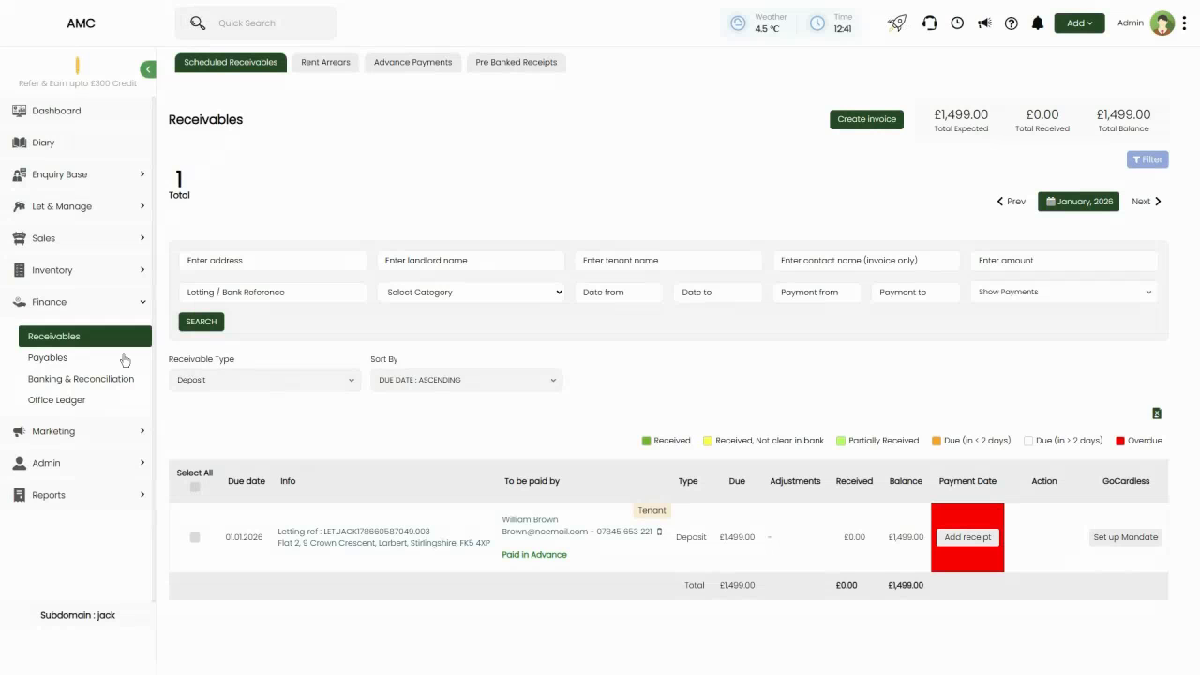
Figure 5: Receivables page showing Scheduled Receivables tab selected. Header shows Total Expected £1,499.00, Total Received £0.00, Total Balance £1,499.00, and 1 Total receivable. Filters include Receivable Type dropdown (currently set to 'Deposit'), search fields for address/landlord/tenant/contact/listing reference, date range pickers, and payment from/to dropdowns. One deposit row visible: William Brown (Tenant) for 'Flat 2, 9 Crown Crescent, Lorbett, Birlingshire' due 01.01.2026, last payment 02.01.2026, balance £1499.00, with red 'Paid in Advance' badge and green 'Add receipt' button
Step 2: Filter to Show Deposits
Use the Receivable Type dropdown and select 'Deposit' to show only deposit receivables. The list will update to show properties with outstanding deposit receivables. Each row shows the tenant name, property address, due date, last payment date, balance, and an 'Add receipt' button.
📌 Note: The 'Paid in Advance' badge (red) indicates that this deposit has already been received but not yet formally recorded in the system. This is common when tenants pay before the official start date of their tenancy.
Step 3: Click Add Receipt
Find the deposit you want to record and click the green 'Add receipt' button in the Action column. This opens the Add receipt dialog.
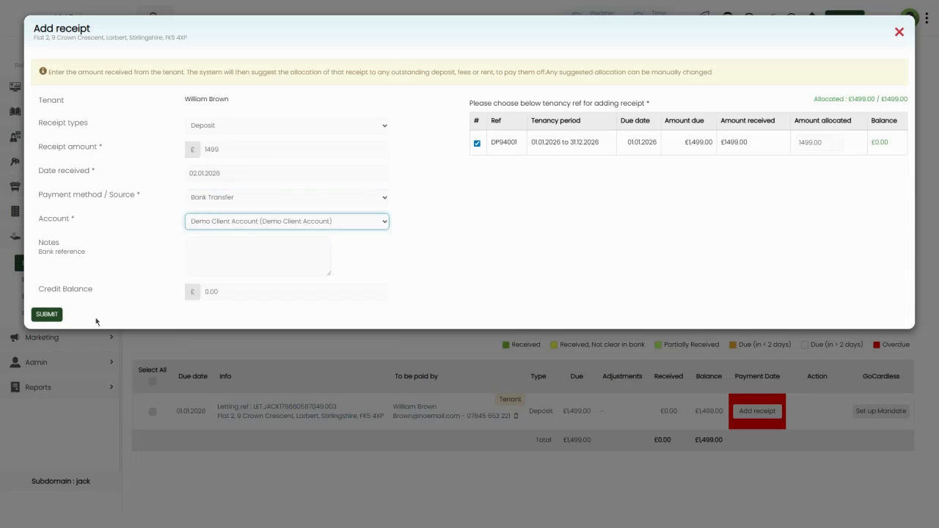
Figure 6: Add receipt dialog for William Brown's deposit (Flat 2, 9 Crown Crescent). Shows tenant info at top with 'Please choose below tenancy's ref for adding receipt' instruction. Allocated summary: £1499.00 / £1499.00. Dialog fields include: Receipt types dropdown (Deposit selected), Receipt amount £1499, Date received (02.01.2026), Payment method / Source (Bank Transfer), Account (Demo Client Account [Demo Client Account]), Notes field (Bank reference), and Credit Balance field (£0.00). One deposit row shown in table: # (checkbox ticked), Ref (DF94031), Tenancy period (01.01.2026 to 31.12.2026), Date done (01.01.2026), Amount due (£1499.00), Amount received (£1499.00), Amount allocated (£1499.00), Balance (£0.00). SUBMIT button at bottom
Step 4: Fill in the Receipt Details
The dialog will show the tenant's name and the receivable reference. Fill in the following fields:
- Receipt types — This should already be set to 'Deposit'. Leave it as is.
- Receipt amount — Enter the amount received (e.g. £1499). In this example, it's pre-filled because the tenant paid the full amount.
- Date received — Enter the date the deposit was received (e.g. 02.01.2026).
- Payment method / Source — Select the payment method (e.g. Bank Transfer, Cash, Cheque, etc.).
- Account — Select which bank account the deposit was paid into (e.g. Demo Client Account).
- Notes — Optional field for any additional information like the bank reference number.
- Credit Balance — This will show £0.00 if the full amount is being allocated. If you're recording a partial receipt, any remaining balance will show here.
Below these fields, you'll see a table showing the deposit receivable with its reference, tenancy period, due date, amount due, amount received, amount allocated, and balance. The checkbox next to the deposit should be ticked, indicating that this receipt will be allocated to this specific deposit.
📌 Note: The 'Allocated: £1499.00 / £1499.00' summary at the top confirms that you're allocating the full receipt amount to the outstanding deposit. If there were multiple deposits or the amount didn't match exactly, you could adjust the allocation here.
Step 5: Submit the Receipt
Review all the details to ensure accuracy. Once satisfied, click the green SUBMIT button at the bottom of the dialog. The system will record the receipt, allocate it to the deposit, and update the receivable status to show that the deposit has been received in full. The tenant's balance will now be £0.00 for this deposit.

Alternative: Add Deposit Directly from Property Page
Another way to record a deposit is to add it directly from the property's tenancy page. This is useful when you're already viewing a property's details and want to quickly record a deposit receipt without navigating through the banking or receivables sections.
Step 1: Navigate to the Property Page
From the left-hand menu, click Let & Manage → Properties. Find and click the property for which you want to record a deposit. This will open the property's detail page showing the property address, rental amount, and tenancy information.
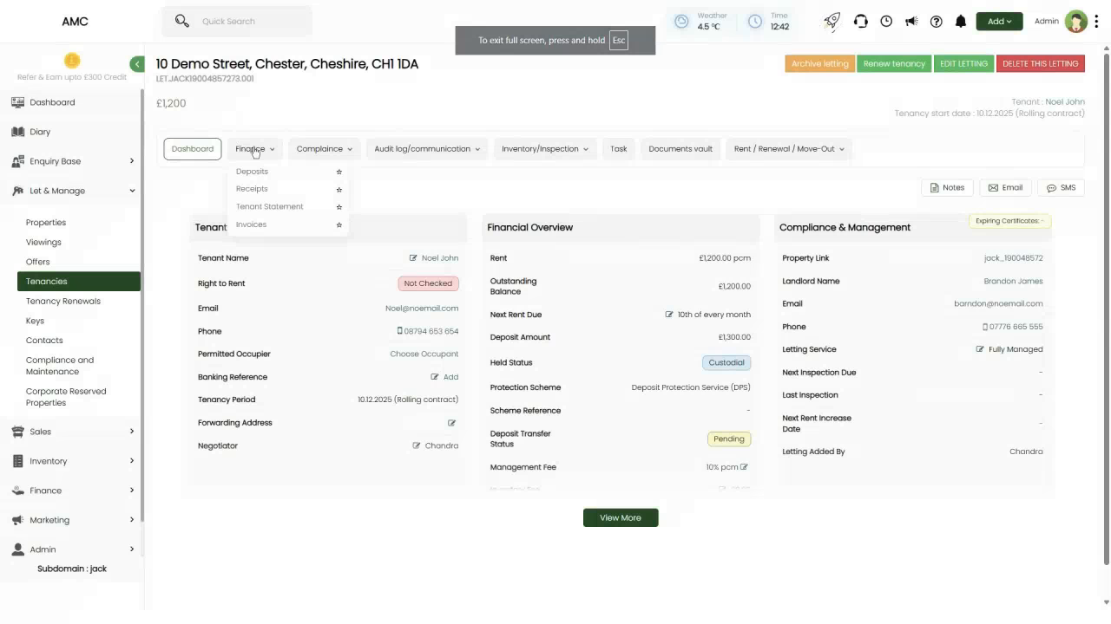
Figure 7: Property page for '10 Demo Street, Chester, Cheshire, CH1 1DA' (letting reference LET.JACK100048577273.001). Header shows property is 'FLAT FOR RENT' with tenancy status 'Managing Letting' and rent £1,200 pcm. Left sidebar shows menu items: Dashboard, Finance (with dropdown showing Deposits, Receipts, Tenant Statement, Invoices), Compliance, and other sections. Main content area displays Tenant section with Noel John (Right to Rent: Not Checked, Email: Noel@snoemail.com, Phone: 08704 653 654), Financial Overview showing Rent £1,200.00 pcm, Outstanding Balance £1,200.00, Deposit Amount (blank), Next Rent Due (12th of every month), Held Status (blank), Management Fee 10% pcm, and Compliance & Management section showing Property Link, Landlord Name (Brandon James), Email, Phone, Letting Service (Fully Managed), inspection due dates, letting details
Step 2: Click Finance Dropdown and Select Deposits
In the left sidebar menu, find the Finance section and click the dropdown arrow next to it. A submenu will appear with options: Deposits, Receipts, Tenant Statement, and Invoices. Click Deposits.
📌 Note: The Finance dropdown is located in the left sidebar when viewing an individual property page. This is different from the main Finance menu in the top-level navigation.
Step 3: Click the Add Deposit Button
The Deposits page will load showing the 'Request Rent and Deposit' section at the top. Look for a button or dialog trigger to add a deposit. In some cases, there may be an 'Add Deposit' button visible directly on the page. Click it to open the Add Deposit dialog.
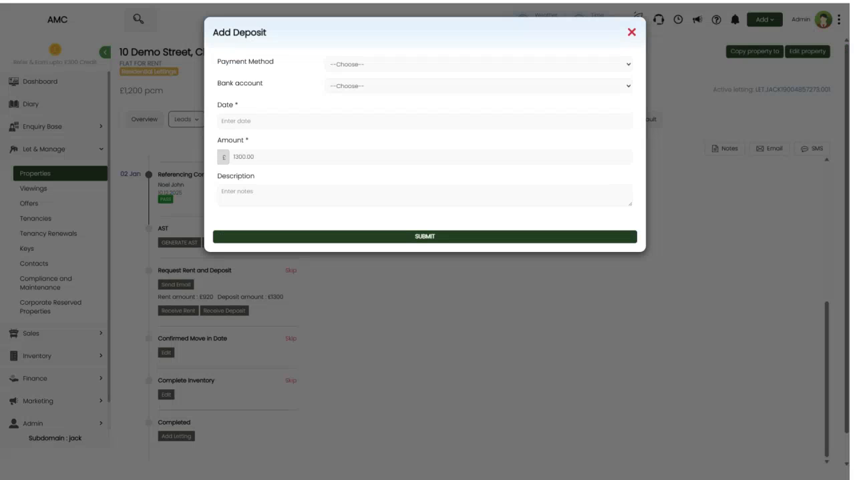
Figure 8: Add Deposit dialog displayed over property page showing 'Request Rent and Deposit' section. Dialog shows: Payment Method dropdown (--Choose--), Bank account dropdown (--Choose--), Date field (Enter date), Amount field (£1300.00), Description textarea (Enter notes). Green SUBMIT button at bottom. Background shows property reference 'LET.JACK100048577273.001', AST section with 'GENERATE HELD...' button, and 'Confirmed Move-in Date', 'Complete Inventory', and 'Completed' sections with 'Skip' buttons
Step 4: Fill in the Deposit Details
The Add Deposit dialog will have the following fields:
- Payment Method — Select how the deposit was paid (e.g. Bank Transfer, Cash, Cheque).
- Bank account — Select which bank account the deposit was paid into.
- Date — Enter the date the deposit was received.
- Amount — Enter the deposit amount (e.g. £1300.00).
- Description — Optionally add any notes about the deposit (e.g. 'Bank reference: XYZ123').
Fill in all required fields with the correct information. Make sure the amount matches what was actually received from the tenant.
Step 5: Submit the Deposit
Click the green SUBMIT button. The system will record the deposit, link it to this property and tenancy, and add it to the overall deposit tracking. The property page will update to show that the deposit has been received, and you'll be able to see it listed on the Deposits page and in the tenant's financial records.

Managing and Transferring Deposits
Once deposits have been recorded in the system, you can view them all in one place and manage their transfer to deposit protection schemes. This is done from the Deposits page under Finance → Payables.
Step 1: Navigate to the Deposits Page
From the left-hand menu, click Finance → Payables. At the top of the page, you'll see multiple tabs. Click the Transfer Deposit tab.
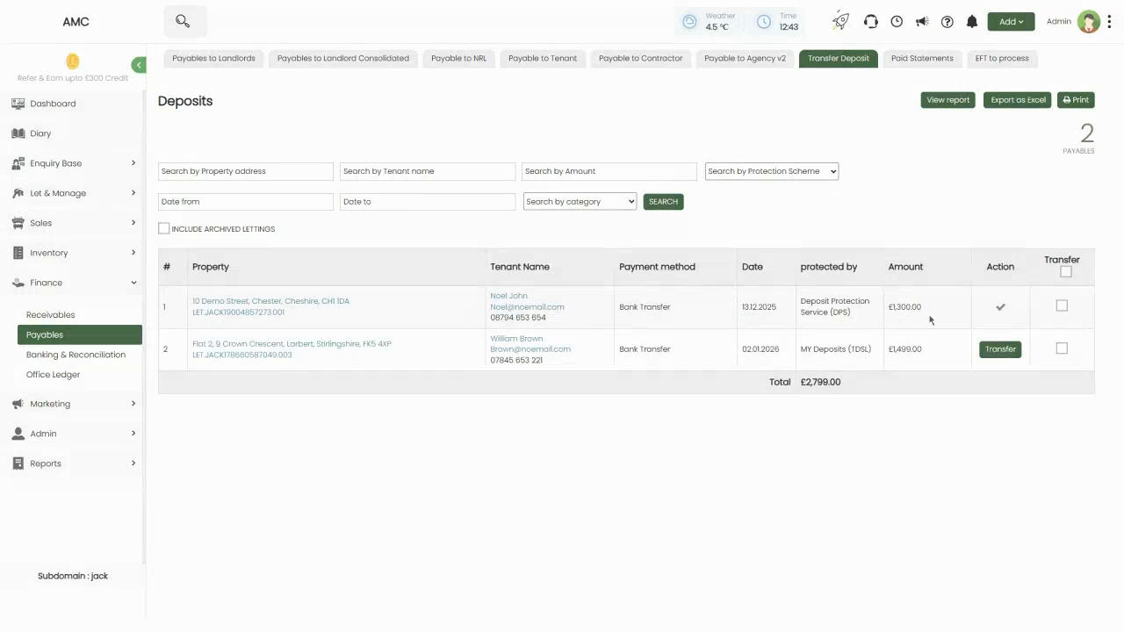
Figure 9: Deposits page (Transfer Deposit tab) showing 2 deposits listed with header showing '2 PAYABLES' and total of £2,799.00. Table columns: # (row number), Property, Tenant Name, Payment method, Date, protected by (protection scheme name), Amount, Action, and Transfer checkbox. Row 1: 10 Demo Street (Noel John, Bank Transfer, 13.12.2025, Deposit Protection Service (DPS), £1,300.00, checkmark in Action column). Row 2: Flat 2, 9 Crown Crescent (William Brown, Bank Transfer, 02.01.2026, MY Deposits (TDS), £1,499.00, green 'Transfer' button). Search filters at top: property address, tenant name, amount, protection scheme dropdown, date range, category dropdown, with SEARCH button. Top-right buttons: View report, Export as Excel, Print
Step 2: Review the Deposits List
The Deposits page shows all deposits currently held by the agency. Each row displays:
- Property — The property address where the tenant is residing.
- Tenant Name — The tenant's name along with their contact details (email and phone).
- Payment method — How the deposit was paid (e.g. Bank Transfer).
- Date — The date the deposit was received.
- protected by — The deposit protection scheme that will safeguard this deposit (e.g. Deposit Protection Service (DPS) or MY Deposits (TDS)). This is set up in the tenancy details.
- Amount — The deposit amount.
- Action — May show a checkmark if the deposit is already protected, or action buttons like 'Create Deposit ID' if scheme registration is pending.
- Transfer — A checkbox to select this deposit for transfer, or a green 'Transfer' button to initiate the transfer process.
Use the search and filter options at the top to find specific deposits by property address, tenant name, amount, protection scheme, date range, or category.
Step 3: Transfer a Deposit to the Protection Scheme
To transfer a deposit to its designated protection scheme account, click the green 'Transfer' button in the row for that deposit. This opens the Transfer dialog.
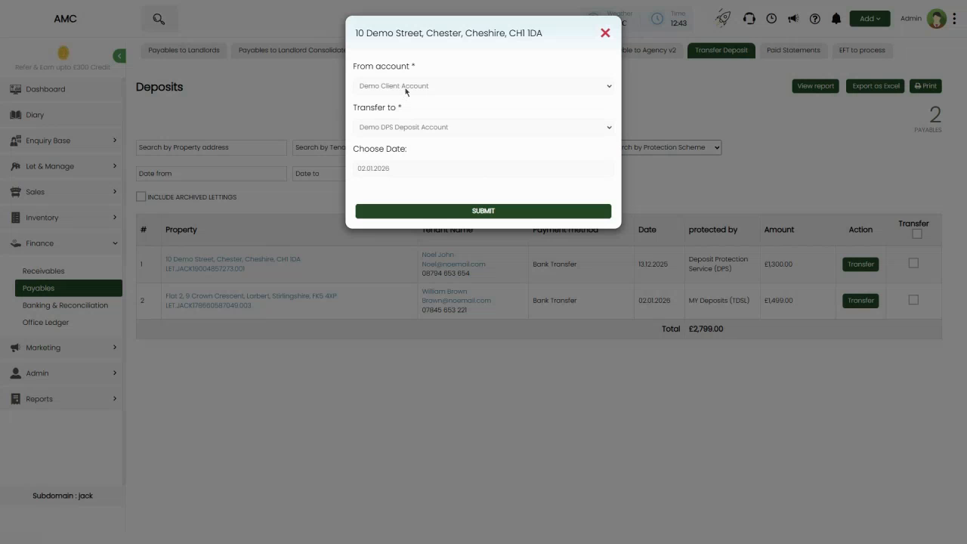
Figure 10: Transfer deposit dialog for '10 Demo Street, Chester, Cheshire, CH1 1DA' showing: From account dropdown (Demo Client Account selected), Transfer to dropdown (Demo DPS Deposit Account selected), Choose Date field (02.11.2026), and green SUBMIT button at bottom
The dialog will show:
- From account — The client account where the deposit is currently held (e.g. Demo Client Account).
- Transfer to — The deposit protection scheme account where the deposit will be moved (e.g. Demo DPS Deposit Account for Deposit Protection Service schemes, or similar for MY Deposits/TDS).
- Choose Date — The date of the transfer. This is typically today's date but can be adjusted if needed.
Review the details to ensure you're transferring the correct deposit to the correct scheme account. Then click the green SUBMIT button.
📌 Note: This action moves the deposit funds from your general client account to the designated protection scheme account in your accounting records. You must still complete the actual registration with the protection scheme itself (online via their portal) and provide the tenant with the prescribed information about their deposit protection.
Step 4: View Deposit Reports and Export Data
The Deposits page has several useful buttons in the top-right corner:
- View report — Opens a detailed report showing all deposit transactions, including receipts, transfers, and current status for each property.
- Export as Excel — Downloads the full deposits list as an Excel spreadsheet for external reporting or analysis.
- Print — Generates a printable version of the deposits list.
Use these tools to maintain accurate records of all deposits held by your agency, track which deposits have been protected, and generate reports for audits or internal reviews.
Step 5: Additional Deposit Actions
Depending on the deposit's status, you may see additional action buttons:
- Create Deposit ID — Appears when a deposit needs to be registered with the protection scheme. Click this to enter the deposit ID provided by the scheme after you've registered the deposit online.
- MarkTransfer — Used to manually mark a deposit as transferred if the transfer was completed outside the system (e.g. via direct bank transfer not recorded in the CRM).
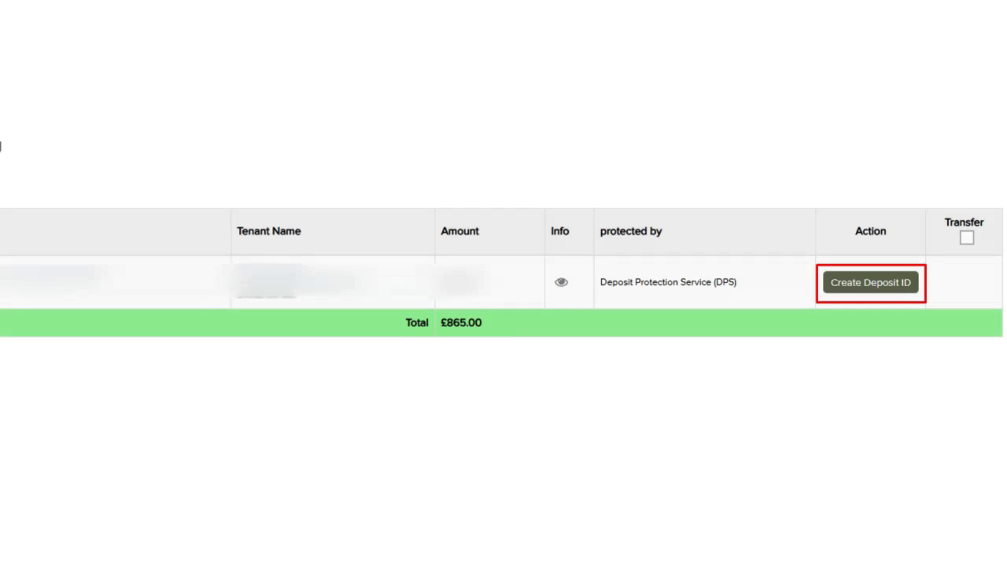
Figure 11: Close-up view of deposit row showing 'Create Deposit ID' button highlighted with red border and 'MarkTransfer' button visible. Total row shows £865.00 in green highlight bar. Table headers: Tenant Name, Amount, Info, protected by (Deposit Protection Service (DPS)), Action, Transfer checkbox
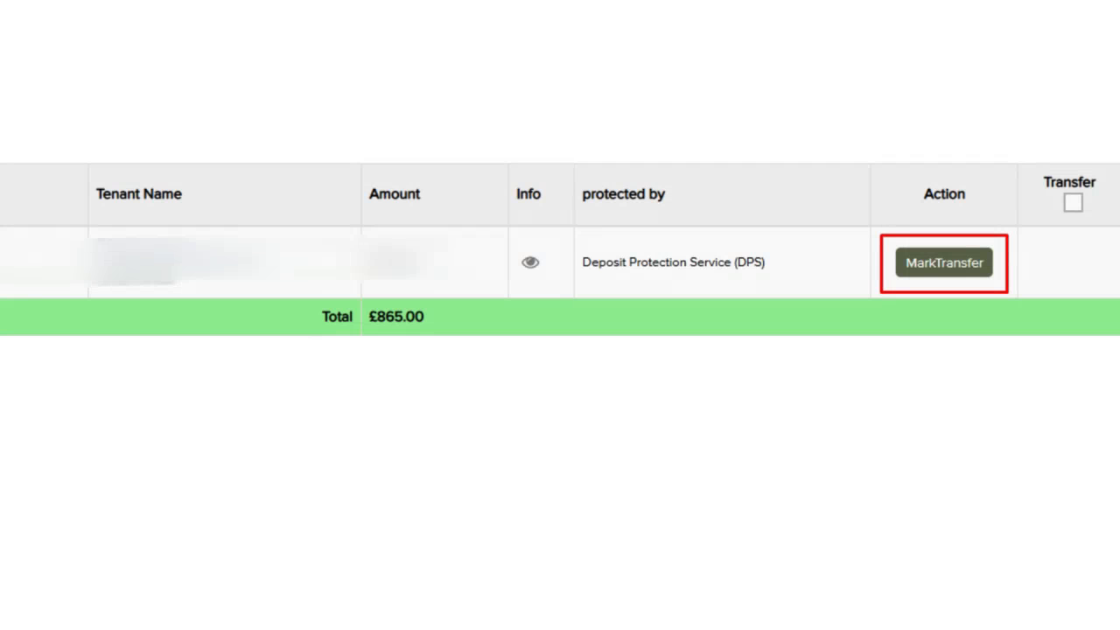
Figure 12: Alternate view showing 'MarkTransfer' button highlighted with red border in the Action column
📌 Note: Always ensure deposits are protected within the legal timeframes (typically 30 days from receipt in England and Wales). Failure to protect deposits on time can result in significant penalties and prevent landlords from serving Section 21 notices.

Quick Access: Deposits from Payables to Landlords
You can also access the Deposits page quickly from the main Payables navigation. When viewing the Payables to Landlords page, notice the tab navigation at the top includes a 'Transfer Deposit' tab alongside 'Payables to Landlords', 'Payable to NRL', 'Payable to Tenant', etc. Clicking this tab takes you directly to the same Deposits page described above.
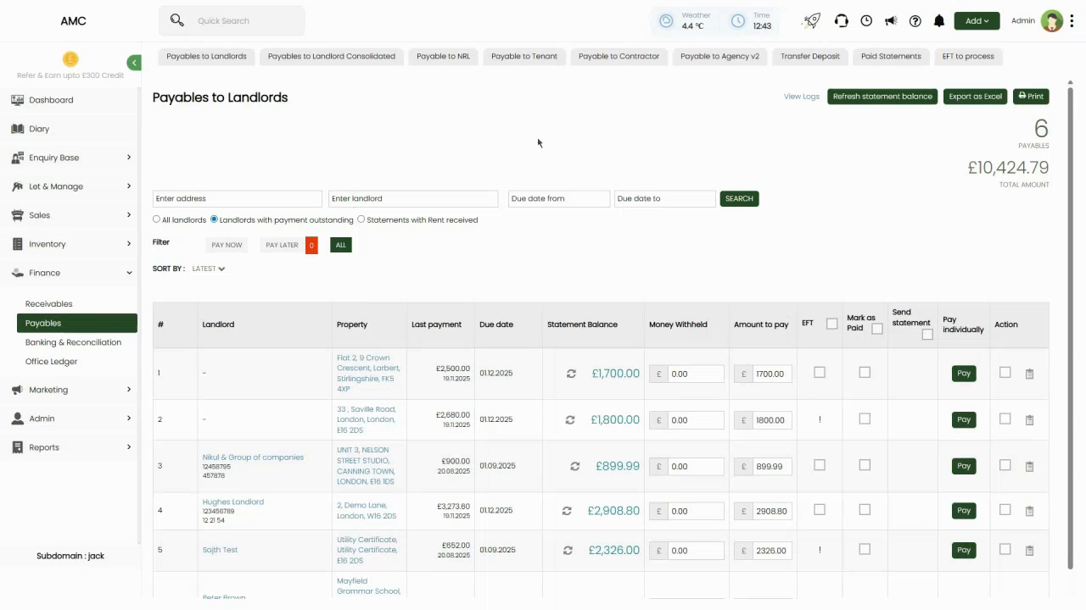
Figure 13: Payables to Landlords page showing tab navigation at top. Tabs visible include: Payables to Landlords (current), Payables to Landlord Consolidated, Payable to NRL, Payable to Tenant, Payable to Contractor, Payable to Agency v2, Transfer Deposit (highlighted), Paid Statements, EFT to process. The Transfer Deposit tab provides quick access to the deposits management page from within the Payables section
📌 Note: This is particularly convenient when you're already working in the Payables section and need to quickly check or transfer deposits without navigating through multiple menus.

Quick Reference Summary
Topic | Detail
Where to navigate | Finance → Banking & Reconciliation → Bank Statement tab → Click transaction row → Find and allocate dialog OR Finance → Receivables → Scheduled Receivables (for deposits)
Two main workflows | (1) Allocate unallocated bank receipt to deposit via 'Map with a letting (Deposit return)' tab. (2) Add deposit directly from property via 'Add Deposit' button
Bank statement allocation | From Banking & Reconciliation → Bank Statement, filter UNALLOCATED transactions, click 'Cr' (Credit) on a deposit receipt, select 'Map with a letting (Deposit return)' tab, choose property/applicant, submit
Add deposit from property | Navigate to property page → Finance dropdown → Deposits → Click 'Add Deposit' → Fill Payment Method, Bank account, Date, Amount, Description → SUBMIT
Add receipt from receivables | Finance → Receivables → Select deposit receivable → 'Add receipt' button → Fill amount, date, payment method, account, notes → Auto-allocates to deposit → SUBMIT
Deposits page | Finance → Payables → Transfer Deposit tab — lists all held deposits with tenant name, payment method, date, protection scheme, amount, Transfer/Action buttons
Transfer deposit | From Deposits page, click green 'Transfer' button → Dialog appears with From account (Demo Client Account), Transfer to (Demo DPS Deposit Account), Choose Date → SUBMIT
Protection scheme | Each deposit shows which scheme protects it (e.g. 'Deposit Protection Service (DPS)' or 'MY Deposits (TDS)'). Set up in tenancy details.
Deposit ID creation | Some deposits show 'Create Deposit ID' button if scheme registration pending. Click to open deposit ID entry dialog for scheme registration.
Mark as transferred | Some deposits may show 'MarkTransfer' button for manual marking of transfers already completed outside the system
View report | Click 'View report' button (top-right of Deposits page) to see detailed deposit report with all transactions
Export as Excel | Click 'Export as Excel' to download deposit list for external reporting

