CRM Guide: Office Ledger
Finance → Office Ledger
A step-by-step visual guide to recording agency income and expenses using nominal codes

Overview
The Office Ledger is where you record all financial transactions that relate to the agency itself — as opposed to client or property transactions. This includes income the agency receives directly (such as bank interest, referral fees, or office rent from sub-letting) and expenses the agency pays (such as office rent, utilities, software subscriptions, marketing costs, and professional fees).
Unlike the other financial modules that deal with landlord payments, tenant receipts, or contractor invoices, the Office Ledger is purely for the agency's own operational income and expenses. Each entry is categorized using a nominal code (also called an account code) which helps organize the ledger for accounting and reporting purposes.
The Office Ledger provides a complete audit trail of all agency financial activity, with filtering, searching, editing, and exporting capabilities. It displays four key summary figures at the top: the Demo Client Account balance, the Demo Agency Account balance, the total credit (income), and the total debit (expenses).

Accessing the Office Ledger
Step 1: Navigate to Finance → Office Ledger
From the left-hand menu, click Finance to expand the Finance submenu. You'll see several options including Receivables, Payables, Banking & Reconciliation, and Office Ledger. Click Office Ledger.
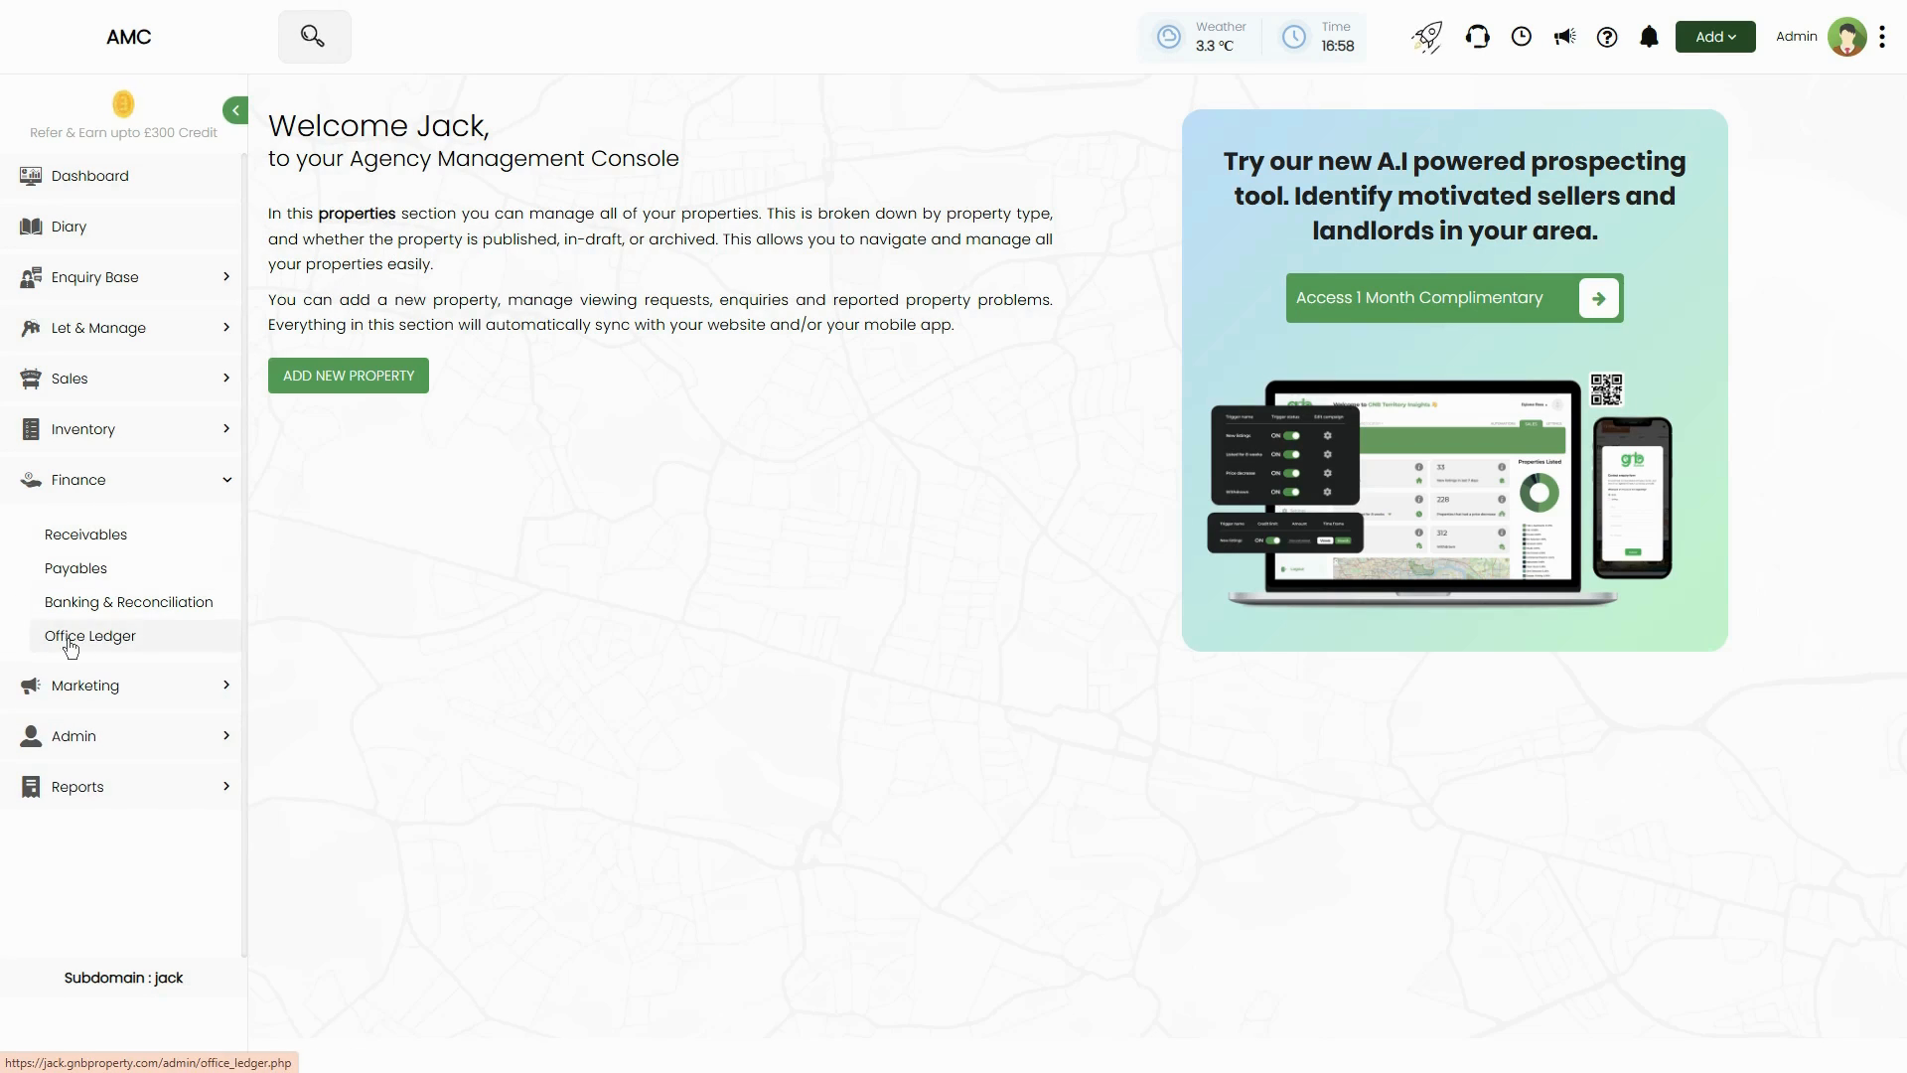
Figure 1: Finance menu expanded showing Office Ledger option in the left sidebar. Other visible options include Receivables, Payables, Banking & Reconciliation, and Office Ledger highlighted. The main dashboard area shows the properties section welcome message on the right
Step 2: Understand the Office Ledger Page Layout
Once the Office Ledger page loads, you'll see:
- Tab navigation at the top with 'Office Ledger' (current) and 'Payables to Office Expenses' tabs.
- Four summary boxes showing: £178,791.30 (DEMO CLIENT ACCOUNT), £73,405.16 (DEMO AGENCY ACCOUNT), £1,095.00 (TOTAL CREDIT), and £48,107.98 (TOTAL DEBIT). A results counter on the right (e.g. '64 RESULTS').
- Filter bar with date range pickers (From date / To date), Show buttons (CREDIT / DEBIT / ALL), and SORT BY dropdown (default: DATE - DESCENDING).
- Additional search fields: Nominal Code, Amount, Search by Contractor name, Search by title or description, and bank dropdown (---Choose bank---).
- Action buttons in the top-right: 'Add Income' (green), 'Add Expense' (green), 'Manage Nominal codes' (green), 'Export', and 'Print' (printer icon).
- Main table listing all ledger entries with columns: # (row number), Date, Nominal Code, Title, Description, Credit (income amounts), Debit (expense amounts), VAT Included, Attachments, Account, and Action (edit/delete icons).
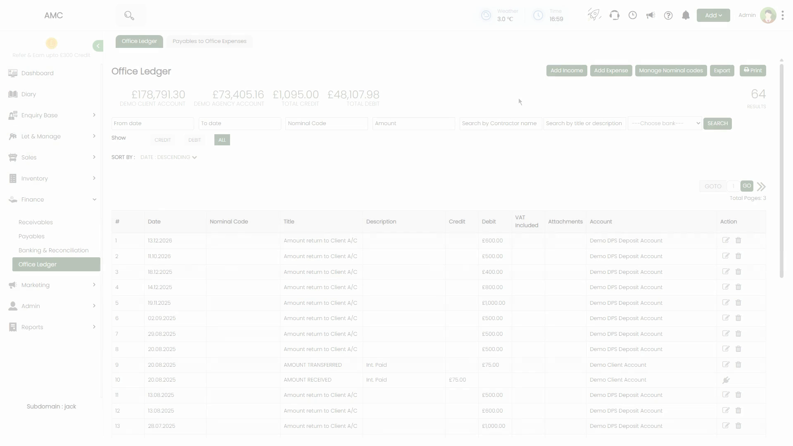
Figure 2: Office Ledger page showing the four summary boxes at top (£178,791.30 DEMO CLIENT ACCOUNT, £73,405.16 DEMO AGENCY ACCOUNT, £1,095.00 TOTAL CREDIT, £48,107.98 TOTAL DEBIT) and '64 RESULTS' count. Filter bar below with date pickers, Show buttons (CREDIT/DEBIT/ALL), and SORT BY dropdown. Action buttons visible top-right: Add Income, Add Expense, Manage Nominal codes, Export, Print. Main table shows entries with date, nominal code, title, description, credit/debit amounts, VAT, attachments, account, and action icons
📌 Note: The Demo Client Account and Demo Agency Account balances represent the total funds held in each account across all transactions recorded in the system. Total Credit is the sum of all income entries, and Total Debit is the sum of all expense entries in the Office Ledger.

Understanding and Managing Nominal Codes
Nominal codes (also called account codes or chart of accounts codes) are the categorization system used to organize income and expenses. Each type of transaction is assigned a specific code. For example, 'Bank Gross Interest' might be code 1000, while 'Electricity' might be code 7200. Using consistent nominal codes makes it easy to run reports, analyze spending patterns, and prepare accounts.
Step 1: View Existing Nominal Codes
To see all the nominal codes currently set up in your system, click the 'Manage Nominal codes' button (green button in the top-right action area). This opens the Manage Nominal codes dialog.
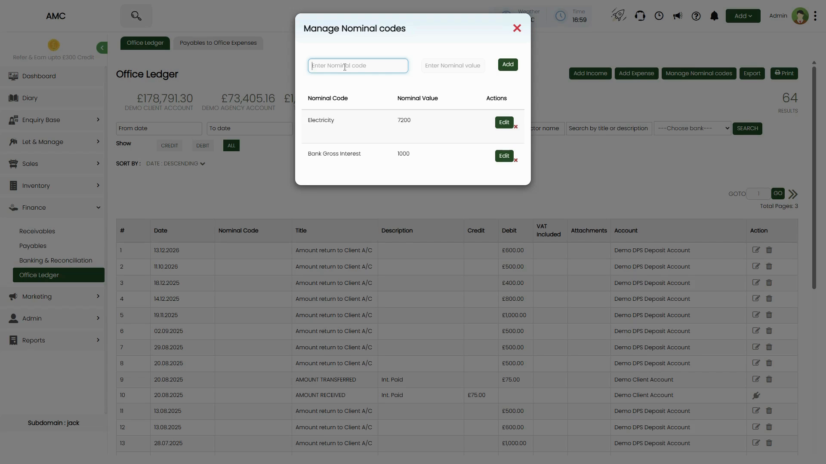
Figure 3: Manage Nominal codes dialog showing 'Enter Nominal code' search field at top with 'Enter Nominal value' field and green 'Add' button. Table below displays columns: Nominal Code, Nominal Value, Actions. Two example codes shown: 'Electricity' (7200) with Edit button and 'x' delete icon, and 'Bank Gross Interest' (1000) with Edit button and 'x' delete icon. Background shows Office Ledger page with summary figures and filter bar
Step 2: Add a New Nominal Code
The dialog has fields at the top to add a new code:
- Enter Nominal code — Type a descriptive name for the new category (e.g. 'Internet Service', 'Marketing Costs', 'Referral Income').
- Enter Nominal value — Type the numeric code you want to assign (e.g. 7300, 8100, 1500). Most accounting systems use standard number ranges: 1000-1999 for income, 7000-9999 for expenses, etc.
After filling in both fields, click the green 'Add' button. The new nominal code will be added to the list below and will be available when adding income or expense entries.
Step 3: Edit or Delete Nominal Codes
In the table below the add fields, you'll see all existing nominal codes with their values and action buttons:
- Edit — Click the green 'Edit' button to modify the code name or value.
- Delete (x icon) — Click the 'x' to remove a nominal code. Be cautious when deleting codes that have already been used in ledger entries, as this may affect historical records.
After making any changes, close the dialog by clicking the 'X' in the top-right corner. Your changes will be saved automatically.

Adding Income to the Office Ledger
Income entries represent money received by the agency directly. This could be bank interest earned on your accounts, referral fees from other agencies or service providers, office space rental income if you sub-let part of your premises, or any other miscellaneous income.
Step 1: Click the Add Income Button
In the top-right action area of the Office Ledger page, click the green 'Add Income' button. This opens the Add Income dialog.
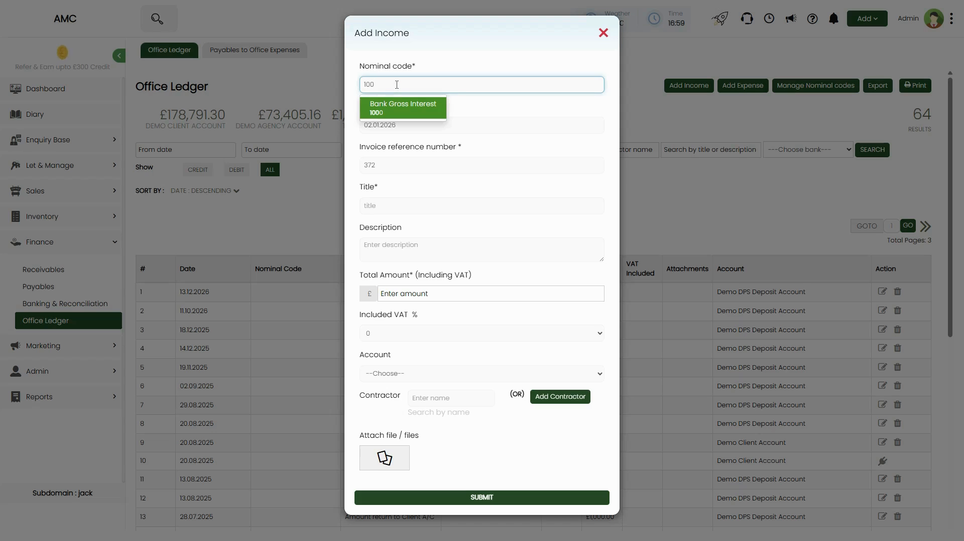
Figure 4: Add Income dialog opened showing: Nominal code field with '100' entered and 'Bank Gross Interest 1000' dropdown suggestion highlighted in green showing date '02.01.2026'. Fields below include: Invoice reference number (372), Title (title), Description (Enter description textarea), Total Amount* (Including VAT) with £ symbol and 'Enter amount' placeholder, Included VAT % dropdown (0 selected), Account dropdown (--Choose--), Contractor field with 'Enter name' placeholder, 'Search by name' text, and green 'Add Contractor' button, Attach file / files section with upload icon, and green SUBMIT button at bottom. Background shows Office Ledger page with transaction list
Step 2: Select or Enter the Nominal Code
The first field is 'Nominal code*' (required). Start typing the code number or the name of the income category you want to use. As you type, a dropdown will appear showing matching nominal codes. For example, typing '100' might show 'Bank Gross Interest 1000' with its associated date.
Select the appropriate code from the dropdown. If the code you need doesn't exist yet, close this dialog, click 'Manage Nominal codes' to add it, then return to the Add Income dialog.
📌 Note: The green highlighted suggestion box shows the nominal code name, its numeric value, and the date it was created. This helps you confirm you're selecting the correct category.
Step 3: Fill in the Income Details
Complete the following fields:
- Date* — The date this income was received (default: 02.01.2026, but change to the actual date). This field appears after selecting the nominal code.
- Invoice reference number* — An internal reference number for this income entry (e.g. 372). This helps track individual transactions.
- Title* — A short title for this income (e.g. 'Bank Interest', 'Referral Fee from ABC Agency').
- Description — Optional longer description with any additional details about this income.
- Total Amount* (Including VAT) — The full amount received, including any VAT. Enter the amount in pounds (the £ symbol is pre-filled).
- Included VAT % — Select the VAT rate from the dropdown (0%, 5%, 20%, etc.). If no VAT applies, leave it at 0.
- Account — Select which bank account this income was received into (e.g. Demo Client Account, Demo Agency Account). Use the dropdown to choose.
- Contractor — Optional. If this income is associated with a specific contractor or entity, search for their name or click 'Add Contractor' to create a new contractor record.
- Attach file / files — Optional. Click the upload icon to attach any supporting documents (invoices, bank statements, receipts, etc.).
Step 4: Submit the Income Entry
Review all the details to ensure accuracy. Once satisfied, click the green 'SUBMIT' button at the bottom of the dialog. The income entry will be added to the Office Ledger, the Total Credit figure will increase by the entered amount, and the entry will appear in the main ledger table.
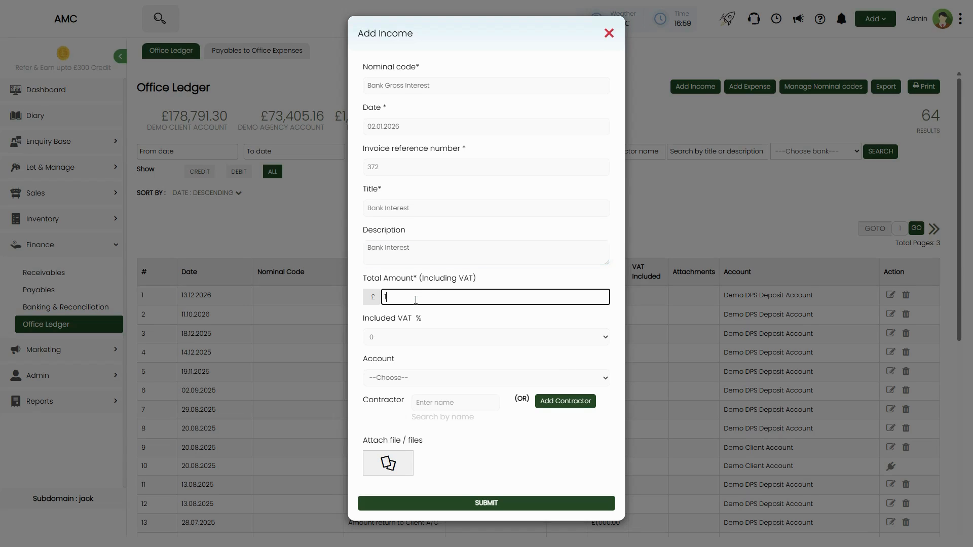
Figure 5: Add Income dialog with fields filled: Nominal code (Bank Gross Interest), Date (02.01.2026), Invoice reference number (372), Title (Bank Interest), Description (Bank Interest), Total Amount cursor in the '£ [ ]' field, Included VAT % (0), Account (--Choose--), Contractor section, and Attach file section. SUBMIT button ready to click

Adding Expenses to the Office Ledger
Expense entries represent costs paid by the agency for its own operations. Common expenses include office rent, utilities (electricity, water, gas, internet), office supplies and equipment, marketing and advertising costs, software subscriptions, professional fees (accountant, solicitor), staff expenses, and any other operational costs.
Step 1: Click the Add Expense Button
In the top-right action area of the Office Ledger page, click the green 'Add Expense' button. This opens the Add Expense dialog.
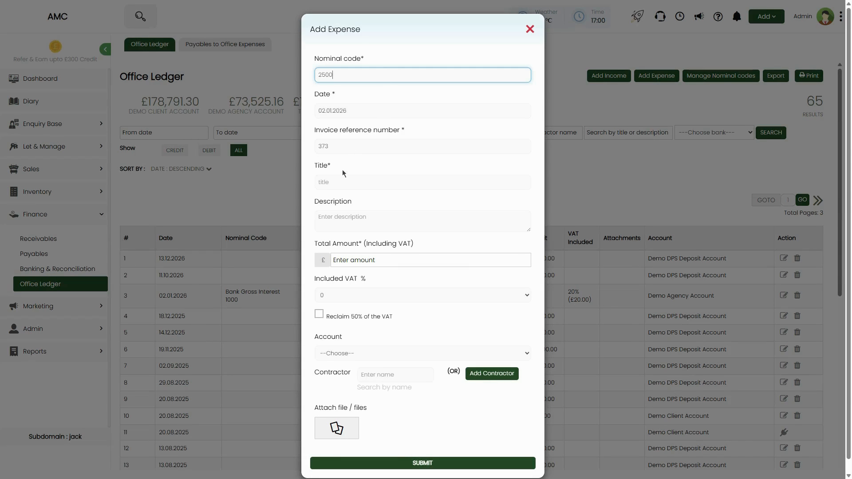
Figure 6: Add Expense dialog opened showing: Nominal code field with '2500' entered (no dropdown visible yet), Date (02.01.2026), Invoice reference number (373), Title field with 'title' placeholder, Description field (Enter description), Total Amount* (Including VAT) with £ 'Enter amount' placeholder, Included VAT % dropdown (0), checkbox for 'Reclaim 50% of the VAT', Account dropdown (--Choose--), Contractor field with 'Enter name' and 'Search by name' with green 'Add Contractor' button, Attach file / files section with upload icon, and green SUBMIT button at bottom. Background shows Office Ledger with transaction list visible
Step 2: Select or Enter the Nominal Code
The first field is 'Nominal code*' (required). Start typing the code number or the name of the expense category. For example, you might type '7200' for Electricity or search for 'Office Rent'. A dropdown will appear showing matching nominal codes as you type.
Select the appropriate expense code from the dropdown. If the code doesn't exist, close the dialog, add it via 'Manage Nominal codes', and return.
Step 3: Fill in the Expense Details
Complete all required fields:
- Date* — The date this expense was incurred or paid.
- Invoice reference number* — Internal reference for this expense (e.g. 373).
- Title* — Short title describing the expense (e.g. 'Monthly Electricity Bill', 'Office Rent - January').
- Description — Optional detailed description of the expense.
- Total Amount* (Including VAT) — The full cost including VAT. Enter the amount in pounds.
- Included VAT % — Select the VAT rate (usually 20% for UK business expenses, but can be 0%, 5%, or 20% depending on the type of expense).
- Reclaim 50% of the VAT — Tick this checkbox if your agency is entitled to reclaim half of the VAT paid on this expense (common for certain mixed-use expenses like vehicle costs). Leave unticked if you're reclaiming the full VAT amount or no VAT.
- Account — Select which account this expense was paid from (e.g. Demo Client Account, Demo Agency Account).
- Contractor — Optional. Search for or add the contractor/supplier who provided the service or goods.
- Attach file / files — Optional. Upload any invoices, receipts, or supporting documents.
Step 4: Submit the Expense Entry
Double-check all the information for accuracy. Click the green 'SUBMIT' button at the bottom of the dialog. The expense will be added to the Office Ledger, the Total Debit figure will increase by the entered amount, and the entry will appear in the ledger table with its debit amount displayed.
📌 Note: The VAT reclaim options help agencies correctly account for VAT they can recover from HMRC. Make sure you understand your agency's VAT status and which expenses qualify for VAT reclaim before ticking the reclaim box.

Viewing, Filtering, and Managing Ledger Entries
Once you've added income and expense entries, the Office Ledger page displays them all in a searchable, filterable table. You can review past transactions, search for specific entries, edit incorrect entries, or delete entries that were added by mistake.
Step 1: View the Ledger Table
The main ledger table shows all entries sorted by date (most recent first by default). Each row displays:
- # — Row number for easy reference.
- Date — The date the transaction occurred.
- Nominal Code — The category code and name (e.g. 'Bank Gross Interest 1000').
- Title — The short title of the transaction.
- Description — Additional details if provided.
- Credit — Income amounts appear in this column.
- Debit — Expense amounts appear in this column.
- VAT Included — Shows VAT percentage and calculated amount (e.g. '20% (£20.00)').
- Attachments — Icon if files are attached to this entry.
- Account — Which account this transaction was recorded in.
- Action — Edit (pencil icon) and Delete (trash can icon) buttons.
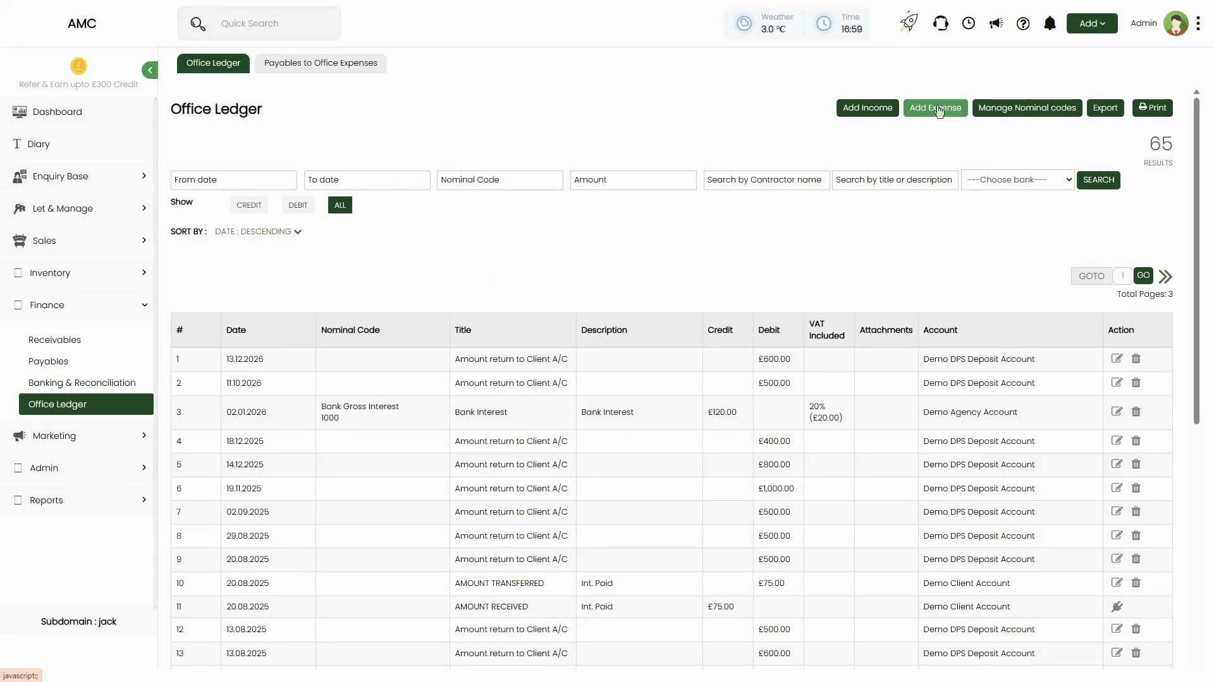
Figure 7: Office Ledger table showing multiple entries. Row 3 visible: Date 02.01.2026, Nominal Code 'Bank Gross Interest 1000', Title 'Bank Interest', Description 'Bank Interest', Credit £120.00, VAT Included '20% (£20.00)', Account 'Demo Agency Account'. Other rows show 'Amount return to Client A/C' with various debit amounts (£600.00, £500.00, £400.00, £800.00, £1,000.00, £500.00, etc.) in Demo DPS Deposit Account. Rows 10-11 show 'AMOUNT TRANSFERRED' and 'AMOUNT RECEIVED' with 'Int. Paid' description, Credit £75.00 and Debit £75.00 in Demo Client Account. Action column shows edit (pencil) and delete (trash) icons. Results count shows '65 RESULTS' top-right
Step 2: Use Filters to Find Specific Entries
The filter bar at the top of the ledger table helps you narrow down the list:
- Date range — Enter 'From date' and 'To date' to show only entries within a specific period.
- Show — Click CREDIT to see only income, DEBIT to see only expenses, or ALL to see everything.
- SORT BY — Change the sort order (default is DATE - DESCENDING, but you can sort by other fields).
- Nominal Code — Type a code number or name to filter by category.
- Amount — Enter an amount to find entries of that specific value.
- Search by Contractor name — Type a contractor's name to see all entries associated with them.
- Search by title or description — Type keywords to search within the title and description fields.
- ---Choose bank--- — Select a specific account to see only entries for that account.
After setting your filters, click the green 'SEARCH' button to apply them. The table will update to show only matching entries, and the results count will update accordingly.
Step 3: Edit an Existing Entry
If you need to correct or update an entry, find it in the ledger table and click the pencil icon in the Action column. This opens the Add Income or Add Expense dialog (depending on the entry type) with all the fields pre-filled with the current values.
Make your changes (e.g. correct the amount, update the date, change the nominal code, edit the description) and click SUBMIT. The entry will be updated in the ledger, and the summary figures will recalculate if you changed the amount.
⚠️ Important: When editing an entry, be careful not to change values that would affect reconciled accounts or reports that have already been exported. Always keep a record of why you made the edit for audit purposes.
Step 4: Delete an Entry
If an entry was added by mistake or needs to be removed, find it in the table and click the trash can icon in the Action column. A confirmation dialog will appear asking you to confirm the deletion.
Click 'Confirm' or 'Yes' to permanently delete the entry. The ledger will update immediately, removing the entry from the table and adjusting the Total Credit or Total Debit figures accordingly.
⚠️ Important: Deleting entries is permanent and cannot be undone. Only delete entries if you're certain they should not be in the ledger. If you're unsure, consider editing the entry instead or consulting with your accountant.

Exporting and Printing the Office Ledger
For reporting, accounting, or record-keeping purposes, you can export the entire Office Ledger to a spreadsheet file or generate a printable version.
Step 1: Export to Spreadsheet
Click the 'Export' button in the top-right action area. The system will generate a spreadsheet file (usually Excel format) containing all the ledger entries currently displayed (respecting any filters you've applied).
The file will download to your computer. You can then open it in Excel, Google Sheets, or any spreadsheet application to perform further analysis, create charts, or share with your accountant.
📌 Note: If you have filters applied when you export, only the filtered entries will be included in the export file. To export the complete ledger, make sure all filters are cleared and 'ALL' is selected before clicking Export.
Step 2: Print the Ledger
Click the printer icon button in the top-right action area. Your browser's print dialog will open with a formatted version of the ledger ready to print.
You can choose to print directly to a printer or save as a PDF file. Adjust print settings (page orientation, margins, scaling) as needed before printing.
📌 Note: The printed version will include all visible entries based on your current filters and sort order. To print the full ledger, clear all filters first.

Quick Reference Summary
Topic | Detail
Where to navigate | Finance → Office Ledger
Page purpose | Record all income and expenses for the agency itself (not client or property-related transactions)
Income examples | Bank interest, referral fees, office rent received from sub-letting, miscellaneous income
Expense examples | Office rent, utilities (electricity, water, internet), office supplies, marketing costs, software subscriptions, professional fees, staff expenses
Nominal codes | Categorization system for income/expenses (e.g. 7200 for Electricity, 1000 for Bank Gross Interest). Click 'Manage Nominal codes' to view/add codes
Four summary figures | Demo Client Account balance, Demo Agency Account balance, Total Credit (income), Total Debit (expenses)
Adding income | Click 'Add Income' button → Select nominal code → Fill date, invoice reference, title, description, amount, VAT %, account, optional contractor → Attach files → SUBMIT
Adding expenses | Click 'Add Expense' button → Select nominal code → Fill date, invoice reference, title, description, amount, VAT %, reclaim VAT checkbox, account, optional contractor → Attach files → SUBMIT
Filter options | Date range (From date / To date), Nominal Code, Amount, Contractor name, Title/description search, Bank dropdown, Show (CREDIT/DEBIT/ALL)
Editing entries | Click the edit icon (pencil) in the Action column to modify an entry
Deleting entries | Click the delete icon (trash can) in the Action column to remove an entry
VAT handling | Set VAT % when adding income/expense. For expenses, tick 'Reclaim 50% of the VAT' if applicable to recover VAT
Export and print | Click 'Export' button to download ledger as spreadsheet. Click 'Print' button (printer icon) for printable version
Results count | Top-right shows total entries (e.g. '64 RESULTS' or '65 RESULTS')

