Momentum Impulse and Vehicle Safety
Mixed-Format Physical Science Assessment | Grades 9–12
Portfolio demonstration | Original sample assessment | Estimated student time: 35–45 minutes
Student name: ___________________________________________________ Date: ____________________

Student instructions
Read each question and scenario carefully before answering. This assessment includes multiple-choice, multiple-select, calculation-based, short-answer, and interactive simulation questions.
- Multiple-Choice Questions: Select the one best answer from the options provided.
- Multiple-Select Questions: Select ALL scientifically correct answers. More than one answer may be correct.
- Calculation-Based Questions: Show your work, including relevant equations, substitutions, calculations, and appropriate units.
- Short-Answer Questions: Provide clear, complete explanations using appropriate physics principles and terminology. Support your reasoning with equations or calculations when necessary.
- Interactive Simulation (Question 5): Click the provided link (https://edwards-patrice.github.io/physics-collision-simulation/) to open the simulation. Follow the instructions, adjust the simulation settings as directed, and record the requested data. Use your observations and the relevant physics principles to answer the accompanying questions.
General Assumptions: Unless otherwise stated, assume that motion occurs in one dimension and that any external forces not specified in the problem are negligible.
Be sure to answer all parts of each question and review your responses before submitting the assessment.
Scenario
Engineers are testing vehicle safety systems. In several tests, a vehicle or test cart experiences a change in momentum over a measurable collision time. You will use mathematical models, graphs, and scientific explanations to evaluate these events.

1 | Multiple choice: Linear momentum
A 1,200 kg car travels east at 20 m/s. What is the car’s momentum?
A. 60 kg·m/s east
B. 1,220 kg·m/s east
C. 24,000 kg·m/s east
D. 24,000 N east
Answer: ______

2 | Multiple choice: Impulse
The same 1,200 kg car comes to rest during a collision. Taking east as positive, what is the impulse exerted on the car?
A. +24,000 N·s
B. −24,000 N·s
C. −1,200 N·s
D. 0 N·s
Answer: ______

3 | Multiple select: Conceptual reasoning
During a car collision, a seat belt and an airbag help bring an occupant to rest. Consider two situations:
- Situation 1: The occupant is brought to rest by a seat belt alone.
- Situation 2: The occupant is brought to rest by a seat belt and an airbag, which increases the time required to stop.

Assume the occupant has the same mass and initial velocity in both situations and comes to a complete stop.
Based on the impulse-momentum theorem, select ALL statements that are scientifically correct.

A. The magnitude of the impulse experienced by the occupant equals the magnitude of the change in momentum.
B. Increasing the stopping time can reduce the magnitude of the average force acting on the occupant.
C. Increasing the stopping time causes the occupant's change in momentum to become zero.
D. An airbag can reduce the magnitude of the average force acting on the occupant even though the occupant experiences the same change in momentum.

Answers (select all): ________________________________

4 | Graph interpretation: Area under a Force vs. Time curve

Use Figure 1 to answer the following.
A test cart experiences the net force shown below. The force is directed opposite the cart’s initial motion. The plotted force is a magnitude.

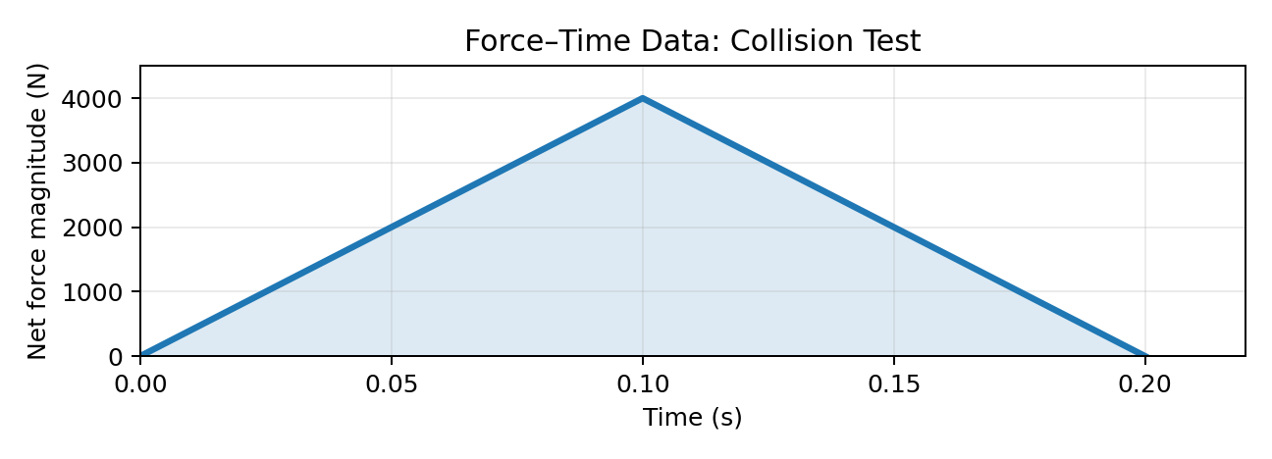
Figure 1: Force vs. Time graph for a collision test.

- Calculate the magnitude of the impulse during the 0.20 s interval. Show your work and include units.

- State the direction of the impulse relative to the cart’s initial motion:

5 | Interactive Item: Collision-time control
During a collision, the time it takes an object to come to rest affects the average force acting on it. In this activity, you will use an interactive simulation to investigate the relationship between stopping time and average force.
The simulation uses a constant change in momentum with a magnitude of 600 kg·m/s. The magnitude of the average net force is calculated using the impulse-momentum theorem:

$$F_{avg}=\frac{\left|∆p\right|}{∆t}$$
- Favg = magnitude of the average net force (N)
- |Δp| = magnitude of the change in momentum (kg·m/s)
- Δt = stopping time (s)

Instructions for Using the Simulation
- Open the interactive simulation and locate the slider labeled “Stopping Time.”
Simulation link: https://edwards-patrice.github.io/physics-collision-simulation/
- Move the slider to 0.10 s. Observe the displayed average force and record its magnitude in the table below.
- Repeat the process for stopping times of 0.20 s and 0.50 s.
- As you adjust the slider, observe how the average force changes while the magnitude of the momentum change remains constant at 600 kg·m/s.
- Use your observations and recorded values to answer questions (a) and (b).

Stopping time (s) | Average force magnitude (N)
0.10
0.20
0.50

- Which stopping time produces the smallest magnitude of average net force?

- Using the impulse-momentum theorem, explain why the magnitude of the average net force changes as the stopping time increases, even though the change in momentum remains constant.

6 | Two-part Item: Claim and evidence

Part A: Cars are designed with crumple zones, which are areas at the front and rear of a vehicle that bend and collapse during a collision. This design increases the amount of time it takes for the car to come to a stop.
A student makes the following statement:
"Crumple zones reduce the average force acting on a car during a collision because they increase the time over which the car's momentum changes."
Assuming the car experiences the same change in momentum, is the student's statement scientifically correct?
A. Yes, because increasing the stopping time decreases the magnitude of the average force.
B. No, because crumple zones completely eliminate the car's momentum without producing a force.
C. No, because increasing the stopping time increases the magnitude of the average force.
D. Yes, because crumple zones reduce the mass of the car during the collision.

Part B. Which relationship best supports your answer?
A. $F_{avg}=\frac{m}{v}$
B. $F_{avg}=\frac{\left|∆p\right|}{∆t}$
C. $p=\frac{F_{avg}}{∆t}$
D. Δp = 0 for every collision

7 | Constructed response: Airbag mechanism

During a car collision, an airbag helps bring an occupant to rest by increasing the amount of time it takes for the occupant to stop moving.

In 3–5 complete sentences, explain how an airbag reduces the magnitude of the average force acting on an occupant during a collision. In your explanation, describe the relationship between impulse, stopping time, and average force. Assume the occupant experiences the same change in momentum with or without an airbag.

8 | Extended response: Evaluate a safety design
Two carts of equal mass are traveling at the same speed. Each cart collides with a different barrier and comes to a complete stop.
Both carts experience the same magnitude of change in momentum, 800 kg·m/s. However, the barriers bring the carts to rest in different amounts of time.

Test | Stopping time | Momentum-change magnitude
Barrier A | 0.10 s | 800 kg·m/s
Barrier B | 0.40 s | 800 kg·m/s

Using the impulse-momentum theorem, answer the following questions. Show your calculations and include appropriate units.
1. Calculate: Determine the magnitude of the average net force acting on each cart during the collision.
2. Compare: Which barrier produces the smaller average net force? How much smaller is this force compared with the other barrier?
3. Explain: Using the relationship between impulse, stopping time, and average force, explain why the two carts experience different average forces even though their changes in momentum are the same.
4. Apply: If these barriers were used in a vehicle safety test, explain why knowing only the average force acting on the vehicle would not be enough to determine how well the occupants are protected.

Developer Materials | Assessment Blueprint
This section is for portfolio reviewers and item developers; it is not part of the student-facing assessment.
Item | Format | Evidence of learning | Primary cognitive demand | Points
1 | Single select | Calculate p = mv with direction | Apply | 1
2 | Single select | Calculate signed Δp and impulse | Apply | 1
3 | Multiple select | Recognize impulse/time/force relationships | Analyze | 2
4 | Graph + numeric response | Calculate area and identify direction | Apply / analyze | 3
5 | Technology-enhanced prototype | Explore inverse force–time relationship | Apply / explain | 4
6 | Two-part selected response | Evaluate claim and supporting equation | Reason with evidence | 2
7 | Constructed response | Explain mechanism coherently | Explain | 3
8 | Extended response | Compare designs quantitatively and note limitation | Evaluate | 5
Total: 21 points

Answer key and scoring guidance

Item 1 (1 point)
The answer is C. p = mv = (1,200 kg)(20 m/s) = 24,000 kg·m/s east.

Item 2 (1 point)
The answer is B. $J=∆p=m\left(v_{f}-v_{i}\right)=1,200\left(0-20\right)=-24000 N∙s$. Negative indicates west, opposite the initial eastward motion.

Item 3 (2 points)
The correct choices are A, B, and D. Award 2 points only if all three correct options and no incorrect option are selected; 1 point if exactly two correct options and no incorrect option are selected; otherwise, 0. Option C confuses stopping time with momentum change.

Item 4 (3 points)
(a) The impulse is the area under the curve. The area is a triangle:$J=\frac{1}{2}\left(0.20s\right)\left(4000N\right)=400 N∙s$ (2 points: method 1, correct value/units 1). (b) Opposite the initial motion (1 point). The graph shows the magnitude of the force.

Item 5 (4 points)
At 0.10 s: 6,000 N; 0.20 s: 3,000 N; 0.50 s: 1,200 N (1 point for all three correct; partial credit at reviewer discretion). (a) 0.50 s (1 point). (b) For fixed |Δp|, $F_{ang}=\frac{\left|∆p\right|}{∆t}$, so longer stopping time yields smaller average force (2 points).

Item 6 (2 points)
Part A: A (1 point). Part B: B (1 point). This is a linked two-part item; operational scoring rules may require Part A correct for Part B credit.

Item 7 (3 points)
During a collision, an airbag increases the amount of time it takes for an occupant to come to rest. According to the Impulse Momentum Theorem, the impulse acting on the occupant equals the change in momentum, which is the same with or without an airbag. Since the magnitude of the average force is equal to the magnitude of the change in momentum divided by the stopping time, $F_{avg}=\frac{\left|∆p\right|}{∆t}$, increasing the stopping time decreases the average force. Therefore, an airbag helps reduce the average force acting on the occupant, lowering the risk of injury.

Item 8 (5 points)
Barrier A: 800/0.10 = 8,000 N (1); Barrier B: 800/0.40 = 2,000 N (1); correctly recommends B as lower average force. Barrier B produces 6,000 N less force, or 75% less than Barrier A. (1); explains fixed impulse with longer stopping time (1); identifies limitation, for example, peak force, force distribution, occupant restraint, or differing occupant motion (1).

