The following projects are in progress:

* DataReporter:
  + Breadboard.
  + Task-Thread Executive sketch.
* Xbee connected sensor reporters:
  + Breadboard.
* Solar panel investigation:
  + 4” x 5” (4).
  + 5” x 6” (2).
* Max power point solar powered Li-Ion battery charger:
  + SunnyBuddy breadboard.
* PCB:
  + PCB Artist.
  + Eagle.

DataPeporter Breadboard Document:

The breadboard is intended to aide the integration and testing of the hardware elements and software sketches that combine to make up the possible configurations of the DataReporter. The configurations differ in the GSM modem used and the hardware elements required to support the modem.

13

3

Li-Ion Charger and

Power Manager

Aduinop UNO Rev 3

Li-Ion Battery

1

12

7

Solar Simulator

Variable

Power Supply

GSM Modem Load

Simulator

Xbee Coordinator and 3.3V Buck

Regulator

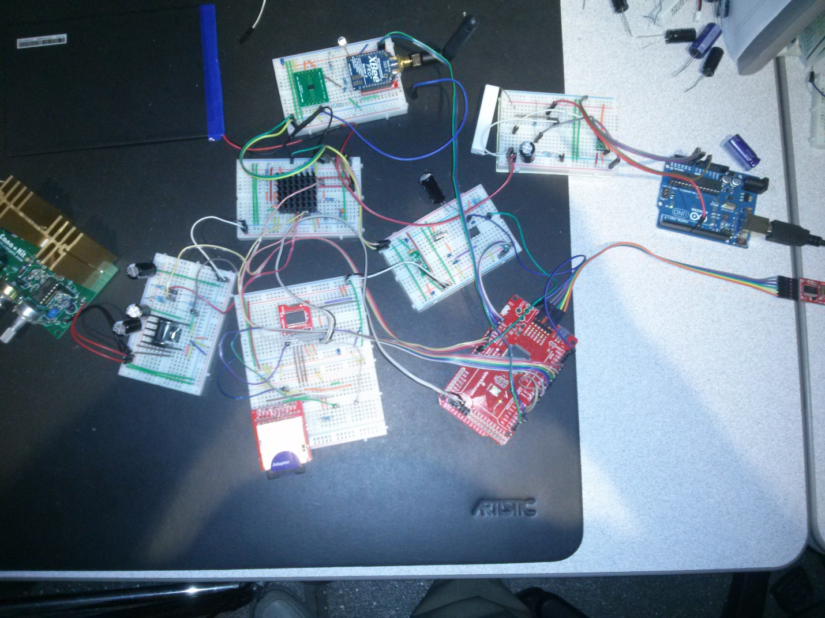

2

2.5V Reference

5V Boost-Buck

Regulator

3.3V Boost-Buck

Regulator

SD Card

Real Time Clock

Solar Regulator

ATmega2560 3.3V

FTDI Board: USB🡪Serial

Interface to Aurduino IDE.

11

8

4

9

5

6

10

1. Solar Simulator:
   1. The solar simulator is mechanized with a 0 to 21V variable power supply purchased from Cana Kit. It is notan actual part of the DataReporter and is only intended to simulate power from a solar panel with an output voltage range of 0 to 21V.
2. Solar Regulator:
   1. The solar regulator is mounted to the DataReporter metal housing for heat sinking and is not part of the DataPeporter’s PCB. The solsr regulator is a 5V buck regulator and functions to limit the solar panel output voltage to 5V maximum to be compatile with the maximum input to the Li-Lion battery charger-power manager.
3. Li-Ion Charger and Power Manager:
   1. The power manager’s primary function is to combine power from the solar panel and or the Li-Ion battery and distribute it to the manager’s output load pin. The power to the load has the highest priority and is maintained until battery can no longer sustain it due to discharge. If solar power is available and greater than that required by the load then the excess power is used to charge the Li_Ion battery. If solar powe is available then the ouput voltage will be equal to the solar regulator – 100 mV. I solar power is not available the output voltage will be equal the the battery voltage – 100mV.
4. Li-Ion Battery:
   1. The battery requires a minimum of two stages of charging constant current and saturation about 1.5 Hr and 3 Hr respectively assuming power availability.
5. 3.3V Boost-Buck Regulator:
   1. The function of this regulator is to supply the 3.3V power to the ATmega2560 and it’s RTC and SD periphers.
6. 5V Boost-Buck Regulator:
   1. The function of this regulator is to provide 5V power to the A/D reference and the Xbee coordinator RF module’s 3.3V buck regulator.
7. ATmega2560 3.3V:
   1. The processor’s function is to drive task threads and is intended to be asleep most of the time. Note that the Atmege2560’s power is the only power enabled at all times. All other power is enabled, only as required, by tasks executing in the processor.
8. Xbee Coordinator and 3.3V Buck Regulator:
   1. The function of the Xbee is to communicate with a network of sensor processors. The communication if time multiplexed and the netork is active only a fraction of the time. The 3.3V Buck regulator is powered by the 5V Boost-Buck regulator in item 6 above.
9. 2.5V Reference:
   1. Provides a stable reference for the ATmega2560’s A/D converters.
10. Real Time Clock:
    1. Provides time synchronization for the network.
11. SD Card:
    1. Provides data buffering.
12. FTDI USB Serial Converter:
    1. Provides Arduino IDE communication for software development and configuration.
13. GSM Modem Load Simulator:
    1. Provides a GSM dynamic load simulation. Simulates power requi
14. Arduino UNO:
    1. Executes the GSM simulation sketch.

The following figure shows the configuration required to support the Arduino GSM shield.

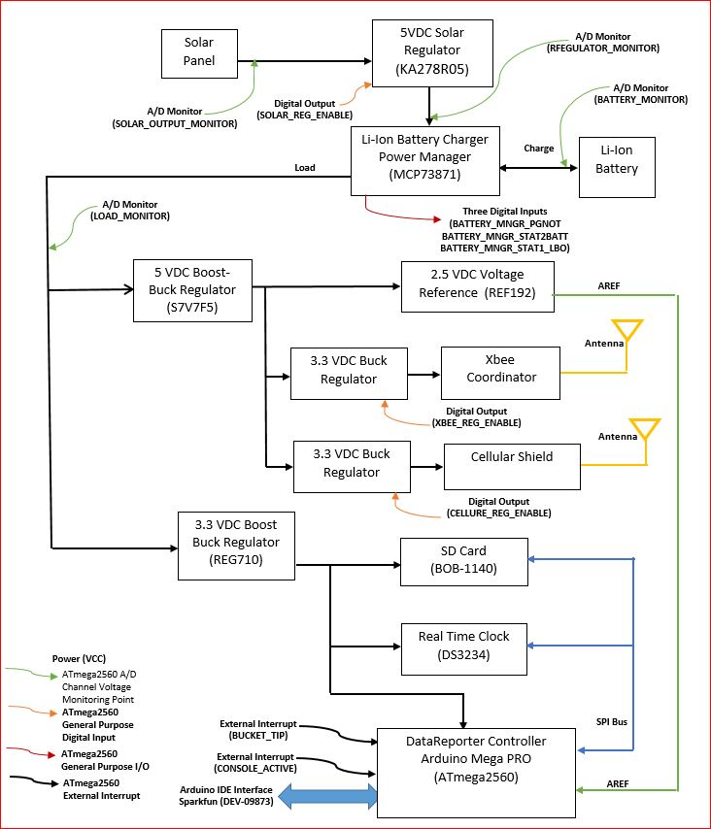

Xbee Network Breadboard:

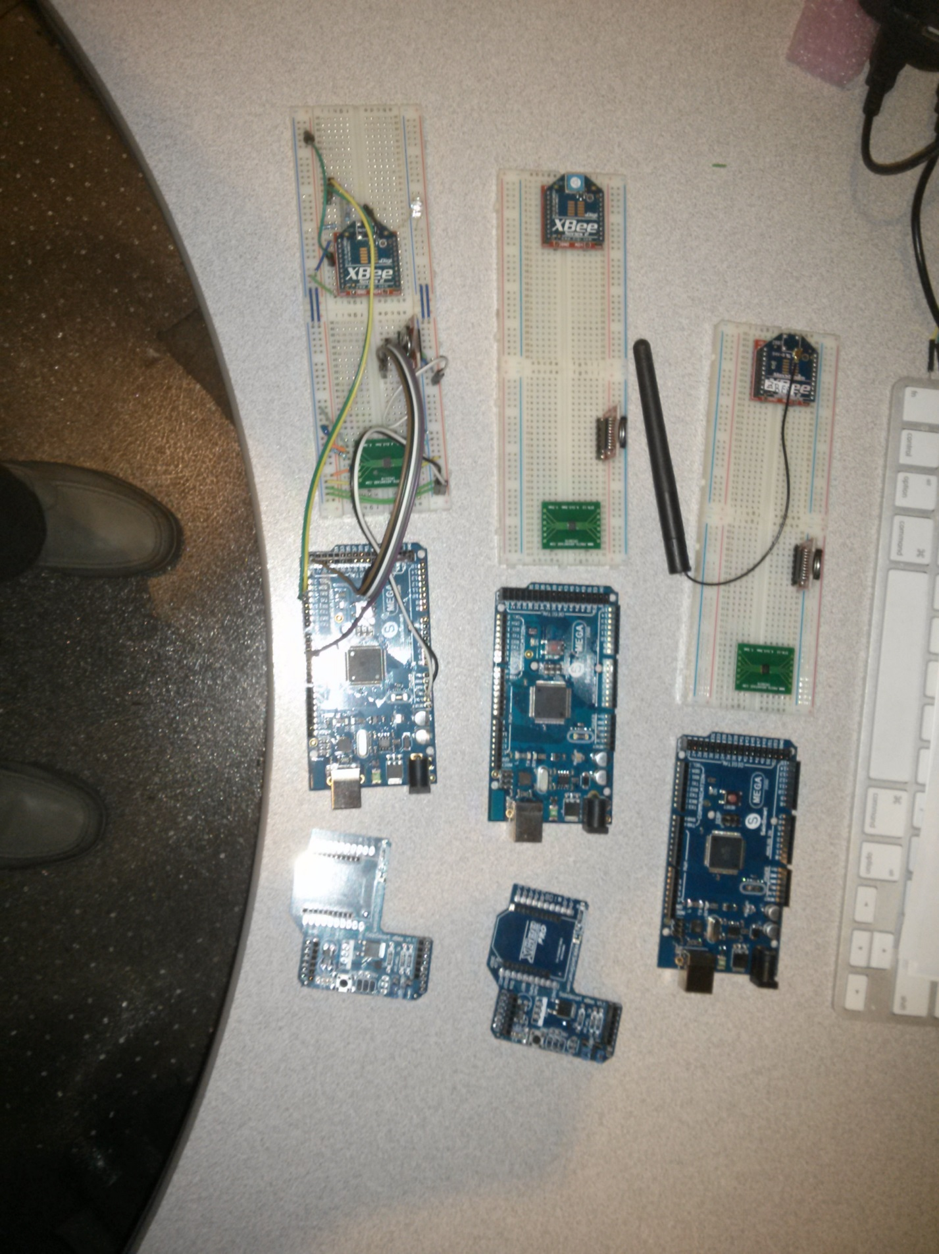

The Xbee network consists of 3 Xbee “connected” sensor reporter breadboards. The breadboards, in conjunction with the DataReporter breadboard, are intended as a platform for developing the the software required for the DataReporter project. Each sensor reporter consists of a 3.3V 250mA buck regulator, a real time clock an Xbee RF module an Adafruit Mega 2560 processor board. The regulator is required to provide the 3.3V power from the MEGA board’s 5V power and is not required in the final product that utilizes a 3.3V ATmega2560.

Two breadboards are not wired at this time. One breadboard is wired and was tested with the XBeeAPI_CmdPassThrough_REV_1 sketch. The Digi International MAX_STREAM USB Xbee development board and the XCTU Version 6.1.1 were used for testing the breadboard. Most of the sketch functions work but the sketch is not complete and it does have a bug that causes crashes under some conditions.

Serial I/O MEGA🡪Xbee breadboard:

Xbee Pin 1 🡪 Breadboard Pin g10 (Xbee and breakout board pins are offset)

MEGA RX1 **Yellow** Xbee DOUT Pin 2 Breadboard **i17**

MEGA TX1 **Green** Xbee DIN Pin 3 Breadboard **i16** (5V🡪3.3v divider)

Xbee !RESET Pin 5 Breadboard j6

Momentairly ground to Reseet Xbee RF module.

SUNNY BUDDY Breadboard:

The SunnyBuddy breadboard is intended to investigate the Peak power points of the smaller solar panels.

