Revised 12-04-2013

*Italics = Not a part of the breadboard.*

**Bold underlined = ordered.**

* *Solar Panel*
  + *12VDC 10W*
  + *Solar Store*
    - [*http://thesolarstore.com/solar-panels-solarland-solar-panels-c-21_166.html?page=1&sort=2a*](http://thesolarstore.com/solar-panels-solarland-solar-panels-c-21_166.html?page=1&sort=2a) *$70*
* **5VDC Buck Regulator**
  + KA278R05
    - <http://www.digikey.com/product-search/en?WT.z_header=search_go&lang=en&site=us&keywords=%09KA278R05CTU-ND&x=6&y=16&formaction=on>
  + Heatsink
    - Digikey Ohmite WA-T220-101E $1.86
    - Black anodized
    - <http://media.digikey.com/pdf/Data%20Sheets/Ohmite%20PDFs/W_Series.pdf>
    - Width = 0.72” 18.3mm
    - Depth = 0.63” 16mm
    - Heigth = 1.2” 30.5mm
    - Distance between Pins = 0.5” 12.7mm
    - Pin diameter = 0.06” 1.5mm Hole diameter = 0.08” 2.0mm
    - 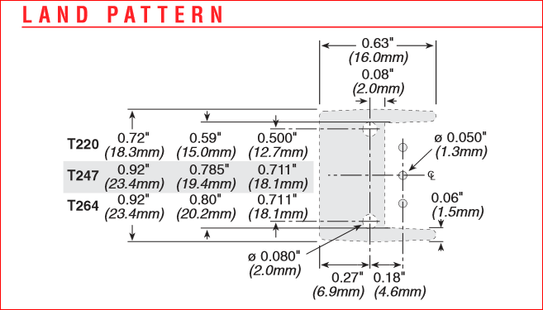
* 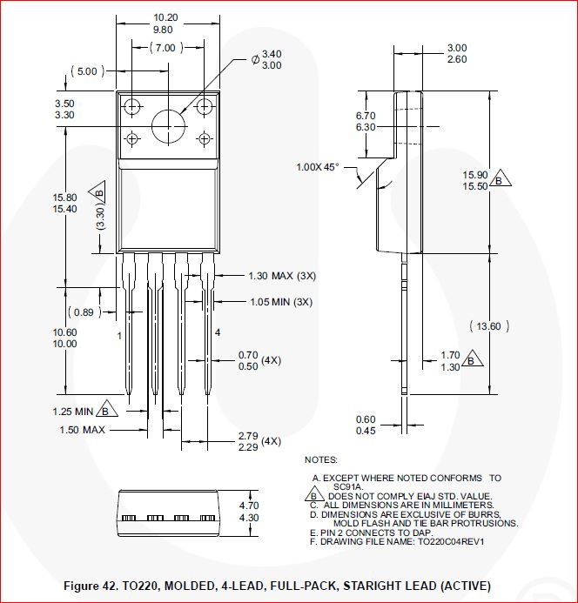
* Li_Ion/Li-Poly Battery Charge Management Controller (Out of stock)

The MCP73871-2CAI/ML

* + Digi-Key
    - <http://www.digikey.com/product-detail/en/MCP73871-2CAI%2FML/MCP73871-2CAI%2FML-ND/1680970>
  + 1 IC and PA0063 20 pin adapter are ordered from Proto Advantaage as a fabricated assembly at:
    - <http://www.proto-advantage.com/store/product_info.php?products_id=2200067>
    - $12.99 + $2.80 = $15.79
  + If this part is not available from Digikey you can substitute the Adafruit Solar LiPoly Charger V1.0 boardat:
    - <http://www.adafruit.com/products/390>
  + MCP73871 Microchip Li-Ion/Li-Poly Battery Charge Management Controller.
  + PA0063 QFN-20 to DIP-20 SMT Adapter (0.5 mm pitch, 4 x 4 mm body) Adapter Proto Advantage
  + 4700 µf 10V
    - <http://www.digikey.com/product-search/en?pv13=181&pv63=19&FV=fff40002%2Cfff80009&mnonly=0&newproducts=0&ColumnSort=0&page=1&quantity=0&ptm=0&fid=0&pageSize=100>
    - <http://www.digikey.com/product-detail/en/ECA-1AM472/P5130-ND/244989>
  + **Resistor 2K +/- 1%**
    - <http://www.digikey.com/product-detail/en/MFR-25FBF52-2K/2.00KXBK-ND/13070>
  + **Resistor 100K +/-1%**
    - <http://www.digikey.com/product-detail/en/HHV-25FR-52-100K/100KGACT-ND/2813157>
  + **Heatsink** 
    - <http://www.digikey.com/product-detail/en/658-25ABT4E/345-1103-ND/2615346>
    - Thermal adhesive
      * <http://www.amazon.com/Arctic-Alumina-Thermal-Adhesive-Tube/dp/B0009IQ1BU/ref=sr_1_1?ie=UTF8&qid=1385476036&sr=8-1&keywords=thermal+adhesive>
* **Li-Poly Battery** (two week delivery time)
  + 3.7V,9200mAH,[4599150] PLIB (polymer lithium ion battery
  + : <http://www.aliexpress.com/item/L074-3-7V-9000mAH-PLIB-polymer-lithium-ion-battery-Li-ion-battery-for-tablet-pc/760284047.html>
  + $13.20 each + $26.36 shipping.
* **5VDC Step-Up/Step-Down Regulator S7V7F5** 🡨**Backordered**
  + <http://www.robotshop.com/en/step-up-step-down-voltage-regulator-s7v7f5.html>
  + $4.94
* **2.5VDC Precision Reference**
  + AnalogDevices REF192
  + <http://www.digikey.com/product-detail/en/REF192GPZ/REF192GPZ-ND/997116>
  + $3.20
* **3.3VDC Boost-Buck Regulator**
  + The REG710NA-5/250 IC and PA0085 6 pin adapter are ordered from Proto Advantaage as a fabricated assembly at:
    - <http://www.proto-advantage.com/store/product_info.php?products_id=2200091>
    - $6.49 + $2.04 = 8.53
  + Texas Instrument REG710NA-3.3/250
    - <http://www.digikey.com/product-detail/en/REG710NA-3.3%2F250/296-12135-1-ND/404728>
    - Poto Advantage PA0085 Adapter
    - **Cin = 2.2uf (2)**
    - <http://www.digikey.com/product-detail/en/FK28X5R1C225K/445-8604-ND/2815534>
    - **Cpump = 0.22uf**
      * <http://www.digikey.com/product-detail/en/K224K20X7RF5TH5/BC1103CT-ND/286725>
* **SD Card**
  + Sparkfun Breakout Board for SD-MMC Cards
    - <https://www.sparkfun.com/products/11403>
    - $9.95
* **Real Time Clock**
  + Sparkfun DeadOn RTC-DS3234 Breakout
    - <https://www.sparkfun.com/products/10160>
    - $19.95
* **Voltage Monitoring**
  + Solar Output Monitor Ratio = 2.5 / 22 = 0.113636
    - R2 = 4.75K
      * <http://www.digikey.com/product-search/en?pv1=496&FV=fff40001%2Cfff80482%2Cfffc000d%2C80004%2Cc0001&k=resistors&mnonly=0&newproducts=0&ColumnSort=0&page=1&stock=1&quantity=0&ptm=0&fid=0&pageSize=25>
    - R1 = 41.2K
      * <http://www.digikey.com/product-search/en?pv1=508&FV=fff40001%2Cfff80482%2Cfffc000d%2C80004%2Cc0001&k=resistors&mnonly=0&newproducts=0&ColumnSort=0&page=1&stock=1&quantity=0&ptm=0&fid=0&pageSize=25>
  + 5V Regulator Monitor Ratio = 2.5 / 5.1 = 0.490196
    - R4 = 20.0K
      * <http://www.digikey.com/product-detail/en/MFR-25FBF52-20K/20.0KXBK-ND/13276>
    - R3 = 40.2K
      * <http://www.digikey.com/product-detail/en/MFR-25FBF52-40K2/40.2KXBK-ND/13396>
  + Load Monitor 2.5 / 5.1 = 0.490196
    - R1 = 20.0K
      * <http://www.digikey.com/product-detail/en/MFR-25FBF52-20K/20.0KXBK-ND/13276>
    - R2 = 40.2K
    - <http://www.digikey.com/product-detail/en/MFR-25FBF52-40K2/40.2KXBK-ND/13396>
  + Battery Monitor Ratio = 2.5 / 4.2 = 0.595238
    - R1 = 20K
      * <http://www.digikey.com/product-detail/en/MFR-25FBF52-20K/20.0KXBK-ND/13276>
    - R2 = 34K
      * <http://www.digikey.com/product-detail/en/MFR-25FBF52-34K/34.0KXBK-ND/13319>
* ***FTDI Board***
  + *This board is required only for program development, i.e. not required for production.*
  + *Sparkfun FTDI BasicBreakout 3.3V*
    - [*https://www.sparkfun.com/products/9873*](https://www.sparkfun.com/products/9873)
    - *$14.94*
* **Processor**
  + Sparkfun Mega Pro 3.3V
    - <https://www.sparkfun.com/products/10744>
    - $44.95
* ***Solderless Prototyping boards*** 
  + *~~5 Required~~*
  + *~~Sparkfun~~*
    - [*~~https://www.sparkfun.com/products/12002~~*](https://www.sparkfun.com/products/12002)
    - *~~$4.95 ea.~~*
  + *Elenco prototyping board*
    - *~~Equivalent to 6 of the above prototyping boards all mounted+ small bent wire kit $29.40 + $14.64 shipping. You pay $25 + shipping for separate boards.~~*
      * [*~~http://www.teachersupplysource.com/product/64509/elenco-electronics/electronics-division/bredboards-and-prototyping/elenco-9438-with-jw-140-jumper-wire-kit/#dp_images~~*](http://www.teachersupplysource.com/product/64509/elenco-electronics/electronics-division/bredboards-and-prototyping/elenco-9438-with-jw-140-jumper-wire-kit/#dp_images)
      * *At Amazon same deal for $28.12 with free shipping* 
        + <http://www.amazon.com/gp/offer-listing/B0002H4W1E/sr=/qid=/ref=olp_tab_new?ie=UTF8&colid=&coliid=&condition=new&me=&qid=&seller=&sr>=
* **Adjustable Power Supply**
  + CanaKit 0🡪24V 2A Regulated Power Supply
    - <http://www.canakit.com/0-24v-0-2a-regulated-power-supply-kit-ck052-uk052.html>
    - $35.95
  + **Transformer**
    - Digikey <http://www.digikey.com/product-search/en?WT.z_header=search_go&lang=en&site=us&keywords=%09HM535-ND&x=0&y=0&formaction=on>
    - $13.60
  + **Power cord**
    - <http://www.amazon.com/gp/product/B0002YTQYA/ref=oh_details_o04_s00_i00?ie=UTF8&psc=1>
* **Cables**
  + 7” male to male [~~http://www.ebay.com/itm/40-Pin-20cm-Dupont-Wire-Connector-Cable-2-54mm-Male-to-Male-1P-1P-For-Arduino-/321207046294?pt=LH_DefaultDomain_0&hash=item4ac96e9096~~](http://www.ebay.com/itm/40-Pin-20cm-Dupont-Wire-Connector-Cable-2-54mm-Male-to-Male-1P-1P-For-Arduino-/321207046294?pt=LH_DefaultDomain_0&hash=item4ac96e9096) ~~$4.68~~
    - 10 Times the above order: <http://www.ebay.com/itm/10-Pcs-Dupont-Wire-Connector-Cable-2-54mm-Male-to-Male-40-Pin-20cm-1P-1P-/221284622333?pt=LH_DefaultDomain_0&hash=item3385975ffd> $18.38
* ~~Jumper wire kit~~
  + [~~http://www.amazon.com/Elenco-Piece-Pre-formed-Jumper-Wire/dp/B0002H7AIG/ref=sr_1_cc_1?s=aps&ie=UTF8&qid=1385142621&sr=1-1-catcorr&keywords=elenco+jumper+wire~~](http://www.amazon.com/Elenco-Piece-Pre-formed-Jumper-Wire/dp/B0002H7AIG/ref=sr_1_cc_1?s=aps&ie=UTF8&qid=1385142621&sr=1-1-catcorr&keywords=elenco+jumper+wire)
  + ~~$10.51~~

5VDC Buck

Regulator

(KA278R05)

Solar Panel

**A/D Monitor**

**(RFEGULATOR_MONITOR)**

**Power (VCC)**

**ATmega2560 A/D**

**Channel Voltage Monitoring Point**

**ATmega2560 General Purpose**

**Digital Output**

**ATmega2560 General Purpose**

**Digital Input**

**ATmega2560**

**External Interrupt**

Cellular Shield

Sparkfun CEL-09607

(SM5100B)

Li-Ion

Battery

Li-Ion Battery Charger

Power Manager

(MCP73871)

SD Card

(BOB-1140)

2.5 VDC Voltage

Reference

(REF192)

5 VDC

Boost-Buck

Regulator

(S7V7F5)

DataReporter

Controller

Arduino Mega PRO

(ATmega2560)

Real Time Clock

(DS3234)

**SPI Bus**

**Solar Panel**

**Charge**

**Load**

**AREF**

**Antenna**

**RS232**

**AREF**

**A/D Monitor**

**(SOLAR_OUTPUT_MONITOR)**

**A/D Monitor**

**(BATTERY_MONITOR)**

**A/D Monitor**

**(LOAD_MONITOR)**

**Digital Output**

**(SOLAR_REG_ENABLE)**

**Three Digital Inputs**

**(BATTERY_MNGR_PGNOT**

**BATTERY_MNGR_STAT2BATTBATTERY_MNGR_STAT1_LBO)**

**Figure 1**

**DataReporter Hardware Block Diagram**

**Arduino IDE Interface**

**Sparkfun (DEV-09873)**

**External Interrupt**

**(BUCKET_TIP)**

**External Interrupt**

**(CONSOLE_ACTIVE)**

3.3 VDC Boost-Buck

Regulator

(REG710)