# Raptor Legacy Site Plan

## Einar Anderson

## WDD 130

## Overview

### Purpose

Provide information on the F-22 Raptor with its history as well as portrayal in media

### Audience

Fighter Jet enthusiasts and those who would like to learn more about the F-22 Raptor

## Branding

### Website Logo



## Style Guide

### Color Palette

|  |  |  |  |
| --- | --- | --- | --- |
| **Primary** | **Secondary** | **Accent 1** | **Accent 2** |
| #2D333B | #4A5560 | #E0E0E0 | #1F4A6F |

### Typography

#### Heading Font: Rajdhani

#### Paragraph Font: Source Code Pro

### Navigation

Home History Media

**Content**

### Homepage:

* Hero Image:

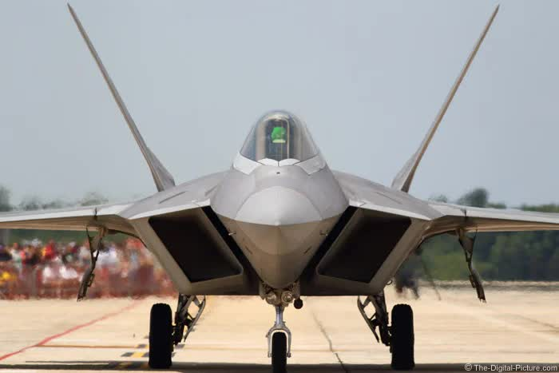

* + Site Name
* Site Navigation:
  + Logo
  + Home
  + History
  + Media
* Introduction:
* The F-22 Raptor is a twin-engine, all-weather stealth tactical fighter aircraft developed for the U.S. Air Force. Designed primarily for air superiority, it also has ground attack, electronic warfare, and signals intelligence capabilities. Its advanced stealth, integrated avionics, and superior performance make it a formidable aerial combatant.
* Fun Facts:

1. **Stealthy as a Marble:** The F-22's radar cross-section is reportedly the size of a marble, making it incredibly difficult for enemy radar systems to detect.
2. **Super-cruise Champion:** It can "super-cruise," meaning it can fly at supersonic speeds (greater than Mach 1.5) without using its fuel-guzzling afterburners. This greatly extends its range and operational envelope.
3. **Thrust Vectoring Wizard:** The F-22 has thrust-vectoring nozzles that can independently direct engine thrust up or down, giving it incredible agility and maneuverability that seems to defy physics.
4. **No Exports Allowed:** Due to its highly advanced and sensitive technology, the F-22 Raptor has never been authorized for export to any other country, making it exclusive to the U.S. Air Force.
5. **Internal Weapons Bays:** To maintain its stealth profile, the F-22 carries its weapons internally in bays that only open for a brief moment when missiles are launched. This keeps it "invisible" until the very last second.

* Image Gallery:

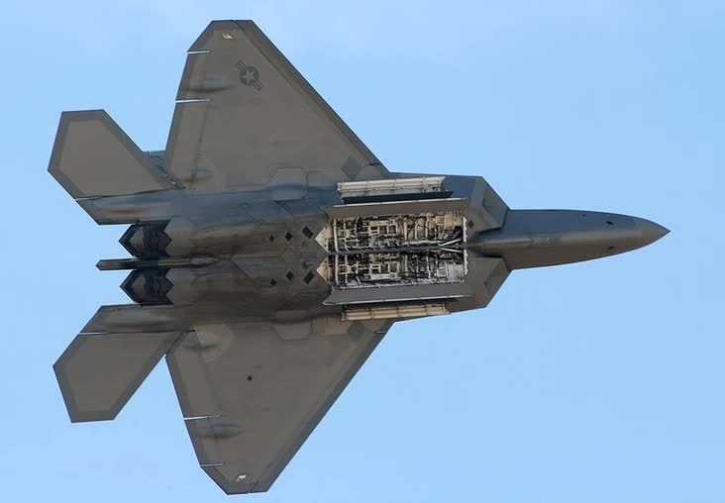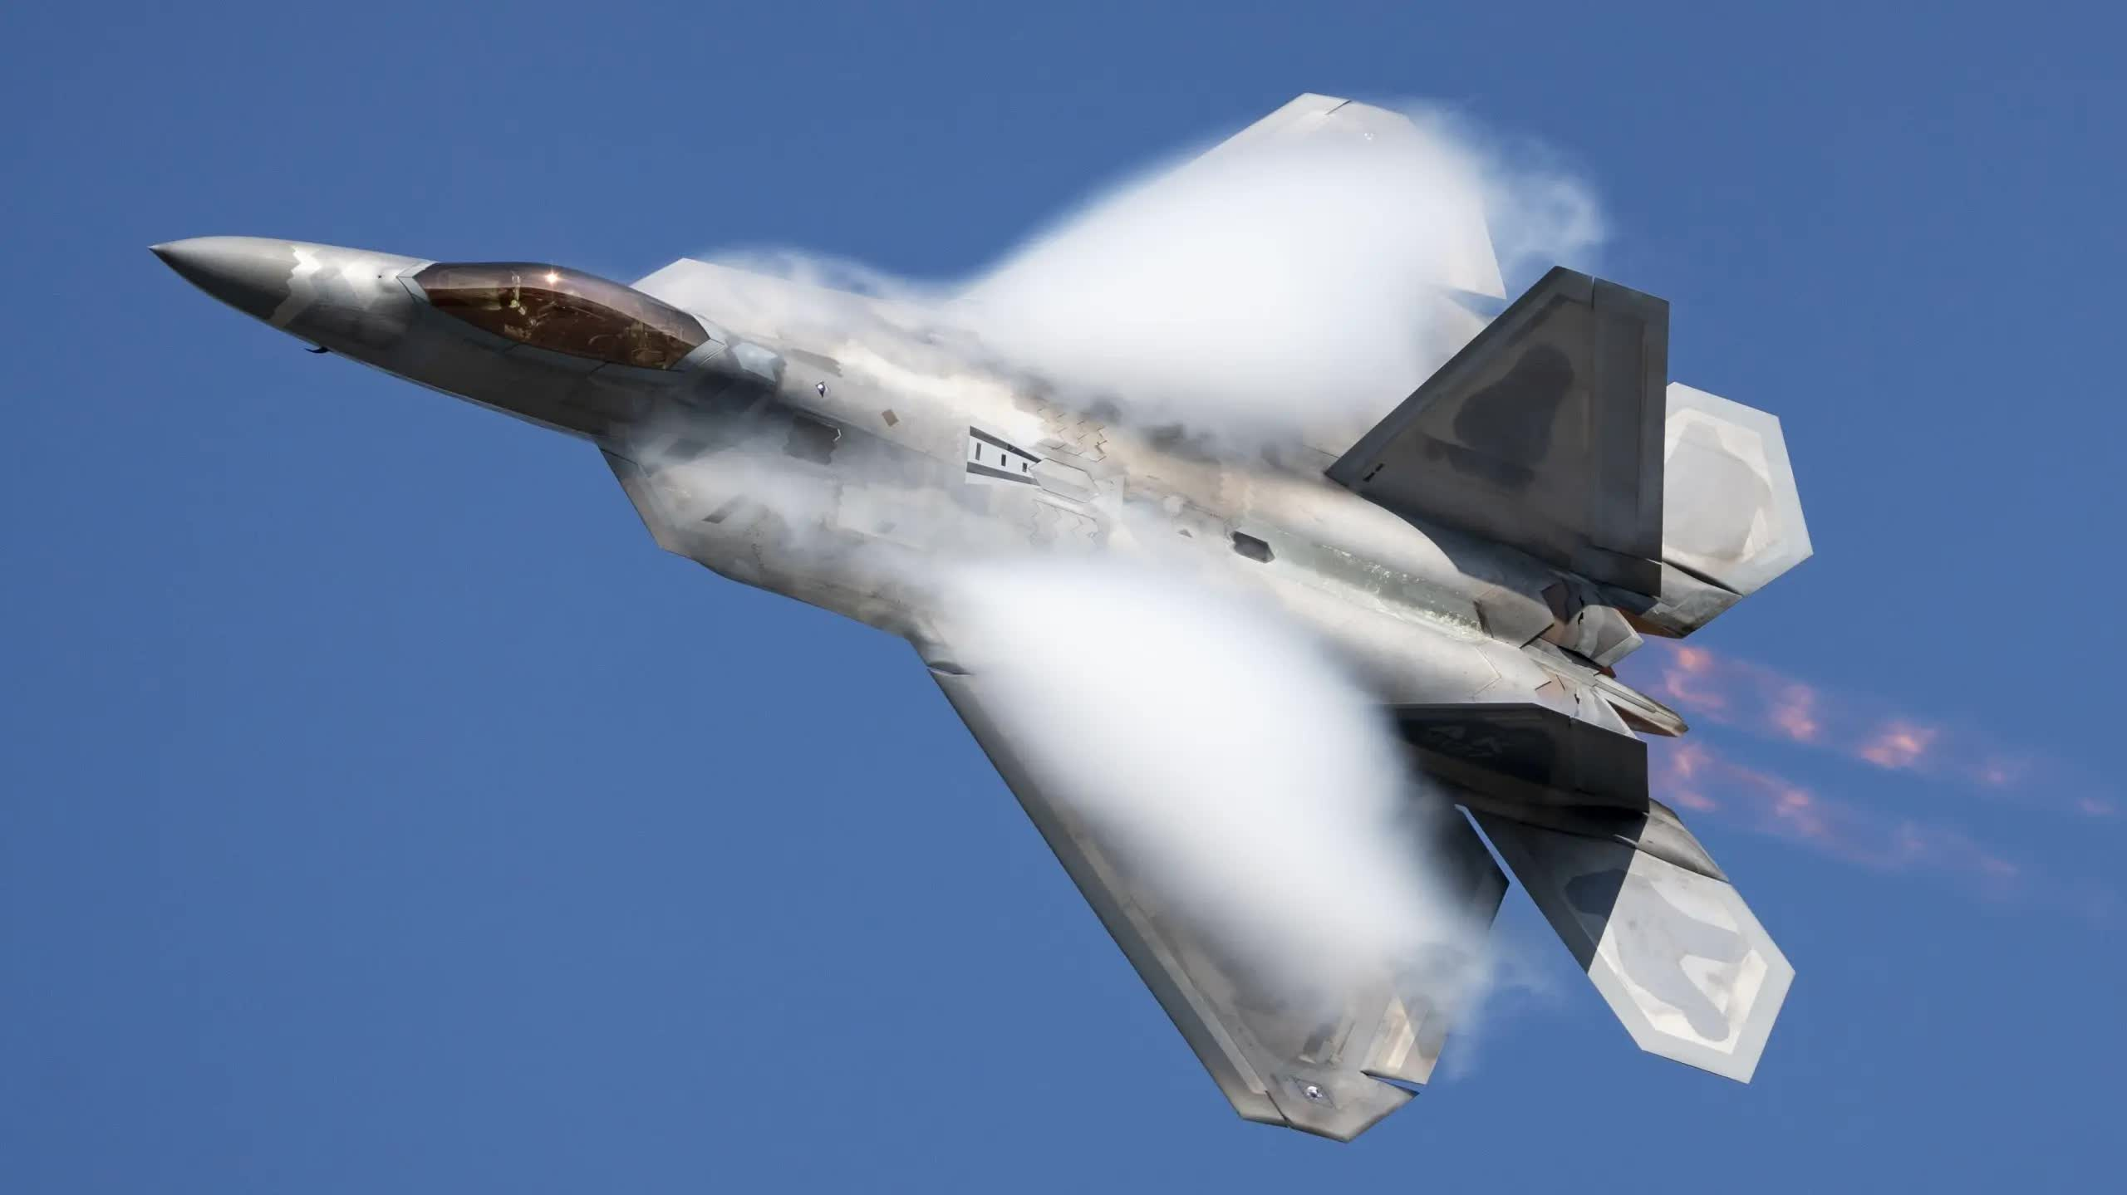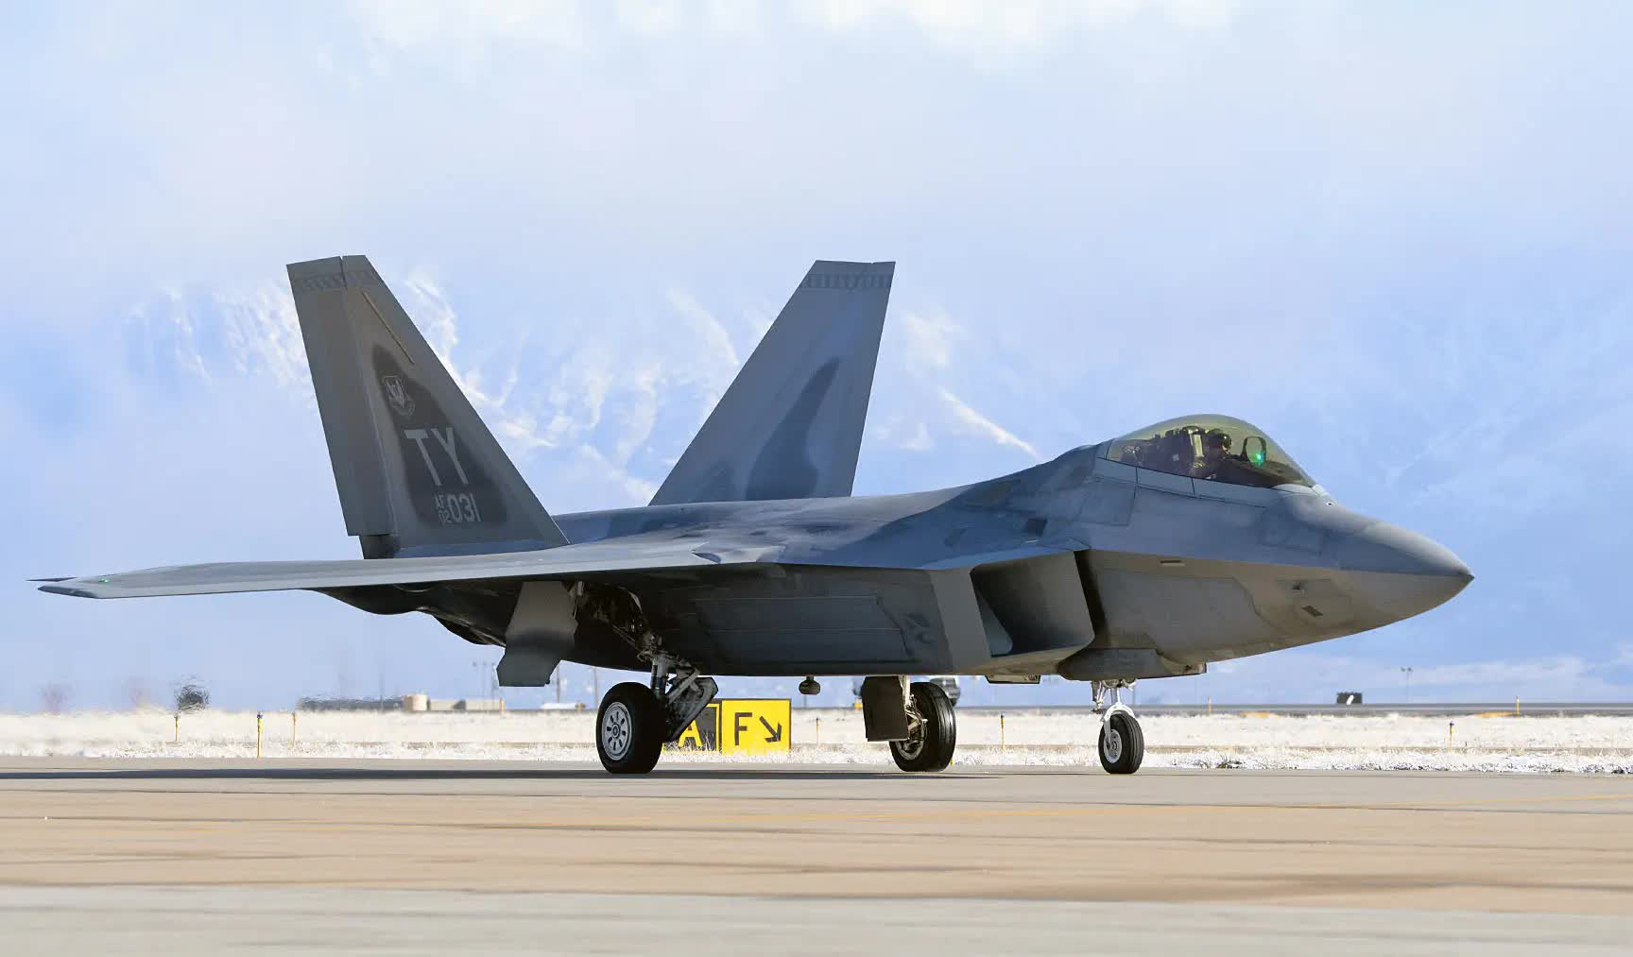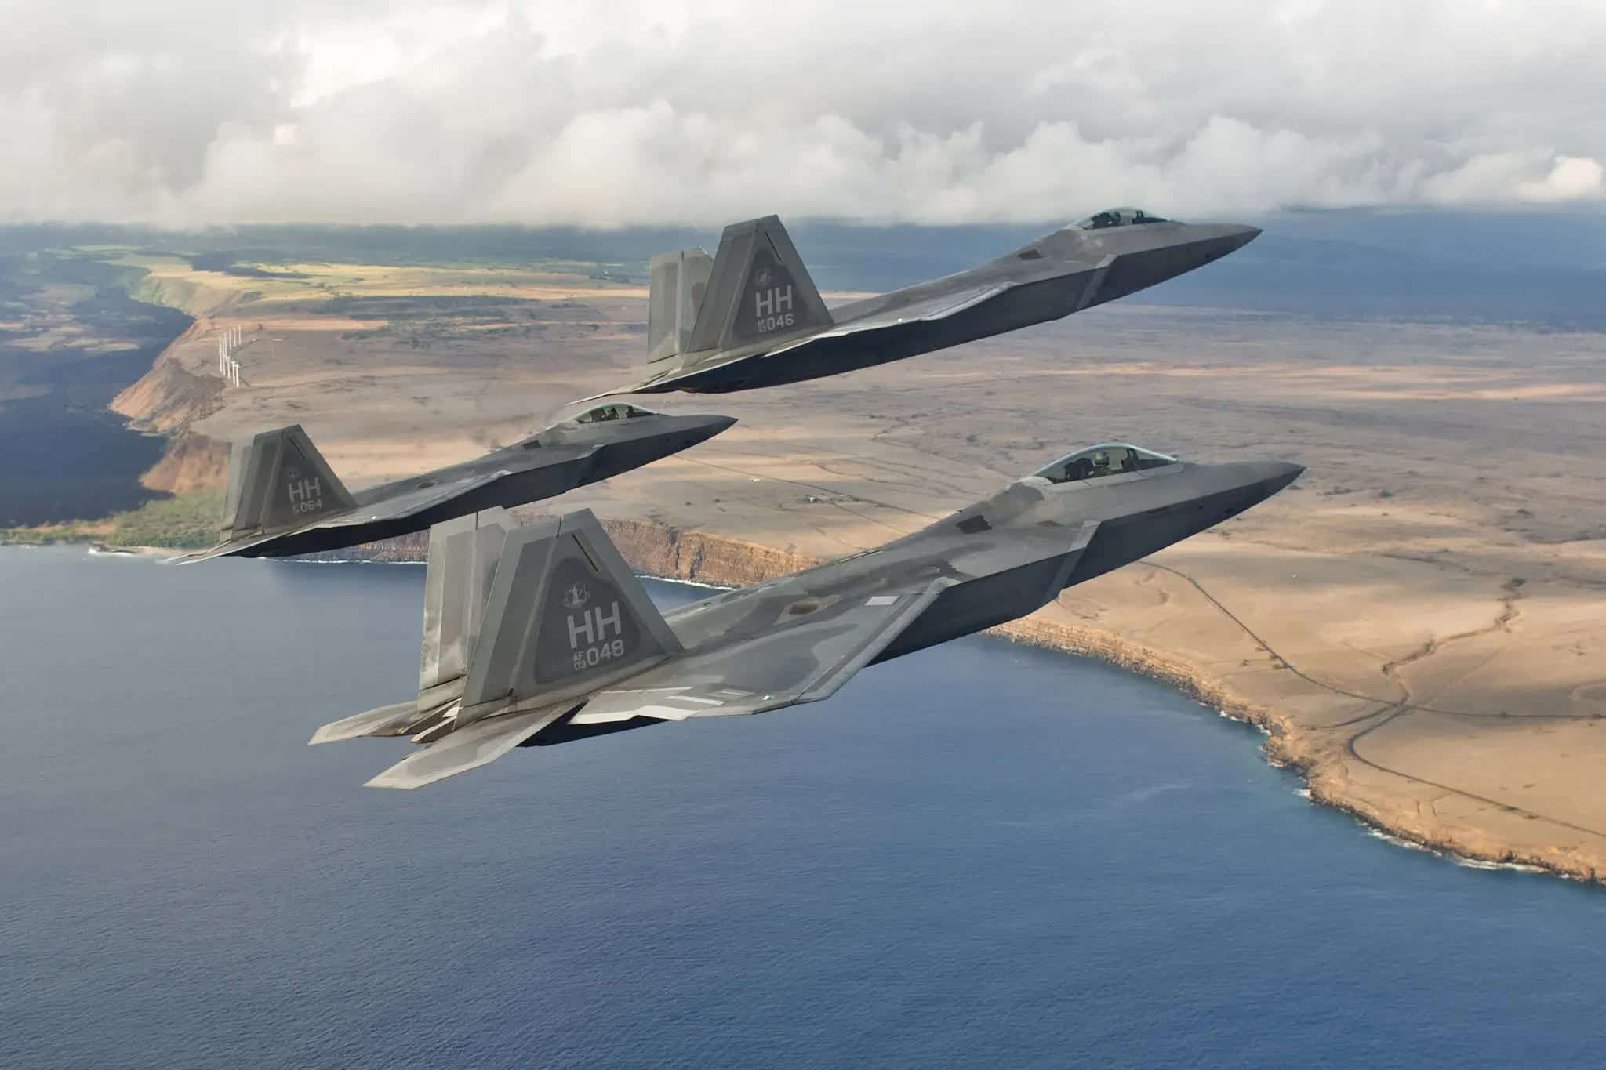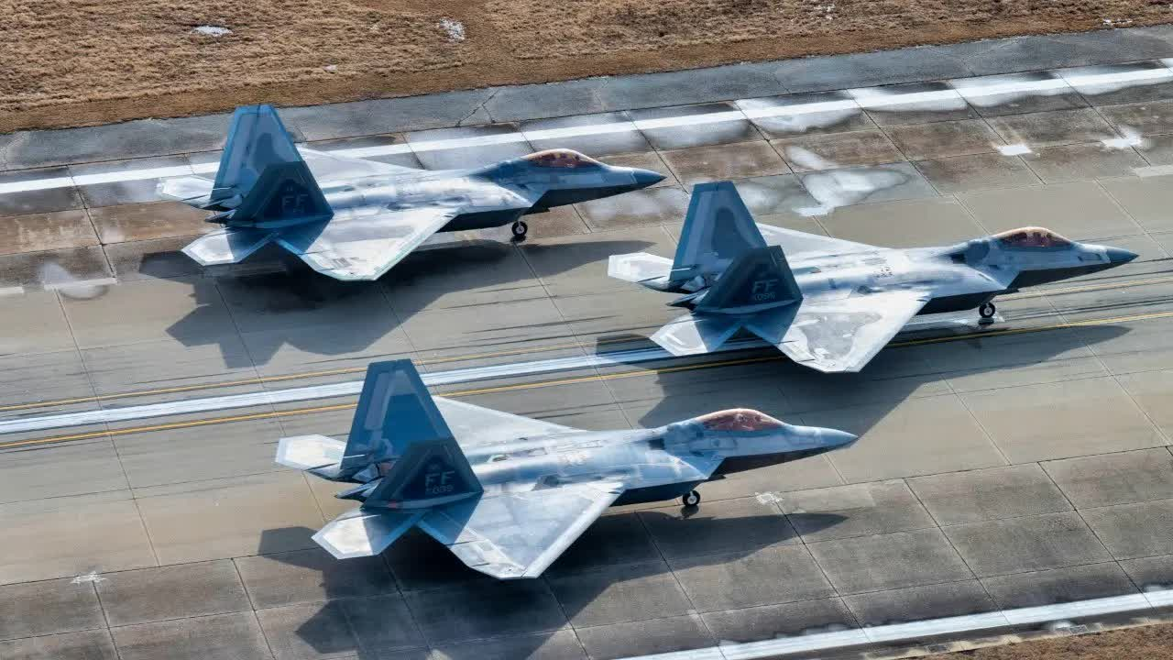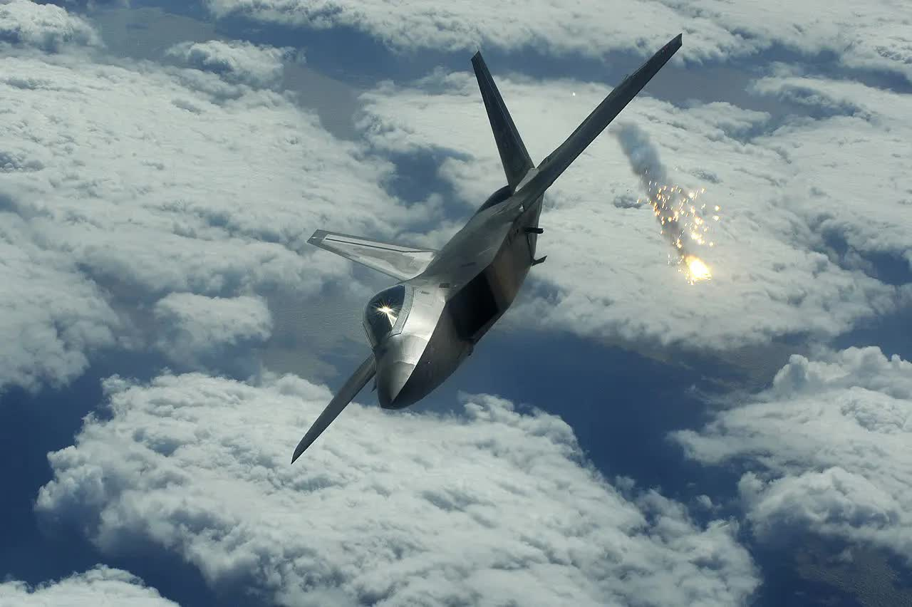

* Footer:
  + © 2025 Raptor Legacy

### Page 1 (History):

* Hero Image:

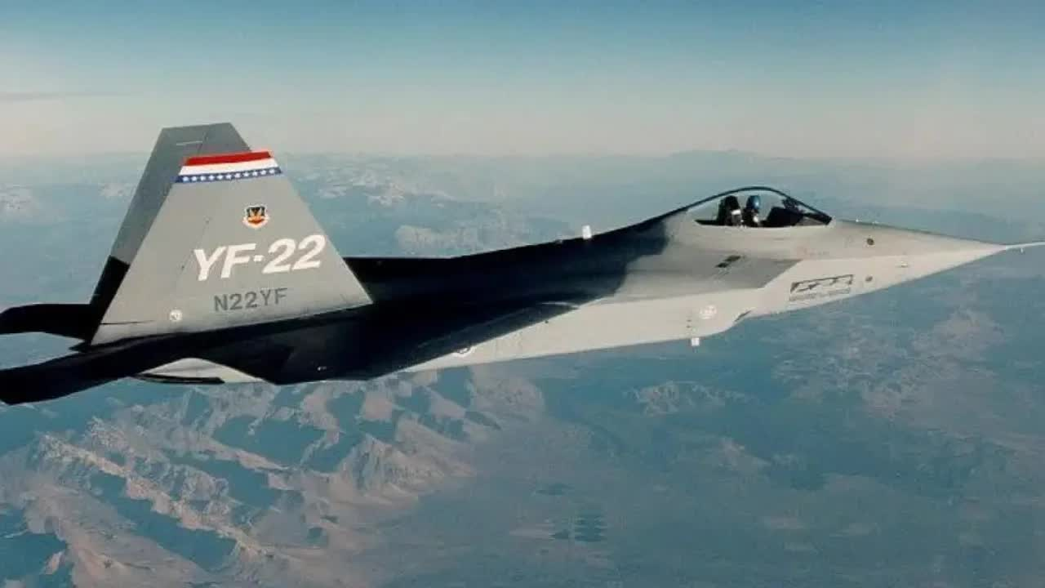

* History
* Navigation
* Development:
  + The F-22 Raptor, a marvel of aerospace engineering, stands as a testament to American air superiority. Its journey began in 1981 with the U.S. Air Force's Advanced Tactical Fighter (ATF) program, aiming to replace the aging F-15 Eagle and F-16 Fighting Falcon against emerging Soviet threats. Lockheed Martin's design, the YF-22, won the competition in April 1991, leading to the development of what would become the world's first fifth-generation stealth fighter.
* Development of the F-22 was a complex undertaking, pushing the boundaries of stealth technology, advanced avionics, and super-cruise capability (sustained supersonic flight without afterburners). The first F-22 Raptor test aircraft took flight in 1997, and after rigorous testing, the program received full-rate production approval in 2005. Initial operational capability was achieved in December 2005, with the first combat-capable Raptors delivered to the 27th Fighter Squadron at Langley Air Force Base, Virginia.
* Deployment:
  + The F-22's deployment has been strategic and impactful. It quickly proved its dominance in exercises, achieving impressive "kill ratios" against simulated adversaries. While primarily designed for air-to-air combat, its multi-role capabilities, including ground attack and electronic warfare, were utilized in combat operations in the Middle East, notably against the Islamic State in Syria from 2014. The Raptor also frequently intercepts Russian aircraft near U.S. airspace, particularly around Alaska. In a notable event, an F-22 achieved the type's first air-to-air kill in February 2023, by shooting down a Chinese spy balloon off the coast of South Carolina.
* Today:
  + Today, the F-22 remains a cornerstone of U.S. air power, despite production ending in 2011 with 195 aircraft built. Its highly classified technology prevents its export, maintaining its exclusivity to the U.S. Air Force. The fleet undergoes continuous modernization through programs that integrate new avionics, radar systems, and countermeasures. Efforts are underway to enhance its connectivity with other platforms, supporting the Air Force's Joint All-Domain Operations strategy. While the U.S. is developing the Next Generation Air Dominance (NGAD) fighter as its eventual successor, the F-22 Raptor continues to be a formidable and essential asset, ensuring air superiority for the foreseeable future.
* Footer:
  + © 2025 Raptor Legacy

### **Media:**

* Hero Image:

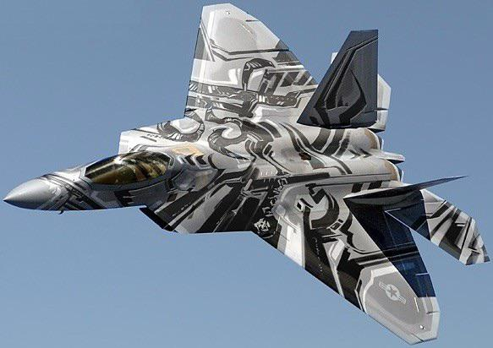

* Media
* Navigation
* Appearances
  + The F-22 Raptor, with its iconic stealth design and unparalleled capabilities, has made numerous appearances across various media, often symbolizing cutting-edge military technology and air superiority.
* In **movies**, the F-22 frequently plays a heroic or formidable role. It's prominently featured in the *Transformers* film series, notably as the alternate mode for the Decepticon Starscream, showcasing its sleek form and menacing presence. The F-22 also appears in *Iron Man* (2008), where Tony Stark in his early Iron Man suit has a brief, memorable encounter with two Raptors. Other films like *Stealth* (2005) and *The Tomorrow War* (2021) also showcase the F-22, often leveraging its real-world reputation for advanced performance in action sequences.
* On **television**, the F-22 often features in documentaries about modern military aviation, such as the "Air Warriors" series, providing in-depth looks at its design, operation, and the pilots who fly it. Its stunning aerial demonstrations at airshows are also frequently broadcast, highlighting its incredible maneuverability and power to a wide audience.
* In the world of **video games**, the F-22 is a highly sought-after aircraft for players in flight simulators and combat games. The *Ace Combat* series, known for its arcade-style aerial combat, consistently features the F-22 as one of its most powerful and agile playable aircraft across multiple titles like *Ace Combat 7: Skies Unknown*. Other flight simulation games, such as NovaLogic's *F-22 Raptor* (1997) and *Jane's Combat Simulations: USAF*, center their entire gameplay around piloting the advanced jet. It also appears in strategy games like *Command & Conquer: Generals*. These appearances solidify the F-22's image as the ultimate modern fighter jet, both for its real-world prowess and its captivating presence in fictional narratives.
* Image Gallery:

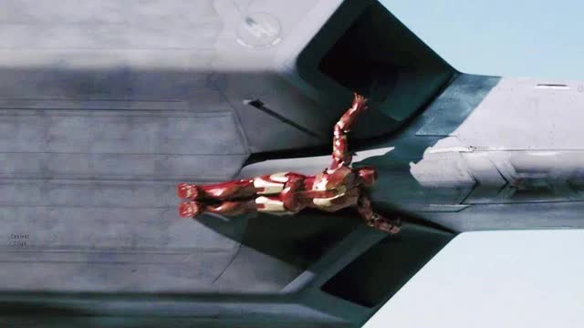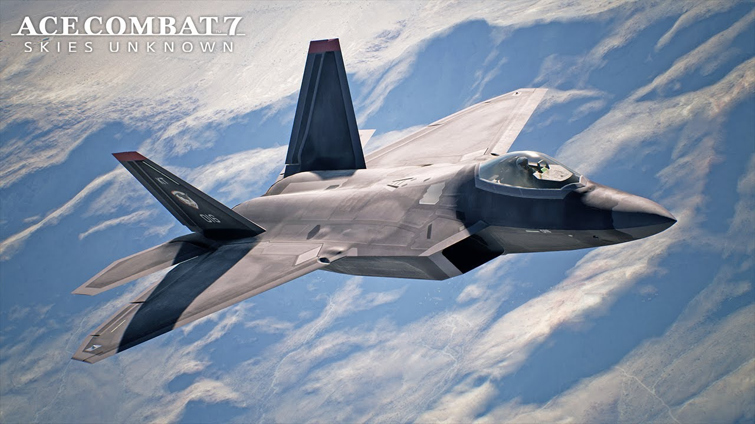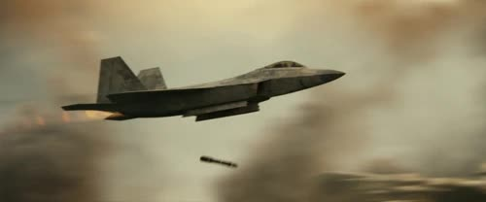

* Footer:
  + © 2025 Raptor Legacy

**Wireframes**

### Home

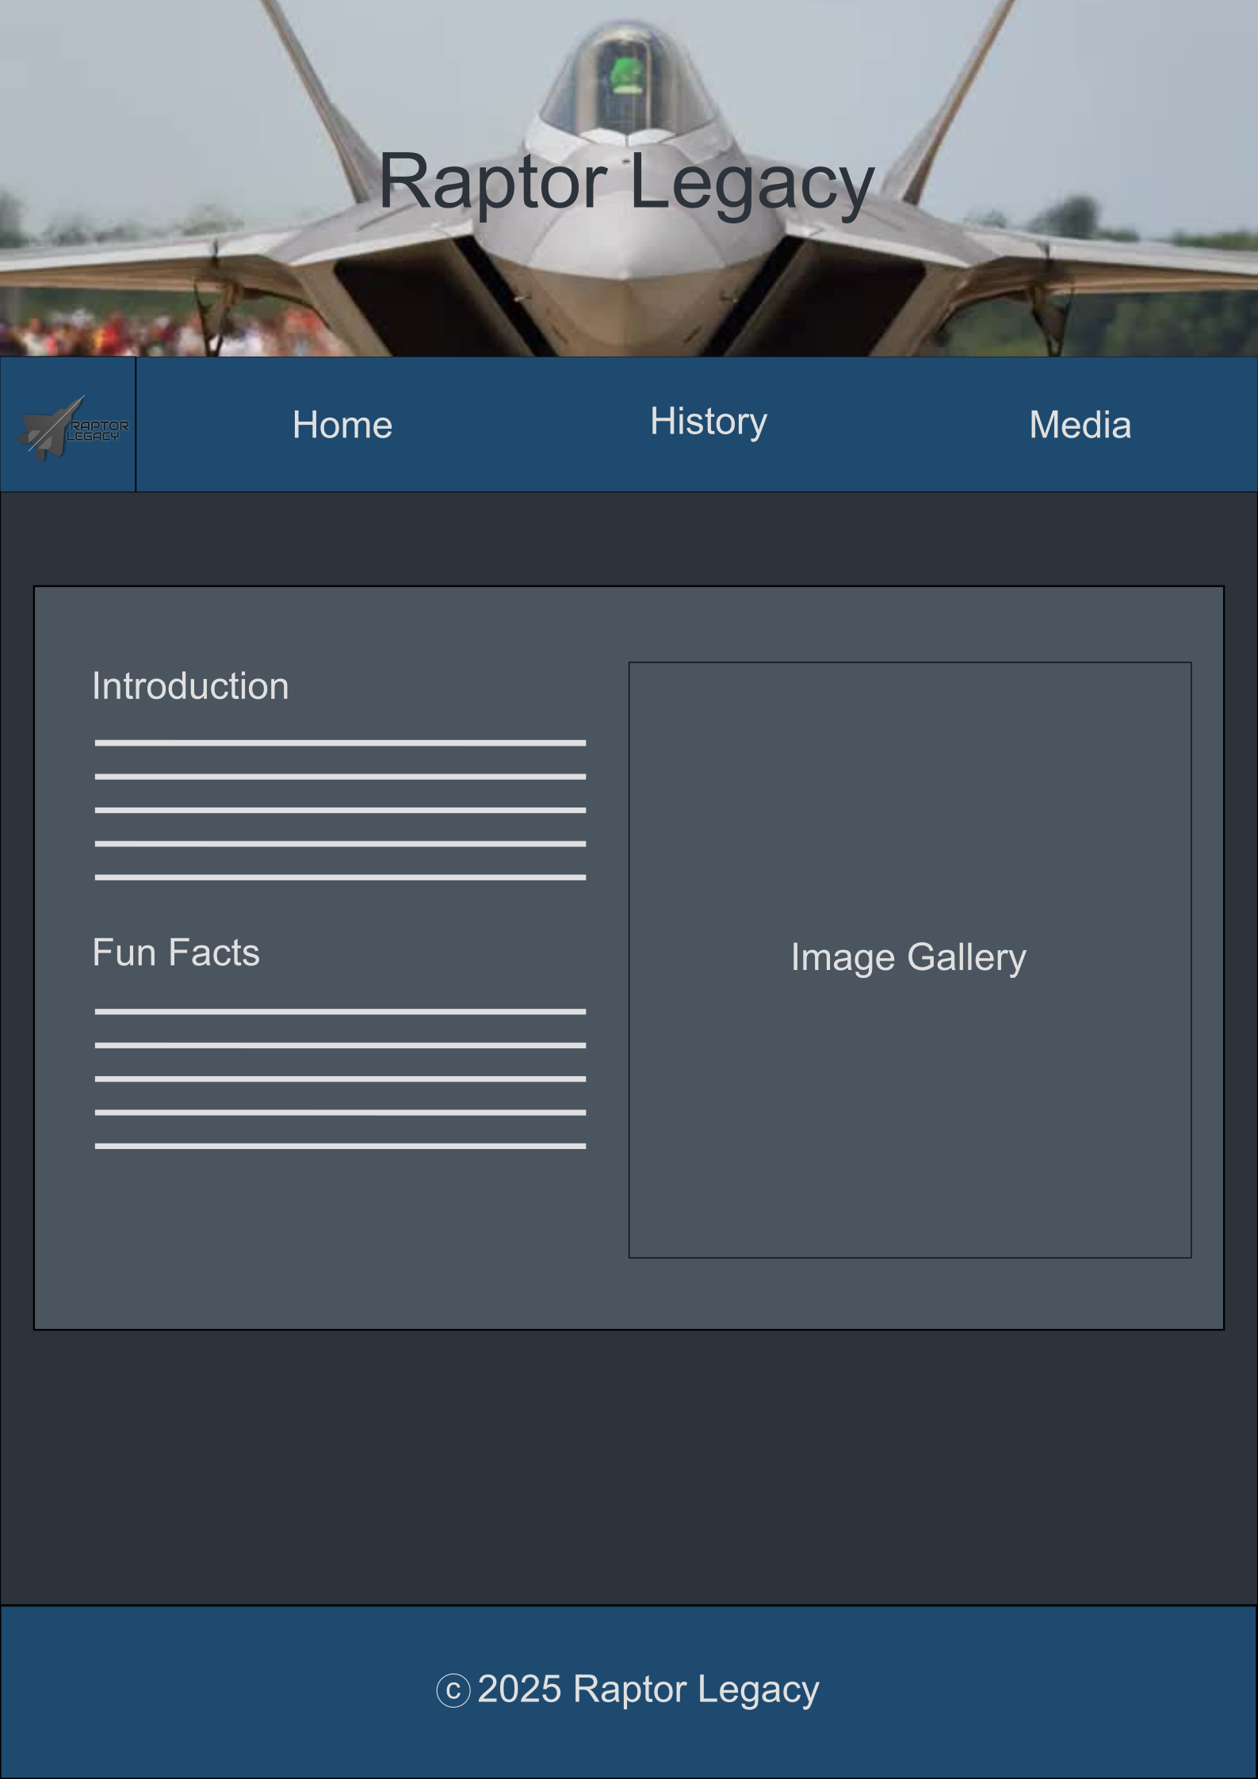

**History**

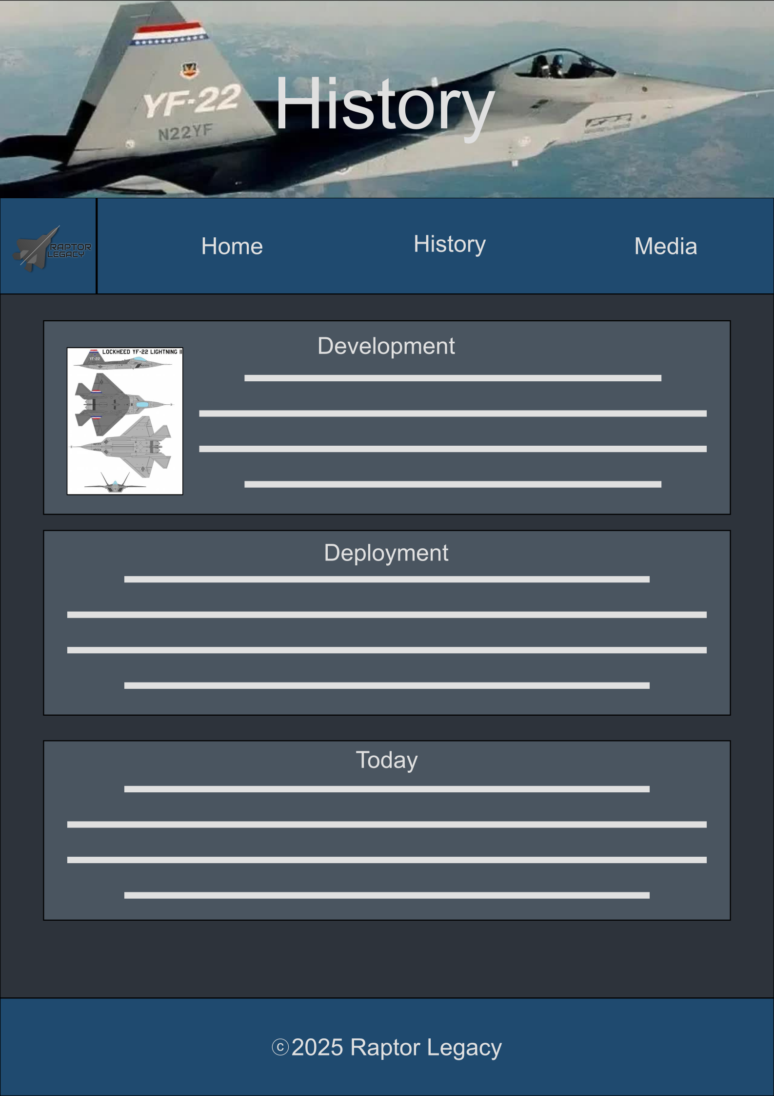

**Media**

