**IVR (INTERACTIVE VOICE RESPONSE)**

**FOR PIZZERIAS**

**Submitted by:**

**EDWARD LE**

**886654797**



**California State University, Fullerton**

**CPSC-597**

**Fall 2021**

**Advisor: Dr. Sampson Akwafuo**

**Department of Computer Science**

**California State University Fullerton**



**Department of Computer Science**

This project has been satisfactorily demonstrated and is of suitable form.

This project report is acceptable in partial completion of the requirements for the award of Master of Science degree in Computer Science.

| **IVR (Interactive Voice Response) For Pizzerias** | | |
| --- | --- | --- |
| Project Title | | |
| **Edward Le** |
| Student Name |
| **Dr. Sampson Akwafuo** |
| Advisor's Name |
|  | |
| Advisor's signature | Date |
| **None** |
| Reviewer's name |
|  | |
| Reviewer's signature | Date |

**Table of Contents**

***Abstract*** ***5***

***Section 1: Introduction, Need and Current Practices*** ***6***

**Section 1.1: Introduction** **6**

**Section 1.2: Advantages of Using IVR For Pizzerias** **7**

**Section 1.3: Competitors** **7**

***Section 2: Project Objectives, Development & Architecture*** ***8***

**Section 2.1: Project Objectives** **8**

**Section 2.2: Technologies used** **8**

Section 2.2.1: Single Sign-On (SSO) 9

Section 2.2.2: Phone Gateway API 9

Section 2.2.3: Order Online (Website) 10

Section 2.2.4: Kitchen Screen 11

Section 2.2.5: Admin Dashboard 11

**Section 2.3: System Block Diagram** **12**

**Section 2.4: Sequence Diagrams** **13**

Section 2.4.1: Single Sign-On Workflow 13

Section 2.4.2: Phone Gateway Workflow 13

Section 2.4.3: Order Online Workflow 14

Section 2.4.4: Kitchen Screen Workflow 14

Section 2.4.5: Admin Dashboard Workflow 14

**Section 2.5: Implementation flow** **15**

**Section 2.6: Product use cases** **15**

***Section 3: Project Results, limitations, and Future work*** ***16***

**Section 3.1: Progress** **16**

Section 3.1.1: Single Sign-On (SSO) 16

Section 3.1.2: Phone Gateway API 16

Section 3.1.3: Order Online (Website) 17

Section 3.1.4: Kitchen Screen 17

Section 3.1.5: Admin Dashboard 18

**Section 3.2: Project Learnings** **18**

**Section 3.3: Limitations** **19**

**Section 3.4: Conclusion** **20**

**Table of Figures**

Figure 1 System Overview 8

Figure 2 System block diagram 12

Figure 3 Single Sign-On Workflow 13

Figure 4 Phone Gateway Workflow 13

Figure 5 Order Online Workflow 14

Figure 6 Kitchen Screen Workflow 14

Figure 7 Admin Dashboard Workflow 14

Figure 8 Implementation Flow 15

Figure 9 Product Use-cases 15

# Abstract

*IVR For Pizzerias* is a customer helpline phone system for pizza restaurants. IVR is a customer helpline phone system for pizza restaurants. This system can handle up to 50 customers at the same time, and helps customers place orders, check order status and pay their orders. This system is a set of 5 synchronized applications that can assist pizzeria owners to communicate closely with customers.

1. **Single Sign-On (SSO)**

Single Sign-on (SSO) is an authentication application that enables users to log in once and access services without re-entering authentication factors.

1. **Phone Gateway API**

Phone Gateway is used to transmit and receive voice communications. Phone Gateway can receive hundreds of phone calls at the same time without interruption or waiting. This is the main part of this project.

1. **Order Online (Website)**

A simple website built to allow customers to order pizza online.

1. **Kitchen Screen**

Kitchen Screen is a screen located in the kitchen that only displays unprepared orders from customers.

1. **Admin Dashboard**

Admin Dashboard is for administrators. It provides necessary reports and interfaces to be able to view the details of the orders, and to enable to configure the entire system.

There were two goals during this phase:

1. Build the structure of the whole system, build relationships, and open up portals so that the systems can communicate.
2. Focus on building IVR, the main part of this project.

Overall, the project is 60% complete. Two goals have been met. The next phase will be completed in 4 weeks, on interfaces and their backends, as well as connecting components and resolving conflicts if any.

# Section 1: Introduction, Need and Current Practices

## Section 1.1: Introduction

## Section 1.2: Advantages of Using IVR For Pizzerias

The obvious advantage is that it saves labor. Especially during peak hours, the ability to receive up to 50 calls at once is a truly unbeatable advantage. In addition, offering a full set of four applications required for a restaurant will bring consistency of data and harmonization of all systems. Another advantage to this automation system is speed. Applications in the system automatically communicate with each other in real time, resulting in fast and accurate data delivery. It only takes 1 or 2 seconds to directly send orders from a customer to a chef. The result of these advantages is increased production efficiency. The result of these advantages is increased production efficiency. Service quality will be improved and costs will be minimized.

## Section 1.3: Competitors

Nowadays, the use of automation systems to replace human labor is the trend; however, there are not many IVR systems for restaurants yet, and a system specifically for pizzerias is nonexistent. This will be the pioneer project in this field. The combination of IVR and AI is expected to create a revolution.

# Section 2: Literature Review

# Section 3: Methodology

## Section 3.1: Project Objectives

A simple set of information technology applications enables small pizzerias to reduce workers by 30% to 50% and help increase orders during peak hours.

* Website: placing orders online
* Phone gateway + IVR: taking orders over the phone
* Kitchen screen: automatically sending orders to the kitchen
* Admin dashboard: View order details and system configuration

## Section 3.2: Technologies used

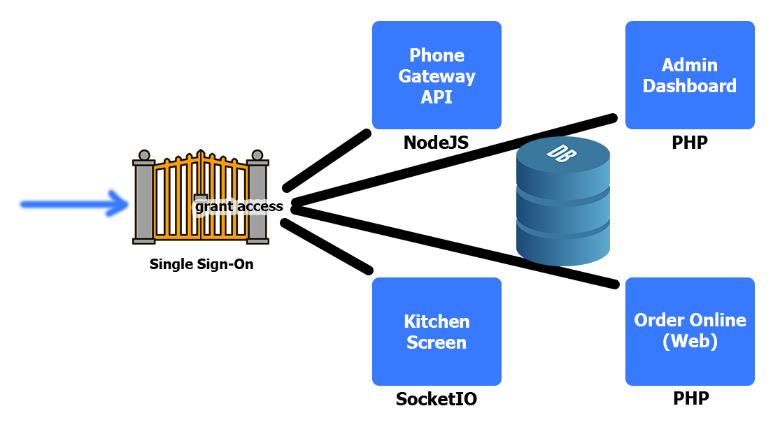

There are four

### Section 2.2.1: Single Sign-On (SSO)

Single Sign-on (SSO) is an authentication application that enables users to log in once and access services without re-entering authentication factors.

Technical information:

* Login form: HTML, CSS3, Javascript
* Backend: PHP, JSON Web Tokens (JWT)
* Database: MySQL

SSO validates sets of credentials by using PHP and MySQL, just like other normal authenticators. After a user has a successful login, JSON Web Token (JWT) generates a token for this user. This token contains all the user's information, including IP and expiration.

When users access our services, such as Admin dashboard, Kitchen screen, Phone Gateway API, and website, which require authentication, the current system sends a request to SSO to confirm access authority. If the user is logged in, SSO will return a trusted token. The current system will create a session and grant permission to this user.

### Section 3.2.2: Phone Gateway API

Phone Gateway is used to transmit and receive voice communications. Phone Gateway can receive hundreds of phone calls at the same time without interruption or waiting. This is the main part of this project.

Technical information:

* Vonage Nexmo APIs
* Google Text-to-Speech
* Google Speech-to-Text
* NodeJS, ExpressJS
* Database: MySQL

By using Vonage Nexmo APIs, we have the capability to build a call center from scratch that allows us to create exceptional customer experiences. Most of the similar services, from either Amazon or Microsoft, have a built-in call center that you don't have full access to construct the unique customisation experiences. Plus, its fee and cost are the cheapest. It means this project is a highly practical system.

Google Cloud provides a speech recognition system that supports 125 languages with a variety of voice patterns. It makes this project possible to deploy to many countries around the world, not just the US.

### Section 3.2.3: Order Online (Website)

A simple website built to allow customers to order pizza online.

Technical information:

* Front-end: HTML, Bootstrap 5
* Back-end: PHP
* Database: MySQL

The purpose of this website is to complete the set of applications supporting restaurants. Describe the synchronization and consistency of data throughout the whole system.

### Section 3.2.4: Kitchen Screen

Kitchen Screen is a screen located in the kitchen that only displays unprepared orders from customers.

Technical information:

* Front-end: Javascript
* Back-end: NodeJS, SocketIO
* Database: MySQL

### Section 3.2.5: Admin Dashboard

Admin Dashboard is for administrators. It provides necessary reports and interfaces to be able to view the details of the orders, and to enable to configure the entire system.

Technical information:

* Front-end: HTML, Bootstrap 5
* Back-end: PHP
* Database: MySQL

## Section 3.3: System Block Diagram

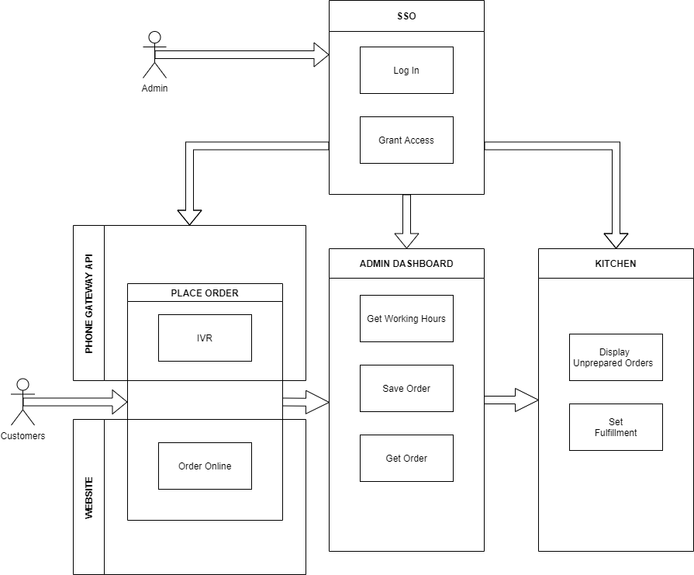

## Section 3.4: Sequence Diagrams

### Section 3.4.1: Single Sign-On Workflow

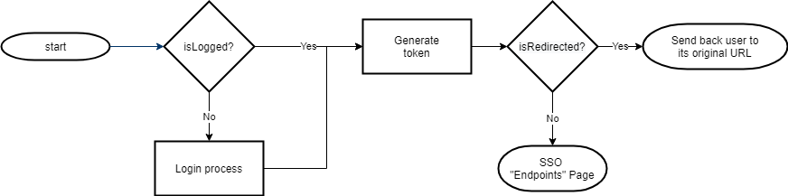

### 

### Section 2.4.2: Phone Gateway Workflow

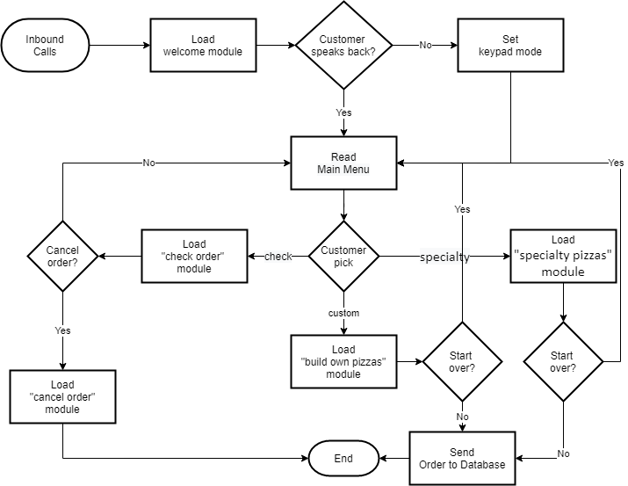

### Section 3.4.3: Order Online Workflow

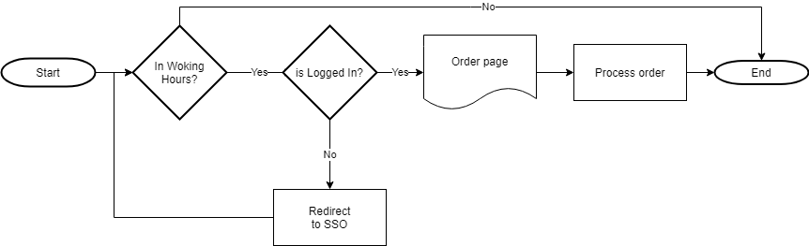

### Section 3.4.4: Kitchen Screen Workflow

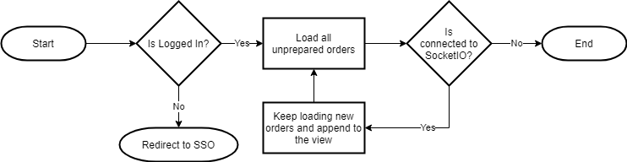

### Section 3.4.5: Admin Dashboard Workflow

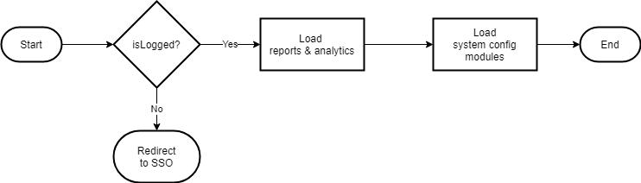

## Section 3.5: Implementation flow

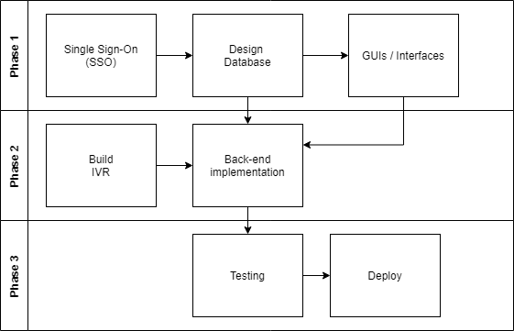

## Section 3.6: Product use cases

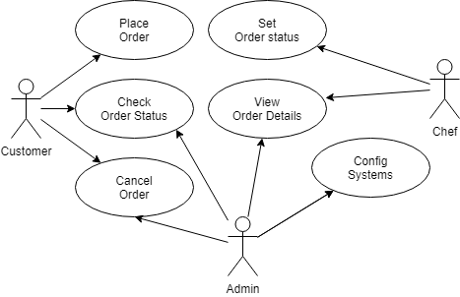

# Section 4: Results and Discussion

## Section 4.1: Progress

The Vonage Nexmo APIs services don't communicate with a private localhost, so I purchased a domain and set up a server with URLs.

### Section 4.1.1: Single Sign-On (SSO)

* Completion progress: 90%
* Domain: https://sso.edwardsle.com/
* Current:
  + SSO is ready for business.
  + It can be used to login and authorize users to our systems.
* Future work:
  + Fixing bugs and logout API

### Section 4.1.2: Phone Gateway API

* Completion progress: 80%
* Domain: https://gate.edwardsle.com/
* Phone number: +1 714-6-606060
* Current:
  + Phone Gateway is ready to take calls.
  + Customers can call this number +1 714-6-606060 to order a specialty pizza or a custom pizza.
  + Customers also can check order status and cancel orders.
  + It also provides a payment method for customer orders.
* Future work:
  + Integrate with Google speech recognition

### Section 4.1.3: Order Online (Website)

* Completion progress: 30%
* Domain: https://shop.edwardsle.com/
* Current:
  + Only a welcome page and a simple designed form is up on this link.
* Future work:
  + Connect to database
  + Send order to server as a post request

### Section 4.1.4: Kitchen Screen

* Completion progress: 50%
* Domain: https://ws.edwardsle.com/
* Current:
  + A Socket IO server is set up for updating orders in real time.
  + The data receiving module is complete and secured.
* Future work:
  + Display orders to chefs

### 

### Section 4.1.5: Admin Dashboard

* Completion progress: 10%
* Domain: https://admin.edwardsle.com/
* Current:
  + There is a front-end framework
* Future work:
  + Back-end implement

## Section 4.2: Project Learnings

Vonage Nexmo APIs send the data to our Phone Gateway API for every single call. There are URLs involved:

* HTTP Get: https://gate.edwardsle.com/answer
* HTTP Post: https://gate.edwardsle.com/event
* HTTP Get: https://gate.edwardsle.com/fallback

Phone Gateway API retrieves the Nexmo Call Control Objects (NCCO) about a call at the event URL and sends back information about the call at the answer URL to Vonage to control the call. Vonage acts as a telephone service provider and is fully controlled by our system, Phone Gateway API. The fallback URL is only used when Vonage services cannot connect to the answer URL.

Besides, Google Cloud provides us with perfect powerful services. Google Speech-To-Text is a speech recognition service with 125 languages supported. Based on the keywords we provide, Google Speech-To-Text can return the customer's needs with high accuracy. In addition, WaveNet is an artificial intelligence application to Google Text-To-Speech that makes this service performing more natural. WaveNet may cost you more, but it is useful in other services, such as storytelling, reading.

## Section 4.3: Limitations

There are four different systems in this project making communication between them complicated. However, because of the specificity of each system and the limitations of the technology, having multiple systems was a must for this project. This is a pioneering project in a new field, so the lack of documentation and guidance is also a difficulty that I encountered during working on the implementation. Applying new technologies to this project is also a difficulty that I have to face. Testing and experimenting with new technologies will take a long time before you can integrate them into the project.

## 

## Section 4.4: Conclusion

The project is challenging and extremely exciting. This project is also realistic and commercialable. Low cost and high efficiency will be the premise for the deployment of this system across small pizzerias in the US. The success of this project is entirely possible and optimizes the business method for restaurants around the world.