How to run scripts

1. Prerequisite.sh
2. Check_status.sh

Prerequsite.sh

1. Run the script from root user.
2. During the installation of azure cli it will ask for enter to create default directory.

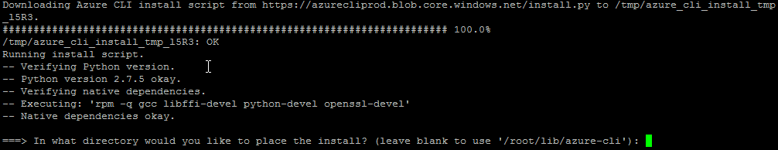

1. We have to enter “y” or enter to continue installation.

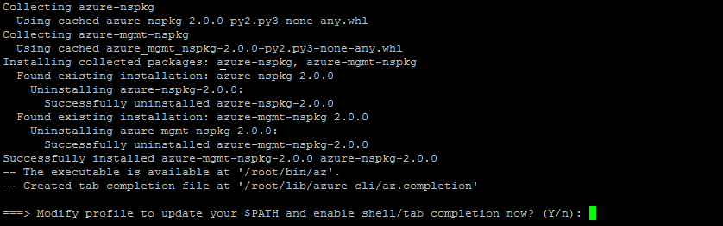

1. Azure CLI installed successfully shown screenshot below-

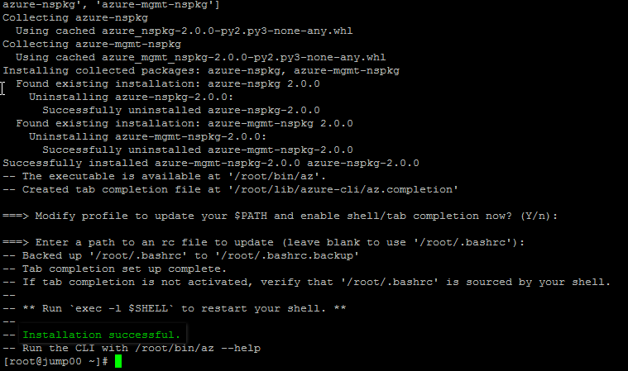

check_status.sh

1. To run “check_status.sh” script we have to pass resource group name and vmss name in sequence shown in screenshot below.



1. Open url: <https://aka.ms/devicelogin> .

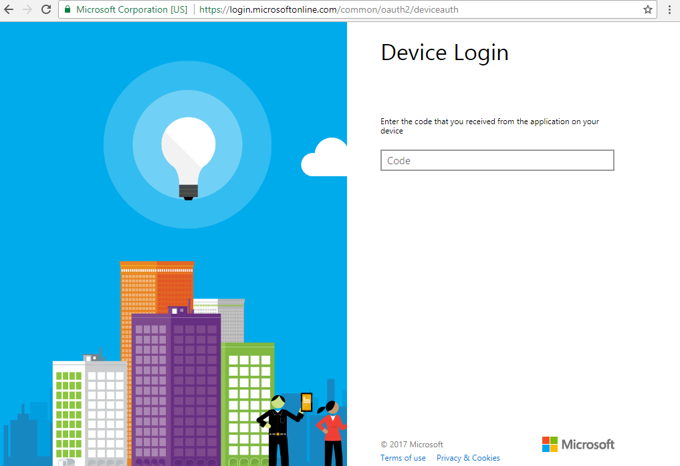

1. Enter generated code (Radom code) highlighted in first screenshot.

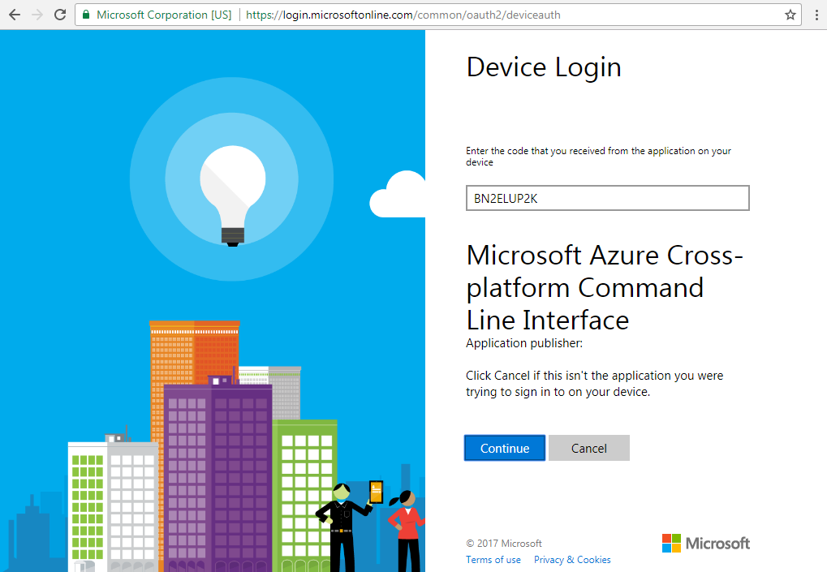

1. Click on Continue button and select id which have access on subscription.

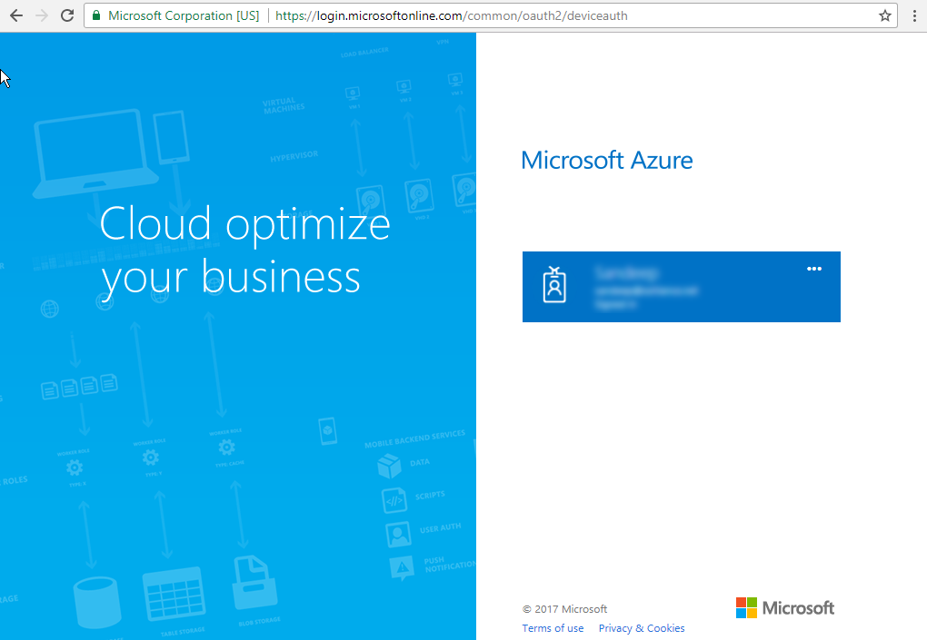

1. Successfully logged in and script is executed to test 4 nodes all is running.

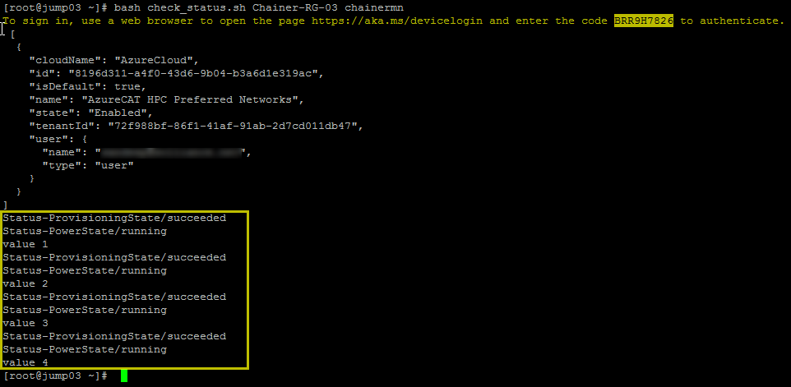

1. When script got a node stopped trying to restart.

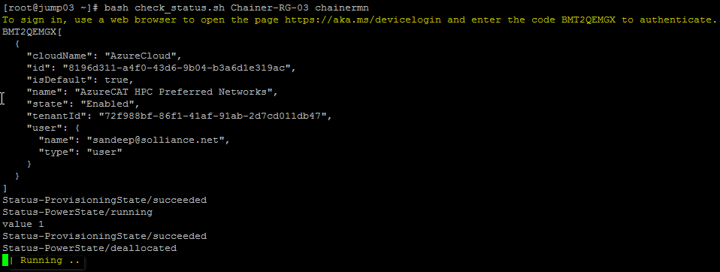

1. Instance is started successfully shown in screenshot below-

